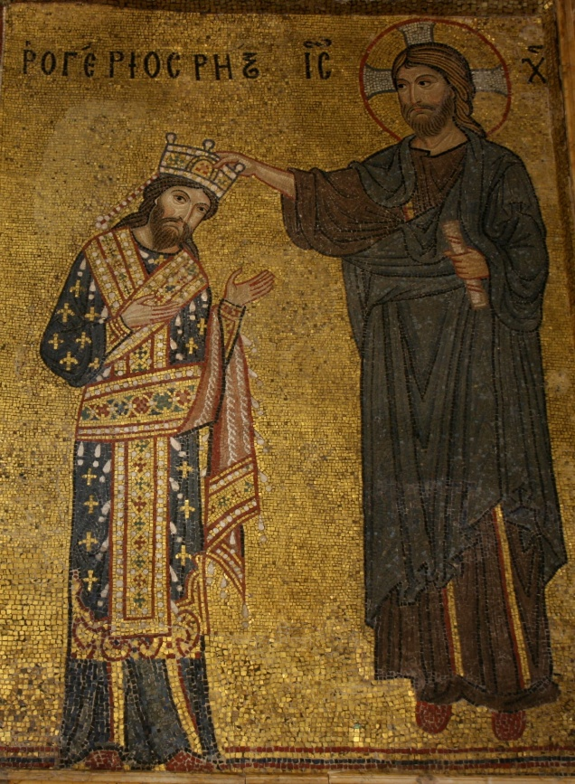
Commentary on the Mosaic of Roger II, King of Sicily
This rather exuberant mosaic, housed inside the Chiesa Santa Maria dell’Ammiraglio (which translates to the Church of Saint Mary the Admiral, which is lacking such admirability) at Palmero, on the island of Sicily. The mosaic, as you can gather from the title, depicts Roger II of Sicily [left] being presumptuously crowned by Jesus [right].
One of the most obvious and standout features of this mosaic, is the fact that it is a mosaic. Now, mosaics are not Norman (as will be discussed later) and a lot of things depicted in the mosaic are not Norman. Mosaics are fundamentally Greek, and in fact were ancient Greek. Greece isn’t Normandy, but neither is Sicily as it is nowadays Italian. But it was Roman, and the Romans also used mosaics. Understanding Norman practises, you would expect them to adjust to the local norms as well as the local culture. Sicily is full of culture at this time; with ethnic Italian, Byzantines and Muslims all coexisting rather well. The Normans come along and with all things considered, they continue to coexist rather well under Roger II. In fact, the Chiesa Santa Maria dell’Ammiraglio has all forms of construction and decretory practises from each of the cultures, presumably because the Normans who planned and built the Church, most noticeably Admiral Geroge of Antioch, would’ve used the best people for the job – as it usually is with the Normans. Therefore, the mosaic itself is a memoir to the history of Sicily and to its Byzantine community. Or is it?
While researching this very golden mosaic, showing off the wealth of Sicily and boasting of the greatness of Roger II, I came across some rather interesting features of the mosaic, especially regarding Roger II and his clothing, to which I would’ve never thought of. The details of Roger II’s clothing in this mosaic, while unassuming, may tell a bigger story of Norman power and Norman desire.
Firstly, his clothing is similar to that of a Byzantine emperor, being blue, and expensive colour for the time, and full of gold; such as the mosaic depiction of Emperor Constantine IX in Hagia Sophia in Istanbul, formerly Constantinople. However, there is a difference between them, a small but rather noticeable design change per se. On Roger II’s robes, are what is called a Fleurs-de-Lis. The Fleurs-de-Lis is a symbol of France, especially when in gold. In fact, a Fleurs-de-Lis on a blue field represents the Royal Arms of France. By being represented with this, it shows Roger II’s French heritage despite the Normans not being French. Additionally, by looking at something even more unassuming. In the words of Dawn Marie Hayes “Roger wears an outdated crown and loros” where the crown is made to feel antique and the loros done for Norman propaganda, hence their desire. The loros is worn by the Emperor of the Byzantines, so it shows Norman desire by Roger II’s potential desire (which is actual desire) to control the whole or at least part of the Byzantine Empire, whether for personal gain, Norman tradition of colonisation or to further the Pope’s control over Christianity. This can be seen by Roger’s raids of the empire in 1147 which lead to Byzantines and the Germans desire for a split of his kingdom. Theres more evidence of this desire too as Roger altered his title to be closer modelled to the Byzantine emperor’s as well as a bribe to an envoy to agree to a treaty where Roger is equal to the emperor. In all simplicity, the older loros represented the “assumption of a higher office”7.
Moving back to the mosaic, as its what the commentary is about; one of the more significant pieces of the mosaic is that it depicts Jesus potentially crowning Roger II, and not the Pope. This is significant as the Pope was actually the one to allow Roger to be crowned King of Sicily. Roger II was coronated on December 25th 1130, through the Pope’s consent. The obvious question would be why depict Jesus? This can be answered simply because he is more recognisable than the Pope to the diverse community of Sicily. As I have mentioned before, Sicily contains Italians (as we would call them), Byzantines and Muslims as major percentages of the population. Sicily was also an Emirate before the Normans took over, meaning that it was in Muslim control. As you would know, Muslims are not Christians and therefore don’t follow the Pope. They may recognise him as a major figure of an alternative religion but they don’t have the need to care. Jesus, on the other hand, is recognisable by all who live on Sicily, as Jesus is in the Qur’an, although he’s known by Isa al-Masih and is a prophet of Allah and not the Son of God. Therefore, Muslims would recognise Jesus more than they would the Pope. Another reason may simply be to show that Roger was made king by the choice of Christ, a way to further his claim to kingship. This may be because the Normans don’t want him to be remembered as a parvenu, which may explain why Roger was so desperate to remarry into other Royal lineages for reasons other than to have more sons7.
To conclude, this mosaic actually says a lot more than you would initially realise, albeit you need to read a lot more into it than usual. Its golden, its flashy and its very on brand for the Normans. Its overzealous use of Jesus and Christianity as a whole is prominent through the mosaic as well as in their lust for integration, as it’s a mosaic and not a painting. However, the subtlety of design choices shows a much darker tone for Norman desire as well for how they are presented which leads to their power at the time.
Bibliography
Aurell, Jaume. 2020. “Roger II of Sicily: Imagining Self-Coronation,” in Medieval Self-Coronations (Cambridge, England: Cambridge University Press), pp. 175–95
“Chiesa Santa Maria dell’Ammiraglio (detta Martorana).” n.d. Portale del Turismo - Comune di Palermo https://turismo.comune.palermo.it/palermo-welcome-luogo-dettaglio.php?tp=68&det=16&id=224 [accessed October 10, 2026]
Di Pietro, Bianca. 2018. “THE CHURCH OF SANTA MARIA DELL’AMMIRAGLIO - Informazioni Turistiche Della Città Metropolitana Di Palermo,” Città, Città Metropolitana di Palermo, 18 July https://turismo.cittametropolitana.pa.it/the-church-of-santa-maria-dellammiraglio/?lang=en [accessed October 10, 2026]
Hayes, Dawn Marie. 2013a. “French Connections: The Significance of the Fleurs-de-Lis in the Mosaic of King Roger II of Sicily in the Church of Santa Maria Dell’Ammiraglio, Palermo,” Montclair State University Digital Commons (Montclair State University), Department of History Faculty Scholarship and Creative Works
——. 2013b. “The Political Significance of Roger II of Sicily’s Antiquated Loros in the Mosaic in Santa Maria Dell’Ammiraglio, Palermo,” ACADEMIA,
Lattanzio, Giada. n.d. “Fashion History Timeline,” Fitnyc.edu https://fashionhistory.fitnyc.edu/byzantine/ [accessed October 10, 2026]
Medievalists.net. 2011. “French Connections: The Significance of the Fleurs-de-Lis in the Mosaic of King Roger II of Sicily in the Church of Santa Maria Dell’Ammiraglio, Palermo,” Medievalists.net, 31 July https://www.medievalists.net/2011/07/french-connections-the-significance-of-the-fleurs-de-lis-in-the-mosaic-of-king-roger-ii-of-sicily-in-the-church-of-santa-maria-dell%E2%80%99ammiraglio-palermo/ [accessed October 10, 2026]
Mozaico. 2021. “A Brief History of Ancient Greek Mosaics,” Medium, 24 March https://mozaico-art.medium.com/a-brief-history-of-ancient-greek-mosaics-977893eff842 [accessed October 10, 2026]
Sicily, Operation. n.d. “Sicily’s Past and Power A Journey through History,” Operation Sicily https://www.operationsicily.com/blog/sicilys-past-and-power-a-journey-through-history [accessed October 10, 2026]
“The Fleur de Lys.” 2018. The Heraldry Society, 24 February https://www.theheraldrysociety.com/articles/the-fleur-de-lys/ [accessed October 10, 2026]

The [left] and [right] are very important additional information just in case the Normans were slightly too good at presenting their image. I would not be surprised if some Normans wanted the halo around them, to show just how saint like they are and how dedicated to Roman Catholicism they were, even if it would cause issues with presenting actual saints and not people pretending to be saints. I just wanted to clarify.
Mozaico. 2021. “A Brief History of Ancient Greek Mosaics,” Medium, 24 March https://mozaico-art.medium.com/a-brief-history-of-ancient-greek-mosaics-977893eff842 [accessed October 10, 2026]
Sicily, Operation. n.d. “Sicily’s Past and Power A Journey through History,” Operation Sicily https://www.operationsicily.com/blog/sicilys-past-and-power-a-journey-through-history [accessed October 10, 2026]
Bianca Di Pietro. 2018. “THE CHURCH OF SANTA MARIA DELL’AMMIRAGLIO - Informazioni Turistiche Della Città Metropolitana Di Palermo,” Città, Città Metropolitana di Palermo, 18 July https://turismo.cittametropolitana.pa.it/the-church-of-santa-maria-dellammiraglio/?lang=en [accessed October 10, 2026] – This source also provides a few more details into he history of the Church before its construction and after (as you would expect with history)
Lattanzio, Giada. n.d. “Fashion History Timeline,” Fitnyc.edu https://fashionhistory.fitnyc.edu/byzantine/ [accessed October 10, 2026] – Constantine IX’s clothes much better show the Byzantine style in more detail than it does with Roger II
“The Fleur de Lys.” 2018. The Heraldry Society, 24 February https://www.theheraldrysociety.com/articles/the-fleur-de-lys/ [accessed October 10, 2026]
Dawn Marie Hayes. 2013 “The Political Significance of Roger II of Sicily’s Antiquated Loros in the Mosaic in Santa Maria Dell’Ammiraglio, Palermo,” ACADEMIA https://www.academia.edu/9918469/The_Political_Significance_of_Roger_II_of_Sicily_s_Antiquated_Loros_in_the_Mosaic_in_Santa_Maria_dell_Ammiraglio_Palermo - This is one long paper (9600 words) on this mosaic. Very useful and very informative. Did have to make an account though but its worth it. This paper was recommended to me when I was researching her other paper on the Fleurs-de-Lis which may or may not be a paper, I’m not entirely sure. However, it is full of other references and I have a copy of the word document, so that’s nice too. I also may or may not have used a fancy word from it later in this commentary.
Jaume Aurell. 2020. “Roger II of Sicily: Imagining Self-Coronation,” in Medieval Self-Coronations (Cambridge, England: Cambridge University Press), pp. 175–95

