Assignment 2

Question 2

This essay will be discussing the role that community based policing has in both preventing terrorism and supporting counter-terrorism efforts. Terrorism is defined as “(threats of) violent action for political purposes” and counter-terrorism is defined as “action intended to prevent violence for political purposes” (Cambridge Dictionary, n.d.).
Terrorism has been a steadily growing issue since the fall of the Soviet Union and was accelerated in 2001 with the 9/11 attacks, which has led to the United States creating several government agencies whose roles were to pursue terrorist groups and prevent the flow of funds into their coffers, in addition to these agencies the US began putting pressure onto other Nations to become involved in the prevention of terrorist activity (Viano, 2020). The US applied pressure to not only organisations that supported terrorists groups but charities and governments as well by taking punitive actions against them, this inevitably led to a reduction if not an outright stop to the funds that many terrorist groups were receiving and in the absence of these crucial funds to support their aims they had to look elsewhere to acquire the revenue. This led many terrorist groups either emulating or allying with organised crime groups in order to generate the revenue they require in order to meet their organisational needs, even if this alliance contradicts their political viewpoint (Viano, 2020). The US drug enforcement agency has linked to the global drug trade nineteen foreign terrorist organisations and believes that up to 60% of terrorist groups are in someway connected to the illegal trade of narcotics, in addition to this there is reason to believe that terrorist organisations are kidnapping young schoolgirls and handing them over to organised crime group who then smuggle them, control them and force them into prostitution, this is not an exhaustive list of the illegal activities that terrorist groups have been linked to with (Viano, 2020). Whilst it can be seen that many terrorists groups are now primarily funded through the use of organised crime an issue that has arising in many countries the United Kingdom included, within the UK organised crime is largely conducted by groups operating on a model known as County Lines which is defined as “County lines is a form of criminal exploitation in which criminals groom and manipulate children and vulnerable adults to recruit them as runners to transport drugs and cash all over the country, so that the criminals behind it can remain detached and less likely to be detected.” (Neighbourhood Watch, 2020) and whilst this essay will not go into detail regarding how the community policing approaches the issue of county lines it can be seen that there has been recent success in the use of the model to disrupt this activity (Hampshire & Isle of Wight Constabulary, 2021), and whilst these activities may not be directly countering terrorism, those groups who rely on organised crime for their revenue will be negatively impacted by their disruption.
Within the UK the Government has established a strategy in order to counter-terrorism called CONTEST which aims to protect it’s communities through the collaboration of government agencies, emergency services and private business’. CONTEST has four main objectives to Pursue by stopping terrorist attacks, Prevent by stopping terrorist attacks, Protect by strengthening the country and Prepare by mitigating the impacts of an attack (Wong, 2021). Community based policing is defined as “Community policing is a philosophy that promotes organizational strategies that support the systematic use of partnerships and problem-solving techniques to proactively address the immediate conditions that give rise to public safety issues such as crime, social disorder, and fear of crime.” (U.S. Department of Justice, 2012).
One key figure within the UK for counter-terrorism is Dr Lambert who is an advocate for community based policing in terrorism prevention and so established the Muslim Contact Unit within the Metropolitan Police Service in London following the 9/11 attacks. This unit was often considered controversial as it would approached Muslim communities in order to engage with them as partners, whereas many would simply view them as suspects (Spalek, 2013). Traditionally policing has operated on an informant based approach for the gathering of intelligence and Dr Lambert was keen to distinguish his partnership based approach from this traditional one. This traditional approach would often lead to distress within the communities or the individual informants themselves and from one of the individuals interviewed by Dr Lambert who’s community member had been approached by MI6 in order to be informant, stated that he believed his community may be considered a suspect as that is why a member of their community had been approached (Spalek, 2013). Dr Lambert wished to create an approach that emphasised partnership which can be broadly conceptualised as equality, transparency and co-operation between the individuals or organisations involved in order to achieve one goal, something that cannot be achieved with the informant based approach as it is inherently non-transparent. The Muslim Contact Unit made it’s best efforts to work with community leaders and representatives rather than attempt to simply recruit as informants which in turn led to a higher level of co-operation from these communities with the police, as when individuals were working as informants they would lose credibility and their effectiveness within the community and contrary to this when they engaged with police in a transparent manner their credibility and effectiveness would be safeguarded (Spalek, 2013).
Continuing along the vein of Muslim terrorism when Britain was rocked by the bombing in London on the 21st of July 2005, one of the attackers managed to elude police for a number of days with the assistance of other Muslims willing to house him in so called “safe-houses” and assist him in getting to Italy (Klausen, 2009). Whilst this is not to say that those who were willing to support the attacker would themselves pick up the torch or that they would even support terrorist groups or organisations and nor was it believed that theses “safe-houses” were not part of an organised group but simply Muslims who were willing to turn a blind eye. This is an important thing to note as without the support of the Muslims who were sheltering the attacker police would be unable to apprehend the attacker as the power of entry into a property in order to effect an arrest requires the officer to have some form of information that leads to the belief that the individual is within that property, information that would be difficult to obtain without the support of either informants or partners within that community (PACE, 1984). One prominent member of the Muslim community Dr. Mohammad Naseem has spoken out quite strongly not only in regards to police but also in relation to the attack that took place on the 21st of July stating that one of the attackers who had been arrested was only an innocent bystander who was being framed by the government and that Muslims could not trust the process (Klausen, 2009).
Community-based policing is not a new concept and has been around for several decades at this point though has only within the past two decades been considered as a potential avenue for tackling the issues surrounding terrorism. Whilst it’s efficacy for dealing with terrorism is still largely un-researched we can look to see how the model has been affective in other areas to evaluate if it is beneficial for the purposes of counter-terrorism. As can be seen from the previous examples explored there is a severe disconnect between the Muslim community and the local authorities, especially the police which has led to enough Muslims losing trust in the legal system or turning a blind eye to a fellow Muslims heinous actions to hide him and assist him in leaving the country (Klausen, 2009), one of the main recorded benefits of community-based policing is that it improves the publics trust and confidence with the police force and with the effective elements including the creation of partnerships within the community (Quinton, 2018). This research goes on to say that with the engagement from police and their partnership approach that not only are individuals more likely to report crime and suspicious activity but that individuals are much more likely to support counter terrorism policing and reduce the use of violence to achieve personal goals.
However despite these serious benefits and the vital information that can be provided to police in order to counter terrorism there are issues that arise with these policing model. One of the largest issues surrounding community-based policing is the large demand it requires on police resources to maintain, some areas especially within large cities require a significant number of officers in order to maintain a presence, or a limited amount of officers covering a large area, in either case for the model to be effective at forming partnership it requires the officer in that area to have a good knowledge of the area and the community within it (Quinton, 2018). This resourcing requirement would lead to one of two issues, either that the officer working his area would have to develop the knowledge of this large area and someone maintain that knowledge and a visual presence or alternatively the force would be required to dedicate a significant number of officers to said area, this in turn would diminish the resources available in other areas or alternative would diminish the forces ability to respond to emergency calls.
One serious issue highlighted with the Muslim Contact Unit is the level of service officers were providing to the community, some individuals would state how excellent they felt the service from one officer was, only to then have to deal with a different officer who’s level of service they felt was lacking (Spalek, 2013). This was potentially an issue surrounding the culture of individual officer with those of a different ethnic background not being able to fully understand the issues facing the Muslim community at the time as they simply did not share similar experiences, and with the level of Muslim officers in the force being limited at the time and that under the equality act individuals could not be hired into a role based solely on them being of the same ethnic or religious group, despite the fact that this may have alleviated some of the issues of forming partnerships with the Muslim community at the time as Muslim officers would most likely share similar experiences and views.
In conclusion it can be shown that a community-based approach to policing can have significant impacts on the level of trust felt by a community towards the police and the local authorities which has shown as a viable and effective form of intelligence gathering in order to prevent future attacks as well as establish links with a community and potentially prevent more individuals from going down the route of extremism. However it should be noted that this model of policing whilst effective in many aspects it requires a large amount of resources to conduct effectively which in some areas or in some forces may leave other key department short on resources, most notably department who respond to emergency calls.

Word Count: 1855

Question 6

This essay will be discussing the role the police service plays within joint emergency service operations and the impacts that such operations can have on the mental wellbeing of officers. In joint emergency service activities, the job of the police is to support other emergency services during times of need or function as a first point of contact for those in need. The police are essential to protecting public safety during collaborative operations such as natural disasters, terrorist attacks, or other high-risk occurrences (JESIP, 2023).
The role of the police service within joint operations is largely dictated within the UK by the Joint Emergency Service Interoperability Program (JESIP) established in 2012 following a review of major incidents that involved multi emergency services. Research into these incidents showed a pattern of services failing to learn from their errors, a problem with leadership failing to set a good example, a lack of a structure for those under their supervision to report errors or problems that could then be learned from, and a prescription for blame instilled in them. Illustrated in figure 1 is a chart exhibiting an example of how blame should be prescribed, thus allowing individuals to be honest and to provide an avenue for organisations to learn (Paresh Wankhade, 2019).
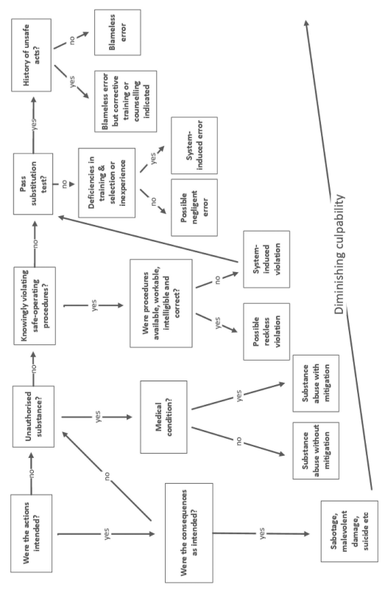
Figure 1. prescribed blame chart (Paresh Wankhade, 2019).

As previously stated the role within the police service for joint operations is largely as the initial responder and to provide support for the other emergency services, and can be examined through a report on the Manchester Arena Bombing in which not only did Greater Manchester Police (GMP) respond and the North West Ambulance Service but so did British Transport Police, Fire and Rescue and Military Assistance. Initially a single call was received by the GMP control room who dispatched armed response vehicles to the scene and within eleven minutes twelve armed response officers were on scene who then relayed information back to the control including casualties, fatalities, the possibility of an explosive device and the belief that there was a marauding terrorist with access to a firearm (Kerslake, 2018). In light of this information operation PLATO was declared and other emergency services were notified of the incident and more firearms officers where dispatched as well as dogs capable of detecting explosive devices. Armed Response officers at this time began conducting emergency searches of the area and to protect the public and other responders from a potential concealed attacker and due to this did not assist by administering first aid. As further police arrived on scene officers began co-ordinating with other agencies within the foyer and began to establish cordons, assist with first aid, and begin the evacuation, during this stage police would largely be co-ordinating with the ambulance service as the priority at this stage was to preserve life (Kerslake, 2018). This co-ordination would require both the on-scene and off-scene police commanders to be constantly sharing information with the ambulance service to both ensure the safety of the paramedics on scene and to allow the paramedics to administer first aid. Following the evacuation, it was the police’s role to create a crime scene and preserve the evidence where possible and to then begin an investigation into the attack, which would include the responsibility of identifying the disaster victims. As can be seen from this report the role of police officers in this situation is both highly specialized and generic, with the main purpose of officers in this incident to provide support to the other services who were present and better suited to the needs of the public.
The role of a police officer is often considered to one of the most stressful jobs any individual can undertake, it requires an individual to be able effectively manage their own emotions an act which often requires an officer to display on the surface emotions which are contrary to what they are actually feeling, this coupled with the organisational stress many officers feel coming the ever changing nature of their role and lack of resources (Black, 2020). Whilst this essay will largely focus on the effects of joint operations on a police officers mental wellbeing it should be noted that research has shown that officers even when dealing with less traumatic incidents than the one previously mentioned can suffer greatly with two officers expressing their issues following what they believed at the time to be a simple welfare check which later turned into a hanging (Black, 2020). It can be clearly seen from the research shown that officers are routinely exposed to incidents that have a negative impact on the mental wellbeing and these stressors that they are exposed do not simply manifest as mental ill-health but expand to physical ill-health as well. Figure 2 presents a chart illustrating the increase in stress from traumatic events from police officers between 2015 and 2019 (MIND, 2019).
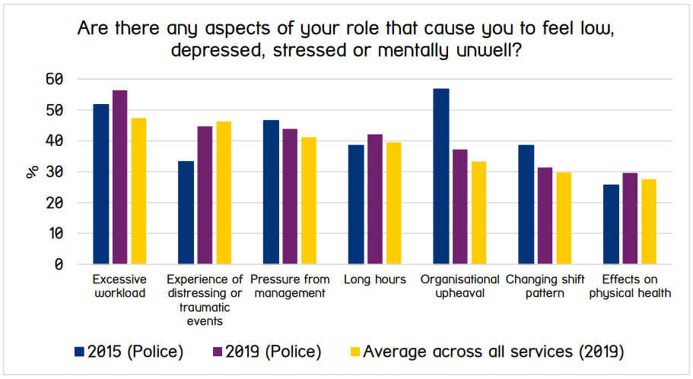
Figure 2. Police officer traumatic stress related incidents

Events that are extremely stressful, frightening, or disturbing can lead to post-traumatic stress disorder (PTSD), an anxiety disorder (NHS, 2022) an issue that is currently reported to affect 16.4% of officers within the federated ranks (Garland, 2020), though these figures are from officers self-reporting. According to research, exposure to critical or severe situations increases the risk of developing PTSD, which, if left untreated, can result in the aforementioned psychological and physical illnesses, one study showed that following a critical incident 46% of those emergency services responders developed trauma symptoms (Andrews, 2018). The effects of these traumatic events on officers mental wellbeing should not be understated as exposure to these traumatic event can lead to many changes within the officer himself, one study conducted on the South African Police Force noted one officer who moved station and after only a single year of dealing with murder scenes he had changed dramatically, the research showed that the man had become short tempered and would struggle to deal with noise and as such his wife being understanding would allow him to sit and move their children away from him so as not to disturb his peace and quiet (Grainne Perkins, 2020), this research shows the potentially far reaching implications that the mental health problems experienced by officers can extend beyond their working lives and into their personal ones. Further research has shown that officers suffering with trauma can resort to substance misuse, with officers being constantly face to face with trauma become so stressed and full of adrenaline they can no longer sleep and will resort to alcohol as a means of coping (Kotera, 2021). It has also been shown that whilst an officers PTSD may be in remission certain events or incidents can cause of re-emergence of their symptoms and further treatment maybe required (Garland, 2020). Due to this continued degradation of many officers mental wellbeing 58% of respondents to the previous study reported they had one or more days as absent due to sickness and 29% stated at least one of their days absent was as a result of work related stress. From the research currently available it would appear that the stress experienced as part of the role of a police has potentially severe consequences not only for the mental well-being of the officer but also for their physical health and in response to this many forces have established support for officers most notably of which is TRiM or the Trauma Risk Management process (Andrews, 2018).
Despite the research showing a clear trend of both physical and mental health problems following these traumatic incidents, police officers have a very low rate of seeking support with studies from all over the world showing a routinely low rate of seeking help despite the majority of officers being aware of the support available to them (Andrews, 2018). From the research available the main reason officers routinely do not seek help is down to the perception that either asking for help would prescribe them with a negative label and thus stall or hinder their career or would cause their colleagues to lose faith in them. TRiM was introduced in an attempt to counter these negative perceptions of help-seeking as it is a peer-support process who’s goals are to provide support following traumatic events, reduce stigma and encourage help-seeking, and from the research currently available on military personnel it has been shown to beneficial with no detrimental effects (Andrews, 2018). TRiM utilises non-medically trained staff from within the organisation itself who are then trained to a basic level of trauma psychology, and thusly would have similar experiences to those they are supporting and be a greater role model who does not carry the stigma of a mental health practitioner. TRiM in itself is not a treatment process and does not intend for it to be, it is largely designed to risk assess those it seeks to help and refer those it deems as high risk to mental health practitioners who are able to accurately diagnosed mental health problems and treat them, however in a study comparing three forces who utilised TRiM and two forces who did not, the research showed that those forces who did utilise TRiM had lower rates of public stigma, which is to say that the officers in those forces were less concerned at how others would respond to mental health, and most importantly those forces utilising TRiM did have lower rates of PTSD amongst it’s officers (Andrews, 2018). However despite the research showing a reducing in public stigma amongst officers there were several key factors that did not have a significant difference, that being self-stigma and in barriers to seeking help, most notably the perception that seeking help would have negative impacts on their career.
This essay has largely focussed on the negative impacts to police officers mental health from major or critical incidents that they are likely to attend through joint operations it should be important to not that research has shown that largest impact on officers mental wellbeing comes more from organisational stressors that being lack or resources, organisational changes etc. Continuing on from this officers and even control room staff when faced with traumatic events can experience a net positive to their mental wellbeing, as when individuals are required to respond to an emergency situation they are placed into a position that allows them to assist someone in need can create a sense of personal accomplishment and perspective (Black, 2020).
In conclusion the research shows that the role police officers have in joint operations is an incredibly varied and specialized role, serving as both to provide general assistance to the other services involved but also to be potentially dealing with the more impactful and traumatic aspects. As previously explored in this essay officers who are exposed to critical incidents also have a much higher chance of developing PTSD and due to the pivotal role officers play in public protection they cannot be excluded in joint operations and more initiatives and research needs to be conducted in order to ensure that officers mental wellbeing is maintained and that they are fit to continue their duties, and as stigma from the research appears to be the largest barrier to help-seeking behaviour ways of reducing this must be explored.

Word Count: 1867

Bibliography
Andrews, L. W. (2018). The Effect of a Trauma Risk Management (TRiM) Program on. International Journal of Stress Management, 348-356.
Black, K. L. (2020). Karen Lumsden and Alex Black. Policing and Mental Health, 223-240.
Cambridge Dictionary. (n.d.). Cambridge Dictionary. Retrieved from Cambridge Dictionary: https://dictionary.cambridge.org/dictionary/english/counterterrorism?q=counter-terrorism
Garland, K. B. (2020). Understanding the mental health and well-being of police officers. Policing and Mental Health, 241-253.
Grainne Perkins, S. H. (2020). The spectre of trauma in the South African Police Service. Policing and Mental Health, 286-299.
Hampshire & Isle of Wight Constabulary. (2021, 05 27). Police and partners disrupt county line networks and local drug networks as part of a national week of intensification. Retrieved from Hampshire & Isle of Wight Constabulary: https://www.hampshire.police.uk/cy-GB/news/hampshire/news/news/2021/may/officers-investigating-new-forest-shed-burglaries-would-like-to-speak-to-this-man/police-and-partners-disrupt-county-line-networks-and-local-drug-networks-as-part-of-a-national-week-o
JESIP. (2023, 01). Emergency Responder Organisations Roles and Responsibilities. Retrieved from JESIP: https://www.jesip.org.uk/downloads/emergency-responder-organisations-roles-and-responsibilities/
JESIP. (n.d.). Major Incidents. Retrieved from JESIP: https://www.jesip.org.uk/uploads/media/app/Jesip-web-version/major.html
Kerslake, L. B. (2018). The Kerslake Report.
Klausen, J. (2009). British Counter-Terrorism After 7/7: Adapting Community Policing to the Fight Against Domestic Terrorism. Journal of Ethnic and Migration Studies, 403-420.
Kotera, A.-M. E. (2021). Mental health in the UK police force: a qualitative investigation into the stigma with mental illness. International journal of mental health and addiction, 1116-1134.
MIND. (2019). Mental Health in the Emergency Services.
Neighbourhood Watch. (2020). County Lines. Retrieved from Neighbourhood Watch: https://www.ourwatch.org.uk/county-lines
NHS. (2022, 05 13). Overview - Post-traumatic stress disorder. Retrieved from NHS: https://www.nhs.uk/mental-health/conditions/post-traumatic-stress-disorder-ptsd/overview/
North West Ambulance Service. (n.d.). Joint Emergency Service Interoperability Programme (JESIP). Retrieved from North West Ambulance Service: https://www.nwas.nhs.uk/services/major-incidents/jesip/#:~:text=Working%20together%20with%20emergency%20service,centres%20or%20other%20open%20venues.
PACE. (1984). Police and Criminal Evidence Act. Retrieved from Leg.gov: https://www.legislation.gov.uk/ukpga/1984/60/section/17
Paresh Wankhade, L. M. (2019). Critical Perspectives on the Management and Organization of Emergency Services. New York: Routledge.
Quinton, S. C. (2018). Neighbourhood Policing: impact and implementation. College of Policing. Retrieved from College of Policing.
Spalek, B. (2013). Terror Crime Prevention with Communities. Community Policing within a Counter-Terrorism Context: Understanding Police and Community Engagement, 47-74.
U.S. Department of Justice. (2012). Community Policing Defined.
Viano, E. C. (2020). Unholy Alliances and their Threat: The Convergence of Terrorism, Organized Crime and Corruption. Internation Annals of Criminology, 91-110.
Wong, J. (2021). Sharing terrorism intelligence: insights from UK law enforcement agencies. Journal of Policing, Intelligence and Counter Terrorism, 218-228.

