

Case study: Implementing an attendance logging web service
by
Patrick Frank Atkinson (1811357)

Supervisor: Michael Dacey

Project submitted as part of the requirements for the award of BSc (Hons) Computing (Software Engineering)

July 2022

DECLARATION
I, Patrick Frank Atkinson declare that I am the sole author of this project; that all references cited have been consulted; that I have conducted all work of which this is a record, and that the finished work lies within the prescribed word limits.

This work has not previously been accepted as part of any other degree submission.

Signature: ______________________________________
Date: 16/07/2022

FORM OF CONSENT
I, Patrick Frank Atkinson, hereby consent that my Project, submitted in candidature for the B.Sc. (Hons) Software Engineering degree, if successful, may be made available for inter-library loan or photocopying (subject to the law of copyright), and that the title and abstract may be made available to outside organisations.

Signature: ______________________________________
Date: 16/07/2022

Abstract
The Attendance Monitoring System (AMS) used for University of Wales Trinity Saint David’s Welsh campuses has various limitations that place a large administrative burden on the lecturers and administrative staff, and reduce the amount to time lecturers can dedicate towards the students. This case study seeks to create a system that moves the onus for logging attendance from the lecturer towards the student, thereby reducing the burden on the lecturers and increasing student awareness of attendance. Existing systems with various attendance logging methods are discussed, along with research into testing and securing web services. This is followed by discussion of the requirements gathering, design, development and testing of the system that was developed. The system is subsequently evaluated based on the results of the testing, and conclusions are drawn about its effectiveness. The developed system was successfully piloted with a smaller cohort, indicating its potential for wider scale deployment.

Contents
1. Chapter 1 – Introduction 1
1.1. Defining the problem 1
1.1.1. Attendance Monitoring Systems (AMSs) at UWTSD 1
1.1.2. Limitations of attendance logging (AL) 2
1.2. Aims and objectives 3
1.3. Structure of the report 3
2. Chapter 2 – Research and literature review 4
2.1. Approaches to attendance logging 4
2.1.1. Applications of the technologies 5
2.1.2. Management of logged data 8
2.1.3. Summarising the attendance logging research 10
2.2. Testing web services 11
2.2.1. Testing in terms of web services 11
2.2.1.1. Functional testing 11
2.2.1.2. Load and performance 12
2.2.1.3. Regression testing 13
2.2.2. Summarising the research into testing web services 14
2.3. Securing web services 15
2.3.1. Basic HTTP Authentication Scheme 15
2.3.2. API keys 15
2.3.3. OAuth 2.0 16
2.3.4. OpenID Connect (OIDC) 17
2.3.5. Summarising the research into web service security 17
3. Chapter 3 – Research methodology 18
3.1. Discussion of research methodologies 18
3.2. Research process 20
3.2.1. Survey design 21
3.2.2. Testing the application 22
4. Chapter 4 – Development methodology 23
4.1. Potential methodologies 23
4.1.1. Waterfall 23
4.1.2. Agile 23
4.1.2.1. Uses of the agile principles 24
4.1.3. Prototyping 24
4.1.4. Choosing the right approach 25
4.2. Development tools 26
5. Chapter 5 – Requirements 27
5.1. Consultation with department leader 27
5.2. Review of the survey 28
5.3. Summarising the requirements 31
6. Chapter 6 – Design 33
6.1. Process flowcharts 33
6.1.1. Student process flowchart 33
6.1.2. Lecturer process flowcharts 35
6.1.2.1. Lecturer creating a session 35
6.1.2.2. Lecturer sharing the session 35
6.1.2.3. Lecturer exporting the attendance 36
6.2. Database design 37
6.3. System architecture 39
7. Chapter 7 – Implementation 41
7.1. API development 41
7.2. Web application 42
8. Chapter 8 – Testing 45
8.1. Functional testing 45
8.2. Performance testing 47
8.2.1. Test type 1 48
8.2.2. Test type 2 48
8.2.3. Test type 3 48
8.3. User testing 49
9. Chapter 9 – Results and evaluation 50
9.1. System compared to requirements 50
9.2. Functional testing and analysis 51
9.3. Non-functional testing and analysis 54
9.3.1. Test type 1 54
9.3.2. Test type 2 58
9.3.3. Test type 3 60
9.4. Usability testing and analysis 60
10. Conclusion and recommendations 62
10.1. Conclusion 62
10.2. Suggestions for future work 63
11. Reflection 64
12. Glossary 65
13. Reference list 67
14. Appendices 78
14.1. Appendix A 78
14.1.1. Previous attempts at improving attendance logging 78
14.2. Appendix B 80
14.2.1. Technologies used for attendance logging 80
14.2.1.1. Radio Frequency Identification (RFID) and Near Field Communication (NFC) 80
14.2.1.2. Bluetooth Low Energy (BLE) 80
14.2.1.3. Biometrics 81
14.2.1.4. Other approaches 82
14.3. Appendix C 83
14.3.1. REST and SOAP 83
14.3.1.1. REST 83
14.3.1.2. SOAP 84
14.3.1.3. Comparison between REST and SOAP 84
14.4. Appendix D 86
14.4.1. Analysis of the survey responses 86
14.4.1.1. Quantitative analysis 86
14.4.1.2. Qualitative analysis 89
14.5. Appendix E 91
14.5.1. User story map 91
14.6. Appendix F 92
14.6.1. Agreed requirements 92

Chapter 1 – Introduction
Attendance monitoring at University of Wales Trinity Saint David’s (UWTSD) Welsh campuses has long been a challenge for teaching and administrative staff, with the logging itself being a key issue. Attempts to improve the process through automation proved challenging and have created some reticence towards similar implementations. This case study seeks to evaluate different approaches to attendance logging and implement a solution that meets the needs of the institution.

Defining the problem

Attendance Monitoring Systems (AMSs) at UWTSD
UWTSD has been using an Excel based Attendance Monitoring System (AMS) on its Welsh campuses since 2016. This system was originally developed in response to the requirements set out by the UK Visa and Immigration (UKVI) authority for monitoring the attendance of overseas students. The system consists of multiple linked workbooks stored on a centrally available Network Attached Storage (NAS) server. Most of the workbooks represent registers for modules, with the remaining workbooks being used for collating the data from the registers for further analysis and reporting, such as for returns required by UKVI.
In contrast to the Welsh campuses, the ‘Learning Centre’ campuses based in London and Birmingham utilise the university’s timetabling system, Celcat, for recording attendance data, and have been doing so successfully for several years. This is done either through a client application deployed to university computers, or via a web interface. A list of the key differences between the Excel based AMS and Celcat can be found in Table 1.
Table 1: Key differences between the Excel based AMS and Celcat.
Area | Excel based AMS | Celcat
Attendance logging method | Attendance collected on paper sign-in sheets and retrospectively entered into spreadsheets. | Attendance entered via attendance client or web interface.
Data storage | Data is stored in Excel spreadsheets. | Data is stored in SQL Server databases.
Data maintenance | Data imported into spreadsheets via macros roughly on a weekly basis. | Registers automatically maintained based on student enrolment and the timetable.
Data extraction | SQL Server Integrations Service (SSIS) package available for extracting data from spreadsheets to an SQL Server database. | Extraction via SQL queries.
Reporting | Spreadsheets for summarising attendance at a portfolio or school level. | SQL Server Reporting Service (SSRS) reports summarising student attendance for the current and last academic year.
Integration with other systems | Process available for importing attendance information from Teams participant lists into registers. | Attendance information synchronised to MyDay (student portal) for students to be able to view their own attendance.

Limitations of attendance logging (AL)
There is anecdotal feedback about the deficiencies of the Excel based AMS in respect to attendance logging. It is the lecturers’ responsibility to log attendance. Lecturers typically pass a paper sign-in sheet around the class for each student to sign. This data is retrospectively entered into the appropriate register outside of teaching time by either the lecturer or faculty administrative team depending on faculty procedures. Whilst this administrative overhead may be manageable for smaller classes, it is a time management issue for those with multiple, large classes. The process is also susceptible to errors from manual data entry, and there is a delay between the session taking place and the attendance being entered into the system.
For sessions taught via Microsoft Teams, there is a procedure for importing attendance information into registers based on participant lists exported from Teams. This has the benefit of reducing the amount of manual data entry, but there is still a data checking process that needs to occur to validate the imported data and enter absent marks.
Information about previous attempts at improving UWTSD’s attendance logging can be found in Appendix A.

Aims and objectives
The anecdotal feedback suggests a better solution is required for AL. An approach that puts more of the onus on the student to log their attendance would make them more conscious of their attendance and would reduce the burden on the lecturer, potentially allowing them to dedicate more time to the students. Therefore, the aim of this project was to conduct a case study to implement an improved approach for attendance logging at UWTSD.
To meet this aim, three main objectives were chosen, those being to:
- Evaluate the available approaches for logging attendance, including prior and current implementations, and those from other institutions.
- Determine the system requirements and implement a new solution that will be compared to the existing approach.
- Critically evaluate the solution against the requirements and the existing approach and assess its viability.

Structure of the report
This introduction is followed by the literature review. The literature review focuses on researching and evaluating attendance logging methods that are used in industry, along with other experiments and case studies. There is also a review of different approaches to testing and securing web services. The literature review is followed by an overview of the chosen research and development methodologies. These outline why the methodologies were chosen and the tools that were used to facilitate them. Also discussed are the development tools used for the implementation.
The implementation section follows next. This outlines the design, implementation, and testing of the solution. There is then an evaluation section, where the implementation is evaluated against the requirements and testing data. This is followed by the conclusion which includes a summary of the project as a whole and recommendations for further work. The final section covers the author’s reflection on how the project has impacted their self-development.

Chapter 2 – Research and literature review
As the previous chapter highlighted, a better solution is required for AL at UWTSD. Therefore, this chapter is dedicated to the research and review of existing literature in two key areas: the various approaches to attendance logging, and different approaches to testing web services and how to secure them. This uncovers different approaches for AL and their relative strengths and weaknesses. It also lays the groundwork for investigating how the information from the AL approach can be logged and retrieved.

Approaches to attendance logging
There is a wealth of literature relating to the collection of attendance data. Many examples are focussed on transitioning from a paper based attendance logging system to some form of automated approach using a range of different technologies [1][2][3][4][5]. In some cases, these technologies are combined to alleviate their relative deficiencies in a bid to ensure data quality or validity [6][3].
There are numerous considerations that should be made when accessing the validity of an AL approach. These areas (shown in Table 2) will be considered when reviewing the literature.
Table 2: Areas that will be considered when reviewing attendance logging approaches.
Area | Considerations
Resistance to foul play | Foul play is sometimes cited as a reason for moving from a paper based system to an electronic collection method [6][3]. The concern is that students will find a way to mark themselves as present even when they are not, resulting in unreliable attendance data. The solution should attempt to safeguard against this kind of forgery.
Impact on the session deliverer | In systems where the session deliverer is expected to log attendance, there is either an impact during the session (e.g., a roll call) or an impact after the session where the data must be recorded retrospectively. Both result in a reduction in time dedicated to facilitating learning. The solution should attempt to reduce the administrative burden placed on the session deliverer so the time can be better utilised.
Impact on the learner | Whilst moving the onus for AL from the session deliverer to the learner reduces the impact on the session deliverer, it does put more responsibility on the learner to ensure their attendance has been logged. Complicated arrangements for logging attendance may result in time lost trying to register and therefore a reduction in learning time. The solution should attempt to make the logging process simple and ‘fool-proof’ to reduce the barrier for engagement.
Hardware requirements | The move to automating AL often relies on various scanners or sensors [1][2][3][7]. This may introduce large financial and administrative overheads depending on the scale of the rollout and the type of hardware. It should be possible for the solution to be scaled as necessary without incurring unreasonable costs and workload.
Software requirements | Some solutions may require software specific to a particular platform or technology, preventing some users from using it. This would reduce the usefulness of the system if large swaths of users are unable to use it. The solution should therefore seek to achieve cross-platform compatibility.
Operational requirements | There may be a need to collect information from, or provide hardware to, the users of a solution, requiring a well-planned and coordinated approach. This is especially true as the number of users increases. The implementation should be realistic about the feasibility of large scale rollouts or the collection of information necessary for the system to operate.

Implementations of attendance logging are discussed in the following section. An outline of some of the technologies used in these implementations can be found in Appendix B.

Applications of the technologies
There are numerous examples of Radio Frequency Identification (RFID) and Near Field Communication (NFC) being used for attendance logging [8][2][9][10]. This is a common approach as institutions may already supply RFID or NFC cards to students for door access or to access other resources [9][10]. This reduces the cost of implementation, as some or all of the necessary hardware is already present.
The reader implementation can have a significant bearing on the success of a project. UWTSD piloted a system using portable RFID readers for logging attendance (see Appendix A). The management of the readers was a key factor in the failure of the pilot, with the need to manually transfer the data from the readers to the AMS creating a bottleneck in the system that cascaded into other issues [8]. A different type of reader with a more ‘hands-off’ transfer process to the AMS would have likely alleviated some of these issues. At the University of Glamorgan, a system using RFID cards was successfully piloted and later developed and deployed further [1]. This system also used portable readers, but these could be polled wirelessly by the server to retrieve the logged card swipes. In comparison, this reduces the level of human intervention and, depending on the frequency of retrieval, reduces the delay between attendance being logged and being transferred to the AMS.
Some readers transmit data directly to a central storage location via HTTP requests [2]. This approach has the benefit of the attendance information being logged in the AMS almost as it happens. However, there may be issues with latency as the reader waits for confirmation its request was received, particularly if other data checks are carried out when the data is received. This was the case at the University of Portsmouth, with some delays exceeding 580 milliseconds [2].
Alternatively, fingerprint readers may be used instead of card readers. Fingerprints are widely considered to be unique [11], making them an ideal candidate for identification. It is also more difficult (although not impossible [12]) for students to have other students sign in for them compared to card-based systems where cards can be passed around more easily. However, the physical process of scanning a fingerprint versus swiping a card or tag is slower, which could potentially cause bottlenecks during lectures. The requirement for physical contact with the sensor may also be a concern for some post-COVID-19 [13], and measures to improve hygiene (e.g., requiring the sensor to be sanitised after each use) would further slow the logging process.
An alternative approach to having dedicated readers is to use sensors for detecting the presence of students. There is the potential with this approach for attendance to be logged with no interaction from the students. Bluetooth Low Energy (BLE) advertising packets broadcast from students’ mobile devices can be collected and the MAC addresses logged [4][7]. The MAC addresses can then be cross-referenced with those collected from the students. The benefit of this implementation is that the only requirement for the student is to ensure Bluetooth is enabled on their device. Due to nature of BLE broadcasting, the devices will periodically broadcast advertising packets, meaning it is also possible to track when the students entered and left the classroom. However, there is a need to collect the MAC addresses for students’ devices so the logged packets can be mapped to a particular student, therefore generating some additional administrative overhead, particularly if students change devices often. In the Thailand system, multiple receivers were used in the same room and signal strength data was also collected [7]. This allowed the positions of the students to be triangulated if required. The author believes this is not altogether necessary for AL, however it could be used to validate students were in the room and not just in the vicinity.
An alternative to sensing via BLE is detecting presence through facial recognition. Some experimental systems use still images of individual students [5][14] or whole classes of students [15]. The training sets in these examples were relatively small (ten or fewer photos per student). The systems that used images of individual students for detection offered greater accuracy. In the class photos, the likelihood of them being recognised was impacted by headwear and glasses, along with the students’ positions in the photos. Biases may also affect the accuracy of these systems, with increased numbers of false negatives or false positives depending on demographic factors such as gender, ethnicity and race [16].
The previously discussed solutions all require additional hardware, leading to procurement and deployment costs. Software-based collection methods are an alternative, with potentially lower implementation and maintenance costs as additional hardware is not required. QR codes are an example of this and can be implemented in two ways. The first is where the students are given a unique code each and they present this to a scanner at the start of the session [17]. The second involves the lecturer generating a code for the session and the students scanning the code before authenticating to confirm the mark [18][19]. The first approach requires preparation ahead of time to give each student a unique code. The lecturer then needs to prepare the scanning device for each session. The second approach does not require the same level of initial setup, only requiring the lecturer to create the QR code before the session starts. This approach also distributes the responsibility for logging attendance to the students.
In some cases, multiple technologies are combined in an implementation. Sometimes, the aim is to prevent ‘proxy’ attendance where students sign each other in. A system was developed at MPSTME in India which used NFC in conjunction with One Time Passwords (OTPs) [6]. The student would scan their tag, and the system would send an SMS containing an OTP. The student would then open the attendance application on their mobile device and enter the OTP to verify their presence. A different pilot at a university in Budapest combined NFC with occasional fingerprint scanning for ‘spot-checking’ [3]. Both approaches appear to offer a greater level of protection against foul play, however, they both introduce additional costs in the form of either hardware (the fingerprint readers) or service costs (for the text messaging service). Both also have the potential to introduce delays at the start of lectures as students log their attendance.
In other cases, technologies are combined to improve or increase data collection. A study was run in the University of Copenhagen which combined data from call logs, text messages, Facebook activity data, location data from GPS, and Bluetooth and WiFi scans in order to assess the factors relating to academic performance [20]. This level of data collection was made possible as the participants were supplied phones free of charge which had custom firmware “to avoid data loss”. For attendance logging, students were defined as having attended based on their proximity to the median location in the primary cluster of students at a location. This was done using Bluetooth scans and GPS data [20]. Their analysis found that 90% of the estimated class locations were within 200 metres of the location designated on the timetable. Whilst this is an interesting approach for collecting location data, the accuracy of the estimated location does not compare well to later studies [7], with accuracy being within tens of metres instead of metres. The need to supply phones to students also makes this approach impractical in terms of costs and administrative burden.
Apart from QR codes, all the previously discussed AL methods rely on a student being physically present at a certain location. The COVID-19 pandemic saw a large scale move to online teaching [21], and it is likely online delivery will still be prevalent at some institutions. As noted in Appendix B, major video conferencing solutions allow attendance lists for meetings to be exported or accessed later [22][23][24][25]. This data can then be transferred to an AMS as required (this approach is used at UWTSD [26]). For fully online sessions, this means the lecturer does not need to log attendance.

Management of logged data
There are other elements of an AL system that can have an impact on its success. These include how the data is validated and how it is stored.
Some implementations choose to apply validation to the data prior to storing it. The pilot system at the University of Bridgeport cross-referenced the logged attendance against the timetable, with mismatched loggings not being stored [27]. Whilst theoretically a logical choice for ensuring data quality, it is highly dependent on the timetable being accurate to prevent a loss of data. A potentially more prudent approach would be to keep all logged data and instead flag any instances where it does not correlate with the timetable. Other, more stringent, examples of data validation are demonstrated by Al-Naima et. al. [28] and at MPSTME [6], where the systems are designed for users to swipe their cards at the start and end of every session. This potentially creates additional delays during the session. A simpler approach may be to only log when the student first arrives and assign a mark of lateness if they arrive after a threshold time.
When it comes to the storage of the data, a common approach is to use an on-premise Database Management System (DBMS) [2][7][4]. However, there are some implementations that use cloud storage. The University of Bridgeport system uses a Microsoft Azure IoT Hub to transfer the attendance data to a SQL Server database hosted on the Azure platform [27]. Whether this is a more practical and cost-efficient approach would likely depend on the existing infrastructure already in place. For example, the Azure IoT Hub pricing is quite low if the number of requests is relatively low (£18.668 per month for 400,000 messages per day per hub [29]), but Azure SQL Server pricing is high (see Figure 1).
Large scale data collection has privacy implications. Students should be made aware of what data is being collected about them and how it will be used [30]. Students could also be given the option of participation as demonstrated in the Copenhagen study [20]. There is also the question of data retention and whether there is a need to keep additional (e.g., location) data once it has been confirmed that the student has attended.
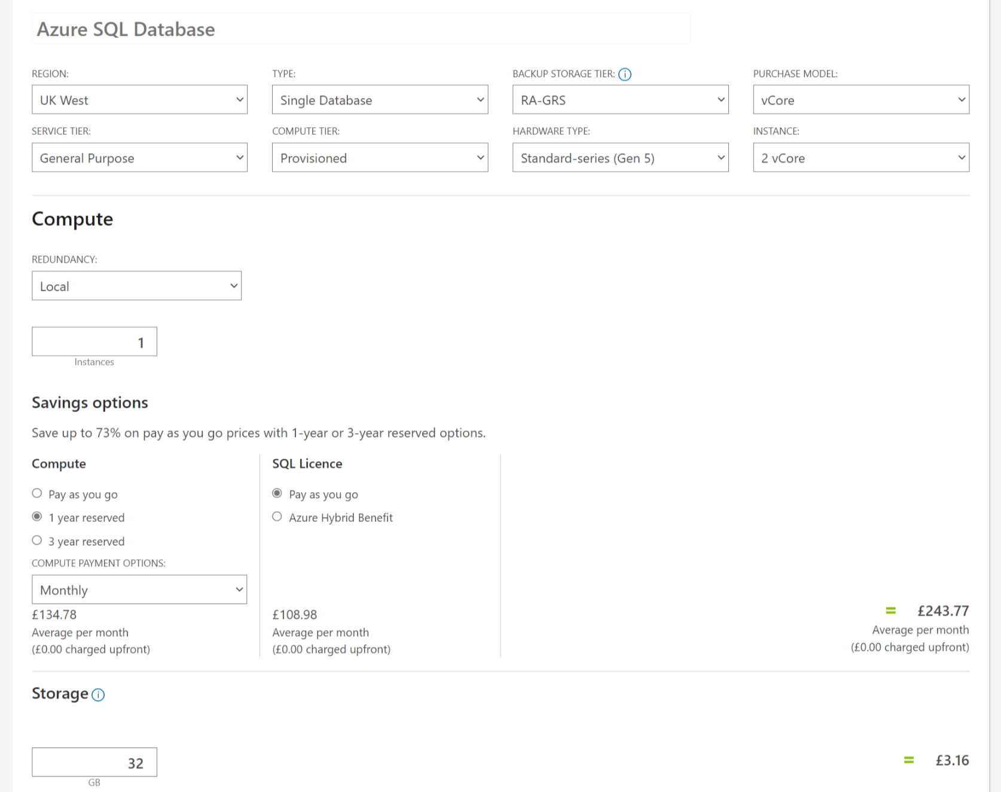
Figure 1: An example of a price estimate for a 2 vCore SQL Server instance on the Azure platform with 32GB of storage. Pricing is from the Azure Pricing Calculator.

Summarising the attendance logging research
As noted earlier in the chapter, the chosen AL solution needs to consider various areas. These are outlined in Table 3, along with the author’s findings.
Table 3: The findings from analysis of the different attendance logging approaches.
Area | Findings
Resistance to foul play | The author believes the importance of this area depends on the policy of the institution. For example, if an institution awards credits based on attendance, this becomes a much more critical consideration. In the case of UWTSD, attendance is only really considered in terms of engagement and meeting any specific government regulations, and therefore this is less of an area of focus. The author therefore does not believe it necessary to implement a solution with multiple factors of verification.
Impact on the session deliverer | The importance of this depends on the current impact on the session deliverers. At UWTSD, the onus is on the lecturers to collect attendance, so an approach with less administrative overhead is preferred. Almost all the researched approaches achieve this, however some are reliant on elements (e.g., the timetable) that are not currently optimised at UWTSD. The author believes an approach where the lecturers can set up either ad-hoc sessions or sessions based on the timetable gives the most flexible approach.
Impact on the learner | The author believes there is a balance between impacting the learners and the lecturers. At UWTSD, the goal is mainly to reduce the impact on the lecturers, and therefore some of the attendance burden would move to the learners. A potential benefit is that this may make them more aware of their attendance. The research demonstrated that systems with a more onerous or slow logging method may frustrate students or cause delays, so a quick and efficient method is required.
Hardware and software requirements | This area has a large impact on the financial implications of an implementation. Ideally, existing infrastructure would be utilised to keep costs down. Many of the researched examples were smaller pilots where the focus was more on proving the operation of a particular system and less on the deployment on a wider scale. The author believes a software-based approach provides much lower deployment costs compared to an approach using physical hardware, especially as the system is scaled.
Operational requirements | The importance of this area depends on the resources an institution can dedicate to the system. Many of the researched systems would require some form of large scale rollout or data collection process (e.g., disseminating ID cards or collecting fingerprints), with on-going processes for new intakes. Using a software-based approach could forego the need for this, with the requisite information being collected as it is logged.

Testing web services
Data collected in the process of attendance logging is relatively simplistic, usually including some form of timestamp, user identifier, and location or session identifier. There is also the need to inform the user when information has been logged. These factors make using a web service a well-suited solution. Prior to reviewing testing web services, Representation State Transfer (REST) and SOAP were first compared, the results of which can be found in Appendix C. There are some features of web services that have implications for testing, and these are discussed, along with the different types of testing that can be conducted for web services, and what areas of the system they focus on.

Testing in terms of web services
There are some aspects of web services that may impact how, and what type of, testing is conducted. This section discusses some of the types of system testing and how they may be impacted for web services.

Functional testing
Functional testing focusses on ensuring an application meets the business requirements. It is a form of black-box testing, and therefore only considers the output and not the intermediate states of the system [42]. These functional tests are usually automated through software, with suites of tests configured for checking the system based on different inputs. ‘Assertions’ are used to define what results are expected from each test based on the given input [43]. These test suites can then be run as desired to evaluate the system’s operation. Whilst these test runs can be manually triggered, they are often integrated as part of the Software Development Lifecycle (SDLC), such as with Continuous Integration (CI) and Continuous Delivery (CD) [44]. For example, when a developer integrates their code with the main branch, the test suite can be run automatically. If the tests are successful, the code can be released, with failures generating some form of bug report and preventing the changes being deployed [44].
There are standards available for REST and SOAP web services that can be used to describe the functionality they offer. In the case of SOAP, this is WSDL. For REST, a popular option is the OpenAPI Specification (OAS) (previously Swagger Specification) [45]. Both define a ‘contract’ between the client and server. The benefit to these definitions is that they provide a good basis to form a test suite. Some testing tools use WSDL [46][47] or OpenAPI [48][49] files to generate tests for automating testing, and can evaluate how much of the web service has been tested [50][51].

Load and performance
Assuming a system has successfully passed the functional testing, tests can then be carried out to assess its behaviour under various conditions, such as heavy load. For example, consider a web service that can be used for checking results for sporting events. This might experience a short period of high demand following a major sporting event as users check results. A test of this nature would be very difficult, if not impossible to replicate manually on a test system, and therefore load tests involve some form of automation (e.g., to generate large numbers of requests). Some key types of performance testing are outlined in Table 4.
Table 4: Some key types of performance testing and their explanations.
Test type | Explanation
Smoke testing | Checks the system behaves as expected when not under load, giving a ‘best case’ scenario for checking functionality and performance [52]. This test is run prior to the others. It also provides an opportunity to validate the test script if applicable [53] and to gather baseline performance metrics.
Load testing | Designed to evaluate performance when the system is subjected to its typical expected load [52]. This can be measured in terms of latency.
Stress testing | Intended to push a system beyond its breaking point and assess its availability [52][54]. This highlights two factors: the amount of load the system can cope with before breaking, and how well the system recovers from failure. This test can be implemented either as a stress test or a spike test. A stress test will gradually increase the load on the system until it fails [54], whereas a spike test will simulate a sudden spike in load [54]. The stress test can be useful for assessing the effectiveness and resilience of auto-scaling mechanisms, and spike testing can be useful for gauging how a system recovers from failure [54].
Soak testing | Aims to seek out bugs that appear after a long period of time, such as memory leaks [55][56]. These tests often run for multiple hours or days, and for this reason are run after the other tests haven been successfully completed to prevent time and resources being wasted.

From the perspective of running these tests on web services, it is important to ensure the testing environment is as close to the production environment in specification and configuration as possible to ensure the validity of the tests. It is also important to consider the cost implications of performance testing in terms of time and monetary commitment. This is particularly true of soak testing where the test duration is long and external services are being used [55].

Regression testing
Regression testing is carried out when changes are made to a system to identify whether the changes result in any unintended side-effects or deviation from the system requirements [57]. The implication, then, is that regression testing is carried out for systems that have already been released and are being altered. Some of the key approaches to regression testing are outlined in Table 5.
Table 5: The key approaches to regression testing and their explanations.
Approach | Explanation
Regression test selection | The areas of the system that are impacted by the changes are identified, and the testing is run against those areas. This reduces the amount of testing to be carried out, reducing the resources required for testing and allowing the tests to be more easily integrated into the development process (e.g., allowing them to be feasibly run at the end of each day [58][59]) [57][58].
Test case prioritisation | Test cases that target critical areas of the system are given higher priority than other test cases. Testing of these critical areas is prioritised, and testing of lower priority areas may be temporarily paused to facilitate this. This can reduce the amount of testing whilst still ensuring the fundamental parts of the system are checked [58][59].
Re-testing everything | Involves running all the system tests again. This approach is the most thorough, but requires a large commitment of time and, potentially, resources depending on how the testing is run [57][58].

When considering web services there may be regressions in two areas, those being regressions against the specification, and regressions in the services [60]. In the first case, the specification may be altered to remove previously allowed requests, breaking clients that switch to the new specification. In the second case, the specification may have been altered in a new release so that requests formatted for the previous version no longer work (for example, a previously optional property in the request body becomes mandatory). Research by Microsoft Research [60] introduced the concept of differential regression testing for REST APIs, which compares the test results from backward-compatible versions against results from previous tests runs against those older versions when using the same input. This allows regressions in output to be identified.

Summarising the research into testing web services
The research into different types of web service suggests that a REST service would be a better choice for an AL solution. The information that needs to be transferred has a simple schema and a small size. There is no need to maintain state, with the only requirement being that a status response is returned to indicate whether the transfer was successful. The inherent caching of a REST service would also potentially provide a performance benefit without any additional implementation overhead.
Regarding testing the web service, there are benefits to including an interface for describing its functionality (e.g., OpenAPI), as this allows a skeleton test suite for functional testing to be automatically generated through various testing tools such as Postman and SoapUI. These suites are a worthwhile investment in time as they can be incorporated into the development process alongside the performance testing to prevent regression in functionality and performance as the system is further evolved. In terms of performance testing, it is important that the infrastructure of the test system needs to be like the production environment for conclusions to be drawn from collected results. There is also a need to understand the requirements of the system to set appropriate performance targets.

Securing web services
The approach for how to secure a web service must also be considered if the nature of some of the data that will be surfaced by the API is sensitive and there need for it to be publicly accessible (e.g., for users on mobile devices). Under the General Data Protection Regulation (GDPR), data controllers and processors are obligated to protect personal data that could be used to identify people, with potentially serious consequences for breaches [61]. This section discusses some of the more common approaches to authenticating and authorising access to web APIs.

Basic HTTP Authentication Scheme
This approach is the most basic form of authentication that can be implemented for an API. It has been built into the HTTP standard as of RFC7617 and makes use of a specific ‘Authorization’ header in the HTTP request. The username and password are concatenated with a colon separator and encoded into Base64 [62][63]. Because the Base64 string is sent in clear text, it is imperative that the transport layer is encrypted (for example, by using HTTPS) to protect the header text. Without the encryption this approach is insecure and does not offer any protection to sensitive information [62][63]. However, the benefit of this approach is that it is very simple to implement and, depending on the sensitivity of the data being protected, may provide sufficient protection when implemented with HTTPS.
Authorization: Basic bG9sOnNlY3VyZQ==
Figure 2: Example of a Basic authentication header.

API keys
API keys are a similar concept to Basic HTTP authentication. Typically, the API key is generated by the server for each first-time user, and this key is used to authorise future requests from that client. It is possible for the key to be sent either as a query string appended to the URL, as a header, or in the request body [64]. The query string approach is completely insecure, as the URL is not occluded even when using HTTPS. Using a header or the request body to send the key is considered the better approach, as these would be encrypted by the transport layer [64].
Authorization: Apikey 1234567890abcdef
Figure 3: An example of an API key being passed in the Authorization header.
API keys generally have the same strengths and weaknesses as Basic HTTP authentication, including the need to be used with HTTPS [65]. The benefit API keys offer over Basic HTTP authentication is that the key is defined server-side, whereas Basic HTTP authentication can be configured so the client defines their credentials. The server defining the key makes it far less likely that the credentials would be used elsewhere, making it less likely that credentials compromised by another system would impact this system [62].

OAuth 2.0
OAuth 2.0 was introduced in RFC6749, and provides a framework for authorisation of third-party applications through an additional layer [66]. This approach is used by APIs from the likes of Google and Facebook [67]. As shown in Figure 4, the client (third-party application) gains authorisation from the end user, after which it attempts to gain authorisation via an authorisation server. The authorisation server returns an access token which is then used by the client to request protected resources from the resource server. This token will have a limited lifetime, after which it will no longer work. In some cases, a refresh token is also supplied which can be used to refresh the access token if it has expired [66].
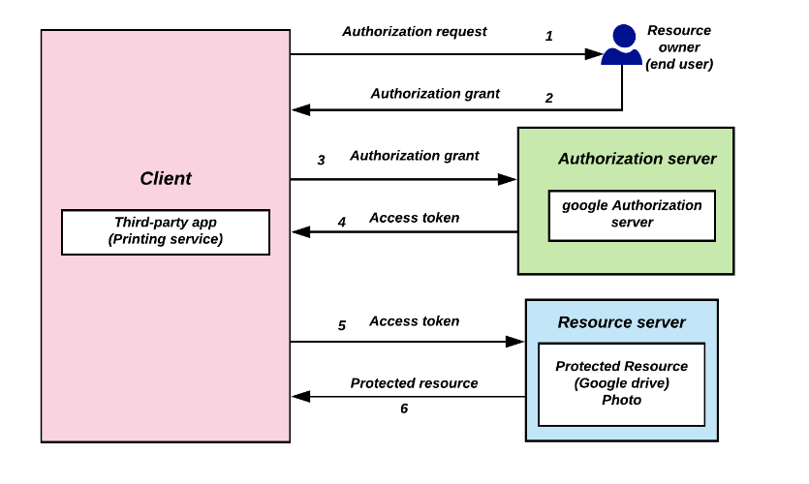
Figure 4: An example of the process for a third-party application to access protected resources on a different server [68].
The benefit of this approach is that the end user does not share their credentials with the third-party service [66], meaning the third-party does not need to store this sensitive information, and the end user does not expose their credentials to the third-party. The fact that the tokens expire also improves security as it makes it harder for attackers to re-use any tokens they acquire, making it less vulnerable than Basic HTTP authentication and API keys that used fixed credentials [64].

OpenID Connect (OIDC)
OIDC is an identity layer that sits on top of OAuth 2.0 [69] and is utilised by services such Microsoft Azure Active Directory (AAD) [70]. It allows the client to obtain additional information (known as “claims”) about the user, such as username or email, in the form of an ID token which is encoded as a JSON Web Token (JWT) [71]. This is useful, as OAuth 2.0 only provides authorisation (i.e., confirmation that a client is allowed access to a resource) and does not include any information about the user’s identity. The ID token in OIDC allows authentication of a user (i.e., verification of who they are) to take place using the included claims [72].

Summarising the research into web service security
OIDC is the most complete approach to authentication and authorisation of the researched methods. There is, however, a necessary level of complication for implementing this approach and, depending on development timeframes and the type of resources being served, this level of verification may not be necessary. In these scenarios, choosing one of the simpler approaches may be prudent as the implementation would in theory be quicker and simpler.

The research conducted in this chapter helped form the idea of what the author’s own research would be about. Before beginning the research, a decision needed to be made about how to conduct it, and therefore different research methodologies needed to be considered. The next chapter discusses potential research methodologies and which approach was chosen.

Chapter 3 – Research methodology
This chapter first describes the ‘research onion’ model and its layers. This is followed by the author’s research proposal which outlines the chosen methodologies and how the research was conducted.

Discussion of research methodologies
There are numerous methodologies that can be used when conducting research. To assist in defining and organising a methodology for dissertation writing, the ‘research onion’ model was developed by Saunders et al [73]. The six layers in its latest revision are outlined in Table 6 and shown in Figure 5.
Table 6: The research onion layers and an explanation of them.
Layer | Explanation
Philosophy | Relates to a set to beliefs and assumptions about the development of knowledge. These assumptions are ontology (the researcher’s perception of reality), epistemology (what is considered to be valid knowledge), and axiology (the impact of the researcher’s values and ethics on the research). In combination, they influence which philosophy is chosen.
Approach to the theory development | Offers different approaches for how theories materialise in the research, whether that be creating theories up front and using the research to test them, or using the research to create the theories. These are usually classified as inductive or deductive. An inductive approach begins with the collection of data which is analysed to develop a theory [74]. In contrast, a deductive approach begins with a theory of hypothesis. Data is then collected and analysed to see if the hypothesis is proved or disproved [74].
Methodical choice | Defines what type of data are collected or analysed. The types are:  - Quantitative – uses or creates numerical data. Examples include questionnaires and statistics.  - Qualitative – uses or creates non-numerical data. Examples include interviews and data categorisation.  - Mixed – uses or creates a mixture of numerical and non-numerical data.
Strategies | Provide a structure for how the researcher will answer the research question and are often linked to specific methodical choices in the layer above.
Time horizon | Relates to the timescale the research represents. The two horizons are cross-sectional and longitudinal. The first means the research represents a snapshot in time. The second horizon represents research taking place over a much longer period.
Techniques and procedures | Focusses on the actual methods used for the research, such as the data, and how it is collected and analysed, as well as any materials and resources required.
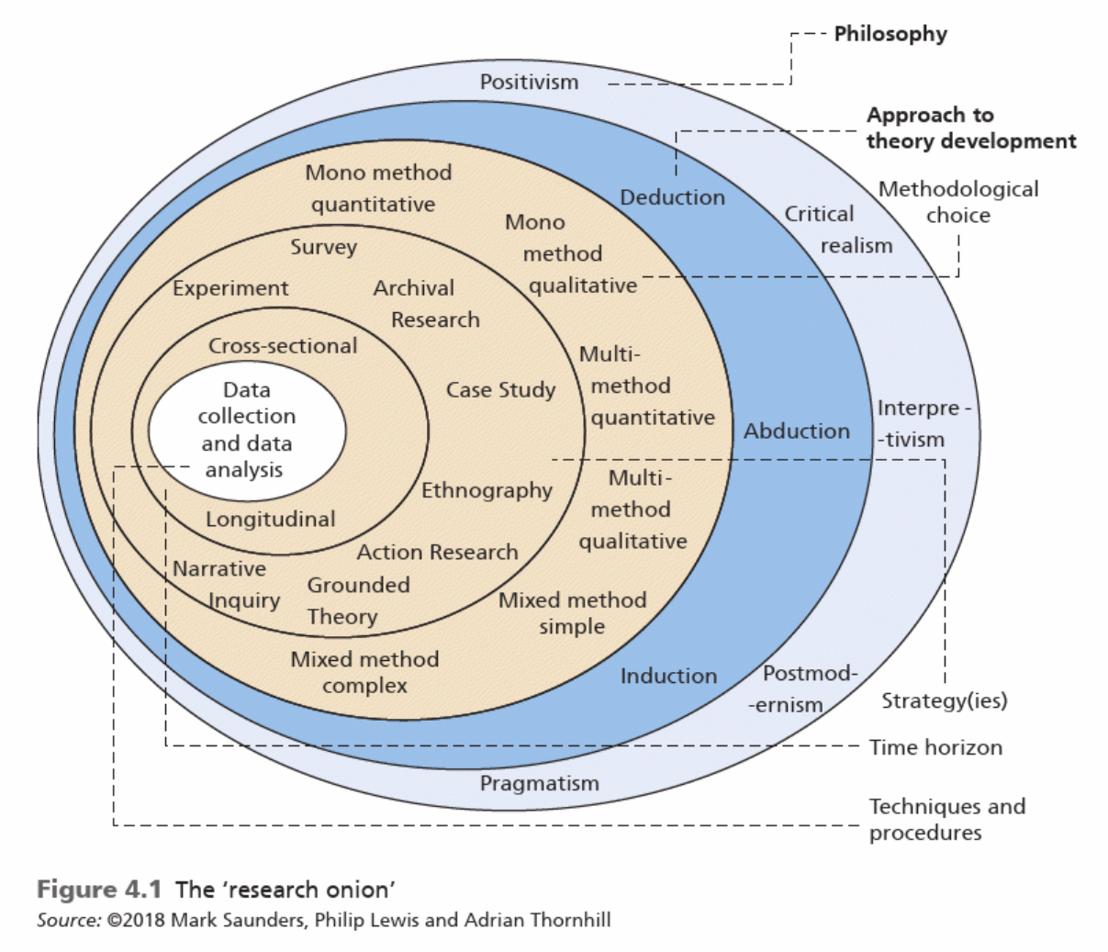
Figure 5: The 'research onion' as defined by Saunders et al [73].

Research process
The review of the literature showed there are multiple ways an AL system could be implemented. It is the author’s belief that the evaluation of whatever system is created is most relevant when it is implemented in a ‘real-life’ setting. Therefore, the author chose to conduct this research in the form of a case study. Case studies focus on studying contemporary phenomena in their typical context [75][76][77]. Both qualitative and quantitative data collection methods can be used, along with data from multiple sources. This allows the results to be triangulated, thereby providing more valid results [75][76]. Case studies may take an inductive or deductive approach [73]. One other strategy that was considered was action research due to it also being focussed on practical research and problem solving. However, its usage is to improve practices, whereas case studies aim to gain a deeper knowledge of a single subject [78]. Experimental research was discounted due to it requiring a controlled environment. Archival research was disregarded as it relies on existing data [74] which is not possible with this project. The research also made use of surveys to gather feedback and thoughts from users. The methods of data collections used are shown in Table 7.
Table 7: The methods of data collection used for the case study.
Method | Reason | Data type
Initial surveys | Used to gather opinion from staff on the existing AMS. | Qualitative and quantitative data
Comparison against system requirements | Used to evaluate whether the system met the requirements. | Quantitative data
Test plan results | Used to evaluate the system’s outputs against expected outputs. | Quantitative data
Performance testing results | Used to evaluate the system performance against the expected targets. | Quantitative data
Follow-up surveys | Used to gather opinion from users on the final implementation. | Qualitative and quantitative data

The author chose to take a mixed approach to theory development. From an inductive perspective, the initial surveys along with the earlier review of different possible AL approaches, informed decisions during the implementation phase and provided a theory for the best approach. The follow-up surveys also generated feedback and recommendations that can be used as the basis for future research or development. From a deductive perspective, the comparison against the requirements, testing data and follow-up surveys provided a mechanism for evaluating against the hypothesis that the chosen system was the correct one.

Survey design
An initial survey with staff was conducted for two reasons. The first was to gather feedback from users of the existing AMS to gain a perspective of the system’s limitations. The second was to gauge opinion on alternative methods for AL and what users believed would be the best approach. The results from the surveys were later used to help steer the system requirements. To evaluate the final implementation, users completed a follow-up survey. The purpose was to understand the users’ opinion of the implementation to see if it was a satisfactory solution, therefore allowing comparison to the existing AMS solution.
Care was taken when preparing the surveys to ensure the wording of the questions did not include any of the author’s biases towards preferred solutions as this would reduce the validity of any responses [79]. The surveys also used a mixture of closed and open questions. Closed questions limit the possible response to gather specific data. Open questions offer the respondent the opportunity to elaborate more in their response. Some of the relative benefits and drawbacks of each can be found in Table 8 [79].
Table 8: Comparison between open and closed questioning.
Open questions | Closed questions
Generates qualitative data | Generates quantitative data
May put people off responding due to effort to respond | Low effort and quick to respond to
Difficult to categorise and analyse | Easier to categorise and analyse
Encourages expression and can provide valuable insight that may not have occurred to the researcher | May not allow the respondent to give the response they want, or may encourage ‘mindless’ responses

The reason for choosing a mixture was so quantitative data could be harvested through the closed questioning whilst ensuring valuable narrative feedback was still collected through the open questioning. It also ensured the surveys were not too onerous and time consuming to complete, therefore increasing the likelihood of them being completed. The types of closed questions were:
- A single choice from multiple options.
- Multiple choices from multiple options.
- Ranking of multiple options in order of preference; and
- A Likert scale.
The questions can be found in Appendix D. The surveys were created in Microsoft Forms. This automatically generates charts and data insights from the responses and allows the data to be exported to a spreadsheet for further analysis. Statistical analysis of the quantitative responses was carried out using Microsoft Excel. Charts were generated to visualise the data and assist in highlighting any potential trends. For the qualitative responses, the answers were reviewed, and key recurring points were identified.
The initial surveys were sent to administrative staff in the Wales Institute of Science and Architecture and the Institute of Management and Health, both for them to complete and to disseminate the survey to the wider teaching staff. This was done to generate as many responses as possible.

Testing the application
As noted earlier, the results of the application testing were quantitative. This meant that the tests needed to generate metrics to compare to the metrics that came from the requirements gathering process. For evaluating how much the final system met the requirements, a simple true/false evaluation was made against each requirement. To check the system’s functional operation, automated test harnesses were created where possible that exercised the various areas of the system, using asserts to evaluate whether a test was passed or not. Again, the percentage of passed tests was calculated and compared against the expected results. Finally, the various levels of performance testing were executed and evaluated again the expected values.
By its nature, a case study requires a ‘real-life’ implementation of an AL system, and therefore a system would need to be developed. Prior to beginning development, a development methodology must be decided on, which includes the development philosophy and tools to be used. These are covered in the next chapter.

Chapter 4 – Development methodology
This chapter first provides a brief assessment of some of the different development methodologies, and how applicable they were to this project. The final methodology is then outlined, followed by an overview of the development tools that were used for the project.

Potential methodologies
The approach to developing software has morphed over the years from an unstructured ‘code and fix’ approach to there now being a variety of methodologies that provide structure, and therefore improve output and predictability [80]. Which methodology is most appropriate for a particular project depends on both the type of project and the development team. In this section, some of these methodologies are discussed, along with their strengths and weaknesses.

Waterfall
The waterfall approach is often credited with being one of the first structured development methodologies to be widely adopted. It splits the SDLC into defined steps and requires that they are carried out sequentially [80], meaning each must be fully completed before the subsequent step begins. The benefit to this approach is that it is easy to understand for inexperienced developers and project managers [81]. However, because the requirements are gathered at the start of the waterfall, there is a risk that the implementation becomes obsolete by the time the project is completed. This means this process is best suited to projects where the requirements are well understood and unlikely to change drastically over the course of the project [80]. Shorter project durations are also advised for this process as they reduce the likelihood of requirement changes as the project advances.
An advantage of the robust requirements gathering this process requires is that it results in comprehensive system documentation that can be useful for future developments or troubleshooting [82]. Also, this process is not reliant on having a team of developers, and can be used for solo development [80].

Agile
‘Agile’ development was adopted at the turn of the century to overcome some of the limitations of ‘traditional’ development approaches. The founding group of developers created a manifesto of key agile principles [83]. The focus is on delivering software in short release cycles, with each iteration offering an incremental evolution of the software [80]. The benefits this offers are numerous. The stakeholders (i.e., who the system is being developed for) get a usable system more quickly than with a process such as the waterfall model. In contrast to that model, requirement changes are welcomed, with the shorter release cycles allowing this flexibility [83]. Another key principle is that there is strong dialogue through face-to-face communication between the stakeholders and development team, with stakeholder satisfaction being a priority [83]. A drawback of this face-to-face interaction is that it typically results in weaker documentation. Another consideration is that agile is best suited to smaller teams, with it being difficult to implement for larger teams [84].

Uses of the agile principles
There are various methodologies that adopt agile principles, with some well-known examples being eXtreme Programming (XP) and Scrum. Both focus heavily on leveraging the benefits of team working and collaboration, with regular development team and stakeholder meetings to work towards a common goal. In the case of XP, there is an explicit focus on creating code that is readily testable to ensure the cost of testing is low and the quality of the code is high [85]. In Scrum, iterations are called sprints, and are a fixed length of time for delivering a particular goal [86]. There are specific, scheduled events within each sprint for planning, daily updates, review and retrospection [86]. These allow the team to adapt and react as the sprint progresses, and provide a mechanism for identifying areas to improves the team’s effectiveness [86].
Feature-Driven Development (FDD) is another approach that utilises some of the agile principles. FDD is also customer-focussed and iterative, and similar in some respects to Scrum. Where it differs is that features are the main focus, which are small, client-valued functions [87][88]. These are roughly equivalent to user stories (XP) and backlog items (Scrum) in that they define the requirements and inform the planning. FDD is more dependent on documentation for each feature, as the documentation is the main means of communicating information within teams [88][89]. This means FDD does not require daily meetings like XP and Scrum, which is a common complaint with those methodologies [89].

Prototyping
Prototyping is an alternative approach for projects where the requirements are unclear or there are technical barriers to the project that are not fully understood [80]. A prototype system can be developed to explore possibilities with the stakeholder and agree a way forward, or to experiment with solutions for any technical impediments. This prototype then provides a better idea of the feasibility and direction of the development [81].
There are two possible strategies for doing this – throw-away or evolutionary prototyping. As the name implies, the output of the throw-away prototyping is not intended to be used after proving the concept and is instead thrown away [80]. This means attempting to meet requirements is not necessarily a consideration, therefore allowing a focus specifically on the prototype and generating a worthwhile proof of concept without the concerns of trying to create a polished product. The benefit is that there is a tangible output that can be demonstrated to the stakeholder if required, or, if the prototype fails, it ensures the barrier is identified before too much time and money is invested [81].
In contrast, evolutionary prototyping assumes that the prototype will eventually evolve into the final product. While this means the prototype needs to be developed with more care due the code being included in the final codebase, and therefore the prototype might be developed a bit more slowly, it does mean the time and effort expended on the prototype results in a usable output without the feeling that effort was wasted [80].

Choosing the right approach
As this case study was an independent project, the team-based software development methodologies could not be fully adopted. However, it was possible to choose certain elements of each methodology to create one that best suited the project. Indeed, there has been some research into adopting some agile practices for solo development [90].
The approach this project used was based mostly on the evolutionary prototyping model, with user stories being adopted for defining the requirements. The prototyping model was chosen as there were regular meetings scheduled with the project supervisor that could be used to demonstrate prototyped features and gather their thoughts and feedback for next steps. Care was taken to ensure the feedback did not result in ‘scope creep’, as the deadline of the project was immoveable, and time needed to be kept available for testing the system with users. Some of the decisions regarding how the system would be implemented were also open for interpretation, and therefore the prototyping approach was the ideal choice for identifying the most appropriate solution. There was also a process of requirements gathering ahead of the development that utilised user stories to assist in defining the requirements and the metrics for evaluating their completion.

Development tools
The author chose to use .NET 6 as the development platform. The reason is that it is the most recent .NET version with Long Term Support (LTS) and the author thought it prudent to choose the version with the longest support period possible. The author chose to use Microsoft Visual Studio 2022 as the Integrated Development Environment (IDE). This is due to familiarity with the product. The 2022 version was chosen because this version is required to develop .NET 6 applications [92]. In terms of Database Management System (DBMS), Microsoft SQL Server 2016 was used. This was due to the need to use existing UWTSD infrastructure to keep down implementation costs. For the same reason, the applications were deployed to an existing Internet Information Services (IIS) instance on a server running Windows Server 2012 R2. C# was chosen as the language for the development as the author had prior experience with it and thought it prudent to use a familiar language rather than adding additional complexity to the project with a new language.
Once the research and development methodologies had been selected, work could begin on the requirements gathering and design of the software. These will be outlined in the following chapter.

Chapter 5 – Requirements
This chapter covers the requirements gathering process and its outcomes. Before design of the software could begin, it was first necessary to gain an understanding of the requirements for the system. The requirements were shaped through two sources of information, firstly through consultation with the department leader and secondly through surveys and interaction with the project supervisor. These two sources are discussed in more detail in the following sections.

Consultation with department leader
The Executive Head of IT Systems and Infrastructure leads the development team the author is a member of. Whilst the project was conducted independently, it was important to ensure the specification of the system aligned with the needs of UWTSD. The limitations of the existing AL solution have long been understood by the department leader but staffing restrictions and institution priorities have meant time has not been allocated in recent years for the development of an improved system. This project offered the opportunity for the development of a system ‘out-of-hours’, meaning that the existing development priorities being implemented by the team were not impacted with the addition of this project.
There were some key factors to consider with the design of the system that were discussed with the department leader. As noted previously, UWTSD has two different systems for attendance monitoring. There is a plan to rationalise the attendance monitoring so that only Celcat is used. However, there is no timeline for this, and there is a need for policy change before the rationalisation can take place. This means that any AL solution created must be flexible enough to accommodate passing the collected data into both the existing AMSes to ensure compatibility and future-proof the system.
Another factor was the limitations in terms of budget. As this project was not included within the department’s development priorities, there was no budget allocated for an implementation. Therefore, the system needed to preferably have no implementation costs, making a hardware-based system for AL unrealistic. For this reason, the QR code approach was chosen as it could be implemented without additional hardware costs. In addition, a solution that did not have an overbearing deployment overhead would be of benefit as it would allow a more straight-forward roll out without a need to involve the Service Delivery team, and a software-based approach like using QR codes lent itself better to this constraint.
As mentioned earlier, it is well understood internally that there are some issues with varying accuracy of the UWTSD timetable depending on department or time of year, and this makes it difficult to rely on that information entirely. It was consequently decided that there should be provision for either using the timetabled events or being able to create ‘ad-hoc’ events which would be able to account for events that were not timetabled correctly or at all.
A common discussion point that had been highlighted to the team in previous years was the unwelcome administrative overhead the lecturers encountered with the existing AMS, including collecting the paper sign-in sheets and entering that data into the registers. It was decided that the system should move the onus to the students for logging their attendance. The QR code would need to allow a link to be made between the student and event to be made. A decision was made that the students could authenticate with their university supplied Microsoft account after scanning the QR code. This would identify the student against that event, allowing the attendance to be logged. The students are familiar for the process of logging in with their Microsoft accounts, and the university policy also forces users to setup Multi-Factor Authentication (MFA) which provides another layer of verification of the student’s identity.
Another security consideration was how to secure the API. The nature of the some of the data available through it is quite sensitive (e.g., staff and student names), and the API will need to be accessible publicly so users can log their attendance through mobile devices that may be using a cellular data connection. The chosen solution would need to be sufficiently secure to protect this data and adhere to the university’s Data Protection policy, and therefore comply with the GDPR.

Review of the survey
Analysis of the initial survey was carried out to understand which areas of the existing process were most problematic and to see which of the potential alternative approaches garner most favour. A more in-depth analysis of the results can be found in Appendix D, but the areas most pertinent to the requirements gathering are summarised in this section.
25 responses were received to the survey, with 80% of the respondents being teaching staff and the remainder being administrative staff. It is therefore not surprising that the most common response when asked which stage of the current attendance logging process had the largest impact on them was the process of entering attendance into the registers, as this is a task carried out largely by the teaching staff. This was borne out in the question where respondents were prompted to give comments regarding the current system. There were numerous responses about how long the logging process took, and whether this was a prudent use of lecturers’ time. Also noted was the system’s vulnerability to data entry errors.
Respondents were also asked who should be responsible for logging attendance (student, staff, or shared). This was done to see whether staff had a preference for moving the onus to the students. Interestingly, the most common response from teaching staff was that there should be shared responsibility, with the second most common response being that the lecturers should log the attendance. This implies that the staff did not have an issue with attendance logging in principle, with the existing system being the cause of issues. Respondents were also asked how they thought students logging their own attendance would impact on their attendance. 56% suggested they thought it would have some form of positive impact.
Respondents were then queried about which AL approaches they thought would be applicable to UWTSD and were also asked to rank them in terms of preference. Charts summarising these results are shown in Figure 6 and Figure 7 respectively. For the approaches that were thought to be applicable to UWTSD, the most commonly chosen options were card scanning and importing from a video conferencing solution respectively, with QR codes and fingerprint scanning been the joint third most common choice. It is possible the reason the two most common choices were that popular because staff have likely seen them being used in the past (for example, with the previous pilot using RFID cards at UWTSD).
When the ranks are compared, it shows a preference towards card scanning again, but this time with QR codes being ranked second and the import from video conferencing solutions being a less popular option. This shows that, although staff realise it is possible to use this approach, they clearly do not have a preference towards it. A potential reason for this could be being put off by poor experiences with the way this is done in the existing system.

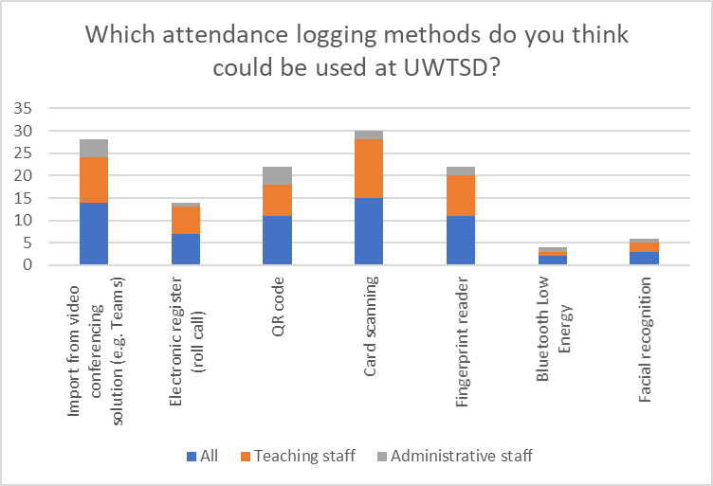
Figure 6: Chart showing which attendance logging approaches respondents thought could be used at UWTSD.
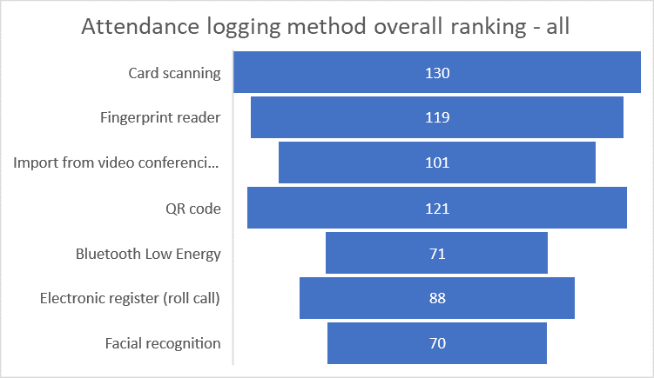
Figure 7: Chart showing the ranking of the different attendance logging approaches as chosen by the respondents. Ranks were calculated by multiplying the count of selections of each option at each rank level, then multiplying the count against the inverse of the rank as a weighting to give options ranked first a higher number than those ranked last.
When this analysis is considered and applied to the requirements, it shows a clear indication that whatever approach is chosen should be more time efficient for the lecturer. Respondents seemed generally happy with the premise of more responsibility for AL being moved to the students, which would reduce the impact for the lecturers. When looking at potential approaches for AL, the fact that a software-based approach like using QR codes ranked as highly as it did makes it well suited to this project as it fits well within the budgetary constraints outlined previously.

Summarising the requirements
As noted in Chapter 4, user stories were chosen as the method of recording the requirements for the system. These were laid out into a user story map using Miro to help visualise the flow of the stories. The user stories were split into those required to create the Minimum Viable Product (MVP), with those that were not strictly necessary to create the MVP being added to a ‘backlog’. The benefit of a user story map is that it splits the requirements into ‘user activities’, and further splits these into ‘user tasks’. This means user stories can be grouped together to define the requirements required to build each area of functionality. The order of items on the map also describes the flow of the system. The user story map can be found in Appendix E, with some examples of the user stories shown in Table 9.
Table 9: Examples of some of the user stories created from the requirements gathering process.
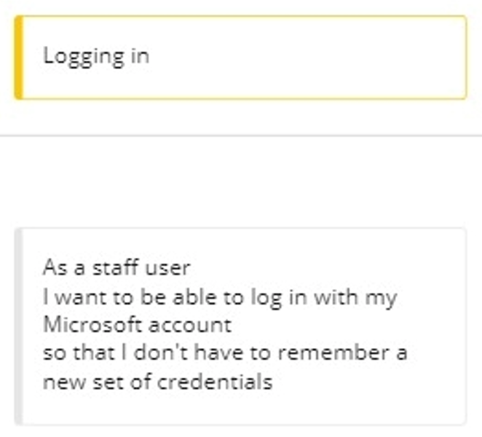 | 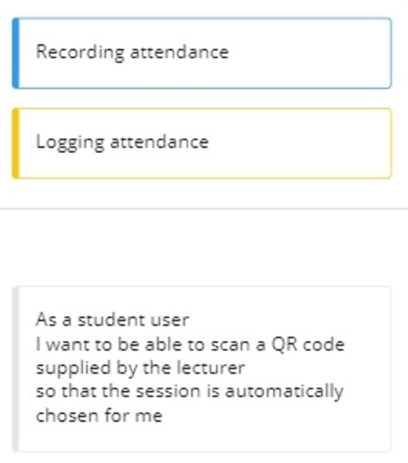
This user story comes under the ‘Logging in’ user task and outlines the requirement for the web app that staff users should be able to log in to the system using their Microsoft account. This means they do not need to remember an additional set of credentials and forces the use of MFA which provides an extra level of security. | This user story can be found in the ‘Logging attendance’ user task which itself is in the ‘Recording attendance’ user activity. It outlines the requirement that the student users should be able to scan a QR code using a supporting device. The session information will be encoded in the QR code, meaning the correct session is chosen for the student.
In addition, a summary of the requirements was also collated into a document that was shared with the department leader for review and signed off. The signed document can be found in Appendix F.
Once the requirements had been gathered, the next stage was to design the system. This is covered in the next chapter.

Chapter 6 – Design
This chapter will discuss the approaches taken to design the various elements of the system. These elements include the database design, system architecture and process flowcharts.

Process flowcharts
The author first chose to diagram some of the key processes that will be encountered to provide a basis for the next stage of design work. These were laid out as flowcharts using Microsoft Visio. There were two types of users to consider: lecturers and students. These are both outlined in greater details below.

Student process flowchart
The author decided that the student’s interaction would be very simple, with the only process available to them to be logging their attendance. This reduces the complexity of the implementation, and the student does not lose any functionality compared to the existing system. The author envisaged that the lecturer would share the details of a session either via a QR code or a link. The student would then either scan the QR code and access the encoded link or click directly on the shared link. This would take them to AL application and prompt them to log in with their UWTSD Microsoft account. As it would use the standard Microsoft log in process, it would prompt them to verify their identity via MFA. Once authenticated, the system would validate against various criteria (e.g., whether the session is active or whether the student has already logged attendance). Assuming the validation was passed, the student’s attendance would be logged, and they would be informed of this fact. If the validation failed, the student would be notified of the reason and the attendance would not be logged. The flowchart can be found in Figure 8.
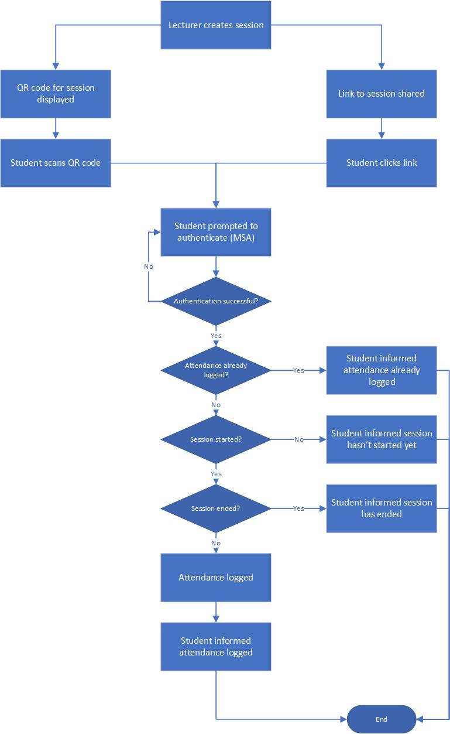
Figure 8: A flowchart showing the process for a student logging their attendance.

Lecturer process flowcharts
The author envisaged that there would be three main processes the lecturer would encounter when using the system. These are listed below and are covered in the following section.
- The lecturer creating a session.
- The lecturer sharing the session with students.
- The lecturer exporting the attendance.

Lecturer creating a session
As defined in the requirements, the system would need to be able to create a session either based on an existing Celcat event, or as an ad-hoc session. As shown in the flowchart in Figure 9, the type of creation method determines what is displayed to the lecturer. For sessions created based on an existing Celcat event, any events the lecturer has timetabled in Celcat within the next 14 days would be shown to the lecturer. They would then choose the appropriate session, the details of which would be used to populate the web form. The lecturer would then verify and tweak the entered data before creating the session.
For ad-hoc sessions, the system would retrieve a list of all the modules associated with the lecturer in Celcat. This list would be presented to the lecturer for them to use when setting up the session. They would be able to choose one or more of the modules, as well as being able to define the start and end time for the session. Once the web form was completed, they would create the session.
In both cases, once the session was created, the list of the user’s sessions would be displayed.

Lecturer sharing the session
The flowchart is simple for this process (see Figure 10). The lecturer would go to the session list and find the session they want to share. They would be able to click a button to generate a QR code. This QR code would be displayed alongside the Uniform Resource Locator (URL) that is encoded in the QR code. This would allow students who cannot use the QR code an alternative method for logging their attendance.
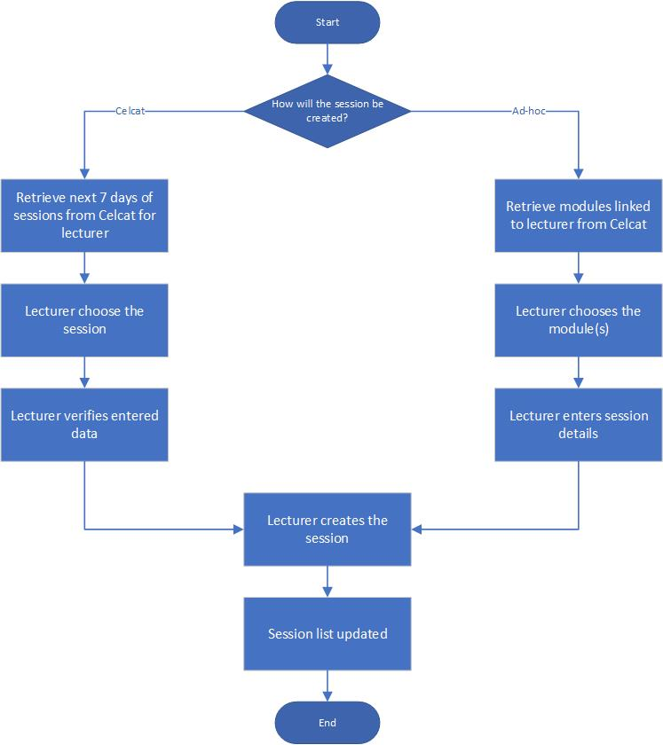
Figure 9: A flowchart showing the process for a lecturer creating a new session.

Lecturer exporting the attendance
One of the other requirements was that the lecturers must be able to export the attendance from the system into a spreadsheet for importing into the existing AMS. The flowchart for this process can be found in Figure 11. The lecturer would first find the session they want to export attendance for, then click the export button. Depending on the type of session, the system would generate slightly different outputs. Outputs for Celcat-based sessions would provide extra data about the module for each student (useful if there are multiple modules against a session) as well as an indication whether the student was ‘expected’ for that session (i.e., they were timetabled for it).

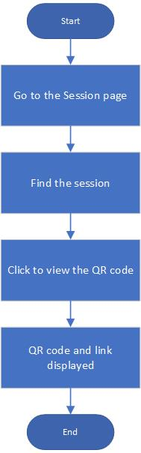  Figure 10: A flowchart showing the process for a lecturer sharing the session. | 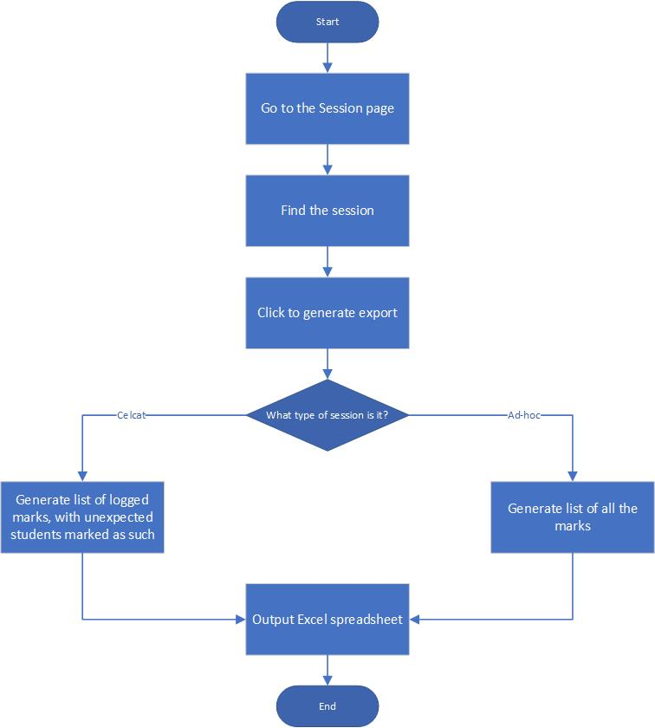  Figure 11: A flowchart showing the process for a lecturer exporting the attendance.

The next part of this chapter focuses on the design of the database.

Database design
As noted in Chapter 2, the information required for logging a student’s attendance is quite simple, requiring a student identifier, a timestamp, and either a location or session identifier. This means the entity for storing the attendance can be quite basic. One of the factors that needs to be considered in the Entity-Relationship (ER) diagram is the database schema of the Celcat databases. Celcat events can be defined with multiples of the same type of resource against an event (e.g., multiple staff or multiple modules). This means any system extracting data from Celcat must reflect this relationship. Therefore, the system will have a central entity, Session, used for storing the key session data, that most of the other entities will be related to. These other entities will be for storing the related modules (SessionModule), staff members (SessionStaff) and attendance (SessionAttendance). There will also be an entity (Staff) for storing a list of active staff members. The Entity Relationship (ER) diagram can be found in Figure 12.
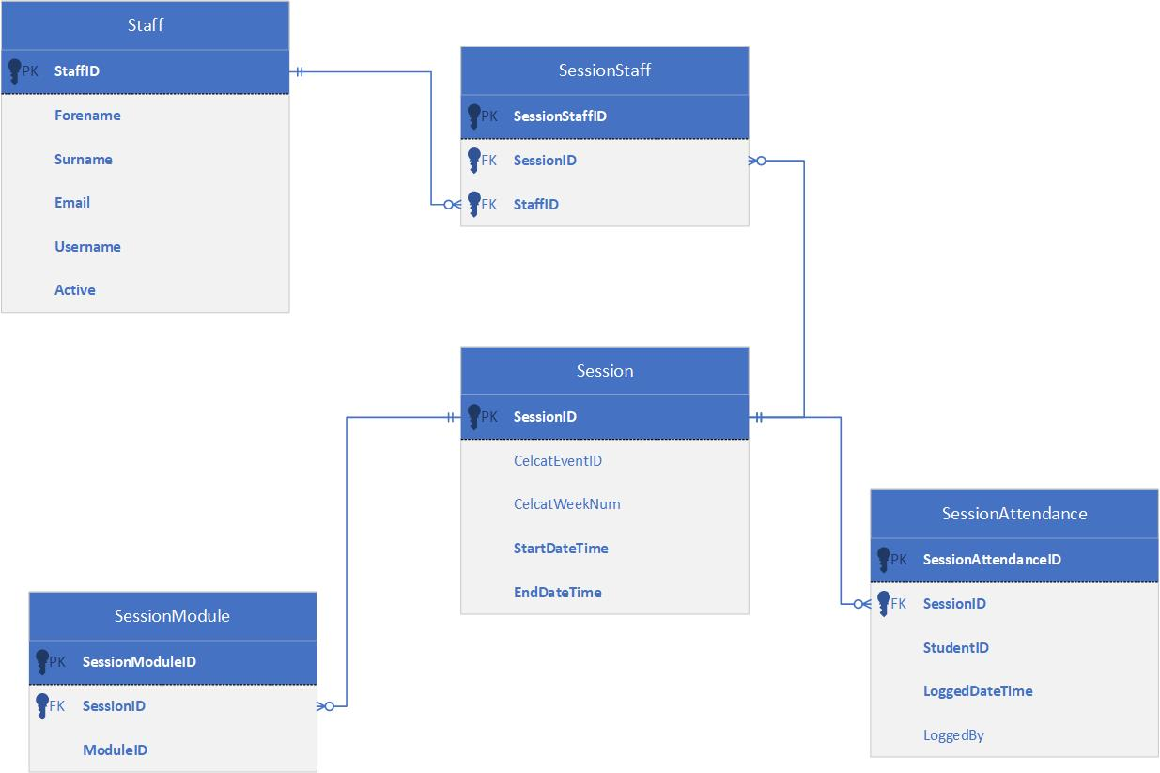
Figure 12: The Entity Relationship diagram for the AttendanceLogger database.
Much of the data that would be used in the system (the student and Celcat data) is stored on different database servers to what the AL system would use (see Figure 13). Due to the good performance of the connection between the AL database server and the SITS Student Record System (SRS) server, the author decided not to have an entity for storing students in the AL database. Having to replicate this data would require periodic updates from the SITS server, meaning there may be short periods between these updates where the data may not be fully correct or complete. It would also dramatically increase the size of the AL database. Instead, the email address of the student will be logged and used to look up the details of the students when required (e.g., when exporting the attendance data).
Regarding the event data, the Celcat databases it is stored in are heavily normalised, requiring many joins to retrieve the required data. The quantity of data is also high, and that data also requires resource intensive manipulation in the queries (e.g., recursive Common Table Expressions (CTEs)) to return the necessary information. It is for these reasons that the author chose to prepare the data into the necessary formats on the Celcat server and store it in static tables which would be periodically refreshed. This approach was chosen to improve response times for the API. Without it, the response times would be what the author believes to be unacceptable (greater than ten seconds for some requests).
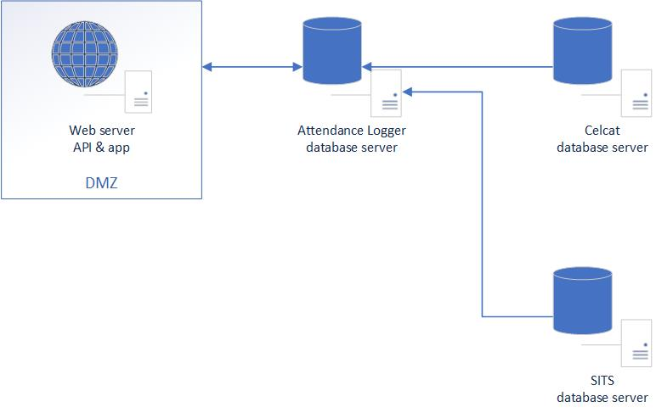
Figure 13: System diagram showing the servers being used for AL system.
The next part of this chapter will discuss the overall system architecture.

System architecture
As noted in Chapter 2, the author chose to create a web API for accessing and storing the attendance data. The reasons for choosing this approach were two-fold: an API would allow the AL system to be extended with other logging methods more easily in future, and it would also give the author experience developing an API using .NET which was not something they had done before. This approach would also make it easier to test the core functionality of the system in terms of accessing and manipulating the data.
The decision was made to create a web application to provide a means for exercising the API. This would serve the purpose of collecting the data to be sent to the API and provide a user-friendly interface for users to interact with the system. As laid out in the requirements, the system would collect attendance data for students via a QR code system and would provide an interface for lecturers to create sessions either based on an existing Celcat event, or on an ad-hoc basis. The web application would authenticate users via the university’s AAD and authorise based on the type of account. All data retrieval and manipulation would be done either through the API, or via AAD when the users authenticated. The MVC (Model-View-Controller) design pattern was chosen as the approach for the web application. The author was familiar with this approach from previous developments and this familiarity would allow them to develop the application more quickly.
The development of the system could begin once the design work was completed. The next chapter discusses this stage of the process and any key points or difficulties that were encountered.

Chapter 7 – Implementation
This chapter discusses some of the areas of the development that were of most interest. The chapter will be split into two areas: one covering the API development, and one covering the web application.

API development
One area of the API development that required in-depth consideration was the process for logging attendance. The author decided that it should be possible for both the student and the lecturer to log attendance. However, the constraints for these two user groups logging attendance would have some differences, most notably that the student would only be able to log attendance during an active session, whereas the lecturer may want to adjust marks before or after a session is active. Once that had been decided, it was then necessary to decide how the API should respond to requests.
Table 10: Scenarios for attendance being logged and what the chosen responses were.
Scenario | Chosen HTTP response
Session not started | 409 (Conflict)
Session expires | 410 (Gone)
Attendance already logged | 409 (Conflict)
Attendance successfully logged | 201 (Created)
Error logging attendance | 500 (Internal server error)

Table 10 shows the scenarios and what the chosen responses were. Of note was the response when the session has not yet started. Ideally, the response code 425 would have been chosen, as this equates to ‘Too Early’. However, this HTTP code is still considered to be an experimental feature, and browser compatibility is not fully understood [93], therefore the author chose to use 409 (Conflict) instead. A code snippet showing the logic for when to send the different responses can be found in Figure 15.
Another area of the API development that required some deliberation was how to authenticate access to it. The web application would need to be available externally to the university’s network for students to be able log attendance using their mobile devices, and therefore the API would also need to be available externally for the web application to be able to access it. Due to the sensitive nature of some of the data available through the API (e.g., staff names and numbers), it was necessary to protect access to the API. The initial plan was to have users authenticate via the web application which would then pass-through the authentication token to the API. However, the author spent a lot of time trying to get this to function without much success. One of the hindrances was the author’s lack of authorisation to make the necessary changes in the university’s Azure tenancy. This meant asking their colleagues to make changes, but due to the experimentation taking place, it required lots of back and forth to try and get a working prototype. This approach was eventually abandoned due to time constraints as the author wanted to get the system functional prior to the start of the third semester so it could be piloted by lecturers and students.
The final approach that was chosen was the inclusion of two values that had to be present in the header of each request to identify the name of the application making the request and provide an authorisation key. If either header was missing or invalid, the API would respond with an appropriate HTTP code and message. This approach was simple enough to be implemented quickly whilst still protecting data served by the API.

Web application
As noted previously, there was a requirement for users to log into the system using their UWTSD Microsoft account. These accounts are in the university’s AAD in the cloud. To use this for the web application, Microsoft’s identity platform was used. This offers an OAuth 2.0 and OIDC-compliant authentication service, and can be used with AAD and personal Microsoft accounts [70]. The particular library used was Microsoft Identity Web which is specifically designed to be used for web applications and protected APIs [94].
In terms of configuration, an ‘app registration’ needs to be created in the Azure Portal. This can be used to alter permissions that control the identity information returned about the user in the ID token when they authenticate. It also defines the redirect URIs that are valid. For this web application, the permissions were kept as basic as possible, with only read access to the user’s profile being allowed.
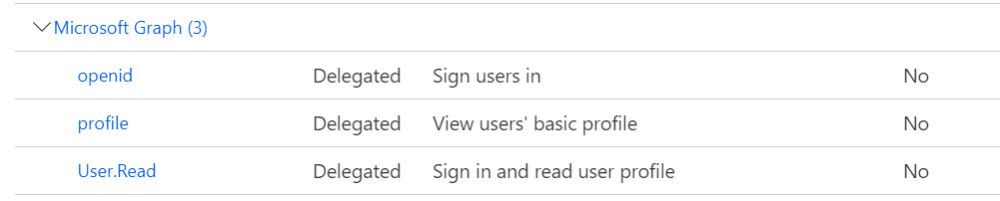
Figure 14: A screenshot of the permissions set up in the app registration for the web application.
One issue that was encountered was with the redirect URIs. The author found that these were case-sensitive so, initially, if the URL used was all lower case instead of the expect Pascal case, the application would not redirect correctly after authentication. Additional entries were added to the app registration as shown in Figure 16 to resolve this.
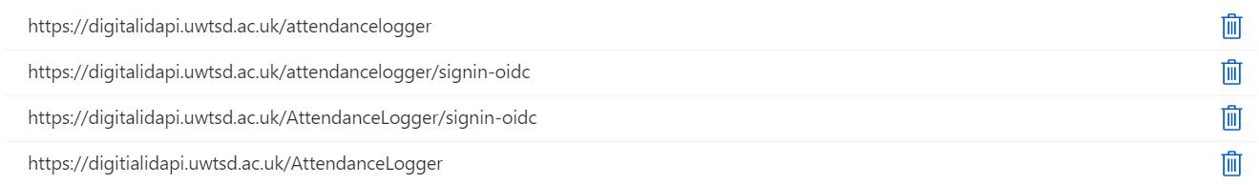
Figure 16: A screenshot of the alternative redirect URIs that need to be added due to the URIs being case-sensitive.
The library is then added to the web application through the Program.cs file through dependency injection, with the configuration for the app registration being set in the appsettings.json file. When the user logs in, the email address is used to identify them as a staff member (email ending in @uwtsd.ac.uk) or a student (email ending in @student.uwtsd.ac.uk) and an associated claim is added to their identity that identifies their role as staff or student. The role can then be used to control access to individual controllers or methods in the application. This is used to only allow students access to the methods for logging attendance, and only allow staff access to the controllers and methods for generating sessions.
Once the implementation of the system had been completed, testing could begin in earnest. The next chapter describes the testing approaches that were taken, and the type of results collected. The analysis of the results is in a later chapter.

Figure 15: Code snippet showing the logic for what type of response to return.

Chapter 8 – Testing
This chapter describes the approaches used to test the AL system. This includes functional testing, performance testing, and user testing in the form of a pilot. In each case metrics were gathered, the processes for which are outlined in this chapter. The analysis of the results will be covered in a later chapter.

Functional testing
As discovered during the literature review, it is possible to use a standard such as the OpenAPI Specification to describe the functionality of a web service. In this project, the Swagger/OpenAPI middleware was injected into the code for the API and enabled to run when the API was run in development mode. This provided a web interface for running simple tests via a web browser, as well as generating the necessary Swagger JSON that describes the API.
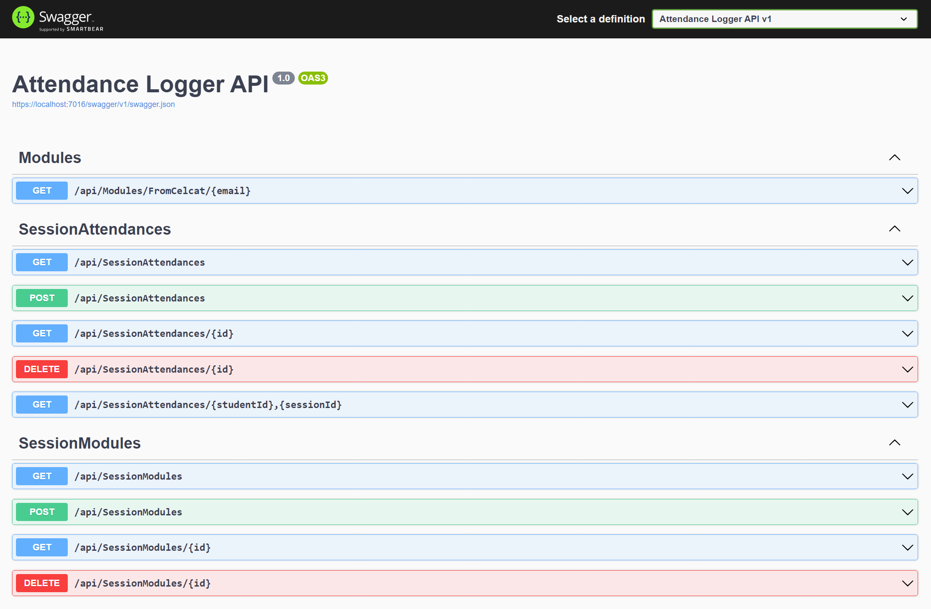
Figure 17: A screenshot of the Swagger web interface that is available when the API is run in development mode.
This JSON file was imported into Postman which uses the file to generate a skeleton test suite containing basic sample requests for each endpoint. These tests were built upon and developed further to exercise the API, ensuring it performed as expected in terms of response data and time. This meant multiple tests were generated for each endpoint, accounting for the differences in request type and payload.
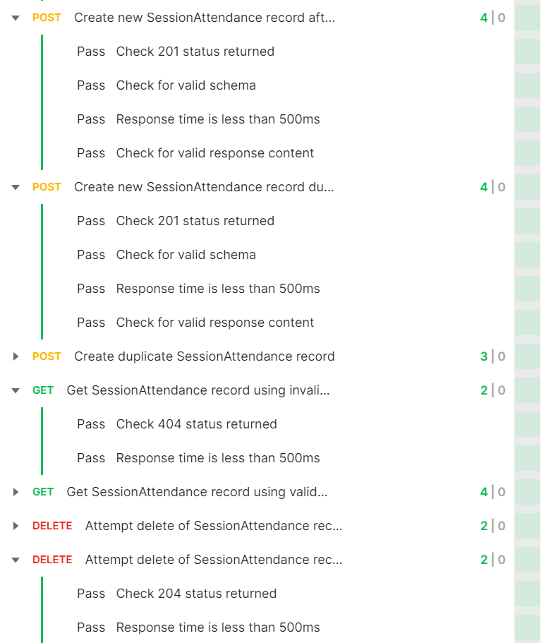
Figure 18: An screenshot of some of the tests from the test suite.
67 tests were created in total, with the test suite designed to ‘tidy up’ as it runs (i.e., if a record was created to test that functionality, it would be used in a later test to validate the delete function). Assertions were used to validate the responses. Tested areas included:
- Checking for the correct HTTP response status
- Checking the schema of response payload was valid
- Checking the response time was under a certain duration
- Checking the contents of the response payload for expected values.
Running the test suites will give a number of overall tests and how many were passed, and these will be used for analysis.
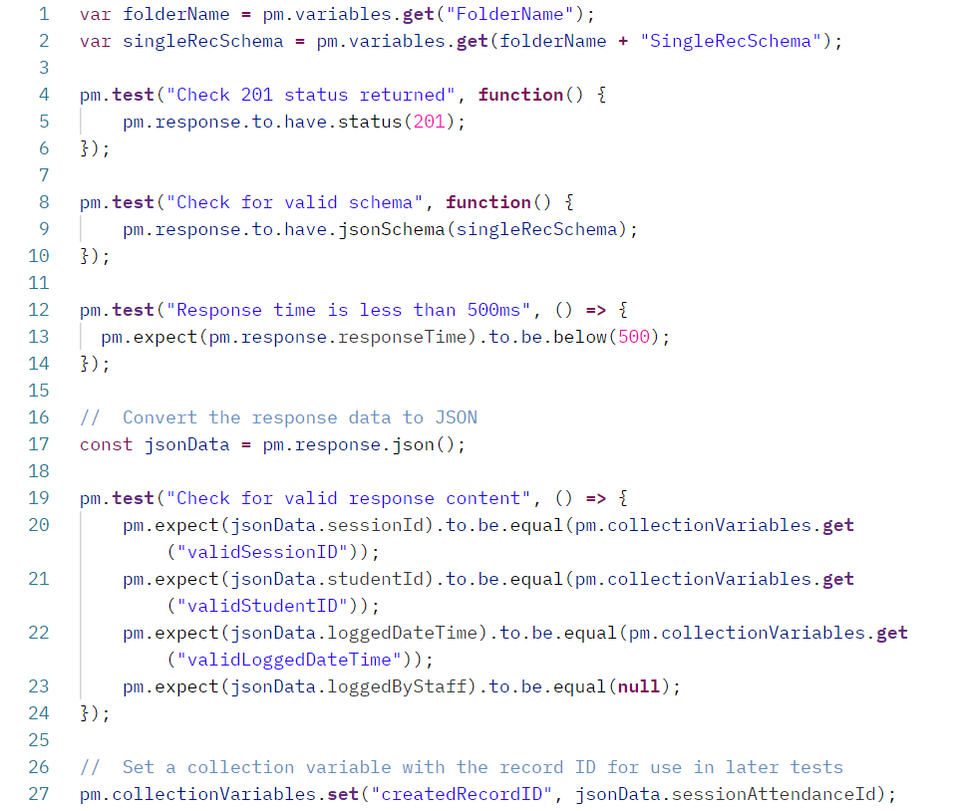
Figure 19: A screenshot of the test script for the test "Create new SessionAttendance record during the session". The variable on line 2 retrieves the valid schema from a variable that is defined in an earlier script in the test suite.

Performance testing
It was also decided to exercise the API in terms of its performance. Because the endpoints are all on the same server, it was decided it would only be necessary to test some of the endpoints, with the thought being that one endpoint doing read requests would perform in a similar way to other endpoints doing read requests. The same thought process was applied to endpoints doing read/write requests. Artillery was chosen as the testing tool, with the chosen types of tests being outlined below.
- A test with a fixed number of POST requests every second designed to simulate students logging attendance at the start of a session.
- A test with a constant arrival rate of POST requests designed to find out how many concurrent record creations the system can handle.
- A test with a constant arrival rate of GET requests designed to find out how many concurrent read requests the system can handle.
The details of the tests are discussed in more detail in the following sections. The metrics collected included minimum, maximum and average response times, and session times, as well as counts of response codes.

Test type 1
This test was designed to evaluate the system’s performance in a ‘worst-case’ real-life scenario. To assist in choosing appropriate parameters for the test, a query was run on the Celcat database to find the event start time with the highest number of timetabled users. As shown in Figure 20, at 09:00 on 23rd November 2021, there were 2561 students timetabled with an event, meaning there could potentially be that many requests sent to the system in a short period of time. These would mostly occur at the start of the session. For this reason, it was decided that the test should make at least 3000 requests over a 5 minute period which would build additional capacity into the system in the event of additional students being timetabled for a particular timeslot in the future.
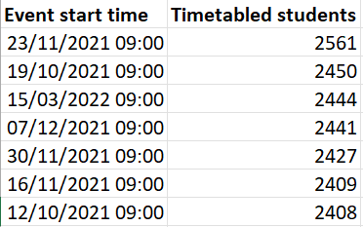
Figure 20: Some of the events with the highest numbers of timetabled students against them.

Test type 2
As noted, this test was designed to understand the system’s limitations regarding how many simultaneous POST requests the system could handle. This was done by running a test that started with 5 virtual users and ramps up to 100 users over 1 minute. This is intended to saturate the system and find its ‘breaking point’.

Test type 3
The same approach was taken for test 3 as for test 2, with the only difference being that GET requests were sent instead of POST requests. The chosen endpoint is one that returns an array of records from the Celcat database. This means the request is a ‘worst-case’ scenario in terms of GET requests, and therefore other GET requests would be expected to behave similarly or better.

User testing
It was agreed with a small group of lecturers that they would pilot the system with one of their small Semester 3 cohorts. This would allow real-world testing whilst minimising the impact of the trial. A demonstration of the system was given to the lecturers by the author prior to them piloting the system. They were unable to use the system during the first week due to Domain Name System (DNS) issues on campus. Once the DNS was resolved, they were able to use the system correctly in the following weeks. A short survey was sent to the student involved asking them for feedback.
Once the results had been collected from the various forms of testing, it was necessary to analyse and evaluate them. This process is discussed in the next chapter.

Chapter 9 – Results and evaluation
This chapter describes the results that were collected from the testing and review of the system and provides analysis and evaluation of them. The results evaluated in the following sections include:
- Comparison of the system against the requirements.
- Functional testing and analysis.
- Non-functional testing and analysis.
- Usability testing and analysis.

System compared to requirements
There were 20 user stories generated to outline the requirements of the system. These requirements were also classified using the ‘MoSCoW’ method to indicate the likelihood of them being completed. As noted in Table 11, all the ‘must have’ and ‘should have’ requirements have been completed, with one of the four ‘could have’ requirements being met. Based on these figures and the positions of these requirements on the user story map (see Figure 21), the final system has slightly exceeded the requirements for the Minimum Viable Product (MVP).
Table 11: The number of requirements classified by the likelihood of them being completed using the 'MoSCoW' method. Note that the 'won't have’ requirements have been excluded from the table as these were note intended to be completed.
Requirements | ‘Must have’ | ‘Should have’ | ‘Could have’
Original | 15 | 1 | 4
Completed | 15 | 1 | 1

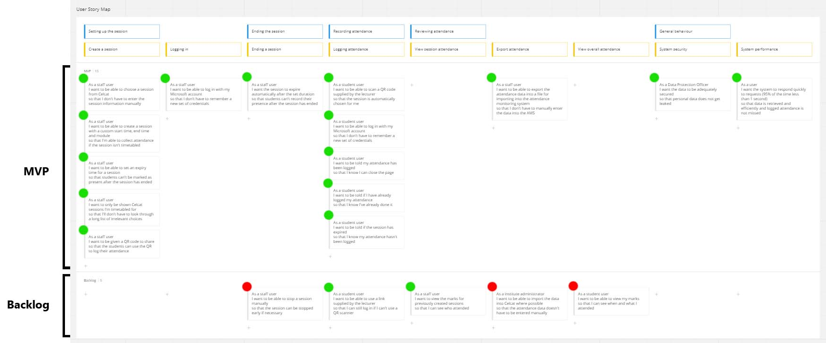
Figure 21: Overview of the user story map with the completed user stories marked with a green dot and the incomplete ones marked with a red dot. Note that all the stories in the MVP section have been completed.

Functional testing and analysis
The functional testing was done using the test suite in Postman. The entire test suite contained 205 assertions across 67 tests on seven different endpoints in the API. The suite was run for 20 iterations, one after the other, to generate data for analysis. The average time to run each iteration was approximately 2.5 seconds. The test run data was exported from Postman and analysed in Excel. A heatmap of the response times was generated (see Figure 22 and Figure 23) along with other metrics. These heatmaps showed some of the tests consistently took longer to complete than others. This is understandable when the targets are considered, as they relate to endpoints that return the largest amount of response data and, in a couple of instances, return data from the Celcat server rather than the AL server. Despite this, the response times are well within the requirements for requests to respond within 1 second (in fact, the tests that assert for response time are checking for a response time of 500 milliseconds or less). These findings were also reflected in the overall metrics shown in Table 12. However, these response times only provide a snapshot of performance for a single user, so the non-functional testing section later in this report provides results from more structured performance testing.
Table 12: The overall metrics from the test runs.
Metric | Response time (milliseconds)
Minimum | 24
Maximum | 494
Mean | 39.8
50th percentile | 31
75th percentile | 35
90th percentile | 51
95th percentile | 82
99th percentile | 187.2

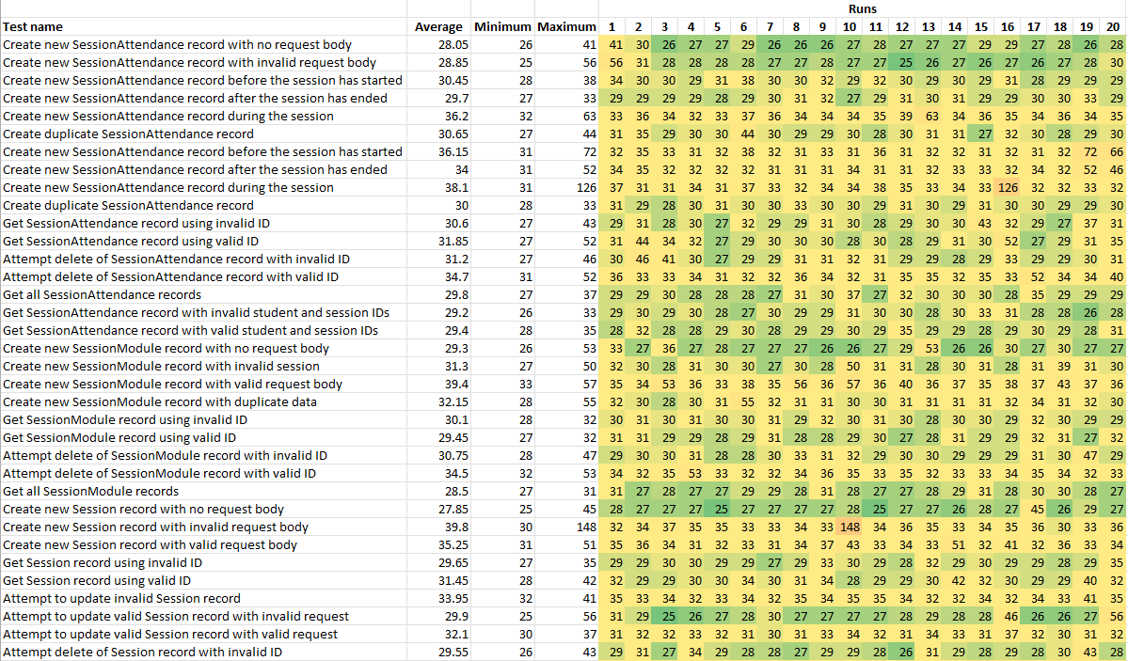
Figure 22: A heatmap of the response times for each run of each test. The colour-coding goes from green from the shortest times to red for the longest times. This is the first half of the results, with the remainder in the next figure. Note that the units for all figures are milliseconds.

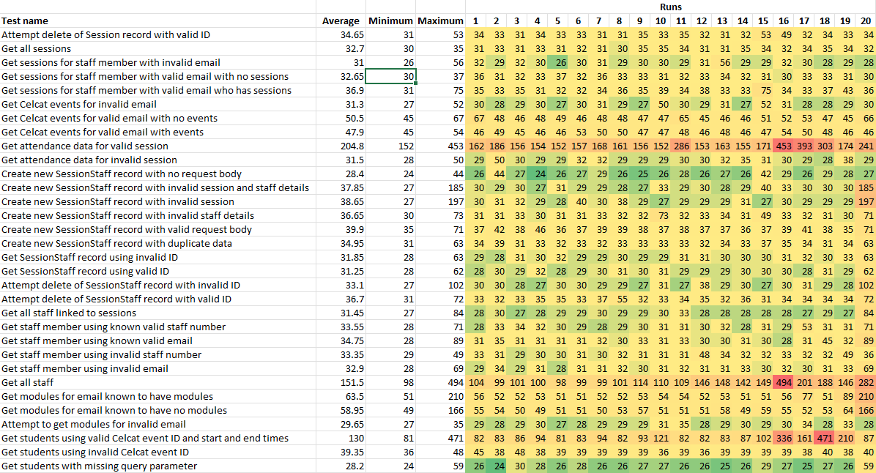
Figure 23: The remainder of the heatmap from the previous figure.

In terms of the testing approach, the author found Postman to be a good tool. Tests can be grouped into different folders for better organisation. This also allows tests to be run at a more granular level instead of having to run the full suite every time. It is also possible to design the suite to ensure it ‘tidies up’ as it runs (i.e., any records created as part of the test run are deleted in later tests). Although not necessarily a concern in development or testing environments, it means the test suite can be run against the production environment without polluting the database with test data.

Non-functional testing and analysis
The performance testing was conducted using Artillery. Artillery reports the status of the test on-screen at 10 seconds intervals throughout the duration of the test, with an option for outputting this data into a JSON file. This provides various metrics for response time and session length at each interval, along with aggregated metrics for the full test. There is a function within Artillery for generating a HTML report from a JSON output, but the limited scope for analysis meant the author instead chose to transfer the data from the JSON files to Excel for further analysis. As noted in Chapter 8, the performance testing was split into three test types, each of which will be covered in turn in the following sections.

Test type 1
As a reminder, it was decided that this test should make at least 3000 requests over a 5 minute period. This would equate to 10 requests per second (rps). In actuality, the final test that was executed was altered to make 4500 requests over the 5 minute period, resulting in an average of 15rps. This was done as the system demonstrated good performance at 10rps and the author thought it would be beneficial to stretch the system further to see if the same standard of performance would be maintained. Table 13 shows the aggregated metrics for the two tests with different request rates. These figures show the test with 15rps often displayed better performance than the test with 10rps, although the differences in time are short enough to go unnoticed by the end user.

Table 13: The aggregated metrics from the two tests (10rps and 15rps) showing the relative response times and session lengths.
 | Response time |  | Session length
Metric  (time in milliseconds) | Test with 10rps | Test with 15rps | Test with 10rps | Test with 15rps
Minimum | 20 | 19 | 842 | 80.9
Maximum | 438 | 380 | 517.7 | 534
Median | 34.8 | 32.8 | 98.5 | 96.6
50th percentile | 34.8 | 32.8 | 98.5 | 96.6
75th percentile | 37 | 36.2 | 102.5 | 100.5
90th percentile | 40.9 | 41.7 | 108.9 | 108.9
95th percentile | 50.9 | 48.9 | 117.9 | 115.6
99th percentile | 71.5 | 59.7 | 153 | 113
99.9th percentile | 247.2 | 290.1 | 407.5 | 368.8

The metrics at each interval were also compared. Charts were generated (Figure 24 to Figure 27) to give a visual representation of the data for easier analysis. The data plotted included the number of each type of response, along with the metrics for response time and session length which both used milliseconds as the unit of measurement. This was done to see if there was a relationship between the responses being sent and the changes in response time and session length.
If the charts for the test with 10rps are considered first, there are periods throughout the test where the maximum response time and session length clearly track with the number of responses with a HTTP status code of 201, suggesting that those responses where new records are created are the slowest. This is to be expected, as the API must first create the record then return a payload containing that record’s values. However, this trend is not present in the test with 15rps.

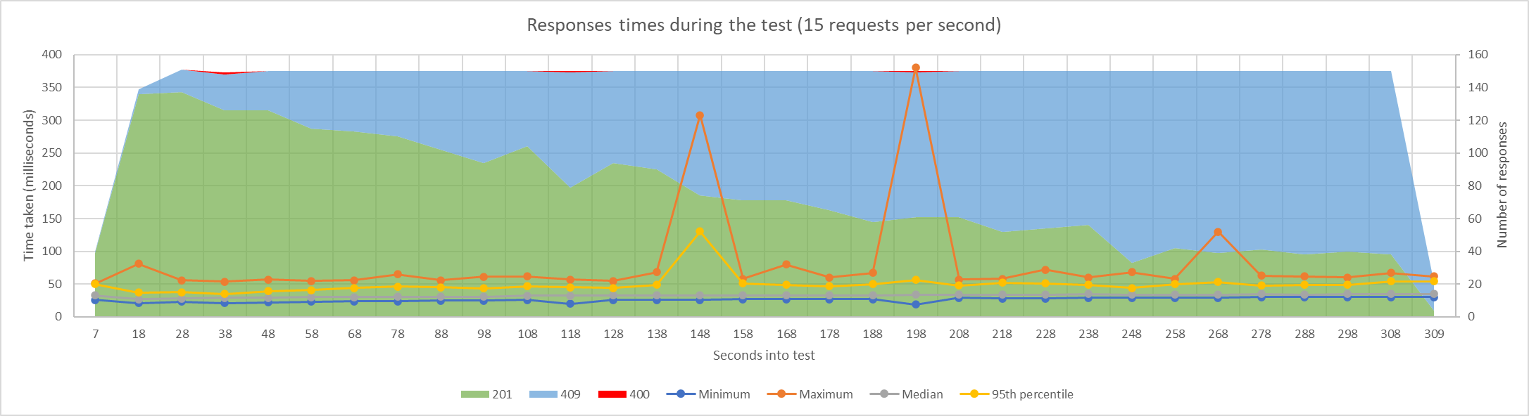
Figure 24: Chart showing the metrics for response time at each log interval during the test with 15 requests per second.
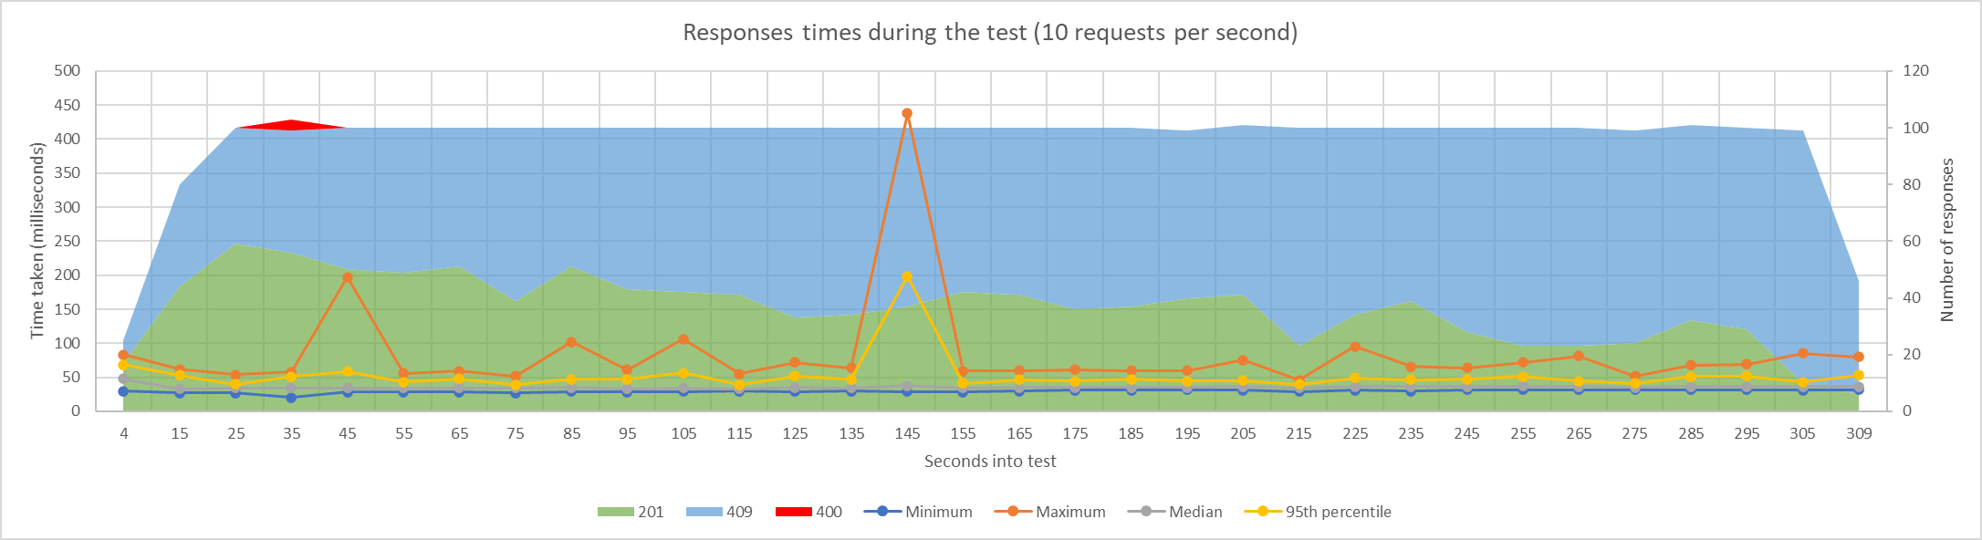
Figure 25: Chart showing the metrics for response time at each log interval during the test with 10 requests per second.
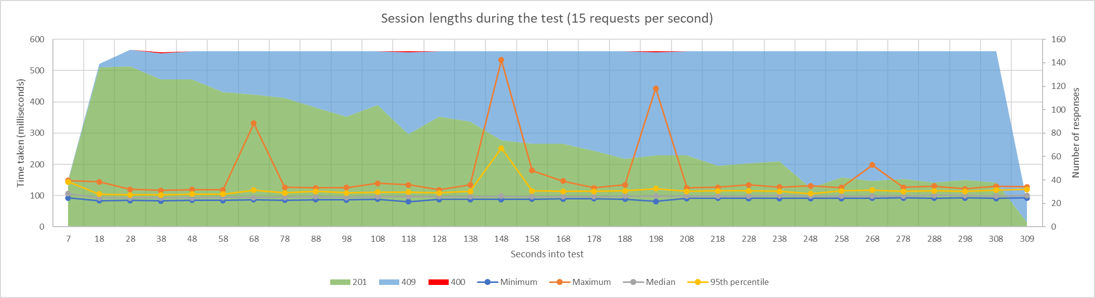
Figure 26: Chart showing the metrics for session length at each log interval during the test with 15 requests per second.
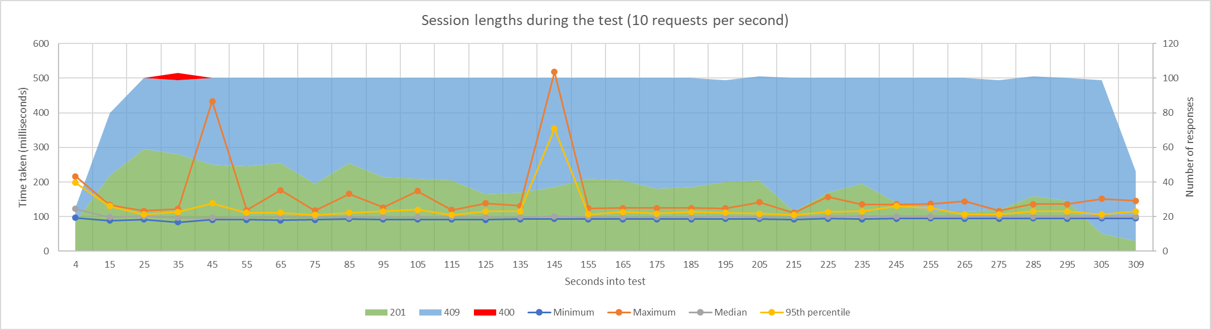
Figure 27: Chart showing the metrics for session length at each log interval during the test with 10 requests per second.
In both tests, there were spikes in response time and session length during the tests. There was also a very small number of 400 responses during the tests (4 out of 3050 for the test with 10rps, and 3 out of 4550 for the test with 15rps). These correlate with the spikes in response time and session length on some occasions but do not fully explain the other spikes. There do not appear to be any other obvious reasons for them in the data.
The tests highlighted a functional limitation of Artillery. As part of the test configuration, 3000 unique sets of data were generated and stored as a Comma-Separated Values (CSV) file for the tool to use as sample data. However, Artillery randomly choose lines from the file rather than reading it sequentially [95], resulting in some values being chosen multiple times. This is the reason the number of 201 requests decreases and the number of 409 requests increases as the test progress. The 409 responses are intentional responses from the API indicating that the record already exists. A solution has not yet been presented for this limitation, however the testing was still sufficient for this project.

Test type 2
This test was designed to saturate the API with POST requests to see what its breaking point was. The test had a 10 second ‘warm-up’ phase with 5 users every second, followed by the main ‘ramp-up’ phase. This was designed to ramp from 5 users every second to 100 users every second over a 60 second test. This is quite an aggressive ramp-up. As with the previous test, charts were created for visualising the response time (Figure 28) and session length (Figure 29) data. The charts show that the system was handling requests well, with acceptable response times up until approximately 60 seconds into the test where the number of completed virtual users (VUs) started to deviate substantially from the number of created VUs. This would be approximately 50 seconds into the ramp-up phase. In the 10 second period up to this (between 38 and 48 seconds), the average request rate was 78rps, substantially higher than the load the system would realistically be expected to endure, and therefore the author does not believe the system’s behaviour in the later phase of this test is of concern.
The logging intervals are fixed to every 10 seconds in Artillery. The author would have liked the option to be able to alter it, which would be particularly useful in these shorter tests. However, it is likely that having too short an interval would impact the testing itself, so it is understandable why this is not an option. In a similar vein, it would be helpful to have more transparency about the number of requests sent each second during the test (especially during ramp-up tests), but again, the logging overhead would probably be too large.

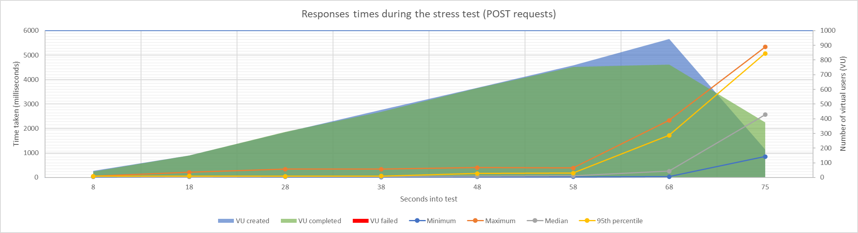
Figure 28: Chart showing the metrics for response time against time for the POST request stress test, with the cumulative numbers of virtual users on the third axis.
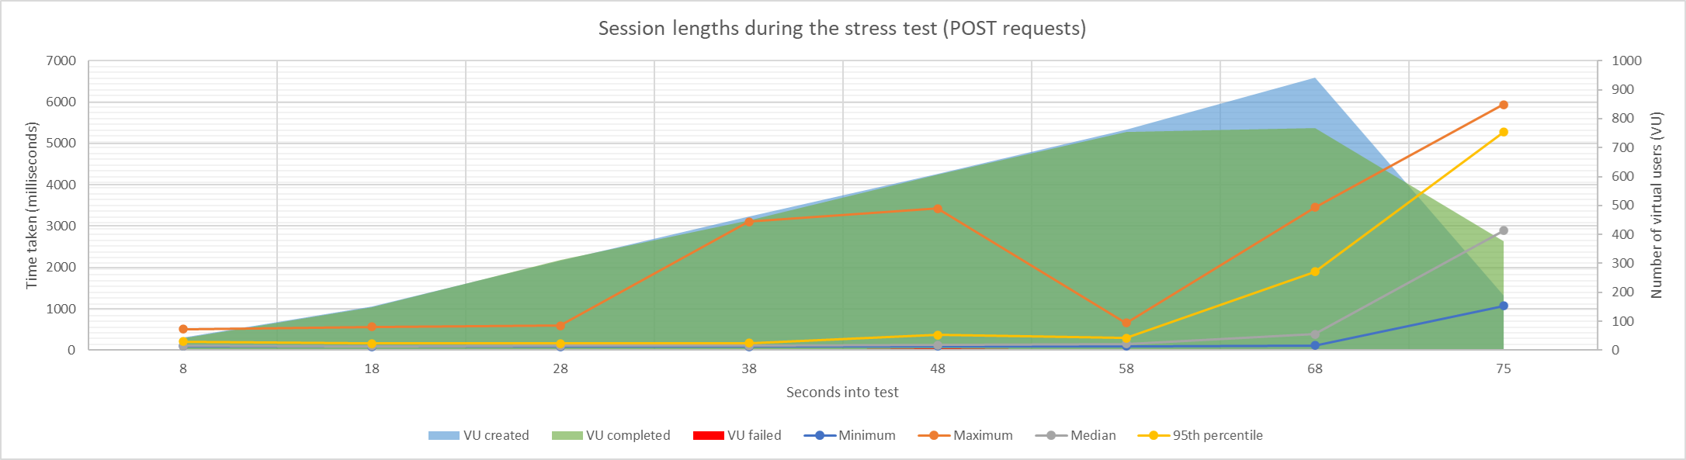
Figure 29: Chart showing the metrics for session length against time for the POST request stress test, with the cumulative numbers of virtual users on the third axis.

Test type 3
This test was essentially the same as test type 2 but sending GET requests instead of POST requests. The other parameters were standardised. An endpoint that returned a relatively large amount of data was chosen over those that returned a single record to stress the system further. Charts of the results can be found in Figure 30 and Figure 31. The GET requests showed better performance than the POST requests despite the same test parameters, with the median response time and session length staying consistent throughout. The maximum response time and session length did trend slightly upwards during the test, but the durations remained well within acceptable levels. The number of completed VUs also tracked closely with the number of created VUs, indicating the system was coping with the requests and not getting over-saturated as with the POST requests. This is likely due to POST requests needing to do two database queries for each request (a write and a read) as opposed to just a read query for the GET requests.

Usability testing and analysis
The students were given a brief survey to complete for them to offer feedback on the system. Four out of the five users that logged attendance provided feedback. All users indicated they logged attendance via a phone and that they all attempted to use the QR code. 75% gave positive responses ranging from 7 to 10 out of 10, with the final student giving low scores and indicating they had problems scanning the QR code. However, they were able to log attendance (probably through the link also provided), so attendance was still collected. Looking at the times of when attendance was logged also showed the students typically logged attendance within three minutes of each other. Although a very small cohort, this pilot suggested the system could be rolled out further for more testing.

Once the evaluation of the results was completed, the final conclusions could be drawn about the project. These can be found in the next chapter, along with suggestions for future work.

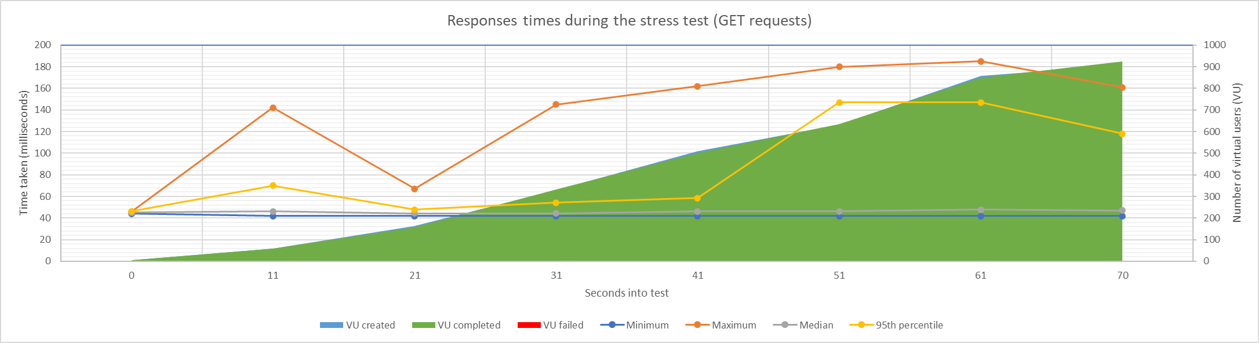
Figure 30: Chart showing the metrics for response time against time for the GET request stress test, with the cumulative numbers of virtual users on the third axis.
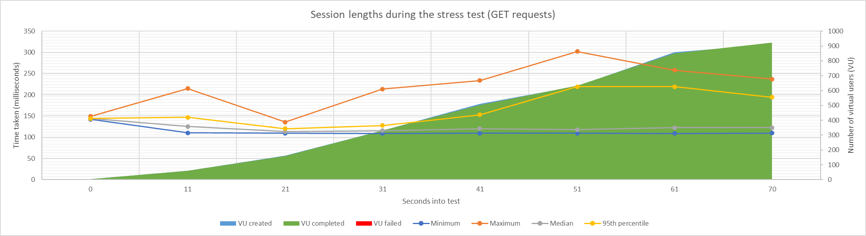
Figure 31: Chart showing the metrics for session length against time for the GET request stress test, with the cumulative numbers of virtual users on the third axis.

Conclusion and recommendations
This chapter covers the conclusion about the project and suggestions for future work.

Conclusion
As outlined in Chapter 1, the aim of this project was to conduct a case study to implement an improved approach for attendance logging at UWTSD through the following objectives:
- Evaluate the available approaches for logging attendance, including prior and current implementations, and those from other institutions.
- Determine the system requirements and implement a new solution that will be compared to the existing approach.
- Critically evaluate the solution against the requirements and the existing approach and assess its viability.
The author believes they have met the aim in that an improved attendance logging system was created and successfully piloted with a small cohort of students. The system greatly reduces the impact of AL on the lecturers without overwhelming the students with a difficult process. It also substantially reduces the administrative overhead of maintaining the system as it largely relies on timetable data. The data generated by the system is stored in a much more usable and accessible format. This greatly improves the potential for integrations with other systems, such as reporting dashboards and the student portal. This could be used to dramatically increase awareness of student engagement not only from the university’s perspective, but also the student’s perspective. The approach to data storage also means the data can more easily be transferred into whichever AMS is used in future. The fact that there is a web service also means different AL approaches can be implemented that make use of the underlying web service and its logic.
The author found the chosen approach for requirements gathering was good as it provided clear expectations for which features needed to be implemented and how they should be implemented. It also reinforced the ‘flow’ of the system which provide a clear picture of the processes. This fed into the design process, with more granular flowcharts being generated. The requirement gathering and design processes also highlighted infrastructure limitations that had to be met, ensuring these were considered early on and accounted for appropriately.
The implementation process largely went well, with the only real limitation being the issues implementing OIDC for the API security. While this is clearly technically feasible, time limitations did not allow further problem solving. The functional and non-functional testing of the system was successful, with the system meeting the main requirements in both, and holding up well to the performance testing. This indicates the system could be readily rolled out further. With more time, it would have been preferable to extend the pilot to a larger group of students and lecturers to gather a broader range of feedback from the user testing. However, the limited feedback that was received was positive overall, again suggesting the system could be deployed further.

Suggestions for future work
There is an almost endless scope for future work relating to attendance logging at UWTSD, but much of it is dependent on policy change and requires wider collaboration across the university. Indeed, there are already discussions taking place about reviewing the policy to make it better suited to the university’s systems. In terms of more immediately actionable progress, the pilot could be extended to include more lecturers and students to see if any limitations become apparent, with the upcoming academic year providing an opportunity for deploying the system more broadly. The API security could also be revised to use an OIDC layer. There is also the possibility of synchronising the attendance data to the student portal (MyDay) for students to be able to track their attendance. Similarly, a reporting dashboard could be set up that allows attendance tracking for monitoring engagement and adhering to UKVI regulations. Changes could be made to the user interface for lecturers so they have more control over what sessions they can see, and module data could also be sourced from the Virtual Learning Environment (Moodle) so ad-hoc sessions can be linked to those groups that are in Moodle but not Celcat.
The next chapter covers the author’s reflection on the impact the project had on their personal development.

Reflection
During this project, I learnt practical and ‘soft’ skills. Though the practical skills learnt are useful from a career perspective, I believe the soft skills will be more beneficial in the long term.
The practical skills mostly relate to the testing that took place during the project, although some relate to the development phase. I had not previously implemented an API using .NET, so this project provided the ideal opportunity to gain those skills. In terms of testing, I had used Postman in the past for smaller scale testing but had not used it to create a test suite. This really highlighted to me the value of generating a test suite that could be run automatically, as it allows validation of the system as development is taking place, and the construction of the test suite provides an opportunity to review any design decisions and logic. The performance testing also forced me to think more about how the system would be used and therefore the expectations for its performance. The testing also highlighted that the testing tools are simple to learn but difficult to master, with there being a lot of potential for more detailed and broader testing.
In terms of the soft skills, I learnt a great deal about my capacity for working under pressure during the time the project took place. I had significant pressures in my job working on a high-profile project with fewer resources than I originally expected. I also developed a recurring headache part way through the independent project (roughly two months in) which is on-going as of the submission date, with the working theory being it was stress related. It became apparent that I should have asked for support sooner than I did, and I should not have put so much pressure on myself both in work and on the independent project. This has made me much more conscious of my stress levels and what methods I can use to reduce them.
On a more positive note, I did feel my approach to time management on the project worked relatively well for me. I tended to begin work on areas of the project well ahead of time to give myself enough leeway for review and refactoring, and this went some way to reducing my anxieties surrounding deadlines.

Glossary
Acronym | Term
AI | Artificial Intelligence
AL | Attendance Logging
AMS | Attendance Monitoring System
API | Application Interface
BLE | Bluetooth Low Energy
CSV | Comma-Separated Values
DBMS | Database Management System
FDD | Feature Driven Development
FTP | File Transfer Protocol
HTTP | Hyper Text Transfer Protocol
HTTP | Hyper Text Transfer Protocol
IDE | Integrated Development Environment
IIS | Internet Information Services
LTS | Long Term Support
MAC | Media Access Control
MFA | Multi-Factor Authentication
NAS | Network Attached Storage
NFC | Near Field Communication
OAS | OpenAPI Specification
OTP | One Time Password
QR | Quick Response
REST | Representation State Transfer
RFID | Radio Frequency Identification
SDLC | Software Development Lifecycle
SMS | Short Message Service
SMTP | Simple Mail Transfer Protocol
SSIS | SQL Server Integration Services
SSRS | SQL Server Reporting Services
UKVI | United Kingdom Visa & Immigration
URL | Uniform Resource Locator
UWTSD | University of Wales Trinity Saint David
W3C | World Wide Web Consortium
WSDL | Web Services Description Language
XML | Extensible Markup Language
XP | eXtreme Programming

Reference list
[1] E. Bowen, T. Price, S. Lloyd, and S. Thomas, “Improving the quantity and quality of attendance data to enhance student retention,” J. Furth. High. Educ., vol. 29, no. 4, pp. 375–385, Nov. 2005, doi: 10.1080/03098770500353714.
[2] G. Tewkesbury, D. Sanders, M. Haddad, P. Omoarebun, A. Gegov, and S. Chester, “Creation of a NFC Reading System for University Attendance Monitoring with Accessibility Considerations for Powered Wheelchair Users,” 2020 IEEE 10th Int. Conf. Intell. Syst. IS 2020 - Proc., pp. 235–240, 2020, doi: 10.1109/IS48319.2020.9199971.
[3] B. Benyo, B. Sódor, T. Doktor, and G. Fördös, “Student attendance monitoring at the university using NFC,” Wirel. Telecommun. Symp., 2012, doi: 10.1109/WTS.2012.6266137.
[4] M. Borić, A. F. Vilas, and R. P. Díaz Redondo, “Automatic attendance control system based on BLE technology,” ICETE 2018 - Proc. 15th Int. Jt. Conf. E-bus. Telecommun., vol. 1, no. Icete, pp. 289–295, 2018, doi: 10.5220/0006830202890295.
[5] T. Sutabri, Pamungkur, A. Kurniawan, and R. E. Saragih, “Automatic attendance system for university student using face recognition based on deep learning,” Int. J. Mach. Learn. Comput., vol. 9, no. 5, pp. 668–674, 2019, doi: 10.18178/ijmlc.2019.9.5.856.
[6] J. Jacob, K. Jha, P. Kotak, and S. Puthran, “Mobile attendance using Near Field Communication and One-Time Password,” Proc. 2015 Int. Conf. Green Comput. Internet Things, ICGCIoT 2015, pp. 1298–1303, 2016, doi: 10.1109/ICGCIoT.2015.7380666.
[7] A. Puckdeevongs, N. K. Tripathi, A. Witayangkurn, and P. Saengudomlert, “Classroom attendance systems based on bluetooth low energy indoor positioning technology for smart campus,” Inf., vol. 11, no. 6, 2020, doi: 10.3390/INFO11060329.
[8] P. Atkinson, “Analysis of the current AMS and potential replacements.” 2017.
[9] A. Kalashnikov, H. Zhang, and M. Abramiuk, “Automated recording and processing of lecture attendance data using RFID student cards,” Proc. Vi …, pp. 81–84, 2018, [Online]. Available: http://shura.shu.ac.uk/21236/%0Ahttp://shura.shu.ac.uk/21236/1/Kalashnikov_Sect4_Attendance_fin.pdf.
[10] R. B. Kuriakose and H. J. Vermaak, “Developing a Java based RFID application to automate student attendance monitoring,” Proc. 2015 Pattern Recognit. Assoc. South Africa Robot. Mechatronics Int. Conf. PRASA-RobMech 2015, pp. 48–53, 2015, doi: 10.1109/RoboMech.2015.7359497.
[11] C. Thompson, “The Myth of Fingerprints | Science | Smithsonian Magazine,” Smithsonian Magazine, Apr. 2019. https://www.smithsonianmag.com/science-nature/myth-fingerprints-180971640/ (accessed Feb. 10, 2022).
[12] “Fingerprint recognition - NCSC.GOV.UK,” NCSC.GOV.UK, Jan. 24, 2019. https://www.ncsc.gov.uk/collection/biometrics/fingerprint (accessed Feb. 10, 2022).
[13] K. Okereafor, I. Ekong, I. Okon Markson, and K. Enwere, “Fingerprint Biometric System Hygiene and the Risk of COVID-19 Transmission,” JMIR Biomed. Eng., vol. 5, no. 1, p. e19623, 2020, doi: 10.2196/19623.
[14] W. Kuang and A. Baul, “A Real-time Attendance System Using Deep-learning Face Recognition,” 2020, doi: 10.18260/1-2--33949.
[15] L. Cronjé and I. Sanders, “Semiautomated Class Attendance Monitoring Using Smartphone Technology,” J. Artif. Intell. Technol., vol. 1, no. 1, pp. 9–20, 2020, doi: 10.37965/jait.2020.0040.
[16] P. Grother, M. Ngan, and K. Hanaoka, “Face Recognition Vendor Test ( FRVT ) Part 3 : Demographic Effects,” Nistir 8280, vol. December, p. https://doi.org/10.6028/NIST.IR.8280, 2019.
[17] A. A. A. Rahni, N. Zainal, M. F. Zainal Adna, N. E. Othman, and M. F. Bukhori, “Development of the online student attendance monitoring system (SAMSTM) based on QR-codes and mobile devices,” J. Eng. Sci. Technol., vol. 10, no. Spec. Issue 2 on UKM Teaching and Learning Congress 2013, May 2015, pp. 28–40, 2015.
[18] F. Masalha and N. Hirzallah, “A Students Attendance System Using QR Code,” Int. J. Adv. Comput. Sci. Appl., vol. 5, no. 3, 2014, doi: 10.14569/ijacsa.2014.050310.
[19] D. Rahmawati, F. Wincoko Putro, A. Y. Wicaksono, and A. Nurdin, “Student Attendance System using QR Codes (Case Study: Institut Teknologi Telkom Surabaya),” Proc. Int. Semin. Inf. Commun. Technol. 2019 (ISICT 2019), vol. 2019, no. March, pp. 83–93, 2019.
[20] V. Kassarnig, A. Bjerre-Nielsen, E. Mones, S. Lehmann, and D. D. Lassen, “Class attendance, peer similarity, and academic performance in a large field study,” PLoS One, vol. 12, no. 11, pp. 1–15, 2017, doi: 10.1371/journal.pone.0187078.
[21] The Quality Assurance Agency for Higher Education (QAA), “Supporting resource - How UK Higher Education Providers Managed the Shift to Digital Delivery During the COVID-19 Pandemic,” Qual. Assur. Agency High. Educ., pp. 1–29, 2020, [Online]. Available: https://www.qaa.ac.uk/docs/qaa/guidance/how-uk-higher-education-providers-managed-the-shift-to-digital-delivery-during-the-covid-19-pandemic.pdf.
[22] Microsoft, “View and download meeting attendance reports in Teams,” Microsoft Support. https://support.microsoft.com/en-gb/office/view-and-download-meeting-attendance-reports-in-teams-ae7cf170-530c-47d3-84c1-3aedac74d310?ui=en-us&rs=en-gb&ad=gb (accessed Aug. 27, 2021).
[23] “Meeting registration and polling reports – Zoom Support,” Zoom Support pages, Jan. 31, 2022. https://support.zoom.us/hc/en-us/articles/216378603-Meeting-registration-and-polling-reports (accessed Feb. 14, 2022).
[24] “Get meeting participant reports - Zoom Developer Docs,” Zoom Developer Docs. https://marketplace.zoom.us/docs/api-reference/zoom-api/methods/#operation/reportMeetingDetails (accessed Feb. 14, 2022).
[25] “Now, Microsoft Teams Meeting Can be Audited Through Teams Audit Log ,” Office 365 Reports. https://o365reports.com/2021/12/08/microsoft-teams-meeting-attendance-report/ (accessed Feb. 14, 2022).
[26] P. Atkinson, “Attendance monitoring with coronavirus.” 2020.
[27] J. Dixon and A. S. Abuzneid, “An NFC Based Student Attendance Tracking/Monitoring System Using an IoT Approach,” Proc. - 2020 Int. Conf. Comput. Sci. Comput. Intell. CSCI 2020, pp. 1082–1086, 2020, doi: 10.1109/CSCI51800.2020.00201.
[28] F. M. Al-Naima et. al., “A Proposed RFID Based Student Attendance System,” Int. J. Comput. Netw. Technol., vol. 03, no. 02, pp. 49–58, 2015, doi: 10.12785/ijcnt/030202.
[29] “Understand Azure IoT Hub pricing | Microsoft Docs,” Microsoft Docs, Nov. 16, 2021. https://docs.microsoft.com/en-gb/azure/iot-hub/iot-hub-devguide-pricing (accessed Feb. 04, 2022).
[30] “Your right to be informed if your personal data is being used | ICO,” Information Commissioner’s Office. https://ico.org.uk/your-data-matters/your-right-to-be-informed-if-your-personal-data-is-being-used/ (accessed Feb. 15, 2022).
[31] R. T. Fielding, “Architectural Styles and the Design of Network-based Software Architectures.” Irvine,California, p. 162, 2000.
[32] J. Thijssen, “Are REST and HTTP the same thing? - The RESTful cookbook,” REST CookBook. https://restcookbook.com/Miscellaneous/rest-and-http/ (accessed Nov. 24, 2020).
[33] R. Fielding et al., “Hypertext Transfer Protocol -- HTTP/1.1.” 1999.
[34] “SOAP vs REST APIs: Which Is Right For You? | SoapUI,” SoapUI. https://www.soapui.org/learn/api/soap-vs-rest-api/ (accessed Dec. 27, 2020).
[35] E. (Microsoft) Christensen, F. (IBM R. Curbera, G. (Microsoft) Meredith, and S. (IBM R. Weerawarana, “Web Service Definition Language (WSDL),” World Wide Web Consortium (W3C), Mar. 15, 2001. https://www.w3.org/TR/wsdl.html (accessed Nov. 25, 2020).
[36] “SOAP Version 1.2 Part 1: Messaging Framework (Second Edition),” W3C, Apr. 27, 2007. https://www.w3.org/TR/soap12-part1/ (accessed Nov. 22, 2020).
[37] “What is SOAP API? | AltexSoft,” AltexSoft, Aug. 20, 2019. https://www.altexsoft.com/blog/engineering/what-is-soap-formats-protocols-message-structure-and-how-soap-is-different-from-rest/ (accessed Nov. 25, 2020).
[38] B. (Microsoft) Atkinson et al., “Web Services Security Language (WS-Security) | Microsoft Docs,” Microsoft Docs, Apr. 05, 2002. https://docs.microsoft.com/en-us/previous-versions/ms951257(v=msdn.10) (accessed Nov. 25, 2020).
[39] M. Philip and G. Clynch, “A Performance Analysis of WS-* (SOAP) & RESTful Web Services for implementing Service and Resource Orientated Architectures,” IT&T - 12th Int. Conf. Inf. Technol. Telecommun., no. May, pp. 93–100, 2013, [Online]. Available: http://ittconference.ie/uploads/conference/2013/ITT Proceedings 2013 v2_0.pdf.
[40] “SOAP Optimisation Modules: Response Caching,” World Wide Web Consortium (W3C), Aug. 23, 2001. https://lists.w3.org/Archives/Public/www-ws/2001Aug/att-0000/ResponseCache.html (accessed Dec. 27, 2020).
[41] ECMA International, “The JSON Data Interchange Syntax,” Stand. ECMA-404, vol. 2nd Editio, no. December 2017, p. 8, 2017, [Online]. Available: http://www.ecma-international.org/publications/standards/Ecma-404.htm.
[42] B. Hambling, “Test Design Techniques,” in Software Testing: An ISTQB-ISEB Foundation Guide, 2nd ed., B. Hambling, Ed. London: BCS Learning & Development Limited, 2010, pp. 71–128.
[43] “Assertion Testing,” TutorialsPoint. https://www.tutorialspoint.com/software_testing_dictionary/assertion_testing.htm (accessed Feb. 23, 2022).
[44] M. Rehkopf, “Automated software testing for continuous delivery,” Atlassian website. https://www.atlassian.com/continuous-delivery/software-testing/automated-testing (accessed Feb. 23, 2022).
[45] “FAQ - OpenAPI Initiative.” https://www.openapis.org/faq (accessed Feb. 23, 2022).
[46] “Working with WSDL Files | Documentation | SoapUI,” SoapUI Docs. https://www.soapui.org/docs/soap-and-wsdl/working-with-wsdls/ (accessed Feb. 21, 2022).
[47] A. Kane, “Postman Now Supports WSDL | Postman Blog,” Postman Blog, Jul. 26, 2021. https://blog.postman.com/postman-now-supports-wsdl/ (accessed Feb. 22, 2022).
[48] “Getting Started with REST Testing in SoapUI | SoapUI,” SoapUI Docs. https://www.soapui.org/docs/rest-testing/?wvideo=eohc7hfzda (accessed Feb. 22, 2022).
[49] A. Saini, “Postman Now Supports OpenAPI 3.1 | Postman Blog,” Postman Blog, Feb. 17, 2022. https://blog.postman.com/postman-now-supports-openapi-3-1/ (accessed Feb. 22, 2022).
[50] “SOAP Coverage Testing | ReadyAPI Documentation,” ReadyAPI Documentation, Feb. 01, 2022. https://support.smartbear.com/readyapi/docs/testing/coverage/soap.html (accessed Feb. 22, 2022).
[51] “REST Coverage Testing | ReadyAPI Documentation,” ReadyAPI Documentation, Feb. 01, 2022. https://support.smartbear.com/readyapi/docs/testing/coverage/rest.html (accessed Feb. 22, 2022).
[52] J. D. Meier, C. Farre, P. Bansohe, S. Barber, and D. Rea, “Chapter 2 – Types of Performance Testing,” in Performance Testing Guidance for Web Applications, 2007.
[53] “What is Smoke Testing? How to create a Smoke Test in k6,” k6 Docs. https://k6.io/docs/test-types/smoke-testing/ (accessed Feb. 23, 2022).
[54] “What is Stress Testing? How to create a Stress Test in k6,” k6 Docs. https://k6.io/docs/test-types/stress-testing (accessed Feb. 23, 2022).
[55] “What is Soak Testing? How to create a Soak Test in k6,” k6 Docs. https://k6.io/docs/test-types/soak-testing/ (accessed Feb. 23, 2022).
[56] “How to Load Test Your APIs | SoapUI,” SoapUI Docs. https://www.soapui.org/docs/load-testing/concept/ (accessed Feb. 23, 2022).
[57] A. Basu, “Non-functional, Acceptance and Regression Testing,” in Software Quality Assurance, Testing and Metrics, Prentice Hall India Pvt., Limited, 2015, pp. 150–163.
[58] “What is Regression Testing? Definition, Tools, Method, and Example,” Software Testing Help, Feb. 03, 2022. https://www.softwaretestinghelp.com/regression-testing-tools-and-methods/ (accessed Feb. 24, 2022).
[59] “Regression Testing Best Practices | PerformanceLab,” Performance Lab. https://performancelabus.com/what-is-a-regression-test-definition-examples/ (accessed Feb. 24, 2022).
[60] P. Godefroid, D. Lehmann, and M. Polishchuk, “Differential regression testing for REST APIs,” ISSTA 2020 - Proc. 29th ACM SIGSOFT Int. Symp. Softw. Test. Anal., pp. 312–323, 2020, doi: 10.1145/3395363.3397374.
[61] Information Commissioner’s Office, “What is personal data? | ICO.” https://ico.org.uk/for-organisations/guide-to-data-protection/guide-to-the-general-data-protection-regulation-gdpr/key-definitions/what-is-personal-data/ (accessed Jul. 21, 2020).
[62] J. Reschke, “The ‘Basic’ HTTP Authentication Scheme,” Sep. 2015, doi: 10.17487/RFC7617.
[63] S. Allamaraju, RESTful Web Services Cookbook, 1st ed. Sebastopol: O’Reilly Media, Inc., 2010.
[64] G. Levin, “4 Most Used REST API Authentication Methods,” RestCase blog, Jul. 26, 2019. https://blog.restcase.com/4-most-used-rest-api-authentication-methods/ (accessed May 30, 2022).
[65] “API Keys,” Swagger Docs. https://swagger.io/docs/specification/authentication/api-keys/ (accessed May 30, 2022).
[66] D. Hardt, “The OAuth 2.0 Authorization Framework,” Oct. 2012. doi: 10.17487/rfc6749.
[67] “OAuth 2.0,” Swagger Docs. https://swagger.io/docs/specification/authentication/oauth2/ (accessed May 30, 2022).
[68] “File:Abstract-flow.png - Wikimedia Commons,” Sep. 02, 2021. https://commons.wikimedia.org/wiki/File:Abstract-flow.png (accessed May 30, 2022).
[69] “OpenID Connect | OpenID,” OpenID website. https://openid.net/connect/ (accessed May 30, 2022).
[70] “Microsoft identity platform and OpenID Connect protocol - Microsoft identity platform | Microsoft Docs,” Microsoft Docs, 2022. https://docs.microsoft.com/en-us/azure/active-directory/develop/v2-protocols-oidc (accessed May 30, 2022).
[71] “OpenID Connect Discovery,” Swagger Docs. https://swagger.io/docs/specification/authentication/openid-connect-discovery/ (accessed May 30, 2022).
[72] “OIDC: What Is OpenID Connect and How Does It Work? What You Need to Know,” Ping Identity content library. https://www.pingidentity.com/en/resources/content-library/articles/openid-connect.html (accessed May 30, 2022).
[73] M. Saunders, P. Lewis, and A. Thornhill, Research Methods for Business Students, 8th ed. Pe, 2019.
[74] J. Crossley and D. Jansen, “Saunders’ Research Onion: Explained Simply (+ Examples) - Grad Coach,” Grad Coach, Jan. 2021. https://gradcoach.com/saunders-research-onion/ (accessed Mar. 10, 2022).
[75] S. Crowe, K. Cresswell, A. Robertson, G. Huby, A. Avery, and A. Sheikh, “The case study approach,” BMC Med. Res. Methodol., vol. 11, 2011, doi: 10.1186/1471-2288-11-100.
[76] P. Runeson and M. Höst, “Guidelines for conducting and reporting case study research in software engineering,” Empirical Software Engineering, vol. 14, no. 2. pp. 131–164, 2009, doi: 10.1007/s10664-008-9102-8.
[77] S. Lee and D. Rine, “Case study methodology designed research in software engineering methodology validation,” Proc. Sixt. Int. Conf. Softw. Eng. Knowl. Eng., no. January, pp. 117–122, 2004, [Online]. Available: http://machinediscovery.com/nise/Papers/SEKE04LeeRineFinalCamera-header.pdf.
[78] “Action Research vs Case Study : Know the Key Difference Between Two Qualitative Research Methods – Five Vidya,” Fivevidya, Jul. 27, 2019. https://www.fivevidya.com/blog/action-research-vs-case-study-know-the-key-difference-between-two-qualitative-research-methods/ (accessed Mar. 10, 2022).
[79] C. W. Dawson, “2.4 Research methods,” in Projects in Computing and Information Systems: A Student’s Guide, 2nd ed., Pearson Education Limited, 2009, pp. 25–35.
[80] C. W. Dawson, “Software development,” in Projects in Computing and Information Systems: A Student’s Guide, 2nd ed., Pearson Education Limited, 2009, pp. 113–147.
[81] A. Nikolaieva, “8 Best Software Development Methodologies,” Uptech blog. https://www.uptech.team/blog/software-development-methodologies (accessed Apr. 11, 2022).
[82] M. A. Awad, “A Comparison between Agile and Traditional Software Development Methodologies,” 2005.
[83] K. Beck et al., “Principles behind the Agile Manifesto,” Agile Manifesto, Feb. 2001. https://agilemanifesto.org/principles.html (accessed Apr. 11, 2022).
[84] A. Cockburn and J. Highsmith, “Agile Software Development: The People Factor,” Computer (Long. Beach. Calif)., pp. 131–133, 2001, [Online]. Available: http://sunnyday.mit.edu/16.355/highsmith-people.pdf.
[85] D. Wells, “Surprise! Software Rots!,” 2009. http://www.agile-process.org/change.html (accessed Apr. 11, 2022).
[86] K. Schwaber and J. Sutherland, “The Scrum Guide - The Definitive Guide to Scrum: The Rules of the Game,” no. November. pp. 1–13, 2020, [Online]. Available: https://scrumguides.org/docs/scrumguide/v2020/2020-Scrum-Guide-US.pdf.
[87] S. W. Ambler, “Feature Driven Development (FDD) and Agile Modeling,” agilemodelling.com. http://agilemodeling.com/essays/fdd.htm (accessed Apr. 11, 2022).
[88] R. Lynn, “What is FDD in Agile? | Planview,” Planview. https://www.planview.com/resources/articles/fdd-agile/ (accessed Apr. 11, 2022).
[89] “Why (and How) You Should Use Feature-Driven Development | Lucidchart Blog,” Lucidchart blog. https://www.lucidchart.com/blog/why-use-feature-driven-development (accessed Apr. 11, 2022).
[90] A. B. Hollar, “Cowboy: An Agile Programming Methodology for a Solo Programmer,” no. December, pp. 1–73, 2006, [Online]. Available: https://web.archive.org/web/20161019163345if_/http://scholarscompass.vcu.edu:80/cgi/viewcontent.cgi?article=1740&context=etd.
[91]. “NET and .NET Core official support policy.” https://dotnet.microsoft.com/en-us/platform/support/policy/dotnet-core (accessed Apr. 08, 2022).
[92] G. Warren, “What’s new in .NET 6 | Microsoft Docs,” Microsoft Docs, Jan. 27, 2022. https://docs.microsoft.com/en-us/dotnet/core/whats-new/dotnet-6 (accessed Apr. 08, 2022).
[93] “425 Too Early - HTTP | MDN,” MDN Web Docs, Aug. 13, 2021. https://developer.mozilla.org/en-US/docs/Web/HTTP/Status/425 (accessed May 16, 2022).
[94] “GitHub - AzureAD/microsoft-identity-web: Helps creating protected web apps and web APIs with Microsoft identity platform and Azure AD B2C,” GitHub. https://github.com/AzureAD/microsoft-identity-web (accessed Jun. 05, 2022).
[95] “Csv not being read in sequence · Issue #922 · artilleryio/artillery · GitHub,” Jan. 25, 2021. https://github.com/artilleryio/artillery/issues/922#issuecomment-1023710167 (accessed Jun. 06, 2022).
[96] Y. Li, R. H. Deng, and E. Bertino, RFID Security and Privacy. Morgan & Claypool, 2013.
[97] B. Violino, “The Basics of RFID Technology | RFID JOURNAL,” RFID Journal, Jan. 16, 2005. https://www.rfidjournal.com/the-basics-of-rfid-technology (accessed Feb. 03, 2022).
[98] M. Hendry, Near Field Communications Technology and Applications. Cambridge University Press, 2014.
[99] J. Thrasher, “RFID versus NFC: What’s the difference between NFC and RFID? - atlasRFIDstore,” atlas RFIS store blog, Oct. 11, 2013. https://www.atlasrfidstore.com/rfid-insider/rfid-vs-nfc/ (accessed Feb. 05, 2022).
[100] J. Longman, “6 Best Bluetooth Speakers With NFC Technology In 2021,” Audio Reputation, Jan. 11, 2022. https://www.audioreputation.com/bluetooth-speakers-nfc-technology/ (accessed Feb. 06, 2022).
[101] D. A. Gratton, “Bluetooth low energy: The Smart Choice,” in The Handbook of Personal Area Networking Technologies and Protocols, Cambridge University Press, 2013, pp. 66–99.
[102] “Understanding the Generic Access Profile (GAP) - Qualcomm Developer Network,” Qualcomm Developer Network. https://developer.qualcomm.com/hardware/qca4020-qca4024/learning-resources/understanding-generic-access-profile (accessed Feb. 07, 2022).
[103] J. Tosi, F. Taffoni, M. Santacatterina, R. Sannino, and D. Formica, “Performance evaluation of bluetooth low energy: A systematic review,” Sensors (Switzerland), vol. 17, no. 12, pp. 1–34, 2017, doi: 10.3390/s17122898.
[104] “Biometrics Definition & Meaning - Merriam-Webster,” Merriam-Webster. https://www.merriam-webster.com/dictionary/biometrics (accessed Feb. 10, 2022).
[105] Z. Kew-Denniss, “Optical, capacitive, and ultrasonic fingerprint sensors —​​​​​​​ how do they work?,” Android Police, Dec. 23, 2021. https://www.androidpolice.com/optical-capacitive-and-ultrasonic-fingerprint-readers-how-do-they-work/ (accessed Feb. 10, 2022).
[106] S. Symanovich, “What is facial recognition? How facial recognition works | Norton,” Norton, Aug. 20, 2021. https://us.norton.com/internetsecurity-iot-how-facial-recognition-software-works.html (accessed Feb. 11, 2022).
[107] I. Sample, “What is facial recognition - and how sinister is it? | Biometrics | The Guardian,” The Guardian, Jul. 29, 2019. https://www.theguardian.com/technology/2019/jul/29/what-is-facial-recognition-and-how-sinister-is-it (accessed Feb. 10, 2022).
[108] M. Deshpande, “Face Recognition with Eigenfaces – Python Machine Learning,” Python Machine Learning, Oct. 02, 2020. https://pythonmachinelearning.pro/face-recognition-with-eigenfaces/ (accessed Feb. 11, 2022).
[109] “What is a QR code and are they safe? | Kaspersky,” Kaspersky Resource Center. https://www.kaspersky.co.uk/resource-center/definitions/what-is-a-qr-code-how-to-scan (accessed Feb. 14, 2022).
[110] “Error correction feature | QRcode.com | DENSO WAVE,” QRCode.com. https://www.qrcode.com/en/about/error_correction.html (accessed Feb. 14, 2022).
[111] “What is a QR Code? | QRcode.com | DENSO WAVE,” QRCode.com. https://www.qrcode.com/en/about/index.html (accessed Feb. 14, 2022).

Appendices

Appendix A

Previous attempts at improving attendance logging
Prior to the introduction of the Excel based AMS, an attempt was made to pilot Celcat on the Swansea campuses with all the faculties based on those campuses, but it fell foul of various issues, some of which are outlined below [8].
- The choice of hardware – portable RFID card readers were supplied to lecturers for collecting attendance. The card readers were passed around the class at the start of lectures for the students to scan their student ID cards. The lecturer would then be required to connect the card reader to a computer and download the log of attendance for upload to Celcat. Issues were encountered with the readers having flat batteries and data not being uploaded in a timely fashion, which led into the next issue.
- Mismatches between attendance and timetable –delays in data being uploaded became a problem when students transferred modules in the time between their attendance being logged and it being uploaded to Celcat. As the student was no longer on the original module, the system was unable to match up the logged attendance with a session at that date and time.
- Complexities of the attendance policy – the attendance policy for UWTSD’s Welsh campuses is different to that on the Learning Centre campuses. The Welsh campus policy measures attendance in terms of ‘contact points’, whereby students are expected to attend a certain number of contact points within a set timeframe. For example, a student may be expected to attendance three contact points in a week, and they may have six sessions timetabled for a week. If they were to attend only three of the sessions, they would have met their contact point target despite having missed half the sessions. Celcat was not designed to accommodate this kind of policy, with it instead reporting ‘actual’ attendance. This made attendance reporting difficult within the confines of the policy.
The experience for those involved in the pilot has caused a reticence towards further attempts to utilise Celcat for attendance monitoring. Although not an employee at the time of the pilot, the author’s assessment is that the project was too ambitious. A smaller pilot group would have reduced the pressure on the team implementing the project and would have allowed more time for problem solving issues. The author also believes the card readers should not have been used in the pilot and that Celcat’s built-in interface for attendance logging should have been used in the first instance. Again, this would have reduced the complexity of the pilot and would have still allowed the timetabling and reporting issues to become apparent.

Appendix B

Technologies used for attendance logging

Radio Frequency Identification (RFID) and Near Field Communication (NFC)
RFID systems are comprised of ‘tags’ that contains some form of identification data, and readers [96]. The reader sends electromagnetic pulses which, when received by a tag, trigger the tag to transmit the identification data. The data can then be used for validating identity against a back-end system [96]. These tags can be built into other objects and can be active, battery-assisted passive, or passive [96]. Active and battery-assisted passive tags both use batteries for power, but the active type is able to independently transmit electronic signal, whereas the battery-assisted tags are only triggered when in the proximity of an RFID reader. Passive tags are also triggered in the same way, but are instead powered by the signal from the RFID reader [96]. Passive tags are cheaper due to due containing less hardware, but also have a shorter range of transmission [97].
NFC is a subset of RFID and operates at a frequency of 13.56MHz (some RFID tags also use this frequency) [98][99]. NFC can be powered or unpowered, with powered devices being either active or passive and unpowered only being passive [98]. Active devices can generate their own radio frequency (RF) fields, whereas passive devices can only act on RF field transmitted by active devices. Active devices can function in either transmit or receive modes [98]. Three mode of operation are available [98]:
- Reader-writer – the mode allows an active device to either read from, or write to, a tag. An example usage of NFC is to initiate a Bluetooth connection as used in some Bluetooth audio devices [100].
- Peer-to-peer mode – this mode allows two active NFC devices to transfer data via NFC. An example may be two smartphones sharing contact information.
- Card emulation – as suggested by the name, this mode allows the active device to simulate a contactless card such as a payment card or access control card.

Bluetooth Low Energy (BLE)
BLE was an addition to the Bluetooth specification in version 4.0 to provide a low power solution for transmission of small packets of data [101]. It has seen widespread adoption in Internet of Things (IoT) devices due to its energy efficiency [101]. For BLE, there are four different roles that define its operational. These are [101][102]:
- Broadcaster – the device broadcasts advertising packets. Connections to the device are not possible.
- Observer – the device receives packets broadcast by a broadcaster device.
- Peripheral – the device advertises in order to receive a connection.
- Central – the device receives advertisements from a peripheral device and initiates a connection to it.
The advertising packets contain information such as the Bluetooth MAC address of the broadcasting device and the data payload [103]. These packets are broadcast openly and can be easily decoded. They are therefore unsuitable for transmitting sensitive data [103].

Biometrics
Biometrics involves the using a person’s physical or behavioural attributes as a means of verifying their identity [104]. This includes, amongst others, facial recognition and fingerprint scanning, both of which have seen use in AL solutions. Fingerprint scanning works on the basis that fingerprints are considered to be essentially unique and can therefore be used as a means for identifying someone [11]. Different types of sensor are used for fingerprint scanners, listed below in increasing order of accuracy [12][105].
- Optical – takes a 2D image of the fingerprint using an imaging sensor.
- Capacitive – creates a 2D map of the fingerprint based on the variations in capacitance caused by the ridges and valleys of the print.
- Ultrasonic – creates a 3D map of the print by firing an ultrasonic pulse at the print and measuring the returning waves.
Facial recognition analyses faces in still or video images and identifies the relative positions of key ‘facial landmarks’, thereby creating a map of a face’s geometry. This is compared against previous captured geometry data of known faces in order to identify the person [106]. Modern systems use neural networks to train the system to identify the various facial features [107]. This is especially necessary where there is a large number of faces to be searched and comparing raw image data would be very slow [108].
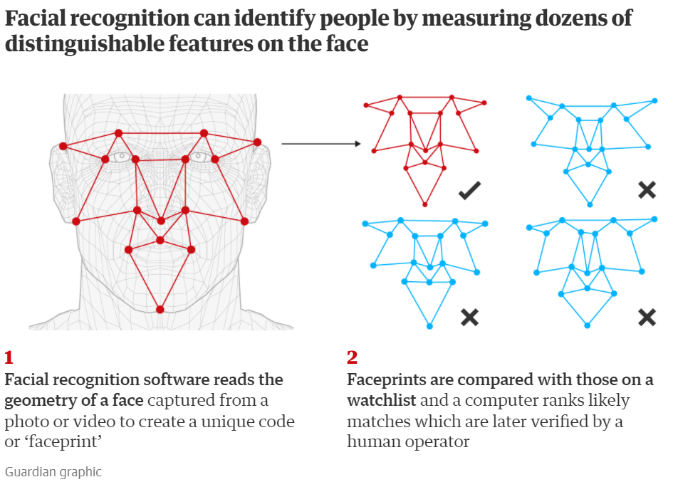
Figure 32: An example of how facial recognition may scan a face and compare the geometry against those in a database in order to identify the person [107].

Other approaches
Other software-based approaches can also be used. QR (Quick Response) codes offer a way to encode data such as URLs and WiFi credentials into a barcode [109]. They can be scanned by a supported device (often a smartphone) which can then access the encoded data [109]. QR codes have built in error correction through a Reed-Solomon code that is added to the encoded data. This can give a data correction rate of between 7% and 30% [110].

Figure 33: A QR code that links to https://www.uwtsd.ac.uk. Note the three bordered squares in the corners that are used for indicating the correct orientation of the code [111].
Another avenue for AL becomes available when video conferencing (VC) is used. VC solutions such as Zoom and Microsoft Teams offer functionality for exporting a list of meeting attendees to a file during meetings [23][24]. Both these providers also offer access to this information through APIs [24] or scripting [25].

Appendix C

REST and SOAP
This section gives a brief introduction to REST and SOAP web services, followed by some comparisons between them and why one may be chosen over the other.

REST
REST is an architectural style for designing an interface, with six constraints as defined by the creator, Roy Fielding [31]. These constraints require that an interface:
- Uses a client-server architecture – separates the user interface from the data storage concerns. This independence allows the user interface to be ported to different platforms and further developed independently [31].
- Is stateless – communication between the client and server should be stateless, meaning all information necessary for the request to be processed should be included in the request, and the session state is maintained solely by the client. This improves scalability as the server not storing the state simplifies implementation. It also makes recovery from failures easier as the client will send the full request again.
- Is cacheable – data in the response can be cacheable, allowing the client to cache it for future use. This can reduce latency for future requests as the data can be retrieved from the local cache rather than the server [31].
- Has uniform interfaces between components – the software principle of generality should be applied to the interfaces between the components to ensure uniformity. This reduces the system complexity and decouples implementations from the services they provide, thereby encouraging independent evolution [31].
- Is layered – the system should be made up of hierarchical layers which control the component behaviour and only allows them to interact with their immediate neighbour layers [31].
- Allows code on-demand – this optional constraint allows the client functionality to be extended though additional code such as applets and scripts in order increase system extensibility.
The Hyper Text Transfer Protocol (HTTP) is often used to implement RESTful web services [32] as it has many of the same characteristics, such as its stateless nature [33] and allowing caching [33]. Operations are usually carried out using specific HTTP methods, some of which are outlined in Table 14. Messages are often encoded using JavaScript Object Notation (JSON).
Operation | HTTP method
Create | POST
Read | GET
Update | PATCH/PUT
Delete | DELETE
Table 14: The HTTP methods that are typically used for the various data maintenance operations.

SOAP
SOAP is a messaging protocol that was originally developed by Microsoft and IBM, becoming an official World Wide Web Consortium (W3C) recommendation in May 2000. SOAP messages are encoding using Extensible Markup Language (XML), and are strongly-typed in nature [34]. SOAP web services often provide a Web Services Definition Language (WSDL) file (also in XML) that outlines the functionality provided by the web service and what its endpoints are [35]. SOAP’s three characteristics are:
- Extensibility – SOAP can be extended through extensions to provide extra functionality or capabilities. The extensions may enhance areas such as reliability, security and routing [36].
- Protocol independence – SOAP messages can be transferred over various transfer protocols, including HTTP, SMTP (Simple Mail Transfer Protocol) and FTP (File Transfer Protocol) [36].
- Platform and language independence – SOAP was designed to be independent of implementation design and programming model [36].
SOAP offers the flexibility of allowing stateless or stateful messaging depending on the service requirements [37]. It can also be extended with Web Services Security (WS-Security), allowing the messages sent via SOAP to be encrypted, ensuring security even if the transport layer is not encrypted [38].

Comparison between REST and SOAP
REST services are often considered to be more performant than SOAP services [39]. This is partly due to the verbose nature of XML compared to JSON, which is typically used for REST services. All REST services are also cacheable (as defined by the constraints), whereas further extensions need to be added to SOAP to allow this [40]. However, SOAP’s extensibility means it can be made more secure and reliable than REST services and, for more complex workflows (payment gateways, for example) the ability to maintain state may be desirable or necessary [37]. This is not a feature that would be required for an AL solution. REST services are considered simpler to implement [37], and the principle of decoupling the client from the server allows easier, independent development of both [31], a feature that would be useful in future if a decision was made to expand or enhance the future AL system. By contrast, SOAP’s strongly-typed nature results in a closer relationship between the client and server, making changes to either more challenging. However, both REST and SOAP services can make use of versioning to allow the service to be evolved without clients being adversely impacted.
The author’s preference would be to develop a REST web service rather than a SOAP one. The simpler development would be beneficial as the author will be working independently to develop it. Performance is important to prevent users becoming frustrated with the system, so the ability to use a less verbose language for the payload is beneficial as there would be less data to transfer. JSON is also language independent and easily converted to a JavaScript object [41], allowing simpler development for the client systems that would interact with the web service. As noted earlier, it would not be necessary for stateful data transfer as the logging itself will be mostly one-way communication, making that feature of SOAP redundant.

Appendix D

Analysis of the survey responses

Quantitative analysis
Q1 - What type of role do you have in the university?
There were 25 respondents to the survey. This was made up of 20 teaching staff and 5 administrative staff. The following analysis is split by job role to see the influence it may have on opinions towards attendance logging.
Q2 - In what capacity do you interact with the existing Attendance Monitoring System?
This question asked respondents to choose multiple options from a short list, as well as an option for adding an option that was not listed. As expected, generally the teaching staff interact with the AMS through collecting the attendance data and entering it into the registers. This was not the case for the administrative staff, whose typical interaction appears to be checking the quality of data or other non-collection tasks.
Q3 - Which stage of the current attendance logging process has the largest impact on you?
This question asked respondents to choose multiple options from a short list, as well as an option for adding an option that was not listed. By far the most frequent choice for the area with the largest impact was entering attendance into the registers. This may be influenced by the higher number of teaching staff respondents who, as shown in the previous question, nearly almost always enter attendance data into the registers.
Q4 - Roughly what percentage of your students are international?
This question asked respondents to enter a percentage of roughly how many international students they dealt with. There was a broad range of answers from 1 to 100%, with most responses at or below 15%, with an overall average of 12.0%. The average for teaching staff was 9.2% and the average for administrative staff was substantially higher at 23.2%. This may be down to administrative staff having interactions with a broader range of students than teaching staff, or them having to monitor international students more closely.

Q5 - Please score these issues with the current attendance logging system in terms of their impact on the use of the system.
This question asked respondents to provide a Likert style response indicating how often various issues with the current system affected usage of it. The responses from administrative staff indicate they encounter issues with data quality (e.g., delays in register updates) more frequently than teaching staff. In general, the teaching staff seem to report fewer issues with the system, with the average modes and medians of the responses for teaching staff indicating issues occur less frequently for them. In most cases, the range of responses for each issue is broader for the teaching staff, but this may be a consequence of the greater number of teaching staff respondents.
Q7 - Who do you think should be responsible for logging attendance?
This question asked respondents to choose a single option from a short list of fixed options. Many of the respondents indicated they believe the lecturer should have at least some responsibility for logging attendance. This is even the case for the teaching staff, where it might be expected that the lecturers would prefer to move the burden to the students. Of note is that none of the administrative staff indicated the responsibility should be shared between lecturer and student.
Q8 - How do you think students logging their own attendance would impact on their attendance (e.g., due to increased awareness)?
This question asked respondents to choose a single option from a short list of fixed options. Just over half the respondents indicated they thought students logging their own attendance would have some form of positive impact on their attendance. There were some respondents who suggested there would be a negative impact on attendance. These respondents were all teaching staff.
Q9 - Which attendance logging methods do you think could be used at UWTSD?
This question asked respondents to choose multiple options from a list, as well as an option for adding an option that was not listed. When asked about which AL approaches would be most suitable, the options chosen most often were importing from a video conferencing solution and card scanning, with both chosen the same number of times. However, the data shows that a higher percentage of the teaching staff chose the card scanning than the video conferencing import, with the reverse being true for administrative staff. A potential reason for this may be assumptions from staff based on existing processes. Teaching staff may prefer the idea of card scanning as it may be less onerous compared to the current process for importing Teams data into the current AMS. For the administrative team, they may prefer the import method as the existing process means they have the original export from Teams to use for data checks on the registers.
QR codes and fingerprint scanning were the next most common choices, again tied. A much higher percentage of administrative staff chose QR codes than teaching staff.
Q10 - Please rank these attendance logging methods in order of what you think is the best overall option
This question asked the respondents to rank the fixed options from the previous question in order of which they thought would be best. The data showed that card scanning and fingerprint scanning were most often the first choice, with facial recognition being the most common final choice. QR codes and video conferencing imports were the most common second choice.
When the counts were multiplied against the inverse of the rank to give an overall rank, card scanning is again the highest, with the QR codes and fingerprint scanning being second and third highest respectively. A similar pattern is shown when the overall rank is calculated for just teaching staff. This likely due to 80% of the respondents being staff. However, the results are quite different for the administrative staff, with the video conferencing imports being ranked highest for them. This shows a similar trend to the other questions where the administrative staff seem to place more value in this approach than the teaching staff.
Q11 - As there is a legal requirement for additional verification for international students, please rank these additional verification methods in order of what you believe would be the most appropriate approach.
This question asked the respondents to rank a short list of fixed options in order of which they thought would be most appropriate for additional verification for international students. Fingerprint scanning was the most common first choice, with e-signature and manual verification being the most common second choices.
When the counts were multiplied against the inverse of the rank to give an overall rank, it showed fingerprint scanning to have the highest overall rank. However, it is not a great deal higher than the other options. When the overall rank is calculated for the different job roles, there is a stark difference in the results. The e-signature option clearly had the lowest overall rank for administrative staff but had the highest overall rank for teaching staff. The overall rank was highest for fingerprint scanning and manual verification from an administrative perspective. It may be possible that these options were less popular with teaching staff as there is potential for them to require greater intervention from the teaching staff than the e-signature approach.
Q12 - How do you think the registers should be made viewable after attendance has been collected?
This question asked respondents to choose multiple options from a short list, as well as an option for adding an option that was not listed. Although reporting via a reporting dashboard was the most chosen option, it is not the clear favourite. The other reporting methods all had a similar, slightly lower number of choices. It may be the case that, if staff were shown example reports from each approach, their preferences may become stronger in one direction or the other.
Q13 - How do you think the registers should be made editable?
This question asked respondents to choose multiple options from a short list, as well as an option for adding an option that was not listed. The data showed a clear preference from teaching and administrative staff for editing to be done via the system that logs the attendance, with 76% of respondents choosing this option. A possible theory for this is that it would require interaction with fewer different systems.

Qualitative analysis
Q6 - Please enter any further comments you'd like to make regarding the current system.
Many of the written responses focussed on the amount of time taken to record attendance and what value it has, largely because it reduces the time available for supporting students and does not have any perceivable benefits to the lecturer. The feedback also highlighted a lack of clarity about who is responsible for monitoring attendance, suggesting a review of the attendance policy may be prudent.
Q14 - Please enter any further comments you'd like to make regarding alternative attendance logging solutions.
There were fewer responses to this question than the earlier open-ended question. However, the feedback received highlighted that the eventual system should be simple and quick. Some respondents re-iterated their earlier viewpoint that the burden should be on the administrative staff rather than the lecturer.

Appendix F

User story map
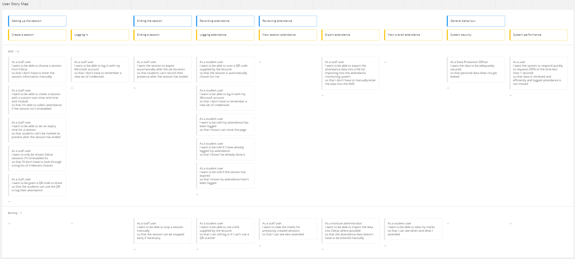

Appendix G

Agreed requirements


