INTERCONTINENTAL HOTEL

Student Name: Adina Roxana Irimia
Student ID: 2125046
BMIH5004
Management and Organisational Behaviour
Lan Zhang

Introduction
The content of this report will discuss how IHG Hotels & Resorts has evolved over the years to be one of the largest players in the global hospitality industry, making changes in its corporate culture, fostering a better guest experience, and approaching its portfolio of brands in a fresh way as well as impacting the world from a social perspective (Fernandes, 2021). Over the past several years, there have been major changes at IHG from an organizational standpoint such as revenue and strategic initiatives which have made a significant difference in what guests and customers see and potential investors understand. IHG’s diversification needs the emphasis on three key strategic pillars that are the Change 100 program, the Ethnic Minority Talent Program which involves well-being and mental health and 2030 Journey to Tomorrow stands for IHG’s devotion to sustainability. Since the world was amid a global pandemic, which has hurt the hotel and travel sectors globally, IHG’s 2023 financial results of substantial growth in average day rate, occupancy, and total revenue, are a clear highlight of how the company has remained resilient regardless of the market downturn. This report will dissect the aforementioned achievements and what they mean for IHG moving forward in terms of staying competitive in the marketplace, implementing long-term growth, and continuing to make a difference from a social standpoint.

Organisation structure, culture, and goals
The IHG way is defined by a clear set of strategic objectives and an effective organisational framework. The Board, which supervises the governance of IHG, is responsible for ensuring that the mission, long-term objectives, strategy, and culture all fit the purpose of the organisation. This then shows that the company exhibits the highest standards of integrity and provision of corporate governance underpinning the operational and strategic performance to report the shape and orchestrate its business through regular reviews, reports, meetings, and dialogue. IHG has an open culture and recognises the value and benefits of transparency, and therefore the Board makes the CEO and the Executive Committee (EC) responsible for building a business culture that can deliver the strategy and vision.
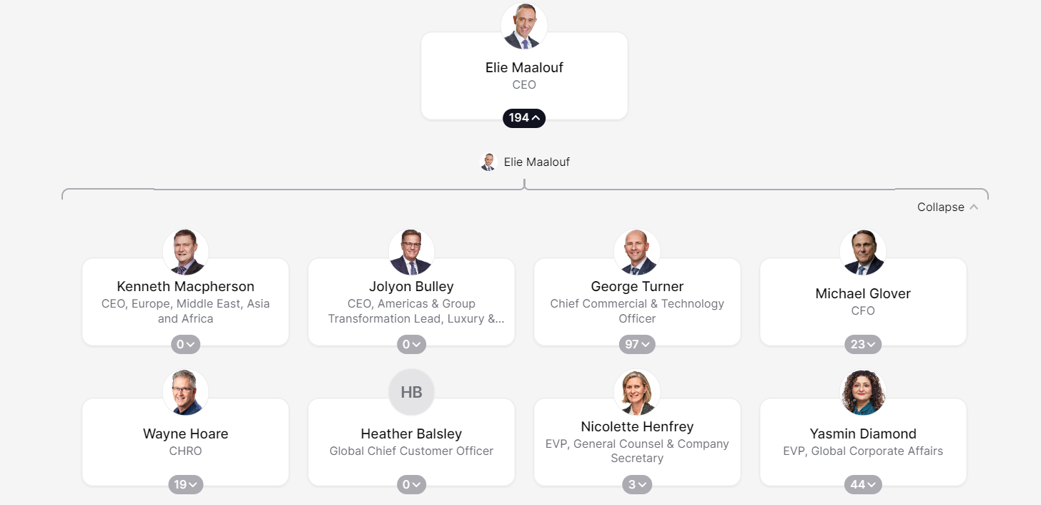
Organizational structure of IHG
(Source: theorg.com, 2024)
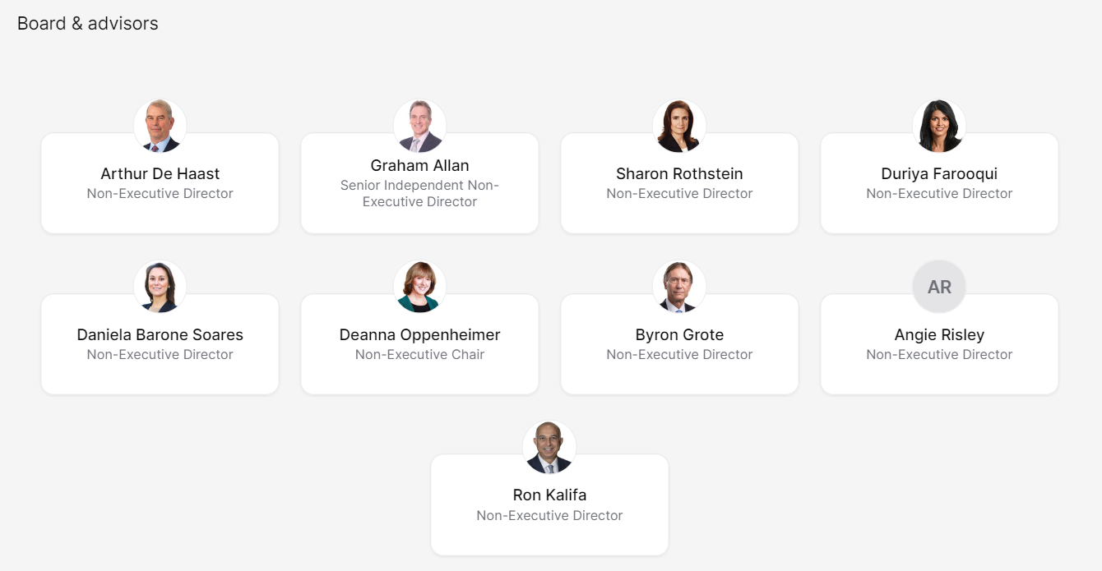
Board and advisors of IHG
(Source: theorg.com, 2024)
Examples of this include the worldwide all-employees calls, where colleagues are encouraged to give feedback and talk about communications etc. The entire global operations – Corporate Affairs, Finance, Human Resources, and Marketing, in addition to the Regional Operations in the Americas, EMEAA, and Greater China - report to the Group, and are grouped into Leadership Teams to deliver on IHG’s five strategic priorities, and continue to uphold the IHG way of doing business, he added (Bastias, 2022). Decision-making processes are closely monitored through a series of deal approvals by a select group of committees, additionally spending committees on a range of topics, which includes hotel projects and capital expenditures.
Creating an inclusive and inspiring home for everyone is a priority imperative at IHG. The Company extended its inclusive mindfulness training to include our hotel colleagues in 2023, over 16,000 people completed it. Employee Resource Groups (ERGs) are important to driving change and supporting a diverse workforce and allies. We have a range of ERGs that cover race, ethnicity, gender, LGBTQ+ topics, disabilities and Neurodiversity, generational diversity, veterans, and remote working, just to name a few. IHG’s inclusive policies fit in with the wider IHG Future Leader Programme, with a full-time Head of Diversity & Inclusion IHG to coordinate events around international D&I holidays such as Pride Month and International Women’s Day, to bring managers and employees together in harmony and understanding. As a result of their work, IHG has been recognized as gender equal by Forbes; second on the Financial Times Europe Diversity Leaders 2024 List; certified as a Great Place to Work for Parents in the US; and as one of the 100 Best Places to Work for Women (IHG, 2024).
IHG has prioritized training to ensure that all of its members are knowledgeable and resilient regarding cyber threats, understanding that cyber security is rapidly becoming as important as physical security in the digital age (Florido, 2024). Throughout its endeavors, InterContinental Hotels Group is committed to providing excellent guest experiences and offers a radical ambiance (Tieng, 2022). Leading the global hospitality sector, InterContinental Hotels Group underscores the significance of bringing inefficient governance structures because it has practical results, employing effective communication channels and putting genuine concern in the front line of the welfare of its workers. Every InterContinental Hotel project serves as a symbol of the company’s lasting commitment to its mission and great conduct as a business (Our Culture, 2024).
Recent change initiatives, their impact, and how well these were managed
IHG UK has significantly driven key transformation projects over the past few years, which illustrates the business priorities towards enhancing diversity, sustainability, and a positive social impact (Legrand et al. 2022). One of these programs is the three-month Change 100 program. Collaboration with Leonard Cheshire Disability began in 2017, with Change 100 interns being offered paid job experience for an internship of 3 months. The program has been developed to offer disabled students and graduates the chance to gain a world of work experience.
IHG UK has created a strategic partnership with WiHTL in the UK and introduced the Ethnic Minority Talent Program to address the lack of representation of ethnic minorities in senior leadership roles within hotels (Intelligence, 2021). The strategic partnership with WiHTL enables IHG UK to access the expertise and resources of a renowned institution that is a proactive advocate of diversity and inclusion. The Ethnic Minority Talent Program has been established to empower aspiring leaders from ethnic minority backgrounds with targeted mentorship, training, and networking opportunities to accelerate their careers and help build a more inclusive working culture at IHG as well as in the wider hospitality sector (Bhopal, 2020). Another example of IHG’s commitment to sustainability and good corporate citizenship is the 2030 Journey to Tomorrow strategy for IHG UK which was announced in 2021. The 2030 Journey to Tomorrow strategy is IHG’s roadmap for how it will bring about positive change over the next decade – on behalf of people, communities, and the planet, as a responsible corporate citizen. It addresses key areas such as reducing the impact on the environment, social responsibility, and economic impact. To make a significant difference IHG UK has set clear goals and benchmarks and put structure in place to monitor progress and hold themselves accountable (IHG, 2024).
IHG UK has got these recent change initiatives right by having clear objectives, well-integrated partnerships, and creative approaches. An example is the Change 100 program which has created a fantastic inclusion program for those with physical impairments gaining vital work experience with IHG UK making us an inclusive employer of choice. IHG UK has hired top talent from a wide cross section of sectors through some focused recruitment campaigns and coupled with tailored support infrastructure IHG UK has supplemented its capability with new opinions and niche skill sets. (IHG, 2023). IHG UK works with WiHTL to generate significant change both inside the company and outside of it by utilizing the resources and combined experience of leading industry players (Intelligence, 2021).
A holistic approach has been employed in managing IHG UK's 2030 Journey to Tomorrow strategy incorporating corporate responsibility and sustainability. IHG UK explicitly illustrates its commitment to long-term value creation and stakeholder engagement in its business strategy by integrating environmental, social, and economic considerations (Avelar, 2020). Continuous monitoring, review, and stakeholder feedback ensure IHG UK’s sustainability activities are aligned with changing stakeholder expectations and international best practices allowing the company to be agile and responsive to new challenges and opportunities. IHG UK has demonstrated expertise in embracing change, by launching change initiatives such as the 2030 Journey to Tomorrow and other sustainability strategies, the Ethnic Minority Talent Programme for its UK hotels, and the Change 100 programme – all of which show a commitment to prime change and to create a better, more enlightened future. Easy-to-read reports are one thing, but well-managed, shared ideas are quite another and have made a significant impact on IHG UK as well as the wider hospitality sector (IHG, 2023a).

The organisation’s strategic direction and current business performance
The center of IHG’s UK business model is to exploit its scale and expertise to supply great guest experiences and owner returns in the most attractive areas and segments in the market (Bastias, 2022). The strategy places intense emphasis on being the hotel company of choice for both guests and owners by creating a culture to attract and retain the very best people it also seeks to, make a positive social contribution, and to develop a strong foundation for future growth. In 2023, IHG UK following on from 2018, refined its 2023 ambition, strategic pillars, and growth behaviors, evolving but not fundamentally altering key aspects of its strategy going forward. IHG UK has confirmed itself further as a business and remained committed to True Hospitality for Good through the enlargement of its brand portfolio from 11 to 19 brands (Kilson, 2022). Building on the changes made to the business two years ago – IHG simplified their goal focusing on being the first-choice hotel company for owners and guests alone but upholding the goal – True Hospitality for Good (Fuchs, 2022). To build on current strengths, the strategic pillars were tuned and a teamwork mentality was introduced to create a more catalyzing view of success and to go quicker. This commitment to improving guest experience and maintaining its market competitiveness is buttressed by investments in the IHG One Rewards loyalty program, redesigned master brand, new alliances, and enhanced digital capabilities. IHG UK’s “Journey to Tomorrow” initiative reflects IHG UK’s efforts to develop its workforce, encourage good community impact, and provide sustainable hotel solutions (IHG, 2021).
To ensure value for all stakeholders, this vision is expected to help. It allows the expansion of IHG’s brand in the best markets bringing sustainable growth in cash flows and profits. Maintaining our industry-leading financial performance gives IHG UK the ability to invest more in the company, and generate more shareholder return, which has a stewardship of our resources and ensures the company plays a positive can be tracked via the delivery of our Corporate Responsibility goals (IHG, 2023b). IHG Hotels & Resorts had a really strong year in 2023 by many important measures. On an average daily rate (ADR) basis (the amount people are charged per night to stay in a hotel), the company’s hotels saw a 13% increase over 2019 levels (2019 being a year unaffected by COVID-19) and a 5% increase over the prior year (2022). Occupancy (how full the hotels are) in 2023 came in 6 percentage points higher than the previous year (2022), and just one index point shy of the occupancy in 2019 when adjusted for distinct segments across the hotel’s network. As a result, total revenue in 2023 reached $4.6 billion, a 19% gain over the prior year’s (2022) $3.9 billion (IHG, 2023b).
Elie Maalouf – CEO of the IHG Hotels & Resorts company – opined the firm had an “excellent set of results”, which was due to strong travel demand in all regions. Examining the results, whilst the total hotel nights had fallen by 2%, the business travel income had increased by 3% versus 2019, based on a 5% rate rise (Xie, 2020). It was reported that even if group booking revenue was still 5% below 2019, this sector of the business began to recover in Q4 2023. In 2023, there will be 275 new hotels and 556 committed hotels. IHG will continue to be bolstered by rising corporate travel expenditures and the advent of flexible and hybrid work environments, and short-term growth will be further fueled by a continuation of the rebound in group and business travel. Performance in the major regions was great. In the UK, revenue per available room (RevPAR) from 2021 to 2022 increased by 14%, and from 2019 to 2022 it increased by an impressive 17%. In continental Europe, RevPAR increased by 19% from 2019 to 2022 and further increased by 8% from 2022 to 2023. This reflects on the strength and dominant position the IHG has in the industry and how the hotel positioned itself well during the dynamic changes (Rob Gill, 2024).
Conclusion
In conclusion, IHG Hotels & Resorts has shown great resilience and agility in dealing with the challenges presented by the COVID-19 outbreak. While focusing strategically on delivering great guest experiences, becoming more inclusive, and growing sustainably, IHG UK has achieved significant success in 2023. Indeed, its strong financial performance reflects its strong market position and new room for opportunities, notably pushing the Average Daily Rate (ADR) and occupancy levels up. Similarly, IHG’s efforts to drive positive change and a more inclusive and sustainable future are visible through its different strategic initiatives, such as the 2030 Journey to Tomorrow plans, the Ethnic Minority Talent Programmed, and the Change 100 programme. Going forward, IHG is still strongly positioned to take advantage of the likely rebound in travel demand, growing its presence worldwide while delivering long-term value to its stakeholders.
References
Avelar, P.A.S., 2020. Hotel industry growth trends–the case of intercontinental hotels group (Doctoral dissertation).
Bastias, R.D.F., 2022. Equity research-InterContinental Hotels Group (Doctoral dissertation, Instituto Superior de Economia e Gestão).
Bastias, R.D.F., 2022. Equity research-InterContinental Hotels Group (Doctoral dissertation, Instituto Superior de Economia e Gestão).
Bhopal, K., 2020. For whose benefit? Black and Minority Ethnic training programmes in higher education institutions in England, UK. British educational research journal, 46(3), pp.500-515.
Fernandes, F.S.M.S., 2021. Intercontinental hotels group-time to check-in? analysis of one of the biggest hotel players in times of a global pandemic (Doctoral dissertation).
Florido-Benítez, L., 2024. The Cybersecurity Applied by Online Travel Agencies and Hotels to Protect Users’ Private Data in Smart Cities. Smart Cities, 7(1), pp.475-495.
Fuchs, M., 2022. Crisis communication and corporate social responsibility: a case study on IHG Hotels & Resorts and what organizations can learn from Covid-19 (Doctoral dissertation).
IHG (2021) Responsible Business Report. Available at: https://development.ihg.com/sites/ihgplc/files/IHG/A%20sustainable%20business/I-H-G-R-B-R-Interactive-280222.pdf (Accessed: 01 March 2024).
IHG (2023) next chapter for diversity, equity & inclusion. Available at: https://careers.ihg.com/media/31qc5mrc/de-i-narrative-final.pdf (Accessed: 01 March 2024).
IHG (2023a) Diversity equity and inclusion, Hotel Jobs & Hospitality Careers. Available at: https://careers.ihg.com/en/life-at-ihg/diversity-equity-and-inclusion/#:~:text=IHG%20Change100%20Programme,100%20Programme%20in%20the%20UK (Accessed: 02 March 2024).
IHG (2023b) Our strategy - intercontinental hotels group PLC. Available at: https://www.ihgplc.com/about-us/our-strategy (Accessed: 01 March 2024).
IHG (2024 b) IHG boosted by improving business travel volumes | Business Travel ... Available at: https://www.businesstravelnewseurope.com/Accommodation/IHG-boosted-by-improving-business-travel-volumes (Accessed: 01 March 2024).
IHG (2024 b) Responsible business - intercontinental hotels group PLC. Available at: https://www.ihgplc.com/en/responsible-business (Accessed: 01 March 2024).
Intelligence, M.B.S., 2021. Inclusion at the core of recovery: the WiHTL 2021 Annual Report. Revised from: https://drive. google. com/file/d/1iYn1FBJiqwVvtSBa3mHBuXDadqiS6dkQ/view.(Accessed on the 10th March 2022).
Kilson, G.A., 2022. The Use of Digital Media for the Employer Brand Management in Hotels (Doctoral dissertation).
Legrand, W., Chen, J.S. and Laeis, G.C., 2022. Sustainability in the hospitality industry: Principles of sustainable operations. Taylor & Francis.
theorg.com (2024) IHG - org chart, teams, Culture & Jobs, THE ORG. Available at: https://theorg.com/org/ihg (Accessed: 02 March 2024).
Our culture (2024) Annual-report-2022.pdf, Annual Report and Form 20-F 2022. Available at: https://www.ihgplc.com/~/media/Files/I/Ihg-Plc/homepage/annual-report-2022.pdf (Accessed: 01 March 2024).
Rob Gill (2024) IHG boosted by improving business travel volumes | Business Travel ... Available at: https://www.businesstravelnewseurope.com/Accommodation/IHG-boosted-by-improving-business-travel-volumes (Accessed: 01 March 2024).
Stoimenov, V., 2023. GOOD PRACTICES IN HOTEL BRANDING–SUSTAINABILITY TRENDS OF INTERCONTINENTAL HOTEL GROUP. Предприемачество, 11(1), pp.108-131.
Tieng, S., 2022. Service Excellence in Tourism and Hospitality. society publishing.
Xie, J. and Tveterås, S., 2020. Economic decline and the birth of a tourist nation. Scandinavian Journal of Hospitality and Tourism, 20(1), pp.49-67.

