Modern & Traditional Construction.

Managing the design and construction process

Name of Student: Mark Robinson

Student ID: 0952289

Name of Award: HND Construction managment

Mode: Part Time

Table of Contents
Introduction 2
Case Study - Primary Structure
Structure 2
Foundations 3
Internal Walls 4
Floors 4
Roof 5
External Walls
Heat Retention 6
Moisture control 6
Fire resitance 6
Aesthetics 6
Cladding system 7
Conclusion 8
Appendix 1 9
Reference List 15

Introduction
This report will discuss structural elements, details, design & cladding system for a structure to be built in the SA1 area of Swansea.

Case Study - Primary Structure

Structure
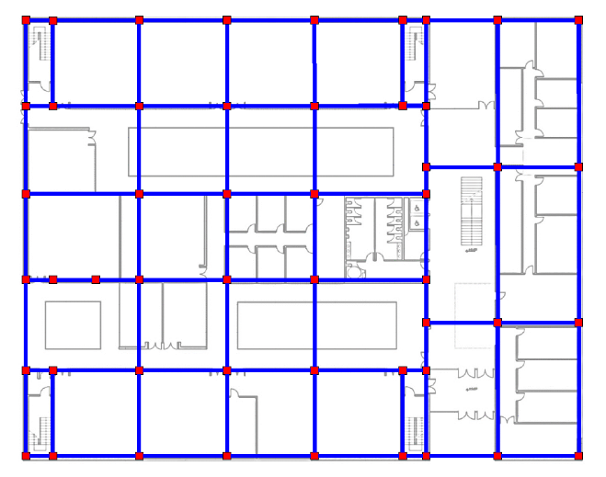
The large spans, open spaces and narrow columns shown in figure 1 mean this structure is most suited to a steel frame. The building is comprised of two blocks separated by an atrium area, the left block as shown on the diagram being the larger block and right being smaller and narrower. The framing columns where possible are to be hidden within walls allowing much of the structural frame to be disguised within the architecture of the building. A key advantage of steel framing is that it gives us long spans relative to weight (Chudley, 2008, p. 389) and with a relatively high sheer strength. Taking advantage of the adtributes of steel we can ensure that the partition walls within the steel frame are not load bearing and can be erected, demolished and moved in order to rearrange the internal space and floorplans without requiring modification to the structural frame. This is a key feature in modern construction, if architects and engeneers can provide the client with an bulding that can adapt then it can extend the life of the building. Allowing the change of function without having to change the structure means the building is somewhat futureproofed. This can be included in the design stage and takes an element of risk away from the client, if the building needs to be sold then it can be adapted for different functions or if the client wishes to change its function then the cost will be largely reduced.
Figure 1 (NTS)
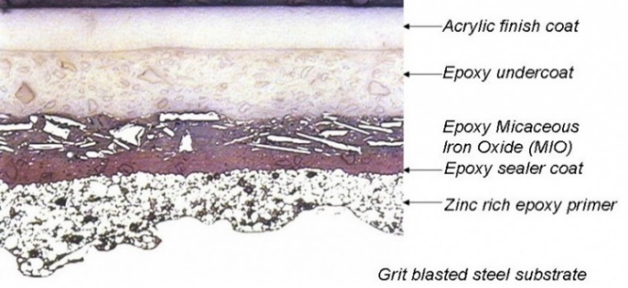
Steel frames have a long life, are quick to erect and provide the adaptability of space (The Steel Construction Instute, 2015, p. 9). Steel has fantasic longevity if its proteceted adaquatly, the steel is completely immune to the effects of insects and mammals that would cause issues in similar timber structures. It also can be treated to enhance its rust resitance (White, 2017). There are a number of ways to protect the steel structure from the effects of moisture that range in cost, longevity and effectiveness. You can protect the steel by creating a painted barrier between the steel and the enviroment, this barrier is built up in layers as shown by figure 2. The steel is first prepared and treated in order to give the paint a key for better adhession, the paint is them applied and built up in layers. The primer is applied first which is often a red oxide based product, then a number of intermediate coats that build up the colour and a final finishing hard coat (SteelConstruction.info, n.d.). Its important that the enviroment when the paint is being applied is controlled, both the temperature and the humidity will have an effect on the paint. To get best performance from the coating, paints are usually applied within a controlled enviroment such as a spray shop and not retroactivly on site once the structure is erected. Care must be taken whille errecting the steel frame not to damage this.
Figure 2
Anon. (2012) Paint system cross section. Available at: https://www.steelconstruction.info/File:Paint_syst_cross.jpg (Accessed: 16 January 2022).
An alternative to a paint coating is to have the steel galvinised. In this process the steel is dipped in molten zinc at high temperatures, the zinc bonds to the steel and gives a tough durable coating (SteelConstruction.info, n.d.). This process is expensive and difficult to do for the large steel members required fo this project.
Protection against fire must be taken into account at design stage and risks must be mitigated where possible. Steel I beams fail at 550°C when exposed on all sides and at 620°C when exposed on three sides (Tata Steel, 2013, p. 17). Because of this the steel must be protected by a fireproof barrier, this can take the form of a piant, board, blanket or board depending on the position withint he building.

Foundations
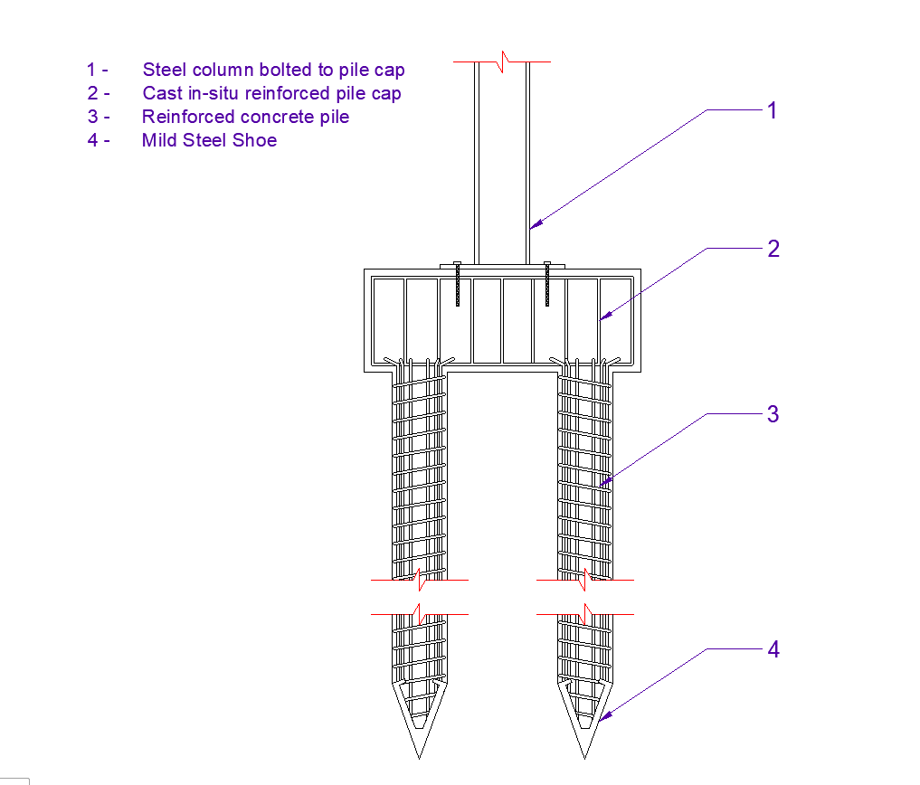
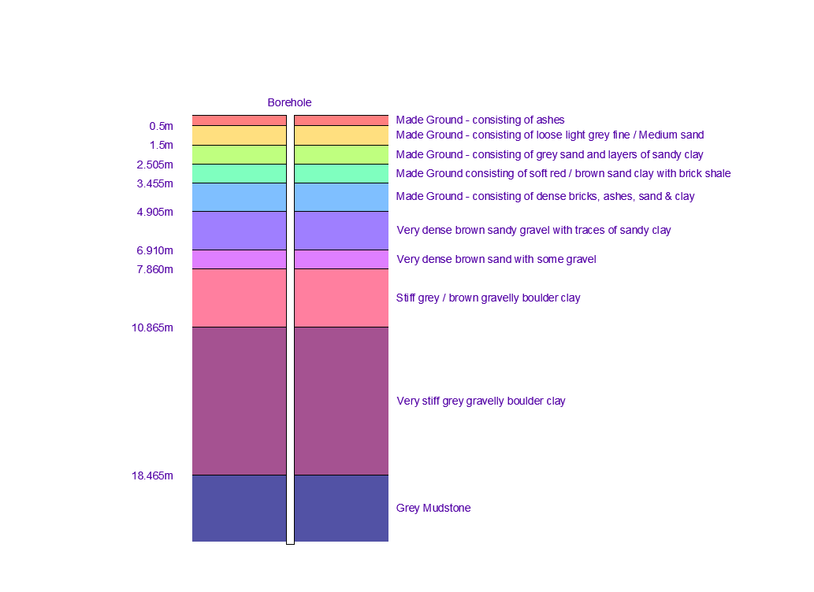
Using the borehole report provided, a recommendation for foundations can be made. A graphical representation of this report is shown in Figure 3. As shown in this depiction you can see the first 4.905m is made ground, this would be unsuitable for most forms of traditional foundation. Pile or raft foundations would be the only foundations for this type of made ground but because of the size and weight of the superstructure pile foundations would be most suitable. The size of the three-story structure and the considerable weight that it has would need to be distributed deep within the earth past the layer of made ground. The pile foundations would need to extend down at least 9m into the stable ground that starts at 7.86m, this stiff boulder clay would take the loading from the structure.
Figure 4 (NTS)
Detail is indicative only. Structural engineers drawings to be consulted for exact design.
Drawing adapted from:
Civilax. (2017) Detail Of Pile Foundation. Available at: https://www.civilax.com/detail-pile-foundation/ (Accessed: 04 February 2022).

Figure 3 (NTS)
The pile foundations would consist of reinforced concrete lengths capped with a steel shoe. These piles would be driven down into the earth past the made ground and into a stable layer beneath. Once these piles are in place a reinforced concrete pile cap would be cast in-situ over the top that wold provide the final surface for the steel frame to be fixed to. Figure 4 shows the detail of the pile foundations with the steel reinforcement and the steel frame bolted to the top of the pile cap.

Internal Walls
Internal partition walls do not need to be structural so they can be designed completely around acoustic requirements, fire control and durability. Figure 5 provides 4 options for different areas within the structure that allow differences in design for higher traffic and noise requirements. The details are designed around a steel partition for a lightweight frame and quilt insulation as a thermal and acoustic barrier.
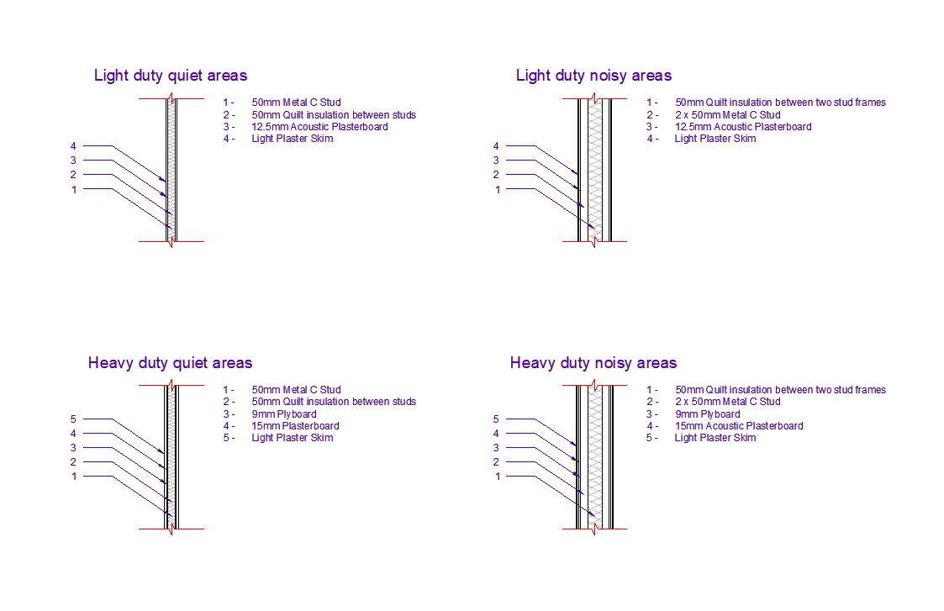
By adapting the internal partitions to the exact requirements of the area, cost can be minimised while providing the best performance possible.
Figure 5 (NTS)
Drawing adapted from:
Yandzio, E., Lawson, R. M. & Way, A. G. J., 2015. Light Steel Framing In Residential Construction. Berkshire: SC

Floors
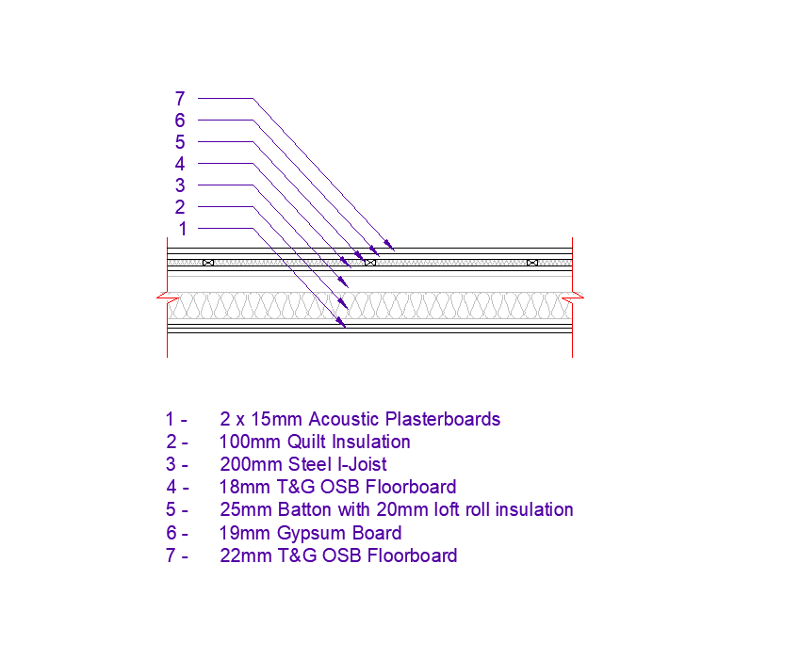
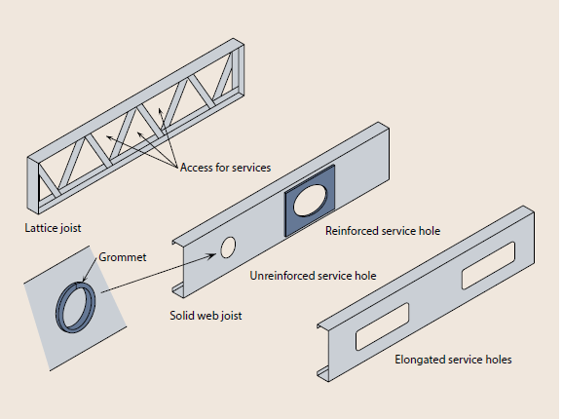
The depth of the steel beams of the frame allows us to easily form an insulation layer and void for electrical and mechanical fittings along the beams. The detail in figure 6 has been designed to reduce noise transfer from one floor to the next, maintain a solid floor without the embodied C0₂ of concrete and the weight of concrete floor slabs. It also keeps the thickness of the floor to a minimum in order to maximise ceiling heights and as a result the height of the overall structure. It does not however provide a suspended ceiling where electrical and mechanical works can travel perpendicular to the steel beams, this would mean that openings in the steel frame would need to be provided on manufacture in reinforced, unreinforced openings or by the use of lattice steel joists, see figure 7 (Yandzio, et al., 2015, p. 107). Intergrating mechanical and electrical plans into the structural design means getting involvement early in the design process and using intergrated software to plan all designs on the same model. This can be most easily done in Revit.
Figure 6 (NTS)
Drawing adapted from:
Yandzio, E., Lawson, R. M. & Way, A. G. J., 2015. Light Steel Framing In Residential Construction. Berkshire: SC
Figure 7
SteelConstruct.info. (2015) Details for service openings. Available at: https://www.steelconstruction.info/images/2/23/SCI_P402.pdf (Accessed: 01 February 2022).

Roof
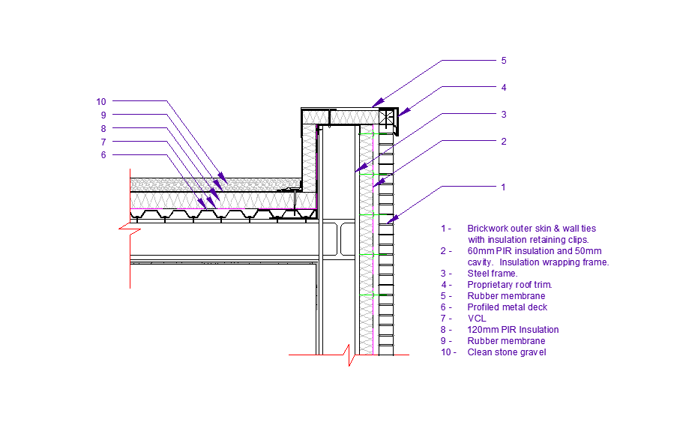
The large floor plan of the structure makes pitched roofing unsuitable. The best solution is to use a warm deck flat roofing system, this will keep the silhouette of the structure low within the landscape and minimise risk of potential leaks from multiple valleys and the details of this form of roof.
Figure 8 (NTS)
Drawing adapted from:
Yandzio, E., Lawson, R. M. & Way, A. G. J., 2015. Light Steel Framing In Residential Construction. Berkshire: SC

The advantage of a warm deck over cold deck is that there is less risk of condensation building up within the system and so is more robust (Yandzio, et al., 2015, p. 103). Using a rubber membrane as a main waterproofing layer is the most cost effective solution, the sheets can be large in order to minimise amount of welds and can easily be repaired if damaged. In order to protect the rubber from UV damage, heat, hail or other inclement weather its best covered in a gravel ballast (IKO, 2021). A large flat roof surface will also allow for easy retrofit of solar PV technology if required and provide easy and safe access for maintenance.

External Walls
The external walls of the structure need to provide the finished building with a number of comforts.
Heat Retention
The walls need to contain a continuous insulation with minimal cold bridging that will retain heat within the structure. This is to make the most of the heat produced to lower bills and to work towards the zero carbon targets. The wall type shown in figure 11 gives an overall thermal performance of 0.13 W/m².K (Appendix 1) and is discussed further on in the report.

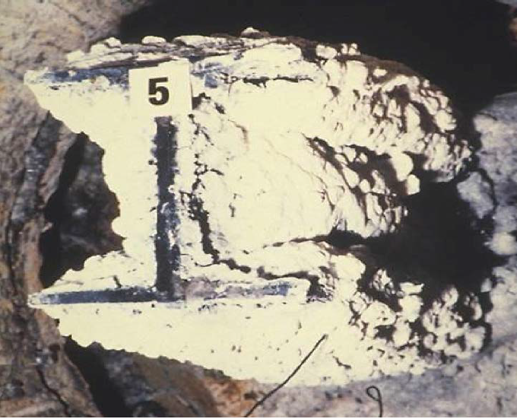
MOISTURE CONTROL
Figure 9
Tata Steel. (2013) Steel Construction Fire Protection. Available at: https://www.steelconstruction.info/images/8/87/Steel_construction_-_Fire_Protection.pdf (Accessed: 01 February 2022).
The external walls must provide an effective barrier against moisture ingress. The most common wall type that acts as a moisture barrier is created by producing a cavity wall with a ‘wet’ outer skin and a ‘dry’ inner skin that are separated by an air gap.
Fire protection
The most common form of fire protection on steel is to use an intumescent coating, this is the form of protection used by 75% of the industry in 2012 (Tata Steel, 2013, p. 21). These coatings react to high temperatures and swell by up to a ratio of 1:50 (see figure 9) that provide an area of low conductivity and protect the steel inside. The most advance products on the market provide up to 120 minutes of fire protection (Tata Steel, 2013, p. 22).
Aesthetics
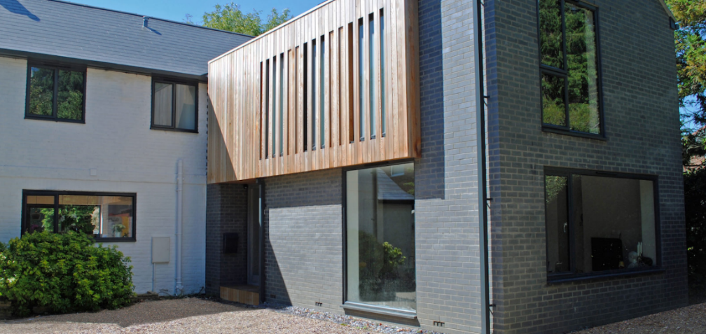
The type of external skin of the building needs to be considered in order to obtain planning and to meet the client brief. Material choices should be guided by zero carbon initiative that has had its public sector target brought forward to 2030 (Welsh Government, 2021). For this project we have a blue brick outer skin at low level and for balconies and a timber cladding at first floor and above. The design is inspired by Talbot house, Hampshire by LA Hally Architect (Figure 10). This blends the use of traditional brick with a modern twist in colour and the natural quality of timber cladding.
Figure 10
LA Hally Architect. (2018) Talbot House. Available at: https://lahally.com/home/projects/house-388/ (Accessed: 03 February 2022).

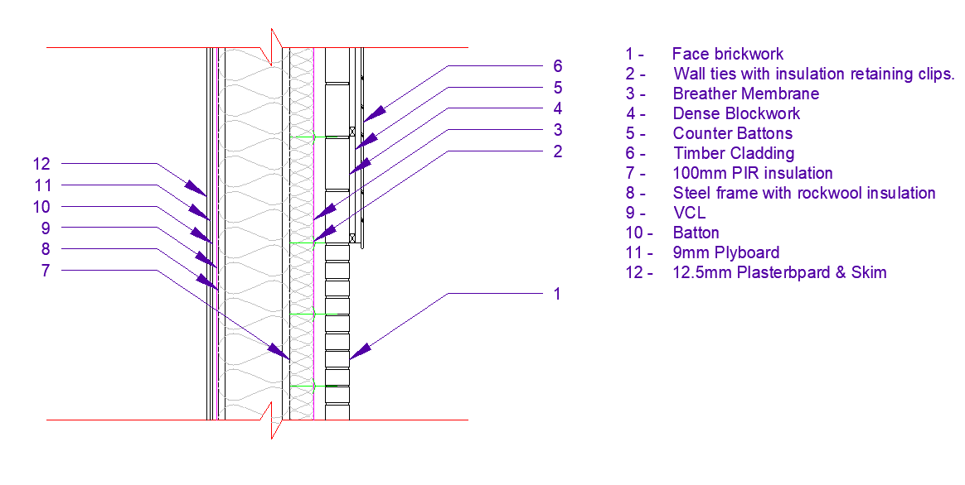
Cladding System
Figure 11 (NTS)
Drawing adapted from:
Yandzio, E., Lawson, R. M. & Way, A. G. J., 2015. Light Steel Framing In Residential Construction. Berkshire: SC

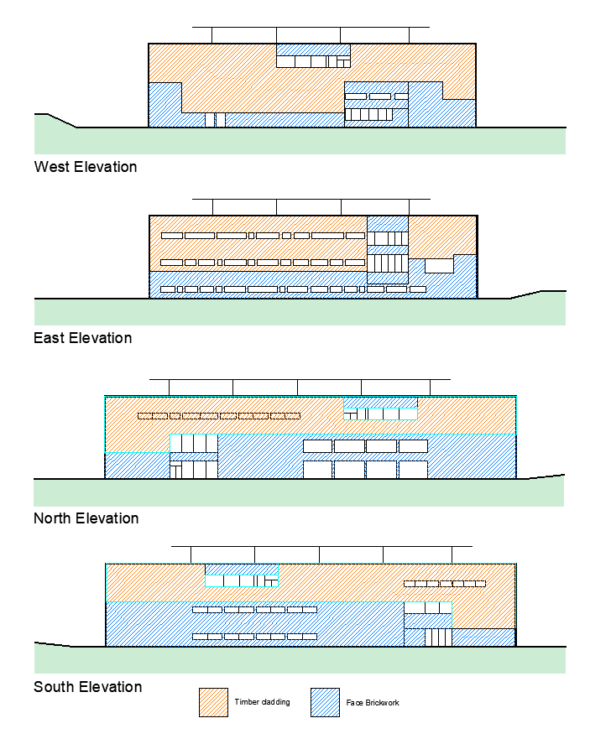
The brick used at low level will provide a hardwearing and durable surface that can take the day to day rigors while having good water resistance and which aesthetic is easily maintained reducing maintenance costs. Colours of brick can vary greatly and can be used to match the surrounding architecture and landscape, for example blue bricks could be used to blend in with surrounding slate or red for Swansea’s copper industry. These are both common historical materials used in Swansea. Ibstock blue bricks (Ibstock Bricks, 2022) are to be used on this project, they are UK manufactured coloured bricks that give a modern twist on a traditional material and have a low water absorption rate of 7% of the weight which will aid in the severe weather conditions. Face brickwork in a zone 4 very severe exposure to diving rain will mean we have to have a 75mm residual cavity in a partial fill construction according to Part C of the building regulations (Welsh Goverment, 2010, p. 49). Tooled flush joints will also be required according to the regulations, mortar shall be coloured to dark black.
Figure 12 (NTS)
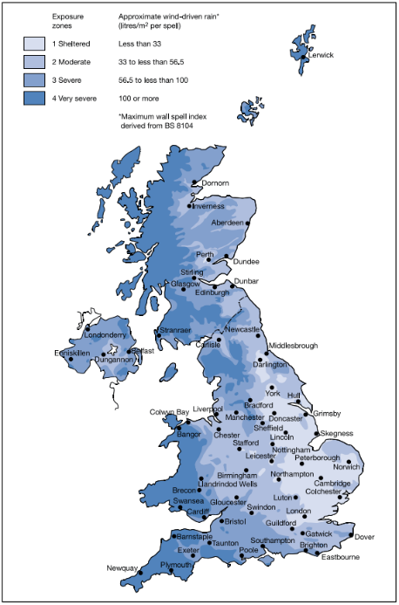
Where Figure 11 / Figure 12 show timber cladding we can use a dense concrete block or greenbloc (CCP, 2021) behind counter battens and timber cladding. The greenbloc product will allow us to save on carbon dioxide used In the manufacturing process. Counter battens mechanically fixed to the blockwork will allow good airflow behind the timber cladding to increase the lifespan of the timber and prevent prolonged water saturation. This are should be capped on the top and bottom with a vented bead with fly mesh to stop fauna from entering. The timber cladding will prevent water for directly coming into contact with the concrete blocks behind giving an additional layer of moisture protection. The choice in type of timber cladding could be left to the client, in this project a number of options would be presented for the client to choose from. In order to choose appropriate materials for our external cladding we must first consider the location of the building along with the weather conditions it will be exposed to. Swansea is classed a zone 4 very severe for wind driven rain (Figure 14), and swansea has a anverage of 83.25mm of rain each month (Figure 13). This high level of rain will mean exterior cladding sytems will be saturated with water for extended periods of time, the cladding system we choose must be able to last in these conditions with minimal maintenance. The second major factor o effect the cladding is that the proposed site in the SA1 area close to the coast, the potential effect of salt crystalisation on the building must be taken into account when specifying materials.
Figure 14
Building Regulations (2010) Site preparation and resistance to contaminates and moisture: Approved Document C. Updated 2017. Available at: URL from https://gov.wales/building-regulations-guidance-part-c-resistance-contaminants-and-moisture (Accessed: 25 October 2020).
Figure 13
weather-averages.co.uk. 2020. Weather Averages. [ONLINE] Available at: https://weather-averages.co.uk/city/uk/swansea#avg_rain_mm. [Accessed 25 October 2020].
Option A for a cladding would be Brimstone Timber Cladding (Vastern Timber, 2019), This is a thermally treated timber grown in British forests with the option of Ash, Sycamore and Poplar. If using a BREEAM framework or if advised by the client to use sustainable materials this would be the most suitable, it will however be the most expensive option. The area of the building that would be most at risk from salt and driven rain would be the south elevation facing the coast, because of this a larger section of brickwork is proposed (See figure 10). Brimstone cladding has an expected lifespan of 30 years in a frequently wet environment and does not require annual treatment, this means we can lower the maintenance costs over the lifespan of the building.
Option B is a Scandinavian grown redwood (Norclad, 2021). This is a light timber cladding that has a 30 year warranty once treated. The product has a larger transport cost that the British grown timber and does not have the durable quality as thermally treated timber but is a more cost effective solution.
The U value for the external wall as a whole without any openings is calculated as 0.13 W/m².K (Appendix 1). Part L2A for new buildings other than dwellings states that the thermal performance of the wall must have a value better than 0.35 W/m².K (Welsh Government, 2016). The performance of this wall type far outperforms minimum standards set by the welsh government building regulations for both buildings other than dwellings and new dwellings.

Conclusion
This project based in Swansea SA1 is to be of a steel frame on concrete pile foundations, a warm flat rubber rood and to be clad with a mixture of brickwork and timber cladding.

Appendix 1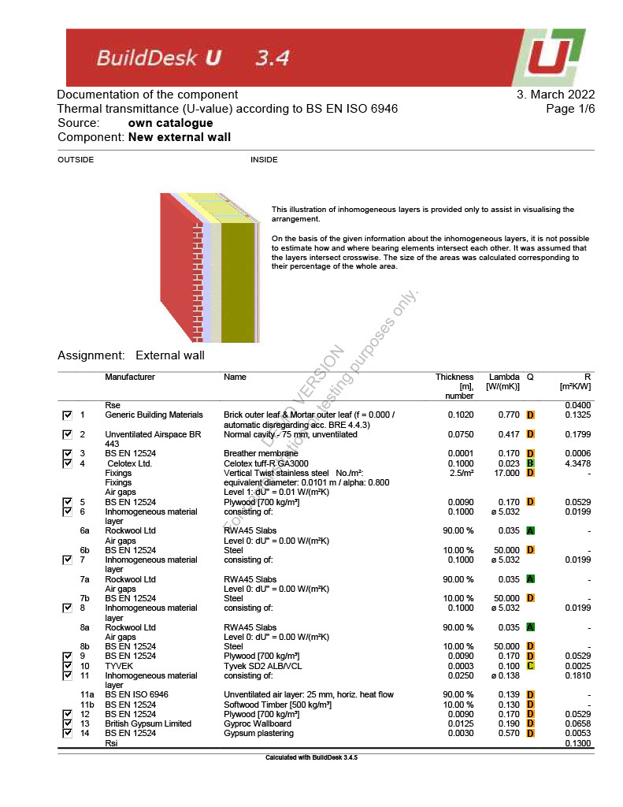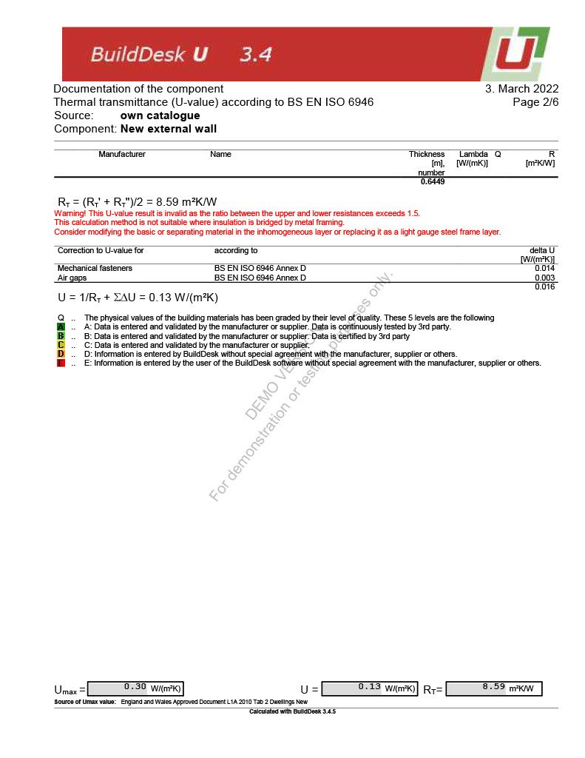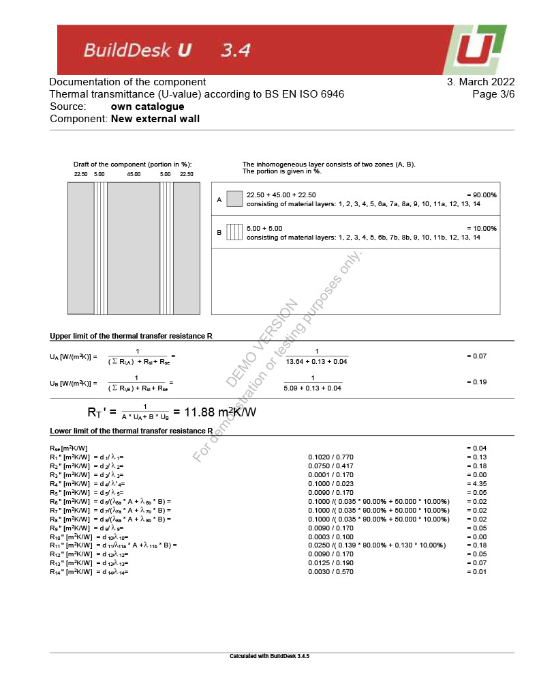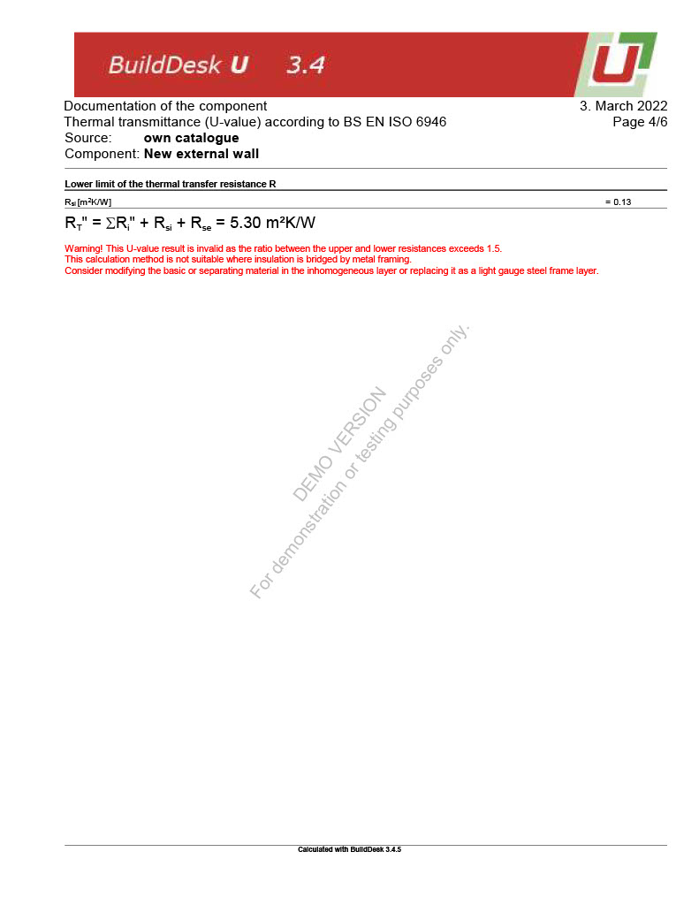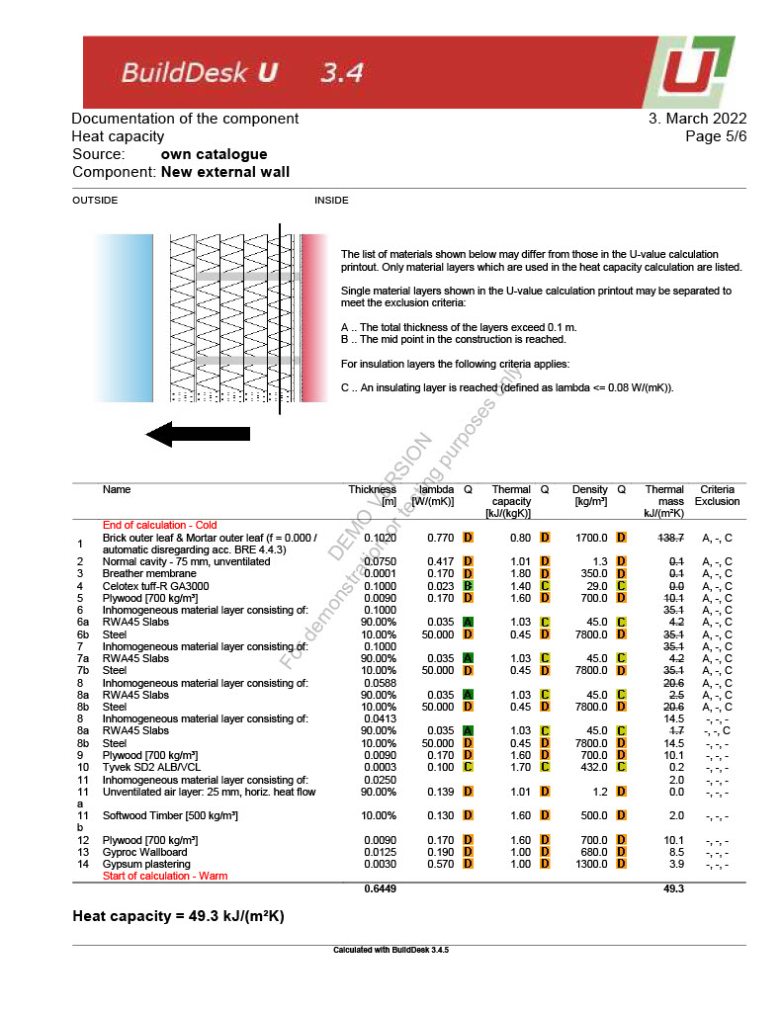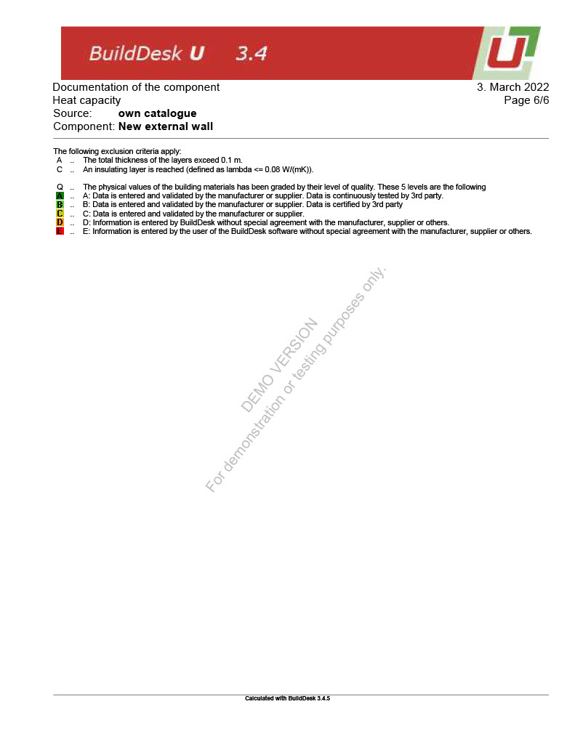

Reference List
CCP, 2021. Greenbloc. [Online]
Available at: https://ccp.ltd/blocks/greenbloc/
[Accessed 01 03 2022].
Chudley, R. a. G. R., 2008. In: Building Construction Handbook. s.l.:Elsevier Ltd., p. 389.
Ibstock Bricks, 2022. Staffordshire Slate Blue Smooth. [Online]
Available at: https://www.ibstockbrick.co.uk/apicon/techdata/techdata.php?brick_code=A2232A
[Accessed 02 03 2022].
IKO, 2021. Why Do They Put Gravel on Flat Roofs?. [Online]
Available at: https://www.iko.com/comm/why-put-gravel-on-flat-roofs/
[Accessed 01 03 2022].
Norclad, 2021. EUROPEAN REDWOOD TIMBER CLADDING. [Online]
Available at: https://www.timbercladdingsolutions.co.uk/european-redwood-timber-cladding-the-ultimate-guide-to-european-redwood-timber-cladding/
[Accessed 2022 03 02].
SteelConstruction.info, n.d.. Corrosion protection. [Online]
Available at: https://www.steelconstruction.info/Corrosion_protection
[Accessed 28 02 2022].
Tata Steel, 2013. Steel Construction Fire Protection. In: s.l.:s.n.
The Steel Construction Instute, 2015. The Steel Construction Instute. In: s.l.:s.n.
Vastern Timber, 2019. Brimstone - Transforming British Woods. [Online]
Available at: https://www.brimstonewood.co.uk/
[Accessed 02 03 2022].
Welsh Goverment, 2010. Building Regulations - Approved Docuement C. [Online]
Available at: https://gov.wales/sites/default/files/publications/2019-05/building-regulations-guidance-part-c-resistance-to-contaminants-and-moisture.pdf
[Accessed 02 03 2022].
Welsh Government, 2016. Building Regulations - Approved Docuement L2A. [Online]
Available at: https://gov.wales/sites/default/files/publications/2019-05/building-regulations-guidance-part-l-conservation-of-fuel-and-power-2014-l2a-new-buildings-other-than-dwellings.pdf
[Accessed 02 03 2022].
Welsh Government, 2021. Wales commits to net zero by 2050, but sets out ambitions to get there sooner. [Online]
Available at: https://gov.wales/wales-commits-net-zero-2050-sets-out-ambitions-get-there-sooner
[Accessed 24 02 2022].
White, G., 2017. The Advantages & Disadvantages Of Steel Frame Construction. [Online]
Available at: https://blog.glwengineering.co.uk/the-advantages-disadvantages-of-steel-frame-construction
[Accessed 22 02 2022].
Yandzio, E., Lawson, R. M. & Way, A. G. J., 2015. Light Steel Framing In Residential Construction. Berkshire: SCI.

