Choice 3 images of ONE group at risk of exclusion and critically reflect upon these representations and how they might be interpreted by society

In the context of what a family is or should look like this essay will show a differentiation on what a family is and can look like in today’s society. The pictures are chosen from 3 different types of looking families to show the differences and similarities between the 3 families. The first image (image 1) is a nuclear family, in which society has shaped to be the main family in today’s society. Being a man, woman and their two children. Of course, in the 1950’s the stimulation on a nuclear family was quite different to what society sees a nuclear family these days. Which is something that will be explored in the image. (Lehr, 1999) Three points in which will be covered in the images are, how these types of families are represented in society, how society consumes the certain type of family in the images and also their impact on society. The images will also explore the state of finance that shows in the images. Image 2 is a single parent family with 1 or more children and image 3 is of a childless family.

Image 1 - Family 4 Bicycle Portrait Mother Father Boy Girl Bikes Suburban Street House Retro.
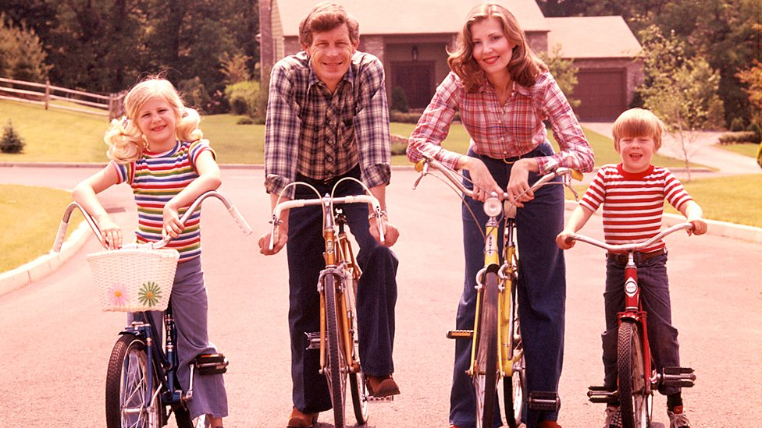

(Roberts, 1970)

This image is firstly interesting because its shot in the 1970’s. Looking at the image you can see that the family of four are happy. From first glance looking at the image you notice the family are in a quiet neighbourhood riding their bicycles and seemed to have stopped to take a picture smiling from ear to ear. From looking at the family it seems like they have an income as they are well dressed, have the ability to have bikes which would seemingly be an extra expense if not necessary. Although the family may seem as though they have money to spend on things like bikes, its unsure if they put on the front of having these things to fit in their neighbourhood and society. The one thing that effects most families and their happiness is money. All families have the worry of being financially stable to fund their lifestyles. Over the years poverty in families with children has increased. It currently stands that 26% of the UK’s population of families with children are suffering from poverty. This shows that the crisis of poverty is still at a high for families. (JRF, 2018)

This is what society calls a nuclear family. It’s a family containing man, woman and their two children. The 1970’s were the years of happiness for families as rationing was on its course of ending, new affordable housing was being built and the wages for individuals had increased. In those years unemployment was at its all-time low. But whilst looking at these photos society asks if this type of ‘happy’ nuclear family is something nurtured by uncompromising images from the post war age. (BBC, 2018) Although when looking at this certain type of family in society in the 21st century compared to this picture in the 1970’s it wouldn’t stand to be the same type of unit. The 1950’s style portrayals of the perfect nuclear family unit are still being sold to society today in magazines, movies and the media. Parsons (1955) theory on the nuclear family shows that society needs the nuclear family for it to function correctly. He states that there must be a sexual division of labour between men and women and their different roles played in a nuclear family and society. In pre-industrial agricultural times, the typical family consisted of extended family this having 3 generations living under the same roof. The extended family performs many functions, educating the young, caring for the elderly and providing its own food to the land and cattle. This was what a family in the 1950’s would look like to society, until society started to industrialise. With the changes in industrialisation it meant families needed to change in order to adapt to society. The family had to adapt to its surroundings, this meaning that the extended family turned into the nuclear family as it lost some of its functions.

Parsons (1955) states that although the extended family is now the nuclear family and had lost some of its primarily functions. The nuclear family still has its useful source to society as its two main functions are primary socialisation of children and the stabilisation of adult personalities. Over the years, Parsons theory has an outdated look on what a family is or should be. Image 1 represents Parsons theory as it shows the happy nuclear family as it would have been seen in the 1950’s. The process of globalization is changing family on a daily basis which is altering the perception on what a family should look like compared to what it actually looks like in today’s society. Social change occurs on three levels in society, its norms, values and its laws and institutions. (Leeder, 2014) Over the years laws have changed into something that gives families a new way of being expressed in society. Laws such as the Children and Families Act 2014 has changed the views on the stereotypical families as it gives a new leaf in protecting families regardless of their age, gender, race or religion. Image 1 is a representation on what society would see as a family in the 1950’s. in the 21st century acts like this has changed the stigma on what a family looks like. The act aims to protect and help families in their time of need. In reality, no family looks as happy as the family do in image 1. Every family has its issues and although society loves a happy story or happy family reality forces through this and shows that family comes in all different ways and legislation has helped improve the stigma on nuclear families as society is changing and the outlook people have on families is changing as in society not all families look like they do in image 1. (Gov, 2012) A Marxist point of view on the nuclear family is that its primarily function is to act as an unit of consumption and teaches acceptance of hierarchy. Engels stated that the nuclear family only emerged with capitalism. He believed that society is structured along class lines with institutions working in the interests of the small elite class who have economic power and the larger working class. (Hunt, 2010)

Image 2 – Successful single parent families



(Polk, 2015)

This image is of a single parent family. The image shows a mother with her three children. In this image you can see that the mother is happy and the three children seem also seem pleased. By looking at the photo you are able to tell that they all are dressed well and seem to have some of the same facial features. The stigma on single parent families in society is usually portrayed as the mother and their children. Often than not in the media we don’t tend to see images of a single father and their children. Could this be down to the role that mothers play in society. The caregiver and natural carer for the child and family unit. As explained in image 1, Parsons (1955) presentation on the nuclear family shows that the mother is the stay at home carer and the father is the breadwinner. This would be an explanation behind how as a society they see a mother being the single parent and the dad not being heard of as such. The ONS (2018) shows statistics that in 2014 there were 2 million lone parents with dependent children in the UK. In the 2 million, 91% of these lone parents were women. In 1971 when the nuclear family was a social norm there were only 8% of single parent families. Over the years and social change happening there has been an increase in single parents.

Over the course of the years society sees family in a different way than what would be shown in the 1950s. What wouldn’t be heard of as much in the 1950s compared to the 21st century is the single parent family. Bumpass (1986) argues that the perspective of the demographic transition theory is related to contemporary family change. The changes in family are shown over the years as its more likely than not the man and woman have children before getting married. As over the years the social norms towards relationships have changed. Therefore, people tend to have children as a norm as its better to go through life with a child than without. Bumpass states that the norm of families having children before they find a security between themselves is the main reason of single parent families becoming more of a norm in society. The adaptations of society have influenced people to as such rush through life and make sure children are secured before marriage and even living together. In the 1970’s mother’s stigma on working was non-existent as it would in their eyes be harmful to a child’s development. Whereas in the 21st century working mothers is something that has to be done in order for a family or single parent family to survive. But then would this create a strain in a relationship if both parents are working? As in the 1950’s a nuclear family was one of the mother staying at home and the father being the breadwinner. Could this be the reason why there were less single parents in the 1950’s compared to the 21st century. (Yarber & Sharp, 2010)
There are many issues within a family for it to have the ability to function. It needs its primary source of finance to have the ability to fit into society and have the primary source of food and drink in order for it to function. With single parent families, it becomes harder to survive as without the other partner there is less of an income for the household. Although in the UK there is a set up fund in or help those parents in need. The family Allowances Act 1945 was set to help parents with funding their child by having a certain amount of government income coming into the bank per week or month. This was a piece of legislation which helped most parents spare a little money for feeding and clothing their families. (BBC, 2018) Another key issue with single parents is the funding of housing, the town and country planning act 1947 was set to have a target for 300,000 houses a year build and 1.25 million council houses being built between the years 1945 and 1951. Acts like this made it easier for parents to get the security needed in order to fund their families and keep them safe. The main priority of these pieces of legislation is to help society’s variety of families and give each family their own equality. (BBC, 2018)

Image 3 – Childless family



(ABC, 2017)

This is an image of a childless family. From looking at the photo you are able to see that the couple are happily displaying affection towards each other and looking happy. It shows them in a home sitting on their sofa. From looking at the image you can see that their relationship is strong as they are sitting cuddling each other. They also don’t seem to look like they have any financial issues as they have clean clothes and a home. Although to society this image could be interpreted completely different. This image is different to the other two images as it shows they have no children but still look happy. Society sees a childless family as abnormal as the traditional family has children. The outlook on poverty for childless families are a less. As there typically two individuals bringing in money for the family. This isn’t always the case of course. The decline in the number of women having children for their own reasons isn’t only because of the money situation. A family without a child is more likely to use their money on giving to charities. The state of poverty for families of two is still the same level than people with children. As without the jobs from the economy the state of poverty isn’t going to decrease until the stability is proven worldwide. Family with children or a family without there is still a chance of being below the poverty line.

The difference in images has become clearer now looking at this image as it shows that through these images with or without children the three different types of family still have a sense of happiness and security. Childless families are still a unit of family regardless of their outlook on having children. Some people choose to have children and some are happy without. Some aren’t able to conceive and then can’t financially afford to take different routes into having another option on having a child. In the recent years people have more options on conceiving children or adopting children if they’re unable to have them. In the 1950’s this is something that wouldn’t happen as technology wasn’t as advanced. The cost on these options are at an expense but some families choose to put themselves in the position of being in the poverty line just to have children and some people just choose that they are able to live without having children. Social change is a huge part in the changes in a family which has been stated in the above images. But to reflect on how its changed the childless family is that some people have the want to spend the rest of their lives without children and be financially stable as having children would leave them with less money. The difference in having children and not having children to some people are that they would be better off financially without. (Ruspini, 2015)

The ONS shows that 9% women born in 1946 were still childless at 45. Of those born in 1971, 18 percent were childless in 2016. This showing that the number of women without children is becoming more common. From the changes in society it’s clear that this issue could be down to the fact that people aren’t in committed relationships or marriages therefore don’t see children as an option until marriage is on the cards. The proportion of women and men without children is increasing therefore is it naturally a given that you don’t have children until you are happy and financially stable in a relationship? Although the statistics show the increase in childlessness the NHS released a statement that childlessness could increase likelihood of death. The statement was published by the NHS after a story from 21,000 Danish couples seeking IVF treatment was released. The study showed that who did not go on to having children were four times more likely to die early and that childless men were twice as likely to die early. (Bazian, 2012)

In society, a childless couple or person would be looked at to be self-centred and careless. The JRF foundation study on childlessness states different as although society may paint an image into why people are childlessness or not having children is a wrong idea the study shows that childfree people aren’t careless as they still have compassion with other things in their lives but may not have an interest in having children. Although the ideal family to society is to have children in order for society to grow its not in everyone’s interests to have children but from the JRF’s findings in the study it shows that it doesn’t make the person any less of a person without children. (JRF, 1999)

Society’s perception on single parent families are changing and have changed compared to the way society used to perceive it in the 1950’s. Although most family types are being accepted it doesn’t take off the fact that a lot of families are still suffering from poverty. (BBC, 2018) Intertwined in poverty are many other factors in which effect families in the UK more so in this decade than any other. Families are socially accepted in today’s society to be any type or looking family they want or are. Looking at the three different types of families in the 3 images it’s clear that the perception on what a family used to be compared to the variety of family there is now is clear to see that although there may be an obvious comparison of happiness in the pictures it’s not always perceived to be as happy as society would like a family to be. Over the years legislation and stigma on what a family is has changed, some argue for the better some argue for the worst. When looking at the nuclear family in image 1 it seems as though issues arising with money don’t seem to be the given vibes from the image. But in today’s society money is the issue in which effects most families good or bad. The change in legislation over the years has helped take a positive step into having a better economy and having a better lifestyle for everyone. As social change happens the world adapts to what is meant to be seen in the foreseeable future. This is when changes in the family happens, people adapt and by doing so not all families are going to look like the stereotypical family. From the 3 images its shown that all types of families are at risk of exclusion in due course due to society itself. It’s not whether a certain class would have interpreted where the family will be its due to the changes around which pushes people to make certain different decision based on the family. This leaving a family or the family to have to make willingly decisions to survive and be happy regardless of the outcome that they may have. (Leeder, 2014) When speaking of a family, society automatically assumes children are a part of the family. As shown in image 3, not all families have children. Overtime it has become more known that a family doesn’t have to contain a child in order for it to be classed as a family. A family in sense is something that is different to each and every person. As a family is defined as something that offers security and love. But this could be offered from all types of family regardless if there are children or not. (JRF, 1999)

Reference List

ABC. (2017) childless couple. (online) Available at:
https://www.mamamia.com.au/couples-without-children/

Bazian. (2012) Childless couples who wanted kids ‘die younger’ https://www.nhs.uk/news/pregnancy-and-child/childless-couples-who-wanted-kids-die-younger/

BBC. (2018) welfare state
http://www.bbc.co.uk/schools/gcsebitesize/history/mwh/britain/welfarestaterev_print.shtml
Economist. (2017) The rise of childlessness
https://www.economist.com/news/international/21725553-more-adults-are-not-having-children-much-less-worrying-it-appears-rise
Polk, H. (2015) successful single parent families. (online) Available at: https://www.crosswalk.com/family/parenting/single-parents/5-rules-for-successful-single-parent-families.html

Gov. (2012) children and families bill
https://www.gov.uk/government/news/children-and-families-bill-to-give-families-support-when-they-need-it-most

Hunt, T. (2010) The origin of the family, private property and the state. London, Penguin Books.

H. Armstrong Robers, (1970), Family 4 Bicycle Portrait Mother Father Boy Girl Bikes Suburban Street House Retro. (Online). Available at: https://www.gettyimages.co.uk/license/81773098 (Accessed 5 march 2018).

JRF. (1999) A study of childlessness in Britain. York, Joseph Rowntree Foundation.
https://www.jrf.org.uk/file/38692/download?token=0xdGjQqm&filetype=findings

JRF. (2018) poverty rate
https://www.jrf.org.uk/data/poverty-rate-person-type-over-time-after-housing-costs-ahc

Leeder, E. (2004) The family in a global perspective. California, Sage Publications.

Lehr, V. (1999) Queer Family Values. United States of America, Temple University.

ONS. (2018) Families and households 2014
https://www.ons.gov.uk/peoplepopulationandcommunity/birthsdeathsandmarriages/families/bulletins/familiesandhouseholds/2015-01-28

Ruspini, E. (2015) Diversity in family Life. Bristol, Policy Press.

Yarber & Sharp. (2010) focus on single parent families: past, present and future. California, Praeger.

