Marketing Plan report
Hilton Hotel
Student Name: Md Imran Hossain
Student ID: 2243506
BMIH4005
Lecturer Name: Dale Clarke

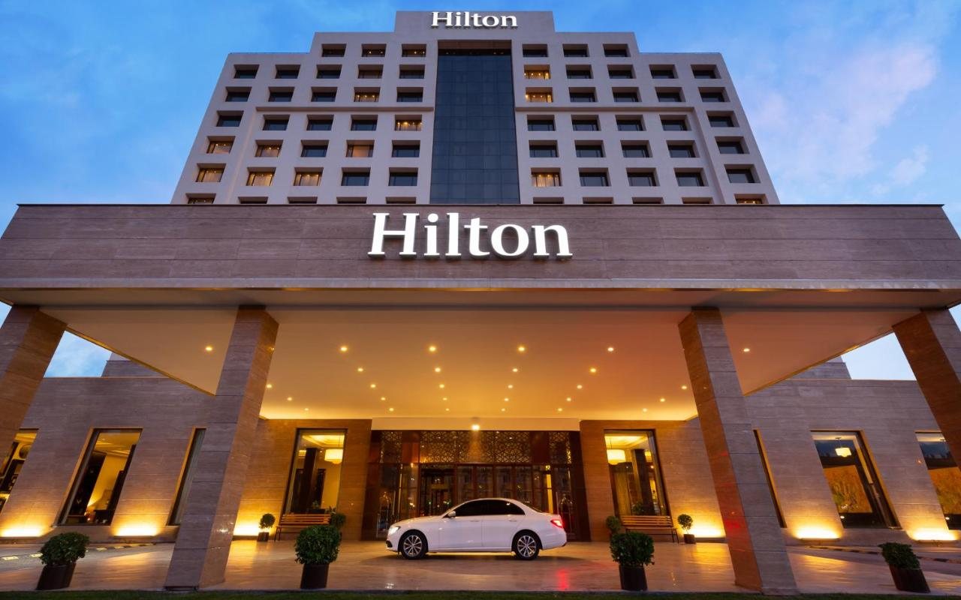

Table of Contents
Introduction 3
Situation Analysis (5C) 3
SWOT analysis (Microanalysis) 3
Customers: Segmentation and Targeting 3
Competitors 4
Collaborators 4
Climate: PESTLE (Macro analysis) 4
Objectives 5
Strategy 5
Tactics 5
Marketing mix: 5
Product 5
Place 6
Price 6
Promotion 6
Action 6
Control 7
Conclusion 7
References 8
Appendix: Presentation 9

Introduction
A marketing plan refers to the document which is the roadmap for setting goals, setting a target audience, and designing a marketing strategy for achieving the target (Roddy, 2018). This marketing plan is about designing the marketing strategy of communications strategy for the current market in the case of Hilton Hotel. This marketing plan report will focus on swot analysis, pestle analysis, competitors, marketing mix, tactics, action plan, and marketing strategy. The key purpose of the marketing plan is to promote the products to the market properly and achieve the target which will help to grow in the competitive market.

Situation Analysis (5C)

SWOT analysis (Microanalysis)
The swot analysis tool is used for analysing the microenvironment of Hilton Hotel:
- Strengths: It is running 584 hotels on 6 continents from its 18 brands globally (Hilton, 2023).
- Weaknesses: Hilton Hotel has negative reviews on social media due to data breach issues.
- Opportunities: Increasing market demand, expanding in developing countries and acquisition strategy (Kotler & Armstrong, 2023).
- Threats: Higher market competition and Russia-Ukraine conflicts reduce customers (Balli et al., 2022).

Customers: Segmentation and Targeting
- Segmentation: The key segmentation strategy for Hilton Hotels is geographic segmentation to build new hotels in specific locations to target new customers.
- Target Market: The target customer segment is based on middle and senior-aged people aged 26-60 years, with a high level of income range and social class (Hilton, 2023).
- Positioning: Hilton Hotels wants to provide quality service to customers through its luxury services.

Competitors
According to the perceptual positional map, the key competitors of Hilton Hotel are Marriott, Hyatt, Ritz Carlton etc. delivers different quality service at a high price (Craft.co, 2022). On the other side, Moxy delivers quality service at a low price. Premier Inn Hotel delivers quality service with neutral services. Hilton provides high-quality service with premium pricing (Hilton, 2023). After that, Hilton Hotel follows a high price and differentiation strategy.

Collaborators
Hilton Hotel has different B2B relationships with different airline companies, travel agencies, online booking agencies, and other tourism businesses. It has many franchises in different countries as it is running a business from 18 brands of its 584 hotels (Hilton, 2023). For example, Hilton and Country Garden started a new relationship where Hilton will see the six hotels of Country Garden for improving the service. After that, the Hilton hotel group signs with Saudi Tourism Authority an MoU for improving the service in this country (Hilton Stories, 2023).

Climate: PESTLE (Macro analysis)
Pestle tool will help to analyse the macro environment and how each factor impacts the business operation of Hilton Hotel:
- Political: Russia-Ukraine war, political instability among countries, government regulations, and tax policy impacts on the business of Hilton Hotels (Balli et al., 2022).
- Economic: The fluctuations of the exchange rate and economic downturn can influence the business of Hilton Hotel as it links to customer affordability (Aji Aditya et al., 2022).
- Social: Customer preferences demand quality service and Hilton can focus on the trends available in the market.
- Technological: Online booking system, online payment, Check-in and check-out system, and distribution method all impact the service of Hilton (Hilton, 2023).
- Legal: Health and safety act, employment contract, consumer protection act link to service of Hilton.
- Environmental: The brand reputation increases through following CSR and sustainability policy.

Objectives
Smart objectives are designed for the Hilton hotel below:
- Specific: Raise the rate of occupancy by 20% by the next 12 months by Hilton.
- Measurable: The occupancy rate will be measured monthly and yearly compared to last year's performance.
- Achievable: According to market demand, attaining 20% occupancy rate is achievable for Hilton hotels by the next 12 months.
- Relevant: Raising 20% occupancy rate of Hilton Hotel is relevant to the business operations which will help Hilton to increase sales profitability and brand value.
- Time-bound: The target time to gain the occupancy rate increment by the next 12 months for Hilton Hotel.

Strategy
The value proposition for Hilton Hotel is to deliver the maximum service with better care to the customers. It will help Hilton to ensure quality service for guests as they get a relaxed ambience (Lesser & Gagnon, 2021).
Digital marketing platforms will be the key tool for delivering a message about the value proposition. Hilton Hotel is committed to delivering quality service to the customers rather than focusing on services. it will focus on social media platforms for delivering messages about value propositions through the use of Facebook, TikTok, Instagram, Twitter etc. As those are the key platforms are using in the marketplace (Lesser & Gagnon, 2021).
The value proposition will help to care for the customers which supports the targeting and positioning of Hilton Hotel. The target customers are the people who want quality service and this strategy will work here for Hilton Hotel.

Tactics

Marketing mix:

Product
Hilton is one of the largest hotel groups globally which delivers quality service to the customers. It has deluxe rooms, bars, restaurants, business meeting rooms, event management service etc. The rooms of the Hilton hotel are decorated with modern technologies. It provides quality foods, and drinks for measuring the best hospitality service to the customers. It gives Wi-Fi facility, room options, a gymnasium, a warm welcome, 24-hour security, and check-in. Hilton provides restaurant facilities to customers for food (Hilton, 2023).

Place
Hilton Hotel is delivering its services in 84 countries in 6 continents, (Hilton, 2023) it is delivering service from 18 brands and 584 hotels in different countries. The hotel service is operated by the franchises of Hilton as a brand. The hotels are located near airports which helps guests to reach their destinations. Google Maps can be used by the guests to track the location of the hotel. Then, taxi drivers are available to go to the hotel to pick up the guests from the airports.

Price
Hilton Hotel focuses on high-quality amenities with a high or premium pricing strategy. As Hilton focuses on four or five start services to the guests, it also thinks about high prices. The price range in London for Hilton Hotels is £127-287 (Hilton, 2023). It considers the value proposition when delivering service. Hilton provides service discounts to attract new and existing customers.

Promotion
Hilton Hotel requires conducting market research for the promotional plan. It will help to understand the best way of promotions or communication. Social media platforms will be the best way of promoting the product or service of the hotel. It can focus on using Facebook, Twitter, TikTok, Instream. Then, it can follow video advertising, and content marketing for communication. The hotel should post the service on time which will attract customers. Email marketing, TV, direct selling, and promotional code can be effective for Hilton hotels (Hilton, 2023). Collecting reviews from guests will help to understand the growth and communication.

Action
Gantt chart refers to the document which represents the activities to be done based on time (Kubicki et al., 2015). A Gantt chart is given below focusing on the marketing activities of Holton Hotel.
Gantt chart firstly focuses on advertising where it will use TV advertising (January to August), social media platforms, direct mail, and Facebook from January to December. After that, it fescues on using public relations through business and media events. Then, it uses direct marketing using video, content, affiliate, and direct mail focusing on different time ranges. Sales promotion includes promotional code.
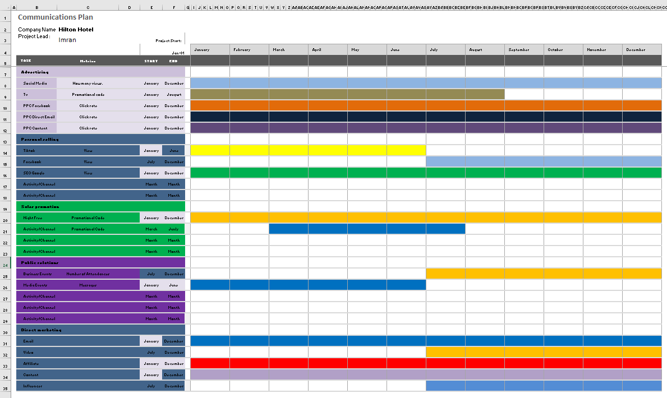

Control
The success will be measured by the marketing plan of Hilton Hotel by collecting feedback from people and performance. If the customers provide positive feedback on the service, it will show success (Kubicki et al., 2015). After that, increasing sales and profitability will show the success of Hilton Hotels. Positive attitudes towards service of the hotel by customers will show success and increase brand loyalty.

Conclusion
To implement the marketing plan, Hilton will face several challenges such as timeframe and budget. The timeframe is the main challenge for Hilton to achieve the target of the plan. Hilton Hotels must focus on time and take patience for achieving the target which is the recommendation for the challenge.

References
Aji Aditya, A., Olivia Angkasaputra, C. and Wahyuni, H. (2022) ‘Human capital downturn effect on firm performance in tourism and Hospitality Industry’, Jurnal Manajemen Universitas Bung Hatta, 17(2), pp. 207–218. doi: 10.37301/jmubh.v17i2.20812.
Balli, F., Billah, M. and Chowdhury, I. (2022) ‘Impact of the russia–ukraine war on hospitality equity markets’, Tourism Economics, p. 135481662211334. doi: 10.1177/13548166221133493.
Craft.co (2022) Top hilton competitors and alternatives | Craft.co. Available at: https://craft.co/hilton-worldwide/competitors (Accessed: 12 June 2023).
Hilton (2023) Hilton Hotels and resorts - find hotel rooms. Available at: https://www.hilton.com/en/brands/hilton-hotels/ (Accessed: 12 June 2023).
Hilton Stories (2023) Hilton and Saudi Tourism Authority Sign Mou for collaboration on ... Available at: https://stories.hilton.com/emea/releases/hilton-and-saudi-tourism-authority-sign-mou-for-collaboration-on-attracting-visitors-to-the-kingdom (Accessed: 12 June 2023).
Kotler, P. and Armstrong, G. (2023) Principles of Marketing. 15th edn. Boston, Boston: Pearson Prentice Hall.
Kubicki, M., Milano, C. and Probert, C. (2015) Marketing mix. Miejsce nieznane: 50minutes.com.
Lesser, T. and Gagnon, M. (2021) ‘Value proposition design using the value Proposition Canvas’, Developing Your Business Model. doi: 10.4135/9781071864920.
Roddy, M. (2018) ‘Promotional marketing’, Promotional Marketing, pp. 14–26. doi: 10.4324/9780203705810-2.

Appendix: Presentation


