The Impact of Virtual Learning Environment

Student: Khalilur Rahman
Student I.D: 2112662
Course Module number: BSMW4003
Name of Lecturer: Mr. Asim Satti
Name of University: University of Wales, Trinity Saint David

Introduction

The present pandemic situation has enhanced the adoption of virtual learning in several aspects, and it is currently one of the most common means of giving instruction and improving students' skills (Peat & Mary, 2019). The purpose of this research-based paper is to determine the influence of a virtual learning environment on learners. (Hewson and Chung, 2021). This will address the effective variables as well as some associated aspects that influence students and instructors' attitudes toward the creation of virtual learning environments. Due to the obvious pandemic condition, the data and information were acquired through web media to compile this report. In the final part of this report, a research shows a suitable scenario of virtual learning environment associated inside the University of Wales Trinity Saint David London Campus, as well as an adequate discussion with correct suggestions.
Rationale:
The main purpose of this report is to discover the impact of the accessible virtual learning environment (VLE) - Moodle learning experience on learners.
Research Objective:
- To check the effectiveness of using the Moodle platform in an online classroom.
- To understand about the disadvantages of utilizing Moodle in the virtual classroom environment of the University campus.
- To collect feedback from users of Moodle as a virtual learning platform.
Research questions:
- How does the Moodle platform improve the breadth of the virtual learning process?

Background Review of Literature:
Title of the research
To end this research work, the title "The influence of virtual learning environment (VLE) - Moodle on students' learning opportunity at the University of Wales Trinity Saint David London Campus" has been chosen

Reason for Online learning choices:
Due to the obvious expanding need for this sort of learning process, the scopes and opportunities that have been utilized via the usage of digital learning methods have been highly popular in recent times. Because of the global impact of the pandemic Covid-19 crisis, there has been an increase in demand (Reese, 2014). In the year 2021, a survey provided various types of information, including the reasons for selecting the online learning process by the students, and it was discovered that there are plenty of reasons, (Reasons why students chose online versus on-campus degree programs U.S. 2021 | Statista, 2021).

Most common reasons for choosing online versus on-campus learning options according to online students in the United States in 2021

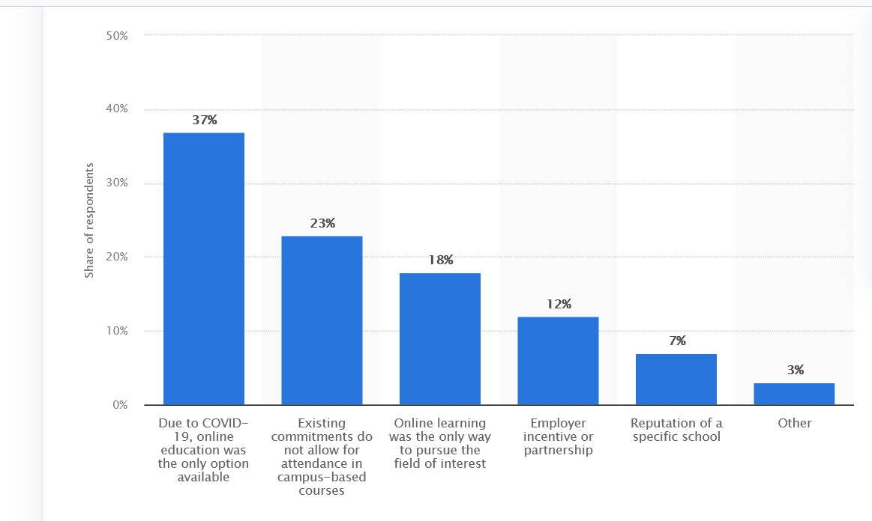
Figure: Reasons for online learning choices (Reasons why students chose online versus on-campus degree programs U.S. 2021 | Statista, 2021)

The majority of them, 37%, stated that online education was the only option due to covid 19 and 23 Percent stated that their current circumstance is not permit them to attend campus-based courses. 18 percent stated that online learning was the only course to pursue their subject of choice, and another 12 percent stated that employee incentives for collaboration were the reason they chose the virtual learning approach. 7 percent on the popularity of a certain school and 3 percent used other factors for selecting online learning. As a result, it has shown that students may have varied interests and may also have diverse motivations for choosing the online learning method for their future advancement. This also demonstrates that students will participate in online and virtual classrooms as they do not wish to attend campus-based learning.
The Community Hub used by Moodle
Moodle uses several sorts of community hub in two distinct types of learning processes, and it truly relies on the peculiarities of the course and the attitude of the professors to provide different types of facilities to the students. Figure has been utilized to discuss an acceptable illustration regarding a very typical sort of community plant that is employed in the learning process of the University of Wales Trinity Saint David London Campus.
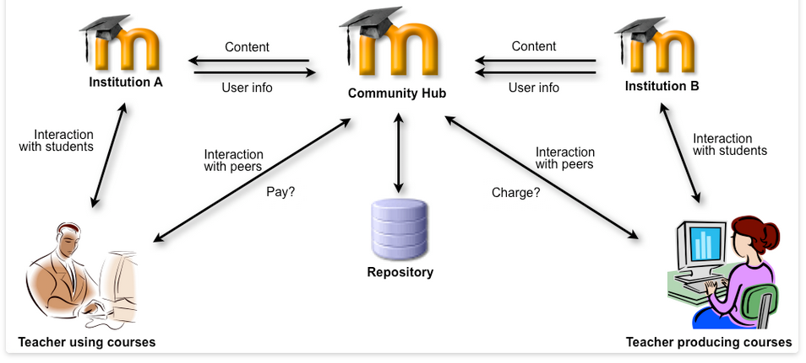
Figure: 2 The Learning Management System MOODLE
Source: (Lazov, Teirumnieka, Teirumnieks and Karadzhov, 2019)

As shown in the figure, the teachers who are taking the course and the teachers who are creating it are both directly connected to the Moodle community hub are the institution A and institution B, where institution A is the University of Wales Trinity Saint David London Campus and institution B is Leeds Trinity University (Sasha A., 2015), In this case, the content and user information of both institutions are communicated within the community, and the instructors utilizing the course and the teachers providing the course are linked to the institution rather than the community and the people themselves (Andersson & Grönlund, 2009). There is also a repository through which the community has collected data and information connected to the course's theme, and the educators who are using the course connect with the community hub a and to the community hub b, and the community has also paid the teacher who is providing the course (Kurilovas & Methods ,2009). Within the University of Wales Trinity Saint David London Campus, a proper contact between lecturers and students is established, which produces a favourable environment for virtual learning for the students.

Method of Analysis
This research was done utilizing an online survey approach, and the analysis was completed using Microsoft Office excel spreadsheet software. The data from the spreadsheet program was displayed using the graph chart, which was included in the report with suitable illustration.

Ethical considerations
As private relevant evidence from respondents have not been displayed, the ethical consideration has been successfully preserved throughout the completion procedure of this research.

Engaging professional learners using the Virtual
Learning Environment (VLE): a case study from social
care.
The above study was done by University of Wales Trinity Saint David, at Carmarthen Campus, with part distance learners. (Davies and Harris, 2016)
Research Methods
The 'Social Work Practice' module was chosen for this case study as it contains a predominantly big unit of learners thus offers very strong data.
This unit is a necessary chunk of post qualification learning for social workers in Wales and is studied at Level 6 (i.e. year 3 undergraduate level) during a 9-month period. Several face-to-face assistance sessions with University officials and employer representatives are included in the delivery of this programme. However, a large portion of the module's study is self-directed, with resources and provision materials accessible on the UWTSD Moodle VLE.
as data analysis and interpretation to give secondary information on the study issue.

Collection of data
The data for this study is secondary data, obtained from the internet.
Results

The percentage of students who logged in to the module's web page divided by the total number of enrolled students. Moodle users averaged 7.5-page views per student, with females averaging 8 and males averaging 3. This may not be a reasonable comparison, however, because just 8 of the learners in this group were male. On the module Moodle website, Figure 1 illustrates the number of page visitors for five primary resources.
As noted previously, every opinion is those of learners, and any multiple views by the same people are included.

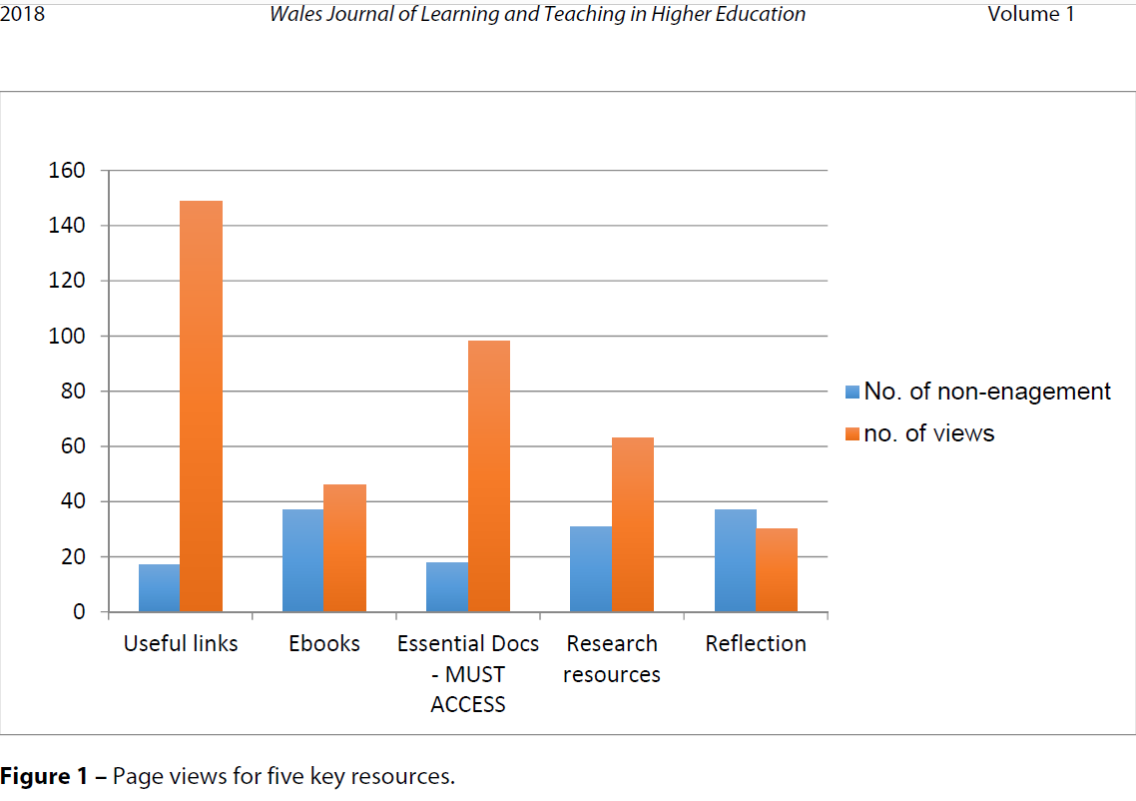
Source: (Davies and Harris, 2016)
The above graph shows that 'helpful links' and 'important papers,' both required for compulsory for valuation of assignments, had the most page views. The smallest amount of page views.
Even though this subject was completely covered during since this topic was first discussed, there were still over 30-page views for this item.
The scatter plot in Figure shows a comparison of student page views and final module grades.

2. A trend-line analysis of the data reveals a minor positive relationship between the two variables; nonetheless, the number of Moodle page views appears to have minimal impact on last grade of the module.
Most of the 0 points was a result of no submission coupled applied for extenuating circumstances, therefore possible this pattern will emerge once marks for these assignments

Additional research findings
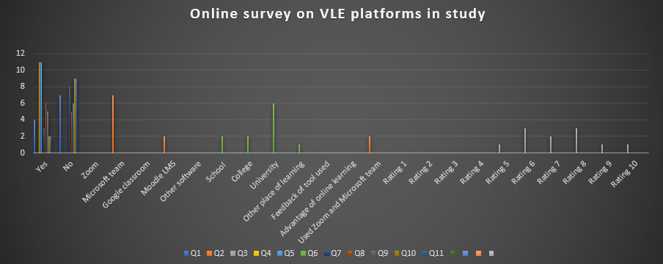
Discussion
The above online learning survey was conducted as per requirement of the module, the lecturer described and explained the aim of this survey and how it should be designed. I then designed the above survey questionnaire and handed out to students in other classes and on online. The above table shows question 1, 7 people said yes, and 4 people said no. Among three different types of platforms used initially as software, most of the people have provided positive information towards the Microsoft team that they use it so often. Then, Moodle LMS only got 2 votes in Q3. Besides, the survey result regarding question number 6 it is found that most of the people have provided their opinion from university. Also, decorating has been profiled head in a different category, but question number 8 rating has been providing maximum and number 6 also got equal with rating 8 with 3 votes each. The result is suggesting that the Microsoft team has been the most popular choice of platform for Virtual Learning and Google classroom and zoom were used in online classes.

Areas of improvement
- Utilizing the Moodle platform, attempt to provide additional possibilities for hands-on learning and practical internet research.
- Engaging the store vertically to speak with one another to develop a great research project that will be more valuable to their future careers by using the Moodle platform

Conclusion and Recommendation

Finally, I can say reflecting from the first term, I had not much knowledge about computers prior to this course ( Digital Skills and Research Methods), I have now learned quite a lot about computers and especially about Virtual Learning Environment as a result of my researches for this report, I believe that students at the University of Wales Trinity Saint David London Campus are having a pleasant experience with the VLE as a result of utilizing the Moodle platform. But I also believe that VLE is not perfected yet and like most things, virtual learning can and should make more improvement because distant learning is always a pleasant experience that every learner desire to have in order to improve their skills and talents. The virtual learning environment expands the scope and chances for both students and lecturers to communicate more comfortably with one another, as well as provide numerous options for undertaking implicit and explicit learning processes.

References

- andersson, a. and gronlund, a., 2009. A Conceptual Framework for E-Learning in Developing Countries: A Critical Review of Research Challenges. [online] Available at: <https://www.researchgate.net/publication/228641067_A_Conceptual_Framework_for_E-Learning_in_Developing_Countries_A_Critical_Review_of_Research_Challenges> [Accessed 8 January 2022].

- Deepak, K., 2017. Evaluation of Moodle Features at Kajaani University of Applied Sciences – Case Study. [online] ResearchGate. Available at: <https://www.researchgate.net/figure/a-Participants-teaching-experience-b-Participants-experience-in-using-Moodle-c_fig1_320397377> [Accessed 8 January 2022].

- Hewson, E. and Chung, G.W., 2021. Beyond the VLE: transforming online discussion and collaboration through Microsoft Teams. Hosted by UNED, Madrid (Spain), p.36.

- Kurilovas E. Methods of multiple criteria evaluation of the quality of learning management systems for personalised learners needs. InECTEL'2009 Workshop" Learning Management Systems meet Adaptive Learning Environments 2009 Sep 29.

- Lazov, L., Teirumnieka, Ē., Teirumnieks, E. and Karadzhov, T., 2019. Figure 2 The Learning Management System MOODLE source:.... [online] ResearchGate. Available at: <https://www.researchgate.net/figure/The-Learning-Management-System-MOODLE-source_fig1_333251588> [Accessed 9 January 2022].

- Peat, Mary July, 2019. "Towards First Year Biology online: a virtual learning environment". Educational Technology & Society. 3 (3): 203–207.

- Reese, S., 2014. Online learning environments in higher education: Connectivism vs. dissociation. [online] Commons.hostos.cuny.edu. Available at: <http://commons.hostos.cuny.edu/online/wp-content/uploads/sites/68/2015/09/Online-learning-environments-in-higher-education.pdf> [Accessed 8 January 2022].

- Statista. 2021. Reasons why students chose online versus on-campus degree programs U.S. 2021 | Statista. [online] Available at: <https://www.statista.com/statistics/731089/reasons-why-students-chose-online-versus-on-campus-degree-programs/> [Accessed 8 January 2022].

- Van Laar, E., Van Deursen, A.J., Van Dijk, J.A. and De Haan, J., 2017. The relation between 21st-century skills and digital skills: A systematic literature review. Computers in human behavior, 72, pp.577-588.

- Wakelet. 2022. Moodle. [online] Available at: <https://wakelet.com/wake/lApzoagcaggdaam0Xej3V> [Accessed 8 January 2022].

- : Davies, C. and Harris, L., 2016. Engaging professional learners using the Virtual Learning Environment (VLE): a case study from social care.. [online] Repository.uwtsd.ac.uk. Available at: <https://repository.uwtsd.ac.uk/id/eprint/1309/1/Davies-and-Harris[2016_article].pdf> [Accessed 9 January 2022].

Appendices:
Online Survey Result

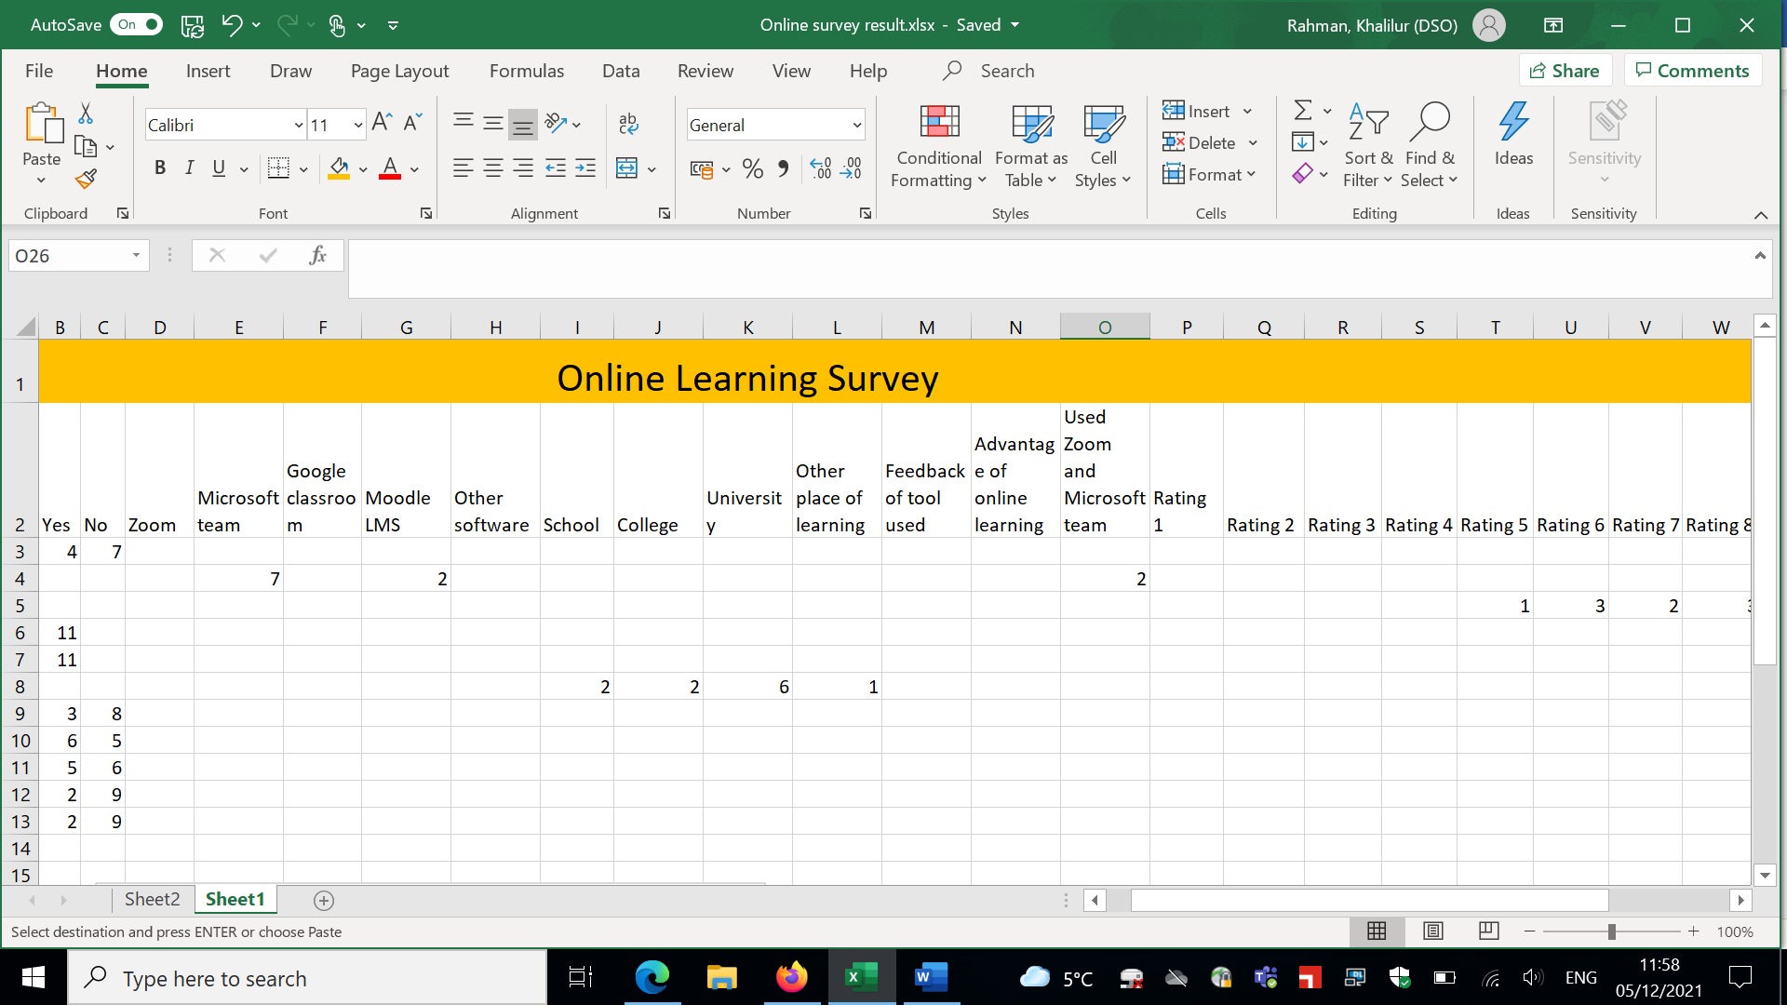

ONLINE LEARNING SURVEY QUESTIONNAIR
Student Name: Khalilur Rahman_ Student ID: 2112662
Module Name: Digital Skills and Research Methods (SFTW) Group: 3

- Have you done any online learning over the course of your academic study or work?

Please tick the appropriate box below.
☐ Yes
☐ No

2. Which learning tools did you use?
Please tick the appropriate box
☐ Zoom
☐ Microsoft-Teams
☐ Google classroom
☐ Moodle LMS
☐other (please write the name of the application)

- Based on your online learning experience please rate the tool you used?
(1 being the lowest and 10 being the highest)

1 | 2 | 3 | 4 | 5 | 6 | 7 | 8 | 9 | 10

- The learning tool you used, was it easy to use?
Please tick the appropriate box below
☐Yes
☐No
- The tool you used, was it an effective learning tool?
Please tick the appropriate box below
☐ Yes
☐ No

- Where did you connect to do the learning?
Please tick the appropriate box below

☐ School
☐ College
☐ University
☐If other, please specify

- Were there issues while using the tool?
Please tick the appropriate box below
☐Yes
☐No

- The issues you faced; did you manage to fix by yourself?
Please tick the appropriate box below
☐Yes
☐No

- Do you have any feedback regards to this tool being used for your online learning?

_________________________________________________________________________________________________________________________________________________________________________________________________________________________________

- Please give brief description of the advantage of online learning.
Please write your comments below

_________________________________________________________________________________________________________________________________________________________________________________________________________________________________
- Please give brief description of the disadvantage of online learning.
Please write your comments below

_________________________________________________________________________________________________________________________________________________________________________________________________________________________________

End of survey

