Contemporary Themes in the Hotel and Hospitality Sector (BMIH6001)

Shift hotel strategies post covid with reduced
business commuting
Part 1

Student name: Loredana Turner
Student id: 2242724

Abstract
The business commuting patterns have been influenced by the Covid-19 pandemic. For example, the post-pandemic period has significantly reduced corporate travel and reshaped the traditional model of the hotel industry. The key influencers of this shift are remote and hybrid working, digitalisation, and sustainability expectations. This report has used secondary research and thematic analysis. The explanation of the Triple Bottom Line framework helps understanding environmental, economic, and social impacts on reducing commuting on hotel operations. Market diversification, digital technologies, and sustainability integration are essential for long-term viability. According to this study, aligning operational strategies with evolving traveller behaviour is crucial for business resilience, reduction of green house gas, enhances competitive advantage, and attract customers.
Table of Contents
Part 1: Research paper 3
1. Introduction 3
2. Literature Review 3
2.1 Decline of Business Travel Post-COVID-19 3
2.2 Strategic Adaptation in Hotel Operations 4
2.3 Sustainability and Reduced Commuting 5
3. Method 5
4. Theme Impact Analysis 6
4.1 Detail of Triple Bottom Line 6
5. Conclusion 9
6. Recommendations 9
Part 2: Presentation 11
Slide 1: Introduction 11
Slide 2: Background of the Global Hospitality Industry 11
Slide 3: Decline in Business Travel and Commuting Patterns 12
Slide 4: Key Theories and Concepts 13
Slide 5: Explanation on the Post-COVID Hotel Adaptation 14
Slide 6: Research Method and Analytical Framework 14
Slide 7: PESTEL Analysis 15
Slide 8: Industry Responses and Strategic Adaptations 16
Slide 9: Future Recommendations 16
Slide 10: Conclusion 17
References 18

Part 1: Research paper

1. Introduction
The sudden outbreak of the pandemic has reduced business commuting because of the increasing hybrid and remote work culture. This new trend in work culture reduces commuting, which has lowered the travellers in hotel. Therefore, the hotel industry needs to shift their business concept and strategies so that this industry can meet this shift in travelling. Corporate commuting is one of the key contributors to the hotels and hospitality industry. The term business commuting can be Walking, cycling, public transport, or personal vehicle. Therefore, shedding light on the business commuting generated by the hospitality industry becomes crucial for addressing this contemporary issue. The sudden outbreak of the pandemic has resulted in long-term reduction in business commuting and corporate travel. The integration of remote working, hybrid work models, and digital communication technologies associated with Business community has been observed. The purpose of this research is to detail the Reasons behind the shift of hotel industries in the business commuting. The shift in the business community associated with the hotel industry is critically important to sustain after the pandemic. The justification behind this shift is that it directly alters demand patterns, cost structures, and long-term strategic viability. Lowering corporate travel has weakened traditional revenue streams. The impact of this shift on the business and employees will be explained in this research. The failing areas and challenges faced by this industry will be another focused area of this research. Additionally, this research will provide effective recommendations to address these challenges and manage the business.

2. Literature Review

2.1 Decline of Business Travel Post-COVID-19
Mismanagement in operational, behavioural, and structural factors generally leads issues in the new trends of business commuting. It has been observed that the travel industry did not gain the similar pace of the Travellers after the pandemic. It has been observed that the travel industry is still lagging 2.9% behind the 2019 peak in 2024 (World, 2024). Additionally, the virtual meeting platforms such as Zoom and Microsoft Teams have replaced the physical interactions. The shift in this business community seems to be helpful in long-term cost savings, reduced carbon footprints, and improved work-life balance. Additionally, this industry can increase sustainability practices with the help of remote work and hybrid work. The hospitality industry should integrate inventory management strategies like Providing cloud-based information, real-time visibility, and monitoring staff. For example, this industry needs to ensure connecting with remote workers timely to manage the business. According to the suggestion of Essential Cooper and Hall (2022), it can be detailed that the hospitality industry has been impacted in various ways after the sudden outbreak of the Covid-19 pandemic. It has been observed that the pandemic has accelerated sustainability practices along with digitalisation in this sector. Reduced commuting becomes significant, while it is considering with the context of sustainability practices. It has been observed that transportation is a key contributor to greenhouse gas emissions. Therefore, less commuting meets the sustainable standard of travel and tourism. This is also a fruitful action for hotels as they can lower indirect emissions by reducing dependencies on business travel. Therefore, the hospitality industry should integrate advanced technologies. For example, this industry can use advanced technologies like big data analytics. The market size of Big Data Analytics in the tourism industry was USD 18.4 billion in 2025, and it is estimated to increase by 8.6% within 2035 (Futuremarketinsights, 2025). Therefore, the key reasons include a structural rather than clinical decline, Sustainable practices, and Real-Time Data Visibility.

2.2 Strategic Adaptation in Hotel Operations
Strategic transformation of business commuting will have far-reaching consequences for the environment, the economy, and society. Remote working culture has helped businesses to reduce transportation, which directly support the sustainability practices of this industry. It has been observed that employees along with customers are demanding sustainable practices in an organisation. Therefore, shift in business commuting after the pandemic will help gaining customer trust in the hotel. The significance of lowering business commuting is also directly connected to the sustainable business practices. It has been observed that transportation alone causes 28% of greenhouse gas emission in the USA (EPA, 2024). Additionally, remote or hybrid working culture will support work-life balance of employees and increase employee engagement. Market diversification is also another significant influencer of this business committing shift in the hotel industry after the pandemic. It is worth mentioning that Hotel shifting is primarily focused on leisure, domestic, and “bleisure” travellers. On the other hand, sustainability practices is another shift in the hotel industry. It has been observed that 80% of Travellers will go with the organisations that provide sustainable business offering (Statista, 2025).
The hotel industry also needs to focus on operation and adoption, which has been Central to strategic changes. Hotels need to redesign physical spaces so that they can maintain accommodate hybrid work patterns. Additionally, they need to introduce co-working lounges, flexible meeting rooms, and long-stay accommodation packages. The hotel industry can integrate strategies such as conference bookings, short business stays, and weekday occupancy. This integration will be helpful for this industry to fight against the reduction in the corporate travel. The rationale behind this strategy is that it will force hotels to make strategic adoption essential rather than optional to create value. However, it has been observed that only 2% of people in the hospitality industry work remotely (Dobrilova, 2024). The key reason behind this issue is that many of the hotel industry do not have clear knowledge regarding the integration of Technology is Managing successful remote working culture. Therefore, the lack of proper knowledge can be considered as one of the key challenges in shifting business community in the hotels. Hotels are also optimising underutilized assets so that they can diversify alternative revenue stream. The primary challenges in business commuting shift in the hotel industry are Declining Traditional Business Travel, Adopting infrastructure and advanced technologies, Suffering from initial costs, Evolving Guest Expectations, and Cyber security threat.

2.3 Sustainability and Reduced Commuting
The above-mentioned paragraph detailed the reason of business commuting shift in the hotel industry. This industry needs to adopt a range of Sustainability and Reduced Commuting strategies to improve efficiency and support environmental goals. The integration of smart technology and performance monitoring systems will be an effective strategy to reduce this issue. The justification behind the integration of digitalization and remote work, from an operational perspective, reduces demand volatility. However, hotels should manage underutilized assets so that they can make hotel accommodations more office-friendly. As a result, remote workers can visit those hotels and complete their office work if required. The implementation of Advanced technology and Big Data Analytics, and inventory management are strategically important to create this type of hotel accommodation. Additionally, employment of Advanced technology will assist the hotel industry to forecast demand more accurately so that they can plan their accommodation and adapt to the shift of the commuting. This strategy will be helpful for organisations to monitor employees, develop communication, and reduce errors in real time. According to the opinion of Alexander and Danzer (2025), it can be detailed that more than 1 million tons of food is wasted every day, which leads to undernutrition and hunger. Greenhouse gas emission and food waste are also to significant factors, which needs to be addressed by the hotel industry. It has been observed that around 45% of food waste is generated by the hotel industry during the process of food preparation and production around the globe (Muchele et al. 2025). Therefore, the food donation and redistribution program will support this initiative. The World food program collect and donate US$9.8 billion raised in 2024 to mitigate food insecurities globally (WFP, 2023). The hospitality industry can partner with local charities and donate excess food, which will help develop brand reputation.

3. Method
This research adopts a secondary research approach so that it can investigate food waste issues in the hospitality sector descriptively. This research has conducted a systematic review of existing academic and industry-based literature thoroughly. This process has helped in providing current and credible evidence. The data sources for this research are peer-reviewed journal articles, academic textbooks, sustainability reports, and publications. This research has collected information from the websites such as Statista, WFP, EPA, and Wttc.org. These sources were selected based on their relevance, reliability, and focus on hospitality sustainability. On the other hand, this research employs thematic analysis to develop themes and analyse them accordingly. According to the study of Nowell et al. (2017), thematic analysis will help in summarising key features of a large data set. Therefore, this technique will allow analysing thematic analysis. As a result, this analysis will help in finding recommendations to reduce food waste in the hospitality sector. The methodology of this research includes Systematic review of peer-reviewed journals, Credible industry reports, Qualitative thematic analysis, and Application of the Triple Bottom Line (TBL) framework

4. Theme Impact Analysis

4.1 Detail of Triple Bottom Line
The decline in business commuting will not be a short-term impact on the hotel industry but a structural shift driven by hybrid work models. The integration of digital communication technologies, and corporate cost optimisation are critically responsible in shifting the business commuting along with the hotel business. The integration of the Triple Bottom Line (TBL) framework will assist in understanding the impact of shift of business commuting on the hospitality and hotel industry. This framework helps in examining sustainability across people, planet, and profit. Therefore, this framework will help in developing strategies like operational performance, financial viability, and stakeholder perceptions related to business commuting in this industry.
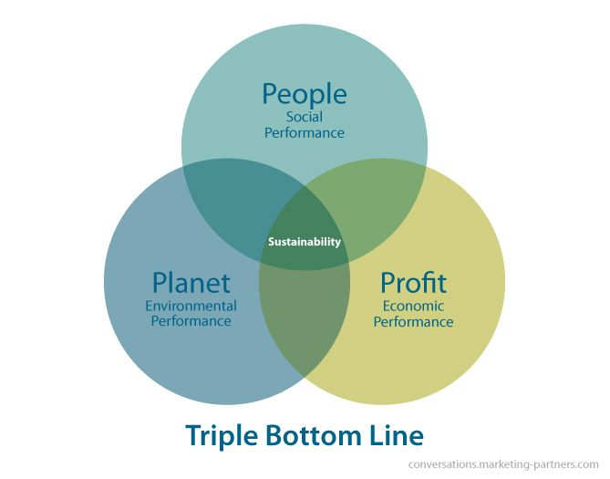
Figure 3: Triple Bottom Line framework
(Source: Inchainge, 2022)
Environmental Impact of Revenue Models and Strategic Diversification
Business shift is a persistent issue in the hospitality sector, and it becomes necessity to address this issue. The key drivers of business shift in the hotel industry are rapid technology adoption, a strong demand personalized guest experiences, and increasing demand for sustainable services. For instance, hotels that provide personalized experiences to travellers are anticipated to generate 34.6% of the market revenue in 2025 (futuremarketinsights.com, 2025).
The business shift in the hotel industry and commuting shift is critical for this industry to meet with the demand of customers and match the sustainability standards. Hotels are adopting shifted strategies such as market diversification and revenue resilience. Shifting in hotel businesses will help in reducing dependence on corporate contracts. It has been observed that the business travel was accountable for 70% of all global revenue for high-end hotel chains before pandemic (Wttc.org., 2021). Additionally, 55 and 75% of airline profits came from business travellers (Wttc.org., 2021). The majority of hotels are providing extended "bleisure" stays by combining leisure plus domestic services. The extended stay market size in the hospitality industry was USD 57.7 billion in 2024 and it is estimated to increase to USD 98.8 billion by 2030 (Grandviewresearch.com, 2023). Mitigating food waste will be helpful in areas like Mitigating Climate Change, Conserving Natural Resources, Protecting Biodiversity, preventing pollution, and Supporting Soil Health.
Economic Impact: Reduced Travel and Sustainability Alignment
The reduction in business commuting will contribute positively, while analysing from an environmental perspective. Businesses may experience financial gain in areas like procurement, storage, preparation, and disposal. Lowering business commuting is directly linked to sustainability outcomes and strengthen business reputation. It has been observed that the hotel industries responsible for an estimated 22% of tourism-related carbon emissions (Untourism.int., 2025). Therefore, integrating strategies like shifting business commuting will help this industry to lower carbon emission. Additionally, this strategy will help the industry to match with the net-zero and ESG commitments. Hotels are promoting local tourism, encouraging longer stays, and investing in energy efficient operations to incorporate with sustainability standards. According to the information of Costa and Costa (2022), it can be detailed that hotel industry can be considered as a most dynamic sector and plays a significant role in regional development. In a nutshell, economic impacts of reducing business commuting in this industry are Reduce the transport-related carbon emissions, align with the corporate sustainability goals, support low-impact and domestic tourism growth, and reduce efficiency in underutilised hotel capacity
Social Impact: Workforce, Guest Expectations, and Community Engagement
Visible actions in reducing business commuting of an organisation can increase brand reputation and gain trust of costumers. However, organisations need to maintain transparent sustainability practices so that it can enhance brand reputation and customer loyalty. As per the opinion of Chkoniya (2021), it can be detailed that the utilisation of data science is useful to derive information from big data and generate efficient utilization to solve real-world problems. It has been observed that Travellers are demanding flexibility, wellness, and work-life balance. Therefore, including offerings like co-working spaces, high-speed connectivity, and wellness facilities will assist the hotel industry in shifting its business process. The integration of the digital and advanced technology is also justified in forecasting reduces overproduction, staffing inefficiencies, and food waste. Hotel industry should focus on reducing their environmental impact and increase sustainable practices to meet the shift on businesses after the pandemic. The post-pandemic period has influenced two business concepts such as sustainability practices and digitalization. Therefore, hotels also can increase guest experiences by focusing on these shifts. Additionally, hotels have the responsibility to provide accurate training to staff so that they can meet the sustainability measures. It is worth mentioning that staff engagement initiative will help increasing sustainability awareness and fostering waste reduction practices. The integration of Advanced Technologies will be helpful for this industry to forecast demand, mitigate over production, connect with local charities to distribute surplus food, and monitor the sustainable process. The following figure detailed that 78% of Travellers are like to stay with an organisation that offer ecofriendly accommodation (Statista Daily Data, 2022).
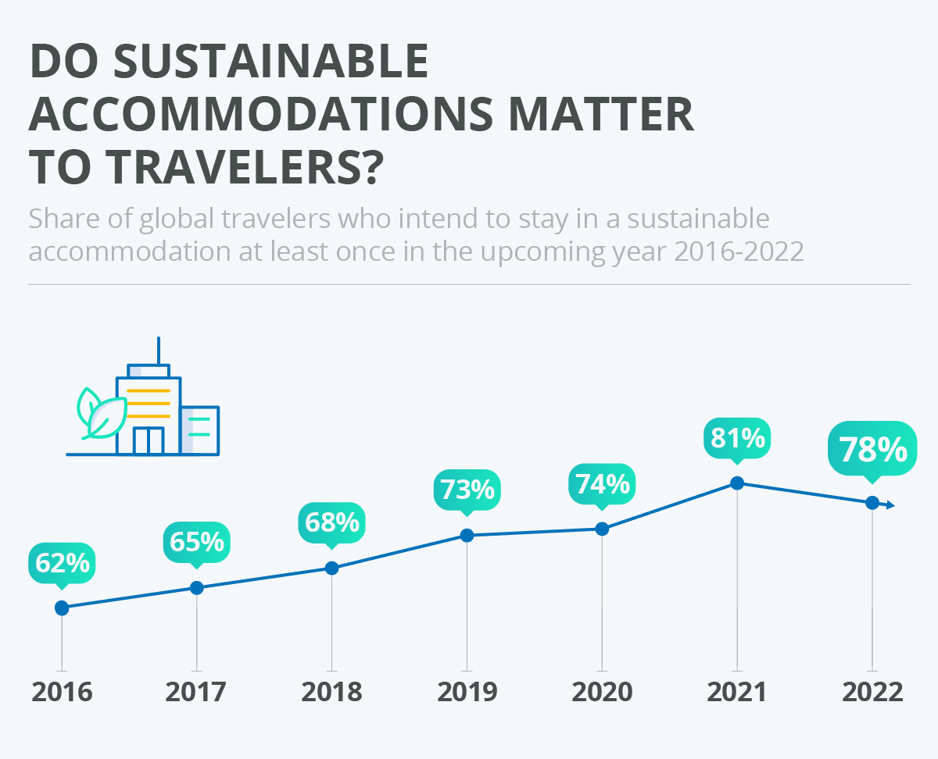
Figure 4: Sustainability accommodation demand of travellers
(Source: Statista Daily Data, 2022)

5. Conclusion
The Covid-19 pandemic has reduced business commuting, which has significantly reshaped operational, economic, and sustainability priorities of the hotel industry. Travel commuting is a very common and persistent issue in the hospitality sector, which needs to be addressed. It has been observed that excessive tourism transportation is creating substantial environmental, economic, and social impacts. This research has provided recommendations to business commuting shift, which can lower carbon emissions, reduce costs, and enhance corporate reputation. It has been observed that the demand of travellers after the pandemic has shifted towards sustainable practices and digitalization. Therefore, the hotel industry also needs to shift its business to align with the trend.

6. Recommendations
The above-mentioned sections have identified the urgency of shifting business commuting in the hospitality industry. This section will provide proactive recommendations for this industry the issue.
Recommendation 1: Invest in Scalable Monitoring and Digital Technologies
The hospital industry needs to adopt scalable digital monitoring and inventory management Technologies. This strategy seems to be fruitful in improving forecasting accuracy, monitoring operations, and generate low-commuting environment. It has been observed that this industry can integrate technologies like contactless check-in, mobile room keys, AI-driven demand forecasting, and dynamic pricing systems. It has been observed that 62% of travellers consider contactless check in as the most convenient way for them (Msrlimited.com, 2025). In addition, this strategy will also assist in Identifying errors in procurement, preparation, and service stages. Integration of Big Data Analytics will assist the sector to make data driven decisions regarding the procurement, preparation, and prediction of food.
Recommendation 2: Diversify Target Markets and Redesign the Value Proposition
Hotel industry needs to reduce their dependency on one traditional business travel market strategically. Therefore, this industry can diversify into leisure, bleisure, remote workers, and long-stay guests. For instance, hotels can diversify they are offerings by including flexible room packages, wellness-focused stays, and destination-led experiences. However, diversifying its business may require upfront investment and marketing alignment. Hence, hotels can ensure long term profit and strengthen revenue resilience by diversifying dear business offerings.
Recommendation 3: Embed Sustainability into Core Strategy
Ethical and ecofriendly practices are the critical part for the hotel industry to sustain in this business environment. It has been observed that 78% of Travellers are like to stay with an organisation that offer ecofriendly accommodation. Hence, Hotels need to integrate sustainability into core strategy not only an Add-On. For instance, this industry needs to lower corporate travel, promote low carbon stage, energy-efficient operations, and local sourcing to match this sustainability demand. Additionally, reducing food waste will help in balancing finances so that it can invest in further development. These practices will help the industry to meet customer demand, gain competitive advantages, and adhere with rules and regulations. Obtaining Eco certificate and maintaining transparent sustainability practices are crucial to strengthen brand reputation.

Part 2: Presentation

Slide 1: Introduction
- The COVID-19 pandemic has resulted in a structural shift in the hospitality industry as it declines business travel
- The pandemic has accelerated remote and hybrid working model
- Market repositioning, transformation in Operation strategies, and increasing sustainable practices
SN: The purpose of this presentation is to detailed the impact of Covid-19 pandemic on the businesses of hotel industry. The new business trend forces the industry to redesign its operations. The hotel industry has experienced a shift towards digitalization and sustainability practices after the pandemic. Corporate travel was a cold revenue stream for hotels before the endemic period. However, the increase in remote and hybrid working culture has reduced the corporate travel. It has been observed that 77% of respondents believed they flew less after COVID-19 (Julsrud and Steffen Kallbekken, 2025). In this regard, it can be stated that the increase in remote working and virtual meetings lower the corporate travel. This is a permanent decline in the business travel demand, which force the hotel industry to reshape their operations and offerings.

Slide 2: Background of the Global Hospitality Industry
- The global hospitality industry supports economic growth, tourism, and employment
- The travel and tourism sector has contributed to the USD 8,707 million within 2025 (Market Data Forecast, 2022)
- Business travel was a major revenue source for the hotel industry before the endemic period
SN: The global hotel industry is experiencing a strategic change after the sudden outbreak of the pandemic. The travel and tourism sector is one of the major contributors of economy and estimated to contribute USD 11030 million within 2033 (Market Data Forecast, 2022). It is worth mentioning that this industry is transforming digitallyto match the current business environment. Additionally, decline in corporate travel also forces the industry to reshape their business strategies. It is worth mentioning that this industry is known for its contribution to economy and employment. For instance, this industry contributes 35% of employment by generating 357 million jobs globally (World Travel and Tourism Council, 2024). This industry needs to balance digitalisation, sustainability adoption, and reduced corporate travel demand to meet the current business demand.
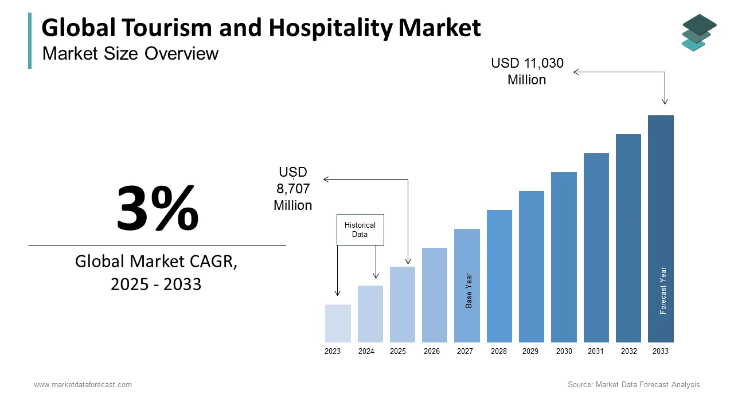
Market Data Forecast, 2022

Slide 3: Decline in Business Travel and Commuting Patterns
- Global Business struggle has reduced 15–20% of corporate travel compared to the pre-pandemic period
- Employees are connecting via Zoom, Microsoft Teams, and Google Meet, which led to reduce corporate travel
- This shift in business help organisations in cost reduction, employee wellbeing, and carbon-reduction targets
SN: The travel pattern has been changed on a large scale after the pandemic, who is influences the hotel industry to restructure its business. The pandemic has accelerated the remote and hybrid working culture, and the utilization of Zoom, Microsoft Teams, and Google Meet. The shift in business community increases cost Savings, ensure sustainability practices of organisations, and produce healthy work life balance for employees. 71% of daily workers stated that remote working culture has helped them achieving healthy work life balance (Jendriks, 2025). Therefore, the hotel industry changes their business model and offerings to address the issue of declining corporate travel. There has been a decline in air traffic after the pandemic as it was 155,000 around the middle of March in 2020 and it declined by 64,522 within March 29 (McCarthy, 2020).
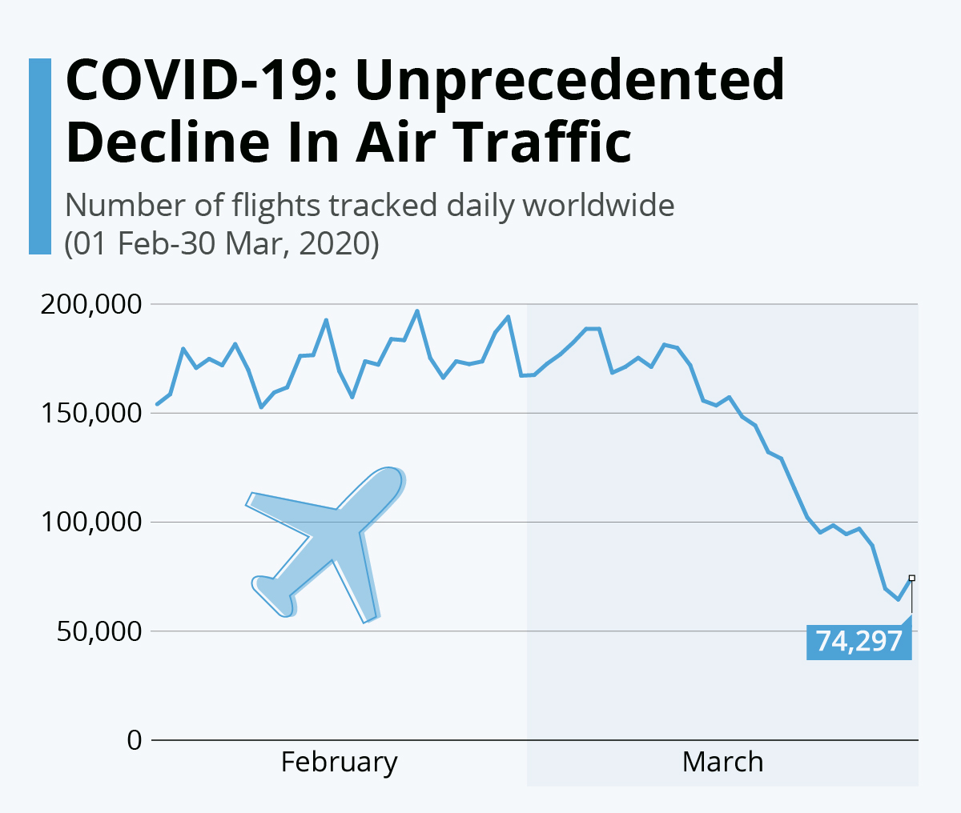
McCarthy, 2020

Slide 4: Key Theories and Concepts
- Triple Bottom Line (TBL) Framework details three factors such as profit, people, and planet
- Digital transformation theory stated the urgency of integrating advanced technology in the hotel industry
- It has been observed that 72% of Travellers prefer booking their trips over the internet in 2023 (Armstrong, 2023)
SN: The integration of these theories will help in understanding the impact of decline business commuting and the reshape the hospitality industry. The Triple Bottom Line framework helps in exploring economic resilience and meeting social expectations. On the other hand, digital transformation theory reinforces the significance of integrating technology to ensure flexible operations, sustainability initiatives, and personalised services. The integration of digital transformation theory will access to the industry in efficient productivity, data analysis, enhance collaboration, digital supply chain, and employee retention. Additionally, digital transformation helps in flexibility, sustainability, and security.
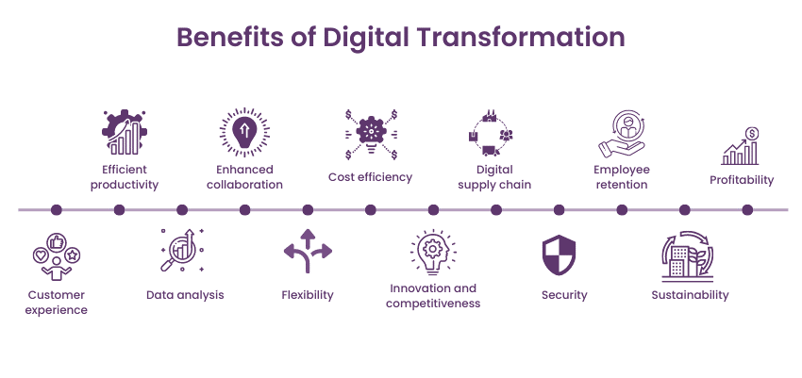
TheKnowledgeAcademy, 2025

Slide 5: Explanation on the Post-COVID Hotel Adaptation
- The pandemic has forced the hotel industry in diversifying strategic market decisions
- The hotels are integrating strategies such as digital tools, contactless services, and energy-efficient systems
- The hotel industry needs to create office-friendly accommodation to match this trend
SN: The sudden outbreak of the pandemic has influenced the hotel industry to transform its business practices. The hotel industry can introduce co-working lounges, flexible meeting rooms, and long-stay packages so that people can manage hybrid work patterns. The two key factors of Transformation are associated with sustainability and digitalisation. For example, this industry can introduce co-working lounges, flexible meeting rooms, and long-stay packages so that travellers can continue their work if required in those spaces. The technology adoption will assist hotels in enhancing efficiency, guest experience, and safety. Customisation trouble market is estimated to increase at a CAGR of 17.8% within 2022 to 2032 (Villa-Clarke, 2024).

Slide 6: Research Method and Analytical Framework
- This research has employed secondary qualitative research approach to collect information from various existing data sources
- These data sources are peer-reviewed journals, industry reports, and credible data sources
- The investigation of Political, Economic, Social, Technological, Environmental, and Legal
SN: The adoption of qualitative secondary methodology was crucial for this research to increase authenticity of information. It has been observed that this research as collected information from various data sources such as peer-reviewed journals, industry reports, and credible data sources. This methodology has helped the research to find information from in a descriptive manner. Additionally, this method has helped in shedding light in different factors associated with the business shift in the hotel industry after the pandemic. Secondary qualitative data analysis also has helped investigating external factors such as Political, Economic, Social, Technological, Environmental, and Legal factors.

Slide 7: PESTEL Analysis
Factor | Impact on Post-COVID Hotel Strategies
Political | Hotel industry needs to follow Government regulations on travel, border control policies, and public health
Economic | The travel and tourism industry has experienced a loss of US$4.5 trillion in 2020 after the pandemic (WTTC, 2021)
Social | The pandemic has resulted in losing roughly 63 million jobs in 2020 (Statista, 2022)
Technological | The integration of digital tools such as virtual meeting platforms, AI, and data analytics will help streamline the operations of the hotel industry
Environmental | Lower commuting reduce carbon emissions and hotels can adopt sustainability practices
Legal | Compliance with health, safety, and sustainability regulations is mandatory for this industry to match regulations
SN: The PESTLE analysis sheds light in the business commuting post-COVID, and the influence of this commuting on the hotel industry. Political and legal factors have influenced travel restrictions and health regulations. The sudden outbreak of the pandemic lead to a loss of US$4.5 trillion in 2020 and 63 million jobs. This decline influences the industry to introduce leisure, domestic, and long-stay markets. Digitalisation and sustainability practices associated with the social trends were another driving force for the hotel industry to shift their business strategies. This industry also can streamline its operations such as efficiency, contactless operations, and personalised services with the help of technology.

Slide 8: Industry Responses and Strategic Adaptations
- Market diversification such as long-stay packages and flexible room offerings can help in stabilising revenue streams
- The extended stay in tourism can be increased by 9.5% from 2024 to 2030 (Grandviewresearch.com., 2023)
- Advanced technology and sustainability integration will be essential for the hotel industry
SN: The hotel industry has responded in the contemporary business issue such as decline in business community. In order to address this issue, this industry has diversified its market, adopted digital technology, increase sustainability practices, and strengthen customised services. The integration of sustainability initiatives will enhance efficiency, reduce environmental impact, and reinforce brand reputation.
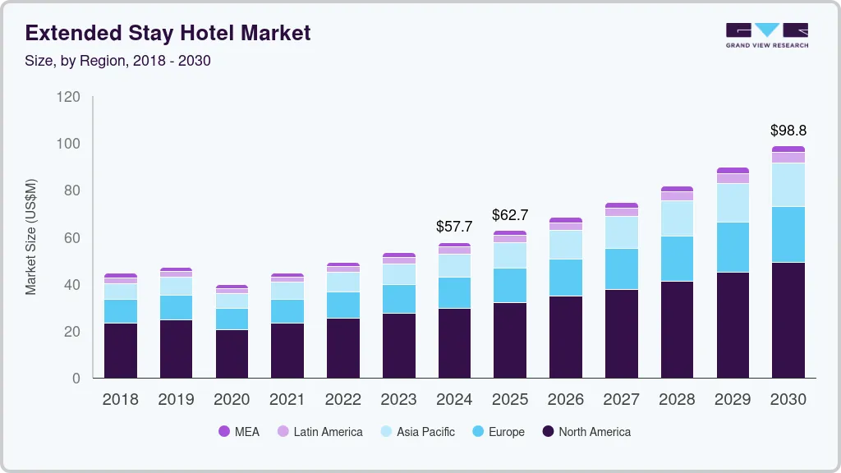
Grandviewresearch.com., 2023

Slide 9: Future Recommendations
Recommendation | Description | Expected Impact
Hybrid-Ready Hotel Models | Introduce co-working spaces, long-stay packages, and flexible room designs | Strengthen occupancy rates, and diversified revenue
Digital and Data-Driven Operations | Integrate AI, big data analytics, and contactless technologies | Cost efficiency, and enhanced guest satisfaction
Sustainability and ESG Integration | Adobe carbon reduction strategy, local Sourcing, and transparent sustainability reporting | Increase Brand reputation and long-term resilience
SN: Hotels can integrate strategies like hybrid ready Hotel models, digital and data driven operations, and sustainability and ESG integration. Advanced technologies such as Big Data Analytics will assist the industry to streamline the operations by investigating vast volume of information easily. Providing transparent sustainable reports will be another effective strategy to meet customer Expectations and gain brand reputations.

Slide 10: Conclusion
- The post-COVID business has declined the corporate travels, which influence the industry to shift its business operations
- Digitalisation and sustainability or two Central strategies for this industry
- The hotel industry significantly depends on flexibility, innovation, and alignment with hybrid work
SN: It can be concluded that the COVID-19 pandemic has restructured the hospitality industry in as this industry is going through declining corporate travel. It has been observed that the hotel industries accelerating digital and sustainable transformation. Therefore, this industry needs to adapt strategies like market diversification, technology adoption, and strong ESG integration.

References
Task 1:
Alexander M. Danzer (2025) Food Waste and Dynamic Inconsistency: A Behavioral Economics Perspective. IZA -Institute of Labor Economics
Chkoniya, V. (ed.) (2021) Handbook of research on applied data science and artificial intelligence in business and industry. Hershey, Pennsylvania: IGI Global. Tourism), Channel View
Cooper, C. and Hall, C.M. (2023) Contemporary tourism : an international approach. 5th ed. Oxford: Goodfellow PublishersLimited. https://www.torrossa.com/gs/resourceProxy?an=5825829&publisher=FZO374
Costa, V. and Costa, C. (eds) (2022) Sustainability and competitiveness in the hospitality industry. Hershey, Pennsylvania: Business Science Reference. https://www.igi-global.com/chapter/challenges-in-times-of-crisis-and-pandemics-in-the-hospitality-industry/305921
Dobrilova, T. (2024). 5 Ways Remote Work Impacts the Hospitality Industry. [online] Expert Allies. Available at: https://expertallies.com/how-remote-work-impacts-hospitality/.
EPA (2024). Carbon pollution from transportation. [online] US EPA. Available at: https://www.epa.gov/transportation-air-pollution-and-climate-change/carbon-pollution-transportation.
Futuremarketinsights, (2025). Big Data Analytics in the Tourism Industry: Overview and Trends Analysis. [online] Available at: https://www.futuremarketinsights.com/reports/big-data-analytics-in-tourism-overview-and-trends-analysis.
futuremarketinsights.com. (2025). Customisation and Personalisation in Travel Marketing: Overview and Trends. [online] Available at: https://www.futuremarketinsights.com/reports/customization-and-personalisation-in-travel-marketing-overview.
Grandviewresearch.com. (2023). Extended Stay Hotel Market Size And Share Report, 2030. [online] Available at: https://www.grandviewresearch.com/industry-analysis/extended-stay-hotel-market-report.
Inchainge (2022). What Do We Know about the Triple Bottom Line? [online] Inchainge. Available at: https://inchainge.com/knowledge/sustainability/what-do-we-know-about-the-triple-bottom-line/
Msrlimited.com. (2025). Contactless Solutions in Hospitality Technology: Trends and Future Directions – MSR. [online] Available at: https://msrlimited.com/contactless-solutions-in-the-hospitality-technology-industry-trends-and-future-directions/.
Muchele, E.M., Osodo, B., Omosa, I. and Kombe, E.Y. (2025). Characterization of Food Wastes from the Hotel Industry as a Potential Feedstock for Energy Production. Energy Nexus, [online] p.100364. doi:https://doi.org/10.1016/j.nexus.2025.100364.
Nowell, L.S., Norris, J.M., White, D.E. and Moules, N.J. (2017). Thematic Analysis: Striving to Meet the Trustworthiness Criteria. International Journal of Qualitative Methods, [online] 16(1). doi:https://doi.org/10.1177/1609406917733847.
Statista Daily Data. (2022). Infographic: Do sustainable accommodations matter to travelers? [online] Available at: https://www.statista.com/chart/28162/how-much-do-sustainable-accommodations-matter-to-travelers/?srsltid=AfmBOopyjWOQE1p9186TVTlvta1ZOPGnzFb_WfWFJhnK9P_Zt-0ACx5Q [Accessed 2 Feb. 2026].
Statista. (2025). Topic: Sustainable tourism worldwide. [online] Available at: https://www.statista.com/topics/1916/green-tourism/?srsltid=AfmBOopCkYzdYYYRm7nNkYKuE05ZOdzgltfJ4wnaiDj7iIBwOlKQfO7p#topicOverview [Accessed 2 Feb. 2026].
Untourism.int. (2025). Climate change. Available at: https://www.untourism.int/sustainable-development/tourism-emissions-climate-change.
WFP (2023). WFP at a glance | World Food Programme. [online] www.wfp.org. Available at: https://www.wfp.org/stories/wfp-glance.
Wttc.org, (2024). Business Travel Set to Surpass Pre-Pandemic Levels to Reach a Record US$1.5 trillion in 2024. [online] Available at: https://wttc.org/news/business-travel-set-to-surpass-pre-pandemic-levels-to-reach-a-record-us1-5-trillion-in-2024.
Task 2:
Armstrong, M. (2023). Infographic: Travel Bookings: Online Vs. Agency. [online] Statista Daily Data. Available at: https://www.statista.com/chart/29622/travel-bookings-online-vs-agency/?srsltid=AfmBOop8sx3FjYTuqFYR_mEmZZsxTKgeH2zjyRrwWq4bPXMtyLOtjRuQ [Accessed 2 Feb. 2026].
Jendriks, T. (2025). 150 Remote Work Statistics: Trends, Benefits, and Demographic. [online] flair Blog for HR Professionals. Available at: https://flair.hr/en/blog/remote-work-statistics/.
Julsrud, T.E. and Steffen Kallbekken (2025). Has international business travel reached a turning point? Exploring the long-term effects of COVID-19 on air-travel practices in knowledge-intensive organizations. Sustainability Science Practice and Policy, 21(1). doi:https://doi.org/10.1080/15487733.2025.2463192.
Market Data Forecast, (2022). Tourism and Hospitality Market | Size, Share, Growth | 2021 – 2027. [online]. Available at: https://www.marketdataforecast.com/market-reports/tourism-and-hospitality-market.
McCarthy, N. (2020). Infographic: COVID-19: Unprecedented Decline In Air Traffic. [online] Statista Daily Data. Available at: https://www.statista.com/chart/21288/flights-tracked-daily-worldwide/?srsltid=AfmBOoq7vksfRIJ2yxBDRmgSyLZmMta-x_F9PD6xQjLJSvSls7mPoRSM [Accessed 2 Feb. 2026].
Statista. (2022). Travel and tourism jobs lost during COVID-19| Statista. [online] Available at: https://www.statista.com/statistics/1104835/coronavirus-travel-tourism-employment-loss/?srsltid=AfmBOordZmo_Ra32MkSEJ0OCOWuvONQFd3NuiOpOR3HazUhztJw-72kh [Accessed 2 Feb. 2026].
TheKnowledgeAcademy (2025). Top Benefits of Digital Transformation - All You Need To Know. [online] www.theknowledgeacademy.com. Available at: https://www.theknowledgeacademy.com/blog/benefits-of-digital-transformation/.
Villa-Clarke, A. (2024). Travel Trends Report 2025: Hyper-Personalisation. Forbes. [online] 17 Dec. Available at: https://www.forbes.com/sites/angelinavillaclarke/2024/12/17/travel-trends-report-2025-hyper-personalisation/.
World Travel and Tourism Council (2024). Travel & Tourism Economic Impact Research (EIR). [online] wttc.org. Available at: https://wttc.org/Research/Economic-Impact.
WTTC (2021). WTTC research reveals global Travel & Tourism sector suffered a loss of almost US$4.5 trillion in 2020 due to the impact of COVID-19. [online] Wttc.org. Available at: https://wttc.org/news/global-tandt-sector-suffered-a-loss-of-almost-us4-trillion-in-2020.
Wttc.org, (2021). Business Travel Spend Set to Reach Two Thirds of Pre-Pandemic Levels by 2022, Reveals New Report From WTTC. [online] Available at: https://wttc.org/news/business-travel-spend-set-to-reach-two-thirds-of-pre-pandemic-levels-by-2022-reveals-new-report [Accessed 7 Feb. 2026].

