Newcastle Emlyn Regeneration Plan

In this report I will be researching the town of Newcastle Emlyn, its existing assets, town historical significance and changing fortunes. With this I will develop and justify two ideas for regeneration projects to revive the town. The two plans will revolve around the Afon Teifi campsite two miles from the town, and the disused buildings dotted throughout the town. I will evaluate the impact each regeneration plan would have on the key stakeholders in the town, giving a comprehensive explanation and argument for why these plans would benefit the majority and play an important role in boosting economic growth.

Newcastle Emlyn is a small historic market town in Northern Carmarthenshire, Wales. “The town takes its name from a 13th-century castle built in a loop of the River Teifi.” (David Ross)
The Castle was first established as a timber and earth fortress during the mid 13th century, it was reconstructed into a stone castle using Welsh rock by Maredudd ap Rhys replacing the older model. The castle was left in ruins after the Civil war over the 1640’s and is now regarded as a key heritage sight of the town.
According to local legend of ancient dragons, Newcastle Emlyn was the last place to have an appearance of a dragon in wales. “According to the tale, a winged creature known as a wyvern flew over the town during a fair. It landed on the castle wall and promptly fell asleep.” (David Ross) As the legend goes, a soldier lay a shawl on the river, hiding to keep a watch. The dragon was lured to the river to retrieve the shawl set out as bait. The soldier emerged from hiding and sayed the dragon with a spear. It is said that the blood of the slayed dragon spilled into the river, poisoning the water. This poisoned water was believed to be the cause of the plague that swept the town in the 14th Century, along with the rest of Britain (David Ross). The castle holds great historical and cultural significance in the town and has a strong heritage. The market town of Newcastle Emlyn was built around the castle, along with the opportunities for work, and so the population grew with the availability of new homes and jobs in the town.

The town is full of independent businesses, a regular welsh market selling fresh farm produce from local farmers and livestock auctions. The old Victorian market hall still stands as the town center community hall. Built in 1892 and gifted to the people of the town by Lord Cawdor, the hall now hosts the Attic Theater group on the upper floor and artist studios, medical herbalists and local history display in the lower half. There is also a new library with a vending machine style, accessible to those with a library card.

Key remaining assets in the town are the castle, Victorian town hall, the King George V playing field gifted to the town after his death (used for fundraiser and community events),old town pubs, and independent businesses. The town is rich with authenticity and creativity, but also has a lot of unused buildings and is currently suffering from the lack of tourism and footfall in recent years, especially since the Covid pandemic. The shops largely consist of independent art shops, card and luxury gift shops, pubs, restaurants and other independent shops - the ideal town for holidaymakers who are looking for something different and unique - less ideal for locals who want to do a foodshop or buy daily necessities. As one shop owner explained when we visited “the locals don’t shop here”. This means many locals travel to other towns for shopping, especially as all of the local banks and free ATMs are now closed and one of the co-op shops closed to relocate during the Covid 19 pandemic. More visitors are essential for the town's business survival. When on holiday, people often appreciate seeing shops and businesses they don't find at home, and buying things they wouldn't buy at home, such as luxury handmade soaps - however many people don’t prioritize this as a regular purchase.

Poor signposting, expensive parking and lack of entertainment or interesting things to do for younger people means less and less people travel to Newcastle Emlyn. According to a business owner we interviewed, it costs them £1.70 per day to park, just to work in their shop which isn't seeing many customers. As the town becomes increasingly hit by the lack of visitors and income, there is even less to draw people in. Annual festivals such as the renowned food festivals, have been put on hold for several years in a row due to the pandemic and lockdown restrictions and the town needs a way to recover and reinstate itself.

Regeneration plan 1: Afon Teifi Caravan & Camping Park, West Wales

A 2 mile drive from the town center of Newcastle Emlyn, is the Afon Teifi Caravan and camping park. This campsite provides great opportunities for tourism and bringing new visitors into the town, however the site is primarily suited to those who have their own tents for campervans and is left with a lot of unmet potential. The site does not currently offer any accommodation for holiday makers who are looking for a camping or caravan holiday, without owning their own and/or having the means to bring it. “The level site has 110 pitches for all units and most have electric hook-ups. Some pitches are sheltered by hedges and trees and some have concrete hard standings” (Afon Teifi website). The site would benefit a lot from offering a range of static caravans, yurts or wooden lodges on site for bookings. As the site is already equipped with electrical hookups, this won't necessarily require dramatic changes or redesign. Many families who enjoy caravan holidays as an affordable break, would be inclined to visit if more were available at the site.

The Afon Teifi Caravan and camping park has a wide range of basic, practical and necessary facilities onsite for visitor convenience but lacks entertainment or creative initiative to attract more visitors. The site has toilet and shower blocks, access to free hot water.
There are family rooms for baby changing facilities, a small Childrens’ Park with a small playing field, and “a Games Room with table tennis, table football and darts”. (Afon Teifi website). Having seen images on the website showing the children's park, it is very simple in its design. There is no mention of kids clubs or organized activities or entertainment for children or families which would be a big attraction for young families looking for affordable holiday breaks. It is dog friendly and very spacious for outdoor activities with “15 acres of grounds for dog exercising and leisure walking” (Afon Teifi website). There is mention of a riverside walk which is separated from the main park by fencing. As the site is self catering, there is a well stocked garage/shop within a 100 yards walk from the campsite for food and basic necessities
Other important facilities include: “Fully equipped laundry room with washing, drying and ironing facilities, Washing up area, Freezer, Water taps at convenient locations, Chemical Toilet disposal point, Calor Gas sales, and Daily and weekly game fishing permits available ” (Afon Teifi website)

Developing the campsite to have onsite entertainment such as stage shows, live music events, game nights etc, would not only increase the interest in the site and see more visitors, but would also create employment opportunities for locals. Currently, many locals are forced to travel out of the town to find employment elsewhere, such as carmarthen. The campsite could become a big employer, especially if they opened an onsite restaurant and bar. It would generate more money for the area and visitors could be encouraged to visit the town center, with information on its rich Welsh history and what the market town has to offer, advertised at the campsites information centers and help desks. There is a hugely creative essence in the town, many independent businesses and artists, and so the pubs and restaurants on the campsite could also follow this trend, thus creating more independent businesses and supporting local creativity and individuality, while generating jobs and income in the town.

Potential criticisms for this plan may come from visitors who prefer the escapism of a simple holiday, with the community of campers who own their own vans and tents for traveling. Adding more attractions to the site could potentially attract a different audience. However, the entertainment can be local live music artists, hosted in an independent bar/restaurant venue on the outer edge of the campsite, so as to not infringe on areas for those who prefer the quiet, off grid camping experience. Due to the flooding risk of having the teifi river running through the site, placement is key for any permanent setup. Seasonal variations in water levels and flooding are less of a concern for temporary setups, as they can cut off certain areas at these times and pitch elsewhere, but static caravans are less easily moved. With 15 acres of land, It's hard to see that none of the land would be suitable. The initial cost of purchasing caravans, and then maintaining, can typically be made back after a few holiday seasons.

Loire Caravan Layout - From £31,090. (Swift Group)
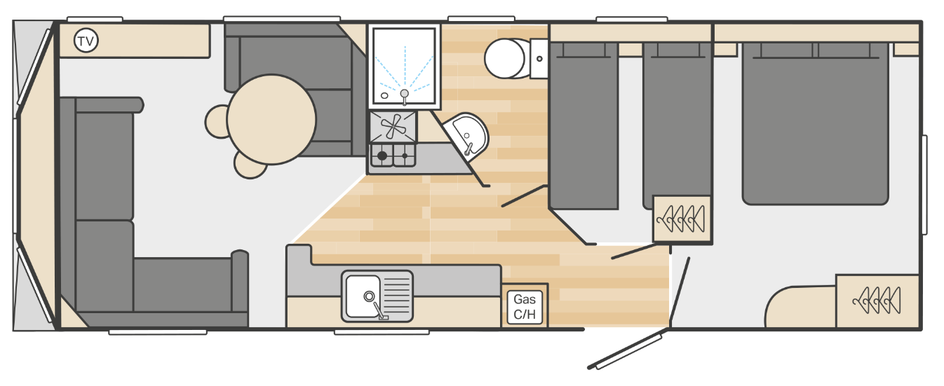
Sleeps 6 - one double bed (2) , 2 twin beds (2) and a sofa bed (2)
Length - 8.63m
Width - 3.05m
Low energy LED lighting throughout
1x washroom

Loire Caravan Layout - From £37,780 (Swift Group)
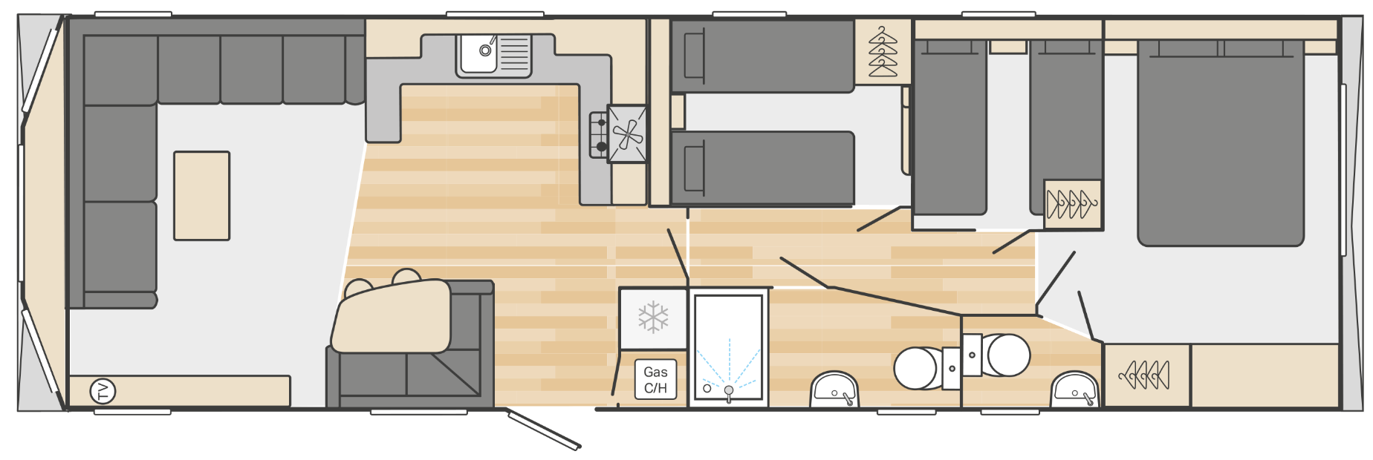
Sleeps 8 - one double bed (2) , 2 twin bedrooms (4) and a sofa bed (2)
Length - 11.73m
Width - 3.7m
Low energy LED lighting throughout
Fridge freezer
2x toilets (one is also washroom)

These are the cheaper models on the swift group website, the most expensive van on their website starts from 71,660.

Assuming they went with the cheaper van, and made no alterations, the van would cost an estimated £31,090. (Excluding delivery as this will vary)

To make an estimate for how much money this could generate, I went through to the booking stage for a savers caravan holiday with a haven holiday park in their lakeland holiday park.
With the ‘haven hideaway’ option which provides access to the restaurant but no free access to other entertainment (similar to what would be available at afon teifi with suggested changes), a 7 night stay for 2 adults, 2 children and 1 dog, would cost around £479. This was a booking from the 1st- 8th July - Mid Summer holidays.

If we go off thes prices, for the cheapest swift Caravan at £31,090, if they charges 479 for 7 nights ( £68.42 per night), during peak seasons,

31,090 ÷ 68.42 = 454.4 (1dp)

454 days = 64.8 weeks

On peak season assuming this price is its highest, to pay off the initial cost of 1 caravan (not including maintenance or delivery fees, as these will vary) would take selling 455 days of peak season holiday stays, which is equivalent to approximately 65 weeks.

As caravans can last years if well maintained (typically 12 years in good condition) , and can be used year round if well insulated,it’s highly likely to pay for itself within the first few years of use if well promoted. It's definitely a long term investment. To get the full benefit of having caravans, I’d advise hosting at least 3-5, ideally more to spread cost. More caravans will attract more visitors, and will look aesthetically much better and more inviting to have a collection together than one standalone. I've provided an example of budget caravans, however it would be more advisable to pay the extra for more luxury caravans, for better holiday experience and to attract more interest. They can also charge far more for better quality caravan holidays.

An alternative route is “glamping” in yurts for which they can charge significantly more per stay covering their costs at a quicker rate. Yurts are popular options for campers, and appear to be on the rise. This will likely be a better investment than cheap caravans. Yurts are “built using ancient techniques, handed down through generations of nomadic tribes. Built to withstand extreme climates” (fieldmag) designed to be portable, and spacious.

Modern yurts can be assembled within a few hours, sometimes less depending on size and help. Woodland yurts, a uk company, has been making and selling yurts since 1991. They are made to order, with their cheapest solid oak door option beginning at £3,300 for 4 ft walls and 11ft ger. The most expensive with the same design is their 5ft wall and 19ft ger, starting at £9,300. The yurts are made with a solid oak and ash frame, full canvas cover and a groundsheet. For an extra £100, you can add a window with a blind. Yurts are designed to be robust and withstand harsh weather conditions, and so the wet and windy climate Wales so often has to offer will be no threat to yurts. Their round shape reduces wind resistance and the reduced surface area means less exposure to outside temperatures. “They can keep you warm in the winter and cool in the summer.” (fieldmag)
Yurts are ideal for luxury group camping, or as a community space, and so the bigger they are the more suitable they are for larger groups. A week's stay in a luxury yurt could easily sell for £1000 if not more during peak seasons. The price could be fixed regardless of numbers, and so the more people who stay at a time the more the cost is spread, enticing more visitors at a time. “Depending on the size, yurts can accommodate separate rooms, comfortable beds, bathrooms, kitchens, and even have electricity. Some yurts can comfortably lodge between five and fifteen people” (fieldmag)

The cost for a medium sized 5ft wall and 15ft ger yurt is £5500. Including UK delivery and an added window with blind, that is £5800. It is self assembled, but comes with written instructions as well as a simple to follow youtube video guide. Good quality Yurts are significantly cheaper investment than the cheapest caravans, can be let out for a much higher cost, and are much more unique, with increasing popularity.

Afon Teifi campsite could use a Yurt as a community hub at the site, maybe using it as a base to teach woodland crafts, and/or to store equipment to host outdoor activities such as sports and outdoor games. Volunteers could run craft workshops, yoga classes and meditation classes. All in keeping with the calm retreat atmosphere the site already upholds. With a growing aging population who no longer work in Newcastle emlyn, there are bound to be people who may wish to volunteer to take part in the community it will create.

Community hubs, pop up shops and business support in the unused buildings.

During our visit to Newcastle Emlyn, researching the town, a large criticism we received form the locals is the lack of initiative for unused buildings in the town, either abandoned or closed as businesses relocated elsewhere. There was a general consensus that far more could be done, with many suggesting pop up shops for local sellers to have a temporary base such as around seasonal holidays; christmas, halloween, easter etc, when sellers may have handmade, or a limited supply of seasonal items to sell. Another use is community event spaces for entertainment or group meetings. The main reason given for the buildings remaining disused is the high price for renting the buildings. The locals cannot afford the rates, and big businesses who can afford it, do not come to the area as there is no business and it would be a poor investment on their part, so the buildings remain unused. If purchased by the council, and spaces were rented at affordable rates, locals could afford to use these spaces for community projects such as temporary art galleries or trial business venture startups, popular suggestions amongst the locals we interviewed in the town.

The June 2021 regeneration plan outlined the issue of disused buildings and offered similar suggestions for uses and proposals for the council to purchase the disused buildings they don't yet own, to rent out at affordable rates to the public. According to their statistics, in June 2021, the research showed that compared to rural carmarthenshire for the 10 years prior, there is “a growing older-aged population, decline in the working-age population, below-average economic activity and full-time employment, lower than average household incomes, lower-skilled local economy, higher than average levels of home working and self-employment” (NE Regen.pdf, 2021)

The main reason for such high self employment is the lack of employment available in the area. The only large employer is the local dairy industry. If the council invested in repurposing buildings for business use, building more housing on disused land, and investing in maintaining the architecture that already exists, more jobs could be created in these spaces.

When searching for Newcastle emlyn online, the first page shows minimal information about annual events such as the foodfair or victorian christmas, and no information on the local independent businesses. The information that is ther appeals to an older audience with the language and tone used to portray the towns key assets, selling a destination for older generations keen on preserving heritage, and doesn't appeal to younger people. The town has potential for strong appeal to younger people with all the independent quirky businesses not on other high streets, however has no activity beyond this to attract that audience. Better online presence and promotion is critical, and there needs to be more of a reason to stay in the town. The annual events typically keep people for a few hours, but there is little to keep people in the town for extended stays, and there is limited overnight accommodation for those who do.

In conclusion, Newcastle emlyn has a lot of potential however its shortcoming is its reliance on visitor trade, and its lack of visitors. The town lacks attractions for many young people. There is no cinema or youth clubs, very little for young families and seems to appeal to an older generation, which is reflected in the area's demographic. There needs to be more to draw people into the town if they are relying on visitors, yet there is very little initiative to do so. The annual events last a few hours and although people visit and they are popular, there is nothing to keep them there after the celebrations. Better online presence so people know what businesses are in the town. Currently all websites by the council look very dated and need a redesign. Investment into community spaces, activities and youth clubs for younger people could boost the community and trade in the town. Making the disused buildings available assets in the community is key in reviving the town, without it, more and more buildings will empty with lack of trade and relocation until the town is bare.

References:

Afon Teifi. (accessed February 2022). Afon Teifi Caravan & Camping Park, West Wales. URL: http://www.afonteifi.co.uk/

Carmarthenshire county council. (June,2021).Newcastle Emlyn Economic Recovery & Growth Plan. [pdf]. URL: https://moodle.uwtsd.ac.uk/pluginfile.php/576008/mod_resource/content/1/NE%20Regen.pdf

Carmarthen County Council. (June 2016). Moving Rural Carmarthenshire Forward. [pdf]. URL:
https://moodle.uwtsd.ac.uk/mod/resource/view.php?id=406002

Castles today. (accessed February 2022). History of Newcastle Emlyn Castle. URL:
https://castles.today/castles/castles/wales/newcastle-emlyn/history/

Distinctiveness and regeneration. (2022). Hyperlinks Newcastle Emlyn and Teifi Valley . [word doc] URL:
https://moodle.uwtsd.ac.uk/mod/resource/view.php?id=392973

Distinctiveness and regeneration. (2022). Lecture - Newcastle emlyn. [powerpoint] .URL:
https://moodle.uwtsd.ac.uk/mod/resource/view.php?id=392948

Distinctiveness and regeneration. (2022). Types of regeneration.[powerpoint] URL:
https://moodle.uwtsd.ac.uk/mod/resource/view.php?id=306820

Fieldmag. (accessed March 2022). What Is a Yurt? A Guide to Semi-Permanent Cabin Style Dwellings. URL: https://www.fieldmag.com/articles/what-is-a-yurt-guide

Newcastle Emlyn Town Council. (accessed February 2022). HISTORY OF NEWCASTLE EMLYN. URL:
https://www.newcastleemlyntowncouncil.co.uk/ncetowncouncil/town-history

Newcastle Emlyn Town Council. (accessed February 2022). Newcastle Emlyn Town Council. URL: https://www.newcastleemlyntowncouncil.co.uk/ncetowncouncil/annual-events

Newcastle Emlyn Traders Group. (accessed February 2022). Visit Newcastle emlyn. URL: https://www.visitnewcastleemlyn.co.uk/

Newcastle Emlyn Traders Group. (accessed February 2022). About Newcastle emlyn. URL: https://www.visitnewcastleemlyn.co.uk/explore/about-newcastle-emlyn/

Ross,D.(accessed February 2022). Newcastle Emlyn, Carmarthenshire
History, tourist information, and nearby accommodation. Britain Express. URL:
https://www.britainexpress.com/wales/pembrokeshire/az/newcastle-emlyn.htm

Safeguard. (accessed February 2022). Everything you need to know before buying a caravan. URL: https://www.safeguarduk.co.uk/customer-zone/everything-you-need-to-know-before-buying-a-caravan

Tripadvisor. (2022). The 10 best Things to Do in Newcastle Emlyn. URL: https://www.tripadvisor.co.uk/Attractions-g580438-Activities-Newcastle_Emlyn_Carmarthenshire_Wales.html

WoodlandYurts.(2022). Buy a yurt. URL: https://www.woodlandyurts.co.uk/buy-a-yurt/

WoodlandYurts.(2022). Yurt Facts. URL: https://www.woodlandyurts.co.uk/yurt-facts/

