HPAH6080. Ancient Lives in Death.
March 2026.

Report on an experimental study of the desiccation of organic material by the use of different salts in order to understand the nature of Ancient Egyptian mummification.
Gareth Jenkins. Student no. 99091195.

Abstract.
In Ancient Egypt, the preservation of the body following death by mummification was a crucial aspect of their funerary beliefs. The primary feature of their mummification process was the desiccation of the body by using natron. This paper will outline an experiment to understand the desiccation process by using different salts to desiccate organic material. The results indicate that common table salt and Epsom salts work better than other salt varieties and also demonstrates the value of scientific analysis to the archaeological interpretation of ancient civilisations.
Keywords. Ancient Egyptian, desiccation, salt, mummification.

Introduction.
A vital component of Ancient Egyptian funerary ritual was the preservation of the body (Shaw & Nicholson, 2003, p. 190). The Egyptians held that an individual's life energy, or ka, would go hungry and their journey to an afterlife would be in danger if the corpse were decaying and unrecognisable (Ikram & Dodson, 1998, pp.15-21; Loynes, 2015, p.1; Shaw & Nicholson, 2003, p.190).
Aside from the physical mummified remains, sources regarding the process of mummification include funerary depictions and inscriptions, but these usually focus on anointing and wrapping practices (David, 2008, p.11). The earliest available source describing the materials used by the Ancient Egyptians during the mummification process was written by the Greek historian Herodotus in the 5th century BC (David, 2008, p.11; Herodotus, Nd, pp.57-60; Ikram & Dodson, 1998, p.103; Loynes, 2015, pp.1-2). Herodotus’ account, combined with descriptions from later Classical authors, has been used as a framework for research on mummification methods (Ikram & Dodson, 1998, p.103). However, many of these sources were not first-hand accounts and were more likely recorded purely for historical reference, which can cause inconsistency (Aufderheide, 2010, p.217).
The use of science in archaeological interpretation has long been a cause of debate, particularly within a discipline usually associated with the study of humanistic or culture studies (Zakrzewski et al, 2016, p.4). Science can provide distinct archaeological interpretation by creating and reassembling ideas and representations of human behaviour and ways of life by experimentation, evaluation and analysis (Zakrzewski et al, 2016, p.4).
The desiccation of the body appears to be a primary feature of the mummification process in Ancient Egypt (Aufderheide, 2010, p.43; Ikram & Dodson, 1998, p.106; Lucas & Harris, 1989, p.272). The earliest mummified remains in Egypt were found in pits dug in the desert sand and were naturally desiccated by extremely hot and dry conditions (Aufderheide, 2010, p.43; Ikram & Dodson, 1998, p.108-112; Nicholson & Shaw, 2009, p.373; Zink, 2014, p.97). Later mummification practices involved the artificial desiccation of the body by the use of minerals such as natron to dry the body and prevent decomposition (Aufderheide, 2010, pp. 41-43; Ikram & Dodson, 1998, pp.103-113; Öhrström et al., 2020, p.861). Natron which is composed of a mixture of sodium chloride (Salt), sodium bicarbonate, sodium carbonate, and sodium sulphate, is naturally found in Egypt and has good desiccation properties (Ikram & Dodson, 1998, p.104; Öhrström et al., 2020. p.862).
This paper will discuss an experiment conducted to investigate the desiccation of organic material using various salts in order to understand the nature of mummification in ancient Egypt.

Method.
Two pork sausages shown in Figure 1, composed of 71% homogenised, smoked and scalded pork meat were halved and immersed in quantities of different salts, wrapped in plastic bags Figure 2, and left on a table covered by a tablecloth, within a classroom environment at room temperature. At the end of the first week, they were examined and any changes in their structure recorded, before re-wrapping in their plastic bags and left for a further week. Following a third week, they were re-examined and details of any changes noted. All relevant data such as weight loss or gain, and any contraction in material composition, as well as any changes in colour, smell and texture were recorded on spreadsheets which can be seen at Tables 1 & 2.

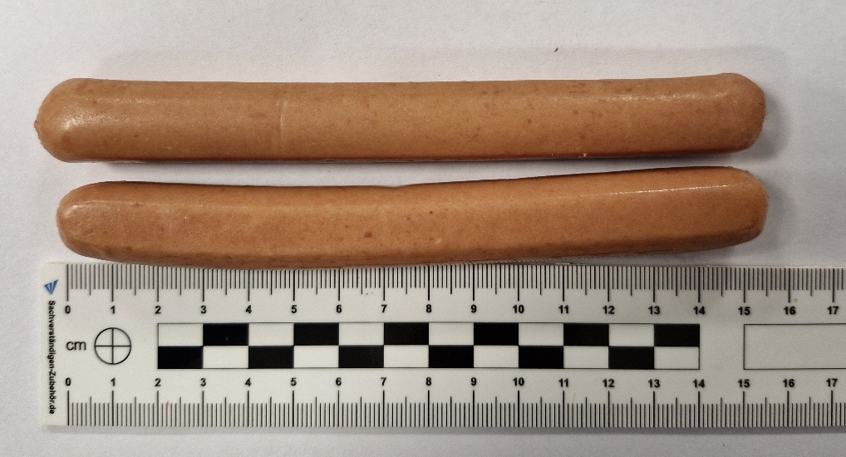
Figure 1, photograph of the two sausages used prior to halving (Author, 2026).

Sample 1 was a control sample which was not subjected to any immersion in salt and was purely left wrapped in a plastic bag. This was done to provide a comparison and to ensure reliable results were achieved.
Sample 2 was immersed in 150g of table salt, made up of Sodium chloride with an added Anticaking agent Sodium ferrocyanide.
Sample 3 was immersed in 150g of Epsom Salts, which was composed of 100% Magnesium sulphate heptahydrate.
Sample 4 was immersed in 150g of bicarbonate of soda, also known as baking soda, which is composed of sodium bicarbonate.

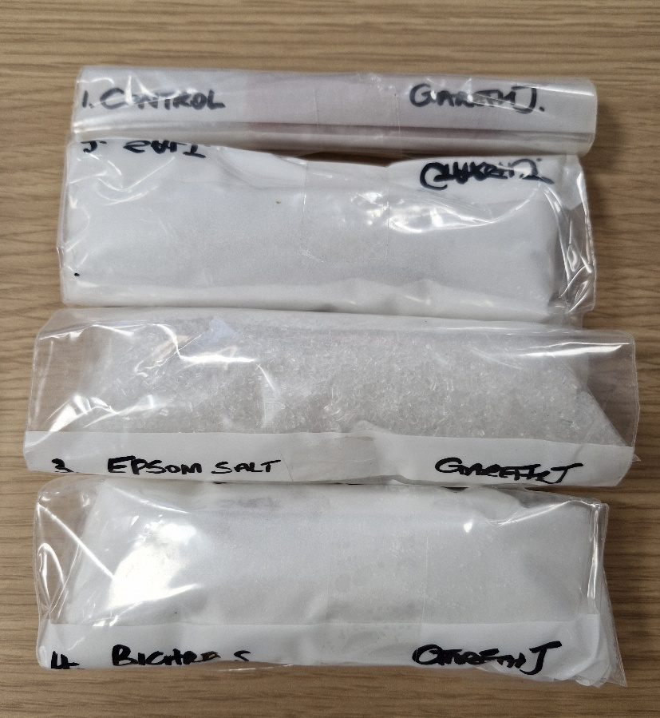
Figure 2. Photograph of prepared samples wrapped in plastic bags (Author, 2026).

Results.
The following results should be read in conjunction with Tables 1 and 2 below.
Sample 1. The control sample did not receive any intervention apart from wrapping in a plastic bag. After the first week, the sample was found to be very slimy and had stained the bag with a light brown coloured sticky residue, shown in Figure 3. The thin skin layer was peeling, shown in Figure 4. The sample showed no change in colour and retained its smoked sausage smell. What appeared to be bacterial growth was seen on the cut edge where the internal meat was exposed as shown in Figure 5.

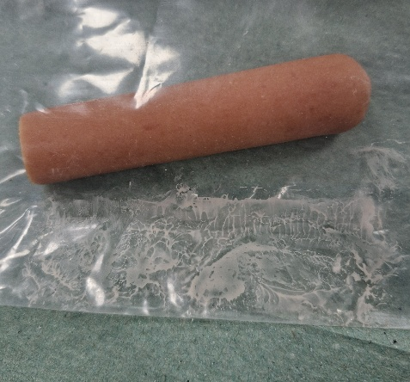
Figure 3. Photograph of Sample 1 after one week showing sticky residue left on the bag (Author, 2026).

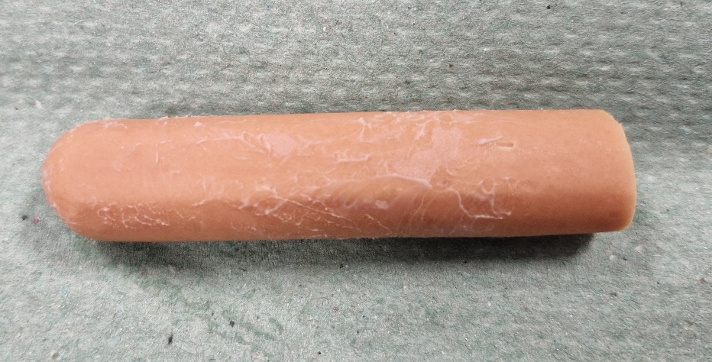
Figure 4. Photograph of Sample 1 showing the peeling of outer skin layer (Author, 2026).

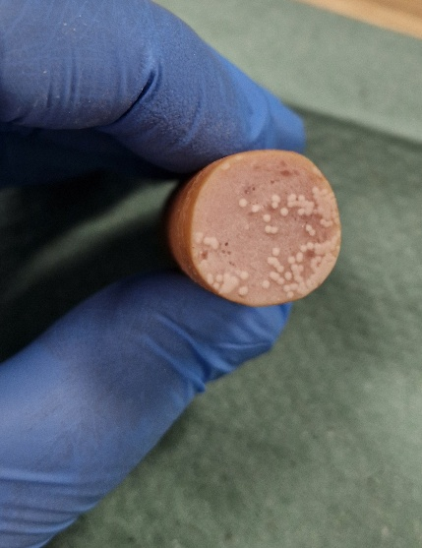
Figure 5. Photograph of the exposed inner meat of Sample 1 with possible bacterial growth (Author, 2026).

The sample had lost 0.2g in weight, which is 1% of its original weight. There was no decrease in the length but a slight decrease in the diameter of the sample.
When examined after a further week, there was no change in colour or smell, and the texture remained slimy and sticky. There was a slight increase in the size of the possible bacterial growth on the exposed meat. The sample had lost a further 0.74g in weight.
The total weight loss was 0.94g, that is 5.3% of the sample’s original weight.
There was no reduction in length or diameter, however, there is a possibility of an error when the diameter reading was taken at the end of the first week.

Sample 2. After one week there was significant change in colour from a light brown to a dark brown as seen in Figure 6. There was no change in smell, but the sample had lost is pliability and was firmer, with a leathery texture.
The sample had lost 6.7g, that is 39% of its original weight and had decreased in length by 0.6cm. It had also lost 0.2cm in its diameter.

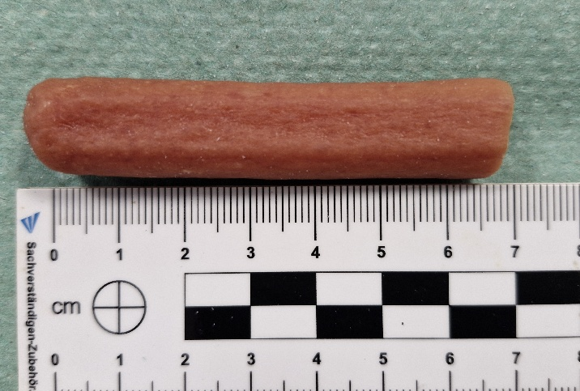
Figure 6. Photograph of Sample 2 showing change in colour to a dark brown (Author, 2026).

At the end of a third week there was no further change in colour, and the texture was dry and hard with a tight leathery skin. Some small pliability was noticed. The sample had lost a further 0.1cm in its length and similarly 0.1cm in its diameter. The total contraction is 1.3cm or 17.33% of its original size.
The sample had gained 0.35g in weight, which may have been by reverse osmosis from the salt (Coard, 2026, pers. comm).
The sample had lost a total of 6.35g in weight, which is 37% of its original weight, even though a small weight gain was noted after three weeks.

Sample 3. After one week there was a significant change in the colour of this sample from its original light brown to a dark brown as seen in Figure 7. There was no change in smell, but its texture had become firmer. The sample had lost 7.7g in weight, which is 41% of its original weight. The sample had decreased in lengthy by 1cm, and its diameter had decreased by 0.3cm.
After a further week, the colour appeared to be a slightly darker brown. Its texture was dry, hard and leathery, and a possible slight curve in its shape may be as a result of the tightening of the outer skin.
The sample has lost a further 1.17g in weight, indicating a total weight loss of 8.87g, which is 48% of its original weight.
The sample had lost a total of 1.1cm in length, which is 13.75% of its original length.

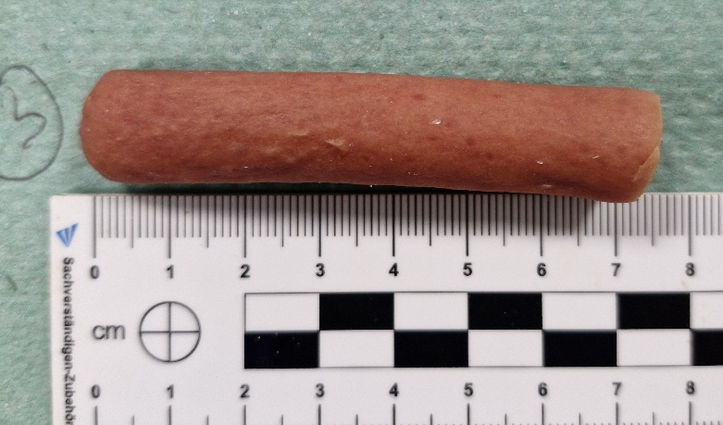
Figure 7. Photograph of Sample 3 showing change of colour to a dark brown (Author, 2026).

Sample 4. At the end of the first week the sample was a lighter brown that its original colour as seen in Figure 8 but was still very pliable and soft. The sample’s smell was noted as being slightly off.
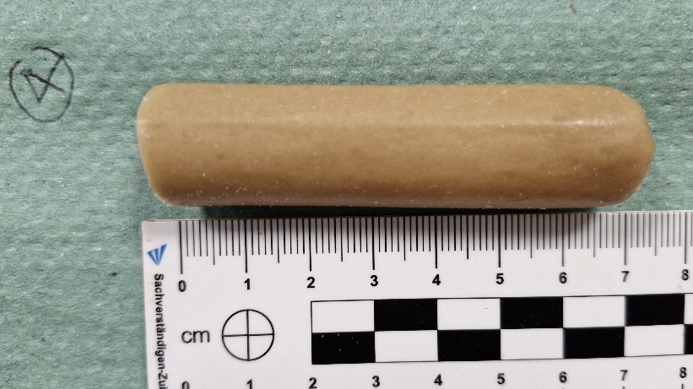

Figure 8. Photograph of Sample 4 showing change in colour to lighter brown (Author, 2026).
The sample had lost 2.5g, which is 14% of its original weight. There was no change in the sample length, however, there was a 0.3cm decrease in its diameter.
At week 3 the sample was noted to have a slightly lighter colour than week 2. There was no further change in smell. The texture was noted as being dry but very flexible, however it was also noted that the outer skin would split very easily when twisted. There appeared to be two small black spots, possibly mould on the outer skin.
The sample had lost a further 0.15g in weight. Its total weight loss was 2.65g, which is 15.2% of its original weight. There was a small decrease of 0.2cm it the sample length, but a gain of 0.3cm in its diameter. Its total contraction was 0.2cm, which is 2.86% of its original size.

Discussion of results.
The core objective of mummification in Ancient Egypt was the desiccation and preservation of the body in readiness for the afterlife (Ikram, 2015, p.53). A key element in this process was the use of natron as a desiccating agent (Ikram, 2015, p.54). Natron was not available for the purposes of this experiment and therefore a variety of other salts were used. Lucas claims that common salt has never been found in Ancient Egyptian mummification, although this is subject to debate among scholars (Lucas & Harris, 1989, pp. 274-278).
During this experiment, the control sample showed signs of decomposition and fungal growth. The other samples did not. Table salt did provide good evidence of desiccation within the three-week period.
There are significant differences in the total weight loss for each of the samples. Sample 3 which was immersed in Epsom Salts shows the highest amount of weight loss, as seen in Table 1a.

Possible contamination of samples.
Details of the composition of each product used can be seen at Appendix 1.
The organic material used for the purpose of this experiment is processed and contains several common chemical compounds used in the food processing industry to stabilise food products, that is E450 – diphosphate, E621 – Monosodium glutamate, E301 – Sodium ascorbate and E250 – Sodium nitrite (Food Standards Agency, 2026), and consideration must be given to these chemicals having some influence on the final results.
Additionally, the table salt used in the experiment contained an anti-caking agent, Sodium ferrocyanide, and consideration was given as to whether this chemical element would have a direct impact on the chemical compounds in the sausage. However, this is not believed to be the case according to recent analysis (European Commission, 2001).
The plastic bags used are made of polythene and are a well-known source of contamination by plasticisers (David, 2008, pp.135-136).
Additionally, the sensitivity of organic material to sunlight was considered (David, 2008, p.136), but as the samples were covered by a tablecloth it is believed this would prevent any issue.

Conclusion.
Sodium bicarbonate did not desiccate its sample very successfully, only by 15%. It may have provided better desiccation during a prolonged period, and this could be the subject of further examination.
The Epsom salts provided the best results for desiccation, with the sample losing 48% of its original weight and 13.75% in length. The sample also showed signs of a tightening of the skin and significant change in colour and texture. These results showed particular similarities to images of Ancient Egyptian mummified remains as seen in Ikram & Dodson (1998, pp. 109-127).
Epsom salts, commonly referred to as magnesium sulphate, is a naturally occurring element that contains oxygen, sulphur, and magnesium, and has the appearance of common salt but does not contain sodium (Eske, 2024). It was not a naturally occurring substance in ancient Egypt having been discovered in England in the 17th century (Schwarcz, 2023). It may therefore be prudent to carry out further experimentation using magnesium sulphates to establish its correlation with the primary substance used by the Ancient Egyptians, natron.
A key element of this experiment is that is has demonstrated the value of scientific analysis to the archaeological interpretation of the customs and traditions of the Ancient Egyptians.

Table 1. Weekly measurements and percentage changes.
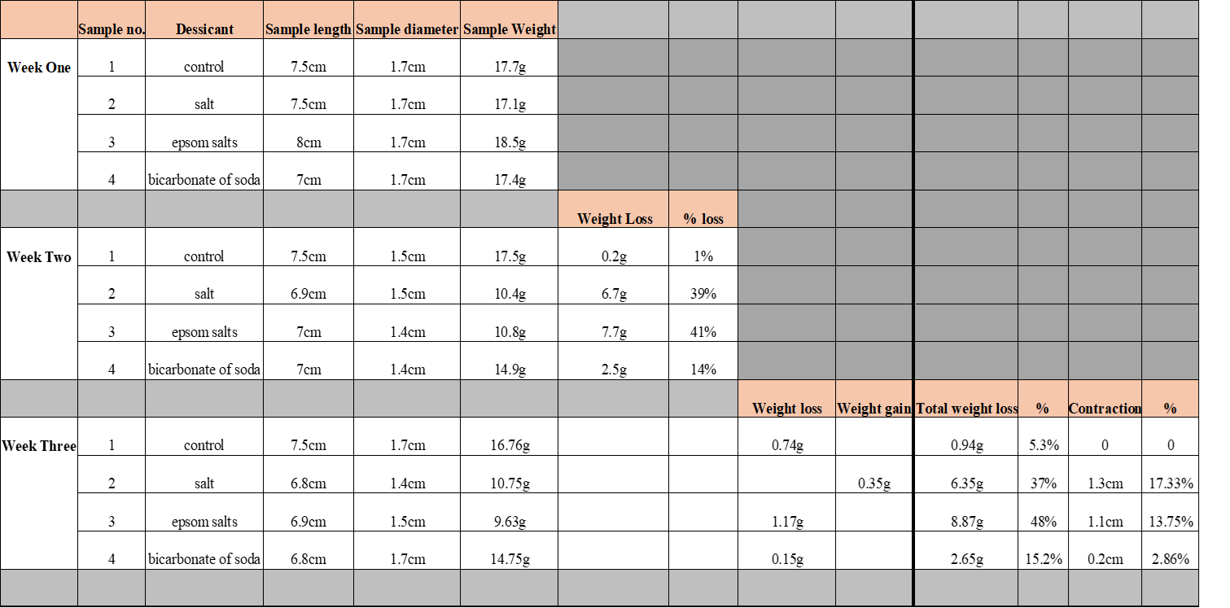

Table 2. Changes in colour, smell and texture.

References.
Aufderheide, A. C. (2010). The scientific study of mummies (1st pbk. ed.). Cambridge University Press.
David, A. R. (Ed.). (2015). Egyptian mummies and modern science. Cambridge University Press.
Eske, J. (2024). Epsom salt uses and benefits. Available at: https://www.medicalnewstoday.com/articles/epsom-salt (Accessed: 24 March 2026).
European Commission. (2001). Opinion of the Scientific Committee for Animal Nutrition on the Safety of Potassium- and Sodium ferrocyanide used as anticaking agents. Available at: https://food.ec.europa.eu/system/files/2020-12/sci-com_scan-old_report_out70.pdf (Accessed: 22 March 2026).
Food Standards Agency. (2026). Approved additives and E numbers. Available at: https://www.food.gov.uk/print/pdf/node/847 (Accessed: 22 March 2026).
Herodotus, (N.d.). An Account of Egypt. Translated by Macaulay, G. C. Abbott Classics.
Ikram, S. & Dodson, A. (1998). The Mummy in Ancient Egypt: Equipping the Dead for Eternity. Thames & Hudson.
Ikram, S. (2015). Death and Burial in Ancient Egypt. The American University in Cairo Press.
Loynes, R. (2015). Prepared for eternity : a study of human embalming techniques in ancient Egypt using computerised tomography scans of mummies. Archaeopress.
Lucas, A. & Harris, J. R. (1989). Ancient Egyptian Materials and Industries. Histories & Mysteries of Man Ltd.
Nicholson, P. T. & Shaw, I. (Eds). (2009). Ancient Egyptian Materials and Technology. Cambridge University Press.
Öhrström, L., Tekin, A., Biedermann, P., Morozova, I., Habicht, M., Gascho, D., Bode‐Lesniewska, B., Imhof, A., Rühli, F., & Eppenberger, P. (2020). Experimental mummification—In the tracks of the ancient Egyptians. Clinical Anatomy (New York, N.Y.), 33(6), 860–871. Available at: https://doi.org/10.1002/ca.23568 (Accessed: 4 March 2026).
Schwarcz, J. (2023). A Farmer, Epsom Salt, Moses, and some Sweet Chemistry: Epsom salt makes for bitter water but its magnesium content makes for some sweet chemistry. Available at: https://www.mcgill.ca/oss/article/history-did-you-know/farmer-epsom-salt-moses-and-some-sweet-chemistry (Accessed: 24 March 2026).
Shaw, I. & Nicholson, P. (2003). The Dictionary of Ancient Egypt. Harry N. Abrams.
Zakrzewski, S. R., Shortland, A. J., & Rowland, J. (2016). Science in the Study of Ancient Egypt. Routledge/Taylor & Francis Group.
Zink, A. (2014). The World of Mummies: From Otzi to Lenin. Translated by Werschkun, C. Pen & Sword Archaeology.
Appendix 1.
Photographs of the packaging for each of the products used during the experiment, providing details of contents and chemical additives.


