
MSc. Public Health and Social Care in Practice
COMMUNITY CARE AND MANAGEMENT OF LONGER-TERM CONDITIONS
LCHS7003

Student ID: 2522651
Student name: Noman vajoddin Malek
COMPONENT 1 - INFORMATION BOOKLET OF LONG-TERM CONDITION MANAGEMENT
ON
DEPRESSION

Table of Contents

1. Introduction 2
2. Understanding Depression as a Long-Term Condition 2
2.1 Definition and Epidemiology 2
2.2 Depression and Multimorbidity 3
3. Impact of Depression 4
3.1 Physical Impact 5
3.2 Psychological Impact 6
3.3 Social Impact 7
4. Evidence-Based Treatment in the NHS 8
5. Theoretical Models and Frameworks 10
6. UK Policy and Political Context 11
7. Recommendations for Improved Care 12
8. End-of-Life Considerations 13
9. Conclusion 13
Reference List 14

1. Introduction
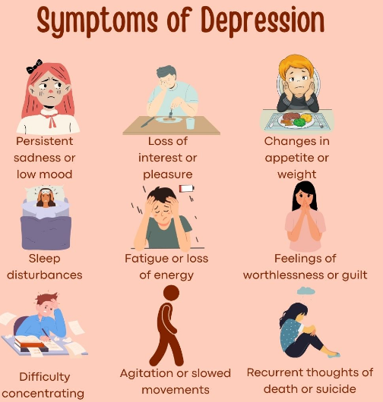
This booklet targets health students and community practitioners in the UK to learn about depression as a long-term condition. Depression is a severe mental disorder which is marked by low mood, loss of interest, fatigue as well as impaired functioning. Its frequent occurrence and association with multimorbidity augment health care demands and burden to society. The topics considered in this booklet are prevalence, impact, theory, NHS treatment, policy context, and person-centred approaches. The aim is to critically evaluate depression and help enhance community-based management.

2. Understanding Depression as a Long-Term Condition

2.1 Definition and Epidemiology
Depression can be described as a mood disorder that is marked by feelings of persistent sadness, loss of interest or pleasure, lack of energy, poor concentration, sleep problems, and poor functionality. It is more and more becoming a long-term condition because it is recurrent, it has high relapses, and a great likelihood of coexistence with chronic physical disease. Depression has been identified to affect a total of about 280 million individuals worldwide, which is about 3.8% of the entire population (WHO, 2025).

Figure 1: Symptoms of Depression
(Source: Inspired by the ideas of de Sousa et al. 2025)
Depression is a significant cause of Years Lived with Disability (YLDs) and is found to be associated with over 720,000 suicidal deaths each year. It is a significant public health issue. Prevalence is still high in the United Kingdom. Among adults, 1 out of 6 individuals reports moderate or severe depressive symptoms at any specific point in time (Mind, 2025). The prevalence is estimated at 4-10% each week in adults (women are almost twice as often affected as men) (Mental Health Foundation, 2025). Risk is also increased by socioeconomic stress. In times of economic uncertainty, up to 27% of adults were reported to have depressive symptoms linked to the cost-of-living pressures, which means the sensitivity of mental health to economic hardship (ONS, 2025). Depression is often chronic or relapsing in nature. In a longitudinal review conducted by de Sousa et al. (2025) over 10 years, it was identified that the relapse rates are over 50% in five years after the first episode and that in many individuals, depression is not an event but an ongoing weakness. The NCBI epidemiological review also shows consistency in prevalence of cross-cultural factors, but with higher rates among the socially underprivileged and those having chronic illnesses which supports the idea of social determinants in long-term risk (NCBI, 2025).

2.2 Depression and Multimorbidity
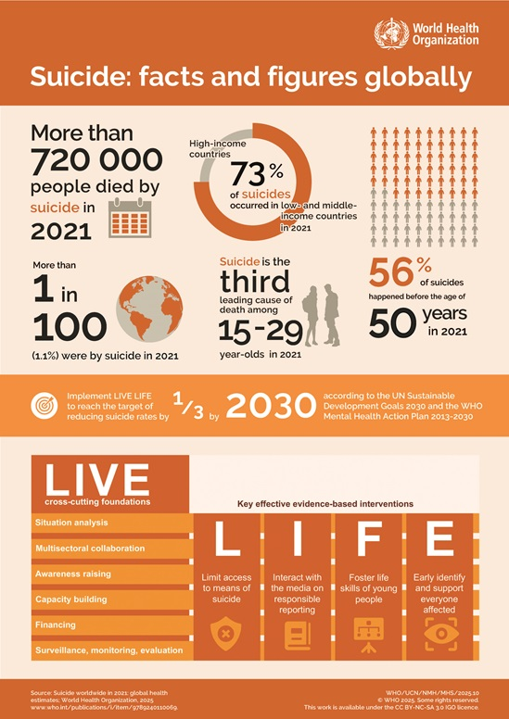
Depression is very rarely an isolated condition. It is commonly present together with physical chronic illnesses, making it difficult to control and leading to the aggravation of the outcome. According to Gregg et al. (2025), the general long-term conditions are defining the shift of global trends in chronic diseases, especially in the field of diabetes, where mental health comorbidity complicates and raises the cost burden. Patients with diabetes and depression die and spend much more on healthcare than their comorbidity-free counterparts (Fanelli et al., 2025). The metabolic dysregulation also affects the treatment outcomes. The examination of UK Biobank primary care data shows that insulin resistance correlates with a worse response to antidepressants, and patient groups refer to the general NHS care, which may be measured in the millions (Fanelli et al., 2025).
Figure 2: Global Prevalence of Depression
(Source: WHO, 2025b)
As shown in the figure above, over 720,000 people died in 2021. In this, 73% were in low- and middle-income countries, and 56% of them younger than 50 years (WHO, 2025b). These statistics illustrated that the mental health burden on the globe can be significantly high. The relationship between suicide and mental conditions, especially depression is found to be well established in high-income countries. Women with chronic disease and multimorbidity are more prone to depressive symptoms in mid-to-late life, which highlights the gendered vulnerability throughout the lifespan (Zhang et al., 2025). High-tech population analytics enforce this trend. Smith et al. (2025) provided multimorbidity clusters according to which depression often presents in combination with cardiometabolic and respiratory disorders. This kind of clustering facilitates categorisation of depression as a chronic illness that is built into larger disease networks and not a separate psychiatric disorder. The exceptional rates, chronic relapse rates of more than 50, associations of multimorbidity and close correlations to socioeconomic disadvantage all have a role to play in the legitimacy of the classification of depression as a long-term, complex and chronic disorder that needs management by communities and not by episodic intervention.

3. Impact of Depression
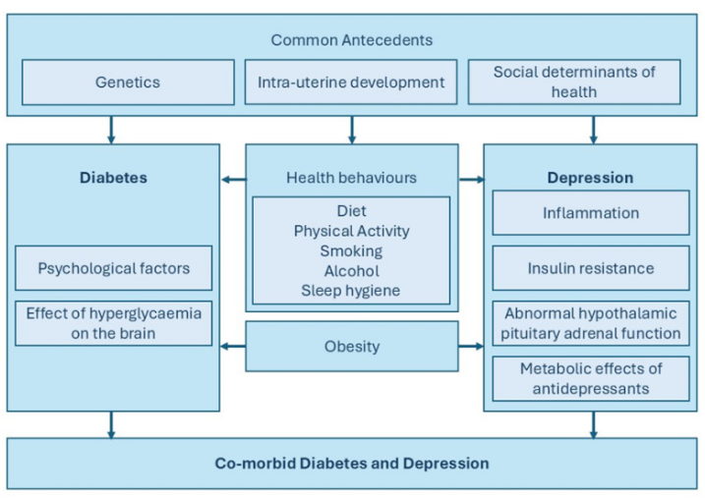
Depression has multidimensional effects that are not limited to mood disturbance but also to physical health, psychological resilience, social involvement and family functioning. It is further exacerbated in its presence with long-term physical ailments that build up pressure on healthcare systems and communities.

3.1 Physical Impact
Depression has been linked to high cardiovascular morbidity, dysregulating metabolism and low adherence to treatment. As per the ideas of Amouzadeh-Ghadikolai et al. (2025), early depressive symptoms were discovered to be one of the red flags that indicate the onset of post-traumatic stress and worse recovery patterns following acute myocardial infarction. Such observations indicate that psychological trauma at an early age may directly affect cardiac outcomes and cardiac mortality. Comorbid anxiety and depression in chronic obstructive pulmonary disease led to an increased rate of exacerbation and hospital admissions, thus increasing healthcare utilisation and cost burden (Siraj, 2025). COPD already has a prevalence of 1.2 million in the UK, and when depression is added, it significantly increases the clinical outcomes and quality of life. There is additional complexity of metabolic comorbidity.
Depression is related to poor glycaemic control and elevated complication rates in patients with diabetes, which are substantially worse than those who are not depressed (Fanelli et al., 2025). Holt (2014) explained the link between diabetes and depression.
Figure 3: Global Prevalence of Depression
(Source: Holt, 2014)
Since over 4.3 million individuals in the UK are now living with diabetes, the comorbidity of depressive symptoms is a significant issue of concern at a population level. Rehab methods are promising but indicate barriers to implementation. According to Evans et al. (2025), custom exercise-rehabilitation programmes for persons with a variety of chronic conditions are feasible and potentially effective. Nonetheless, compliance is not stable, especially with those who are socioeconomically disadvantaged. Both multimorbidity and depression are disproportionately found in the lower-income groups, which also supports the cyclical nature of poverty and physical health loss.

3.2 Psychological Impact
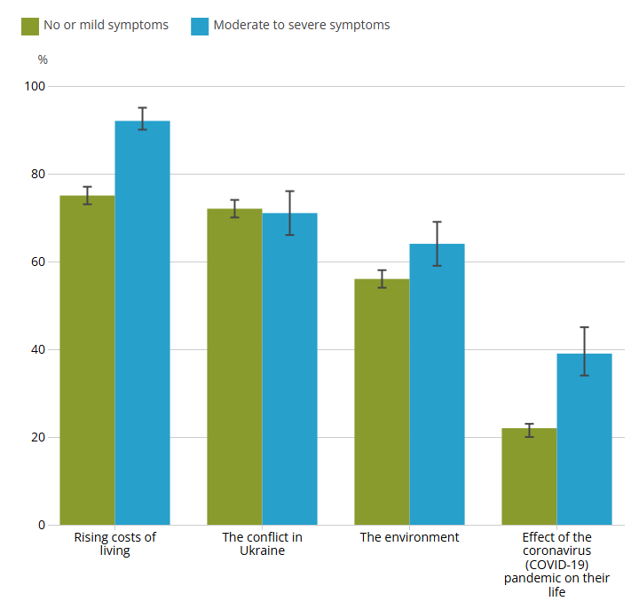
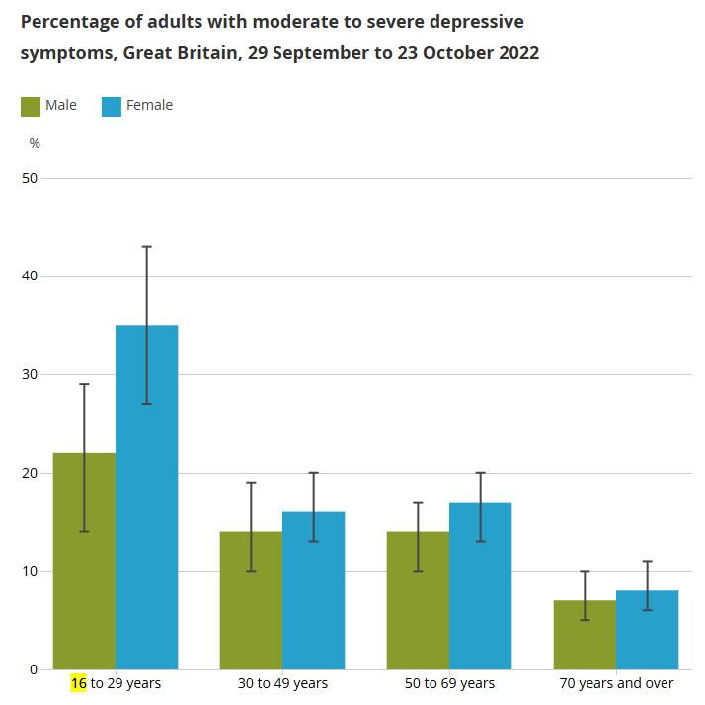
Figure 4: (a) Female (16 to 29 years) experience depression more, (b) Proportion of adults with depressive symptoms in Great Britain as of 2022
(Source: ONS, 2025)
The above two figures revealed that approximately 35% female with age between 16 and 29 years report the highest levels of depression, whereas its 22% in case of male (ONS, 2025). Figure (b) added that 92% of adults have shown moderate to severe symptoms of depression due to rising costs of living, which supports the study issues regarding psychological vulnerability (ONS, 2025). Depression is closely associated with suicidal danger and lifetime psychological ineffectiveness. Vulnerability increases in marginalised groups. According to Dagli and Webb (2025), structural exclusion and lack of mental access to health services are identified as reasons behind disproportionately high suicide risk in Roma and Traveller communities in the UK and Ireland. Another characteristic is chronicity. It is analysed through longitudinal data that the rate of relapse is over 50% in five years after the first depressive episode (de Sousa et al., 2025). Treatment resistance, poor occupational functioning, and interpersonal relationships are linked with persistent symptoms. Mental health burden in occupation is becoming the order of the day. According to Knights et al. (2025), the incidence of burnout and depressive symptoms is high in people belonging to the UK dental workforce, and professional groups that are exposed to persistent stress are at a high risk. This is indicative of a wider trend in the healthcare professions, in which workforce shortages and the rise in service demand are adding psychological pressure.

3.3 Social Impact
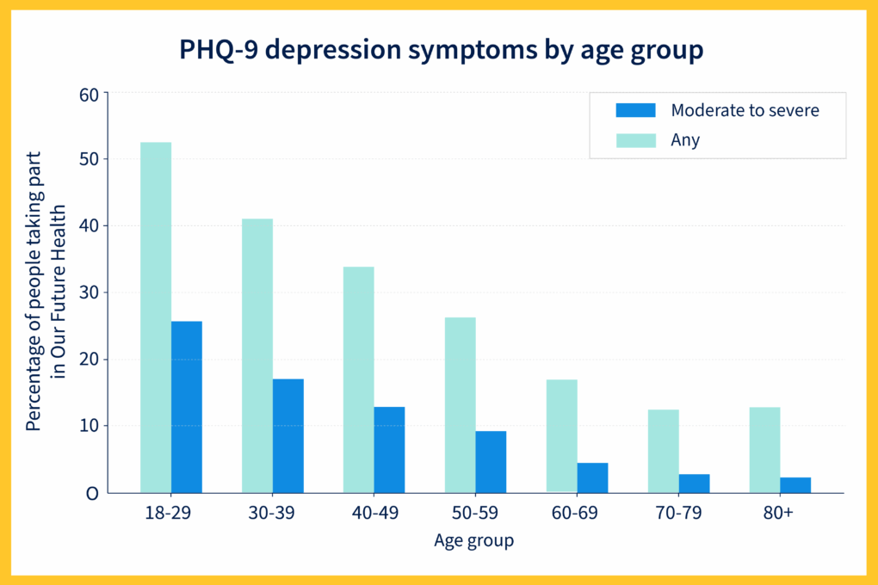
Depression is strongly influenced by social determinants. Awan et al. (2025) reveal that the South Asian males with long-term conditions experience distress associated with the financial strain, stigma and pressure because of migration. Limited help-seeking behaviours and cultural expectations also increase risk. Struggle on the economic front is a burning force. The sensitivity of mental health to macroeconomic turmoil has been proven by the fact that 27% of the UK adult population displays signs of depression during times of cost-of-living crisis (ONS, 2025). Financial insecurity not only causes more prevalence of symptoms but also lowers access to supportive services. There are still policy initiatives that do not eliminate inequalities in health. Melame et al. (2025) claimed that social prescribing programmes should address inequality through the connection of people with community resources, but adoption is still lopsided in deprived regions. There are also significant impacts on family systems. About one-fifth of the adults in the UK claim to be unpaid carers, and a substantial number of these adults claim to be experiencing lowered psychological well-being (Redican et al., 2025).
Depression in one member of the family requires more time and causes mutual stress and financial burden. System vulnerabilities were also further revealed during the COVID-19 pandemic. The disruption of services in community multidisciplinary teams serving older adults with long-term conditions and workforce pressure and backlog, indirectly increased the burden of depression in the high-risk populations (Rehackova et al., 2025). All in all, depression causes palpable physical morbidity, a high rate of suicide of 700,000 or more deaths in a year, high rates of relapse of more than 50% in five years and extensive social disruption up to 27% of the adult population in periods of economic crisis. Its effects are felt both in healthcare systems, labour markets and family structures, which puts it into the category of complex long-term conditions that need long-lasting integrated intervention.

4. Evidence-Based Treatment in the NHS

Figure 5: UK Depression Weekly Prevalence
(Source: Mind, 2025)
The above figure shown that 18 to 29-year-olds are the highest with depression (53%), followed by 26% with moderate-severe symptoms, thereby depicting youth to be most vulnerable to be focused (Mind, 2025). The NHS-based management of depression is organised according to the principles of stepped-care, where the severity of the symptoms and the functional impairment need to be aligned to the level of treatment. As only a small fraction of the UK population (1 in 6 adults) reports moderate to severe levels of depressive symptoms, interventions that are scalable and economical are necessary to address the needs of the population. The use of antidepressant medication is among the most actively prescribed in primary care. In a large population-based cohort study, it is established that antidepressants have real-world effectiveness in the reduction of the rate of relapse and hospital readmission in individuals with depressive disorder (De Crescenzo et al., 2025). Medication adherence, however, is inconsistent, especially among patients with the presence of multimorbidity and socioeconomic disadvantage. In the cases of persons having treatment-resistant depression, augmentation measures are usually necessary. A randomised controlled trial in the UK indicates that lithium augmentation is a better clinical and cost-effective option than quetiapine for patients who have already failed to respond to a preliminary therapy (Cleare et al., 2025). The results are strong enough to inform prescribing practice in the secondary care facilities, especially among patients with persistent or recurrent symptoms at a risk of 50% of relapse at five-year follow-up.
The NHS is based on psychological therapies. According to Barnhofer et al. (2025), mindfulness-based cognitive therapy provided following non-remission in NHS Talking Therapies was considerably better than treatment as usual in terms of clinical and cost-effectiveness. Due to the large number of referrals to NHS Talking Therapies services, it is necessary to implement interventions that can increase the rate of remission to alleviate the long-term disability and reuse of the service. As revealed in figure 6, these services are focused on psychological interventions for adults in England (NHS, 2025). This is significantly useful for people relying on British Sign Language (BSL).

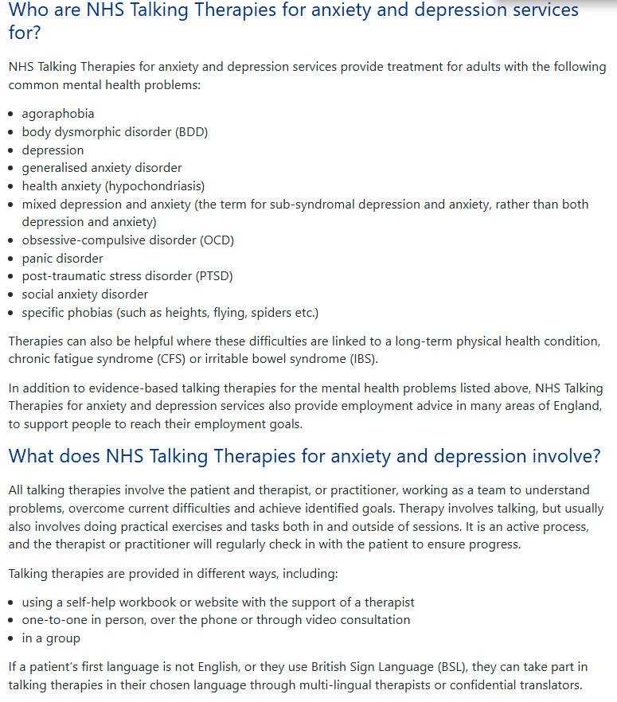
Figure 6: NHS Talking Therapies for dealing with depression
(Source: NHS, 2025)
It is also important to detect subthreshold symptoms in their early stages. According to Cabasag et al. (2025), people with chronic physical conditions very often experience subclinical depression symptoms, which are not identified in the primary care setting. Early screening can eliminate the progression to major depressive episodes and, as a result, lower healthcare use and enhance the quality of life. The IC approaches proved to be economically beneficial in the case of multimorbidity (Wang et al. 2025). It is discovered that the community-based interventions of patients with diabetes and depressive symptoms were cost-effective as they led to a decrease in the overall healthcare spending and improvement in mental health outcomes. The use of digital innovation is more frequently examined to assist with multifaceted decision-making. The article by Cooper et al. (2025) indicates a reserved professional acceptance of AI-assisted tools in the treatment of various chronic illnesses despite the existence of governance, transparency, and data protection concerns. Taken together, it is a sign that successful NHS handling of depression should be pharmacologically treated, psychologically treated, identified at an early age and combined with community care, with emerging digital technologies that can manage increased demand and multimorbidity intricacy.

5. Theoretical Models and Frameworks
The use of integrated care models in which coordination between primary care, secondary care, and social services is a priority is increasingly the model of managing depression as a chronic disease. The idea of multidisciplinary collaboration is especially relevant to the fact that 1 out of 6 adults in the UK has moderate to severe symptoms of depression and multimorbidity increases in the ageing population Whole-person care is based on practical foundations of community-based integrated models. As per the findings of Rehackova et al. (2025), the integrated care and support structures are created for older adults with have long-term conditions. It is determined that multidisciplinary team models enhanced continuity of care and service integration after the disruption of the COVID-19 period. This kind of framework shifts towards the episodic treatment to persistent monitoring and continuity. There is international evidence advancing the importance of integration. Wang et al. (2025) illustrated that community-based integrated care to people with diabetes and depressive symptoms appeared to be cost-effective. Integrated mental and physical care in chronic disease populations where depression may be more than 20-30 years old cuts down on the duplication and fragmentation.
Pretorius et al. (2026) criticise single-condition clinical guidelines, stating that patients with multiple long-term conditions are continually subject to inconsistent recommendations and overuse of treatment. Since multimorbidity became a dominant trend in epidemiology, the management of depression should cease isolated procedures and shift to flexible and individual-focused courses. The development of digital health analytics can facilitate this shift. The authors show that big language models are able to find clusters of multimorbidity at the population level and indicate patterns that are predictable in the context of depression being comorbid with cardiometabolic and respiratory conditions (Smith et al., 2025). High-risk groups may have precision-based chronic care pathways, which such data-driven stratification can make possible. Taken together, these theoretical frameworks highlight integration, flexibility and data-driven coordination as the key concepts towards the management of depression in complex networks of long-term conditions.

6. UK Policy and Political Context
The UK mental health policy facilitates equality of measure between mental and physical health and emphasises the provision of care in the community. Yet, the increasing prevalence as well as workforce limitations threaten long-term implementation. The proportion of adults with depressive symptoms reached up to 27% during the time of economic instability, which explains the magnitude of service pressure (ONS, 2025). These numbers raise awareness of the necessity of preventative and community-based approaches that are built into the Integrated Care Systems. According to Wilson et al. (2025), social prescribing interventions are known to enhance the well-being outcomes of individuals with long-term conditions by providing them with community-based resources, including exercise groups and community support networks.
Melame et al. (2025) further suggested that these efforts can decrease health disparities, especially among the deprived groups but strong long-term assessment results are not available. The policy is also being affected by the digital transformation. Cooper et al. (2025) have discovered that medical workers acknowledge the possible efficiency improvements of AI-assisted multimorbidity management decision-making, yet the issues of governance and data security remain. Minority mental health disparities should be given particular consideration. Dagli and Webb (2025) capture institutional obstacles in the lives of the Roma and Traveller communities that include a lack of access to culturally-sensitive services. Successful policy should thus be a combination of equity, prevention and technological innovation to deal with prevalence and inequality.

7. Recommendations for Improved Care
- Subthreshold depressive symptoms in the primary care setting must be highlighted and identified early to avoid escalation of major depressive episodes, especially in patients with multimorbidity (Cabasag et al., 2025). Proactive screening is clinically warranted considering relapse rates of over5% in a period of five years.
- Single-condition models of care ought to be substituted with integrated models of multidisciplinary care that would decrease treatment load and conflicting recommendations in the instance of two or more long-term conditions in patients.
- Social prescribing programmes should be expanded, and equity control should be systematic to tackle 27% increase in depressive symptoms that has occurred during economic stress (Wilson et al., 2025).
- Exercise and rehabilitation interventions implemented within the community should be scaled to assist people with multimorbidity and increase their functional outcomes.
- Risk stratification based on data with the use of AI tools that are controlled ethically can be used to improve personalised care planning (Smith et al., 2025).
- Online art psychotherapy is an example of creative therapies that provide pathways to complementary psychosocial support to children living with long-term conditions (Watts et al., 2025).

8. End-of-Life Considerations
Depression can exacerbate the risk of suicide and make the course of a chronic illness more difficult. Psychological red flags after cardiac events are identified early to decrease morbidity in the long run (Amouzadeh-Ghadikolai et al., 2025). The approach of multimorbidity should consequently encompass suicide risk assessment and suicidal protection channels. The findings of Akhal et al. (2025) suggested the integration of structured self-management interventions into community services is essential to enhance resilience and response to symptoms.

9. Conclusion
Depression is a widespread and recurring chronic disorder of millions of people around the world, and a large number of the population of the UK. The complexity of the condition is highlighted by its close relation to multimorbidity, health disparity and economic burden. There is evidence behind integrated multidisciplinary care, personalised treatment strategies and social interventions. Nevertheless, deficits in policy implementation and workforce pressures remain as barriers to the equitable delivery. The future community care should focus on early detection, multimorbidity-sensitive guidelines and person-centred integrated framework as a means of enhancing lifelong outcomes.

Reference List
“Akhal, T., Gabra, M., Adesokan, M. and Babatunde, O.O., 2025. Self-management interventions for common long-term conditions in low-and middle-income countries: a synthesis of current evidence. Journal of global health, 15, p.04148.” https://pmc.ncbi.nlm.nih.gov/articles/PMC12099277/
“Amouzadeh-Ghadikolai, O., von Lewinski, D., Wagner-Skacel, J., Mörkl, S., Enko, D., Harb, B.M., Rothenhäusler, H.B., Schweinzer, M., Platzer, M., Harpf, L. and Wagner-Kronberger, A., 2025. Red flags for depression and PTSD following acute myocardial infarction: the role of early psychological symptoms. Scientific Reports, 15(1), p.14033.” https://www.nature.com/articles/s41598-025-97755-0
Awan, H., Corp, N., Kingstone, T. and Chew-Graham, C.A., 2025. Social determinants of distress in South Asian men with long-term conditions: a qualitative study in primary care. The British Journal of General Practice, 75(755), p.e397. https://pmc.ncbi.nlm.nih.gov/articles/PMC12070298/
“Barnhofer, T., Dunn, B.D., Strauss, C., Ruths, F.A., Barrett, B., Ryan, M., Ladwa, A., Stafford, F., Fichera, R., Baber, H. and McGuinness, A., 2025. Mindfulness-based cognitive therapy versus treatment as usual after non-remission with NHS Talking Therapies high-intensity psychological therapy for depression: a UK-based clinical effectiveness and cost-effectiveness randomised, controlled, superiority trial. The Lancet Psychiatry, 12(6), pp.433-446.” https://www.thelancet.com/journals/lanpsy/article/PIIS2215-0366(25)00105-1/fulltext
“Cabasag, P., Sundram, F., Chan, A., Beyene, K., Shepherd, L. and Harrison, J., 2025. The Identification and Management of Subthreshold Depression and Anxiety in Primary Care for People With Long‐Term Conditions. Depression and Anxiety, 2025(1), p.9497509.” https://onlinelibrary.wiley.com/doi/abs/10.1155/da/9497509
“Cleare, A.J., Kerr-Gaffney, J., Goldsmith, K., Zenasni, Z., Yaziji, N., Jin, H., Colasanti, A., Geddes, J.R., Kessler, D., McAllister-Williams, R.H. and Young, A.H., 2025. Clinical and cost-effectiveness of lithium versus quetiapine augmentation for treatment-resistant depression: a pragmatic, open-label, parallel-group, randomised controlled superiority trial in the UK. The Lancet Psychiatry, 12(4), pp.276-288.” https://www.thelancet.com/journals/lanpsy/article/PIIS2215-0366(25)00028-8/fulltext
“Cooper, J., Haroon, S., Crowe, F., Nirantharakumar, K., Jackson, T., Fitzsimmons, L., Hathaway, E., Flanagan, S., Marshall, T., Jackson, L.J. and Gunathilaka, N., 2025. Perspectives of health care professionals on the use of AI to support clinical Decision-Making in the management of multiple Long-Term conditions: interview study. Journal of Medical Internet Research, 27, p.e71980.” https://www.jmir.org/2025/1/e71980/
“Dagli, A. and Webb, R.T., 2025. Mental illness and suicidality among Roma and traveller communities in the UK, Ireland, and other countries: a systematic review. BMC psychiatry, 25(1), p.331.” https://link.springer.com/article/10.1186/s12888-025-06752-0
“De Crescenzo, F., De Giorgi, R., Garriga, C., Liu, Q., Fazel, S., Efthimiou, O., Hippisley-Cox, J. and Cipriani, A., 2025. Real-world effects of antidepressants for depressive disorder in primary care: population-based cohort study. The British Journal of Psychiatry, 226(5), pp.278-287.” https://www.cambridge.org/core/journals/the-british-journal-of-psychiatry/article/realworld-effects-of-antidepressants-for-depressive-disorder-in-primary-care-populationbased-cohort-study/2364972207BAD22AE4A5B30A8BFBB224
“de Sousa, R.D., Zagalo, D.M., Costa, T., de Almeida, J.M.C., Canhão, H. and Rodrigues, A., 2025. Exploring depression in adults over a decade: a review of longitudinal studies. BMC psychiatry, 25(1), p.378.” https://link.springer.com/article/10.1186/s12888-025-06828-x
“Evans, R.A., Simpson, S.A., Manifield, J.R., Ahmed, Z., Barber, S., Barwell, G., Brown, S.E., Daw, P., Dean, S.G., Doherty, P.J. and Fraser, H., 2025. Personalised exercise-rehabilitation for people with multiple long-term conditions (PERFORM): a randomised feasibility study. BMJ open, 15(9), p.e100195.” https://bmjopen.bmj.com/content/15/9/e100195.abstract
“Fanelli, G., Bralten, J., Franke, B., Mota, N.R., Atti, A.R., De Ronchi, D., Monteleone, A.M., Grassi, L., Serretti, A. and Fabbri, C., 2025. Insulin resistance and poorer treatment outcomes in depression: evidence from UK Biobank primary care data. The British Journal of Psychiatry, pp.1-10.” https://www.cambridge.org/core/journals/the-british-journal-of-psychiatry/article/insulin-resistance-and-poorer-treatment-outcomes-in-depression-evidence-from-uk-biobank-primary-care-data/82E7C4A2EDFC6DD576F37D5596A32C4E
“Fanelli, G., Raschi, E., Hafez, G., Matura, S., Schiweck, C., Poluzzi, E. and Lunghi, C., 2025. The interface of depression and diabetes: treatment considerations. Translational Psychiatry, 15(1), p.22.” https://www.nature.com/articles/s41398-025-03234-5
“Gregg, E.W., Holman, N., Sophiea, M., Misra, S., Pearson-Stuttard, J., Valabhji, J. and Khunti, K., 2025. Multiple long-term conditions as the next transition in the global diabetes epidemic. Communications Medicine, 5(1), p.42.” https://www.nature.com/articles/s43856-025-00742-9
Holt, R.I., 2014. Diabetes and depression. [Updated 2025 Jan 11]. https://www.ncbi.nlm.nih.gov/books/NBK498652/
“Knights, J., Young, L., Humphris, G., Newton, T. and UK Dental Team Mental Health Research and Implementation Group, 2025. Burnout and depression in the UK dental workforce: findings from a cross-sectional survey: Burnout and depression in the UK dental workforce: findings from a cross-sectional survey. British Dental Journal, 239(3), pp.189-196.” https://www.nature.com/articles/s41415-025-8605-7
“Melam, C., Dyson, J. and Thomson, K., 2025. The role of social prescribing interventions in addressing health inequalities in the United Kingdom: a narrative review. Health & Social Care in the Community, 2025(1), p.6613809.” https://onlinelibrary.wiley.com/doi/abs/10.1155/hsc/6613809
Mental Health Foundation. 2025. Depression: statistics. Available at: https://www.mentalhealth.org.uk/explore-mental-health/statistics/depression-statistics [Accessed on 01.03.2026].
Mind. 2025. Key facts and statistics about mental health. Available at: https://www.mind.org.uk/information-support/types-of-mental-health-problems/mental-health-facts-and-statistics/ [Accessed on 25.02.2026].
NCBI, 2025. The epidemiology of depression across cultures – PMC. Available at: https://pmc.ncbi.nlm.nih.gov/articles/PMC4100461/ [Accessed on 24.02.2026].
NHS. 2025. NHS Talking Therapies, for anxiety and depression. Available at: https://www.england.nhs.uk/mental-health/adults/nhs-talking-therapies/ [Accessed on 20.02.2026].
ONS, 2025. Cost of living and depression in adults, Great Britain. Available at: https://www.ons.gov.uk/peoplepopulationandcommunity/healthandsocialcare/mentalhealth/articles/costoflivinganddepressioninadultsgreatbritain/29septemberto23october2022 [Accessed on 20.02.2026].
“Pretorius, S., Bartle, V., Bellass, S., Blackburn, E.R., Bold, H., Cooper, R., Cordell, H., Evison, F., Holding, R., Howe, N. and Lam, E., 2026. Making clinical guidelines work for people with multiple long term conditions: analysis and recommendations from review of single condition guidelines. BMJ Medicine, 5(1), p.e001495.” https://pmc.ncbi.nlm.nih.gov/articles/PMC12933760/
“Redican, E., Meade, R., Harrison, C., McBride, O., Butter, S., Murphy, J. and Shevlin, M., 2025. The prevalence, characteristics, and psychological wellbeing of unpaid carers in the United Kingdom. Social Psychiatry and Psychiatric Epidemiology, 60(4), pp.869-879.” https://link.springer.com/article/10.1007/s00127-024-02745-8
“Rehackova, L., Durand, M.A., Pacho, A., Wistow, G., Thana, L., Al-Haboubi, M. and Mays, N., 2025. The impact and legacy of COVID-19 on community-based multidisciplinary teams organising integrated health and social care for older people with long-term conditions: Findings from the evaluation of the integrated care and support Pioneers. Journal of Health Services Research & Policy, 30(1_suppl), pp.58-68.” https://journals.sagepub.com/doi/abs/10.1177/13558196251349410
“Siraj, R.A., 2025. COPD and comorbid mental health: addressing anxiety, and depression, and their clinical management. Medicina, 61(8), p.1426.” https://www.mdpi.com/1648-9144/61/8/1426
“Smith, A., Beaney, T., Hockham, C., Su, B., Elliott, P., Downey, L., Denaxas, S., Barnaghi, P., Dehghan, A. and Tzoulaki, I., 2025. Identifying clusters of people with Multiple Long-Term Conditions using Large Language Models: a population-based study. NPJ Digital Medicine, 8(1), p.453.” https://www.nature.com/articles/s41746-025-01806-9
“Wang, Y., Guo, D., Xia, Y., Hu, M., Wang, M., Shi, Z., Guan, X., Zhu, D. and He, P., 2025. Cost-effectiveness of community-based integrated care model for patients with diabetes and depressive symptoms. nature communications, 16(1), p.2986.” https://www.nature.com/articles/s41467-025-58120-x
“Watts, P., Zubala, A., Iranpour, A., Jayne, K., Jandial, S., Wigham, S. and Hackett, S., 2025. Developing online group art psychotherapy for children with long-term health conditions. International Journal of Art Therapy, 30(3), pp.147-155.” https://www.tandfonline.com/doi/abs/10.1080/17454832.2024.2347906
WHO. 2025. Depressive disorder (depression). Available at: https://www.who.int/news-room/fact-sheets/detail/depression [Accessed on 25.02.2026].

