Impact of the Well-being of Future Generations (Wales) Act on Carmarthenshire County Council
Jamie W Davies - 1302337
Wellbeing of Future Generations Act (BMPF7324D)
15/01/2024

Contents
1.0 Introduction and Rationale 1
1.1 Overview of the Act 1
1.2 Relevance to Carmarthenshire County Council 1
1.3 Purpose of the Report 1
2.0 Benefits and Barriers 2
2.1 Benefits of Engaging with the Act 2
2.2 Potential Barriers to Implementation 3
2.3 Mitigation Strategies for Barriers 4
3.0 Expected Measurable Outputs 5
3.1 Defining Success Metrics 5
3.2 Alignment with Organisational Goals 6
3.3 Anticipated Long-Term Impacts 6
4.0 Implementation Plan 8
4.1 Key Steps for Implementation 8
4.2 Resource Allocation 11
4.3 Stakeholder Engagement 11
4.4 Timeline of Activities 12
5.0 Recommendations 14
5.1 Priority Actions 14
5.2 Future Development Opportunities 14
6.0 Conclusion 16
References 17

1.0 Introduction and Rationale

1.1 Overview of the Act
The Well-being of Future Generations (Wales) Act (WFG), introduced in 2015, is a legislative framework requiring Welsh public bodies to operate towards seven well-being goals and follow five ways of working, leading to a more sustainable Wales. Therefore, public bodies must provide services that account for the potential impacts they could have on people’s well-being (Weatherup and Zambon, 2020).

1.2 Relevance to Carmarthenshire County Council
Carmarthenshire County Council (CCC) for whom I work for is responsible for aligning its actions with the Act. The Digital Strategy 2024-2027 has been developed to build on progress made prior to the COVID-19 pandemic and emphasizes leveraging digitalisation to improve public services (Carmarthenshire County Council, 2024). The inclusion of the Act within the strategy reflects CCC’s commitment to sustainable and forward-thinking developments, set out by The Future Generations Commissioner (Davies, H., 2016), highlighting the Act’s relevance to the organisation.

1.3 Purpose of the Report
This report evaluates the potential impact of the WFG Act on CCC, focusing on the Digital Services department. By aligning the Act’s well-being goals with digital transformation, it proposes opportunities to leverage technical innovation to enhance sustainable development (Luo and Liu, 2024). Specifically, this proposal highlights the implementation of the Power Platform as a key initiative. The report presents opportunities, barriers, measurable benefits and an implementation plan for integrating these improvements into CCC’s Digital Strategy 2024-2027.

2.0 Benefits and Barriers

2.1 Benefits of Engaging with the Act
The WFG Act integrates CCC’s four well-being objectives outlined in its Corporate Strategy 2022-2027 (Carmarthenshire County Council, 2022). These objectives align closely with the Act’s well-being goals, driving sustainable development across different circumstances. Therefore, CCC’s engagement with the Act enables long-term solutions that benefit both CCC and the well-being of local communities.
It is important to highlight CCC’s target of providing efficient services, which aligns with their fourth well-being objective. As part of the Digital Strategy 2024-2027, efficient design can improve accessibility and foster community participation (Carmarthenshire County Council, 2024). This can be achieved through modernisation through technologies such as Artificial Intelligence (AI). Moreover, this can enhance service delivery by adapting the Power Platform to develop solutions, which reduces CCC’s reliance on additional third-party providers to deliver services. By engaging in innovative digitalisation, CCC can contribute on a broader scale rather than just being economic (Davies, G. H. et al., 2019, p. 244), leading to a “More Equal Wales,” by ensuring services are user-centric and inclusive (Carmarthenshire County Council, 2024). Tailored systems strengthen community engagement by addressing end users’ needs.
The Act’s principle of collaboration enhances CCC’s ways of working by promoting collaboration across departments and with necessary stakeholders. This collaboration also extends to the pooling of resources between departments, which is crucial for addressing the needs of the population (Kolovou, Bolton and Crone, 2023, p. 40) and aligning with the Act’s objectives. For example, in developing solutions, I have been collaborated with multiple departments along with their resources to ensure target audience needs are met. Moreover, cross-sector projects support the seamless development of solutions whilst developing a culture of diverse perspectives (Woodcock, 2022), improving service efficiency and sustainability.
To engage with the Act and the inclusion of Power Platform brings additional benefits of cost savings and improved resource efficiency. By adopting the Power Platform within the Digital Strategy 2024-2027, regarding modernising service delivery, it is possible to lower long-term operational costs that come from the reliance of unreliable third-party services. Moreover, without this reliance, CCC can maintain cyber resilience (Lewis, 2018) and align with the Act’s objectives.

2.2 Potential Barriers to Implementation
The WFG Act provides opportunities for sustainable development, implementing the Power Platform within CCC’s digital solutions poses challenges. Collaboration and stakeholder engagement, key principles of the Act, are required to foster an innovative culture (Phillips et al., 2024), to ensure successful implementation. Without this alignment, meeting the Act’s objectives would become challenging.
Implementing the Power Platform requires extensive resources, including time, money, and training, and are major barriers to the implementation of any digital transformation proposals with organisations (Nath and Kanjilal, 2018). While the platform is free under CCC’s Microsoft licensing, additional features already available from the existing third-party systems, may incur additional costs. Moreover, training to use the Power Platform would be necessary, which adds time and potential external costs. However, the platform’s low-code capabilities, particularly through Power Apps, enable seamless sustainable application development integrated with CCC’s existing packages.
Dependence on legacy systems is another major barrier. Transitioning from these solutions will be time-intensive and potentially disrupt essential services which are delivered through these legacy systems. These barriers will make transition difficult because CCC’s overreliance on these legacy systems over the years has resulted in a large quantity of critical services relying on systems. This attachment can make it difficult to transition and could even prevent CCC from discontinuing the previous system (Rezazade Mehrizi, van den Hooff and Yang, 2022, p. 195). Therefore, it is important that sufficient preparation and planning be carried out to minimise these risks.

2.3 Mitigation Strategies for Barriers
To address barriers, CCC must phase the Power Platform’s implementation alongside existing services ensures that disruption is kept to a minimum while maintaining essential services. Furthermore, extensive testing has equipped me to provide free training to the team, which would require no costs. In relation to costs, initial developments will focus on the free features. Additionally, engaging other departments fosters collaboration, aligns with the Act’s goals and supports sustainable digital solutions. This approach ensures CCC’s well-being objectives are met, essential to developing capable Digital Transformations (Erjavec, Indihar Štemberger and Jaklič, 2024, p. 9580).

3.0 Expected Measurable Outputs

3.1 Defining Success Metrics
To measure the success of Power Platform implementation and its alignment with the WFG Act, well-defined metrics are essential to improve outcomes, including efficiency and effectiveness (Almeida and Carneiro, 2023).

Figure 1: Metrics to determine the success of implementation
Cost savings are a primary indicator, with reductions expected by comparing annual expenditures on third-party systems before and after implementation. Secondly, service efficiency, can be measured by reduced downtime, comparing existing third-party systems to the Power Platform. Thirdly, staff engagement would reflect increased awareness and adoption rates of the new platform, while user satisfaction could be measured through positive feedback on services developed using the Power Platform. Lastly, sustainability would be evidenced by reduced reliance on legacy systems, aligning with the Act’s well-being goals. These sustainable measures have the potential to further justify the potential success of Power Platform’s implementation as a project (Khalifeh, Farrell and Al-edenat, 2020), supporting its long-term benefits.

3.2 Alignment with Organisational Goals
The implementation of the Power Platform aligns with CCC’s Digital Strategy 2024-2027 and its well-being objectives. It supports CCC’s goal of modernising service delivery by enhancing efficiency and reducing reliance on unreliable third-party services. Low-code solutions improve service efficiency through simplicity and innovation (Azmy et al., 2023) encouraging staff engagement and supporting sustainable development. This aligns with Objective 4, focusing on cost reduction and service reliability.
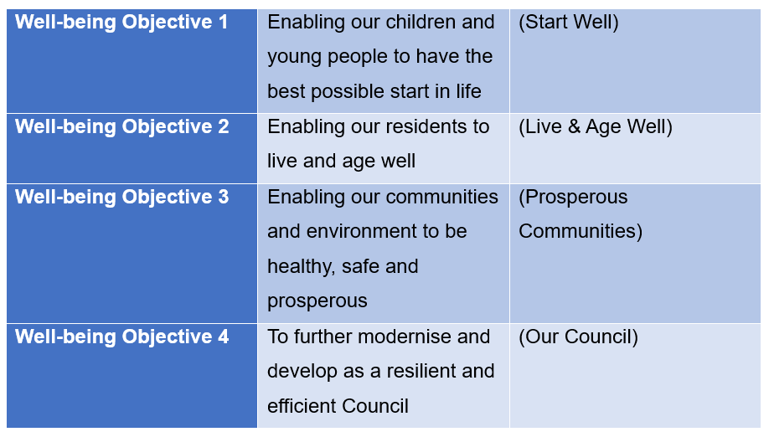
Figure 2: The four well-being objectives for CCC (Carmarthenshire County Council, 2024)
Replacing legacy systems is likely to improve essential services that the community relies on for well-being. Key improvements include increased accessibility, supporting Objective 3, by ensuring equitable access to services. These advancements align with the well-being goals of the Act, such as creating a “More Equal Wales” and a “More Resilient Wales”.

3.3 Anticipated Long-Term Impacts
The Power Platform’s implementation should bring long-term benefits for CCC and the community, enhancing operational reliability, reducing costs, and ensuring sustainable service delivery by replacing legacy systems through technical innovation.

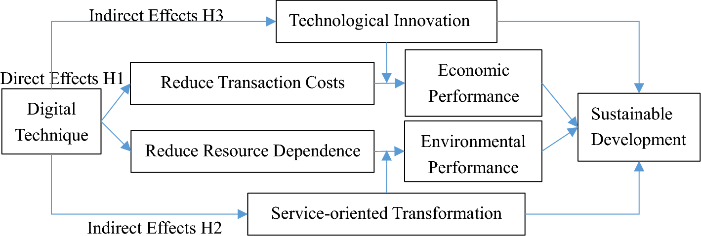
Figure 3: Overview of long-term benefits resulting in sustainable development (Luo and Liu, 2024)

From a community perspective, it improves digital accessibility through integrated low-code solutions, aligning with CCC’s well-being objectives. It fosters a “More Equal Wales” and “More Prosperous Wales” while enabling scalability for future growth, being a relatively new technology. Over time, these advancements are expected to support effective resource allocation, cost reduction and alignment with the WFG Act, improving community satisfaction and service efficiency.

4.0 Implementation Plan

4.1 Key Steps for Implementation
The implementation plan needs to be an agile, flexible approach for successful implementation, especially in the context of IT systems, and can significantly improve processes (Walee et al., 2024, p. 1172). Agile approaches provide quicker and more flexible integration (Aral et al., 2024, p. 754), in comparison to more structured approaches, which can incur higher implementation costs. Therefore, the following approach is important for CCC when implementing the Power Platform so that it aligns with the WFG Act.
The first step to implementation is through the definition of the Power Platform implementation procedure. Then, to invoke the principles of involvement and collaboration, it is important to engage with all departments and create a cross-functional team. (Blindenbach-Driessen, 2015, p. 31) hypothesised the cross-functional teams had the potential to drive innovation through organisational connectedness. Within this team would be representatives of each department, those involved with existing services, digital staff, which would include myself and those within my team, and lastly, end users, which are those that will be using the services. These ways of working will work towards long-term sustainable solutions.
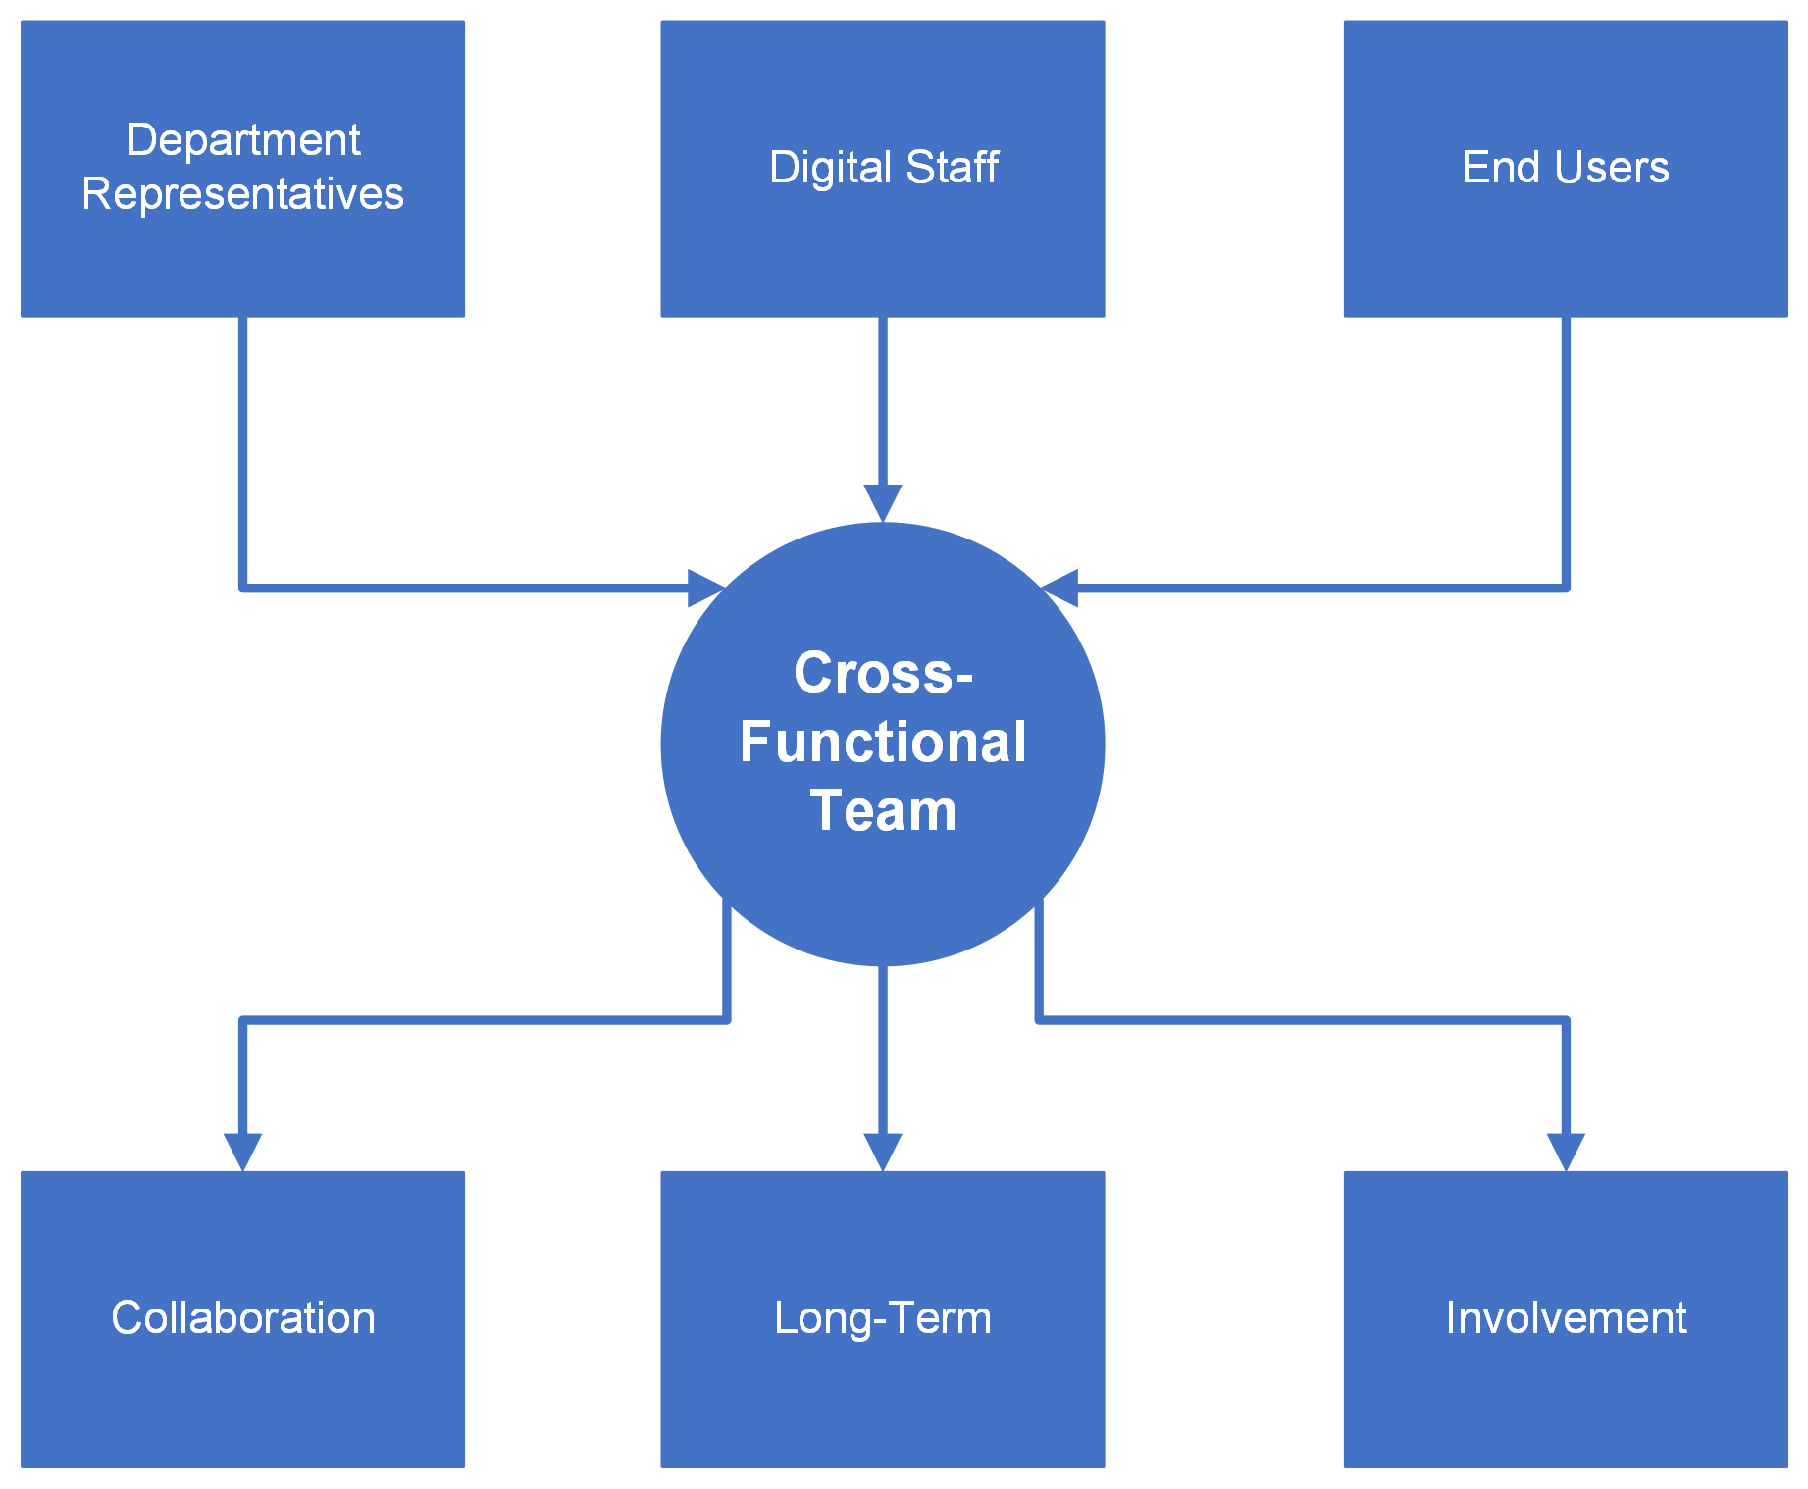
Figure 4: Input-Output diagram highlighting a cross-functional team

Once the objectives have been defined and the cross-functional team has been established, it would then be appropriate to begin the implementation of the Power Platform. To ensure services remain as is, the Power Platform will be implemented alongside the existing systems and developed through short sprints; keeping existing systems running prevents further disruptions. These short sprints will target one system at a time, starting with the least critical and then repeating the sprints per process.
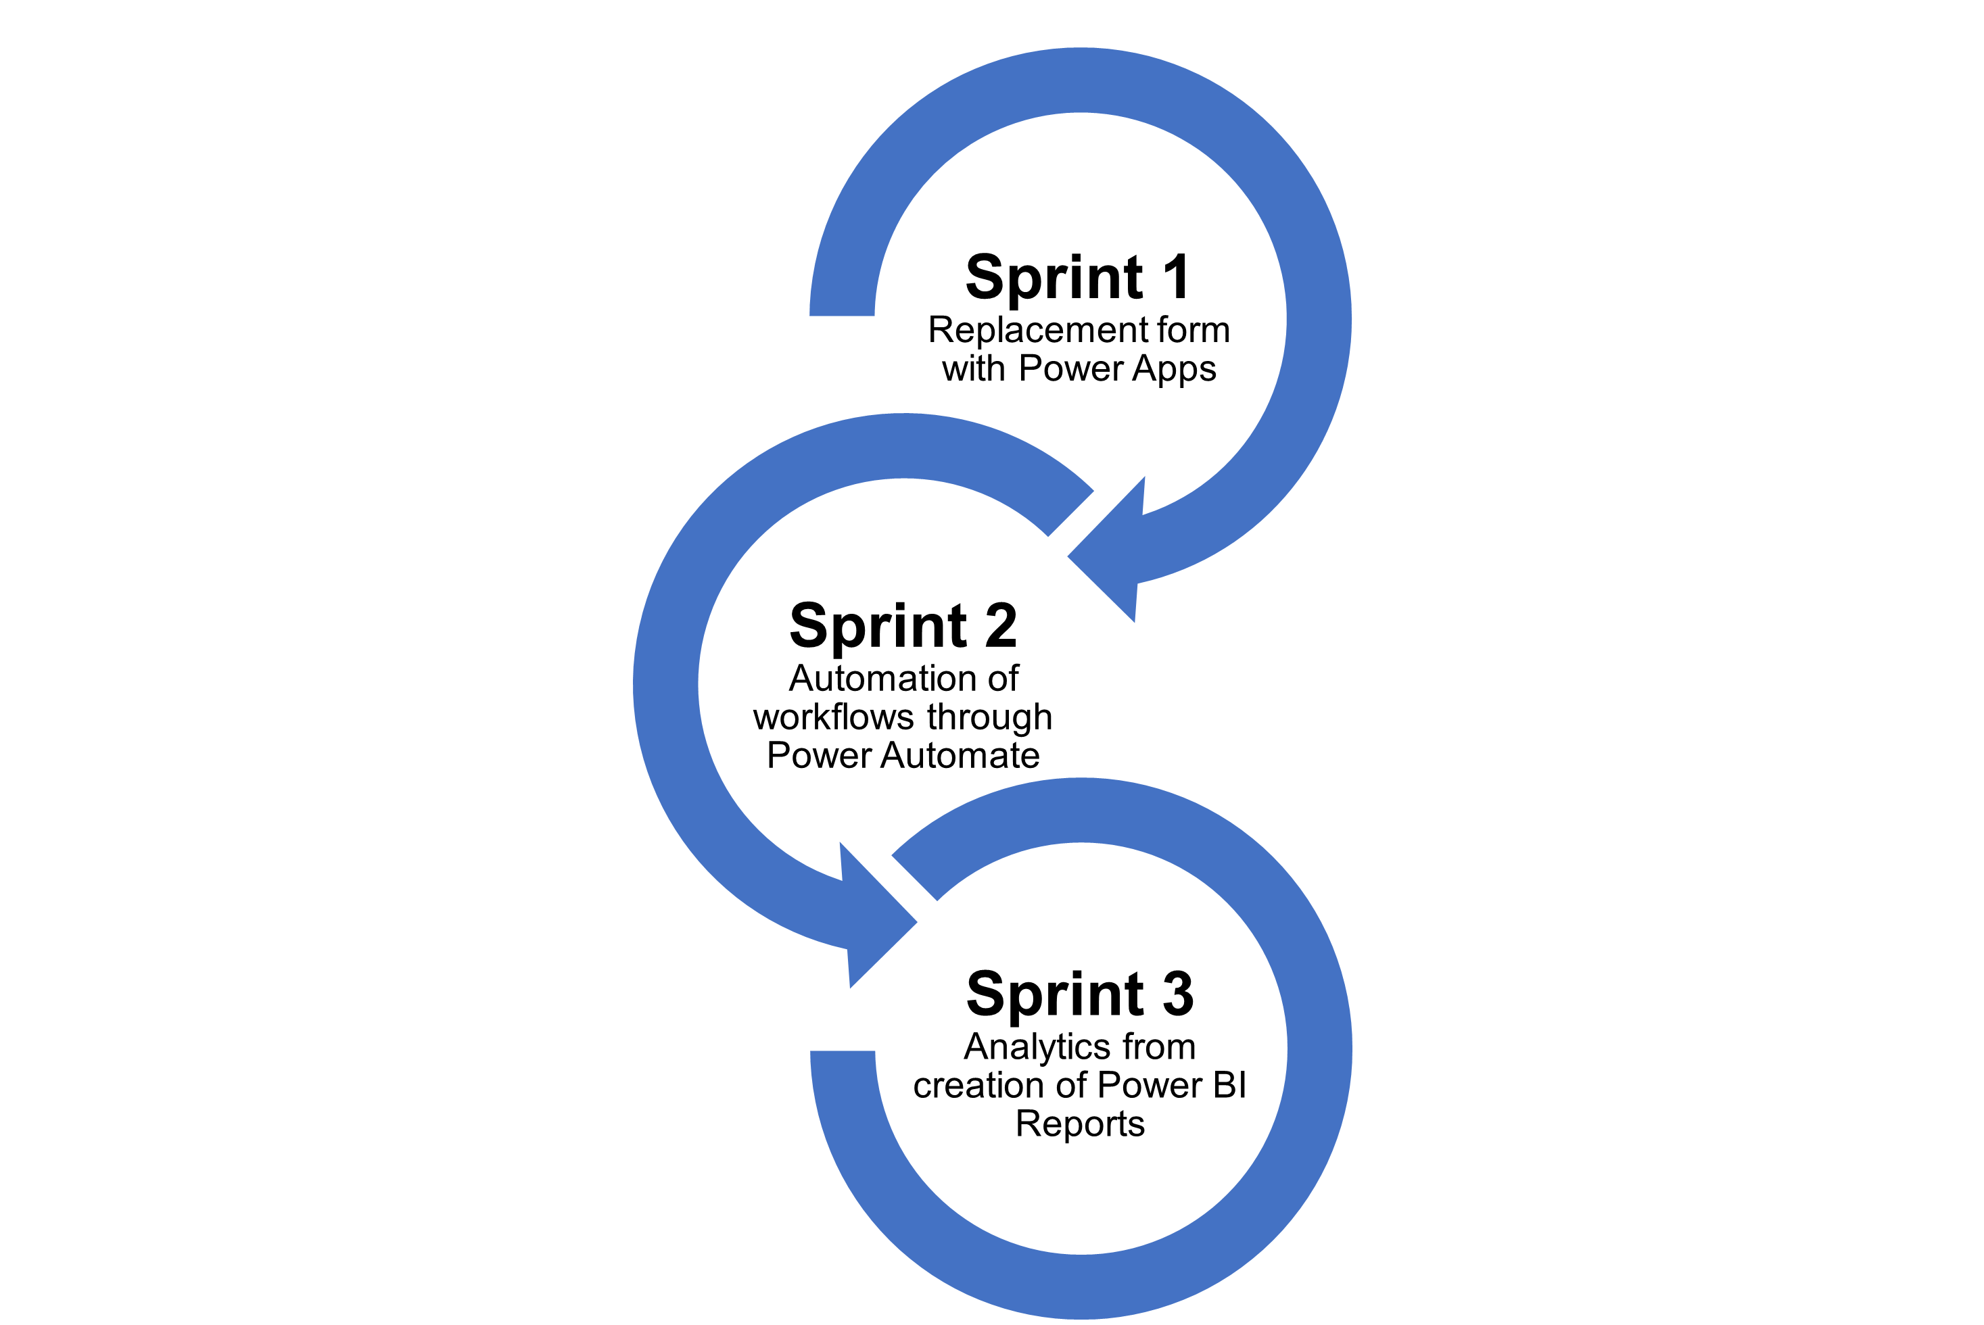
Figure 5: Basic sprints to replace legacy processes

From each sprint, feedback is collected from both the department representatives for those systems as well as the end users. This will be used to evaluate the performance through numerous criteria, including accessibility, usability, and reliability. Agile emphasises collaboration through constant feedback; this enables the development of solutions that meet expectations (Kate, Bhalerao and Sharma, 2023, p. 9). The collected data will then be used to address each issue before initiating the next iteration of the process. This feedback, along with the analytics collected from the Power BI reports, will be used to align with the Act’s principle of prevention by minimising potential disruption. This iterative process will also allow CCC to meet its well-being objective of reliance and efficiency.

345 words

4.2 Resource Allocation
Careful resource allocation is crucial for successfully implementing the Power Platform in CCC while aligning with the WFG Act. Firstly, financial aspects are key; while the Power Platform is included in CCC’s Microsoft licensing, it is important to anticipate that additional costs may arise for premium connectors to enhance these solutions. Moreover, legacy systems must be funded until the Power Platform can fully replace them. Therefore, to ensure sustainability, financial resources should be carefully managed by prioritising free features and then expanding to premium features as funding opportunities arise. These opportunities can be further expanded in the future once legacy systems are retired and recouped funding from these systems can support to long-term planning and efficient resource use.
The engagement of the cross-functional team plays a key role in the successful implementation of the platform. Opportunities for training with the Power Platform will drive motivation and provide them the skills needed to fully understand the platform. This also includes end users; for instance, giving guidance on using solutions developed in Power Apps gives alignment to CCC’s well-being Objective 3 and fostering a “More resilient Wales.”

4.3 Stakeholder Engagement
Stakeholder engagement is crucial for the successful implementation of the Power Platform in CCC, particularly regarding its alignment with the WFG Act, because it fosters innovation and sustainable practices that lead to long-term cost-effective solutions (Nguyen, Mohamed and Mostafa, 2024, p. 594). The cross-functional team allows for unification between developers, departments, and end users, giving essential stakeholders consultation throughout the entirety of the digital transformation.
Being an agile implementation, communication with stakeholders is key; to do so, communication channels must be established so that stakeholders can provide feedback at each cycle of the development process. This communication can be done in conjunction with these feedback loops and then through meetings on Microsoft Teams and/or face-to-face. This engagement ensures that service delivery is of the highest quality by meeting the needs of the end user and aligning with the Act’s well-being goals, including a “More Equal Wales” through accessibility and participation in decisions that make a difference.

157 words

4.4 Timeline of Activities
The implementation plan for integrating the Power Platform, in alignment with the WFG Act, will follow an agile approach using short sprints; as an indicator, this proposal will last a 14-month period.

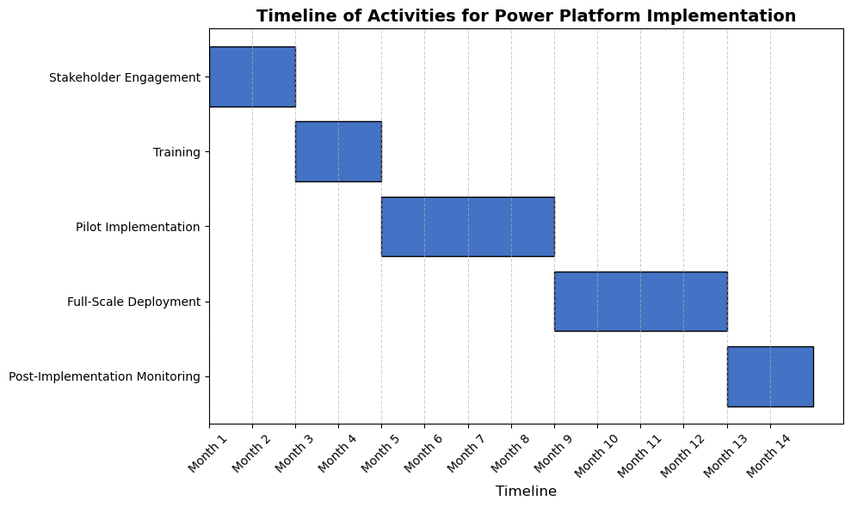
Figure 6: Timeline of the proposal for Power Platform

In months 1-2, stakeholder engagement will involve defining objectives, forming a cross-functional team, and creating awareness of replacing legacy systems with the Power Platform. In months 3-4, departmental representatives will receive training from digital services, and end users will be informed of the change, with necessary documentation. From months 5-8, non-critical systems will transition to the Power Platform, and feedback loops during sprints will be reported in Power BI for continuous improvements. In months 9-12, if feedback is positive, deployment will extend to critical services, while retaining legacy systems to prevent disruptions. From months 12 onwards, legacy systems would be retired, and solutions being further developed. These procedures, in alignment with the WFG Act, will enable the sustainable transition to the Power Platform and allow CCC to further achieve their own well-being goals.

5.0 Recommendations

5.1 Priority Actions
To implement the Power Platform successfully and align with the WFG Act, the following priority actions are recommended:
- Engage with the stakeholders from the start to foster collaboration, define objects, establish a cross-functional team, and create awareness of the transition from legacy systems.
- When opportunities arise, conduct training sessions within the established cross-functional team to build knowledge and foster an innovative culture.
- Use an agile, phased approach with short sprints, starting with non-critical systems and gradually transitioning to critical systems. Additionally, incorporating feedback loops for continuous improvements while keeping legacy system operational to avoid disruptions.
- Initially, focus only on using free features as part of the Power Platform for effective management of financial resources. Expansion to premium features could be introduced when funding opportunities arise and after legacy systems are retired.
These actions enable sustainable, cost-efficient solutions that align with the Act’s principles and CCC’s long-term goals.

5.2 Future Development Opportunities
CCC can enhance the Power Platform’s implementation through the following opportunities.
- Integrating AI tools like Co-Pilot into the Power Platform can potentially lead to the development of more efficient solutions and align with the WFG Act’s well-being goals.
- Being a relatively new technology, Power Platform’s evolving capabilities offer opportunities for modernisation, scalability, future growth, and alignment with the CCC’s Digital Strategy 2024-2027.
- Expanding Power Platform beyond the cross-functional team enables staff to create their solutions, fostering innovation amongst CCC and driving a “More Prosperous Wales” through low code solutions.

6.0 Conclusion
The implementation of the Power Platform aligns with CCC’s Digital Strategy 2024-2027 and the WFG Act, offering significant internal and external benefits. Modernising digital solutions with the Power Platform enables the development of efficient systems that integrate with existing CCC packages while reducing reliance on legacy systems, supporting sustainability. This transition aligns with CCC’s well-being objectives, particularly Objectives 3 and 4 promoting a prosperous, modern, and resilient community.
A phased implementation approach minimises disruption by prioritising non-critical systems while maintaining legacy systems until they are replaceable. Agile sprints with feedback loops ensure continuous improvements and cost-efficient development by focusing on free features, with opportunities to expand to premium features for added efficiency and sustainability once legacy systems are retired.
The Power Platform fosters low-code solutions, enabling digital staff to develop user-centric systems efficiently that meet the needs of the community, contributing to a “More Equal Wales” and “More Resilient Wales.” Collaboration through cross-functional teams, involving digital staff, department representatives, and end users, drives innovation and ensures solutions meets the community needs sustainably.
Long-term, the Power Platform enhances system accessibility, supports sustainable development, and aligns with the Act’s principles. It’s potential inclusion in CCC’s Digital Strategy 2024-2027 and digital transformation ensures a more efficient, inclusive, and long-term sustainable future for the council and the community.

References
Almeida, F. and Carneiro, P. (2023) 'Perceived Importance of Metrics for Agile Scrum Environments', Information, 14(6), pp. 327 Available at: https://doi.org/10.3390/info14060327.
Aral, S., Brynjolfsson, E., Gu, C., Wang, H. and Wu, D.J. (2024) 'Understanding the Returns from Integrated Enterprise Systems: The Impacts of Agile and Phased Implementation Strategies', MIS quarterly, 48(2), pp. 749 Available at: https://doi.org/10.25300/MISQ/2023/17420.
Azmy, I.H., Azmi, A., Kama, N., Mohd Rusli, H., Chuprat, S. and Anuar, A.W. (2023) Methods for Application Development by Non-Programmers: A Systematic Literature Review. , Tokyo. 22 September 2023. New York, NY, USA: ACM, pp. 1.
Blindenbach-Driessen, F. (2015) 'The (In)Effectiveness of Cross-Functional Innovation Teams: The Moderating Role of Organizational Context', IEEE Transactions on Engineering Management, 62(1), pp. 29–38 Available at: https://doi.org/10.1109/TEM.2014.2361623.
Carmarthenshire County Council (2024) Digital Strategy 2024-2027. Carmarthenshire: Carmarthenshire County Council. Available at: https://www.carmarthenshire.gov.wales/council-democracy/strategies-and-plans/digital-strategy-2024-2027/ (Accessed: 2 October 2024).
Carmarthenshire County Council (2022) Corporate Strategy 2022-2027. Carmarthenshire: Carmarthenshire County Council. Available at: https://www.carmarthenshire.gov.wales/council-democracy/strategies-and-plans/corporate-strategy-2022-2027/ (Accessed: 19 November 2024).
Davies, G.H., Jones, Y., Williams, M. and Joyce, N. (2019) Sustainable Development Legislation: The Case of the AgorIP Technology Transfer initiative Reading: Academic Conferences International Limited, pp. 238–245.
Davies, H. (2016) 'The Well-being of Future Generations (Wales) Act 2015: Duties or aspirations?', Environmental law review, 18(1), pp. 41–56 Available at: https://doi.org/10.1177/1461452916631889.
Erjavec, J., Indihar Štemberger, M. and Jaklič, J. (2024) 'How to Develop Organizational Forms for a Successful Digital Transformation? Findings from Two Case Studies', Journal of the knowledge economy, 15(2), pp. 9576–9596 Available at: https://doi.org/10.1007/s13132-023-01479-3.
Kate, V., Bhalerao, S. and Sharma, V. (2023) Exploring Agile Methodologies in Educational Software Development- A Comparative Analysis and Project Management Insights. , IEEE International Conference on ICT. 2023. Business Industry & Government (ICTBIG): IEEE, pp. 1.
Khalifeh, A., Farrell, P. and Al-edenat, M. (2020) 'The impact of project sustainability management (PSM) on project success: A systematic literature review', The Journal of management development, 39(4), pp. 453–474 Available at: https://doi.org/10.1108/JMD-02-2019-0045.
Kolovou, V., Bolton, N. and Crone, D. (2023) 'O.1.3-1 Senior stakeholder views and experience of cross-sector engagement and collaboration to improve long-term health and wellbeing in Wales', European journal of public health, 33, pp. 39–40 Available at: https://doi.org/10.1093/eurpub/ckad133.098.
Lewis, M. (2018) 'Outsourcing, new technologies and new technology risks: Current and trending UK regulatory themes, concerns and focuses', Journal of securities operations & custody, 10(2), pp. 145–156 Available at: https://doi.org/10.69554/CNCU7710.
Luo, S. and Liu, J. (2024) 'Enterprise service-oriented transformation and sustainable development driven by digital technology', Scientific Reports (Nature Publisher Group), 14(1), pp. 10047 Available at: https://doi.org/10.1038/s41598-024-60922-w.
Nath, A. and Kanjilal, D. (2018) 'Addressing the challenges of e-Government: learning from the IT industry', VINE journal of information and knowledge management systems, 48(1), pp. 62–82 Available at: https://doi.org/10.1108/VJIKMS-11-2016-0062.
Nguyen, T.S., Mohamed, S. and Mostafa, S. (2024) 'Optimising project outcomes in complex environments: empirical insights on agile practices and stakeholder dynamics', Built Environment Project and Asset Management, 14(4), pp. 590–606 Available at: https://doi.org/10.1108/BEPAM-06-2023-0107.
Phillips, A., Davies, G., Rees, D. and Jones, P. (2024) 'Initial insights from Innovation Strategy development in Wales', European conference on innovation and entrepreneurship, 19(1), pp. 994–998 Available at: https://doi.org/10.34190/ecie.19.1.2588.
Rezazade Mehrizi, M.H., van den Hooff, B. and Yang, C. (2022) 'Breaking or keeping the habits: exploring the role of legacy habits in the process of discontinuing organisational information systems', ISJ.Information systems journal/Information systems journal, 32(1), pp. 192–221 Available at: https://doi.org/10.1111/isj.12341.
Walee, N.A., Onisha, T.A., Akinola, A., van Deventer, G. and Chen, L. (2024) Impact of Agile Methodology in IT Industries: A Comparative Study. , SoutheastCon 2024. 2024. IEEE, pp. 1167.
Woodcock, E. (2022) Cross-sector collaboration for Wales' national well-being : transformative action in communities of practice. Doctor of Philosophy in Sociology and Social Policy. Bangor University. Available at: https://research.bangor.ac.uk/portal/en/theses/crosssector-collaboration-for-wales-national-wellbeing(a935f539-869b-4be5-a41b-38f91ee738d5).html (Accessed: 20 November 2024).

