CHAPTER 4.0 ANALYSIS OF RESULTS

4.0 INTRODUCTION
The goal of chapter 4 is to analyse the results obtained from primary research. The online questionnaire amassed 187 respondents which has provided a considerable amount of data pertaining to motivating factors in consumer buying behaviour.
The results will be coherently analysed and collated with secondary research to build a concise argument so to achieve the aim of this dissertation, whilst also contributing to the achievement of the following objectives:
To investigate the correlation between consumer attitudes and awareness with consumer behaviour when purchasing fashion.
To integrate primary and secondary research to achieve a greater level of understanding regarding consumer motives and recommend changes that can be implemented by organisations to better meet these motives in a sustainable manner.
It should be noted that the results obtained from the primary research will be in the format of a percentage. Data has been condensed in order to most effectively communicate the results of this research study. It is important to note that the hypothesis for this dissertation is as follows;
H₀: Consumer buying behaviour within the fashion industry is not influenced by sustainability.
H_{0A}: Consumer buying behaviour within the fashion industry is influenced by sustainability.
The raw data of the authors primary research is available in appendix 2.

4.1 DATA ANALYSIS
Data analysis is the process in which the researcher collates and organises their data so that it can be evaluated to draw patterns and themes that have emerged (Collis & Hussey, 2014). Different techniques can be utilised dependent on the type of data for example, the researcher has utilised statistical analysis software SPSS as well as NVivo to best analysis the data obtained.

4.2 PRIMARY RESEARCH RESULTS
The questionnaire was delivered online via the google forms survey software, the link to the questionnaire was shared over various social media platforms, as well as being shared via email to other students attending the university. To ensure an appropriate sample was collected an in-depth description was provided as seen in figure 4.1. This provided the necessary information that respondents would need before filling out the questionnaire.
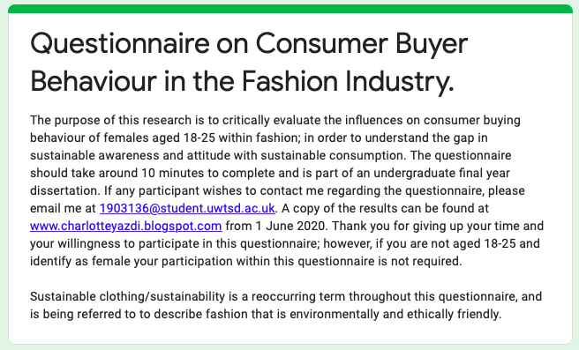

Figure 4.1 Questionnaire Description (Authors Own)

4.2.1 SECTION ONE - DEMOGRAPHICS

4.2.1.1 ACCEPTANCE OF DATA COLLECTION
The purpose of this question was to ascertain that respondents were happy with how data was being collected in accordance with the ethics form.
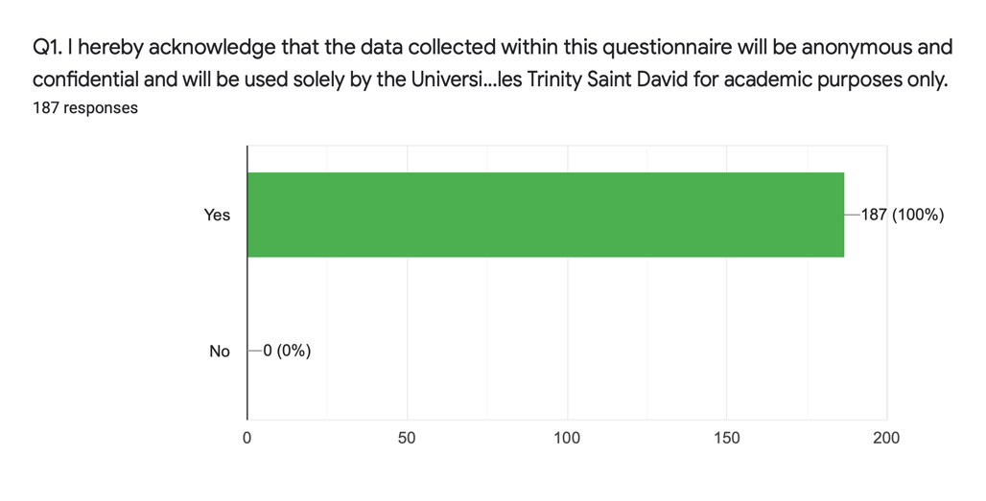
Figure 4.2 Acceptance of data collection (Authors own)

4.2.1.2 NATURE OF OCCUPATION
In regard to descriptive statistics respondents were asked about the nature of their occupation, this was carried out to determine the sort of income that they may have. The assumption being that those employed would have a higher disposable income.
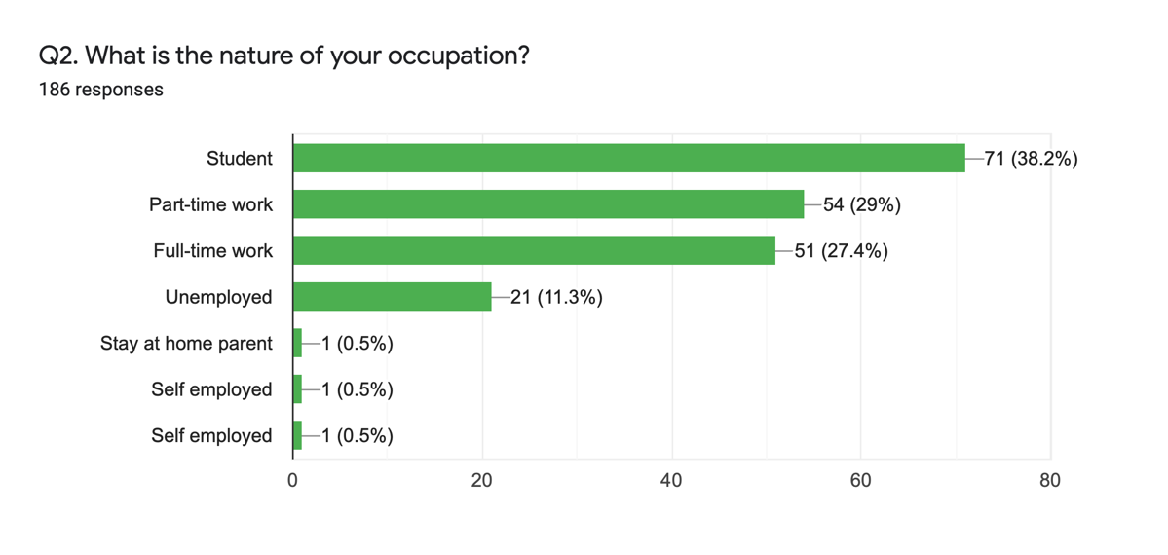
Figure 4.3 Respondents occupation (Authors own)
The figures obtained from this question clarify that the majority of respondents perhaps do not have a high disposable income and therefore consumption behaviour exhibited by them may be less sustainable due to income as theorised by Summers (2016).
Figure 4.4 shows that students have the highest degree of sustainable awareness in regard to fashion with 50% stating they were aware of which shops were green which is in agreement with White, et al (2019) that millennials say they want to embrace sustainability; as such it could explain that as a result their buying behaviour will be in favour of sustainability.
Figure 4.4 Crosstabulation Q2*Q4 (Authors own)
Additionally, it can be seen in figure 4.5 that 32.5% students follow influencers which could indicate the motivations behind their purchase behaviour. This shows a way in which organisations could target consumers in order to increase sustainable consumption as 64.5% of respondents admitted to trusting the opinions of influencers and 47.1% stating that social influence was an important factor in their decision-making process.
Figure 4.5 Crosstabulation Q2*Q19 (Authors own)

4.2.2 SECTION TWO - CONSUMER AWARENESS AND KNOWLEDGE
Secondary research made it clear that it was important to gauge the degree of awareness that respondents have. The majority, 86.7% of respondents believe themselves to have some degree of awareness whether this be ethically or environmentally, figure 4.6. In light of Peattie’s (2001) findings, questions four and five were designed to measure the extent of this awareness within the fashion industry. From which the research supports the notion that behaviour and knowledge in one area may not be carried through in another (Peattie, 2001), with only 13.4% having knowledge of green fashion shops, figure 4.7. Though the majority of respondents did correctly acknowledge those retailers that are considered friendly fashion, figure 4.8.
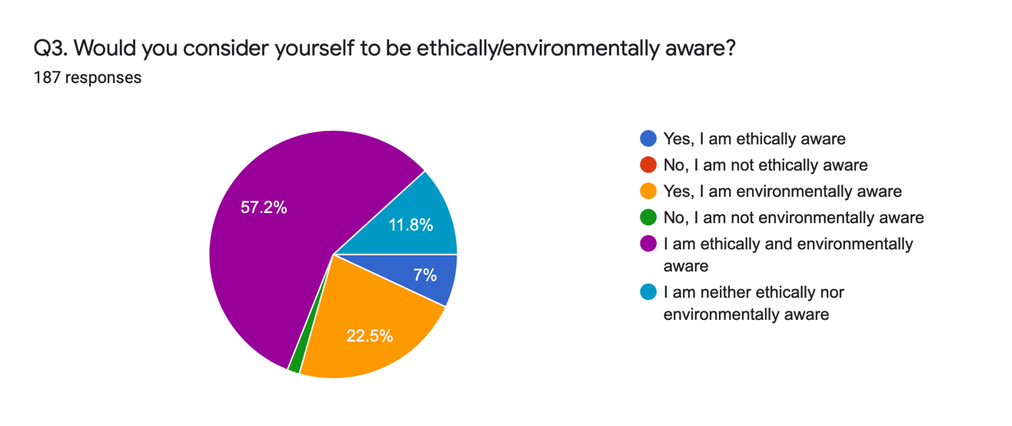
Figure 4.6 Respondents awareness (Authors own)

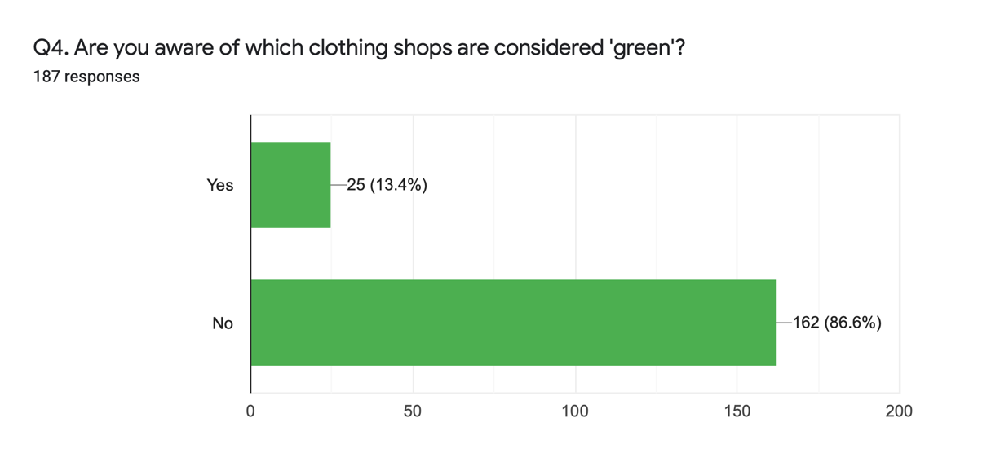
Figure 4.7 Awareness on green clothing shops (Authors own)
Figure 4.8 Crosstabulation Q3*Q4 (Authors own)
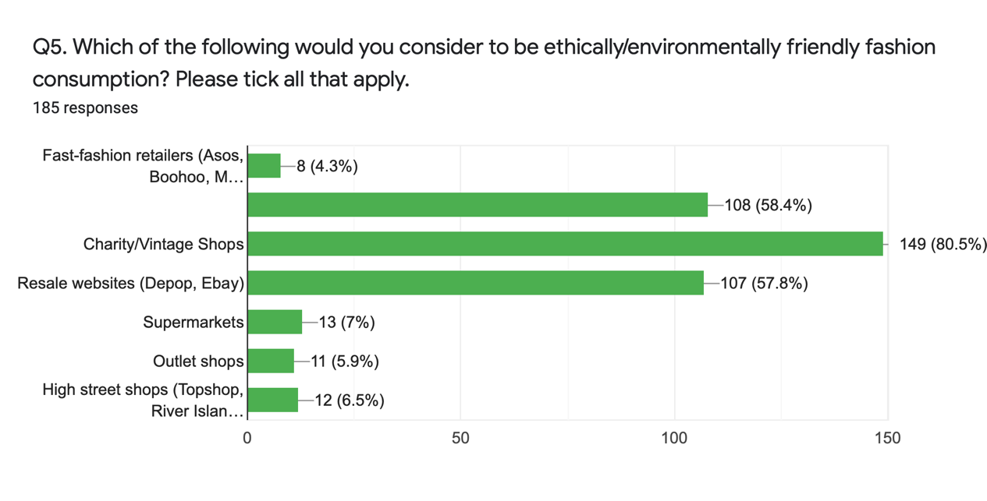
Figure 4.9 Respondent’s knowledge about friendly fashion (Authors own)

These findings reemphasis the observation that despite the growing trend surrounding ethical consumption and awareness, concern does not equate to sustainable consumption (Wiederhold & Martinez, 2018; Vermeir & Verbeke, 2008). This is further enforced in the data from question seven, where 72.7% maintained they do not avoid shops due to negative sustainability issues.
Figure 4.10 Crosstabulation Q3*Q7 (Authors own)
This constrained consumer knowledge is considered to be one of the most substantial barriers to sustainable fashion consumption (Moon, et al., 2015). Which is reinforced by the fact that it was only recently that Vogue (2019) released an article stating “Eco-friendly, ethical and sustainable fashion is finally on the industry’s agenda” (Blanchard, 2019). Furthermore, greenwashing within the industry is quite considerable with many retailers talking about ethics and sustainability and not making business decisions that reflect this (Slater, 2019) making it challenging for consumers to know if they are shopping responsibly or buying into greenwashing (Chan, 2020). Off the back of this it is clear that consumers do not know how to find this information or where to look for it with 56.5% stating as such.
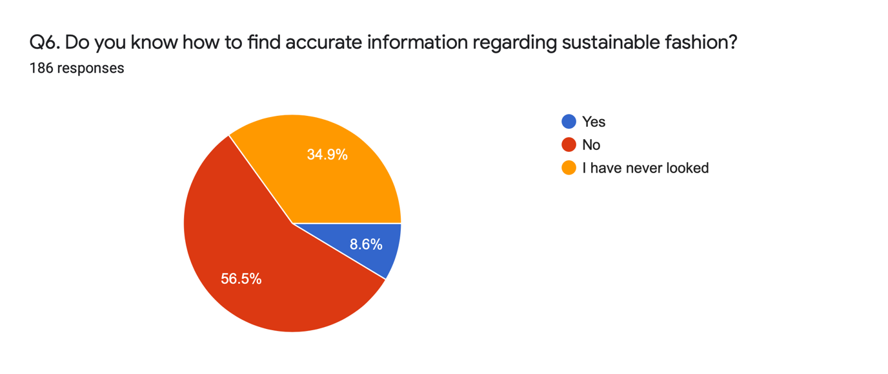
Figure 4.11 Procurement of information (Authors own)
Similar to the researchers own findings figure 4.12 depicts the search trends of ‘sustainable fashion’ and ‘Missguided’ a popular fast fashion brand on Google over the past five years. Despite the increase in consumers searching sustainable fashion when compared to the amount Missguided is searched there is a considerable difference. Again, reiterating that despite awareness growing, unsustainable fashion is still a growing trend which corresponds with the researchers own data.
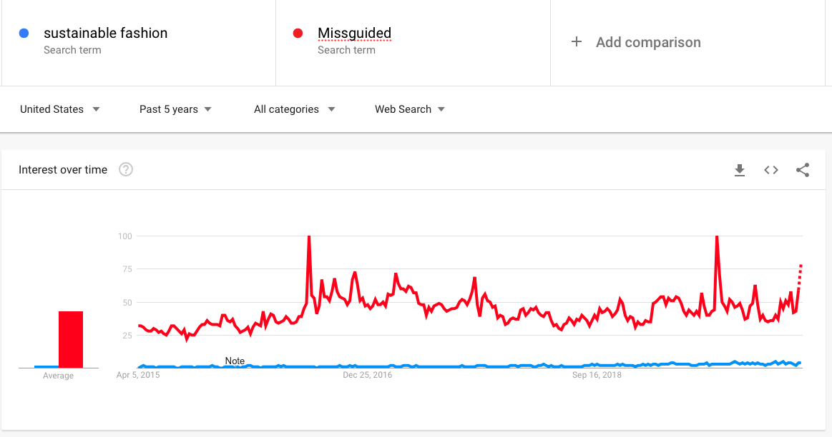
Figure 4.12 Sustainable Fashion Vs Missguided (Google Trends, 2020)

4.2.3 SECTION THREE – CONSUMPTION BEHAVIOUR AND TRENDS

4.2.3.1 MORALS AND VALUES
72.1% of respondents said that their values and morals pertaining to issues surrounding human, animal or environmental welfare did not impact the purchases that they make; therefore, directly contradicting Long and Schiffman (2000) and Groening et al (2018) who maintain values often shape the purchase that we make. Though it should be noted that one response stated that they were restricted by cost which meant they couldn’t uphold their morals and values.
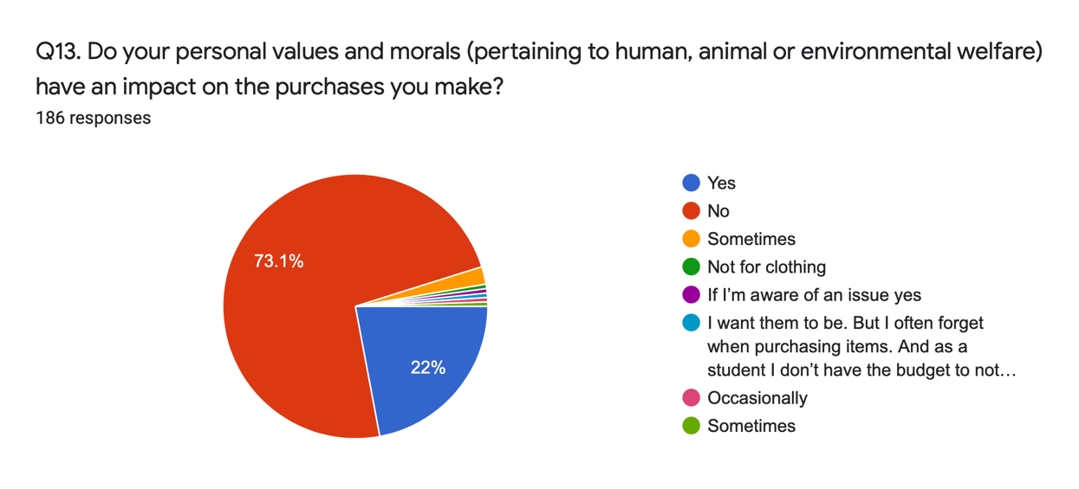
Figure 4.13 The impact of values and morals (Authors own)

4.2.3.2 UNSUSTAINABLE BEHAVIOUR
Researching the fashion industry highlighted the unsustainable nature of it, whether this be from consumers or fashion brands. The works of Fielding, et al (2008) and Stern, et al (1995) are suggestive that negative issues will influence individuals behaviour to be more sustainable. A considerable scandal in the fashion industry was that of Primark’s factory collapse killing over 1,000 people (BBC News, 2013), despite the clear unethical actions Primark’s sales rose 20% regardless of the backlash (Neville, 2013). This response corresponds with the data from the questionnaire where 72.2% disagree with the statement of avoidance. Zaroff (2014), suggested sustainability is a matter of the heart and decisions are made with the head therefore; other factors, like price are often considered more important (Purt, 2014).
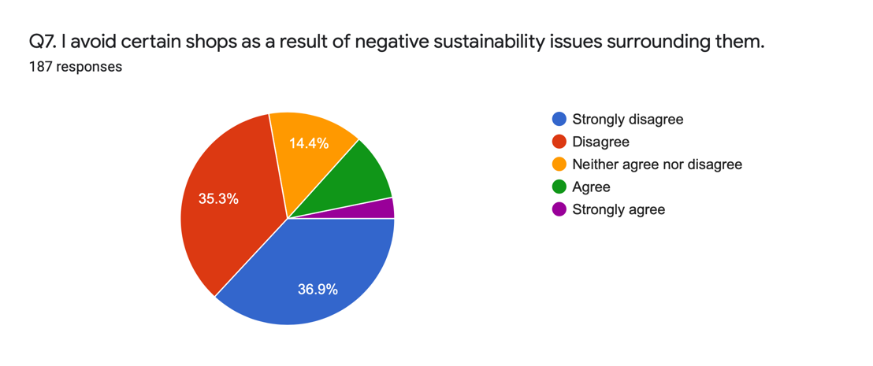
Figure 4.14 Respondents’ attitudes to negative issues (Authors own)
A factor to consider as Summer (2016) suggests is income; therefore, to ascertain if there is an association with this variable a Mann-Whitney U test was conducted, the hypothesis for which was as follows:
H₁: The distribution of Q7 is the same across all categories of Q2.
H_{1A}: The distribution of Q7 is not the same across all categories of Q2.
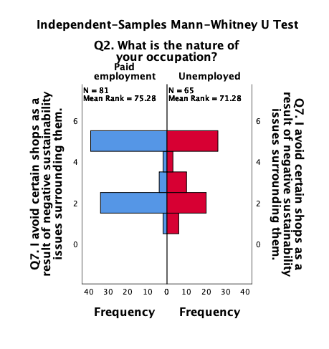
1: Agree 2: Disagree 3: Neither Agree, nor disagree 4: Strongly Agree 5: Strongly Disagree
Figure 4.15 Mann-Whitney U Test Q2*Q7 (Authors own)
In this instance H₁ is retained as regardless of employment there is a similar distribution throughout Q7. Though that does not disregard the notion that other factors are often more significant.

4.3.3.3 CONSUMPTION PATTERNS
The most substantial problem that the fashion industry is facing is from mass consumption rates; therefore, the questionnaire sought to understand the current consumption patterns of respondents so to evaluate the sustainability of it. The data from question eight, corresponds with the research undertaken by WRAP (2017), that sees high levels of consumption at an unsustainable rate with 41.4% buying 31+ items in a year.
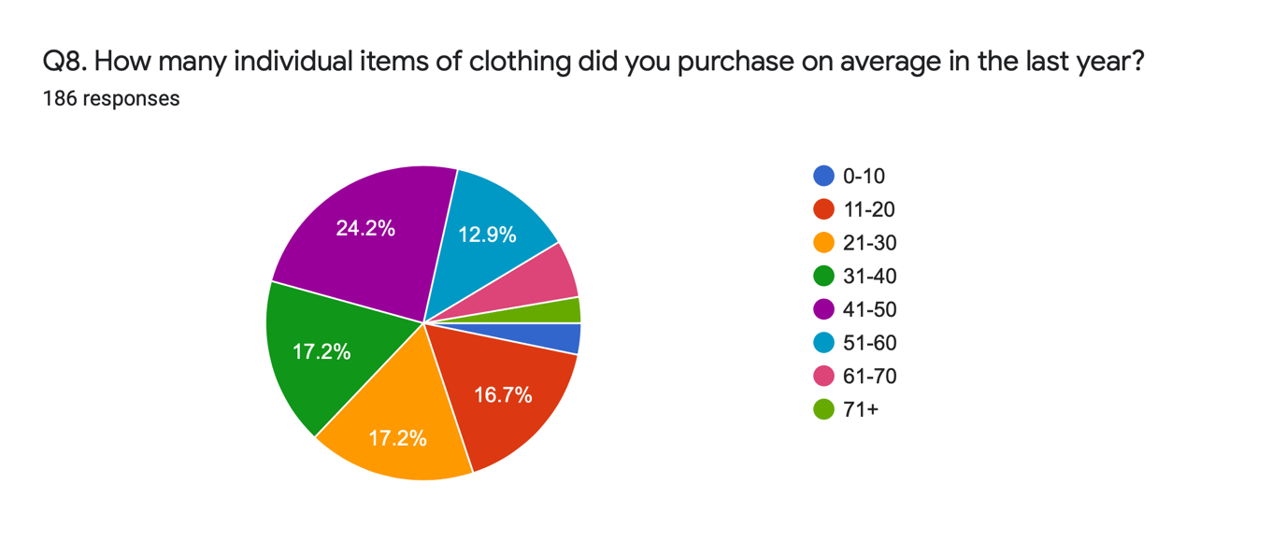
Figure 4.16 Clothing consumption (Authors own)
Alongside overconsumption is its partner in crime, the throwaway culture. 22% of individuals have stated to owning fewer than half of those clothes that they have purchased in the past year along with an additional 36.6% owning only half, this again supports the data produced by WRAP (2017) of thousands of tonnes of clothes ending up in landfill. This throwaway culture is not just detrimental for the environment, retailers alike Primark and Boohoo have come under fire for fuelling this culture that consequentially results in the exploitation of factory workers (Wood & Butler, 2018). The low-cost nature of fast-fashion brands results in consumers perceiving these items as disposable, in short its destined for the bin (Wood & Butler, 2018).
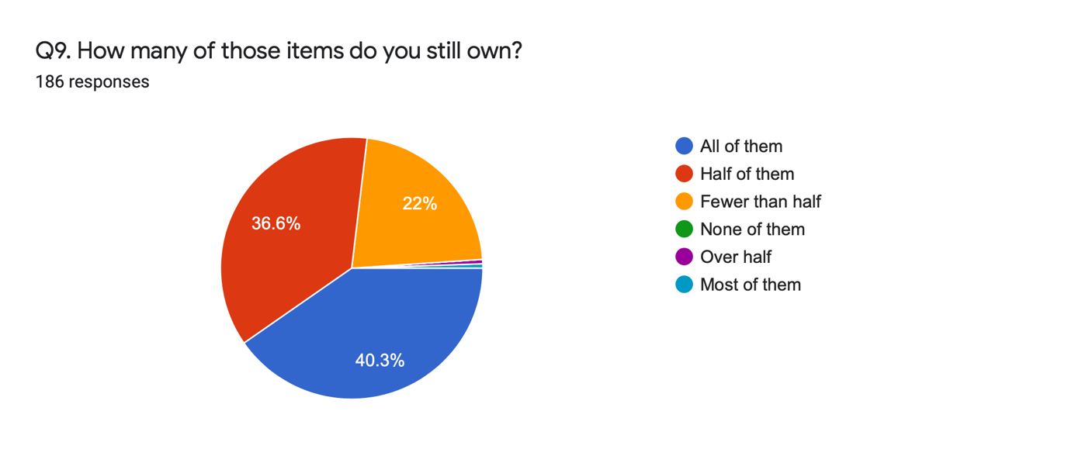
Figure 4.17 Throwaway culture (Authors own)
Figure 4.18 shows that those in paid employment indulge most in this throwaway behaviour, which is suggestive that their higher disposable income means they are able to regularly revitalise their wardrobe resulting in old and out of fashion clothes going in the bin.
Figure 4.18 Crosstabulation Q2*Q9 (Authors own)
Consumers are not single handily driving this trend as it was only recent that brands return policies have been found to be detrimental to sustainability. Due to the cost incurred to check and repackage returned garments it is often cheaper to throw away products (Vasil, 2019). 71.7% of respondents have unknowingly contributed to this unsustainable trend inadvertently resulting in an unsustainable industry.
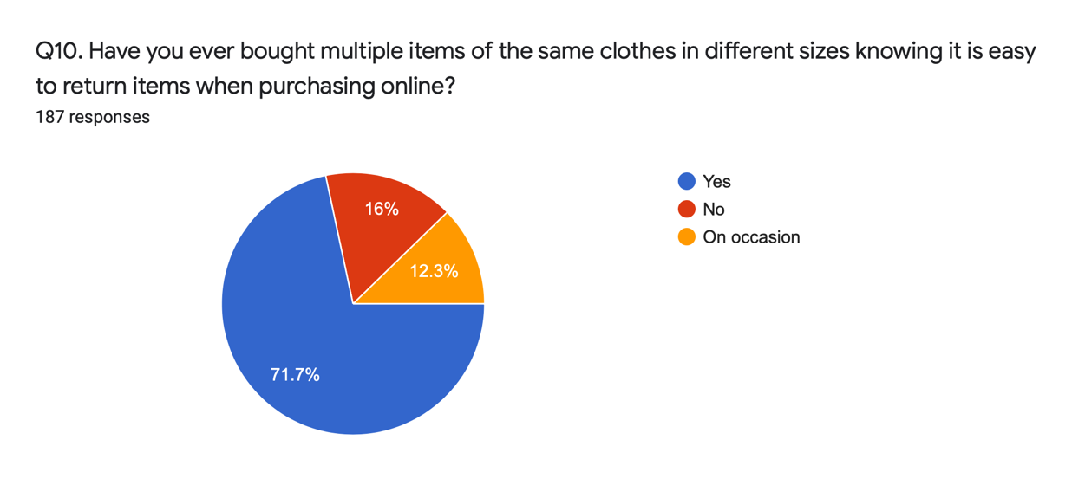
Figure 4.19 The growing ‘return’ trend (Authors own)
Fashion operates on a season basis, there are four seasons which designers produce new garments for (De Klerk, 2020) feeding this need for over consumption; resulting in the behavioural trend of being fashionable. 75.8% have stated they keep up with fashion trends therefore, insinuating the high levels of consumption and throwaway behaviour attributed to staying fashionable. Which is supported by the findings in figure 4.20, where those in paid employment make up the majority, 53.2%, that are keeping up with trends which agrees with the previous findings in figure 4.18 where the same group are disposing of clothing more regularly.
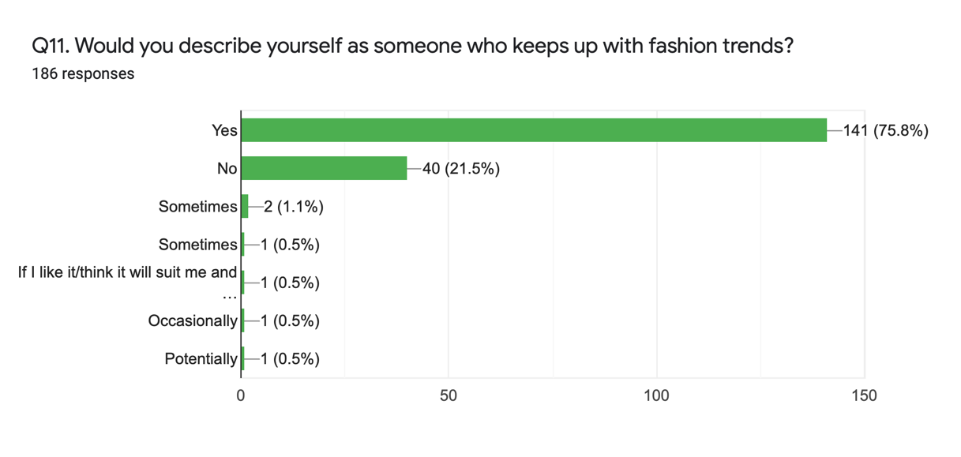
Figure 4.20 Fashionability (Authors own)
Figure 4.21 Crosstabulation Q2*Q11 (Authors own)

Fashion in the 21st century is not made to last (Zarroli, 2013), before garments were kept for years and often repurposed now, brands are enticing consumers desire for novelty by constantly bringing out new fashion lines (Zarroli, 2013). Consumer behaviour incorporates the disposal of clothes and therefore the longer that clothes are keep the more sustainable this behaviour is; however, the results from this question are suggestive that consumers are engaging unsustainably as an alarming amount of clothes are being keep for as short as 4-11 months with a total of 57.5% of respondents stating to keeping clothes within this timeframe.
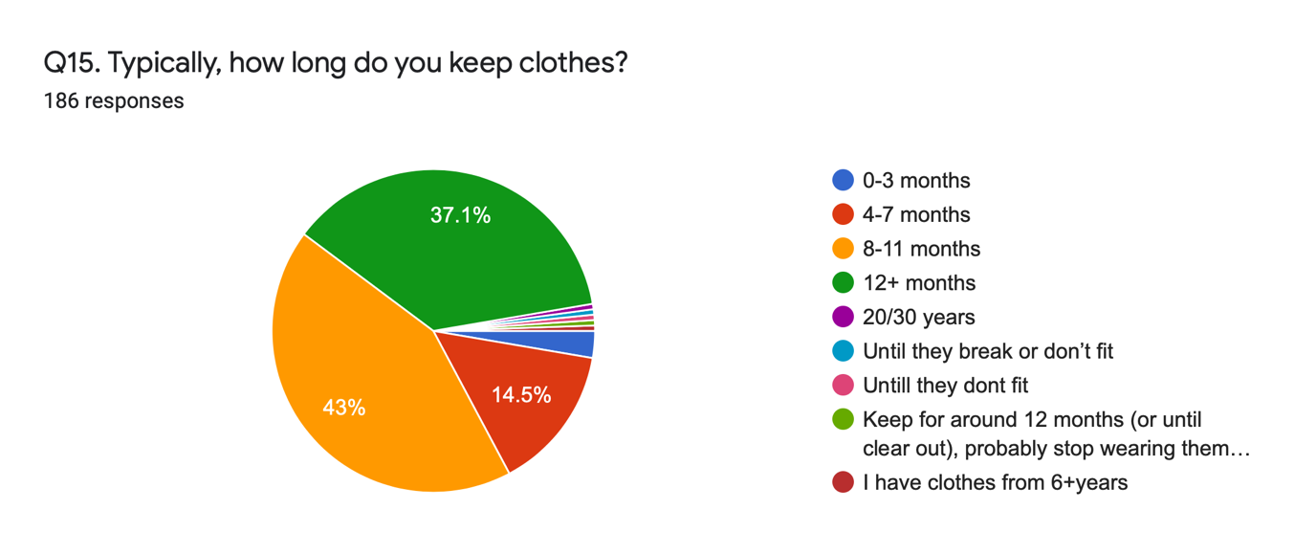Figure 4.22 Clothing lifecycle (Authors own)

Ethical consumption largely considers the disposal of products, one of the biggest problems of overconsumption is that vast amount of clothes going to landfill. Making it vital to consider the post-purchase approach that consumers take, by which the negative impacts on the environment can be mitigated through the selection of more sustainable options (Prothero, et al., 2011). Overall the disposal of clothes is relatively sustainable amongst these respondents with the majority of garments are receiving a longer product life cycle by being passed on or resold and therefore resulting in a more circular economy. Though general waste was selected by 37.4% of respondents, figure 4.28 illustrates the Chi-square test conducted the hypothesis of which was:
H₂ – Paid employment is not associated with general waste disposal.
H_{2A} – Paid employment is associated with general waste disposal.
The null hypothesis is rejected as there is an association between general waste disposal and those in paid employment. It could be theorised that this unsustainable method of disposal is more heavily utilised by those in paid employment is due to the fact that it is less time consuming and more accessible.

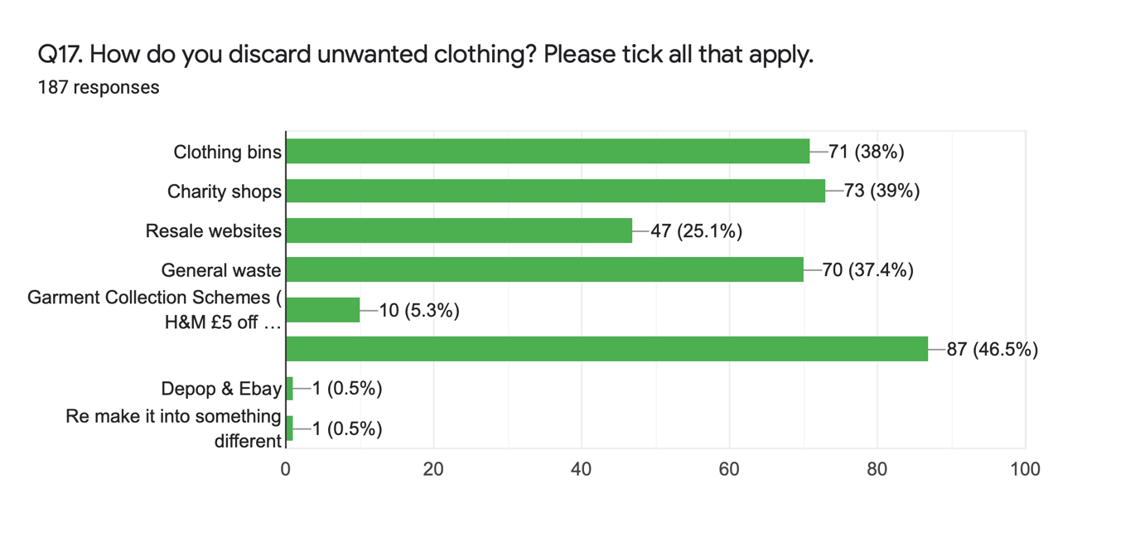
Figure 4.23 Disposal patterns (Authors own)
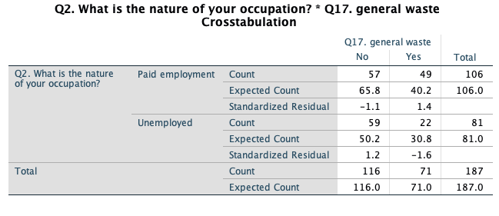
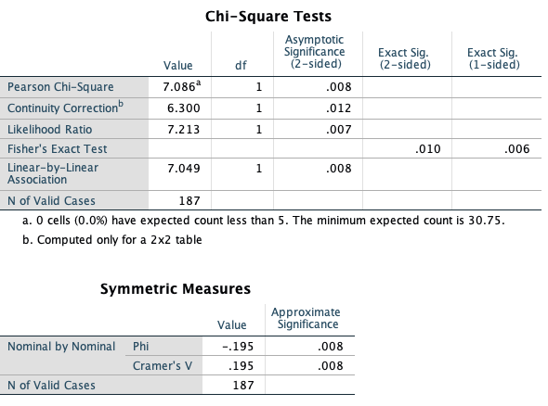
Figure 4.24 Chi-square test Q2*general waste (Authors own)
The type of retailers frequented by consumers, elucidates the nature of their behaviour, overall the majority of respondents shop with unsustainable retailers that often offer more for your money.
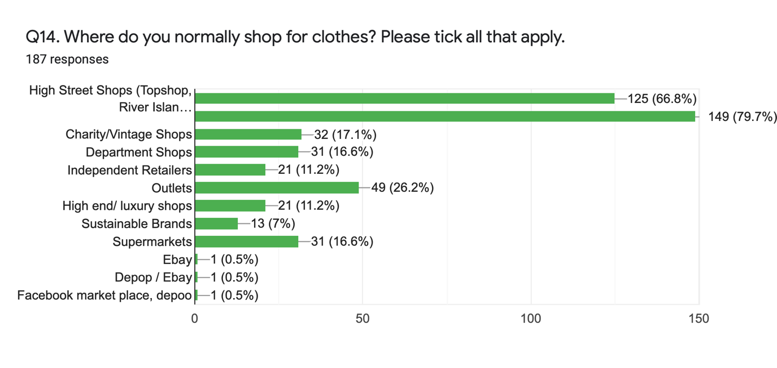Figure 4.25 Popular clothing retailers (Authors own)

Summers (2016) maintains that income is associated with sustainable consumption, to test this theory a Chi-square test was run:
H₃ – Paid employment is not associated with sustainable brands consumption.
H_{3A} – Paid employment is associated with sustainable brands consumption.
There is weak evidence against H₃ and therefore, there is no association between employment and sustainable consumption; thereby, contradicting Summers (2016).
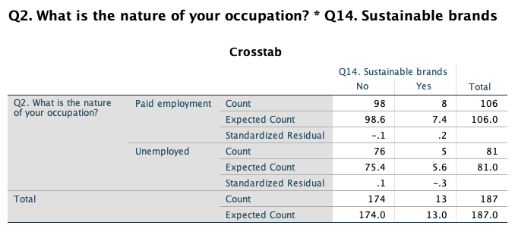
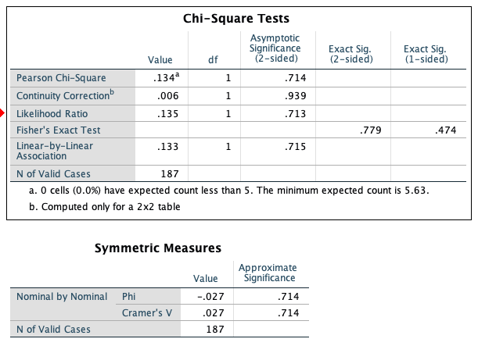
Figure 4.24 Chi-square test Q2* sustainable brands (Authors own)

4.2.3.4 MOTIVATING FACTORS
The purpose of the questionnaire was to ascertain consumers attitudes and intentions by understanding their knowledge, awareness and opinions towards sustainable fashion, whilst also evaluating the behaviour they exhibit. Question twelve highlights the key motivating factors to purchase behaviour in fashion. Few are influenced by sustainability or the environment, which contradicts previous findings that young consumers claim sustainability to be a significant factor in their decision-making process (Pasquinelli, 2017). The findings supports Wiederhold and Martinez’s (2018) and Vermeir and Verbeke (2008) findings in that although respondents have an awareness it is not translating to sustainably favourable behaviour.
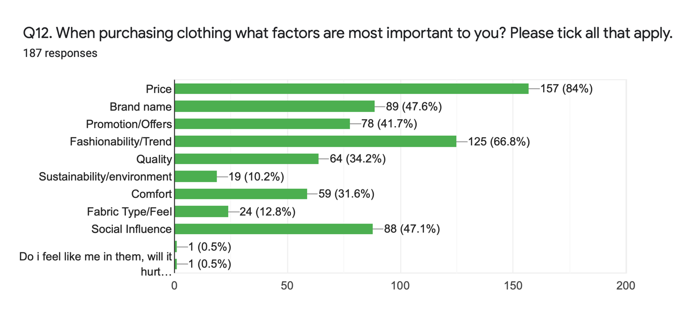Figure 4.27 Factors influencing purchases

Chi-square tests were carried out between question two and the variation of responses from question twelve the hypothesis is as follows;
H₄: Consumer buying behaviour within the fashion industry is not influenced by being in paid employment.
H_{4A}: Consumer buying behaviour within the fashion industry is influenced by being in paid employment.
These tests measure the association between two variables while Phi and Cramer’s V shows the strength of this association. For these tests to be valid the data for Q2 had to be collapsed into two groups, those in paid employment and those unemployed.
Chi-Square Test | Significance | x | df | p
Q2*Q12 – Price | Not significant | .643ª | 1 | .423
Q2*Q12 – Brand Name | Not significant | .777ª | 1 | .378
Q2*Q12 – Promotion/Offers | Not significant | .498ª | 1 | .480
Q2*Q12 – Fashionability/Trend | Not significant | 5.016ª | 1 | .025
Q2*Q12 - Quality | Significant | 10.221ª | 1 | .001
Q2*Q12 – Sustainability/environment | Not significant | .013ª | 1 | .911
Q2*Q12 - Comfort | Significant | 7.936ª | 1 | .005
Q2*Q12 – Fabric Type | Not significant | .501ª | 1 | .479
Q2*Q12 – Social influence | Significant | 12.837ª | 1 | .000
Table 4.1 Chi-Square tests Q2*Q12 (Authors own)
The majority of the test run shows that due to the P-value being higher than 0.05 and therefore the association between the variables are not significant. Hence; regardless of being in employment or not, respondents are compelled by similar factors. It is clear that consumers are heavily motivated by price, which presents a significant barrier to sustainable behaviour as sustainable fashion comes at a slightly higher expense (Davis, 2019). Figure 4.26 shows the Chi-square test between question 2 and quality, in which case the alternate hypothesis is accepted; therefore, is influenced by being in employment. The standard residual shows a figure of 2.0 for unemployed respondents that consider quality showing a strong association with this variable. This is understandable as with less income these respondents are more concerned with buying clothes to last.
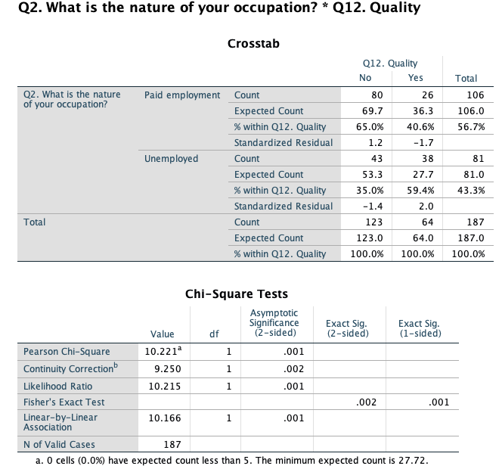
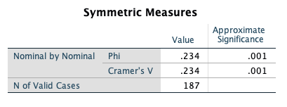
Figure 4.28 Chi-square test Q2*Quality
Building on the factors that are influential, question eighteen was a long answer question which gauged what respondents thought would increase sustainable consumption. The answers have been thematically sorted as shown in figure 4.27.

Figure 4.29 Consumers opinions (Authors own)
The researcher utilised the NVivo text search query to identify the most common themes amongst respondents’ answers, generating a word cloud. Affordability, price and income are all factors that agree with Summers (2016) findings in that income affects sustainable consumption. Furthermore, advertising, promotion and knowing are themes which are assumed to generate more environmental consumer behaviour (Zsóka, et al., 2013); however, John, et al, (2017) maintain that advertising on social media and particularly generating ‘likes’ does not mean behaviour will change.

Figure 4.30 Word Cloud (Authors own)

4.2.4 SECTION FOUR - SOCIAL INFLUENCE
Social media influencers have risen at a considerable rate over recent years and they have reshaped marketing today (Sanders & Sastry, 2019). Influencers have a huge follower base of young and impressionable individuals and as such businesses utilise this to promote their products. Out of the 187 respondents asked, 80.7% of them follow an influencer on social media. Consequently, 64.5% stated that they trust these influencers this demonstrates how easy it is for them to market products and successfully generate sales from a single post, which presents a platform that organisations can use to try to transform consumers behaviour to be more sustainable. It is important to understand how much of what influencers are posting is sustainable fashion considering the high following and trust that they have built with consumers, as such only 37.6% of influencers often post sustainable content. This lack of marketing could explain that high levels of unsustainable consumption especially considering 47.1% of respondents identified social influence as an important factor in their decision-making process.
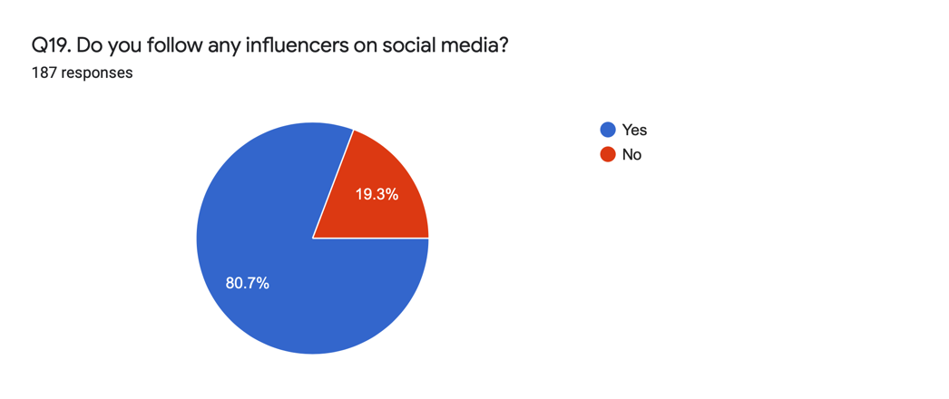
Figure 4.31 Social Media following (Authors own)
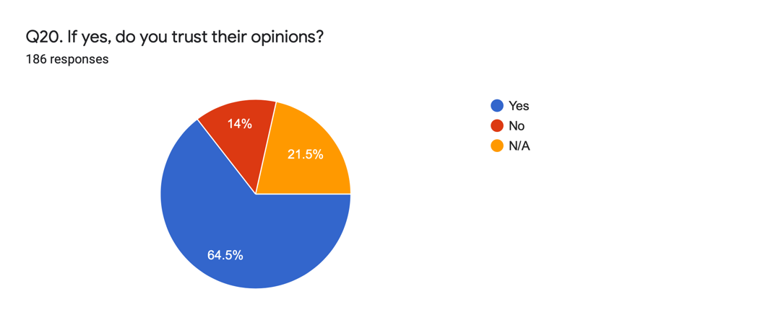
Figure 4.32 Influencer trust (Authors own)
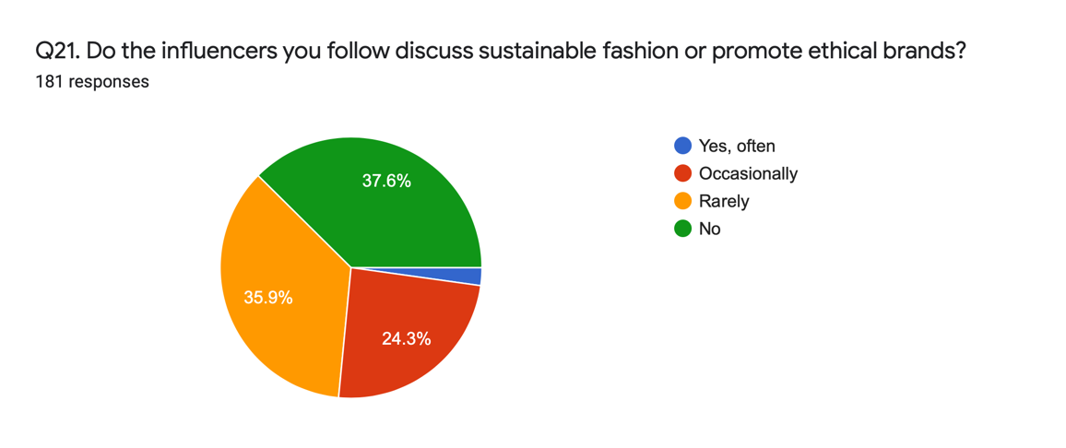
Figure 4.33 Influencer content (Authors own)

4.4 CONCLUSION
The objective of chapter four has been achieved by thorough analysis of the primary research collected by the author. Several themes have been bought to light from both the qualitative and quantitative data. The following chapter will summarise these findings and present recommendations and discuss areas for further research.

CHAPTER 5.0 CONCLUSIONS AND RECOMMENDATIONS

5.0 INTRODUCTION
Chapter 5.0 seeks to achieve the final objective of this dissertation;
To integrate primary and secondary research to achieve a greater level of understanding regarding consumer motives and recommend changes that can be implemented by organisations to better meet these motives in a sustainable manner.
This chapter will offer several recommendations, provide a concise collusion but also identify areas of this research document that could be improved upon in future studies.

5.1 THE RESEARCH STUDY QUESTION AND THE HYPOTHESIS
The dissertation sought to investigate consumers buying behaviour and the factors influencing this in relation to the sustainability of the industry. The research was conducted to formulate an argument based on the hypothesis of the dissertation:
H₀: Consumer buying behaviour within the fashion industry is not influenced by sustainability.

5.2 MAIN FINDINGS
The findings of this dissertation are in agreement with H₀ and as such sufficient evidence has been collated to exemplify that despite a growing interest in sustainability there is an obvious attitude-behaviour gap.
The main findings from this research supports most of the literature within chapter two, there are a few contradictions though that only reinforces the attitude-behaviour gap identified in chapter two.
Awareness into issues both environmental and ethical is prominent amongst most respondents; however, it has not always translated to knowledge and awareness of sustainable fashion. This highlights perhaps how much consumers are hearing about global warming, exploitation and other similar issues but do not necessarily consider that it is a problem within fashion and therefore, much of the data compiled in this dissertation calls for more information to be accessible and advertised so that consumers can make better more informed decisions.
Several barriers to sustainable consumption have been demonstrated throughout the data that has been explored and as such it has highlighted just how consumers are being drawn away from friendly fashion decisions. As commonly found with sustainable consumption within any industry is the barrier of price, this is quite substantial when it comes to fashion purchases and is only reinforced through the popularity of fast fashion houses that offer “cheaper alternatives” (Respondent 111) where consumers can “get so much more for my money” (Respondent 111). Along the same line as price there were a variety of responses stating a higher income would encourage them to indulge in sustainable fashion once again highlighting this higher price barrier. However, this is not something that necessarily needs to be the case. TALA is a sustainable fashion brand that has amassed insurmountable popularity, CEO Grace Beverly states that their approach as a company is working, with consumers choosing TALA over fast-fashion equivalents, though this has taken sacrifice on a price point meaning smaller profit margins in comparison to those brands but means consumers can afford the sustainable alternative (Rackham, 2019). This demonstrates that TALA is an organisation following the triple bottom line framework and shows that it is possible to for sustainable fashion to be more affordable, which from research findings and the success TALA insinuates that consumption rates would increase.
Another issue which has been highlighted is the lack of transparency within the industry, respondents are being motivated by brands to act in a way that is not sustainable which is not being communicated with consumers. It is this lack of communication between brands and consumers that has resulted in knowledge being limited about the fashion industry and its sustainability. Similarly to this is the issue of procurement, respondents reiterated that being able to access sustainable fashion more easily would increase their consumption.
The impact of social influence is evident through both secondary and primary research conducted, whether this be television programs, friends or social influence it is clear it influences consumer behaviour. This is spurred on by the nature of fashion itself what with the changing seasons and constant product line revitalisations. Particularly within fashion, brands have realised the reach that social media influencers can have, as such, influencers regularly receive high quantities of products from brands that they promote in order to drive sales more. The research conducted by the author shows that there is minimal promotion of sustainable fashion by influencers which is something that should be explored further.
The implications uncovered from this research is that overall consumers are lacking enough knowledge surrounding sustainable fashion and the need for it, more strikingly the majority of respondents did not know how to obtain this information either. In line with what theory suggests the more informed consumers are it is more likely to result in sustainable consumption. An increased awareness could result in more friendly-fashion sales however, there are other barriers which require attention.

5.3 THE IMPLICATIONS OF THE FINDINGS
The results of this dissertation provide an in-depth insight into areas of the industry that need better control. Organisations should pay attention particularly to areas such as, the sharing of information surrounding sustainability as well as the promotion of more sustainable practices and fashion pieces.
Without considerable intervention it is unlikely that the high consumption rates within fashion will change. It is all too clear that the fast fashion structure is compelling consumers to indulge in unsustainable consumption and unless this changes, consumers will continue to purchase apparel due to the cheap nature of it. It is important that the view of fashion is altered from disposable to further deter consumers purchasing from fast-fashion companies where clothes are simply not made to last. The implications of fashions changing seasons and constant change in product lines is problematic for sustainability as it encourages this throwaway behaviour that has been highlighted throughout. Therefore, it would be beneficial for further research to be carried out to investigate the fast fashion industry.

5.4 LIMITATIONS OF RESEARCH
After thorough analysis of the research conducted, some limitations of the research have become clear. Purposive sampling was used as the researcher wanted to summarise the findings of consumers ages 18-25-year-old females; however, it is only a presumption that these are the respondents as there was no question explicitly asking either age of gender.
Additionally, though behavioural trends have been explored considerably further research could have been conducted to better gauge the extent of respondents’ attitudes towards sustainable fashion.
Furthermore, Covid-19 has been the most considerable limitation to this dissertation and impacted the research conducted particularly as interviews did not take place this presented a limitation in the value of data collected as the interviews would have allowed more deeper evaluation of the topic from a different point of view; however, the data collected from the questionnaire was substantial and allowed for a insightful level of understanding to be extracted.

5.5 FUTURE RECOMMENDATIONS
A recommendation that has been highlighted is the ways in which this research could be improved upon. Particularly through the use of a questionnaire asking more demographic based questions as it allows for better descriptive statistical analysis to take place. Also not limiting the sample to only female respondents may produce interesting data that is full of comparable factors. Similarly, though respondents were asked the nature of their occupation, in future research it would be more prudent to ask what salary they earn as this would have given a bigger indication into factors like disposable income that could correlate with their consumer behaviour.
In order to see a shift towards sustainable consumption it is clear that consumers need to be able to access the information they need easily and even have it marketed to them. It is time consuming and off putting that currently consumers need to investigate whether an organisation is actually being sustainable or if they are simply greenwashing to generate sales. As such; having this information on a tab clearly presented on websites, apps and social media can allow for the information to be found quickly and easily and may see sustainable fashion consumption increase.
The nature of fashion instils the need to be fashionable in consumers which is consequently driving consumption. If this continues harsh measures and restrictions could be placed on brands to limit the amount of product lines introduced in a year or to change the season basis from four season to two. Intervention like this though extreme could see the deterrent of overconsumption due to a decrease in the amount of choice.
From the research conducted, though social media influencers have been found to generate a large following little of the data suggests their content is beneficial to the fashion industry in terms of sustainability. Consumers on a whole trust what influencers promote and as such its equated to a higher rate of consumption in fast fashion houses. It is recommended that sustainable brands and retailers promote more heavily on social media and if possible engage with influencers to do the same.
Secondary research highlighted the motivator of perceived behavioural control as a facet of the Theory of planned behaviour. It is theorised that consumers will be motivated if they can see and understand the impact that purchasing sustainably is having. Therefore, in order to motivate consumers could demonstrate the extent to which switching to sustainable fashion has through means of social media outlets and podcasts. The result of which could leave consumers feeling less like they are fighting a losing battle.

5.6 CONCLUSIONS
This study has achieved all the objectives set out by the researcher but more importantly it has achieved the overarching aim of the dissertation, which was to investigate what is driving consumption in the fashion industry and the impact that this has on the industry’s sustainable footprint. The research has provided a deeper insight into consumers behaviour and the barriers preventing them from being sustainable and indicated the areas which are considerably worse; for example, respondents disposal behaviour indicates a more sustainably driven approach compared to the purchase behaviour. The dissertation has identified areas that exemplify why consumers are unsustainable in their behaviour whilst showing the areas that could be utilised more to drive this sustainable behaviour.
To conclude, the findings from this dissertation have shown that there is need for change from both consumers and organisations in order to ensure that the fashion industry sees a drastic change in consumption behaviour; thereby, resulting in significantly less detrimental impacts to the planet.

5.5.1 SELF REFLECTION
The purpose of this study was to gain a better understanding into sustainable consumer behaviour particularly within fashion and to understand the motives behind consumption. The interest in this topic grew from several modules studied throughout the researcher’s BA Business Management course.
The completion of the dissertation has resulted in further knowledge being gained and development of skills in the software packages utilised. The research has been eye-opening, and it has been enjoyable taken on a project that required such in-depth research.
The researcher has gained a thorough understanding of the theory behind consumer behaviour, particularly sustainable consumption. Though, the researcher could hone the skill of producing and conducting primary research in order to ensure that the data obtained is suitable and best helps the researcher to answer the research question.

5.5.2 FINAL SUMMARY
This dissertation coherently outlines the fashion industry’s need to be more sustainable and has provided insight and understanding into why consumers are consuming at unsustainable rates. Several influencing factors have been identified as well as those factors that consumers consider to be barriers to being sustainable. The research has presented the need for more investigation into the fast-fashion industry and the unsustainable structure of it. Though the research has collated several recommendations that could result in more sustainable consumption and see the attitude-behaviour-gap shrink.

Bibliography
BBC News, 2013. Bangladesh Dhaka building collapse leaves 87 dead. [Online]
Available at: https://www.bbc.co.uk/news/world-asia-22275597
[Accessed Apr 2020].
Blanchard, T., 2019. Is 2019 The Year Fashion Finally Takes Sustainability Seriously?. [Online]
Available at: https://www.vogue.co.uk/article/has-fashion-finally-got-sustainable-2019
[Accessed Apr 2020].
Chan, E., 2020. 6 Ways to be Greenwashing Vigilant. [Online]
Available at: https://www.vogue.co.uk/news/article/greenwashing-in-fashion
[Accessed Mar 2020].
Collis, J. & Hussey, R., 2014. Business Research: A Practical Guide for Graduate and Postgraduate Students. 4th ed. Basingstoke: Palgrave Macmillan Higher Education.
Davis, J., 2019. How you can help make sustainable fashion more affordable. [Online]
Available at: https://www.harpersbazaar.com/uk/fashion/fashion-news/a28609044/sustainable-fashion-expensive-why/
[Accessed Mar 2020].
De Klerk, A., 2020. Are we seeing the end of seasonality in fashion?. [Online]
Available at: https://www.harpersbazaar.com/uk/fashion/a31255947/end-of-fashion-seasons/
[Accessed Apr 2020].
Fielding, K. S., McDonald, R. & Louis, W. R., 2008. Theory of Planned Behaviour, identity and intentions to engage in environmental activism. Journal of Environmental Psychology, 28(4), pp. 318-326.
Google Trends, 2020. Sustainable fashion and Missguided - Google Trends. [Online]
Available at: https://trends.google.com/trends/explore?date=today%205-y&geo=US&q=sustainable%20fashion,Missguided
[Accessed Mar 2020].
Groening, C., Sarkis, J. & Zhu, Q., 2018. Green marketing consumer-level theory review: A compendium of applied theories and further research directions. Journal of Cleaner Production, 172(1), pp. 1848-1866.
John, L. K., Mochon, D., Emrich, O. & Schwartz, J., 2017. What's the value of a like. Harvard Business Review.
Long, M. M. & Schiffman, L. G., 2000. Consumption values and relationships: Segmenting the market for frequency programs. Journal of Consumer Marketing, 17(3), pp. 214-232.
Moon, K. K.-L., Lai, C. S.-Y., Lam, E. Y.-N. & Chang, J. M., 2015. Popularization of Sustainable fashion: barriers and solutions. The Journal of The Textile Institute, 106(9), pp. 939-952.
Neville, S., 2013. Primark sales rise 20% despite Bangladesh factory disaster backlash. [Online]
Available at: https://www.theguardian.com/business/2013/jul/11/primark-sales-rise-despite-bangladesh-factory
[Accessed Apr 2020].
Pasquinelli, I., 2017. Will transparency become the norm in fashion?. [Online]
Available at: https://www.wgsn.com/blogs/sustainability-is-change-management/
[Accessed Mar 2020].
Peattie, K., 2001. Golden Goose or Wild Goose? The hunt for the green consumer. Business Strategy Environment, 10(4), pp. 131-148.
Prothero, A. et al., 2011. Sustainable consumption: Opportunities for consumer research and public policy. Journal of Public Policy and Marketing, 30(1), pp. 31-38.
Purt, J., 2014. Consumer behaviour and sustainability - what you need to know. [Online]
Available at: https://www.theguardian.com/sustainable-business/2014/sep/10/consumer-behaviour-sustainability-business
[Accessed Mar 2020].
Rackham, A., 2019. Grace Beverly: The 22-year-old taking on the gym wear world. [Online]
Available at: https://www.bbc.co.uk/news/newsbeat-50732940
[Accessed Apr 2020].
Sanders, S. & Sastry, A., 2019. The New Celebrity: The Rise of Infleuncers - And How They Changed Advertising. [Online]
Available at: https://www.npr.org/2019/09/09/759127302/the-new-celebrity-the-rise-of-influencers-and-how-they-changed-advertising
[Accessed Mar 2020].
Slater, S., 2019. The 'Greenwashing' Hiding the Truth of Your Favourite Fashion Brands. [Online]
Available at: https://www.vice.com/en_uk/article/kzmw5a/the-greenwashing-hiding-the-truth-of-your-favourite-fashion-brands
[Accessed Apr 2020].
Stern, P. C., Dietz, T. & Guagnano, G. A., 1995. The new ecological paradigm in social-psychological context. Environmental Behaviour, 27(6), pp. 723-743.
Summers, N., 2016. Ethical consumerism in global perspective: A multilevel analysis of the interactions between individual-level predictors and country-level affluence. Social Problems, 63(3), pp. 303-328.
Vasil, A., 2019. Report: Many Returned Products Thrown Out Instead of Resold. [Online]
Available at: https://www.npr.org/2019/12/29/792146756/report-many-returned-products-thrown-out-instead-of-resold?t=1584017058682
[Accessed Mar 2020].
Vermeir, I. & Verbeke, W., 2008. Sustainable food consumption among young adults in Belgium: theory of planned behaviour and the role of confidence and values. Ecological Economics, Volume 64, pp. 542-553.
White, K., Hardisty, D. J. & Habib, R., 2019. The Elusive Green Consumer. Harvard Business Review.
Wiederhold, M. & Martinez, L. F., 2018. Ethical Consumer Behaviour in Germany: The attitude-behaviour gap in the green apparel industry. International Journal of Consumer Studies, 42(4), pp. 419-429.
Wood, Z. & Butler, S., 2018. MPs criticise high street fashion's throwaway culture. [Online]
Available at: https://www.theguardian.com/fashion/2018/nov/27/mps-criticise-high-street-fashion-throwaway-culture
[Accessed Apr 2020].
WRAP, 2017. Valuing Our Clothes: The cost of UK fashion. [Online]
Available at: http://www.wrap.org.uk/sites/files/wrap/valuing-our-clothes-the-cost-of-uk-fashion_WRAP.pdf
[Accessed Oct 2019].
Zarroli, J., 2013. In Trenfy World of Fast Fashion, Styles Aren't Made To Last. [Online]
Available at: https://www.npr.org/2013/03/11/174013774/in-trendy-world-of-fast-fashion-styles-arent-made-to-last?t=1585138923402
[Accessed Mar 2020].
Zsóka, Á., Szerényi, Z. M., Széchy, A. & Kocsis, T., 2013. Greening due to environmental education? Environmental knowledge, attitudes, consumer behavior and everyday pro-environmental activities of Hungarian high school and university students. Journal of Cleaner Production, Volume 48, pp. 126-138.

