Research in practice
Proposal for independent Project
Word count: 2397

Proposed question: How does the representation of feminism and equality in modern children’s picture books empower the young generation?

3 key words: Feminism Empowerment Picture books

In my proposal, I aim to explore the intersection of these three key themes: feminism, empowerment, and picture books. To fully comprehend these complex concepts and effectively communicate them to children, I plan on conducting extensive research on both classic and contemporary picture books that represent these themes. Through careful analysis of various elements such as character design, storytelling, and colour palettes, I hope to gain insight into how to effectively convey mature ideas to younger audiences. In addition to examining picture books themselves, I also plan to delve into the work of theorists who explore the importance of picture books and education on movements like feminism, in childhood development. By analysing the theories and research of experts in the field of childhood education, I hope to gain a deeper understanding of how picture books can be used as a tool for empowering and educating children.

Feminism
"Feminism is the radical notion that women are human beings." (Kramarae, Treichler 1990)
Feminism is a social, political, and cultural movement that advocates for the equality of sexes and women's rights. It is based on the belief that women have been historically oppressed and marginalized by patriarchal societies and seeks to challenge and dismantle gender-based discrimination and inequality. Its origins were heavily influenced by the enlightenment in Europe in the 1700s which was a movement focused on equality for all. Illustration has been used throughout history as a tool for the feminist movement. One of the earliest examples of feminist illustration can be traced back to the suffragette movement of the late 19th and early 20th centuries. Suffragettes used illustrations to promote their cause and to highlight the injustices faced by women who were denied the right to vote. These posters and illustrations made for the suffragettes were placed in magazines and newspapers, like the image shown in figure 1, showing a ‘Lady liberty’ like woman on the map of the USA striding over the states, showing the gradual change of ideas on equality sweeping across the country. The injustice felt by the suffragettes and how this was expressed through these drawings proves that "art is not neutral. It either upholds or disrupts the status quo, advancing or regressing social justice"(Baca 1985) as the movement was successful in getting women the vote.
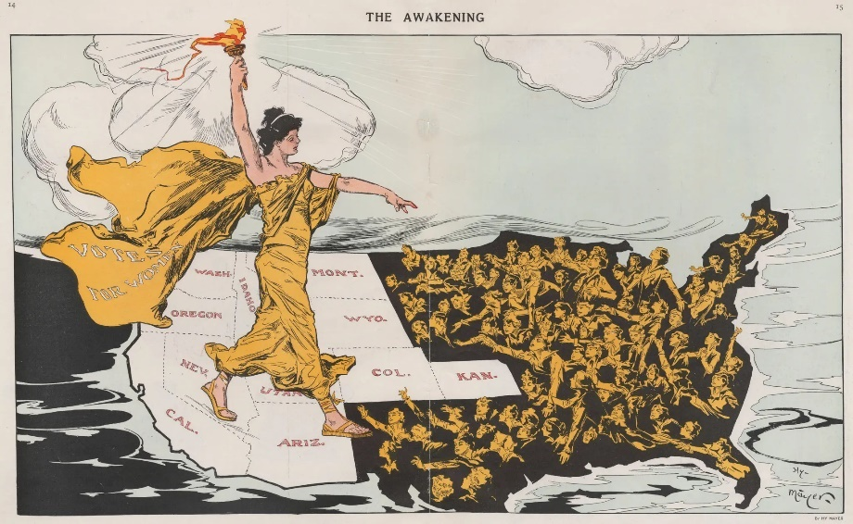

Fig.1, The Awakening, Puck Magazine, 1915

Modern feminism and feminist illustration continued to evolve and adapt to changing social and cultural contexts. In the 1960s and 70s, the feminist movement saw a surge of radical feminist artwork that used illustration as a means of challenging the male-dominated art world and promoting women's creativity and expression. Feminist artists like Judy Chicago, used illustration to create powerful works that celebrated women's bodies, sexuality, and experiences. “The goal of feminist art was to change the world, to change consciousness, to make visible what had been invisible, to question what had been assumed." (Chicago, 2006)


Fig.2, Judy Chicago, Birthing Trinity, 1985

"Visual images have always been a powerful means of conveying ideas, and feminists have long understood the importance of challenging dominant images and creating alternative ones." (Hooks 1981) This speaks to the feminist movement's use of illustration as a means of challenging traditional gender roles and promoting positive representations of women. Although the image shown in figure 2 holds concepts that would not be appropriate for a children’s book, I will further explore images that are appropriate keeping to the theme of feminism but will use feminist artists as inspiration when creating my work.
The use of picture books to educate children on feminism has long been in practice. In order to relate to younger audiences at time, feminist picture books began to emerge in the 1970s as a way to challenge gender stereotypes and promote positive messages about women's roles and contributions to society. These books were written and illustrated by feminists who were passionate about empowering young girls and boys with a more inclusive and diverse worldview.
Illustration has the ability to engage with the viewer on an emotional and intellectual level, to inspire curiosity, to challenge ideas, and to provoke thought.
(Lawrence 2009)
More recently, picture books such as Good Night Stories for Rebel Girls by Elena Favilli and Francesca Cavallo have become popular for their portrayal of strong and inspiring women. These books feature biographical sketches of women who have made significant contributions to various fields, from science to politics to the arts. Through these stories and illustrations, children can learn about the accomplishments of women throughout history and be inspired to follow their own dreams. Further exploration into children’s picture books exploring the theme of feminism will be undertaken as well as possible narratives that are appropriate and well fitted to the theme.

Empowerment
Empowerment is a concept that has gained significant traction in recent years, particularly with the recent increase of social and political movements, such as ‘Black lives matter’, empowering illustrations and art has been emerging more frequently. “Empowerment is the experience of self-discovery, of discovering one's own authentic self and unique voice, and then using that voice to make a positive contribution to the world.” (Covey 2014) It is about giving people the tools and resources they need to take control of their lives and allow them to have the knowledge and resilience to be successful. Empowerment is often achieved through education, access to resources and opportunities, and the development of skills and self-confidence. The use of illustration to show empowerment is a modern way of educating children on sometimes mature and difficult themes. As history has shown the lack of empowerment and education on its importance leads to inequality.
Illustration has been used to promote empowerment by highlighting the strengths, resilience, and capabilities of marginalized communities.
Art can foster empowerment by allowing people to express themselves, to articulate their own stories, to claim their own histories and futures, and to resist marginalization and oppression. (Bloom and Gullotta 2003)
This indicates to the fact that these empowering illustrations help with social and political movements like feminism, but also with other movements helping communities who suffer from racism and homophobia. An empowering image is “immediately and universally accessible, whereas written language can be complex and culturally bound” (McCloud 1994). Anyone from anywhere can see the image and understand the meaning behind it disregarding whether or not they speak the same language or are 7 or 96 years old. The visual language is universal communication.

One powerful example of how illustration has been used to promote empowerment is in the work of artist and activist Molly Crabapple. She is best known for her intricate, detailed illustrations that often feature strong, independent women in positions of power. Through her artwork, Crabapple seeks to challenge traditional gender roles and empower women to take control of their lives and their bodies.

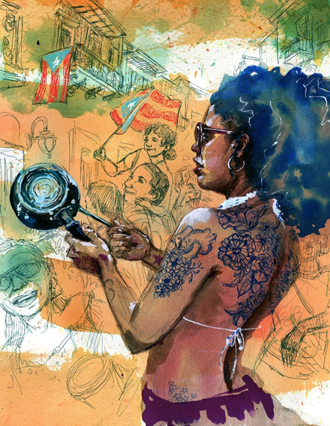

Fig.3, Molly Crabapple, Verano, 2019

Empowering children means allowing them to take charge of their own learning and development, while providing the guidance and support they need to succeed.

(Robinson 2011)

To see a woman of colour represented with beauty and grace as well as celebrating her culture is massively influential to young people. It shows them that they matter and that their beliefs and culture matter.
Illustration has also been used to promote empowerment in the realm of education. In recent years, there has been a growing movement towards using illustrations and graphic novels as educational tools. By presenting complex ideas and concepts in a visual format, these tools can help make learning more engaging and accessible for people of all ages and backgrounds. Illustrations can also help to empower students by giving them a sense of ownership and agency over their own learning process. Davies and Brazell said that “Great illustration is about creating something that is both visually striking and emotionally resonant, something that captures the imagination and lingers in the memory”. (2011) While not all empowering illustrations are appropriate for a younger audience, the ideas behind them are and I plan to interpret these themes and concepts with my work in the future.

Picture Books
Picture Books have been around for hundreds of years and are enjoyed by millions of children. “In the age of digital media, illustration has become more important than ever, as it can cut through the noise and capture the attention of an increasingly distracted audience” (Heller 2010) With the continuous growth of digital art and technology, the simple picture book is still around but has had to change over the years and adapted to the modern world. The importance of these books are paramount to young minds as they encapsulate them into another world not located on a screen.
The illustrations in picture books can be used to educate children about a wide range of topics. For example, picture books about animals can feature detailed illustrations of different species, helping children to learn about the natural world. Similarly, picture books about history or culture can use illustrations to provide a visual representation of different time periods or customs, making it easier for children to understand and remember the information.
The use of picture books to educate children on feminism and empowerment has been majorly successful. When creating a picture book that explores these mature themes, the artist needs to be mindful of what they choose to include. For example, when designing characters, they would need to keep in mind how they represent the characters as it’s not just about the appearance.
Character design is not just about drawing pretty pictures. It's about creating a visual representation of a character's personality, motivations, and desires. It's about telling a story through images. (Oatley 2019)
This relates to the fact that these books would need to represent all kinds of women and girls, showing depth in their characters. Much like the characters shown in figure 4.

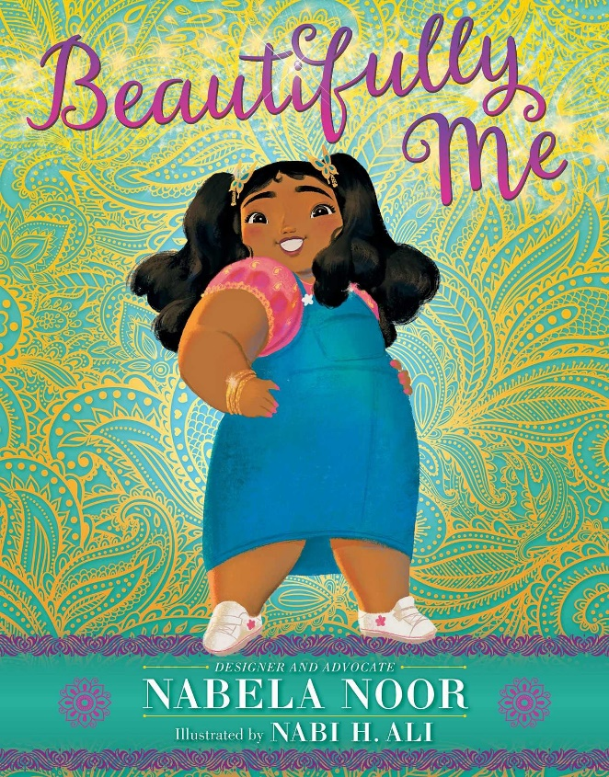

Fig.4, Nabela Noor and Nabi H. Ali, Beautifully me, 2021
This book is a prime example of how modern picture books are embracing inclusivity and diversity as essential aspects in the 21st century. The book is about a young Bangladeshi girl who is starting school but begins to feel conscious about how she looks after her mother comments on her weight. Throughout the book she overhears other people talk about their own insecurities and finally confronts her family about how their words hurt. “Teach your children that their worth is not tied to their appearance, but rather to their inner qualities and talents." (Hartstein, 2011). The message behind the book is inspiring to young people as it teaches them about the importance of self-acceptance.
Okwui Enwezor, a renowned curator and art critic, once remarked that "Representation in art is about creating a visual language that reflects the diversity and complexity of human experience" (2003), and this book brilliantly embodies this concept. The young girl in the story is depicted with rounded edges and softly blended shadows, giving her a playful and cheerful appearance. The artist has also made a conscious effort to showcase the character's cultural heritage by incorporating traditional patterns in the background and featuring Bangladeshi jewellery in the character's attire. What is particularly noteworthy about this book is that the young girl is also depicted as a plus-size character, which is a refreshing and empowering choice. In the past, such a portrayal might have been an uncommon and underappreciated decision, but now it reflects the current feminist views on body positivity and empowerment. However, I did some research into how many modern children’s picture books have a female protagonist and found that “46% of books had male protagonists, while only 17% had female protagonists (in 32% of books there was no lead character)” (Mokrzycki 2019) which I find to be shocking as our society has evolved from the previous sexist ideals of the past. I will research into this subject further as to why there is still inequality how this can be changed.
Compared to traditional children’s books like Cinderella, or Snow White, contemporary picture books are empowering and inclusive. The book shown in figure 5 is the classic, Snow White And The Seven Dwarfs. The traditional fairy tale depicts a princess cleaning for a house full of men and waiting for a prince to show up and save her. It contrasts massively to modern picture books like Beautifully me as the protagonist is drawn as a traditionally beautiful girl, with pale skin and a slim figure. “Fairy tales reinforce gender stereotypes and perpetuate harmful messages about beauty, power, and relationships.” (Zipes, 1979) this quote perfectly encapsulates the misogynistic views of the past and how society has changed it views for the better. Furthermore, how these societal changes have impacted the way we educate the young generation on matters that were taboo in the past and how the modern way of teaching helps to make us a more understanding and inclusive civilization.
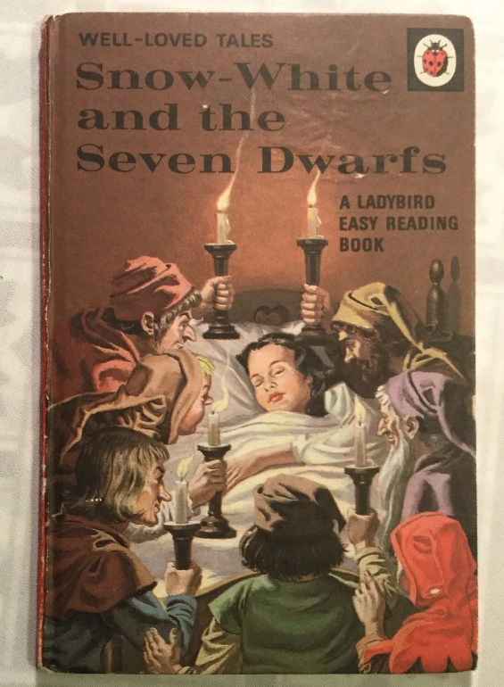

Fig.5, Snow White And The Seven Dwarfs, 1969

This proposals intention was about exploring the intersection of feminism, empowerment, and picture books. Illustration has been used to promote empowerment by highlighting the strengths, resilience, and capabilities of marginalized communities. By conducting extensive research on classic and contemporary picture books and delving into the work of childhood education experts, I have gained a deeper understanding of how picture books can be used as a tool for empowering and educating children.
To conclude my findings, the question I have come to is, How does the representation of feminism and equality in modern children’s picture books empower the young generation? I plan to create a children’s picture book, encapsulating all my research on how to empower young girls and educating both boys and girls on feminism and equality. Keeping culture, race and religion in mind as well. The story will be an original written by me so I plan to explore narrative writing and how that will meld together with my illustrations. I will also be answering some sub questions like, what makes and empowering image? What makes a feminist book? How to successfully include male characters into a picture book about feminism and empowering women?
Figure 6 is some of my previous work and how I plan to present my picture book next year. This book had the text written out as a poem. My intention for my practice is to also write a poem as I found this way of writing to be more enjoyable to read.
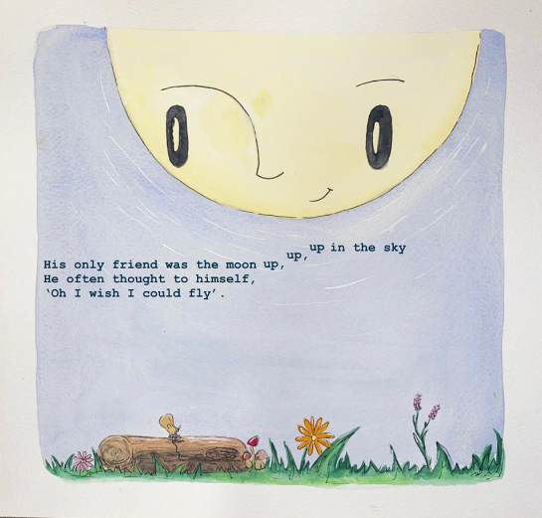
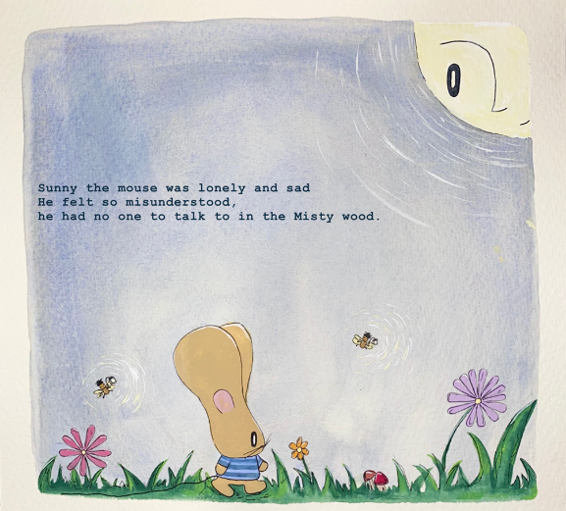

Fig.6, Rosie Banks, The mouse and the moon, 2022
Bibliography
Arisman, M. and Heller, S. (2010). Marketing Illustration. Simon and Schuster.

Baca, J.F. (1985). Toward a Definition of Public Art. Art in Public Places: A Guide to the Issues.

Cheris Kramarae and Treichler, P.A. (1990). A Feminist Dictionary. London, Sidney: Pandora.

Chicago, J. (2006). Through the flower: my struggle as a woman artist. New York.: Authors Choice.

Covey, S.R. (2014). The 8th habit: from effectiveness to greatness. London: Simon & Schuster, [Tussen En.

Davies, J. and Brazell, D. (2011). Making Great Illustration.

Enwezor, O. (2003). The Postcolonial Constellation: Contemporary Art in a State of Permanent Transition.

Gullotta, T.P., Bloom, M. and Child (2003). Encyclopaedia of primary prevention and health promotion. New York: Kluwer Academic/Plenum.

Hartstein, J.L. (2011). Princess Recovery. Simon and Schuster.

Hooks, B. (1981). Ain’t I a Woman: Black Women and Feminism. New York: Routledge, Cop.

McCloud, S. (1994). Understanding Comics: The Invisible Art. New York: HarperCollins Publishers.

Mokrzycki, S. (2019). I looked at 100 best-selling picture books: female protagonists were largely invisible. [online] The Conversation. Available at: https://theconversation.com/i-looked-at-100-best-selling-picture-books-female-protagonists-were-largely-invisible-115843 [Accessed 23 Apr. 2023].

Oatley, C. (2019). The Art of Visual Storytelling.

Robinson, K. (2011). Out of our minds: learning to be creative. Oxford: Capstone.

Zeegan, L. (2009). What is Illustration.

Zipes, J. (1979). Breaking the magic spell: radical theories of folk and fairy tales. London: Heinemann.

List of Figures

Fig.1, The Awakening, Puck Magazine, 1915
Fig.2, Judy Chicago, Birthing Trinity, 1985

Fig.3, Molly Crabapple, Verano, 2019
Fig.4, Nabela Noor and Nabi H. Ali, Beautifully me, 2021
Fig.5, Snow White And The Seven Dwarfs, 1969
Fig.6, Rosie Banks, The mouse and the moon, 2022

