University of Wales Trinity Saint David
School of Engineering
Valve Train Dynamics and Intake/Exhaust Pulse Tuning
James Smith
1801879
Bsc Motorsport Engineering
Powertrain Design & Efficiency M5X02200
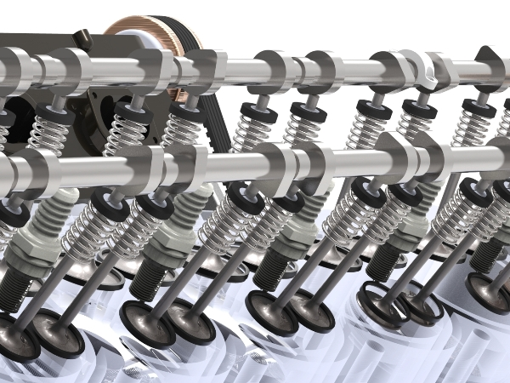

-Figure 1: Valve Train (Force Technology, 2017)

Contents

Title Page………………………………………………………………………………….………………………..………. Page 1
Contents……..……………………………………….…………………………………………………………….………. Page 2
List of Figures…………………………………………………………………………………………………….………… Page 3
Abstract…………………………………………………………………………………………………….………………… Page 4
1. Introduction…………………………..…………………………………………………………………………..…… Page 5
2. Research…………………………………..……………………………………………………………………….….… Page 6
3. Methodology……………..…………………………….…………………………………………………………..… Page 8
4. Results / Analysis……………..……………………………………………………………………..……..…..…… Page 9
4.1. Velocities, Accelerations and Contact Forces up to 10,000 RPM…..………..… Page 9
4.2. Engine Speed Increased to 12,000 RPM without Valve Float Present ……. Page 11
4.3. Intake System Design……………………………………………………………………………… Page 11
4.4. Exhaust System Design…………………………………………………………………………… Page 14
4.4.1. Exhaust Valve to Collector…………………….……………........……………. Page 14
4.4.2. Speed of Sound Calculation…………….……….…………........……………. Page 14
4.4.3. Harmonics and RPM Calculations……………………….……………………. Page 15
4.5. Exhaust System Design Two…………………………………………………………………… Page 15
4.5.1. Harmonics and RPM Calculations……………..……………………………… Page 16
5. Conclusion……………..……………………………………………………………………….……….….……..… Page 16
Figure References……………..……………………………………………………………………….……….….… Page 17
References……………..………….……………………………………………………………….…….……………... Page 17
Appendix…………………………………………………………………………………………………………………… Page 18

List of Figures

Figure 1………………………………………………..……Valve Train (Force Technology, 2017)………. Page 1
Figure 2…………………………………..…Velocity Against Crank Angle up to 10,000 RPM………. Page 9
Figure 3………………….…………Acceleration Against Crank Angle up to 10,000 RPM………. Page 10
Figure 4………………..…………Contact Force Against Crank Angle up to 10,000 RPM………. Page 11
Figure 5………………………………Contact Force Against Crank Angle for 12,000 RPM………. Page 12
Figure 6…………………………………………………………………Inlet Design One, Excel Work………. Page 13
Figure 7……………………………………………..…………………Inlet Design Two, Excel Work………. Page 13
Figure 8………………………………………………..……………………………RPM and Harmonics………. Page 13
Figure 9…………………………………………………………Exhaust Manifold Second Design………. Page 15

Abstract

This investigation and analysis of valve train dynamics performed in this report, aimed to use a range of techniques and resources to successfully calculate valve velocities, accelerations and contact forces, for the data provided by the University. This has been undertaken by developing an understanding around the valve train topic, by performing research and including literature reviews where appropriate to support the calculations made and the analysis and conclusions stated from the work carried out.

1. Introduction

This vale train dynamics report is going to include a valve train analysis using data provided by the University of Wales Trinity Saint David (UWTSD). A research section will include background information around the valve train dynamics topic, to help explain and prove that all calculations and results presented in this report are correct. A methodology section will then be stated, showing and explaining the work to be carried out and the equations that will be used.

The analysis section of this report will include, calculated valve velocities, accelerations and contact forces up to 10,000 RPM, to help to indicate the point of valve float. This will be done by using the sample data supplied, using an excel spreadsheet created to produce calculations and graphs. Succeeding this, suggestions for changes to be made to the valve train will be stated, to allow for an increase of RPM up to 12,000, with no valve float. This will be done by using the same excel spreadsheet created, showing calculations made to achieve this.

The intake and exhaust system for a 1,000cc Vee 4 gasoline superbike, will then be designed. This will be fulfilled to maximize the torque and power produced from the engine, assumptions can then be made from this after producing calculations for both the intake and exhaust design. This section of the report will include two designs for the intake and two designs for the exhaust. Then, allowing for a conclusion section in the report, to show a comparison between the designs, stating which one will be more suitable for high and low speed cornering tracks.

2. Research

The research section for this report will include background information around the valve train topic to further help the analysis and comparisons for the calculations and results collected in this report. These will include details around intake and exhaust tuning, giving a background around the types of systems, including ideal designs for the intake and exhaust to produce maximum torque and power.

Important factors for intake systems include, low air flow resistance and an evenly distributed amount of air and fuel within the cylinders. Runner and port lengths are another important factor to help take advantage or RPM and tuning effects, these include longer runners and larger ports, to improve output. With proper design, the runner length and intake manifold can give optimum engine performance per the needs of the vehicle (Bayas, Wankar, Jadhav, 2016, p.102). Longer intake manifolds overall give higher torque at lower RPM and shorter manifolds normally give peak torque figures at high RPM (Bayas, Wankar, Jadhav, 2016, p.105).

The most ideal time for perfect suction within the induction system of the engine is when the piston is moving fastest, this is when the lowest pressure is created and when the layer of air above the piston is fastest during the cycle. The pressure drop is created, when the piston draws down the first layer of air, creating a vacuum between the second layer of air, this then creates a force. There is a delay between the piston moving down and the pressure drop in the inlet, these delays can be used as an advantage when pulse tuning the system. Optimum full valve lift is when the air is fastest, therefore the vacuum effect is greatest at full valve lift. The suction pulse (vacuum effect), moving from the valve to the inlet, moving at the speed of sound, then reaching the trumpet sucks air in creating the pressure pulse.

Flow resistance in a long trumpet length can be a disadvantage, causing a pressure drop, therefore by shortening the trumpet length can reduce the resistance, causing the pulse to return and reach the cylinder earlier. Variable valve timing (VVT), can also be used to retard the full valve lift by 40 degrees, to avoid contacting the piston as it moves.
The intake tuning aids the ability of breathing of the engine, and with careful design applied can help to get the maximum performance from the intake system. Intake tuning can gain greater advantages for the breathing of the engine, over exhaust tuning by providing a range of inlet length for various engine speeds (Bayas, Wankar, Jadhav, 2016, p.102).

Exhaust and inlet tuning have a great effect on the performance of an engine, but their individual contributions to the breathing and performance of an engine are mutually independent (Bayas, Wankar, Jadhav, 2016, p.102). The exhaust manifold, is the flow system of removing gases from the cylinders, treating them, then some are sent back to the induction through, exhaust gas recirculation (EGR) and the rest are exhausted into the surrounding atmosphere (Narayan, Gupta, 2016, p.74).

The exhaust system can determine the operational behaviour of the engine in steady and transient modes regarding engine performance and emission. As previously stated, variable valve timing (VVT) can be used to retard the valve lift, this also intern effects the problems of valve overlap, which is then used to reduce fuel consumption and emission produced (Kesgin, 2004, p.2259).

3. Methodology

To further investigate valve train dynamics, data supplied by The UWTSD will be used alongside an excel spreadsheet created. Within this spreadsheet, calculations will be made for valve velocities, accelerations and contact forces up to 10,000 RPM and then indicating the point of valve float. By testing various changes made to the valve train, it is then hoped to archive an increase of RPM to 12,000 RPM at a point of no valve float. All calculations will be shown.

The next section of the results and analysis, will include the designing of the intake and exhaust systems for a 1,000cc Vee 4 gasoline superbike, where it will be designed to maximum torque which is 10,000 RPM and the power which is 12,000 RPM. Both the intake and exhaust CAMs are symmetrical and data has been supplied for the duration of each of these CAMs.

The first design for the inlet system will have 4 equal running lengths, the length from valve to trumpet will then be calculated, discussing the effect of Harmonics and the length chosen. The opening point and duration will then be changed for the second design, showing the effects that is has on the inlet length designed.

The first exhaust system will have a 2 into 1 manifold design, which is separate from the other cylinder bank. The length from exhaust valve to collector, will be calculated, whilst the purpose of this design will be to achieve maximum power. The effects of Harmonics will then be stated alongside reasoning for the choice in exhaust length. The second exhaust system will have a 4 into 2 into 1 system, the suitable lengths for the primary and secondary manifold pipes will then be calculated, whilst keeping the overall manifold length the same as the first design. This will be carried out to help the engine achieve better mid-range performance and power.

4. Results / Analysis

The analysis section is going to include the excel work carried out to calculate valve velocities, accelerations and contact forces. Calculations used to design the intake and exhaust systems for a 1,000cc superbike will then be stated, where necessary graphs and literature reviews will be included to better explain the modifications made and the work carried out. All excel data and worksheets used, will be included in the appendix of this report.

4.1. Velocities, Accelerations and Contact Forces up to 10,000 RPM with Valve Float

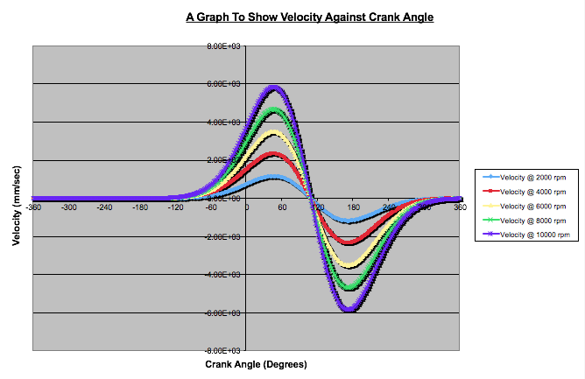
To start the valve train analysis, data provided for the standard intake, exhaust masses and spring data have been used in an excel spreadsheet to calculate the valve velocities, accelerations and contact forces up to 10,000 RPM, these were calculated in 2,000 RPM intervals. These will now be shown with the excel equations used to calculated the velocities, accelerations and contact forces, along with graphs to indicate the difference between the RPM intervals.
-Figure 2: Velocity Against Crank Angle up to 10,000 RPM
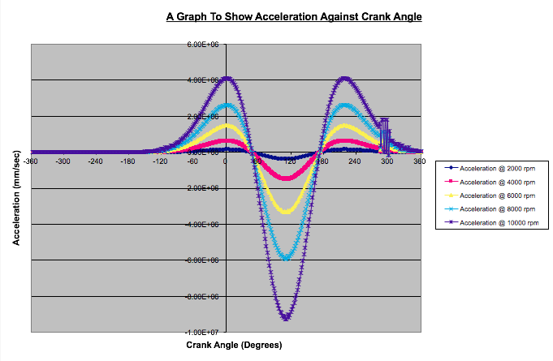
The graph in figure 2, has been created after calculating the valve velocity up to 10,000 RPM with valve float present. To calculate the velocities for -360 to +360 degrees of crank angle up to 10,000 RPM, the velocity was first calculated by using the equation L2-L1, where L is equal to the valve lift. This equation was used for every degree of crank angle in intervals of 2 degrees. The equation, $Veleocity x 6 x \frac{1}{2}RPM$, was then used for the first velocity of each RPM up to 10,000 and then dragged down to calculate the velocity at every degree of crank angle. The graph shows VMAX occurs around 60 degrees of crank angle and then reduces.
-Figure 3: Acceleration Against Crank Angle up to 10,000 RPM

Figure 3 shows the valve acceleration against crank angle from 2,000 RPM to 10,000 RPM. This graph was created by firstly calculating the acceleration, by using the equation V2-V1, where V is velocity. After calculating this, the equation $Acceleration x (6x\frac{1}{2}{RPM)}^{2}$ was used for the first line of each RPM interval, this was then dragged down to calculate all the valve accelerations up to 10,000 RPM. The graph shows that around 0 degrees of crank angle, the max acceleration of the valve is reached and valve float occurs around 60 degrees of crank angle.

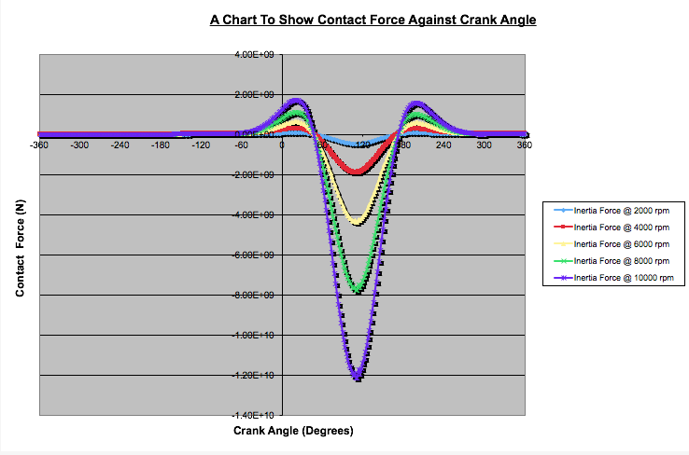
-Figure 4: Contact Force Against Crank Angle up to 10,000 RPM

The graph in figure 4 shows contact force against crank angle for the engine speed from 2,000 to 10,000 RPM. This was calculated by using the data for moving mass and spring force for every degree of crank angle. The equation Moving Mass X Acceleration X Spring Force, was used for the first line of each RPM column, this was then dragged down to work out all the contact forces up to 10,000 RPM. The point of valve float starts at 48 degrees of crank angle and stops at 160 degrees. Calculations will now be used to work out modifications to be made to increase the RPM to 12,000 without valve float.

4.2. Engine Speed Increased to 12,000 RPM without Valve Float Present

To achieve an increase in engine speed to 12,000 RPM, the masses and spring data sheet within the excel spreadsheet were modified. The masses for the intake and exhaust valve, bucket and retainer were reduced slightly. The spring data, including the spring stiffness and force were increased to 5000000 Newton’s. These new masses were then used in the same calculation as used before for contact force to calculate the increased RPM without any valve float present.
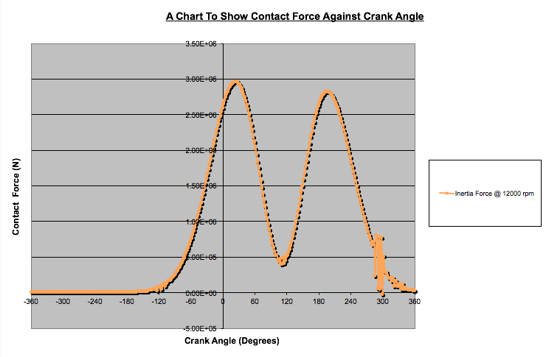
-Figure 5: Contact Force Against Crank Angle for 12,000 RPM

The graph above shows the contact force increased to 12,000 RPM against crank angle, but with no valve float present. The graph shows the full valve lift is at 56 degrees of crank angle, starting to open around -120 degrees of crank angle. The increase spring force has allowed for the valve to produce no valve float for the increased 12,00 RPM.

4.3. Intake System Design

To design an intake system for a 1000cc gasoline superbike to help achieve maximum torque at 10,000 RPM, a new excel worksheet was created, imputing the data supplied. The data for the first design for the intake cam was a duration of 280 degrees and the maximum opening point of 108 degrees after top dead centre (ATDC). The equation, $Length= \frac{330}{2} x \frac{M.O.P.}{360}x \frac{60}{RPM}$, was then used to calculate the runner length for the max torque and power of the superbike.

Figure 6 shows the excel spreadsheet including the results for the runner lengths for inlet design one, for 10,000 RPM and 12,000 RPM for the 1000cc bike. To design the second intake system, cam timings were changed to a duration of 305 degrees and maximum opening point at 80 degrees before top dead centre (BTDC) was used. The equation, $Length= \frac{330}{2} x \frac{M.O.P.}{360}x \frac{60}{RPM}$, was then used to calculate the ideal runner length for the new cam timings. These calculations are as shown in figure 7.
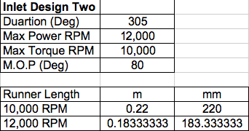
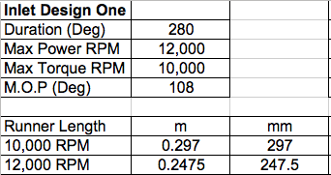

-Figure 6: Inlet Design One, Excel Work -Figure 7: Inlet Design Two, Excel Work
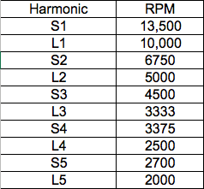
After calculating a suitable intake length for design one and design two of the intake system. The harmonics can now be calculated and discussed. The first inlet design to help achieve max torque for the bike at 10,000 RPM has been designed with a longer intake length as listed as ‘L’ in figure 8. The second inlet design has been designed shorter due to the duration and max opening point as listed as ‘S’ in figure 8.

-Figure 8: RPM and Harmonics

To work out and check what RPM each of the intake lengths are best tuned for, the equation; $RPM= \frac{330}{2 x N x L} x \frac{M.O.P.}{360} x 60$ is used, where N is the harmonic and L is the intake length. For example, for the first harmonic of the longer inlet design the calculation $\frac{330}{2 x 1 x 0.297} x \frac{108}{360} x 60=10,000$, showing that this length is best tuned up to 10,00 RPM.

For the first design of the intake system, the max torque produced by the engine is at 10,000 RPM and from the calculations made to create figure 8, it is shown that the inlet length chosen shows that the first harmonic is perfectly tuned for max torque for this engine. The harmonics show that the engine is well tuned for lower RPM’s of the engine. The chosen inlet length also shows that the tuning is most effective at 10,000 RPM and 5,000 RPM.

The second intake design shows that the engine is well tuned for max torque at 10,000 RPM and max power at 12,000 RPM. This is proven for the first harmonic equalling 13,500 RPM, the harmonics for the shorter second intake design shows that this length is good but due to there being less air momentum, the intake may suffer from flow reversal after bottom dead centre.

4.4. Exhaust System Design One

To design the exhaust manifold system for the same 1000cc superbike to achieve maximum power at 12,000 RPM, the length from exhaust valve to collector is going to be calculated. The aim of this type of exhaust tuning is to scavenge wasted exhaust gases from the cylinder to then deliver a pressure pulse before the exhaust valves close. Starting the calculations, the following equations and assumptions were used;

4.4.1. Exhaust Valve to Collector;
Total length from exhaust valve to merge collector = 0.9 m
Port Length= 0.15m
Collector to End of Manifold = 0.3m
Total Length of Manifold = 0.9 +0.3 = 1.2 m

4.4.2. Speed of Sound Calculation;
$$\frac{Speed of Sound at 720℃}{Speed of Sound at 20℃}\sqrt{\frac{720+273}{20+273}}=1.841$$
$$Speed of Sound at 700℃=1.841 x 330=607.53 m/s$$

4.4.3. Harmonics and RPM Calculations
$$RPM= \frac{Speed of Sound}{N x 2 x L}x\frac{Duration}{360}x 60$$
$$Where, N=Harmonic and L=Length of Pipe$$

$$N1=\frac{607.53}{1 x 2 x 0.9}x\frac{290}{360}x60=16,313 RPM$$
$$N2=\frac{607.53}{2 x 2 x 0.9}x\frac{290}{360}x60=8,156 RPM$$
$$N3=\frac{607.53}{3 x 2 x 0.9}x\frac{290}{360}x60=5,437 RPM$$
$$N4=\frac{607.53}{4 x 2 x 0.9}x\frac{290}{360}x60= 4,078 RPM$$
$$N5=\frac{607.53}{5 x 2 x 0.9}x\frac{290}{360}x60=3,262 RPM$$

The harmonics as shown above, show that for the best tuning effect to obtain maximum power from the superbike, is the first harmonic which is ideal for max power because max power is at 12,000 RPM. So, the 0.9m exhaust valve to collector length is good for this type of 2 into 1 system.

4.5. Exhaust System Design Two
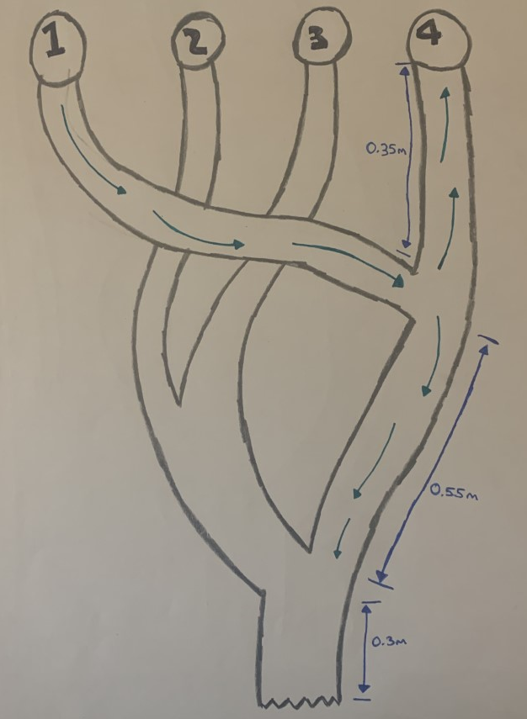
The next exhaust system design will be a 4 into 2 into 1 system, that still has the same overall manifold length but different primary and secondary manifold pipe lengths. This design will be used to optimise the mid-range performance of the superbike to help with circuit racing that need a wider spread of torque.

Collector to End of Manifold = 0.3m
Primary Manifold Pipe= 0.35m
Secondary Manifold Pipe=0.55m
Total Length = 0.3 + 0.35 + 0.55 = 1.2m
-Figure 9: Exhaust Manifold
Second Design
4.5.1. Harmonics and RPM Calculations
$$RPM= \frac{Speed of Sound}{N x 2 x L}x\frac{Duration}{360}x 60$$
Using the previously calculated speed of sound and duration for the engine, the harmonics for the secondary length of the manifold will be calculated.
$$N1=\frac{607.53}{1 x 2 x 0.55}x\frac{290}{360}x60=26,694 RPM$$
$$N2=\frac{607.53}{2 x 2 x 0.55}x\frac{290}{360}x60=13,347 RPM$$
$$N3=\frac{607.53}{3 x 2 x 0.55}x\frac{290}{360}x60=8,898 RPM$$
$$N4=\frac{607.53}{4 x 2 x 0.55}x\frac{290}{360}x60= 6,673.63 RPM$$
$$N5=\frac{607.53}{5 x 2 x 0.55}x\frac{290}{360}x60=5,338 RPM$$

The harmonics calculated show that the length chosen allows the engine to be well tuned for max power at 12,000 RPM, with the second and third harmonic satisfying this. For a track set-up, this length of secondary manifold pipe seems to be also well tuned for a wide spread of torque which reaches max torque at 10,000 RPM.

5. Conclusion

To conclude this report, the work carried out shows that by tuning the intake and exhaust systems of an engine can have an increasing effect on the maximum power and torque achieved. But by tuning both the intake and exhaust systems to different RPM points, you can create a broader torque and power curve through the RPM’s achieving better mid-range and max power.

Concluding the intake designs produced, the first design of the intake system would be best suited to lower speed tracks, due to the wider range of mid-range power and torque, allowing faster acceleration out of corners. The second design would be much more suitable for high speed tracks due to the tuning being most effective at 13,500 and 6,750 RPM, allowing for max power and torque to be achieved in the high speed straight lines.
Figure References

Figure 1. Force Technology. (2017) Force Technology starts PhD “Predictive Valve Spring Dynamics for Valve Train Optimisation”. [Online]
Available: http://www.forcetechnology.co.uk/2017/10/01/force-technology-starts-phd-predictive-valve-spring-dynamics-valve-train-optimisation/
(Accessed 21st April 2020)

References

Bayas, J, Wankar, A, Jadhav, N.P. (2016) A Review Paper on Effect of Intake Manifold Geometry on Performance of IC Engine. p.102, 105. [Online] Available: https://www.researchgate.net/profile/Nilam_Jadhav3/publication/311615682_A_REVIEW_PAPER_ON_EFFECT_OF_INTAKE_MANIFOLD_GEOMETRY_ON_PERFORMANCE_OF_IC_ENGINE/links/5851274308ae4bc8993b77f6.pdf
(Accessed 24th April 2020)

Kesign, U. (2004) Study on The Design of Inlet and Exhaust System of a Stationary Internal Combustion Engine. p.2259. [Online] Available:
https://reader.elsevier.com/reader/sd/pii/S0196890404002626?token=11F9DF2E01924F5C5EF14D1D8CD6E5DC7BC5E1C9D8DB67C0810A8B91DE9DA73676148A211CE679F1922BF3D25B7DE237
(Accessed 30th April 2020)

Narayan, S and Gupta, A. (2016) An Introduction to Combustion Engines. p.74. [Online] Available: https://search-proquest-com.ezproxy.uwtsd.ac.uk/docview/1853306244?accountid=130472&rfr_id=info%3Axri%2Fsid%3Aprimo
(Accessed 28th April 2020)

Appendix



