

Should Frontline Officers wear Body Worn Video as Standard?

Name of Student: Jaswant Singh
Student Number: 22458522
Degree Title: BSc (Hons) Professional Policing Practice
Due Date: 5th January 2025
Word Count: 8,477
Acknowledgements
I would like to express my sincere gratitude to my wife, children, and family for their unwavering support and encouragement throughout the duration of my three-year journey in this project and degree program.

I would like to express my sincere gratitude to my colleagues on my shift, my supervisor, PS Jenkins, PS Briggs, PS Rees, my assessor, Jones, the PDU team, and the Gwent Police for their invaluable support. Your provision of the necessary tools has been instrumental in enabling me to complete this dissertation. Moreover, I appreciate the attention to my well-being throughout the three years I have pursued this degree.

I would like to extend my heartfelt gratitude to all uniformed officers and police staff of Gwent Police who participated in the survey conducted for this dissertation.

Finally, I would like to express my sincere gratitude to The University of Wales Trinity Saint David, as well as to Jane Davies, Michelle Hill, and all staff members associated with the program, for the invaluable support provided throughout this degree and dissertation.

Declaration
This work has not previously been accepted in substance for any degree and is not being concurrently submitted in candidature for any degree.
Signed: Jaswant Singh
Date: 06/01/2026

STATEMENT 1
This dissertation is being submitted in partial fulfilment of the requirements for the degree of BA.
Signed: Jaswant Singh
Date: 06/01/2026

STATEMENT 2
This dissertation is the result of my own independent work/investigation, except where otherwise stated.
Other sources are acknowledged by footnotes giving explicit references. A bibliography is appended.
Signed: Jaswant Singh
Date: 06/01/2026

STATEMENT 3
I hereby give consent for my dissertation, if accepted, to be available for photocopying and for interlibrary loan, and for the title and summary to be made available to outside organisations.
Signed: Jaswant Singh
Date: 06/01/2026

STATEMENT 4
I hereby give consent for my dissertation, if accepted, to be available on the university’s IT system to those who have consent to use the system.
Signed: Jaswant Singh
Date: 06/01/2026

Abstract
This dissertation sought to assess the appropriateness of implementing body worn video (BMV) as a standard requirement for all frontline officers and to evaluate the potential positive outcomes for police officers associated with its use.
This decision was reached after conducting a comprehensive literature review on the subject and comparing contemporary perspectives with the viewpoints of Gwent Police frontline officers and Police staff.

As a result, a literature review on the subject was conducted, comparing the perspectives of frontline officers and staff within Gwent Police. Questionnaire surveys were created and distributed to all internal Gwent Police officers and staff to capture their thoughts and experiences related to the topic.

To achieve this, several objectives were identified and addressed through the survey.
- To determine how BWV impacts upon how an officer is treated by the public
- What impact does BWV have on the success of the investigation?
- To determine if all the officers should wear BWV.

Contents
1 Introduction 8
1.1 Introduction 8
1.2 Background 8
1.3 Rational 9
1.4 Aims and Objectives 9
1.5 Research Structure 10
1.6 Conclusion 10
2 Literature Review 11
2.1 Introduction 11
2.2 Introduction of BWV 11
2.3 Argument 12
2.4 Human Rights in using the BWV camera 14
2.5 To determine how BWV impacts upon on an officers are treated by the public. 15
2.6 What impact does BWV have on the success of the investigation? 20
2.7 To determine if all the officers should wear BWV. 22
3 Methodology 26
3.1 Introduction 26
3.2 The Research Onion 27
3.2.1 Research Philosophy 28
3.2.2 Research Approach 28
3.2.3 Research Strategy 29
3.2.4 Research Methodological Choice 30
3.2.5 Research Time Horizon 31
3.2.6 Research Techniques and Procedures (including data collection and analysis) 31
3.3 Survey Design 32
3.4 Ethical Considerations 32
3.5 Conclusion 33
4 Systematic presentation of the findings, discussion, and analysis 34
4.1 Introduction 34
4.2 Data Analysis 34
4.3 Demographics and Descriptive Statistics 35
4.4 Statistic Findings 35
4.5 Questionnaire Findings 36
4.5.1 Survey Participants 36
4.5.2 Length of service 36
4.5.3 Employment Type 37
4.5.4 Do you use BWV as part of your role? 37
4.5.5 Used BWV as part of their role. 38
4.5.6 All the public-facing officers should have BWV. 38
4.5.7 Technical Issues when using BWV. 39
4.5.8 Technical Issues when using BWV 39
4.5.9 BWV has had a positive or negative impact on policing. 40
4.5.10 The Public's behaviour changes when BWV is activated. 41
4.5.11 The public response to BWV is positive response. 41
4.5.12 The public would be more open and forthcoming to the investigation if BWV were not activated. 42
4.5.13 Positive example of when you have used BWV. 43
4.5.14 Negative experience with BWV and give an example. 43
4.5.15 Negative experience with BWV and give an example. 44
4.5.16 Involved with a successful investigation where BWV has played a key role in the positive outcome. 44
4.5.17 Should BWV be activated at all the calls? 45
4.5.18 What point BWV should be turned off. 46
4.5.19 BWV should be used when completing DASH. 46
5 Conclusion and Recommendations 48
5.1 Chapter Introduction 48
5.2 Summary of Primary Findings 48
5.3 Research Objectives 49
5.3.1 To determine how BWV impacts upon how an officer is treated by the public. 49
5.3.2 What impact does BWV have on the success of the investigation? 49
5.3.3 To determine if all the officers should wear BWV. 50
5.4 Recommendations 50
5.5 Final Thoughts 51
6 Bibliography 52
7 Appendix 61
7.1 Appendix 1– Research Proposal 61
7.2 Appendix 2 – Ethics Form 61
7.3 Appendix 3 – Police Survey in spreadsheet format 61
7.4 Appendix 5- Survey Questions 61

List of Figures
Figure 1 - The Research Onion (Saunders et al., 2016). 27
Figure 2 - Length of service 36
Figure 3 - Employment Type 37
Figure 4 - Do you use BWV as part of your role 37
Figure 5 - Used BWV as part of their role 38
Figure 6 - All the public-facing officers should have BWV 38
Figure 7 - Technical Issues when using BWV 39
Figure 8 - Technical Issues when using BWV 39
Figure 9 - BWV has had a positive or negative impact on policing 40
Figure 10 - The Public's behaviour changes when BWV is activated 41
Figure 11 - The public response to BWV is positive response 41
Figure 12 - The public would be more open and forthcoming to the investigation if BWV were not activated 42
Figure 13 - Positive example of when you have used BWV 43
Figure 14 - Negative experience with BWV and give an example 43
Figure 15 - Negative experience with BWV and give an example 44
Figure 16 - Involved with a successful investigation where BWV has played a key role in the positive outcome 44
Figure 17 - Should BWV be activated at all the calls 45
Figure 18 - What point BWV should be turned off 46
Figure 19 - BWV should be used when completing DASH 46

Introduction

Introduction
This chapter seeks to offer a concise background on the implementation of body worn video by law enforcement agencies in the United Kingdom. It will then articulate the rationale behind the selected topic for the project and outline the aim and objectives that will guide the research. Finally, a brief overview of the chosen research structure and a concluding statement regarding this chapter will be provided.

Background
In a brief period, police body cameras have transitioned from experimental programs in small jurisdictions to widespread implementation within the contemporary global policing framework. By capturing interactions between law enforcement and the public, body cameras have significantly reduced the number of complaints against officers while enhancing clearance rates. The journey of body cameras in policing began with a pilot program in 2005 in the UK counties of Devon and Cornwall. Police leadership anticipated that the cameras would provide crucial evidence in criminal cases, expediting the justice process, as offenders often opted to plead guilty upon discovering that the police possessed video evidence of the incident. Additionally, they believed that recording interactions between police and civilians would foster accountability, transparency, and trust, while also highlighting areas for improvement in officer conduct. Initial findings were promising officers in those counties reported that the cameras served as a deterrent for misconduct and provided compelling evidence. Data supported these assertions, showing an 8% decrease in violent crime during the first ten weeks of the six-month pilot program. Over the subsequent years, similar pilot initiatives were introduced in various departments across England, eventually reaching London in 2014. (AXON, 2024)

Rational
Police body-worn video cameras raise significant privacy concerns, particularly given that their applications can often be more intrusive than traditional CCTV. These cameras may be used in public spaces, such as on public transport, during protests, and on the streets, but they can also be deployed in private settings, including within individuals' homes. This adaptability heightens the risk of privacy violations. The Information Commissioner’s Office (ICO) has issued guidance regarding the use of body-worn video. They emphasise the importance of justifying the decision to procure and deploy such a system, advising that it should be necessary, proportionate, and aimed at addressing a specific need. If audio recording is to be included alongside video recording, it is essential that both types of data collection are justifiable. Therefore, the implementation of body worn video requires conducting a Data Protection Impact Assessment (DPIA). (Chitseko. S, 2024)

Given the inherent risks associated with the use of body worn video by officers, it is essential to obtain the most current perspective of the police officers regarding the subject matter.

Aims and Objectives
To assess the potential implementation of body worn video as a standard for all frontline officers, it is essential to consider the perspectives of both police officers and police staff. The following research objectives have been established to facilitate this discussion.
- To determine how BWV impacts upon how an officer is treated by the public
- What impact does BWV have on the success of the investigation?
- To determine if all the officers should wear BWV.

Research Structure
The research will be carried out utilising publicly available statistical data, alongside a carefully designed questionnaire survey targeted at Gwent Police officers and staff.

Conclusion
This chapter has successfully met the objectives outlined in the introduction. The dissertation will now proceed with a comprehensive literature review on the topic of body worn video.

Literature Review

Introduction
This chapter delivers a comprehensive overview of the compelling arguments surrounding the use of body worn video by police officers. Following this introduction, it will systematically address each of the research objectives by thoroughly exploring the available literature on the topic. This chapter will delve into the advantages of wearing body worn video and examine whether it should be mandatory for all officers. The conclusion will aim to assess whether the use of BWV fosters a positive or negative relationship between the police and the public. The dissertation has the following objectives:
- To determine how BWV impacts upon how an officer is treated by the public
- What impact does BWV have on the success of the investigation?
- To determine if all the officers should wear BWV.

Introduction of BWV
According to Devlin (2007), body worn video cameras have been employed in the United Kingdom since 2005, with Devon and Cornwall Police being the pioneering force to adopt this technology. Within five years, most police forces across the country had integrated BWV into their operations to varying extents.
BWV cameras are compact, visible devices attached to officers' uniforms, typically located on the chest. These cameras are employed to capture both video and audio evidence during various incidents and are issued to all officers who interact with the public. The positioning of the cameras enables viewers to experience situations from the officer's perspective, serving as an impartial witness to events. Footage is recorded onto an internal storage device. At the conclusion of the officer's shift, the recorded material is transferred to a secure location for potential use as evidence in court or other legal proceedings, or it may be deleted if deemed unnecessary. When activated, the camera begins capturing a continuous 30-second loop of video and audio. However, this 30 seconds of footage is not saved unless the officer explicitly activates the recording feature. Once activated, this recording includes the preceding 30 seconds of video and audio. (Metropolitan Police, 2025)

Argument
According to Makwanas (2023), the deployment of BWV raises various ethical concerns, including the delicate balance between surveillance and privacy rights, as well as the risk of selective recording. Additionally, practical challenges arise, such as the storage and management of large volumes of footage, along with the necessary training for its effective and ethical application.

According to Clare (2019), this article examines police, public, and arrestee survey responses from a single jurisdiction to provide a multifaceted perspective on the use of BWV cameras by law enforcement. Data on police attitudes were gathered before (n = 190), during (n = 139), and after (n = 221) a BWV implementation trial. Public attitudes were assessed at the conclusion of the BWV trial through an online survey (n = 995 respondents) and an intercept survey (n = 428 respondents). Additionally, attitudes from arrestees (n = 302) were collected from individuals in police custody over a six-month period leading up to the BWV trial. Results indicated that:
- All three groups expressed support for the use of BWV
- Police perception of BWV’s impact on their behaviour diminished throughout the trial
- Both the public, who had interacted with BWV-wearing officers, and the arrestee sample conveyed a limited belief that BWV would effectively reduce misconduct
- There was notable disagreement regarding policy and practice related to recording.
These findings are significant for BWV trials, highlighting the necessity of collecting police attitudes at various points, distinguishing the views of the public who encountered BWV wearing officers, and addressing data collection and policy for evaluating outcomes.(Clare, 2019)
The use of BWV by police in the UK began with small-scale trials of a head-mounted video system in Plymouth (Devon and Cornwall Constabulary) in 2006. This initiative significantly enhanced the quality of evidence provided by police officers. Today, every police force in England, Wales, and Northern Ireland employs BWV technology. BWV captures both video and audio recordings of incidents, allowing viewers to experience events from the officer's perspective. The camera serves as an independent witness, documenting what the officer saw, heard, said, and did during the encounter. The implementation of BWV in policing presents several notable benefits. It promotes transparency in police operations, as recorded footage can be reviewed, scrutinised, and used as evidence, thus increasing accountability for both officers and offenders. A key advantage of BWV is the improvement in evidential quality. Traditionally, police officers would create a written record of an incident, including the language and gestures observed, immediately following the event. (Scottish Police, 2024)

Human Rights in using the BWV camera
Body worn video serves as a tool for documenting evidence and ensuring transparency regarding police actions during encounters. However, it is essential to recognise that BWV should complement rather than replace evidence obtained from other sources, such as testimonies from police officers or eyewitnesses. Users must take into account Article 6 of the European Convention on Human Rights (ECHR), which assures the right to a fair trial; Article 8 ECHR, which protects the right to respect for private and family life; and Article 10 ECHR, which guarantees the right to freedom of expression. It is crucial to consider the needs of all individuals involved in incidents and to take measures that prevent any group or individual from being disadvantaged using BWV. (Metropolitan Police, 2024)

Article 6: The Right to a Fair Trial
In principle, the use of body-worn video is justifiable for the prevention and detection of crime, as it can provide valuable evidence for criminal prosecutions. Such footage serves as an objective record, offering information that can benefit both the prosecution and the defence. It is crucial that this footage is properly exhibited and safeguarded with a clear audit trail. Nonetheless, courts retain the authority to scrutinise the justification for its use, and it is imperative that law enforcement only retains footage related to an offence, unless there exists another compelling reason for its retention.

Article 8: The Right to Private and Family Life
Law enforcement agencies must consider this article when operating in both public and private spaces, ensuring that their actions remain lawful and proportionate. Under the European Convention on Human Rights (ECHR), it has been established that police officers possess sufficient powers under common law to justify the use of body-worn video, as referenced in *R (on the application of Wood) v Commissioner of Police for the Metropolis* (2009) EWCA Civ 414 at (98) and *Murray v the UK* (1995) 19 EHRR 193. However, the use of body worn video may be seen as an infringement on privacy and must be justified for each instance of its use. Users must be vigilant to ensure that recordings do not extend beyond what is necessary for policing purposes. (NPCC, 2024)

The Criminal Procedure and Investigations Act 1996 (CPIA) establish the framework for the disclosure of evidence in criminal proceedings. It is the responsibility of both the police and the prosecution to disclose any evidence that may be pertinent to the defence. Any BWV footage recorded during an encounter that could be relevant to an investigation must be reviewed, retained, and included on the disclosure schedule. (NPCC,2024)

To determine how BWV impacts how officers are treated by the public.
According to the College of Policing (2021), review one indicates that the implementation of body worn cameras (BWCs) enhances self-awareness among police officers, driven by the understanding that their interactions with the public are being recorded and observed. This heightened awareness is believed to deter excessive use of force, as officers are likely to exercise greater restraint when they know they are being monitored. From the perspective of the public, being recorded prompts individuals to moderate their behaviour during encounters with law enforcement, leading them to avoid socially unacceptable actions. Review two suggests that in addition to the concepts of self-awareness and deterrence, BWCs may facilitate evidence gathering. They can aid in accurately recalling key events, especially considering that officers’ memory retention may be compromised following traumatic experiences. This improved collection of evidence could potentially result in an increase in early guilty pleas.

According to Lum (2020), research on the effects of BMC presents a nuanced picture rather than a definitive argument for their impact. For instance, findings regarding the influence of cameras on police and public behaviour show mixed results. In some studies, the presence of cameras correlates with improved behaviour, such as a reduction in the use of violence, while other studies reveal no significant effect. Similarly, research on the impact of cameras during interactions between the police and marginalised communities also yields varied outcomes.

According to O’Neil (2024), BWV serve as a significant component of police uniforms and can influence the dynamics of interactions with the public. In certain instances, these devices facilitate more seamless encounters, while in other cases, they may complicate engagements.

The issue of police use of force has gained significant public attention in many countries. BWV have been suggested as a potential solution to reduce both police use of force and assaults against officers. However, only a limited number of peer-reviewed randomised trials have investigated the effectiveness of BWVs, primarily focusing on incidents of use of force and complaints. In our study, we aimed to replicate these studies while adding assaults against police officers as an additional outcome. We conducted a prospective meta-analysis of multi-site, multinational randomised controlled trials, encompassing ten distinct tests with a total population exceeding two million and 2.2 million police officer-hours. Our assessment evaluated the impact of BWVs on the rates of:
- Police use of force
- Assaults against officers. Analysis of the 10 trials revealed that BWVs had no significant effect on police use of force (d = 0.021; SE = 0.056; 95% CI: –0.089–0.130). In contrast, the presence of cameras was associated with an increased rate of assaults against officers wearing them (d = 0.176; SE = 0.058; 95% CI: 0.061–0.290). Given the evidence that BWVs may elevate the risk of assaults against officers, it is crucial to consider how these devices are implemented in practice. (Ariel, 2016)

According to BDCAM (2025), Research indicates that when officers wear body cameras during incidents, it promotes more civil behaviour from individuals involved. Furthermore, witnesses are often more inclined to come forward with information. BWV footage can also assist police officers in gaining a comprehensive understanding of all elements of an incident, from the initial call for service to its resolution.

The research was conducted during November and December 2021 through a combination of a literature review and semi-structured interviews with experts in BWV technology. The objective was to provide Police Scotland with informed advice and guidance regarding the potential widespread implementation of BWV across Scotland. The findings indicate that BWV is being increasingly adopted by law enforcement agencies and other public service providers worldwide. It is recognised for its capacity to capture evidence of incidents, offer personal protection, and promote transparency in policing. The rationale for utilising BWV is well-established and enjoys considerable public support. However, there are notable differences in how various police forces in the UK employ this technology and the associated governance mechanisms. This presents a valuable opportunity for Police Scotland to learn from what is considered 'best practice' in other regions of the UK and beyond. Significantly, emerging governance mechanisms across UK police forces emphasise scrutiny and accountability in the use of BWV. These mechanisms include dedicated Scrutiny Panels, practices commonly referred to as random ‘dip sampling,’ and established codes of practice and usage protocols. It is recommended that Police Scotland explore the approaches of other police forces in this area and design processes that are compatible with its own institutional framework. Furthermore, the research suggests that protocols for BWV usage and data management procedures should be established before the technology is widely implemented. However, there is a noteworthy gap in the literature regarding the impacts of BWV on minority groups and ethnic minorities. Existing evidence is mixed; while some authors contend that BWV strains community relations, others argue that it enhances transparency in police interactions. (Webster, 2022)

Researchers suggest that the benefits of wearable cameras may be attributed to the ‘observer effect;’ the awareness of being recorded tends to enhance both the demeanour of suspects and compliance with police protocols. The presence of a “digital witness” through the camera promotes more composed interactions. The researchers indicate that if the frequency of complaints serves as a measure of police conduct and misconduct, their findings imply that the use of body-worn cameras represents a profound sea change in modern policing. There is no doubt that body-worn cameras enhance the transparency of frontline policing. Recorded footage can be reviewed, scrutinised, and presented as evidence, leading to greater accountability among individual officers, who often adjust their behaviour in response. Moreover, the likelihood of revealing frivolous complaints serves to diminish disingenuous claims from the public. The cameras create a balance between the accounts of both officers and suspects regarding the same incident, thereby increasing accountability on both sides. Complaints against police can be costly not only financially but also in terms of public trust, as noted by researchers. In the United States, these complaints can lead to significant expenses, including multimillion dollar lawsuits. Last year, the Independent Police Complaints Commission (IPCC) reported a continuous rise in complaints across most UK police forces. (University Of Cambridge, 2016)

In response to question nine of the survey regarding behavioural change, the two most prevalent responses pertained to an officer’s interaction with the public. The most frequently selected statement was, "When wearing BWV, I speak to people in exactly the same way as before," with 76.3% (n = 71) of respondents agreeing. This suggests that BWV has had a neutral to positive effect on the relationship between police officers and members of the public. Interviews revealed mixed feedback from officers on how the cameras have influenced their interactions. One officer, who had previously served as a community beat manager, expressed a positive view of the technology. (The University of Sheffield, 2021)

BWV as a Two-Way Street: While body worn cameras are owned and operated by the police, members of the public occasionally exert influence over the recording process. For instance, a citizen may request that an officer activate the camera to document the distress of children following a burglary at their home. Conversely, individuals might also ask officers to turn off the camera in situations they find particularly upsetting or personal. This awareness of being recorded often prompts people to seek a degree of control over the circumstances. This dynamic is further illustrated by instances in which members of the public use their smartphones to record officers, thereby attempting to regain a sense of control in the situation. (O’Neil, 2024)

What impact does BWV have on the success of the investigation?
According to Hogan-Howe (2025), our experience with the use of cameras indicates that individuals are more likely to plead guilty when they know their actions have been recorded. This not only accelerates the judicial process but also ensures that offenders are incarcerated more swiftly, enhancing the protection of potential victims. Video footage conveys events with a level of detail that written accounts simply cannot match; as the saying goes, a picture is worth a thousand words. Moreover, it has been demonstrated that the mere presence of such video footage can often deescalate potentially violent situations without resorting to force. Witnesses have chosen to plead guilty upon viewing the recorded evidence, rather than disputing the accounts provided by our officers. This visual evidence holds significant power, as it captures the emotional states of all individuals present at the scene, including the suspect, the victim, and even how children may be affected. Such evidence is crucial in ensuring the transparency of our actions.

According to BDCAM (2025), BWV systems have the potential to significantly minimise paperwork by automatically tagging evidence and offering real-time data access. This capability enables law enforcement officers to review and process evidence more efficiently, thereby decreasing the time required to investigate cases and prepare them for court.

Police Scotland (2024), in a similar context, BWV footage has been identified as a valuable tool in facilitating investigations into complaints lodged against police officers by members of the public. BWV provides a precise record of events, which has demonstrated a reduction in the time required for investigations.

The statement chosen by most participants was “BWV improves my ability to gather evidence,” selected by 89.3% (n = 108) of respondents. Highlighting the advantages of capturing such evidence, one disclosure officer remarked, “A picture is worth a thousand words; seeing something happen conveys more than written words can adequately describe” (Interview 2). Another officer pointed out that reviewing footage as part of a handover package revealed significantly more evidence than a statement or handover sheet could provide, stating, “We can see for ourselves what’s been said and the demeanour of individuals” (Interview 5). Officers who recorded footage often found it beneficial when drafting their statements, particularly in high-stress situations or when details were difficult to recall, noting that “it’s useful for significant comments” (Interview 9). The footage was also considered crucial for victimless prosecutions, particularly in cases where there were records of similar incidents. Having evidence of multiple occurrences, which included the victim’s injuries, demeanour, and complete narrative, was regarded as essential. In such cases, interviewees believed that the footage played a significant role in presenting what they perceived as the “true” picture for a jury to consider. (The University of Sheffield, 2021)

To determine if all the officers should wear BWV.
In February 2021, Police Scotland conducted the first of two public consultations to gauge public sentiment on the use of BWV. The initial survey concentrated on the deployment of BWV by Armed Policing Officers across the nation. The consultation yielded 9,000 responses, including over 1,000 from officers and staff, reflecting a diverse range of perspectives within both the community and the organisation. The findings indicated that 73% of participants believed that the use of BWV by Armed Policing Officers would enhance their sense of safety. Moreover, 90% of respondents felt that BWV should be always used, and 78% indicated that their trust and confidence in Police Scotland would increase if their interactions were recorded. Following this, a subsequent public consultation was commissioned to further explore sentiments regarding the national rollout of BWV and its potential impact on both communities and operational staff. This second survey received more than 9,300 responses, reinforcing the staunch support for the introduction of BWV, with 90% of participants endorsing its use during police activities. Additionally, over 73% of respondents agreed that the implementation of BWV would bolster their trust and confidence in Police Scotland. (Scottish Police, 2024)

The authority for policing to utilise body-worn video stems from common law. This usage is permitted in the lawful execution of their duties, aimed at safeguarding life and property, maintaining public order, preventing criminal acts, and ensuring that offenders are brought to justice. Additionally, there exists further legislation pertinent to the police use of body worn video, which is summarised here, although more comprehensive details can be found within the actual legislative texts. (NPCC, 2024)

Leicestershire Police equip all frontline officers with body worn video cameras, which are mandatory components of their uniform. Officers are required to ensure that the devices are charged and readily available for use, while other departments have access to shared pool devices. Body worn video has become an essential tool for operational policing, offering numerous advantages for both officers and the public. These benefits include creating a live visual and audio record of events, capturing the condition of crime scenes upon arrival, injuries to victims, and the behaviour of individuals present, thereby minimising the risk of misinterpretation or disputes. Enhancing transparency during interactions with the public, especially in situations involving the use of force or powers such as Stop and Search. This transparency helps to assure the public that such powers are being exercised appropriately, reduces complaints, and facilitates quicker resolutions and valuable learning opportunities when complaints do arise. Mitigating the risk of violence directed at officers and staff by clearly demonstrating that the actions of those being dealt with are being recorded. Improving the quality of evidence presented to the Crown Prosecution Service, the Defence, and the courts can lead to earlier guilty pleas and help alleviate court backlogs. (Leicestershire Police, 2025)

Public perceptions regarding the advantages BWV cameras have been positive. Many individuals believe that the implementation of these cameras will lead to improved conduct among both citizens and police officers, as well as enhance the quality of evidence collection. (Laming, 2019)

To facilitate data analysis, officers were categorised into three groups: patrol and response officers; those involved in investigation, prisoner processing, or protecting vulnerable people (PVP) units; and disclosure officers. Despite some ambiguity surrounding their roles, most of our officers expressed a positive outlook on the implementation of body-worn video (BWV), describing it as ‘crucial’ (Interview 7) and ‘vital’ (Interview 1). All patrol and response officers surveyed indicated that they would opt to wear the camera if given the choice. Similarly, those in investigation, prisoner processing, or PVP units also stated they would prefer to have the camera and its footage available. Among the three groups, disclosure officers displayed the most scepticism; however, even within this group, many acknowledged certain positive aspects of the technology. (Gaub et al, 2016)

Methodology

Introduction
As identified in the previous literature chapter, the secondary research method focuses on determining whether police officers should be mandated to wear Body Worn Video. The literature review revealed more positive than negative feedback on this issue. However, there are noticeable gaps regarding police officers' perspectives, particularly with updates from 2025. This chapter will address these gaps and outline the research design adopted for the study. Additionally, it will explain the primary research methods selected to gather the necessary data, utilising “The Research Onion” model proposed by Saunders et al. (2016).

Primary research entails collecting data directly from the original source. This process requires the researcher to either conduct the investigation themselves or delegate the task to others. The emphasis of primary research lies in obtaining firsthand information rather than relying on existing datasets. In contrast, secondary research, often referred to as desk research, depends on pre-existing data sources such as company websites, articles, and market research reports. This type of research is typically conducted at a desk, whether through offline resources like books and research documents or online platforms such as websites and PDF reports. (SmartSurvey, 2025)

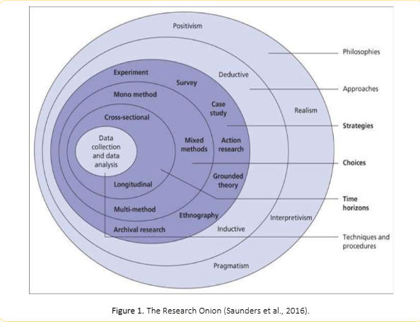
The Research Onion
Figure 1 - The Research Onion (Saunders et al., 2016).
One approach to constructing research methodology is grounded in the theoretical framework of the “research onion” (Figure 1), as proposed by Saunders (et al, 2016)

The diagram entitled "Research Onion" illustrated in Figure 1 delineates the various layers that must be addressed to develop an effective research methodology. Saunders (et al, 2016) recommend navigating their "Research Onion" by beginning with the outer layer and working inward, selecting the appropriate step from each layer based on the specific research context. The Research Onion comprises six key stages:
  - Research Philosophy
  - Research Approach
  - Research Strategy
  - Research Methodological Choice
  - Research Time Horizon
  - Research Techniques and Procedures (including data collection and analysis).

Research Philosophy
From a historical perspective, it is possible to identify two classical or mainstream positions of scientific research philosophy: positivism and interpretivism. In addition, there are two more contemporary positions: pragmatism and critical realism (Mingers, 2006; Molis, 2008; Saunders et al., 2016). The selected research methodology is categorised as a Positivist Research Approach, employing techniques such as surveys with closed-ended questions to gather quantifiable data on specific performance indicators. This approach aims to achieve definitive and factual conclusions. (LinkedIn, 2025)

The Positivist Research Approach offers exciting benefits, such as measurable and generalisable results, though it is important to remember that it might simplify the richness of human experience. (Cambridge Proofreading, 2025)

Research Approach
In the context of research methodology, there exist two principal approaches: the Deductive Approach and the Inductive Approach. The chosen research approach is the Deductive Approach, which starts with a pre-existing theory or hypothesis often formulated from a review of existing literature and aims to test its validity against empirical evidence. This approach moves from general principles or theories to specific predictions or observations. Deductive research is associated with positivism and quantitative methods, with the primary goal of verifying or refuting established theoretical frameworks. (LinkedIn, 2025)

Deductive research is employed because robust theories are already present in the secondary sources. It aims to test specific hypotheses, measure relationships, or establish cause-and-effect dynamics. This approach will assess the performance of the primary survey as an indicator of adaptation and evaluate whether the data align with the theory's predictions. (Cambridge Proofreading, 2025)

Research Strategy
In their discussion of research strategies, Saunders et al. (2016) identify several key approaches, including experiments, surveys, archival research, case studies, ethnography, action research, grounded theory, and narrative inquiry. However, in the field of futures studies, research strategies may be categorised in a different manner. A research strategy is a general framework that guides researchers in selecting primary data collection methods or combinations of methods to effectively address their research questions and achieve their objectives. The selected research strategy is survey research, which will be conducted using Microsoft Forms. A link to the survey will be created and posted on the internal police systems, ensuring that all personnel within the Gwent Police Force can participate. The surveys will remain anonymous to promote freedom of expression and encourage honest responses. The survey will be available for a duration of 30 days.

The advantages of conducting an anonymous survey are evident, as the option for respondents to remain anonymous typically leads to higher response rates compared to surveys that require personally identifiable information. When participants know their responses are confidential, they are more likely to address sensitive topics and offer more thorough and honest feedback. This is why anonymous staff surveys are often preferred over those that request identifiable information. (Stone N, 2021)

Research Methodological Choice
The fourth layer of the Research Onion, known as "Choices," focuses on the decisions related to the types of data whether qualitative or quantitative that will be utilised in the research, as well as how these data types will be integrated within the study. This layer goes beyond a simple dichotomy between qualitative and quantitative approaches, introducing a spectrum of data integration that reflects an increasing acknowledgement in contemporary research that complex phenomena often necessitate multifaceted investigation, leading to more robust and nuanced findings. (LinkedIn, 2025) The chosen research methodological approach is a mixed methods strategy, which integrates both quantitative and qualitative techniques within the same study. This approach is used to achieve diverse objectives and mitigate the limitations of using a single method. (Saunders et al, 2016) Secondary research will be employed, complemented by primary research through data collection from surveys. This dual approach will yield robust qualitative data for the dissertation, capturing the perspectives of officers within the Gwent Police force effectively.

The survey will include a combination of open and closed questions directed at the Gwent Police Officer. The choice between these two major question types is essential for maximising the effectiveness of your survey. Open-ended questions provide rich, in-depth insights, while closed-ended questions are vital for clarifying specific details and gathering quantifiable data without introducing unexpected or undesirable insights. (UserQ, 2025)

Research Time Horizon
The primary research method will involve conducting a survey, which will be made available on the internal website of Gwent Police for officers and staff to participate in. The survey will remain accessible on the police's internal site for a duration of 30 days, allowing all members of Gwent Police the opportunity to take part.

On the Research Time Horizon, the selected research approach is cross-sectional studies, which will compare data collected from secondary research with primary research. This is particularly relevant to the topic of "determining how Body-Worn Video (BWV) influences the way officers are treated by the public," as noted by O’Neil (2024).

Research Techniques and Procedures (including data collection and analysis)
The research approach will utilise various Data Collection Methods, as the data gathered from the survey will help us understand how officers feel about wearing BMV devices. For instance, a researcher might use surveys to collect quantitative data on delivery timings, as well as qualitative insights into officers' experiences. The survey is one of the considered methods for data collection, where participants will be asked a series of questions to capture their thoughts and provide them with the opportunity to discuss related subjects. (LinkedIn, 2025)

Survey Design
The survey will be designed using Microsoft Office, and data collection will take place 30 days after the survey is launched. The survey link will be accessible on the internal Gwent Police website. This single survey will feature both open and closed questions for participants. It aims to gather accurate data on several topics, allowing individuals to respond honestly and openly. The survey will provide insights into experiences with body worn cameras and the thoughts of participants regarding their use.

Ethical Considerations
In conducting this dissertation, it is essential to consider ethical implications due to the sensitive nature of the research. Therefore, at the outset of the study, an ethics form must be completed to ensure that both the topic and the subjects involved in the research are thoroughly reviewed and approved before proceeding. While filling out the ethics form provided by the University of Wales Trinity Saint David, I will be required to detail how the primary data will be collected and how participation will be utilised for data analysis. The primary aim of this research is to examine the safeguards that protect individuals participating in the study, specifically through an anonymous survey. At the beginning of the survey, participants will encounter an introduction related to the topic. The survey is hosted on the internal Gwent Police website, allowing access to colleagues working within the Gwent Police Force.

Conclusion
This Methodology chapter has effectively outlined and demonstrated the appropriate methodology required for the dissertation, detailing the specific research method to be employed. The forthcoming chapter will analyse the data gathered from the primary research method, specifically the survey distributed to colleagues at Gwent Police, and will compare this data with the findings from the secondary research.

Systematic presentation of the findings, discussion, and analysis

Introduction
This chapter will provide an analysis and discussion of the results, along with a systematic overview of the findings. A total of thirty participants completed the questionnaire during the thirty-day period it was available on the internal police website. The aim of this research is to investigate how BWV affects the public's treatment of officers. The literature review indicated a predominance of positive feedback on this matter; however, there are significant gaps concerning police officers' perspectives, particularly with updates from 2025. This chapter will explore current gaps in knowledge and outline the research design employed in the study. The data collected from participants, as compiled by Gwent Police, will be compared with the findings from the literature review. To achieve this, four primary objectives have been defined:
- To determine how BWV impacts upon how an officer is treated by the public.
- What impact does BWV have on the success of the investigation?
- To determine if all the officers should wear BWV.

Data Analysis
Data analysis entails the inspection, cleaning, transformation, and modelling of data to derive insights that facilitate decision-making. As a data analyst, the responsibilities include analysing large datasets, uncovering hidden patterns, and converting raw data into actionable insights that promote informed decision-making.
Organisations depend on data analysis to make strategic decisions, improve efficiency, and anticipate future outcomes. This practice is widely utilised across various industries, including business, healthcare, marketing, finance, and scientific research, to generate insights and address complex challenges. (Jain.P, 2025)

Demographics and Descriptive Statistics
This study targeted police officers across the UK police force, focusing on statistics available through secondary research on the website. However, police officers and colleagues at Gwent Police are permitted to complete this survey anonymously on the Gwent Police internal page. The survey was designed to capture their feelings and opinions regarding the use of body worn video devices. It provided an opportunity for police staff at Gwent Police to express their views, even if they do not currently wear Body Worn Video devices.

Statistic Findings
A previous study examined the effects of BWV on complaints at a test site compared to a control site. Operation Hyperion, which provided BWV cameras to all officers on the Isle of Wight (IoW), revealed a 15% decrease in 'lower level' complaints on the IoW after the cameras were issued. In contrast, there was only a 5% reduction in similar complaints across the rest of Hampshire. Additionally, data concerning more serious complaints indicated an 11.5% decline on the IoW, while the rest of Hampshire experienced a 6.9% increase in such complaints. (College of Policing, 2015)

Questionnaire Findings
This survey involved the development of a questionnaire designed for the officers and staff of Gwent Police, which was made accessible through links posted on the Internal Gwent Police website. The questionnaire consisted of eighteen questions, including three open-ended and fourteen closed-ended questions. (SurveyMonkey, 2025)

Survey Participants
When the survey was distributed to police officers and staff with access to the Gwent Police website, participation was optional. Out of a total of 2,604 individuals employed by Gwent Police, only thirty chose to participate in the survey. (HMICFRS, 2025)

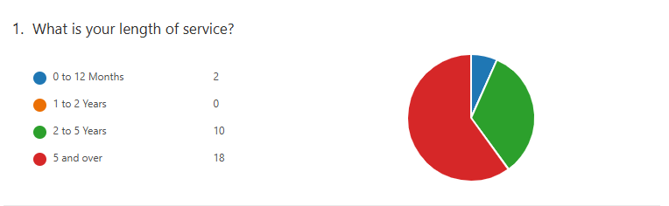
Length of service
Figure 2 - Length of service.
When the above questions were posed to 30 participants in the survey, the results revealed that 18 individuals had more than 5 years of service with the Gwent Police Force, 10 participants had between 2 to 5 years of service, and 2 participants had served between 0 to 12 months with the Gwent Police Force.

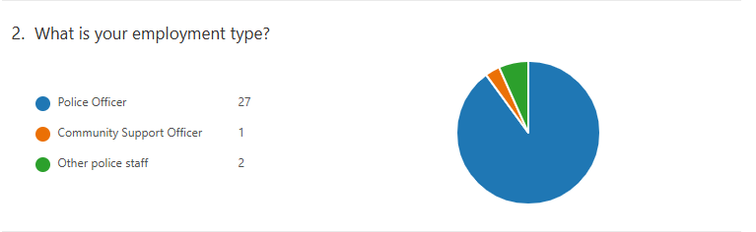
Employment Type
Figure 3 - Employment Type

In response to the questions posed, a total of thirty individuals participated in this survey. Among them, twenty-seven were police officers, one was a Police Community Officer, and two were other members of police staff. The survey saw a greater participation from police officers compared to other police staff.

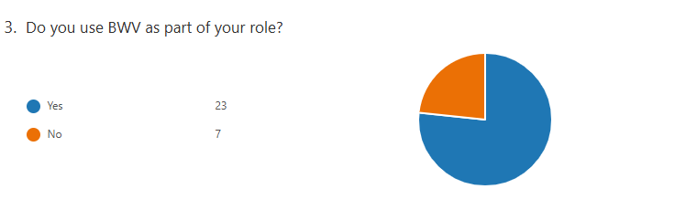
Do you use BWV as part of your role?
Figure 4 - Do you use BWV as part of your role
In response to the questions raised, survey participants were invited to share their insights. Of the thirty individuals selected, twenty-three reported using BWV as part of their role, while seven indicated they did not utilise BWV in their responsibilities.

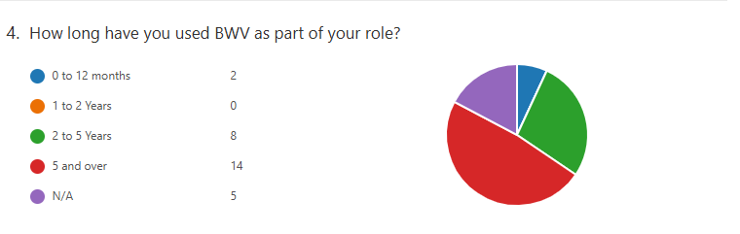
Used BWV as part of their role.
Figure 5 - Used BWV as part of their role.
In response to the questions raised, participants in this survey were asked to provide their insights. Out of thirty individuals selected, twenty-nine participated in the survey. Among them, fourteen reported using body-worn cameras as part of their role for five years or more. Additionally, five individuals stated that they had not used body-worn cameras during their time in the force, either as police staff or due to a lack of exposure to these devices. It is also possible that some were not entirely honest in their responses to this question.

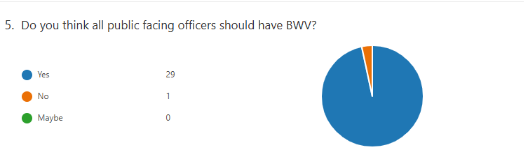
All the public-facing officers should have BWV.
Figure 6 - All the public-facing officers should have BWV.
In response to the questions posed, a total of thirty individuals participated in this survey. Of these, twenty-nine respondents expressed support for the use of body-worn video (BWV) by public-facing officers, while only one individual opposed it. Secondary research indicates that the survey, which focused on Police Scotland, revealed a significant majority in favour of equipping public-facing officers with BWV (Scottish Police, 2024).

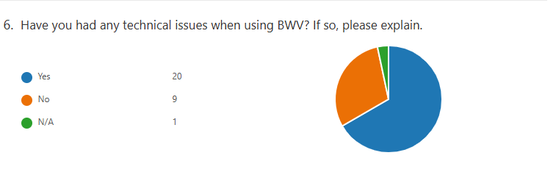
Technical Issues when using BWV.
Figure 7 - Technical Issues when using BWV.

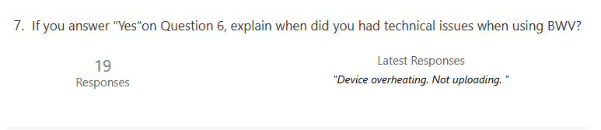
Technical Issues when using BWV
Figure 8 - Technical Issues when using BWV.
In response to the questions posed, a total of thirty individuals participated in this survey. Among them, twenty reported experiencing technical issues while using the BWV, while nine indicated that they did not encounter any technical problems. One individual was uncertain about their usage of the BWV in their role. Of the twenty respondents who reported technical issues, nineteen provided feedback. The most recent feedback included comments such as, "Device overheating. Not uploading." According to the Home Office, there may be instances in which an incident is only partially recorded. This can occur due to technical failures, equipment being knocked, covered, or dislodged during a struggle, or because the nature of the incident restricts the camera's view. Additionally, there may be times when sound recordings are unclear or verbal responses are difficult to hear due to louder surrounding noises, such as police radio traffic or high winds. The Home Office also noted that there could be technical issues with the Body-Worn Video (BWV) equipment. (Home Office, 2007)

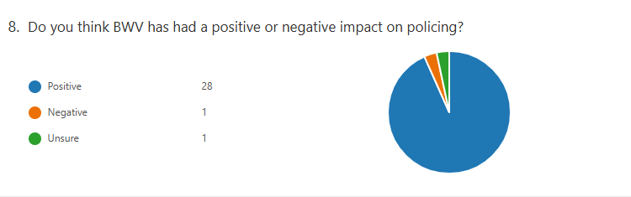
BWV has had a positive or negative impact on policing.
Figure 9 - BWV has had a positive or negative impact on policing
A total of thirty individuals participated in this survey regarding the posed questions. Among them, twenty-eight respondents indicated that the impact on policing is positive, while one person reported a negative impact, and another expressed uncertainty. Researchers, along with the survey findings, suggest that the implementation of these cameras has created a positive effect. It is expected to lead to improved behaviour among both citizens and police officers, as well as enhance the quality of evidence collection. (Laming, 2019)

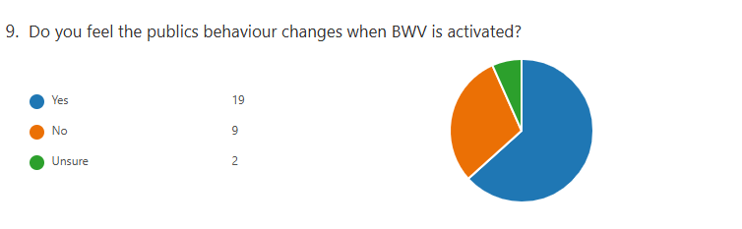
The Public's behaviour changes when BWV is activated.
Figure 10 - The Public's behaviour changes when BWV is activated
A total of thirty individuals participated in this survey addressing the posed questions. Of these respondents, nineteen indicated that public behaviour changes when Body-Worn Video (BWV) is active, while nine stated that they do not believe public behaviour shifts under these circumstances. Additionally, two individuals expressed uncertainty regarding whether BWV influences public behaviour. A study conducted by the University of Sheffield indicated that there is a range of feedback from officers interviewed regarding the impact of cameras on their interactions and behaviours. (The University of Sheffield, 2021)

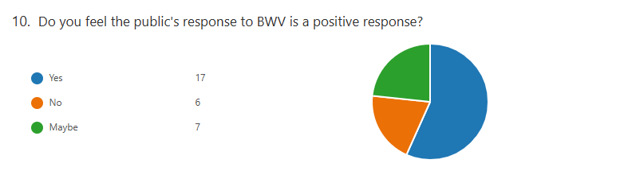
The public response to BWV is positive response.
Figure 11 - The public response to BWV is positive response

A total of thirty individuals participated in this survey, which addressed the posed questions. Among the respondents, seventeen agreed that the public's response to the use of Body-Worn Video (BWV) is positive, while six disagreed with this assertion. Additionally, seven individuals expressed uncertainty regarding whether the public views the use of BWV by police officers positively. According to Lum (2020), research on the effects of body-worn cameras (BWV) presents a nuanced picture rather than a definitive argument for their impact. For instance, findings regarding the influence of cameras on police and public behaviour show mixed results.

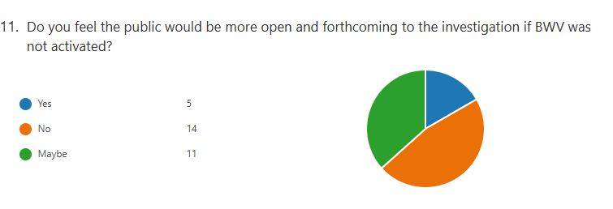
The public would be more open and forthcoming to the investigation if BWV were not activated.
Figure 12 - The public would be more open and forthcoming to the investigation if BWV were not activated

A total of thirty individuals participated in this survey, which addressed the posed questions. Among the respondents, five individuals agreed with the statement that the public would be more open and forthcoming in an investigation if Body-Worn Video (BWV) were not activated. In contrast, fourteen individuals disagreed with this statement, while eleven individuals believed that the public might be more open and forthcoming if BWV were not activated. The research conducted by O'Neil suggests that the public may either engage with the body-worn video (BWV) system or remain unresponsive while the BWV is active. (O’Neil, 2024)

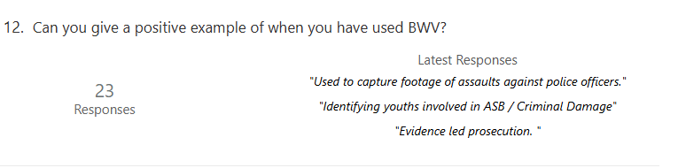
Positive example of when you have used BWV.
Figure 13 - Positive example of when you have used BWV
A total of thirty individuals participated in this survey, which focused on the posed questions. Feedback was provided by 23 participants, and the most recent response is summarised as follows:
- “Used to capture footage of assaults against police officers.”
- “Identifying youth involved in ASB/ Criminal Damage.”
- “Evidence led prosecution.”

Negative experience with BWV and give an example.

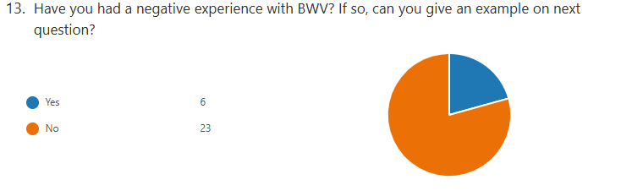

Figure 14 - Negative experience with BWV and give an example.

Negative experience with BWV and give an example.
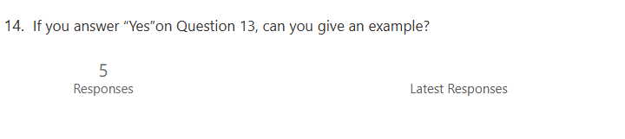
Figure 15 - Negative experience with BWV and give an example.
A total of thirty individuals participated in this survey, which centred around the posed questions. Among the respondents, six reported having a negative experience with BWV, while twenty-three indicated that they did not have a negative experience. However, one person chose not to answer this question. Of the six individuals who experienced negativity with BWV, only five provided examples of their negative experiences, although their answers were not displayed.

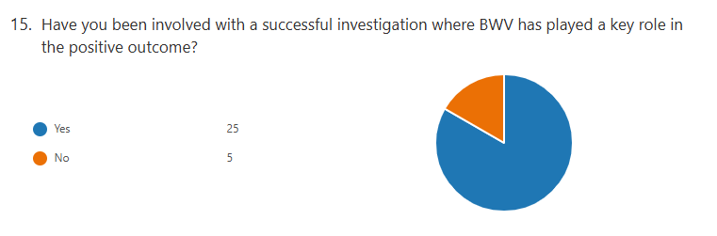
Involved with a successful investigation where BWV has played a key role in the positive outcome.
Figure 16 - Involved with a successful investigation where BWV has played a key role in the positive outcome

A total of thirty individuals participated in this survey, which centred around the posed questions. Among the respondents, twenty-five expressed their agreement that body-worn video (BWV) has significantly contributed to the success of investigations, while five disagreed. Additionally, a report from Policinginsight indicates that 98% of officers surveyed believed that BWV positively affected the effectiveness of their investigations. (Policinginsight, 2022)

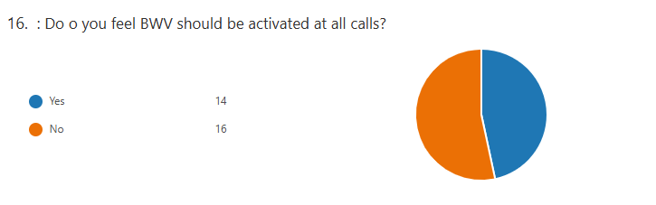
Should BWV be activated at all the calls?
Figure 17 - Should BWV be activated at all the calls
A total of thirty individuals participated in this survey, which focused on the questions posed. Among the respondents, fourteen agreed that BWV should be activated for all calls, while sixteen disagreed. According to Nottinghamshire Police, BWV should only be used when justifiable and necessary, considering its impact on individuals and their privacy. There are circumstances in which the use of BWV may not be suitable, some of which are detailed in this document; however, this list is not exhaustive. Users and supervisors must exercise their professional judgment regarding recording practices in accordance with legislation, best practices, and the national decision model. (Nottinghamshire Police, 2026)

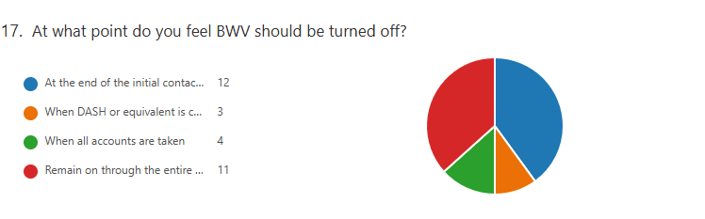
What point BWV should be turned off.
Figure 18 - What point BWV should be turned off
A total of thirty individuals participated in this survey, which focused on the questions posed. Among the respondents, 12 individuals said that at the end of initial contact, 3 individuals said that when the Domestic Abuse, Stalking, and Honour-based violence( DASH) form or equivalent is completed, 4 individuals said that when all accounts are taken from the individual from the incident, and 11 individuals said that it should remain on throughout the entire situation.

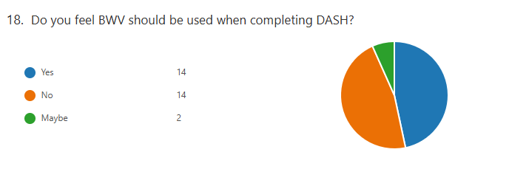
BWV should be used when completing DASH.
Figure 19 - BWV should be used when completing DASH
A total of thirty individuals participated in this survey, which focused on the questions presented. Among the respondents, fourteen agreed that BWV should be utilised when completing the Domestic Abuse, Stalking, and Honour-Based Violence (DASH) form, while fourteen disagreed. Additionally, two participants indicated that they were uncertain about the use of BWV in this context. According to the National Police Chiefs' Council (NPCC), users of BWV should be aware that recordings made during non-crime domestic abuse incidents may hold significance for future prosecutions. BWV users responding to such incidents must consider any risk factors they record in the DASH form and, where applicable, any history of incidents involving the victim that may indicate they are experiencing some form of abuse. If such a history exists or if risk factors are identified, users should treat the recording as evidential material, ensuring it is retained to support victims and their children in potential future prosecutions or to assist in other legal proceedings, such as applications for non-molestation orders or restraining orders. This material can also be leveraged to support preventive measures, such as domestic violence protection orders, when appropriate. (NPCC, 2022)

Conclusion and Recommendations

Chapter Introduction
The conclusion chapter will provide a summary of the key research findings. This paper aimed to capture the perspectives of serving police officers and police staff to evaluate the impact of body worn video on public interactions with law enforcement. Mixed methods approach was employed to address these questions, incorporating both quantitative and qualitative data. The quantitative research was based on data collected by the University of Sheffield, as surveys were administered to police officers and staff to achieve the research objectives, while qualitative research was also conducted. The previous chapter analysed and documented the results obtained. (The University of Sheffield, 2021)

Summary of Primary Findings
The aim of this dissertation is to conduct a mixed methods exploration addressing the question of whether all officers should wear BWV devices and how the presence of these cameras influences public interactions. Data collected from surveys completed by thirty participants support the findings of BDCAM (2025), which suggest that when officers utilise body cameras during incidents, it encourages more civil behaviour from those involved. Additionally, witnesses are often more willing to come forward with information. BWV footage also aids police officers in obtaining a comprehensive understanding of all aspects of an incident, from the initial call for service to its resolution.

Research Objectives
The chapter will conclude with a set of recommendations.
- To determine how BWV impacts upon how an officer is treated by the public.
- What impact does BWV have on the success of the investigation?
- To determine if all the officers should wear BWV.

To determine how BWV impacts upon how an officer is treated by the public.
In response to the survey questions, approximately nineteen participants expressed their agreement with BDCAM (2025). Research suggests that when officers wear body cameras during incidents, it encourages more civil behaviour from those involved. Additionally, witnesses are often more willing to provide information. The footage from BWV can help police officers gain a thorough understanding of all aspects of an incident, from the initial call for service to its resolution.
According to the College of Policing (2021), the presence of recording devices during interactions with law enforcement influences individuals' behaviour, prompting them to moderate their actions and refrain from engaging in socially unacceptable conduct.

What impact does BWV have on the success of the investigation?
Based on the survey distributed among Gwent Police officers and staff, 25 participants indicated their support for Hogan-Howe (2025), who noted that their experience with camera use suggests individuals are more inclined to plead guilty when they are aware that their actions have been recorded.
A recent survey conducted among Gwent Police officers and staff on the internal police website yielded twenty-three responses, indicating a general agreement on the findings. According to BDCAM (2025), Body-worn video (BWV) systems have the potential to reduce paperwork by automatically tagging evidence and providing real-time data access. This innovation could also enhance the effectiveness of evidence-led prosecutions.

To determine if all the officers should wear BWV.
The survey conducted among Gwent Police officers and staff via the internal police website, twenty nine out of thirty participants agreed that all public facing officers should have BWV as part of their uniform. This second survey garnered over 9,300 responses, further demonstrating staunch support for the introduction of BWV, with 90% of participants endorsing its use during police activities. Additionally, more than 73% of respondents expressed that implementing BWV would enhance their trust and confidence in Police Scotland. (Scottish Police, 2024)

Recommendations
Upon the completion of this dissertation, the subsequent recommendations have been formulated.
- The research may also provide insights into the perspectives of law enforcement officers and personnel from police agencies outside of the Scottish police force concerning the advantages and disadvantages associated with the use of Body Worn Cameras.
- There are fewer sources in the secondary research on the viewpoint of the public reaction to police officers or frontline face officers on wearing Body Worn Cameras.

Final Thoughts
The concluding insight of this dissertation addresses the inquiry regarding the necessity for police officers and frontline personnel to utilise body worn cameras. The literature review revealed that the perspectives of police officers on this matter, particularly in relation to the year 2025, have yet to be documented.

The research conducted through a survey, along with analysis of data from a literature review, suggests that all frontline officers should wear body worn cameras, as this would have a positive impact based on the findings.

Bibliography
- Ariel, B., Sutherland, A., Henstock, D., Young, J., Drover, P., Sykes, J., Megicks, S. and Henderson, R., 2016. Wearing body cameras increases assaults against officers and does not reduce police use of force: Results from a global multi-site experiment. European journal of criminology, 13(6), pp.744-755. Accessed on 23/11/2025

- AXON., 2024 The police body camera has gone from being an experiment to become a foundational tool for law enforcement agencies around the globe Available at www.axon.com/resources/police-body-cameras Accessed on 06/01/2026

- BDCAM., 2025 How the police use Body cameras Available at www.bodycameraonline.co.uk/how-the-police-use-body-cameras/ Accessed on 28/07/2025

- Chitseko. S., 2024 The case against police body-worn video cameras Available www.openrightsgroup.org/blog/the-case-against-police-body-worn-video-cameras/#:~:text=So%20while%20there%20remain%20serious,Data%20Protection%20Impact%20Assessment).” Accessed on 06/01/2026

- Cambridge Proofreading., 2025 Understanding positivism, interpretivism, and pragmatism Available https://proofreading.org/blog/understanding-positivism-interpretivism-and-pragmatism/ Accessed on 31/12/2025

- Cambridge Proofreading., 2025 What is deductive research? Applying theory to data Available https://proofreading.org/learning-center/what-is-deductive-research-applying-theory-to-data/ Accessed on 31/12/2025

- Clare, J., Henstock, D., McComb, C., Newland, R., Barnes, G.C., Lee, M. and Taylor, E., 2019. Police, public, and arrestee perceptions of body-worn video: A single jurisdictional multiple-perspective analysis. Criminal Justice Review, 44(3), pp.304-321. Accessed on 28/07/2025

- College of Policing., 2015 Police, Camera, Evidence: London’s cluster randomised controlled trial of Body Worn Video Available at https://bja.ojp.gov/sites/g/files/xyckuh186/files/media/document/police_camera_evidence_london-uk.pdf Accessed on 01/12/2025

- College of Policing., 2021 Body-worn cameras Available at www.college.police.uk/research/crime-reduction-toolkit/body-worn-cameras#:~:text=Review%20one%20suggests%20that%20the,to%20increased%20early%20guilty%20pleas. Accessed on 28/07/2025

- Devlin., A 2017 Britain straps video cameras to police helmets Available at www.nbcnews.com/id/wbna19750278#.VN-wl_nF8y4 Accessed on 28/07/2025

- Gaub J, Choate DE, Todak N, et al. (2016) Officer perceptions of body-worn cameras before and after deployment: a study of three departments. Police Quarterly 19(3): 275–302. Accessed on 31/12/2025

- HMICFRS., 2025 Gwent Police 2023–25 Available at https://hmicfrs.justiceinspectorates.gov.uk/police-forces/gwent/more-about-this area/#:~:text=As%20at%2031%20March%202025,277%20volunteers%20and%20121%20cadets. Accessed on 01/12/2025

- Home Office., 2007 GUIDANCE FOR THE POLICE USE OF BODY-WORN VIDEO DEVICES Available at https://library.college.police.uk/docs/homeoffice/guidance-body-worn-devices.pdf#:~:text=The%20recordings%20from%20BWV%20units%20provide%20a,hinder%20the%20production%20of%20the%20recorded%20evidenceAccessed on 31/12/2025

- Hongan-Howe., B 2025 Body Worn Cameras and Training Available at www.met.police.uk/foi-ai/metropolitan-police/disclosure-2023/november-2023/body-worn-cameras-training/#:~:text=The%20MPS%20commenced%20the%20role,by%20end%20of%20August%202017 .Accessed on 28/07/2025

- Jain.P., 2025 What Is Data Analysis: Examples, Types, & Applications Available at www.simplilearn.com/data-analysis-methods-process-types-article Accessed on: 01/12/2025

- Laming E (2019) Police use of body worn cameras. Police Practice and Research: An International Journal 20(2): 201–216. Accessed on:31/12/2025

- Leicestershire Police., 2025 Body Worn Video (BWV) Factsheet Available www.leics.police.uk/SysSiteAssets/media/downloads/leicestershire/advice/bwv-factsheet.pdf Accessed on 23/11/2025

- LinkedIn., 2025 Mastering Your Methodology: Guide to Saunders' Research Onion Available www.linkedin.com/pulse/mastering-your-methodology-guide-saunders-research-assignment-help-smqfe Accessed on 27/11/2025

- Lum C, Koper CS, Wilson DB, et al. (2020) ‘Body‐worn cameras’ effects on police officers and citizen behaviour: A systematic review’. Campbell Systematic Reviews, 16:e1112. https://doi.org/10.1002/cl2.1112 Accessed on 28/07/2025

- Makwanas., 2023 Body-Worn Video: Its Role, Evidentiary Value, and Legal Framework in England Available at www.makwanas.co.uk/body-worn-video/#:~:text=The%20use%20of%20body-worn%20video%20%28BWV%29%20by%20law,the%20conduct%20of%20public%20officials%2C%20and%20civil%20liberties. Accessed on 28/07/2025

- Metropolitan Police., 2024 Freedom of Information Publication Scheme Available www.met.police.uk/SysSiteAssets/foi-media/metropolitan-police/policies/body-worn-video-policy-statement-september-2024.pdf Accessed on 23/11/2025

- Metropolitan Police., 2025 How and when BWV cameras are used Available at www.met.police.uk/advice/advice-and-information/bwv/body-worn-video-bwv/how-and-when-bwv-cameras-are-used/ Accessed on 23/11/2025

- Mingers, J. (2006). Realising Systems Thinking: Knowledge and Action in Management Science. New York: Springer. Accessed on 27/11/2025

- Molis, A. (2008). Bendrosios ES saugumo ir gynybos politikos plėtros scenarijų tyrimas. Doctoral dissertation. Vilnius: Vilnius university. Accessed on 27/11/2025

- Nottinghamshire Police., 2026 Body Worn Video Policy (PS 306) Available at www.nottinghamshire.police.uk/foi-ai/nottinghamshire-police/publication/our-policies-and-procedures/human-resources/body-worn-video-policy-ps-306/#:~:text=This%20policy%20is%20intended%20to,of%20Investigatory%20Powers%20Act%202000%20. Accessed on 05/01/2026

- NPCC., 2022 Body-Worn Video Available at https://library.college.police.uk/docs/NPCC/Body-worn-video-2022.pdf#:~:text=Body-Worn-Video%20(BWV)%20is%20now%20well%20established%20within,arrived%20within%20Policing%20in%20England%20and%20Wales. Accessed on 05/01/2026

- NPCC., 2024 BODY-WORN VIDEO GUIDANCE 2024 Available www.npcc.police.uk/SysSiteAssets/media/downloads/publications/publications-log/local-policing-coordination-committee/2024/npcc-bwv-guidance-2024.pdf Accessed on:23/11/2025

- O’Neil, M., 2024 Body-worn Video and interactions with the public: who does it benefit and how is it used? Available at www.sipr.ac.uk/wp-content/uploads/2025/01/INTERACT-Briefing-6_BWV-interactions-with-public-1.pdf Accessed on:28/07/2025

- Policinginsight., 2022 The voices of Cumbria Constabulary: Enabled by technology Available at https://policinginsight.com/feature/the-voices-of-cumbria-constabulary-enabled-by-technology/ Accessed on 05/01/2026

- Saunders, M., Lewis, P. & Thornhill, A. (2016). Research Methods for Business Students. 7th edition, Harlow, Pearson Education Limited . Accessed on 24/11/2025

- Scotland Police., 2024 Body Worn Video – Public Briefing Available at www.spa.police.uk/spa-media/4j3j12mt/doc-20241118-public-briefing-bwv-oct2024-v2.pdf Accessed on:28/07/2025

- Scottish Police., 2024 Body Worn Video – Public Briefing Available www.spa.police.uk/publication-library/body-worn-video-public-briefing/why-use-body-worn-video-in-policing/#:~:text=Police%20Services%20have%2C%20for%20several,incident%20occurs. Accessed on:23/11/2025

- Scottish Police., 2024 Public Surveys Available www.spa.police.uk/publication-library/body-worn-video-public-briefing/public-surveys/#publication-parent Accessed on:23/11/2025

- SmartSurvey., 2025 Primary Research Methods Explained Available www.smartsurvey.co.uk/articles/primary-research-methods Accused on 24/11/2025

- Stone, N., 2021 The Benefits of Anonymous Surveys Available www.smartsurvey.co.uk/blog/the-benefits-of-anonymous-surveys Accused on 31/12/2025

- SurveyMonkey., 2025 Closed-ended vs. open-ended questions: Best practices, tips and examples Available at https://uk.surveymonkey.com/mp/comparing-closed-ended-and-open-ended-questions/ Accessed on: 01/12/2025

- The University of Sheffield., 2021 The positive impact of BWV in policing Available https://eprints.whiterose.ac.uk/id/eprint/174980/3/Harrison%20et%20al%2C%202021.%20Exploring%20the%20impact%20of%20body-worn%20video%20on%20the%20everyday%20behaviours%20of%20police%20officers.pdf Accessed on:23/11/2025

- University Of Cambridge., 2016 Use of body-worn cameras sees complaints against police ‘virtually vanish’, study finds Available www.cam.ac.uk/research/news/use-of-body-worn-cameras-sees-complaints-against-police-virtually-vanish-study-finds Accessed on:23/11/2025
- UserQ., 2025 Survey success: when to use open-ended vs closed-ended questions Available https://userq.com/survey-success-when-to-use-open-ended-vs-closed-ended-questions/ Accessed on 31/12/2025

- Webster, C.W., Miranda, D. and Leleux, C., 2022. Evidence Review into Public Experience and Confidence of Body Worn Video in a Policing Context. Accessed on:23/11/2025

Appendix

Appendix 1– Research Proposal
Research Proposal Sheet (3).docx

Appendix 2 – Ethics Form
PG2_Application_for_Ethical_Approval_10-2022.docx

Appendix 3 – Police Survey in spreadsheet format
Spreedsheet.xlsx

Appendix 5- Survey Questions

- What is your length of service?
- 0 to 12 Months
- 1 to 2 Years
- 2 to 5 Years
- 5 and over

- What is your employment type?
- Police Officer
- Community Support Officer
- Other police staff

- Do you use BWV as part of your role?
- Yes
- No

- How long have you used BWV as part of your role?
- 0 to 12 Months
- 1 to 2 Years
- to 5 Years
- 5 and over
- N/A

- Do you think all public facing officers should have BWV?
- Yes
- No
- Maybe

- Have you had any technical issues when using BWV? If so, please explain.
- Yes
- No
- N/A

- If you answer “Yes” on Question 6, explain when you had technical issues when using BWV?
Comment

- Do you think BWV has had a positive or negative impact on policing?
- Positive
- Negative
- Unsure

- Do you feel the publics behaviour changes when BWV is activated?
- Yes
- No
- Unsure

- Do you feel the publics response to BWV is a positive response?
- Yes
- No
- Maybe

- Do you feel the public would be more open and forthcoming to the investigation if BWV was not activated?
- Yes
- No
- Maybe

- Can you give a positive example of when you have used BWV?
Comment

- Have you had a negative experience with BWV? If so, can you give an example?
- Yes
- No

- If you answer “Yes” on Question 13, can you give an example?
Comment

- Have you been involved with a successful investigation where BWV has played a key role in the positive outcome?
- Yes
- No

- Do you feel BWV should be activated at all calls?
- Yes
- No

- At what point do you feel BWV should be turned off?
- At the end of the initial contact when the threat is under control
- When DASH or equivalent is completed
- When all accounts are taken
- Remain on through the entire process

- Do you feel BWV should be used when completing DASH?
- Yes
- No
- Maybe

