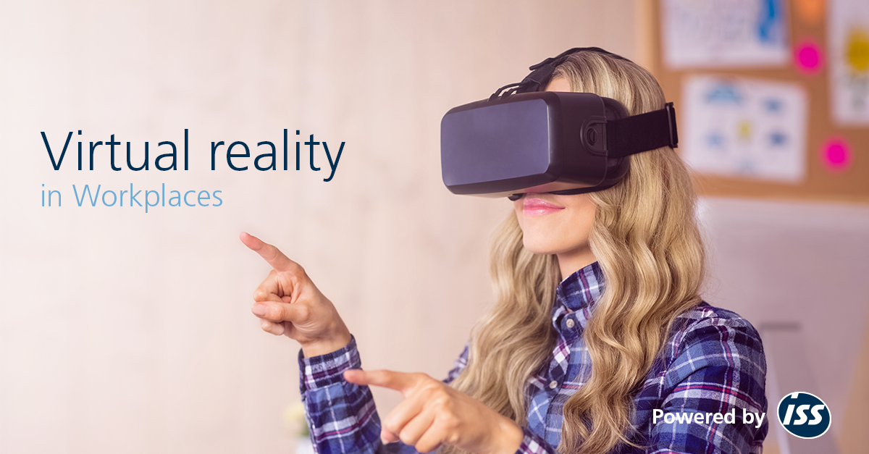

Figure 1 – Virtual Reality in Use.
Is Virtual Reality Relevant in the Workplace?
  - Dissertation
Connor Furneaux P149696 | Creative Games /Design | 11/12/2018
Submitted in partial fulfillment of the requirements for the degree of BA (Hons) University of Wales Trinity Saint David, Swansea.
Word Count: 6,329
(Excluding Reference/Image List)

Abstract
This paper is to investigate the future and current day application of Virtual Reality (VR) in the workplace and its positives and negatives. VR is a way for people to be able to experience real world or fictional simulations. VR is experienced via a headset with a screen for each eye and stereo or surround sound. There is also occasionally a haptic feedback system to allow the two screens to display slightly different stereoscopic images, mimicking the feedback received from your eyes, which creates a realistic 3D perspective of a virtual world. This uses accelerometers to detect your head both in position, orientation, tilt and pointing.
This dissertation aims to research into companies that apply virtual reality within their company infrastructure, either as a social tool or as part of a practical learning process. It will discuss the positives also the negatives and compare to see if virtual reality has a role within the workplace, or as a tool for learning. This dissertation will meet these research aims through an extensive study of relevant case studies, and the reviews and opinions of reliable sources. Multiple case studies will be used to develop the thesis, ranging from a company called Beam using virtual reality to help new workers smoothly fit in to their new workplace, to a kit created to help improve hospital waiting rooms. The main conclusions drawn from this research were that: Virtual reality has a role in being used frequently within the workplace. This is in the form of a tool for education and creating scenarios that may occur in a safe virtual world. This is so that the user can prepare just in case it occurs in reality. It doesn’t, however, have a reliable use for social interaction, not to the extent of social media. With a solid, cheap but reliable method of production for the hardware it may also have a function within the global education system.
Contents Page
Title Page
(1) – Abstract
(2) – Contents Page
(3) -Table of images
(4) – Introduction
(5) – Context of Virtual Reality.
(6-8) - Case Study (Applied VR)
(9-11) – Case Study (Enterprise VR/Kaleido Insights)
(12-14) – Case Study (Beam)
(15-17) – Virtual Reality in Schools
(18-19) – Negatives of Virtual Reality
(20-22) – Is Virtual Reality Just Hype?
(23-24) – Future of Workplace VR
(25) – Methodology/Conclusion
(26-31) – References
Table of Images
- Figure 1 – pg. 1 – Servicefeatures - Virtual reality in use.
- Figure 2 – pg. 7 – AppliedVR – AppliedVR Kit.
- Figure 3 – pg. 10 – Beamland – Engine In VR.
- Figure 4 – pg. 11 – TheDrum – Red Bull VR.
- Figure 5 – pg. 13 – Vimeo – Andys Profile.
- Figure 6 – pg.15 – Telegraph – Student playing VR.
- Figure 7 – pg. 19 – Gamespot – Man in VR feeling sick.
- Figure 8 – pg. 21 – Gamesmoviedeals – enemy in Rush of Blood.
- Figure 9 – pg. 21 – Gamepressure – Doom 1993.
- Figure 10 – pg. 21 – Fandom.Wiki – Doom VR 2016.
- Figure 11 – pg. 24 – Vrfocus – Virtual Trainer EON.
Introduction
Virtual reality is a medium, a means by which humans can share ideas and experiences.” ALAN B. CRAIG, Developing Virtual Reality Applications
(Craig, Sherman and Will, 2009).
This dissertation will aim to address whether or not Virtual Reality (VR) has some significant relevance within the workplace. Starting with a brief insight to VR. Then throughout this dissertation the selected areas of study have been picked from a vast subject pool. There are many case studies that have been conducted within relevance to virtual reality, processing through them and choosing specific work areas that benefit most from the use of virtual reality, more on an ethical and diverse platform rather than purely based of financial gains.
With VR becoming a household must for the current generation as a tool to entertain. Within this dissertation, the use of VR will be researched to see if it has the potential to be an influential part of an interactive business. Analyzing businesses that are now entirely dedicated to working with other enterprises to place VR into the client company’s infrastructure. The areas of study that will make up the main content of this dissertation include the different approach to the sense of social standards within the workplace. Briefly looking into the positives of VR being used within the medical practice. Looking into virtual reality surgical procedures, the improvements that are gained with the use of virtual reality, reinforced with a test example and results to prove the benefits of virtual reality. Delving into the social aspect of virtual reality to see if aspects can be used to benefit social aspects of the workplace or if it will be a hindrance. Within the chosen case studies like previously stated the medical benefits will be mentioned, for patient and surgeons. Followed by looking at entrepreneurship VR, with a company called Kaleido dedicating itself to the promotion of VR within businesses to help create so called “Super Employees”. Social aspects of the workplace when VR is implemented will be inspected with the specific workplace task of onboarding being the main topic of study. Comparing to other forms of social necessities in the workplace. Final study looks into the possibility of VR having a place in the education system looking at current use and the issues that may occur when trying to implement it. The future of VR being the final subject before an overall conclusion of the dissertation. It will cover the possible future endeavors and focusing on the main possible use going forward for workplace VR. This being that companies are being created to just be used to implement VR within other establishments for specified benefits.
Context of Virtual Reality.
Virtual reality allows the user to be able to visualize things in a way their imagination cannot alone. This has applications to be beneficial in many aspects of the real world. If you had to ability to be able to learn the day to day objectives of a job before attending the job interview that would give you an edge like no other. Purchasing your dream car, created from the deepest depths of your mind is no longer being made on a computer screen and shown on still images. Through VR people have the ability to look a projected clone of a car they have designed themselves from options given by the retailer. This allows for a better understanding of the mechanics of the car and gives the buyer an amazing visualization something a still image could not do as well. All this VR needs training to operate allowing more skills to be developed for the already employed. VR is being used for medical diagnostics, creating visuals of the data making it easier to read and interpret to find answers. VR attempts to break boundaries and be the trailblazer of technology for all fields of work and learning.
(Virtual Reality Society, n.d.)
VR headsets are paired with motion controls or data gloves. They allow the user to handle virtual objects. Traditionally the data glove were the accessories paired with the headset, using fiber-optic cables to cover the length of the user’s fingers. A photocell collects light that escapes from the cuts in the cables when the user flexes their fingers. The photocell measures the amount of light that has reached it and the computer uses this to figure out what the fingers are doing. However, in the more commercialized VR “Wands” (motion controllers) are the more favorable technology. The user just has to move and point the motion sensor to interact within the virtual world. It uses accelerometers build, they are now wireless and have a handful of mouse like buttons placed on them for shortcuts.
(Woodford, 2018)
Case Studies
Applied VR
Inova Mount Vernon Hospital based in Alexandria, Virginia, uses VR to calm the patients waiting in emergency rooms. When trying to figure out a way to reduce anxiety and pain, strategy and growth officer Thomas Pianta researched VR. This could have been difficult for the hospital at first, as adding new technology to an already busy emergency department, could have led to a more strenuous workload for employees. Looking into AppliedVR (first ever virtual reality platform designed to manage pain) Pianta set up a meeting with Josh Sackman, CEO of AppliedVR. Through this connection the hospital now uses AppliedVR kits in its emergency rooms in both Lorton and Alexandria.
The kit consists of “Samsung Gear VR headset, headphones and a Samsung Galaxy smartphone loaded with AppliedVR’s platform — which features an extensive library of guided meditations, 360-degree tours of exotic locations and immersive games meant to distract patients during and after medical procedures.
(Samsung Business Insights, 2017)
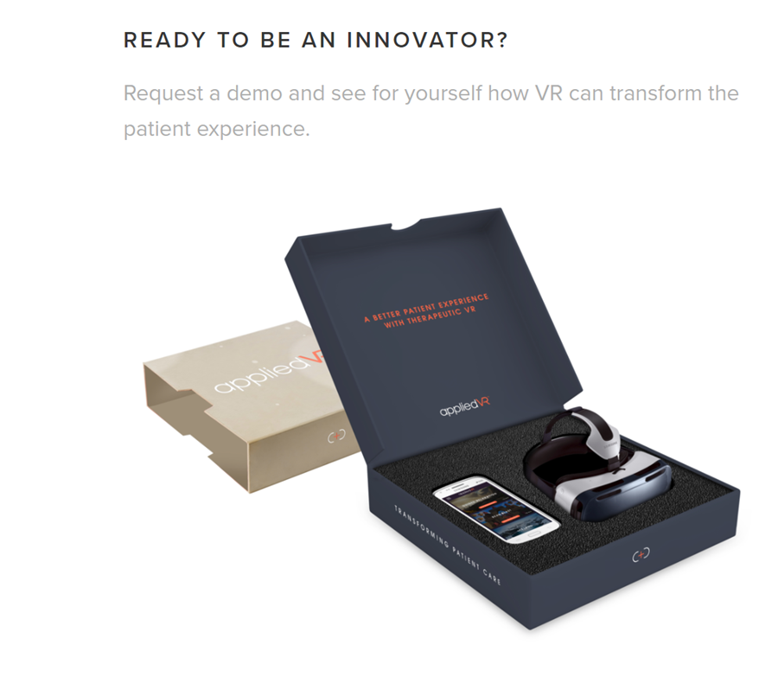
The results of this project have yielded only positive potential. Being in place for only a short while. Key benefits the hospital has recognized include; improved health outcomes, enhanced patient experience, cost reduction and a stronger differentiation within a competitive marketplace. Over 50 hospitals are now using AppliedVR to help better manage pain and anxiety.
Figure 2 – Applied VR Demo kit
Applied VR has found a market that has a serious benefit for the introduction of virtual reality. It hasn’t tried to jump on the bandwagon of this mainstream VR technology and tried to just ram virtual reality down the consumer’s throat. It has identified that hospitals can benefit, then created a product to fill that gap, making hospital waiting rooms a much easier place to be and introducing virtual reality to so many people who otherwise wouldn’t have been able to experience it. The cost of the experience isn’t unreasonable. According to VRHealth, 2018,
This will allow for more hospitals to get involved and help develop more areas of research into getting virtual reality used within the hospital workplace. Schools dedicated to teaching medicine or hospitals that have a teaching while on the job scenario have very limited access to a number of cadavers (corpse) so up until the introduction of VR simulating surgery scenarios had been difficult.
Through the introduction of VR that’s no longer the case. Surgeons now have access to equipment that allows them to spend much more time practicing operations, mainly with the use of realistic simulations. With the added time to improve their skills the more prepared they will be during the actual procedures. Early testing indicates that VR has been very effective. This is very apparent in a study that medical residents took part in, they trained only with the use of virtual reality. The residents showed significant improvements within the operating room. All of the procedure was recorded, independent reviewers watched the footage of the gallbladder procedure the result shown was:
Gallbladder dissection was 29% faster for VR-trained residents. Non-VR- trained residents were nine times more likely to transiently fail to make
progress (P < .007, Mann-Whitney test) and five times more likely to injure
the gallbladder or burn non-target tissue (chi-square = 4.27, P < .04). Mean
errors were six times less likely to occur in the VR-trained group (1.19 vs.
7.38 errors per case;P < .008, Mann-Whitney test). - (Neal E. Seymour, 2012)
By using VR surgical simulations to arrive at specific criteria targeted at significantly improving performance of residents during surgery’s in this case a laparoscopic cholecystectomy. Time is saved, efficiency and safety is increased and less restrictions occur within the need of practice subjects (corpses). This validates the method of being able to transfer training skills from VR to physical reality sets the stage for more sophisticated uses of VR in assessment, training, error reduction, and certification of surgeons. Implementing itself as a very useful and relevant tool for the medical workplace.
(VRHealth, 2018)
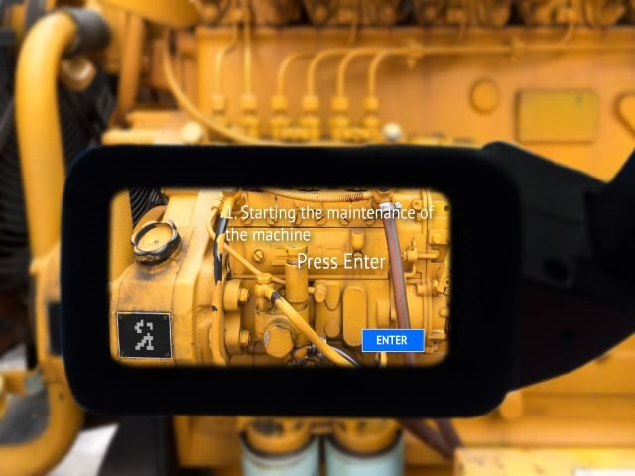
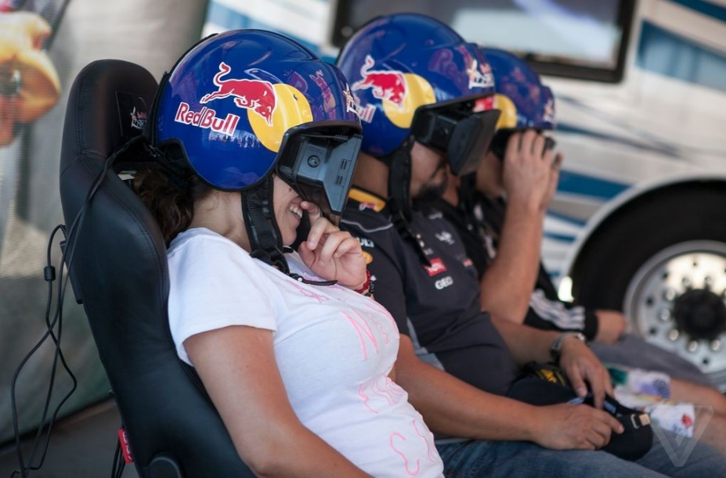
Enterprise VR.
Mixed reality space (combination of virtual and augmented reality) is an area that’s filled with opportunity for innovative corporations seeking to empower employees, helping them to become the most efficient workers possible and achieving greater engagement.
From designing machinery in a collaborative VR space to avoid collision issues, to utilizing augmented reality (AR) wearables to overlay information for technician repairs in real-time. AR headsets can provide real-time data delivery to service technicians. Making repairs to products, homes etc. allowing for quality control, quicker efficiency an working more effectively.
Prepare for the New Reality of “Super Employees”.
(Nicastro, 2018)
A company that definitely believes in the era of the “Super Employee” is Kaleido Insights. Through the increase in popularity of virtual and augmented reality, Kaleido Insights believes:
Organization, and ecosystem are increasing exponentially.
Kaleido analysts work in concert to decipher actionable
insights from the noise, helping you to envision the clear
impacts on your future business models, customer experience
design, marketing, content, and automation roadmap.
Implementing the future (virtual reality) to your business.
(Szymanski and Owyang, 2018, pg. 10)
These are some areas that they believe are benefiting from the use of virtual reality and augmented reality.
ENGINEERING & DESIGN MODELING: Prototyping products, machinery and site plans all in VR before any pen has hit paper or physical assets have been made. This helps avoid issues down the line in ﬁtting. Helps avoid collision with other machinery.
Figure 3 – Engine in VR being worked on in a training module.
TRAINING & EMPLOYEE EDUCATION: Helps develop teamwork during training scenarios. Useful for multiple scenarios through the use of “self-service" VR programs. Helpful in displaying small part intricacies. With some further development the application of multiple workers within the same simulation.
THEFT PROTECTION: Showcasing merchandise in a virtual space allows for more stock storage while decreasing the changes of store robbery. Avoid planogram and merchandising issues with real-time data updates this will allow for further interactivity features leading to an increase of consumer engagement.
B2B SALES: Immersive opportunities to sell industrial products while simultaneously increasing portability as well as salesperson efforts. Useful for large equipment and tradeshow with the need for less physical equipment.
MARKETING & ENTERTAINMENT: Repurpose existing content in an interactive XR environment with demos or simulations. Use in gamifying employee experiences and increasing onboarding engagement and retention.
(Staff, 2016), (Szymanski and Owyang, 2018)
With companies such as Kaleido Insight, the everyday business could find out if there are ways for virtual reality to benefit their business or make an aspect of their work life easier. Being a helping hand, virtual reality is a piece of hardware that could quite possibly be the main development of future design within retail, health and safety savior in high risk jobs or even beneficial for progression within the education system.
Another company that embraces VR is Red Bull.
Case in Point: Red Bull uses mixed reality to engage onboarding
employees Instead of flipping through a fat binder when joining Red
Bull, employees are treated to a mixed reality experience where
they learn about the company, its history, their role, and more
foundational corporate content This helps employees find their
place within the organization, and they’re continually reminded of
corporate values and their applications through ongoing XR
“micro-learning” applications.
They also give employees and the public access to experiences based of what made the company a global face of extreme sport.
(Szymanski and Owyang, 2018)
Figure 4 – employees and fans using red bull virtual reality experience.
Beam
Very similar to Red Bull is a design and digital marketing agency, called Beam. It has built an AR-based onboarding program, which is purposed to inform newly hired workers about their job, coworkers, and the organization so they have the resources necessary to successfully produce the desired organizational outputs. Within the first six months of hire, the well thought out onboarding program takes advantage of this time to connect with new employees on an ongoing basis.
The goal being, within that six-month timeframe, the new employee will feel fully “onboard” in terms of the company’s culture, goals, and ambitions.
(Lessonly, 2018)
In short, companies that buy into efficient onboarding programs have employees that buy into the company.
That buy-in looks like:
- Reduced turnover.
- Accelerated performance.
- Established team trust.
New employees can use AR headsets during their onboarding with new organizations to gain knowledge about the work environment, business and help connect with the current staff. Issues could occur by placing first day employees into a VR headset, so Beam suggests “organizations encourage their new employees to use the AR headsets during off-hours.” The headsets allow information that is relayed to the first day employees to contain things such who sits where, what they do, which clients they have and how you can connect with them. Clicking on a person will cause a pop-up quick video that informs the user what the employee does, and how he or she can help the new recruit. For example,
Ask me about joining the new Fantasy Football League. I’m the
commissioner.
Andy says in a video Beam produced to demonstrate its AR onboarding program.
“Onboarding is still kind of a weak link in the chain,” said James A. Gardner,
James who worked as a consultant with Beam on its AR onboarding program.
“I don't think it's as bad as it used to be, but I can remember starting a job
where you show up and don’t have a spot to work and a computer for the
first week. It’s really unwelcoming."
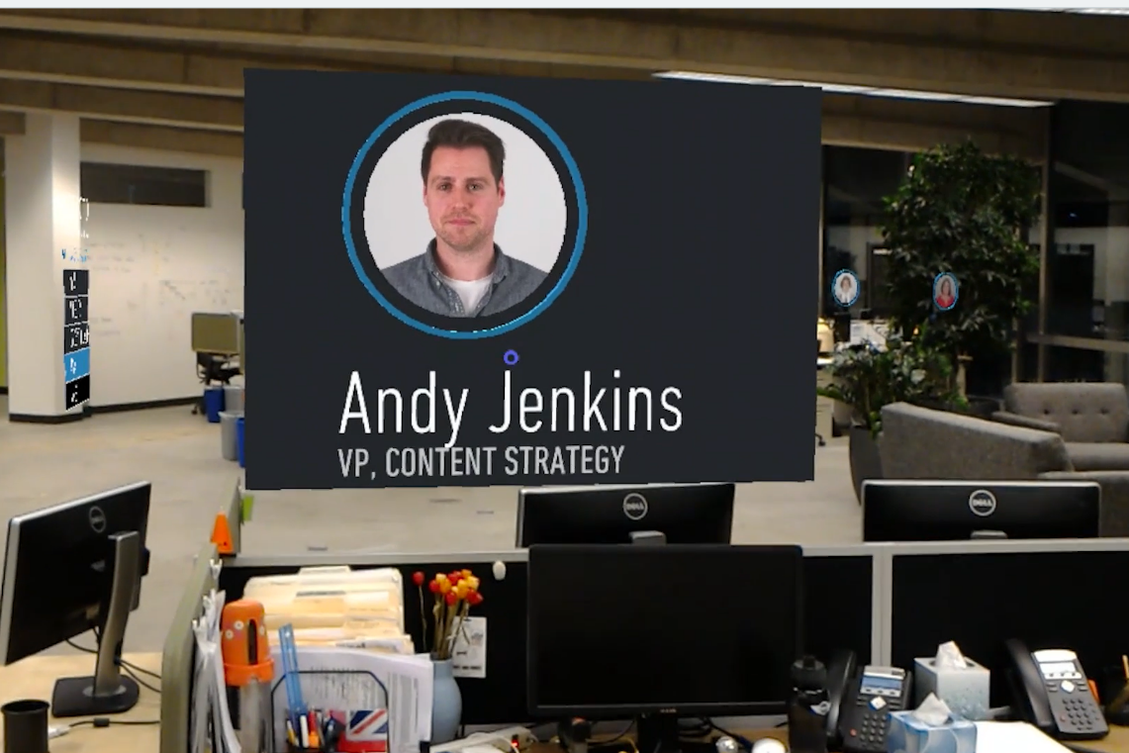
(Vimeo, 2018)
Figure 5 – Andy’s profile in virtual reality for Beam.
AR for onboarding helps the new employees understand the company’s roots and show what the main aims for the company are, what different departments do and encourage the new staff member to “really get productive and acclimated quickly,”
It goes beyond,” Gardner added, “just shaking hands and getting the standard, “Welcome to the team, Bill.” Ultimately, it can help collapse the time of a new employee getting comfortable and productive.
(BEAM, 2018)
With this being the company’s chosen way of introducing current and new work employees, it falls within the same trap as online dating. Online dating’s biggest issue is deceit, according to those that have experienced it and discussed their experiences on a thread on reddit, with hundreds also sharing the same issues. These issues consist of men being married, having hidden children etc. Just like an online dating profile, the owner of the BEAM profile has full control of the information shared. Just like Andy saying to the new employee come join the fantasy football, he has dictated that, that hobby is the one he wants to be shared. However, you’re not into fantasy football and now due to this video being projected to your eyes of him only talking about fantasy football, why would you want to socialize with him? Through this company applying this profile technique it causes a social human response of “profiling”.
The act or process of extrapolating information about a person
based on known traits or tendencies
(Merriam-webster.com, 2018)
Before even meeting Andy, you as a new employee are already giving Andy behavior traits and deciding if he is worth talking to. This also puts Andy at a disadvantage as he knows nothing about you. According to Eharmony, an online dating site.
20% of current, committed relationships began online
while your best chance at finding love is through a friend-which
is how 63% of married couples say they met their partner-you still
only have a 17% chance that you will like the person you're set up
with. Only 9% of women report finding a relationship at a bar or
club, and only 2% of men has made a relationship through that
scenario.
(Eharmony.com, 2018)
No benefits seem to come with knowing set information about someone before meeting them, discovering details about someone using the more traditional social method would seem to be the more successful way of introducing people, instead of placing a virtual reality headset and projecting profiles of workers made from specific handpicked information.
Virtual Reality in Schools
We are moving away from simply ‘learning’ a subject or topic to ‘
feeling’ the content. This is not simply an engagement tool or a
gimmick, it allows a student to explore, to experience or to be
involved in something, as if they are actually present in that
environment or place.
(Lawrie, 2018)
Sevenoaks School is fortunately able to spend a lot of time researching virtual reality technologies. They experiment to find out the uses and share their findings with other schools and teachers. This enables further progress and shows the benefits or disadvantages of the use of this technology in classrooms. Some of the most frequently requested information coming within the topics: which is the best device, what software is used and most importantly how does this improves learning?
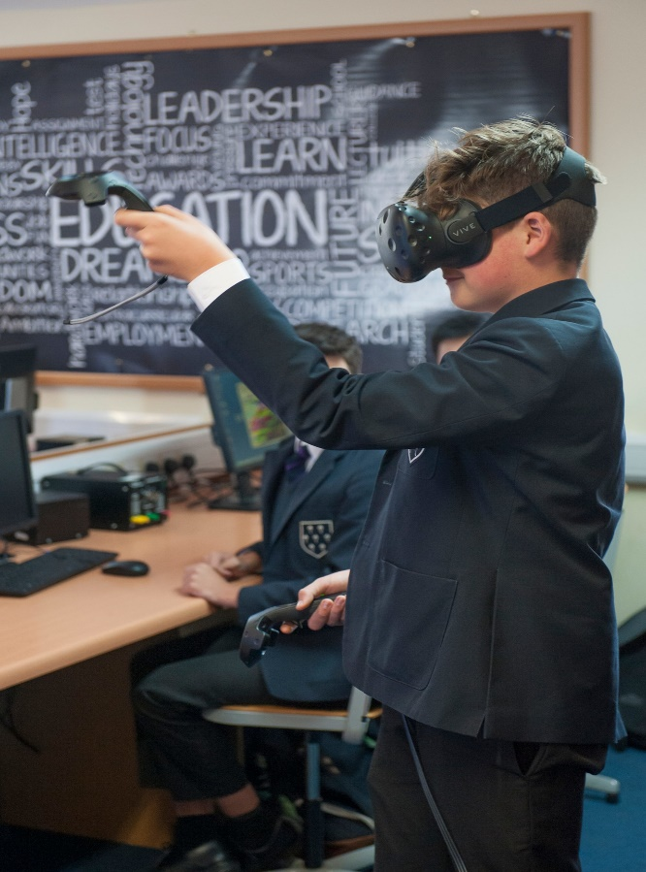
Figure 6 – Student of Sevenoaks school using VR
The answer that has been given is always the same –
Artificial reality is a tool for the classroom teacher of any
subject, it gives the professional educator another avenue to
explore with learners. It can be an effective new way to engage
those that struggle, or it can just provide another opportunity to
engage with a variety of learning styles.
(Lawrie, 2018)
With the technology still evolving, there is an abundance of 360-degree videos and plenty of useful apps. Feedback from the school however isn’t all positive.
In my opinion all these devices have a little way to go before they are
genuinely useful in the classroom. The cost is prohibitive and the
set-up a little clunky. There is not a device out there which does not
have a significant constraint attached for school acquisition and
inclusion in the curriculum.
(Lawrie, 2018)
The price is a factor that does cause worry for those that are looking into investing in VR. The cheapest high-end headset (Playstation VR) with all the necessities had an initial retail price of $399 for the standard version without any games. Essential to consider is the fact that, to successfully run a virtual reality experience with multiple students, you would need multiple headsets. Even though you could project what the user sees on a big screen television the interactivity gets lost with a single user. “experiencing on Google Earth VR or the Tilt Brush by Google art platform, it soon loses its novelty if you have a large cohort.”
(UploadVR, 2018)
Even if you were to supply the cheaper headsets to schools for learning benefits, they still require a minimum spec phone to be able to get them to function the way they are designed to. This would lead to either the students having to use their own personal devices, or the school providing the handset. With some schools not being able to spare the funds on updated school books, the likelihood of schools (especially public schools) being able to afford these devices is little to none.
The virtual reality world is progressing drastically however, staying away from the mobile phones and staying with peripheral devices like sensors and controllers is key in allowing the most immersive experience for the user. The restrictions of this are the transmitters and receivers required on walls or cameras on top of monitors and wires to create a drastic improvement of the experience. This could possibly be the defining way of providing the best learning experience at the cost of multiple students using the software. You settle for one high end device that gets used when the students need it or when teachers are demonstrating something that benefits being paired with a virtual reality experience. It could also be booked out like schools used to do when the first computer was brought to schools.
When in a classroom it is sometimes easier to see and hear something than have it explained to you, especially with students that prefer to learn in a visual and physical style. “Occasionally students just need to be taken out of a classroom environment and dropped into an immersive world; where they can watch dinosaurs walk around them, experience a performance at a West End theatre or in a concert hall.” (Lawrie, 2018) There are a fair few apps being generated for experiences targeted at learning. With each new development of every piece of software, another avenue for learners opens up and allows the teacher to give the student the best learning experience possible.
For the students that transition into more specific studies, the technology itself offers massive scope for areas such as; electronics, product design, automotive design and of course coding and games design. This allows students who understand how it works, to use their creativity to make their own software.
One of the big advocates of using virtual reality in the workplace and especially within the education system is Google. Google has stepped up to the mark with a tremendous solution for schools in the form of Google Expeditions, which allows teachers and students to take ‘immersive virtual journeys,’ such as exploring the surface of Mars in an afternoon or delve into the sea and search through coral reefs. Google will also be offering VR training to teachers to show how this technology can be used in a variety of ways to enhance literacy, creating an easy and efficient transition for virtual reality to be added to the workplace.
(Lawrie, 2018)
Negatives Of Virtual Reality
- Ethics: During the month of April 2016 in a theater called the Woolly Mammoth in Washington, D.C., a playwright called Jennifer Haley deals with the questions that occur when a character in the play known as Papa uses a specific software to create this fantasy world where adult clients harm and kill children. Within the play another character playing as the hero, detective Morris questions Papa on the line between fantasy and reality. He asks about the rightful boundaries of human experiences. The whole play raises multiple hair-raising questions such as: Should there be limits on human fantasies involving heinous thoughts? Do fantasies that remain in the private realm of someone’s brain warrant any rules or regulations by society as a whole?
- Cost/Restrictions: It isolates those who cannot afford or possibly may not be allowed access to the use of virtual reality. This is being caused either through age restrictions, the need for so many software and hardware requirements and general cost. This could further separate social classes in “Information Age” based societies.
- Communication: The use of virtual reality as a form of communication should not be a replacement for the more traditional meet and greet, especially when communicating within a group of people. More importantly the use of virtual reality and especially virtual reality common rooms allows the user to be susceptible to deception, similar to that you see when it occurs on social media.
- Lawless: Virtual reality is being developed at such a high pace, including the constant development of online worlds and interactivity between virtual characters being controlled by humans in the real world. There is a lack of any written or binding law within these virtual worlds. People portraying virtual characters can say things and act in ways that if they were replicated within the physical reality would be punishable by law. Also, users may be less inhibited than in real life due to a sense of anonymity, and may act in a way that is socially unacceptable
- Too Much Immersion: People can become addicted to living in these virtual worlds. As they see them as a place of endless opportunities and a realm without responsibilities, this can lead to forgetting or neglecting their real-life responsibilities. The only thing harder than facing your responsibilities, is facing them after being in a virtual world where you had none. This can lead to the users of virtual reality feeling depressed and worthless. They feel that they are escaping from the real world and sometimes this feeling is proved to be very dangerous for them.
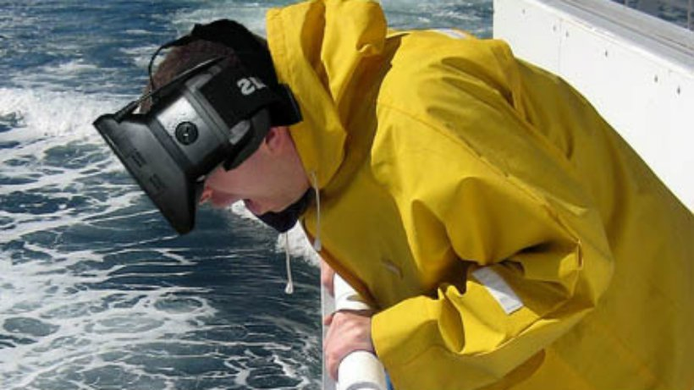
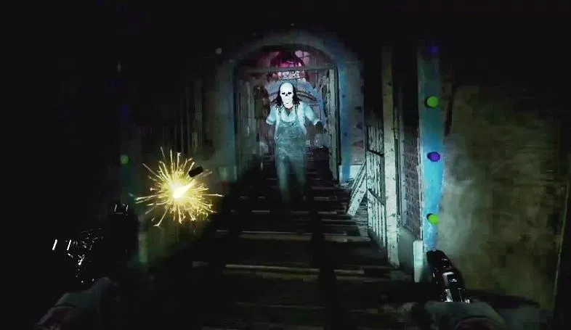
- Motion Sickness: When using the virtual reality headsets some people, especially while using games and experiences that include a lot of movement, react in a negative way. The constant light being projected closely to your eyes can cause blurred vison and headaches. The movement of just your head can cause motion sickness for some users as well.
(Virtual Reality, 2018)
Figure 7 – A man being sick over a boat with a headset photoshopped into place.
Is Virtual Reality Just Hype?
Even with all the positives that virtual reality can bring, some people still believe that it’s a fad and has no application for the real world. Steven Schkolne, Contributor, Caltech VR PhD, 3dSunshine founder, former CalArts, UCLA prof and now writer for the Huffington post (2016) says that even though virtual reality shows us exactly what we can already see in a photograph but more sensationally. Which seems to be a very simple mans form of describing the potential of what virtual reality is. Even though he seems to agree that virtual reality is entertaining it is unlikely to create new industries.
So, when you read headlines that The Future of Travel Has Arrived:
Virtual-Reality Beach Vacations, Google Cardboard Saves Baby’s
Life, Father Witnesses Son’s ‘Miracle’ Birth In Virtual Reality,
realize these authors are making a cognitive error. They believe a
VR headset is necessary to see a 3D world in a computer.
Somehow, these authors forget that people have been living inside
3D worlds since the days of Doom (1993) and Super Mario 64
(1996).
(Schkolne, 2017)
One of the biggest issues virtual reality faces is that the user must be involved to truly experience what it has to offer. If you are worried about looking silly or afraid of what virtual reality is then the experience will unfortunately be lost on the user. There is no comparison to be made between 1993 Doom and a current virtual reality game such as PSVRs (Playstation VR) Until Dawn Rush of Blood (2016) except the fact they both come under the genre of gore shooter.
The experience for the user could not be further apart. Doom is a classic and will always be labeled as a good game. The experience of Rush of blood (ROB) is unique in its own right and that’s purely due to the fact it’s experienced in virtual reality. Zooming through an amusement park on a roller-coaster while shooting killer clowns is an experience like no other, when placed within virtual reality.
Figure 8 – Enemy from ROB running at you as you shoot them.
If Doom was truly a whole 3D experience, there would have been no need for the creation of Doom VR. (2016)
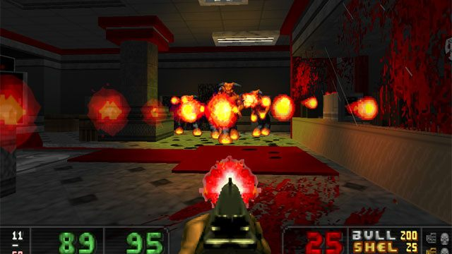
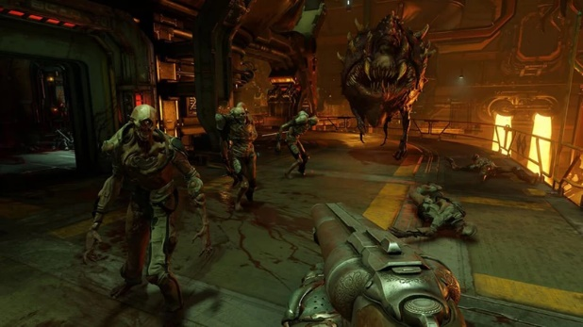
Figure 9 – Original Doom (1993) Shooting enemies.
Figure 10 – Doom VR (2016).
Even though the idea of experiencing 3D space isn’t being completely taken onboard many people agree that the use of your hands in 3D space has many benefits especially medical. Steven even agrees with seeing the benefits of hands in a 3D space.
VR for the hands, on the contrary, empowers humans like never
before. If you want a magic thread to follow to find VR gold, just
follow the hands. While I was doing my PhD at Caltech in the early
part of the millennium I laid the foundations for what would later
become Tilt Brush and Quill. (Schkolne, 2017)
What Steve had found was that, it’s a lot more important to be able to manipulate 3D space with your hands than to just have the ability to see it. His program, Surface Drawing, allowed a profound human experience: this allowed for people to be able to create meaningful 3d creations without learning highly technical software like Maya. This allowed for whenever his team 3dSunshine, would create project they don’t even need expensive displays, just the motion controllers, this would also be the case for consumers or teachers.
The implications of being able to interact with objects and simulations within a virtual space allows for so many options within the workplace, for specific areas within specific jobs such as: engineers being able to simulate an engine schematic and alter aspects of it to fix a simulated problem. However, as mentioned before with Applied VR using virtual reality as a way to inform patients and also entertain them while waiting in the hospital it is accomplished without the use of any motion controls. It’s just visual experiences created to help relax or a tool for sharing information. Therefore, there are aspects of some workplaces that strictly benefit from being able to interact with virtual objects in a 3D space, whilst others can work perfectly well as visual aids using just a headset.
Future of Workplace VR
The future of mixed reality in the form on enterprising completely lies in on-demand experience creation. Technology leaders are already offering “software as a service” products that will allow companies the ability to create AR experiences faster, with fewer resources. “Scope AR’s WorkLink has helped organizations do so in aerospace, manufacturing, and automotive, including AstraZeneca and Toyota.” If you decide to spend your time on quality content and attractive user interface you will succeed. You could have the most creative, useful and entertaining virtual or augmented reality experience. However, if it doesn’t have a usable interface and engaging content it will fall flat.
UX design principles in virtual environments require new, immersive
approaches to experience design. At John Deere, AR training
content comes directly from workers performing the tasks. At
Genesis Systems, “digital copies” of robotics and machinery are
consistently reused for troubleshooting. (Staff, 2016)
Just this year on November the 2nd it was announced that Shell will collaborate With EON Reality to employ AR & VR solutions globally. The companies will be working together to deploy training solutions. This has come to light due to more and more companies developing ideas for deploying virtual reality and augmented reality solutions across the entire individual companies infrastructure. Royal Dutch Shell plc, which is only really known as an oil and gas company announced that, its “Digital Realities team will work with EON Reality to create a global immersive training program.”
One of the first prototype tests was on an aircraft refueling training program. Within this test Shell was able to trial its Virtual Trainer, which is part of the EON Reality, connected AVR (Short for automatic voice recognition, AVR is the ability of a computer or other electronic devices to identify and understand human voice) platform for learning. (Definitions and Hope, 2018)

The whole purpose is that Shell plans to target key used cases where
Virtual Trainer provides an efficient solution that can be scaled, rather
than used in only a single facility.
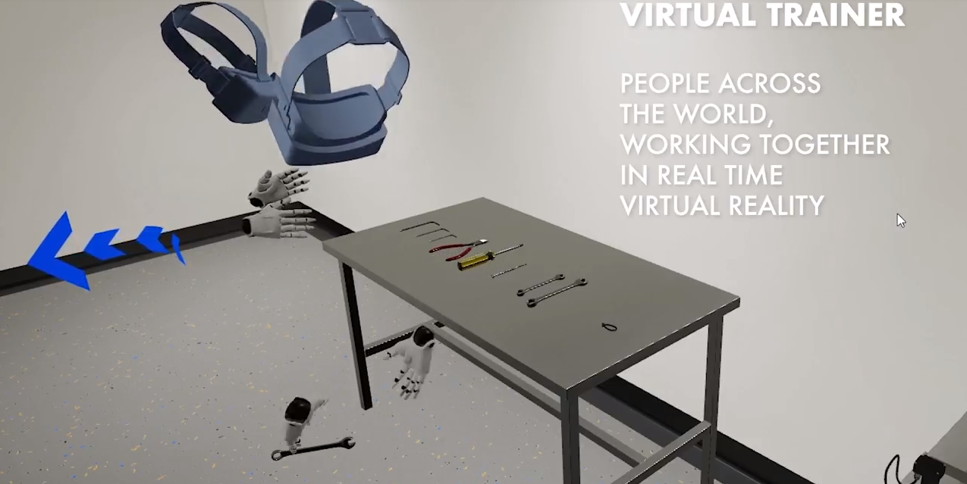
(Graham, 2018)
Figure 11 – Virtual trainer for EON
Eamonn Watson, Business Development Director at EON, has spoken about
VR and AR becoming a mainstream platform in not only entertainment but also in enterprise. Companies like Shell are aiming to tackle real business issues and apply solutions through virtual training programs and stay away from silos of departmental activity developing into a support system that targets specific applications.
Through Shell and EON Realities partnership the immersive training in VR can be made available on demand, via Virtual Trainer lessons and can negate the costs of production or operational shutdown for training and offer global, preparatory training for high risk, HSSE emergencies. This could potentially help to get companies back up and running faster when issues do occur.
The biggest benefit to this is that Shell can recreate any environment within VR or AR that they would then use for training or assessment and make those modules accessible at any time. This would be with or without a live trainer in a multitude of different languages
(Graham, 2018)
Conclusion
This dissertation is supported with case studies from attempts of VR implementation into medicine and workplace training, and the issues that companies will come across when trying to implement VR into the workplace. Education has been considered as well and reinforced with experiences that occurred in a school when VR has been implemented. Research into the future of VR is covered as well as the current day.
The way that virtual reality will be relevant in the workplace is by being used as a learning tool or to inform. With companies such as Shell leading the way in distributing globally accessed training modules, it will only be a matter of time until smaller companies begin to implement the same technology, allowing for safe simulations to be tested at any time, in any industry. This enables protocols to be tested, and ready the employees before the physical version of that scenario happens. Getting a reliable and cheap hardware to power the learning software, is the key to global distribution for VR within schools. If this was to occur, then the students will benefit from endless creativity and the ability to experience things words cannot quite describe. Making the job of teachers easier, especially those that teach in a more descriptive subject such as history, geography and design.
VR doesn’t seem to be a necessity on a social side. If anything, it cause more issues than positives. If you remove the option to use VR as a social tool in the workplace, you remove the chance of awkward interactions when employees meet face to face. This could easily occur if you are greeted with a virtual reality onboarding experience at a new job, which has been created poorly. Removing the ability to interact with people in a virtual social space also removes the issues that can occur in a lawless virtual world. As most of the best examples of workplace VR consist of simulations, the option to socially interact with people isn’t something that will be missed. With further testing and rules, the addition of being able to work on simulations with other workers across the world would most likely be a welcome addition by employees.
Virtual reality is not only a creation for gamers but a tool for education. With companies such as Shell, EON, Applied VR, BEAM, Kaleido and Google pioneering virtual reality for companies, it is only possible to conclude that virtual reality has real and increasing relevance in the workplace.
References
Woodford, C. (2018). What is virtual reality? - A simple introduction. [online] Explain that Stuff. Available at: https://www.explainthatstuff.com/virtualreality.html [Accessed 13 Oct. 2018].
Craig, A., Sherman, W. and Will, J. (2009). Developing virtual reality applications. Amsterdam: Morgan Kaufmann/Elsevier.
Virtual Reality Society. (n.d.). Virtual reality in medicine - Virtual Reality Society. [online] Available at: https://www.vrs.org.uk/virtual-reality-healthcare/medicine.html [Accessed 13 Oct. 2018].
Samsung Business Insights. (2017). Virtual Reality in Healthcare: How Inova Mount Vernon Hospital Puts Emergency Room Patients at Ease - Samsung Business Insights. [online] Available at: https://insights.samsung.com/2017/08/03/virtual-reality-healthcare-inova-mount-vernon-hospital-puts-emergency-room-patients-ease/#jump3 [Accessed 13 Oct. 2018].
VRHealth. (2018). How Virtual Reality is Revolutionizing Surgeon Training Programs - VRHealth. [online] Available at: https://www.xr.health/virtual-reality-surgeon-training.html/ [Accessed 16 Oct. 2018].
Neal E. Seymour, R. (2012). Virtual Reality Training Improves Operating Room Performance: Results of a Randomized, Double-Blinded Study. [online] PubMed Central (PMC). Available at: https://www.ncbi.nlm.nih.gov/pmc/articles/PMC1422600/ [Accessed 15 Oct. 2018].
Nicastro, D. (2018). 5 Ways Augmented and Virtual Reality Are Infiltrating the Enterprise. [online] CMSWire.com. Available at: https://www.cmswire.com/digital-workplace/5-ways-augmented-and-virtual-reality-are-infiltrating-the-enterprise/ [Accessed 18 Nov. 2018].
Szymanski, J. and Owyang, J. (2018). Prepare for the New Reality of “Super Employees”. [ebook] Available at: http://www.kaleidoinsights.com/order-reports/prepare-for-the-new-reality-of-super-employees/ [Accessed 20 Nov. 2018].
Lessonly. (2018). The History Of Employee Onboarding Pt. 1 - Lessonly. [online] Available at: https://www.lessonly.com/blog/the-history-of-employee-onboarding-pt-1/ [Accessed 24 Nov. 2018].
Vimeo. (2018). Beam AR D13. [online] Available at: https://vimeo.com/215520764 [Accessed 25 Nov. 2018].
BEAM. (2018). BEAM | About Us. [online] Available at: https://www.beamland.com/about-us/ [Accessed 25 Nov. 2018].
Merriam-webster.com. (2018). Definition of PROFILING. [online] Available at: https://www.merriam-webster.com/dictionary/profiling [Accessed 25 Nov. 2018].
Eharmony.com. (2018). 10 Online Dating Statistics You Should Know (U.S.). [online] Available at: https://www.eharmony.com/online-dating-statistics/ [Accessed 25 Nov. 2018].
Lawrie, G. (2018). How our school is using Virtual Reality to prepare pupils for a future dominated by technology. [online] The Telegraph. Available at: https://www.telegraph.co.uk/education/2017/01/23/school-using-virtual-reality-prepare-pupils-future-dominated/ [Accessed 2 Dec. 2018].
UploadVR. (2018). PSVR Price Announced. [online] Available at: https://uploadvr.com/psvr-pricing-launch-details-announced-gdc/ [Accessed 2 Dec. 2018].
Virtual Reality. (2018). Pros and Cons. [online] Available at: https://virtual-reality.weebly.com/pros-and-cons.html [Accessed 3 Dec. 2018].
Schkolne, S. (2017). What Nobody Will Tell You About Virtual Reality. [online] HuffPost. Available at: https://www.huffingtonpost.com/steven-schkolne/what-nobody-will-tell-you_b_9312026.html [Accessed 3 Dec. 2018].
Staff, C. (2016). The UX of VR. [online] Creative Bloq. Available at: https://www.creativebloq.com/ux/the-user-experience-of-virtual-reality-31619635 [Accessed 8 Dec. 2018].
Definitions, A. and Hope, C. (2018). What is AVR?. [online] Computerhope.com. Available at: https://www.computerhope.com/jargon/a/avr.htm [Accessed 8 Dec. 2018].
Graham, P. (2018). Shell Collaborates With EON Reality to Employ AR & VR Solutions Globally. [online] VRFocus. Available at: https://www.vrfocus.com/2018/11/shell-collaborates-with-eon-reality-to-employ-ar-vr-solutions-globally/ [Accessed 8 Dec. 2018].

Image References.
- Figure 1 – pg. 1 (https://www.servicefutures.com/virtual-reality-in-the-workplace)

- Figure 2 – pg. 6 (https://appliedvr.io/)

- Figure 3 – pg. 8 (https://www.beamland.com/)

- Figure 4 – pg. 9 (https://www.thedrum.com/topics/red-bull)

- Figure 5 – pg. 11 (https://vimeo.com/215520764)

- Figure 6 – pg.13 (https://www.telegraph.co.uk/education/2017/01/23/school-using-virtual-reality-prepare-pupils-future-dominated/)

- Figure 7 – pg. 17 (https://www.gamespot.com/forums/system-wars-314159282/does-vr-make-you-sick-33374648/)

- Figure 8 – pg. 19 (http://gamesmoviesdeals.com/until-dawn-rush-of-blood-review/)

- Figure 9 – pg. 19 (https://www.gamepressure.com/download.asp?ID=59098)

- Figure 10 – pg. 19 (http://fandom.wikia.com/articles/doom-fallout-4-vr-versions-announced)

- Figure 11 – pg. 22 (https://www.vrfocus.com/2018/11/shell-collaborates-with-eon-reality-to-employ-ar-vr-solutions-globally/)

