NAME: LEKAN AHMED NURENI
MODULE: SOFTWARE DEVELOPMENT (PYTHON)
MODULE CODE: ACCA4017
LECTURER: SUNETH FERNANDO & RENUGA JAYAKUMAR
ASSIGNMENT TITLE: ASSESSMENT 1

PART A
A1. What is a variable and why are they important in writing programs? Discuss the way variables are handled in the programming language you have studied (eg static vs dynamic typing)

A variable is a name that references a value stored in the computer memory. Once an object is assigned to a variable, the object can be referred to/ called by the name given to the variable.
Example:
text = “Hello World!”
print(text)
“text” is a variable and “Hello World” is the object assigned to it.

Variables are important in programming because they are used for containing and referencing data.
Another example:
x = 2
y = x + 4
print(y)

Using a variable to store a result would speed up its application. The variable can be called many times and used to solve many other arithmetic equation.
Variables make programs more understandable to both programmer and users.

Python is a dynamically typed language. The python interpreter does type checking at runtime.

A2. Explain what an if/else statement is, how and why they are used, and give a code example of when you would use one. Include in your answer a discussion of the use of multiple conditions.

The if/else statement is used to execute both the true and false part of a given condition. The “if” statement executes a block of code if the condition is true and the else statement executes a block of code if the condition is false.
If/else statement are used when there’s a condition to be met.
Example
if height >= 2.0:
print(“This is the if block”)
print(“Unless you are a giant, that seems a bit high”)
else:
print(“This is an else block”)
print(“Height noted”)

We can define an if statement with multiple conditions using logical operators.
Example
num = 5
If num <10 and num %4 !=0:
print(num)
num is printed because both conditions are met.
A3. Explain why loops are needed in a program and when you might use a for and a while loop. Give suitable examples of each in the programming language you have studied.

Loops are needed in a program to shorten long lines of codes to just a few. Defining loops in code allows computers to perform a particular task repeatedly. Programming languages require loops so that the codes execute the action as many times as needed.

A ‘for’ loop can be used for iterating over a sequence either a list, dictionary, set, string.
Example in python:
cars = [“BMW”, “Mercedes Benz”, “Jeep”, “Toyota”]
for x in cars:
print(x)

A ‘while’ loop keeps executing a block of code/ set of statements as long as a specified condition is true.
Example:
i = 1
while i < 5:
print(i)
i += 1
We need to increment i or else, the loop will continue forever.

PART B
- Show how variables can contain different types of values by declaring three variables that will contain a name, a measure of height (e.g. 1.84m) and a person's age (e.g. 26). Prompt the user to input these values and display them on the screen. The variables should be appropriately typed for the data required.

#prompt user to enter name
name = (input("Please enter your name: \n"))
#prompt user to enter age
age = int(input("Please enter your age: \n"))
#prompt user to enter height
height = float(input("Please enter your height in meters: \n"))
#validation to prevent user from entering value >= 2.5
if height >= 2.5:
print("Unless you are a giant, that seems a bit high!")
new_height = float(input("Please enter your height in meters: \n"))
print("Thanks, you entered: ", name, "-", age, "years old - ", new_height, "m tall")
else:
print("Thanks, you entered: ", name, "-", age, "years old - ", height, "m tall.")

OUTPUT 1
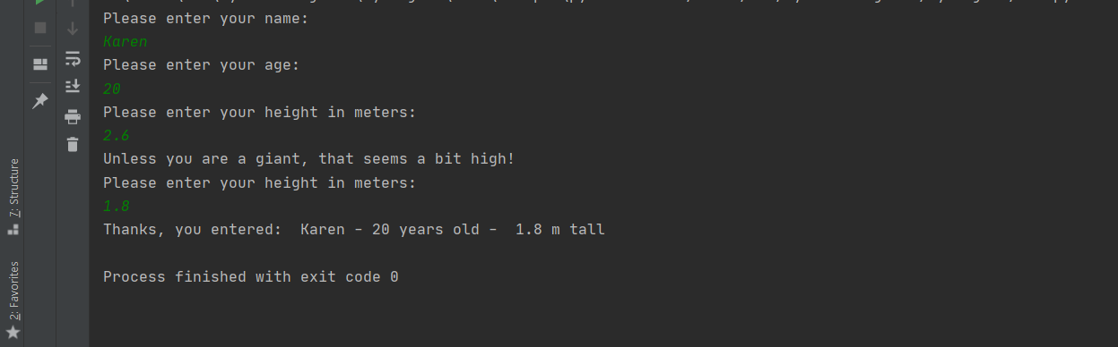

OUTPUT 2
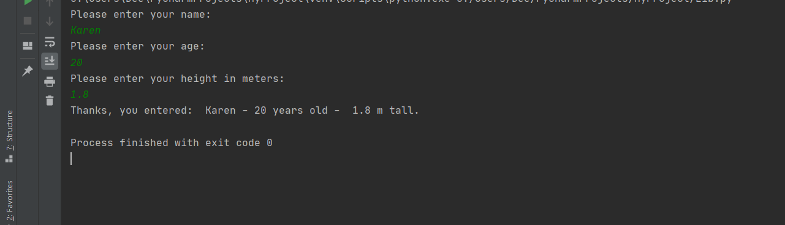

- The user would be prompted to enter the values for the dimensions of the shapes and the users values are then assigned to the variables and called when needed.
Compute the area of the circle using pi * (r*r)
Compute the area of rectangle l*w
Compute the area of square l*l
Shaded area is given by Area of Circle - (Area of Square + Area of rectangle)

#prompt user to enter radius of circle and store value in rc
rc = float(input("Please enter radius of circle: \n"))
#prompt user to enter square sides and store value in sw
sw = int(input("Please enter side of square: \n"))
#prompt user to enter width of rectangle and store value in rw
rw = float(input("Please enter width of rectangle: \n"))
if rw >= 11:
print("That seems a little big, please try again: \n")
newRW = int(input("Please enter width of rectangle: \n"))
rl = float(input("Please enter length of rectangle: \n"))
AreaOfCircle = 22/7 * pow(rc, 2)
AreaOfRectangle = rl * newRW
AreaOfSquare = sw * sw
ShadedArea = AreaOfCircle - (AreaOfSquare + AreaOfRectangle)
print("The shaded area is = %.2f" % ShadedArea, "cm")
else:
rl = float(input("Please enter length of rectangle"))
AreaOfCircle = 22/7 * pow(rc, 2)
AreaOfRectangle = rl * rw
AreaOfSquare = sw * sw
ShadedArea = AreaOfCircle - (AreaOfSquare + AreaOfRectangle)
print("The shaded area is = %.2f" % ShadedArea, "cm")

OUTPUT 1
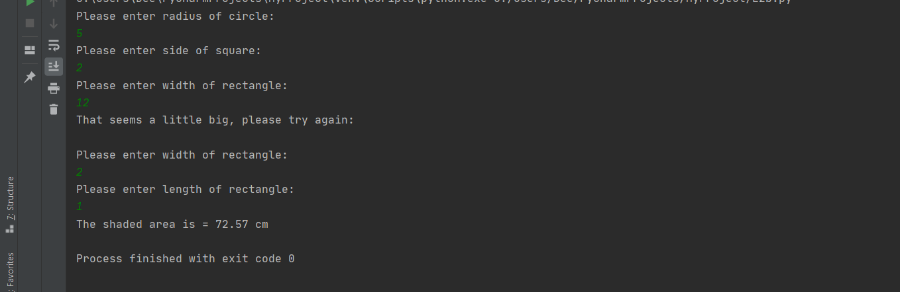

OUTPUT 2

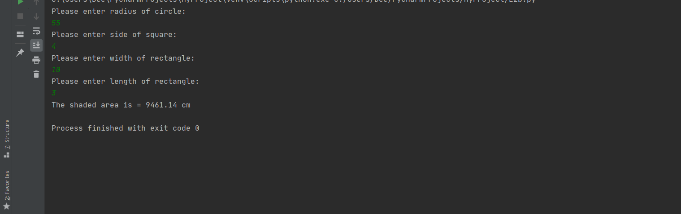

- A list of days in the week is created and stored in a variable called days.
A for loop was used to iterate over the list.
Instead of writing multiple lines of code to prompt a user to enter mileage per day, this program makes use of the python string title() method syntax.

#list of values stored in variable days
days = ["Monday", "Tuesday", "Wednesday", "Thursday", "Friday", "Saturday", "Sunday"]
#compute totalMileage from 0
totalMileage = 0
#loop to iterate over the list
for day in days:
mileage = float(input(f"Enter miles for {day.title()}:\n"))
if mileage < 0:
print("Please try again")
mileage = float(input(f"Enter miles for {day.title()}:\n"))
totalMileage = mileage + totalMileage
print("The total mileage was: ", totalMileage)
CostOfPetrol = (totalMileage / 11.2) * 1.35
print("Cost of petrol: = %.2f" % CostOfPetrol)

OUTPUT 1

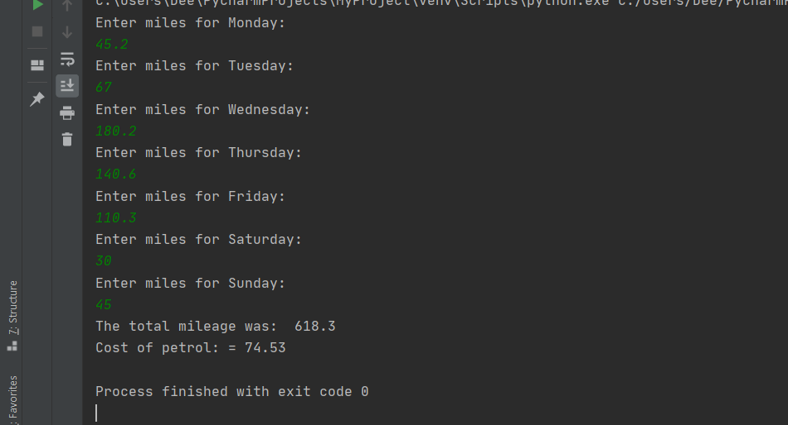

OUTPUT 2
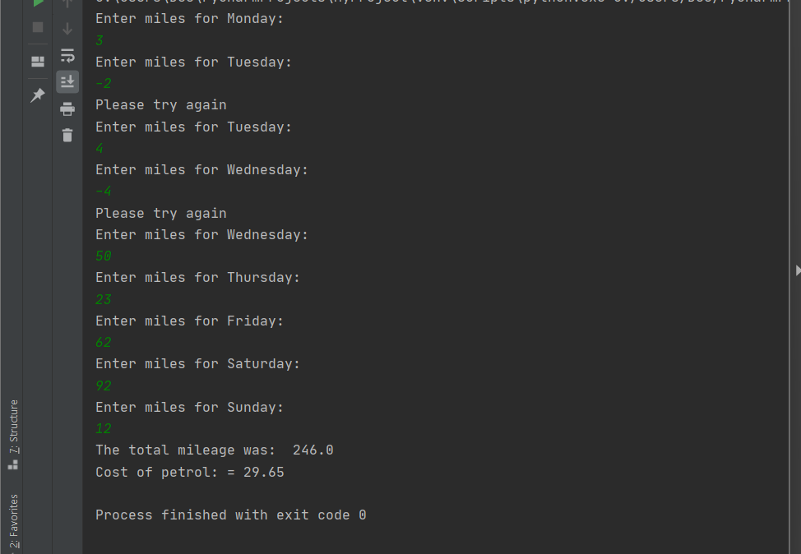

- A board pair game

theNumbers = [0, 1, 2, 3, 4, 5, 6, 7, 8, 9, 10, 11]
matches = ['dog', 'cat', 'mouse', "dog", 'cat', "mouse", 'monkey', 'fly', 'bird', 'fly', 'monkey', 'bird']
correct = ["?", "?", "?", "?", "?", "?", "?", "?", "?", "?", "?", "?"]
userNumbers = []
print("Welcome to the pairs game. There are six pairs to find.")
print("Here is the board")
print("0", "1", "2", "3", "4", "5", "6", "7", "8", "9", "10", "11")
print("?", "?", "?", "?", "?", "?", "?", "?", "?", "?", "?", "?")
# initial number of turns
turns = 0
def turn():
guess1 = int(input("Please enter guess1: "))
while guess1 < 0 or guess1 > 11:
print("That number is not on the board. Please choose a number from the board:")
guess1 = int(input("Please enter guess1: "))
guess2 = int(input("Please enter guess2: "))
while guess2 < 0 or guess2 > 11:
print("That number is not on the board. Please choose a number from the board:")
guess2 = int(input("Please enter guess2: "))
if matches[guess1] == matches[guess2]:
print("Well done. That's a match on", matches[guess1])
correct[guess1] = "X"
correct[guess2] = "X"
print(theNumbers)
print(correct)
elif correct[guess1] == "X" or correct[guess2] == "X":
print("This is not available! Please try again.")
else:
print("Not a match. Position", guess1, "was", matches[guess1], "and position", guess2, "was", matches[guess2])
global turns
turns += 1
print("You've had", turns, "turn(s) so far.")
while turns < 10: # you can change to as many guesses as you want to allow the player
turn()
if correct == ["X", "X", "X", "X", "X", "X", "X", "X", "X", "X", "X", "X"]:
print("Congratulations. You have got all the pairs. You did it in", turns, "turns")
break
else:
print("Game over! You ran out of guesses...")

OUTPUT


