Reflective Report
Academic Skills
Name: Chloé Chignell
Student Number: 1702365

Project Group: Bright Art at Ysgol Crug Glas
Date: February/March 2018
Table of Contents
1. Executive Summery 3
2. Introduction 4
2.1 Report Remit 4
2.2 The Organisation 4
3. Models of Reflection 5
3.1 Understanding the models 5
3.2 The models and the project 5
4. Masterclass Sessions 5
4.1 Influences on the project 5
4.2 Influences on my personal development and learning 5
5. Conclusion 5
References 6
Appendices 7

Figures
Figure 3-1 - Three Stage Models of Reflection (Driscoll, 2007) 4
Figure 3-2. Kolb’s Model of Reflection (Kolb & Fry, 1975) 4
Figure 3-3 - Gibbs' Multi Stage Model 5
Figure 4-1 -Stifyn Parri on Voices and Energy 6

Tables
Table X-X -

Appendices
Appendix A – Guest Speakers Summery
Appendix B – Guest Speaker Notes
Appendix C – Skills Audit and Action Plan

Introduction
This reflective report will evaluate and analyse the application of reflective models and the impact the masterclass session had on my experience of the project as well as my personal experiences. The masterclass sessions were a sequence of guest speakers put on by the university each week on a Thursday afternoon. Within the audience were first-year undergraduate business students and final year masters business students. The reflective models discussed are used to promote critical thinking. Conway (1994) said critical thinking is ‘the process of looking back on what has been done and pondering on it and learning lessons from what did or did not work’ (Conway, 1994).

The Organisation
Within the first semester, my group and I were working with Ysgol Crug Glas, a school working with children with ‘profound and multiple, or severe and complex learning difficulties’ (Ysgol Crug Glas, 2018, p. About Us). The main aim of the project was to raise £100 for an ultraviolet light for aid the children’s sensory development. We raised the money through a coffee morning held in the university and a sponsored 10k walk from Swansea Marina to the Mumbles Pier. The coffee morning raised just over £100 and, with the sponsorship money from the walk, we raised a total of £450. This was enough for the school to buy a bigger ultraviolet light to be fitted to fill the whole room. Another aspect of our project involved getting messy and working with class five in their Friday morning art lessons to promote inclusion and understanding.

Models of Reflection
Over the years, various writers and thinkers have produced different models of reflection, each focusing on different aspects. Many ideas model have been evolved and changed over the years to fit modern issues and bring about a deeper level of reflection.

Understanding the models
There are many types of staged models which follow a set of steps to apply but the most common are three stage models as set out by Borton (1970) and then advanced upon by Driscoll (1994) who identified the three trigger questions; ‘What?’, ‘So what?’ and ‘What now?’. See Figure 1.

Figure 3-1 - Three Stage Models of Reflection (Driscoll, 2007)
Kolb (1975) came up with an experimental learning model consisting of four stages; Experience, Reflection and Observation, Development of Ideas and Testing Ideas in Practice. See Figure 3-2.

Figure 3-2. Kolb’s Model of Reflection (Kolb & Fry, 1975)
This was then developed by Gibbs (1988) into a multistage model containing six steps to consider; Description/Context, Feelings, Evaluation, Analysis, Further Analysis/Review and Action Plan.

Figure 3-3 - Gibbs' Multi Stage Model
Gibbs developed Kolb’s experience section into description/context and feelings. The reflection and observation section has become evaluation of the positives and negatives of the. The development of ideas evolved into analysis and review. The final fourth section of testing ideas in practice was turned into an ‘action plan’.

The models and the project
Gibbs Multistage Model I feel is an appropriate model to apply to my project as the levels seem to be the most attainable.
This model starts with

Masterclass Sessions
Throughout the course of semester one, the class were given the opportunity to attend a series of masterclass session consisting of various guest speakers from various industries, see appendix a. The guest speakers ranged from small town businesses started from a mum’s kitchen such as Kate Jenkins from Gower Cottage Brownies to Stiffyn Parri’s journey through every medium of success. Although, with all the different guest speakers, there were a few common themes which shined through. These included the importance of networking, confidence, you are your own wall, understanding the customer, your previous experience doesn’t define you and the importance of enjoying yourself.

Influences on the project
Of all the key themes identified, confidence, ‘you are your own wall’ and understanding the customer were the ones which stuck with me during the project. Stifyn Parri’s lecture in particular stayed with me throughout. His confidence and his talk on how to project the correct energy for the correct audience, see figure 4-1, has definitely been present in my mind during talks with teachers, classes of children and my group. Its allowed me to be more self-aware and conscious of how I’m presenting myself.
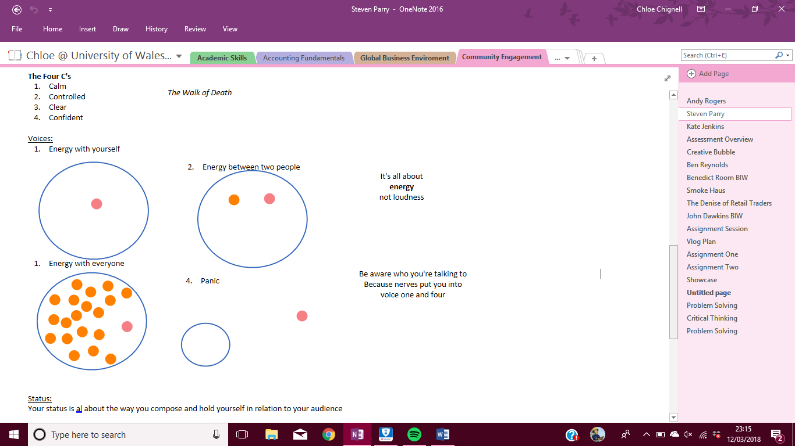
Figure 4-1 -Stifyn Parri on Voices and Energy
Another theme which resounded throughout the project was the sentiment of ‘you are you own wall’. This means that you are the only barrier in the way to your success and was talked about and emphasized upon by Stifyn Parri and Benedict Room. Benedict Room was another of my favourite of the gust speakers. He was engaging and lively through, like Stifyn Parri, but gave a more interactive talk with a adgenda to focus his talk onto us applying it to ourselves.

Influences on my personal development and learning
These included the importance of networking, confidence and the importance of enjoying yourself. After all the talks on networking, I realised how key networking is to a successful business career. The talks have encouraged me to take part in networking events and after the talk from creative bubble, ive attended the Pizza with a Pro events they run. These have enabled me to meet like-minded people as well as experienced professionals who may be able to help me in the future.
The idea that you need to enjoy yourself throughout your career ran through with Stifyn Parri, Kate Jenkins at Gower Cottage Brownies, Benedict Room and the talk from the Smoke Haus. This idea has been relevant in my own development of my own idea of a career and business. Its made me more determined to follow my dream of opening a tea room rather than getting a desk job.

Conclusion
In conclusion, this was a valued experience which I have been able to learn a lot from and apply to real life situations as well. Ive learn a lot of myself and where I want to go in life as well. For the future, I think a similar project can be improved by having less entrepreneur focused talks. Although they were very helpful for me, a lot of students struggled to engage with them. Possibly different section of business each week could work well, ie. Accounting, Human Resource management, Recruitment, marketing, entrepreneurial, etc.

References
Borton, T., 1970. s.l.:s.n.
Conway, 1994. s.l.:s.n.
Driscoll, 1994. s.l.:s.n.
Driscoll, 2007. s.l.:s.n.
Gibbs, G., 1988. Learning by doing: A guide to teaching and learning methods. London: Further Education Centre.
Kolb, D. A. & Fry, R., 1975. Toward an applied theory of experiential learning.. London: John Wiley.
Schön, D., 1983. The Reflective Practitioner, How Professionals Think In Action. New York: Basic Books.
Ysgol Crug Glas, 2018. About Ysgol Crug Glas: Ysgol Crug Glas. [Online]
Available at: https://swansea-edunet.gov.uk/en/schools/crugglas/Pages/About_Ysgol_Crug_Glas.aspx
[Accessed 10 02 2018].

Appendices

Appendix A – Guest Speaker List
Date | Guest Speaker | Presenting | Theme(s)
05th Oct | Andy Rogers | Guest Speaking for introverts | Networking is key to success
12th Oct | Stifyn Parri | Mr. Producer | Confidence – where is your energy?  Networking is key to success (Who you know, not what you know)  Grades arn’t everything  You don’t have one destiny  You are your only wall
12th Oct | Kate Jenkins | Gower Cottage Brownies | From a mum cooking in the kitchen to small time business to big time success
26th Oct |  | Creative Bubble
26th Oct | Ben Reynolds | Trilein | Don’t let your degree define you, allow it to aid you  Find your dreams  Networking is key to success
02nd Nov | Benedict Room |  | The bigger picture  Understanding the customer  Now is the time to sart something  You are your only wall
09th Nov? |  | Smoke Haus | Don’t give up on your dream  Find good people to work with  Understand your team  Get your niche  Understand the stretch of your business
16th Nov |  | The Denise of Retail Traders – the financial industry | Find your niche  90/90/90 rule
23rd Nov | John Dawkins | Dirty Little Serifs – Advertising and marketing design  Maykher – ethical support for women | Write down every idea you have  Enjoy yourself, do what you’ll love  Understand how children perceive us  Know what keeps you going  Networking is key to success
30th Nov | Joy | Joy @ Christmas | **CANCELLED**  not rescheduled

Appendix B – Guest Speaker Notes
- Andy Rogers on ‘Guest Speaking for introverts’ on the 5th October 2017.
Key themes: Networking is key to success

Networking for Introverts
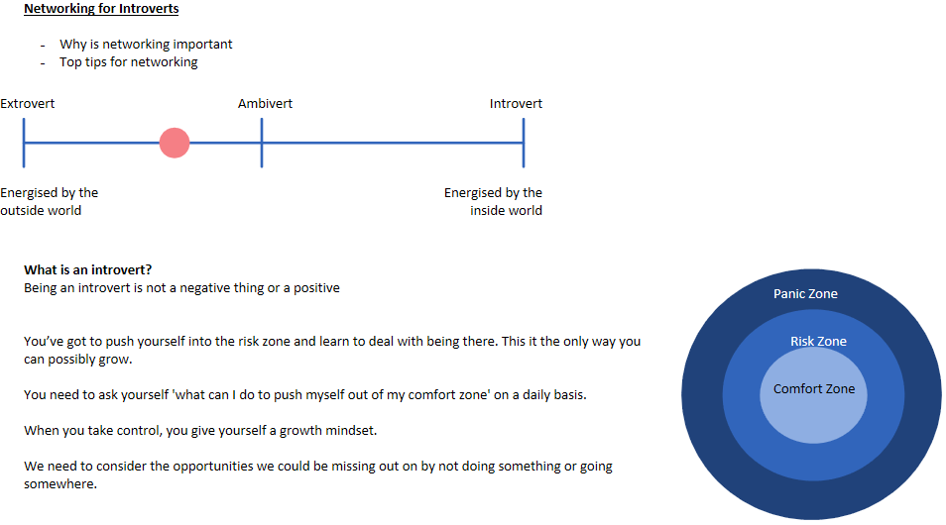
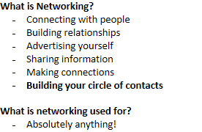
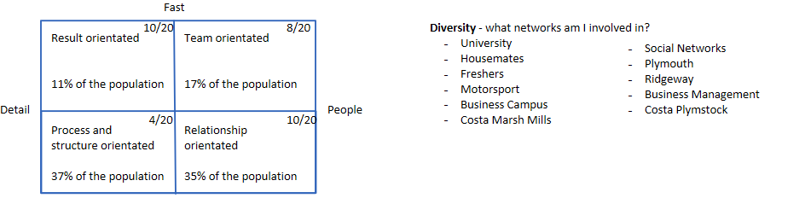
Considered

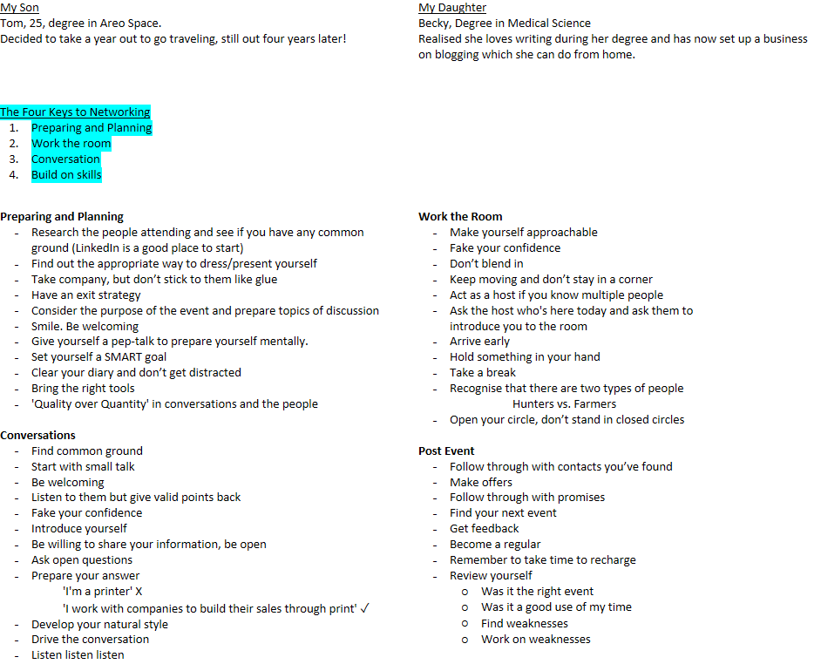
@AndyRogersBiz

- Stifyn Parri on his life and successes ‘Mr. Producer’ on th 12th October 2017.
Key Themes:
Confidence – where is your energy?
Networking is key to success (Who you know, not what you know)
Grades arn’t everything
You don’t have one destiny
You are your only wall

Mr. Producer
Has run some of Wales' biggest events

He organised a play at the age of three which then ran nearly every Friday until he was aged 18.
Went to drama school in London
Biggest actor role would have been working on a soap called Brookside.
He was the first male-male kiss on TV and made the nine o'clock news for being so ground breaking

He then decided to go into Broadway.
He got the part of the lead in Les Miserable just from being 'cocky' and confident. Yes he could sing but he couldn’t nearly reach the high notes.

Then asked to present a Bafta in Cardiff, ask to produce the Bafta Award Show, Started Mr Producer.
Got job after job after job!
Heard about the wales Millennium Stadium and asked to be the event producer after basically stalking the woman in charge for months. Making sure he was at EVERY event she was at, every coffee shop. Everywhere. Until she would recognise him.
He invited her over his for dinner so there was no distraction all they could talk about was hum and him alone. He got the job!
Then become the Creative producer at the rider cup stadium for 18 months.

He focused on what he wanted to do.
Not luck, just rewards for going out and taking what he wanted.

"stay focused, stay genuine,
you're only as good as your last gig"

His job became soemthing he didn’t carefore so he reinvented it into what he wanted to do.

Created his one-man show based on backstage gossip.

What stops us from aiming high?
Our lack of confidence.

Nerves and excitement are the same thing. They share the same adrenaline.
Fear causes our brains to become our enemy. Ignore our brains negativity. Walking up in frount of people isnt going to kills you! You’ve ust got to focus tour confidence.

Take gambles, belive in our convictions

What we think people expect from us:
- Perfection
- Something different
- For us to be better than we are
We can only ever be the best version of ourselves
We cant control what others expect from us, but we can put them at ease.

The Four C's
- Calm
- Controlled
- Clear
- Confident

Status:
Your status is al about the way you compose and hold yourself in relation to your audience

Low Status = pleading, puppy like, desperate

High Status = Patronising, overly loud, a twat

Equal Status = being equal to that person/those people

Match your person's status

Be genuine, be passionate.

Find your answers and don't take anything for granted.

You have to prepare for every eventuality.

Start everything with 'Hello, I'm Chloé' as soon as you walk in a room

Be familiar with the content

Keep eye contact. Smile!

Have a structure and rehearse everything out loud
Keep your notes in very small bullet points but big font.
Add in 'breath' ' pause' 'smile'
No pause is too big, you're in control

- A short introduction to the company Creative Bubble given on the 28th of October 2017

Creative Bubble
A UWTSD project

An empty shop in Craddock Street for us to use for free!
For an exhibition, a launch, a fundraiser.
Have a small budget to help with funds
Safe space away from campus
Swansea Bid are a partner, co-run creative bubble

Pizza with a Pro
An entrepreneur comes in and shares their experiences
Also an opportunity to network and possibly get a job offer!!

Facebook: Swansea Creative Bubble

Contact Details:
On flyer

- Ben Reynolds on his company Trilein given on the 26th of October 2017 at Unit Nineteen
Key themes: Don’t let your degree define you, allow it to aid you. Find your dreams. Networking is key to success

Ben Reynolds
Trilein
Creative regeneration agency
Don’t wait for anything!

2004
Small to country wide

Starting out:
Geography student, musician with original songs
Started own company to have a place to play (not a cover band)
Showcase nights at bars
Never had a business degree, fell into being a business man

Started with lots of collaborative work
No money,

Most valuable thing: his big network
Forced himself into people

PHD in geography from Swansea University
Mostly urban geography, which help with business

Discovered he was an entrepreneur
Google: Mrs Bucket
29 years old and a multi-millionaire

He wanted to make a difference in the world

2004 - founded the business
Jumped into it, no business plan, no research, no brand.
It was all in his head, and that worked for him as the business was based on his skill.

All he had was
- A car
- A laptop
- Broadband
- A phone

Where do I begin?
His network.
'I know a guy, he can help you out'
First 18 months of business, no marketing as he had the network.
Through using his network, he was building

Get a domain name
ben@hemustbeserioushesgotadomainname.com
Its makes you look more serious

Don’t use your home address, or a PO box.
Use a mate who has a business, get your mail sent there!

Love me tender…
How am I going to market myself, sell myself
Lots of time and effort into writing tenders

Nothing was really expensive, just his time.

Creative regeneration agency..?
The Dylan Thomas Prize
- Under 40
- The writer who wins comes in to talk in schools and universities in English Literature classes

Taking crap youth centres and regenerating them into something modern. Somewhere people want to be

Swansea: City of Culture
I <3 NY -> Cwtch Swansea

Oriel Swansea
Swansea uni wanted to engage people with Physics

Unit Nineteen
Owned by one company who own the whole of Little Wind Street
Paint job, lights

Science of Luck
Richard Wiseman's research shows that…
'Lucky' people do:
- Skilled at creating and noticing chance opportunities
- Make 'lucky' decisions by listening to their intuition
- Create self-fulfilling prophecy through positive expectation
- Adopt a resilient attitude that transforms bad luck into good

How do you react to the world

ben@trilein.com
Linkedin: Benreynoldstrilien
:trilein
www.trielien.com

Urban Foundry

- Benedict Room from Big Ideas Wales on the 2nd of November 2017
Key themes: The bigger picture. A wave only happens once and you’ve got to be there to grab it. Understanding the customer. Now is the time to sart something. You are your only wall

Benedict Room
Company director of three extreme sport companies
- BRD gravity centre
- Team BRD cic - national championships (mountain boarding)
- Surf-ability uk cic (community interest company)

An insight into the mind of an entrepreneur

How successful do you want to be?
What does success feel like to you?

A wave only happens once and you’ve got to be there to grab it

To be successful, you need to be brave enough to

Pink tutu, symbols the future

Need to be able to see the bigger picture

You’ve got to listen to the customer, not just do what they say!

Take the pound coin and make sure the person who looks in the other hand
Do things different, think in a different way

Skateboarders have a different view of things. On ledges, tables, stairs
Photographers have a different view of things.

Think about the possible customers views on what you're doing. Figure out what they want from you

An entrepreneur look at the pains and problems of the world, and come up with solutions to solve them

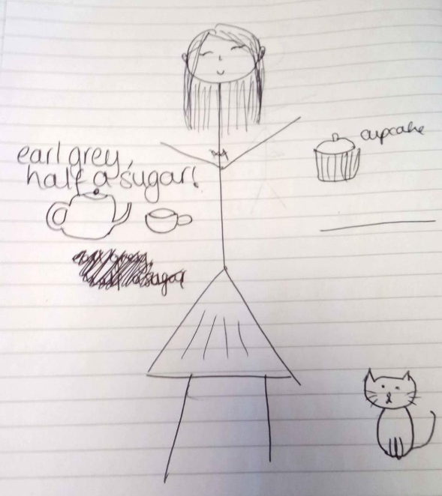
Now is the time to start something.

2001 the front skatepark was born.

Me:

Find your creative space.

Living in the future, consciously anxious

Every week, do something new

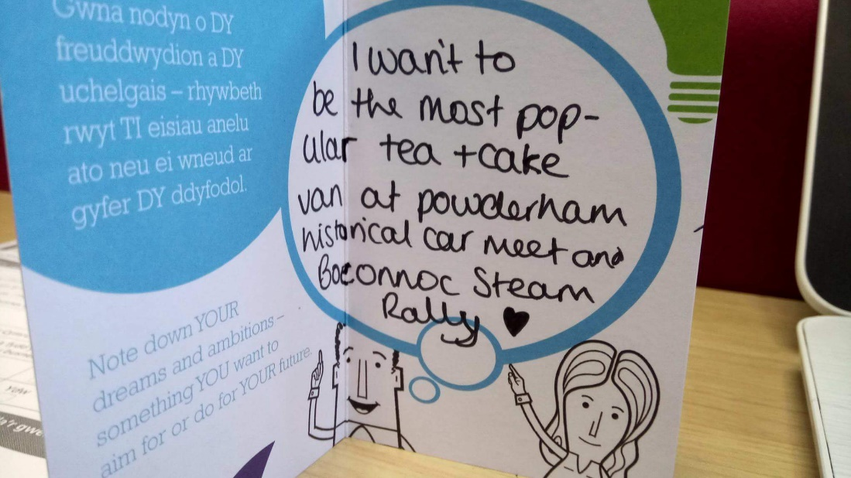

A.C.R.O.
Attitude - understanding yourself and tour motivation and setting and achieving your goals
Creative - generating idea, solving problems and creating opportunities
Relationships - expressing your own views and ideas, appreciating others' viewpoints
Organising - being able to make decisions and fulfil your objectives

The only person standing in the way of your success, is yourself.

- Smoke Haus on the XXth of Novemeber 2017
Key themes: Don’t give up on your dream. Find good people to work with. Understand your team. Get your niche. Understand the stretch of your business


The Denise of Retail Traders
My Journey
- Swansea born
- Studied economics at Cardiff business school
  - Invested in:
    - Barrett developments share price: ££3.63 'I will hold it for three years' sold a week later for £3.72. two years later its worth £6
    - Royal Mail £4.82 week later for £5.85
    - Penny stock 0.1p per share. Pump and dump. Day after he got involved, the share price crashed.
- Offered two jobs out of uni. Worked with high profile people who
- Idea of Sanktuary was born - all equality funds out there/fees stuck in the 1980's
- 150 major companies in the UK today. Each has an equity fund

Sanktury
- 1st fund management company in Wales
- Started in July 2016
- Performance-only pricing structure

Gecko FX
- Heard about the education industry from others - did some research
- Quality courses that deliver value - accredited
- Holistic approach
- Selling reality, not the dream
  - But we will be doing a trading challenge starting January 2018

The Industry
- What is a finacial market? A place where buyers and sellers meet.
- Market participants
  - The broker
  - The 'reail traider' - dumb money - amateur
  - The 'professional trader'
    - smart money
    - massive players of the industry
    - move the markets
- 95% of retail traders lose money, feeding the 5% who make money
  - Mass transfer of wealth
- 90/90/90 rule
  - 90% of retail trader lose 90% of their money in the first 90 days

History of the Brokerage Industry
- Wolf of Wall Street
  - Set in the 1980's
  - Advisory broking
- Big bang 1986
  - A period of no sell and buy but a transition to internet trading
- Thatcherism 'share ownership for all'

The Brokerage Problem: 90/90/90 rule
- John Dawkins on Dirty Little Serifs on the 13th of November 2017

Dirty Little Serifs
John Dawkins

Hairdressing Names:
- Clippers
- Hair 4 you
- Your hair
- Coiffeur
- salon de coiffure
- Hair Mania

Dirty Little Serifs
- Brand identities, logo design
- Brochure work
- Advertising campaigns
- Photo and video shoot
- Website design

Maykher
- Getting young girls into an industry
- 62 million girls and women out of a job
- Favour ethical

Background
- Didn’t do well in school
- Found art in secondary school
- Specialised in art for a levels
- Came to this university to do art
- Moved to London with girlfriend who had a job there
- Got a job with a small publishing company by accident
- They actually had a lot of big names including pizza express
  - Work for them for ages
- Moved out to Abu Dhabi to work out there
- Got head hunted and ask to transition from a

Entrepreneurs and Intrapreneurs
- What do Richard Branson, Steve Jobs, David Beckham and your local butcher have in common?
  - They're all

ACRO
Attitude Creative Relationships Organising

How did I become an entrepreneur?
- Packed in jobs with girlfriend and went traveling for three months
- Spend all their money
- Came back and couldn’t start their own businesses and he had no moneys so had to back into employment

Procrastinating
- Social media
- Only take half an hour, three times a day to check socail media - set up his own boundaries
- 9 months, no where to live. Couch surfing!
- If you do want to have your own

Maykher was Lola and me
- Got a very aggressive letter from a Belgium company and had to rebrand to Maykher

Go watch on YouTube: Simon Sinek hfwuiwni; theory

The idea
The values
The vision
The story

Brand Values
- Brand essence - a short slogan
- Think about how little children understand your logo

Group Task: re brand garden bowls for our generation
- New name
- A slogan
- Three brand values
- 2 media options for advertising

Name:
- #Launch
Slogan:
- Touch your bowls
Brand values:
- Precision
- Enjoyable
- Connect
Media:
- Social media (Facebook events)
- Pop up adverts on Youtube and Instagram

Go and look at what Australia is doing with lawn bowls

Motivation
You need to know what keeps you going.
Lots of people have pictures of their family or their dog

Write down every idea you have!

Maykher – another company. making with (makers) and working with females (her)

- Joy on the 30th November 2017 was cancelled and not rescheduled

