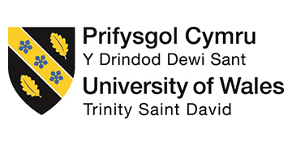

THE NEXT BIG BATTLE FOR CANCER IS GENDER

LAURIE SIMMONS

Submitted in partial fulfilment of the requirements for the degree of BA (Hons) Advertising and Brand Design, University of Wales Trinity Saint David, Swansea, 12th December 2018.

Word count: 5,581
Contents

- Abstract 4.
- Introduction 5.
- Chapter One: Gender in Contemporary Society 6.
- Chapter Two: The Challenge for Cancer Charity Advertising 15.
- Chapter Three: Can Prostate and Breast Cancer be Gender Neutral? 27.

- Conclusion 34.

- Bibliography 36.

List of Illustrations

- Evening Telegraph. (2017) Race for Life. Available at: https://www.eveningtelegraph.co.uk/fp/men-encouraged-take-part-dundee-race-life/ [ Accessed: 18 Nov. 2018].
- Co-op. (2017) Treat your daughter. Available at: https://www.the-pool.com/news-views/opinion/2017/14/caroline-odonoghue-on-sexist-advertising [Accessed: 25 Nov. 2018].
- Always. (2014) #LikeAGirl. Available at: https://www.youtube.com/watch?v=XjJQBjWYDTs [Accessed 27 Nov. 2018].
- Cancer Research UK. (2015) The 20 Most Common Cancers, UK, 2015. [graph] Available at: https://www.cancerresearchuk.org/health-professional/cancer-statistics/incidence/common-cancers-compared#heading-Zero [Accessed 30. Nov 2018].

Abstract

The society that we live in and the issues that arise throughout western culture are continuously changing and progressing. These problems and cultural issues are more prominent than ever before as a result of today’s world and the various political and societal movements that have emerged within the last few years. These societal issues, in turn, influence the way advertisements are created to suit the audience. Gender is a topic within today’s society that is appearing at the forefront of conversation. This study will investigate how cancer charities raise awareness and advertise to their audience in regard to gender and the issues surrounding gender in cancer.

Introduction

This dissertation will explore the notion of gender within contemporary society affect the way cancer charities advertise to their audiences. It will focus on whether or not advertisements and awareness campaigns for certain gender specific cancer take into consideration the issues of gender in the form of transgender and non-binary individuals. The aim of this dissertation is to find out how the issues of gender within cancer are affecting how cancer charities advertise and raise awareness for an audience while investigating the challenges cancer charities face. It will also investigate whether certain cancers can in fact be gender neutral or whether they are only susceptible to a certain gender. There are several reasons for the interest of this subject area. I am interested in delving into this subject area as I am curious to investigate the link between advertising and the actions taken by the audience. Alongside this, there are personal reason for my interest in this subject area. I have a close connection to this subject area and I am passionate to research further. The passion that I have for this subject will help me stay focused and interested while also elevating my research. The subject area of my research is also not a common area of conversation.

Chapter One
Gender in Contemporary society

The concept of gender as a whole is a very complex subject. In today’s society there is considered to be a multitude of different gender identities that people identify with. As there is considered to be more genders than just ‘male’ and ‘female’, this in turn means that in relation to advertising for cancer charities, there is uncertainty on how certain topics should be portrayed to this vast audience. Along with this, there is also the issue of uncertainty surrounding what aspects of cancer charities and awareness should be targeted at each gender. This is down to the fact that there are so many genders that some people don’t identify simply as ‘male’ or ‘female’ anymore.

Gender is a vast and very confusing subject area for most people. Sex and gender are commonly inter-changed, but each term is associated with separate meanings. “Sex” is used to relate to the biological differences such as male and female genitalia. However, “gender” is used to relate to physiological differences. Gender identity and biological sex are usually matched in most people, this is not always the case for some individuals. (National Health Service, n.d). For the individuals who suffer with their gender identity, life can be extremely hard and distressing at times.
“This review indicates that trans people attending transgender health-care services appear to have a higher risk of psychiatric morbidity” (Dhejne, 2016).

This statement made by Dhejne indicated that a study has shown that transgender people have a higher risk of psychiatric morbidity. It shows us that more people who are transgender suffer with their mental health than those who do not suffer with any form of gender dysphoria. This mainly could be put down to the fact that transgender people and individuals who suffer from gender dysphoria still face discrimination. Despite there being a lot more recognition and understanding around gender and different gender terms, there are still a lot of people who do not ‘believe’ or understand it.

“The male/female split is often seen as binary, but this is not entirely true. For instance, some men are born with two or three X chromosomes, just as some women are born with a Y chromosome.” (Newman, 2018.)

According to Newman (2018), the sex of an individual is determined by genetic factors. When an individual has a mix of these chromosomes, they can be born with a mix between male and female genitalia which is commonly referred to as intersex. This can cause a lot of problems for that individual as more commonly than not; the parents of the child decide what gender their baby will be. Sometimes the parents are wrong about the gender which results in the child’s body not matching their psychological gender. This is where sex and gender become confused by a lot of people. People assume that your sex equals your gender and that it is as simple as that, however it is not as straight forward as that for people suffering with gender dysphoria.

There are now considered to be seventy-one different genders as of 2014 according to an article published by The Telegraph (Williams, 2014). The idea of having such a vast number of different genders is relatively new concept and has only recently come to light in today’s society compared to earlier times where there was understanding of gender dysphoria consisting only within the ‘male’ and ‘female’ labels.
“Sexual historians have illustrated how medicine took an increasingly dominant role in understandings of sexuality during the nineteenth century” (Hines, S; Sanger T, 2010).
However, there are still a lot of debate around gender identity and if there are actually seventy-two genders or in fact just two. Up until recently, the majority of people considered there to be only two genders, male and female. Mary Holmes shows an understanding of this in her book What is Gender? Sociological Approaches. (Holmes, M. 2011) where she relies on the readers imagination while reading a gender-neutral text. She goes on to explain how
“we do not know how to think about people as neutral; we always think about them as women or as men and we interact with this accordingly.” (Holmes, M. 2011).

The strategy that she uses within the book to explain her point of view is clear example of how we, as humans, put a label on everything, even when it hasn’t been stated. This is very telling of the time that the book was written in, which is 2011. These gender issues were not as prominent within our society as they are now, and the majority of people didn’t recognise this as an issue.

“Conformity to gender specific roles is increasingly being rejected in favour of a more individual approach. Modern men and women don't want to be pigeon holed into one type of role.” (Bejanyan, 2016)

This statement made by Kathrine Bejanyan displays the mindset of a more modern society. It shows how gender isn’t such a set-in stone structure for a lot of people compared to 2011, where Mary Holmes explains that there was such a need for a gender structure to be in place and that labels were very much important in society then. This comparison of times shows how much our culture and society has changed and progressed. The idea of each individuals gender is personal to them and it is not important to live up to the ‘roles’ and stereotypes of the gender that you are, is almost imbedded into our society today, compared to a few years back. It is such a vast progression in only a few short years. The statement made by Katherine Bejanyan can also be applied to the societal issues faced outside of gender identity.

Men and women could be considered to be not wanting to be pigeon holed in one type of role across all aspects of daily life within our society. Sexism is a societal issue that has always been there but has only recently been brought to people’s attention that it is wrong and unfair. It forces these stereotypes and roles onto people that are considered to be true. It has become such an issue that there are movements being created to bring awareness to the subject such as The Everyday Sexism Project. “The Everyday Sexism Project exists to catalogue instances of sexism experienced on a day to day basis (Everyday Sexism). The fact that there are movements on this topic show how vastly imbedded the problem is within our society and has been for decades. These gender roles and stereotypes are issues that have been imbedded in our mindsets all of our lives. We are taught from a young age what is considered feminine and what is considered masculine and what things each gender should be. For example, from birth we are taught that pink is a ‘girls’ colour and that blue is a ‘boys’ colour. We dress babies and buy gifts in these colours according to their gender and these principles don’t seem to be reversed. In more recent years, this isn’t such a vast issue, however, because it has been imbedded into the way that we think, it is second nature to most people. According to Pandey (2016), an 1918 article, called Earnshaw’s Infants’ Department, claimed that was considered to be a strong colour, therefore it would be suitable for boys, and blue was considered to be delicate and dainty, which would be suitable for girls. However, this concept changed during the 1960’s when “marketing teams of children's apparel and toys were largely responsible for the trend of gender-specific colours” (Pandey, 2016). This was the time when separate colours were assigned to each gender e.g. blue for boys and pink for girls. This concept has stuck in society up until present day, however, there is a lot more awareness around the subject and it isn’t as set in stone as previous years. Despite there being much spread awareness, some parents are still choosing to use these gender specific colours for things such as gender reveal parties. These parties are where the gender of the baby is hidden and then revealed by using a colour in a surprise method e.g. popping a balloon. This is a trend that is becoming very popular within western society at the moment.

The concept of certain colours being used for one gender has bled into the advertising industry, and more specific to my topic, cancer charity branding and advertisements. In previous years there has been and still is a large trend of using these colours for the different ‘gendered’ cancers. For example, Cancer Research UK run an event every year called the Race for Life run which is a women’s only event. The idea that it is a women’s only event is made very clear by the branding and marketing of the event. Everything surrounding the charity event is pink; the branding, the signage and the participants attire.

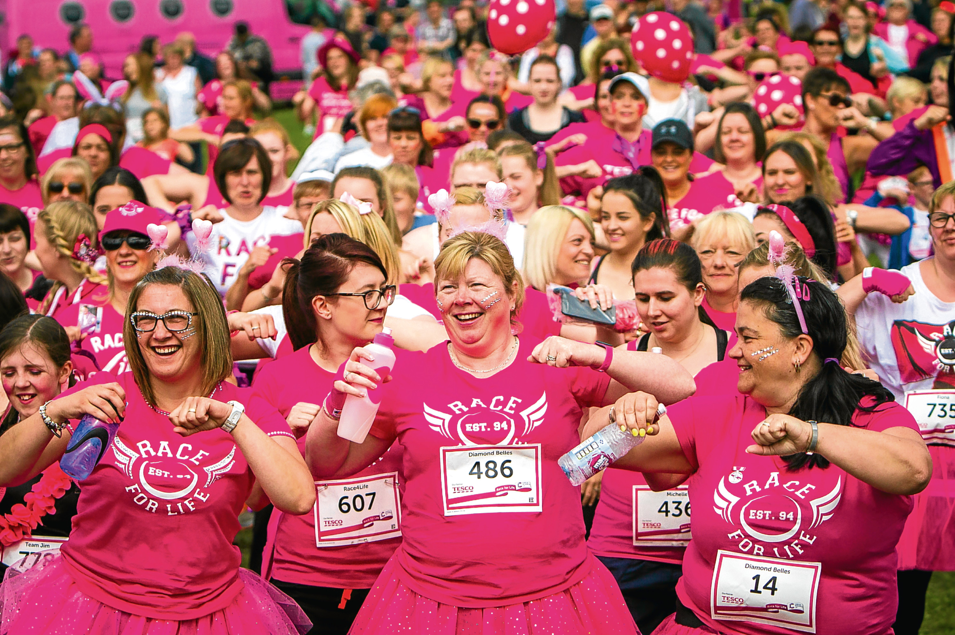

Fig. 1.

The photograph above that was taken at one of the Race for Life events shows the use of the colour pink within the event. The participants look like a sea of pink as most are dressed head-to-toe in pink. Race for Life has been running its events since 1994 and has since expanded vastly across the country. However, throughout the years, the colour scheme has stayed the same. The direct link between it being a women’s only event and the use of pink is very prominent, and the connection can be made very easily by the average person that this is a women’s event. However, this seems to be an obsolete way of thinking. Could this concept now be considered outdated for our generation? With more and more interest in the issues of sexism and how certain colours/tasks are not specifically appointed for one gender, it could be disputed that the charity would have rethought and rebranded.

Chapter Two
The challenge for cancer charity advertising

Cancer is such a vast subject area in its own right, which is a mass of complication and confusion to the average person. It is an evil disease that needs to be talked about and approached in a very sensitive manner. Gender in contemporary society has become such a large spectrum that, as mentioned previously, there are now considered to be seventy-two genders that individuals identify with, which makes it very difficult to advertise to such a vast audience without offending certain people. We have entered a time where the issues of gender have become very sensitive, making the concept of advertising and raising awareness for cancer within all genders, a very difficult field to navigate. Delving deeper into the subject area of gender within cancer, it is not as simple as males being susceptible to certain types of cancers and women being susceptible to other type of cancers. As a result of gender dysphoria, where people identify as transgender, or not identifying at all with one gender, this makes it much more complicated to raise awareness and advertise for, as you have to take into consideration all these varying factors. Does the way that cancer charities advertise and raise awareness to their audiences needs to be re-thought about as a result of our societal world evolving? One could argue that the advertising industry must learn to adapt to these relatively new issues to be able to adopt a sense of inclusivity for everyone.

Despite cancer being a potential devastating and confusing reality for ‘normal’ males and females, it can be argued that it is particularly more confusing for transgender and non-binary individuals. This is down to the fact that they may have had full or partial reconstructive surgery or not have had any reconstructive surgery and are confused by what tests and screenings they are allowed to attend. This seems to be quite a large problem for people within these ‘boundaries’ as the government has released an information booklet on what screenings transgender individuals are entitled to attend. Within the booklet, it is stated that
“It is important that you feel that you are treated with dignity and respect at all times” (National Health Service, 2017). This is a nod to the fact that the government appreciate that there is an issue of allowing transgender and non-binary people to feel comfortable and at ease in a confusing and unnerving position. The booklet covers the subjects of breast screening, cervical screening, abdominal aortic aneurysm (AAA) screening and bowel cancer screening. The booklet highlights throughout how the lines are blurred in terms of transgender and non-binary getting the help that they need. It isn’t clear within the public eye what help these individuals are entitled to and where to find it. It is far more complicated than ‘normal’ males and females as a ‘trans’ man might still have a vagina and/or breasts and a ‘trans’ female might still have a penis and testicles. This means that they will need to attend screening for the opposite sex which arguably, could be quite daunting.

In conjunction to this, one could argue that advertising and awareness around each type of cancer needs to be more inclusive and much clearer. However, there has been a long-standing debate around the “mirror” argument (Holbrook, 1987) or the opposing “mold” argument (Pollay, 1986, 1987) in relation to advertising.

The “mirror” argument maintains the idea that advertising reflects the values that already exist. This can be applied to the gender roles and stereotypes within the advertising for cancer charities, meaning they only reflect the existing cultural expectations towards gender. This could indicate that society isn’t as socially evolved as what was thought (Holbrook, 1987). However, the opposing argument, the “mold”, states that advertising is able to mold and morph the opinions and values of its target audience. (Pollay, 1986, 1987)
This theory can also be applied to the gender roles and stereotypes within the advertising for cancer charities. New and insightful advertising and awareness campaigns have played a part to an extent in helping identify the issues with gender as a whole as it has become a widespread concept that is evolving within our society. Eisend, (2010) refers to a statement made by Ganahl et al, (2003), “Hence, gender roles in advertising create, shape, and reinforce gender-stereotypical beliefs and values in a society”. He goes on to argue that this theory is based on how changes in behaviour and attitude can be due to exposure to media and advertising. However, when both arguments are placed alongside idea of gender roles and stereotypes within cancer charity advertising, they both could be plausible.

One could argue that cancer charities need to take the “mold” approach with their advertising and awareness campaigns. As it stands there are very few adverts and awareness campaigns that highlights the issue of gender while trying to tackle the stereotypes. Despite our society progressing into the future with gender in all its forms, the area of cancer awareness and advertisements has been slow progressing in comparison. There is information out there such as the governments Information for Trans People: NHS Screening Programmes booklet (National Health Service, 2017), but one must conduct their own research to find it.
Over the years, the issue of gender equality and sexism has steadily made its way into the advertising industry as a result of the demand to stay relevant with the public. However, gender equality hasn’t always been prevalent within advertising, while sexism has also played a major part in this. Sexism and gender stereotyping have been a running trend throughout advertising, since as early as the 1910’s.
“Beginning in 1910, ads clearly present the woman as the cook, mother, and keeper of the home. These identifications predominate throughout the entire period reviewed.” (Stemple, D & Tyler, J E, 1974)

This statement made by Stemple and Tyler (1974) tells of how as early as the 1910’s, gender stereotypes have been set as the new standard where women are portrayed as the cook, mother and home keeper whereas the man is portrayed to be the breadwinner. However, this was the standard of living within society at this time. It is how most people lived and wasn’t seen as outrageous or degrading of women. This is a standard that ran throughout most of the 1900’s up until 1950’s where it could be considered to be at its strongest. In terms of gender stereotypes within the field of cancer, it’s more presentable in such a way that only men are considered to have testicular and prostate cancer, whereas women are only considered to have breast cancer and cervical cancer. However, when the lines of gender are blurred and there are men who were born female and females who were born male, it becomes far more complicated.

Despite sexism and gender stereotyping not being so robust within advertising today, there are still glimpses of it here and there. A recent advert from the Co-op is an example of the stereotyping of genders and sexism within today’s society. The advert is from 2017 and is an Easter print advert.

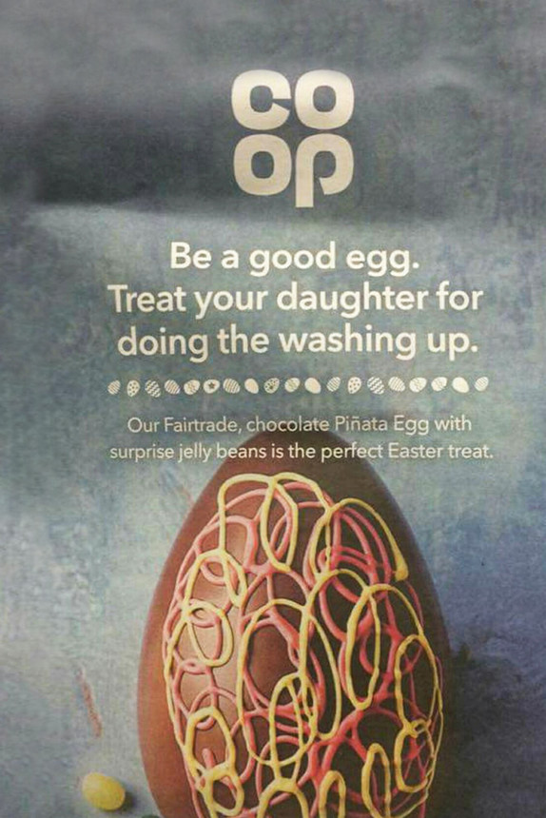

Fig. 2.

Despite the decrease in sexism within advertising and society in general, it’s interesting to observe how the narrative for women is still being portrayed as the cook, cleaner, mother and home keeper. The advert is a direct link to the sexist adverts from previous generations, which make it hard to believe that the Co-op approved this advertisement. There are more advertisements similar to this floating around from this time period, however, most advertisements and campaigns seem to have had a realisation and have evolved with society.

A great example of advertising for the issues that are faced within the 21st Century is Always #LikeAGirl campaign. (Always, 2014)

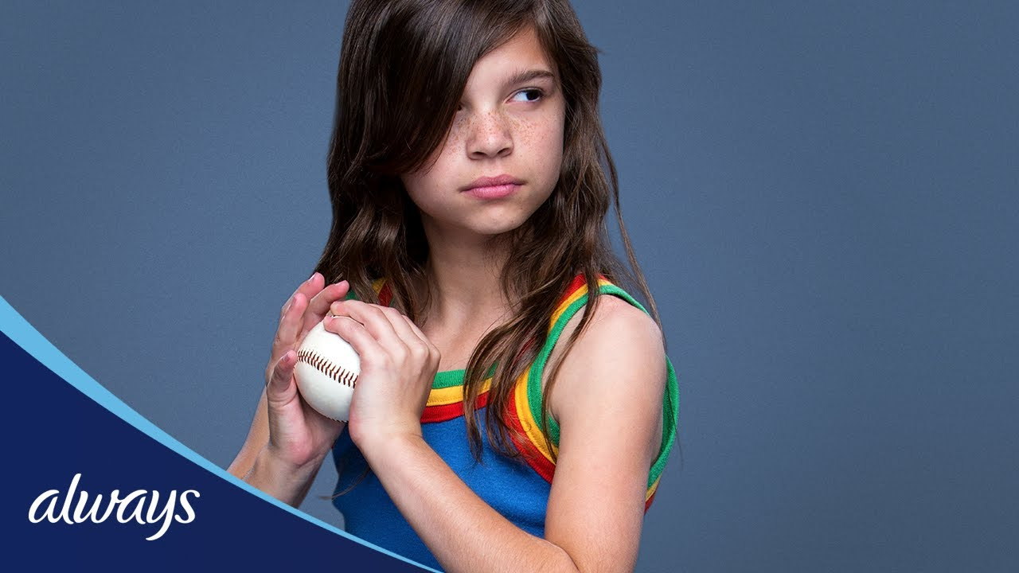

Fig. 3.

The campaign uses the insult “like a girl” and turns it on its head. The campaign asks a group of people from young ages to mid teenage years to act out tasks like a girl e.g. “run like a girl”. The teenagers and older children automatically think of this in a negative way and portray the stereotype that women are useless and not very good at anything physical. However, the younger children, especially the girls, see the tasks as a challenge and try their hardest at each, displaying confidence and determination. It is refreshing to witness an advert that is very forward thinking with its values within society and that is teaching people that these stereotypes can be broken and will be broken by the younger generation.

Alongside this advert, there are many more in existence that break the mold in terms of gender equality and stereotypes. Today’s society is becoming more progressive in the fact that it’s more aware of what affects people negatively and how each thing put out into the media has an effect. However, advertisements and awareness campaigns surrounding cancer as a whole aren’t progressive in terms of gender equality and stereotypes. The existing cancer campaigns that are out there are very focused on emotion and family values, but not so much on the gender issues. An example of this is an advert by Macmillan Cancer Support called A Dad with Cancer is Still a Dad (Macmillan Cancer Support, 2017). The advert features a dad reading a bed time story to his young daughter. It’s a very simple advert but it reinforces the idea that cancer doesn’t have to take over an individual’s life and just because they have cancer, it doesn’t mean their home life must change. It shows the physical and emotional effects that it can have on a person while keeping the main focus on “Life with cancer is still life” (Macmillan. Cancer Support, 2017).

The cancer charity Breast Cancer Now have a number of adverts that raise awareness for breast cancer. The short film made by them called “The Last One” stands out as being slightly problematic in terms of gender equality. The short film features a series of women from all backgrounds who have breast cancer. They talk about how they won’t be the last, but there soon will be an end to breast cancer, and one woman will soon be the last to get it. At the end of the advert, a statement appears that reads “By 2050, no woman should die of breast cancer” (Breast Cancer Now, 2015). Regardless of breast cancer being much more relevant to women than men, men can still get breast cancer despite whether they are biologically male or female. This completely discredits the fact that men can fall victim to breast cancer as well as women. It shuts down the conversation of breast cancer in men and transgender men, and as a result of this, men might be unaware of the symptoms or become embarrassed and ashamed to get checked. There are a large number of very similar advertisements out there that contain the same gender stereotypes, that only a certain gender can get certain cancers. There isn’t enough light being shone on the transgender and non-binary issues within cancer. Another example is an advert created by the NHS called ‘Be Clear on Cancer’ (National Health Service, 2018). It depicts an older woman talking about her experience with cancer. The advert has a very strong female presence, with no males appearing throughout. Also, the call to action at the end of the advert is in the colour pink, which again integrates the stereotypes of females into the advert.

However, there are a small number of cancer advertisements that don’t specify what type of cancer it is. For example, the Macmillan Cancer Support ‘Not Alone’ advert. (Macmillan Cancer Support, 2016). The advert showcases the emotional and mental struggles for an individual dealing with cancer, while also displaying the support given by Macmillan. The detail that stands out throughout the advert is how there is no mention of the type of cancer. It diminishes any chance for the viewer to paint a picture in their mind of any gender stereotypes. The majority of cancer adverts include the type of cancer within the advertisement to be able to clearly raise awareness for that specific type. However, it is refreshing to see a small number discard this detail and just focus on cancer as a whole.

It is clear from researching and delving deeper into the world of cancer advertising that there aren’t enough leading examples that diminish gender stereotypes within gender specific cancers. Within this category of advertising, there doesn’t seem to be a lot of progression outside of the standard emotional and heartfelt appeals that are pushed on viewers. This remains a large problem within the LGBT+ community, where transgender and non-binary people are unsure on what avenues they are able to seek out. This also results in any conversation surrounding the topic to become non-existent and non-progressive, as no one is any more knowledgeable about the subject. It has been disputed that the “mold” argument takes lead within this subject area of advertising. It’s clear that the “mirror” argument isn’t being implemented within cancer advertising as there is no evidence of gender stereotypes and roles being broken within the adverts. The challenge for cancer charity advertising is that it needs to influence its audience to become more proactive in taking part in conversations surrounding the topic. It needs to show the audience what the problem is and how it can be fixed.

Chapter Three
Can prostate and breast cancer be gender neutral

To most, the of that prostate and breast cancer being gender neutral can seem ridiculous and completely impossible as only males can get prostate cancer and only females can get breast cancer. This seems to be a rational thought process as for the majority of people there hasn’t been a lot of awareness raised and not enough conversation around the subject. It seems to be common sense that prostate and breast cancer cannot be gender neutral as these cancers are only present in one of the specific genders. However, arguable, this is the result of years of sexist and uninformed advertising. It’s clear from the research carried out that there isn’t any representation of these issues within cancer adverts and awareness campaigns, past or present. For this certain subject area, it’s a case of knowing exactly what to look for and specifically researching that topic to find the information. These issues are not being brought to the eyes of the public through advertisements and awareness campaigns. This is another factor that can make it especially hard for a transgender or non-binary individual as most of the time they don’t have a clear topic they are looking for.

Prostate cancer appears to be more obviously a male exclusive cancer. This is due to the fact that women do not have a prostate and men do. This claim is backed up by statistics released by Cancer Research UK, exhibiting “The 20 Most Common Cancers, UK, 2015 (Cancer Research UK, 2015).
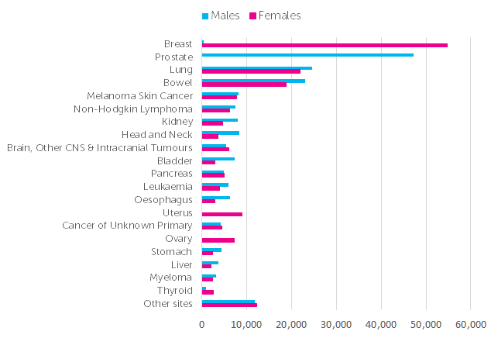

Fig. 4.

The graph above shows the statistics of male diagnosis of prostate cancer in 2015. That number is very high, with approximately 47,000 cases during that year. It’s clear the vast scale of the disease and how many lives it’s affecting. The graph shows no statistics for females with prostate cancer, which is to be expected. However, after delving deeper into prostate cancer, it has become clear that prostate cancer can in fact, be gender neutral. According to Prostate Cancer UK, transgender women can get prostate cancer.
“Trans people who were assigned male at birth and male assigned non-binary people can get prostate cancer or prostate disease. This includes trans women (or transgender women or transsexual women) who identify and live as women” (Prostate Cancer UK, n.d.)

This statement made by Prostate Cancer UK makes it extremely clear that a male to female transgender individual (transgender woman) can still get prostate cancer. Regardless of whether or not a transgender woman has had gender reassignment surgery, they will still have a prostate. In line with the previous statement, Prostate Cancer UK also state that an individual who is also receiving hormone therapy e.g. oestrogen, are still at risk of prostate cancer. “Trans women who have been taking feminising hormones are still at risk of prostate cancer” (Prostate Cancer UK, n.d.)

In response to whether or not prostate cancer can be gender neutral, some would argue that the answer to this question would be a definite no. However, this has proved not to be the case, and in fact prostate cancer can be gender neutral. It is not gender neutral in terms of ‘normal’ cisgender females getting the disease, as this is impossible, but more in terms of transgender women and individuals born male who identify more on the feminine or non-binary side of the spectrum. This is a fact that needs to be more widespread throughout awareness and advertising campaigns as this information could potentially save the lives of many transgender women who are not aware/don’t believe they can get prostate cancer.

In contrast to this, it is already a known fact within the medical world that breast cancer can be gender neutral. It doesn’t matter whether an individual is born male or female, all genders, regardless of what they identify, can get breast cancer. This is because all individuals of both genders possess breast tissue. According to the graph shown above by Cancer Research UK, approximately 55,000 women and 500 – 1,000 men were diagnosed with breast cancer in 2015. It is clear that breast cancer is much more common in females than males, with around 54,000 more cases being reported within females than males. However, despite females being more at risk of breast cancer, men who were born male at birth and transgender men are also at risk as they are not routinely screened the same as women. Transgender men could be considered to be at more of a risk of getting breast cancer than ‘normal’ cisgender men, as they were born female. According to Breast Cancer Care, if an individual is registered as male with their GP, they will not be invited in for a breast screening.
“Recent news has revealed that trans men who are registered with their GP as male will miss out on being invited to routine cancer screenings, including breast cancer” (Breast Cancer Care, 2018).

This statement by Breast Cancer Care is backed up in the Government issued leaflet Information for Trans People: NHS Screening Programmes (National Health Service, 2017). The leaflet goes on to state “If you are a trans man aged 50 to 70 who is registered with a GP as male, you won’t be invited for breast screening.” This leaflet contains information for transgender and non-binary people on what screening each individual is eligible for. It explains that if an individual is a transgender man but is still registered as a female with a GP, that individual will be routinely invited in for breast screenings, however, if that individual is registered as a man, they will not be invited in. This system is the same for ‘normal’ cisgender males. As they are registered as males, they do not get breast screenings. Evidence suggests that male statistics for breast cancer diagnosis are a substantial amount less than the diagnosis for female breast cancer, but despite this, some would dispute that there should be some type of screening system for males so that it becomes more accepted and not something that is embarrassing for males to face. This leaflet is highly informative for transgender and non-binary people as it covers most, if not all of the necessary subject areas. It allows transgender and non-binary people the freedom of choice in their own health while giving them the power to make informed decisions.

According to Henry Bodkin (2018) at The Telegraph, the HPV (human papillomavirus) vaccine has been called upon by an influential Government committee to be given to boys. This would make the vaccine gender neutral. The vaccine is currently given to all girls aged twelve to eighteen years old. However, despite the vaccines main purpose being to guard against cervical cancer, there has been growing demand to make it available to males. According to Bodkin, the reason for this is
“Experts believe doing so would both increase protection against cervical cancer in girls through “herd immunity”, but also protect against mouth and throat cancers in both sexes” (Henry Bodkin, 2018).

This would be the more favourable avenue in relation to transgender and no-binary individuals as it would eliminate any worries for a female to male transgender individual who is at the age of receiving the vaccine as they will be protected no matter what their chosen gender identity. It is also a good idea for all ‘normal’ cisgender males as they will be guarded against other cancers such as mouth and throat cancer. The idea of making the vaccine gender neutral logical, given the changes that society face. It is a strategy that allows protection for each individual for these changes.

Conclusion

This dissertation has explored the notion of gender within contemporary society and the challenges cancer charities face in relation to gender to remain relevant within today’s society. In doing this, it has addressed the vast spectrum of gender while identifying the issues that transgender and non-binary people face in terms of their heath and cancer screenings. It has also addressed the different challenges that cancer charities face in advertising for these gender issues.

From the findings of this study, it can be concluded that charity advertisements and awareness campaigns are not doing enough to battle the gender stereotypes that certain cancers such as breast and prostate cancer face. It is clear that in today’s society, gender has become a spectrum on which an individual decides where they fit in compared to the age-old structure of only males and females. As a result of this, it is clear that transgender and non-binary individuals don’t have enough information on what screenings and tests they qualify for. It has been found that throughout this study, cancer charities do not advertise for this audience. These charities are not progressive within their advertisements like the rest of society are in terms of diminishing gender stereotypes and preconceptions. It is clear that the next big battle for cancer charities, is in fact gender.

Bibliography

Books
Andreasen, A. (2006). Social Marketing in the 21st Century. Thousand Oaks, California: SAGE publications.

Alvesson, M. and Billing, Y.D., 2009. Understanding gender and organizations. Sage.

Elias, N. and Jephcott, E., 1978. The civilizing process (Vol. 1). Oxford: Blackwell.

Gauntlett, D. (2008). Media, Gender and Identity: An Introduction. Routledge.

Hines, S. & Sanger, T. (2010). Transgender identities towards a social analysis of gender diversity (Routledge Research in Gender and Society). New York: Routledge.

Holmes, M. (2011). What is Gender? Los Angeles: SAGE.

Johansson, T. (2017) The Transformation of Sexuality. [S.I]: Routledge.

Lorber, J. (1995). Paradoxes of Gender. Yale University Press.

Mac an Ghaill, M. and Haywood, C. (n.d). Gender, Culture and Society.

Sheehan, K B. (2013). Controversies in Contemporary Advertising. SAGE Publications.

Journals & Articles
Dhejne, C. (2016). Mental Health and Gender Dysphoria: A Review of the Literature. International Review of Psychiatry, Vol 28, Issue 1, page 44-57.

Eisend, M. (2010). A Meta-analysis of Gender Roles in Advertising. Journal of the Academy of Marketing Science, Vol 38, Issue 4, pp418-440.

Holbrook, M.B. (1987). Mirror, mirror, on the wall, what's unfair in the reflections on advertising? The Journal of Marketing.

Pollay, R.W. (1986). The distorted mirror: Reflections on the unintended consequences of advertising. The Journal of Marketing.

Pollay, R.W., 1987. On the Value of Reflections on the Values in" The Distorted Mirror". The Journal of Marketing.

Stefano Puntoni, Steven Sweldens, Nader T. Tavassoli (2011) Gender Identity Salience and Perceived Vulnerability to Breast Cancer. Journal of Marketing
Research: June 2011, Vol 48, No. 3, pp. 413-424.

Stemple, D & Tyler, J E. (1974). Sexism in Advertising. The American Journal of Psychoanalysis, Vol 34, Issue 3, pp 271-273.

Websites

Bejanyan, K. (2016). The Rules Have Changed: Gender Roles in Modern Society. [online] HuffPost UK. Available at: https://www.huffingtonpost.co.uk/kathrine-bejanyan/gender-roles-in-modern-society_b_9934970.html?guccounter=1&guce_referrer_us=aHR0cHM6Ly93d3cuZ29vZ2xlLmNvbS8&guce_referrer_cs=AqZe646V483xdOUlI9JLDA [Accessed 8 Nov. 2018].

Breast Cancer Care. (2018) Trans People Missing Out on Breast Cancer Screening. [online] Available at: https://www.breastcancercare.org.uk/about-us/news-personal-stories/trans-people-missing-out-breast-cancer-screening [Accessed: 2 Dec. 2018].

Cancer Research UK. (2015). Cancer Incidence for Common Cancers. [online] Available at: https://www.cancerresearchuk.org/health-professional/cancer-statistics/incidence/common-cancers-compared#heading-Zero [Accessed: 30 Nov.2018].

Ditum, S. (2016). What is Gender, Anyway? [online] New Statesman. Available at: https://www.newstatesman.com/politics/feminism/2016/05/what-gender-anyway [Accessed 16 Nov. 2018].

Everyday Sexism Project. (n.d). [online] Available at: https://everydaysexism.com/about [Accessed 8 Nov. 2018].

Gender Spectrum. (n.d) Understanding Gender. [online] Available at: https://www.genderspectrum.org/quick-links/understanding-gender/ [Accessed 9 Nov. 2018].

Henry Bodkin. (2018). HPV vaccine likely to be rolled out for boys as officials call for 'gender-neutral' vaccinations. The Telegraph [online] Available at: https://www.telegraph.co.uk/news/2018/07/18/hvp-vaccine-likely-rolled-boys-officials-call-gender-neutral/ [Accessed: 4 Dec. 2018].

National Health Service. (n.d). Gender Dysphoria. [online] Available at: https://www.nhs.uk/conditions/gender-dysphoria/# [Accessed 9 Nov. 2018]

National Health Service. (2017) NHS Population Screening: Information for Transgender and Non-binary People. Public Health England. Available at: https://assets.publishing.service.gov.uk/government/uploads/system/uploads/attachment_data/file/623309/Transgender_cross_programme_screening_leaflet.pdf [Accessed: 25 Nov. 2018]

Newman, T. (2018). Sex and Gender: What is the difference? [online] Available at: https://www.medicalnewstoday.com/articles/232363.php [Accessed 8 Nov. 2018]

Pandey, A. (2016). ‘Pink and Blue: The Colours of Gender Stereotyping’, HuffPost [blog]. Available at: https://www.huffingtonpost.in/aradhana-pandey/pink-and-blue-the-myth-be_b_9191840.html [Accessed 9 Nov. 2018].

Prostate Cancer UK. (n.d.) Can Trans Women Get Prostate Cancer? [online] Available at: https://prostatecanceruk.org/prostate-information/are-you-at-risk/trans-women-and-prostate-cancer [Accessed: 30 Nov. 2018].

Psychology Today. (n.d) Gender Dysphoria. [online] Available at: https://www.psychologytoday.com/gb/conditions/gender-dysphoria [Accessed: 16 Nov. 2018].

Schreiber, K & Hausenblas, H. (2016). Why Transgender People Experience More Mental Health Issues. [online] Psychology Today. Available at: https://www.psychologytoday.com/gb/blog/the-truth-about-exercise-addiction/201612/why-transgender-people-experience-more-mental-health [Accessed: 15 Nov. 2018].

The Irish Examiner. (2018). Irish Cancer Society calls on government to introduce gender-neutral vaccination into budget. [online] Available at: https://www.irishexaminer.com/breakingnews/ireland/irish-cancer-society-calls-on-government-to-introduce-gender-neutral-vaccination-into-budget-867428.html [Accessed: 4 Dec. 2018].

Williams, R. (2014). Facebook's 71 gender options come to UK users. [online] The Telegraph. Available at: https://www.telegraph.co.uk/technology/facebook/10930654/Facebooks-71-gender-options-come-to-UK-users.html [Accessed 8th Nov. 2018].

Videos

Always. (2014) Always #LikeAGirl [video]. Available at: https://www.youtube.com/watch?v=XjJQBjWYDTs

Breast Cancer Now. (2015) The Last One – Breast Cancer Now [video]. Available at: https://www.youtube.com/watch?v=W3PEJQCo4yk

Macmillan Cancer Support. (2017) A Dad with Cancer is Still a Dad [video]. Available at: https://www.youtube.com/watch?v=A2U6LtYsezk

Macmillan Cancer Support. (2016) Not Alone [video]. Available at: https://www.youtube.com/watch?v=c8R4EhrAgXY

National Health Service. (2018) Be Clear on Cancer- Breast Cancer in Women over 70 advert [video]. Available at: https://www.youtube.com/watch?v=OwTylmEIY2s

