RESEARCH REPORT FOR ANALYSIS OF SMART TECHNOLOGY IN A WORKPLACE.

Prepared for
University of Wales Trinity Saint David
Certificate for Higher Education Level 4

Digital skills and research methods{BMSK4003-LON}

Prepared by
Juliet Nansubuga
ID 1711379

TERM 1-FEB 2018

Table of contents

Introduction 1
Smartphones and tablets 1
Smartphones 2
Why do businesses such as the small market players adopt smartphones? What are the advantages that businesses can get from these electronic devices? 2
I. Allows smooth communication even in remote areas. 2
II. Advance and powerful features. 3
III. Storage of important files 3
Tablet computer 3
Advantages of using tablets in a workplace 4
Disadvantages of using smart phones and tablets in business 6
Web conferencing 7
Advantages of using web conferencing in a workplace. 9
TWITTER 10
Benefits of Twitter for business 11
LinkedIn 12
Facebook 13
Benefits of Facebook for business 14
References 16

SMART TECHNOLOGY IN A WORKPLACE

Introduction
Gone are the days when the workplace was merely a physical space employees occupied during regular office hours. Today’s always connected; instant access environment has blurred the lines between the physical office and the place where work actually happens. As the distinction between professional and personal life dissolves, and the workplace becomes truly digital, employees are communicating and collaborating in unprecedented ways. To enable knowledge sharing across the organization, they want the ability to forge productive business relationships beyond natural work groups. As a result, it is increasingly clear that the traditional 'create and push' information approach no longer meets employees’ evolving needs. To accurately reflect their staff’s changing work experience, leading organizations have begun to implement an entirely new working environment – the digital workplace. By integrating the technologies that employees use (from e-mail, instant messaging and enterprise social media tools to HR applications and virtual meeting tools), the digital workplace breaks down communication barriers, positioning you to transform the employee experience by fostering efficiency, innovation and growth. The key to success, however, lies in the effective implementation of a digital workplace strategy capable of driving true cultural change.

Smartphones and tablets
Mobile applications and services firms are broadening their solutions to address the needs of line-of-business workers in particular roles such as sales, marketing, customer service, and support. Research revealed that leading activities workers access on both smartphones and tablets include accessing the employee intranet or portal and using email and/or calendar applications. However, there are also variances, depending on the type of device used. For example, smartphones are primarily used to read or view documents while tablets are more likely to be used to edit documents, access a web meeting, or perform processor-intensive activities such as analytics. The key benefits business units achieve from these mobility applications include increased employee responsiveness and decision-making speed, resolving internal issues faster, and increasing worker productivity.

Smartphones
A smartphone is a handheld personal computer with a mobile operating system and an integrated mobile broadband cellular network connection for voice, SMS, and Internet data communication; most, if not all, smartphones also support Wi-Fi. Smartphones are typically pocket-sized, as opposed to tablet computers, which are much larger. They are able to run a variety of software components, known as “apps”. Most basic apps (e.g. event calendar, camera, web browser) come pre-installed with the system, while others are available for download from official sources like the Google Play Store or Apple App Store.
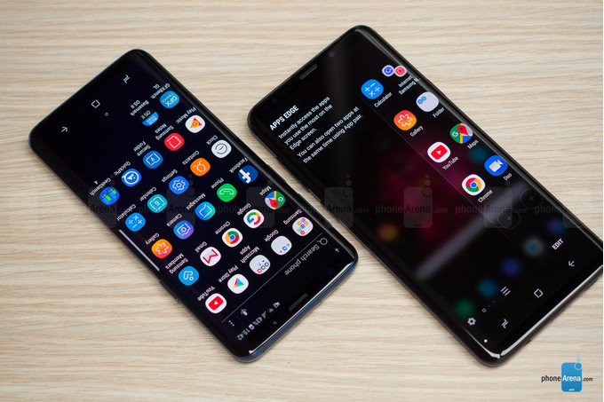

Why do businesses such as the small market players adopt smartphones? What are the advantages that businesses can get from these electronic devices?
- Allows smooth communication even in remote areas. As a business person, you know that business is can happen anywhere. This means that business deals and transactions can be done outside the office. With this, it is crucial to have something that can help you maintain a smooth communication with your employees, business partners and customers. With business becoming more and more mobile, it is thus necessary to adopt smartphones in the communication system. With smartphones, you can easily perform communication actions such as sending and receiving of Internet fax, making and receiving calls, checking and recording voicemails, and many others. So, if you are on a business meeting far from your office, you can conveniently ask your employee to send reports such as financial statement. You do not have to go outside and look for an Internet café just to check your email.
- Advance and powerful features. Unlike the traditional mobile phones, smartphones are equipped with advance and powerful features. Some of these are Internet connection which is possible either by plan or wireless connectivity, Bluetooth, and various apps. The Bluetooth feature allows for the effortless sharing of files such as music, photos and videos. For businesses, important business files such as presentations can be easily shared. Users can also send emails directly from apps such as Microsoft Outlook. In this way, less time is spent on performing communication actions. As a result, more time can be allotted on other more important business matters. Another feature that can be of great use for businesses is the video conferencing. In this way, communication with multiple people is possible. It also ensures that you are communicating with the right person.
- Storage of important files. Smartphones today have bigger memory capacity. With this, users can easily store files particularly those that are important for the business. Aside from this, files such as photos and music can be also stored right after downloading or after sharing via Bluetooth. By having storage for files in your phone, you can easily send or share files whenever necessary.

Tablet computer

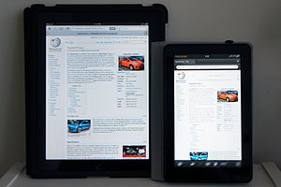
Apple's iPad (left) and Amazon's Fire (right), two popular tablet computers.

Advantages of using tablets in a workplace
1. Tablets Are Low Cost The cost of providing each employee a PC, workstation, or laptop is enormous when compared to the cost of a tablet. The tablet also does not incorporate any moving parts such as hard disks and so forth, thereby minimizing wear as well as the chance of data loss in the long run.
2. Tablets Are Great Consumption Devices
Though you may not know the terminology, it is a well-known fact that tablets are considered to be consumption devices. A greater number of employees usually browse the internet for information, rather than creating it – therefore they ‘consume’ information, and tablets provide a great way to do that.
3. Tablets Include Powerful Networking Tools
Networking is very important for a business, whether that has to with getting in touch with clients through VOIP or transmitting and receiving data from the office itself. Tablets are designed with connectivity in mind.
4. Tablets Improve Workforce Mobility
Business people have to travel a lot. They move from one office to another, giving out presentations, meeting clients or performing various projects. Checking email, browsing the web or keeping in touch with clients on the go becomes a breeze with tablets. Regardless of their location, they can submit projects on time. Customer-focused benefits are also achieved from mobility solution implementation.
5. Tablets Are Great For Meetings
While you can carry a laptop into a meeting, a tablet can prove to be much more practical due to its compact size and swiftness.
6. Tablets Are Environmentally Friendly
Tablets have a favorably small impact on environment. They help in reducing paperwork by providing access to manuals and books in a digital format – in some cases totally eliminating the requirement for printed material.
7. Tablets Make Note Taking Easier
If you wish to take notes during a meeting or during a long flight, it is far easier to do so with a tablet because of the handwriting recognition features. Reading or viewing documents, spreadsheets, or presentations are top smartphone activities. For some activities, one device dominates employee usage. For example, 82% of workers use smartphones to read or view documents, spreadsheets, or presentations, while only 36% of employees engage in these work activities using tablets. In comparison, tablets are much more likely to be used for editing activities as compared with “In regard to the following types of collaborative applications that can be used on your smartphone and/or tablets, how much of a driver is it for your business initiatives?”
8. Increased employee responsiveness, decision-making speed, and issue resolution are key benefits. The top benefit to deploying mobility solutions for smartphones and tablets are increased employee responsiveness and decision-making speed, with 76% of respondents identifying these benefits to mobility solution implementation. In addition, nearly 60% of firms indicate that faster internal issue resolution is a benefit experienced as a result of deploying mobility solutions for smartphones and/or tablets.

Disadvantages of using smart phones and tablets in business
Significant business challenges can emerge from using mobile phones at work. For example:
Significant business challenges can emerge from using mobile phones at work. For example:
- Workflow disruption - always-on communication in the form of personal and work-related calls can disturb employee workflow and decrease their productivity.
- Compromised work-life balance - 'all hours' availability can interrupt your employees' personal life if they receive calls outside their working hours.
- Costs - providing mobile phones to your workforce can be expensive. However, you can enable features on your handsets and SIM cards to restrict the use of phones to business purpose only. You can also choose a tariff that suits company usage. Speak to your service provider about what is possible.
- Legal issues - the law prohibits using handheld phones while driving. If you require or permit your staff to use a handheld mobile phone while driving on duty, you could be committing an offence.

Web conferencing

Web Conferencing is an online service by which you can hold live meetings, conferencing, presentations and trainings via the internet particularly on TCP/IP connections. You can connect to the conference either by telephone or using your computer’s speakers and microphone through a VoIP connection.
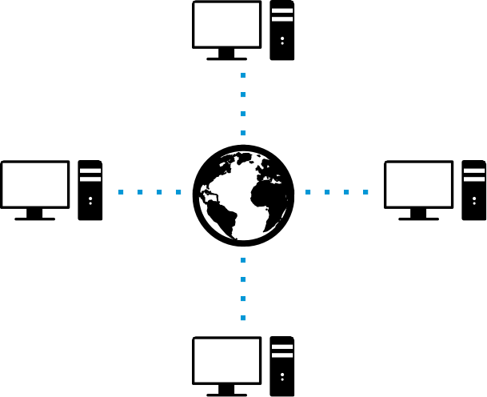
Web conferencing usually allows real time point-to-point communication as well as multi task communications from one sender to many receivers in separate locations. Depending on the service, either an application (additional software) is downloaded and installed or a web-based application is launched in the attendee’s browser. The newest open source technology for Web Conferencing is Google’s WebRTC.
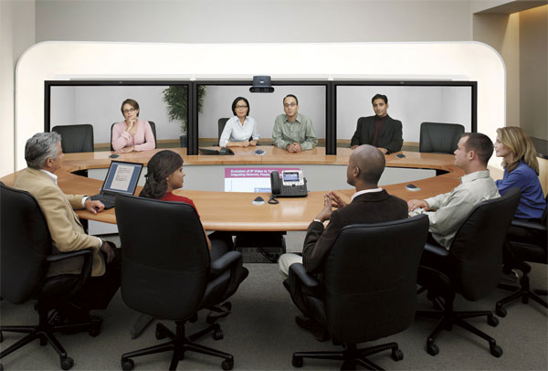

Advantages of using web conferencing in a workplace.
- Saves on Travel Cost and Time
Prior to web conferencing in business, if you wanted to bring together a sales team spread out across the country or meet face-to-face with a client who lives out of town, you (or they) had to travel. Not only can travel be expensive but it also takes time. Web conferencing saves businesses time and money. Within a few minutes, meeting attendees can log on to the meeting without wasting time at the airport or spending money on a ticket. Even if the business pays for a web conferencing service, it is typically less expensive than travel expenses.
- Increases Work Efficiency
Scheduling meetings typically takes more work than simply inviting or mandating attendees. If you’re the host, you have to book a conference room, plan the agenda and in some cases order catering and more. Web conferencing eliminates all of these booking needs, which means putting together a meeting is faster and easier than face-to-face meetings.
- Flexible
It can be difficult to hold an impromptu meeting when the people you need to meet with are not local. Web conferencing provides more flexibility. Typically, you send an email invitation or pick up the phone to alert attendees of the web conference. Within minutes, attendees can log into the web conference system and the meeting starts.
- Increases Engagement
Web conferencing allows the host to upload slides and other graphics, too. With the audio and visual components of holding a web conference, the format helps to increase the engagement level of the conference attendees.
- Eliminates Geographic Barriers
Since anyone with an Internet connection and computer can attend a web conference, web conferencing eliminates geographic barriers of all kinds. Web conferencing opens up possibilities for communication with employees and customers worldwide.

Part 2

TWITTER
Twitter is an online news and social networking service, on which users post and interact with messages known as "tweets". Tweets were originally restricted to 140 characters, but on November 7, 2017, this limit was doubled for all languages except Japanese, Korean, and Chinese.[11] Registered users can post tweets, but those who are unregistered can only read them. Users access Twitter through its website interface, through Short Message Service (SMS) or mobile-device application software ("app").^{[12]} Twitter, Inc. is based in San Francisco, California, and has more than 25 offices around the world.[13]

Benefits of Twitter for business
If your current or potential customer base fits with the Twitter user profile, and you can commit to regularly tweeting about things your customers will find interesting, then you may decideto sign up to Twitter.

Twitter has a range of uses and benefits for business, and can complement other communication channels.
- Communicating
Twitter is a way to keep your followers up to date with current information about your business. Importantly, it lets followers communicate with you too. For example, cinemas use Twitter to converse with patrons, recommend new release movies and retweet interesting tweets from movie buffs and experts.

- Showing your brand's personality
Twitter is a chance to liven up your image. Tweeting about your people and your brand's personality gives followers a sense of your business as more than just a supplier of goods or services. For example, bookshops can use quirky language and humour to share links to interesting articles, promote events, comment on literary awards and announce new products via Twitter.

- Seeking feedback
Many businesses use social media, including Twitter, to invite online feedback, reviews or comments. This information is useful for businesses that want to improve, and also for potential customers doing research for their own purchases.
Twitter's business pages provide more information, including a Twitter guide for small business.

LinkedIn
How to Use LinkedIn for Business
Using LinkedIn for business requires you to have a stronger understanding of what LinkedIn is and can be for your business.
LinkedIn is more powerfully used as a prospecting CRM. Sure, you can connect with your existing business connections, but the real power is connecting with new potential prospects for your business.
The purpose of this social networking tool is to give you a 24-7 pool of potential prospects. It’s not about creating a fan base. It’s about networking. Here are some ideas to think about with LinkedIn.
Research
Are you looking to find a contact at a company? You can do this with LinkedIn by doing a company search and viewing all the employees who work there. You can also see, in some cases, whom you should connect with based on some of their connection.
Networking
Providing connections to others, and staying in touch with what is happening with others in your network, has never been easier with LinkedIn. See job changes, birthdays, etc. Also, in the same way, give them a reason to follow up with you.

Facebook
Facebook is an American online social media and social networking service company.

Benefits of Facebook for business
A Facebook page has many potential benefits for your business. While some of these benefits are similar to having a website, a number are unique to Facebook. Combined, the benefits listed below can lead to increased sales and profits for your business.
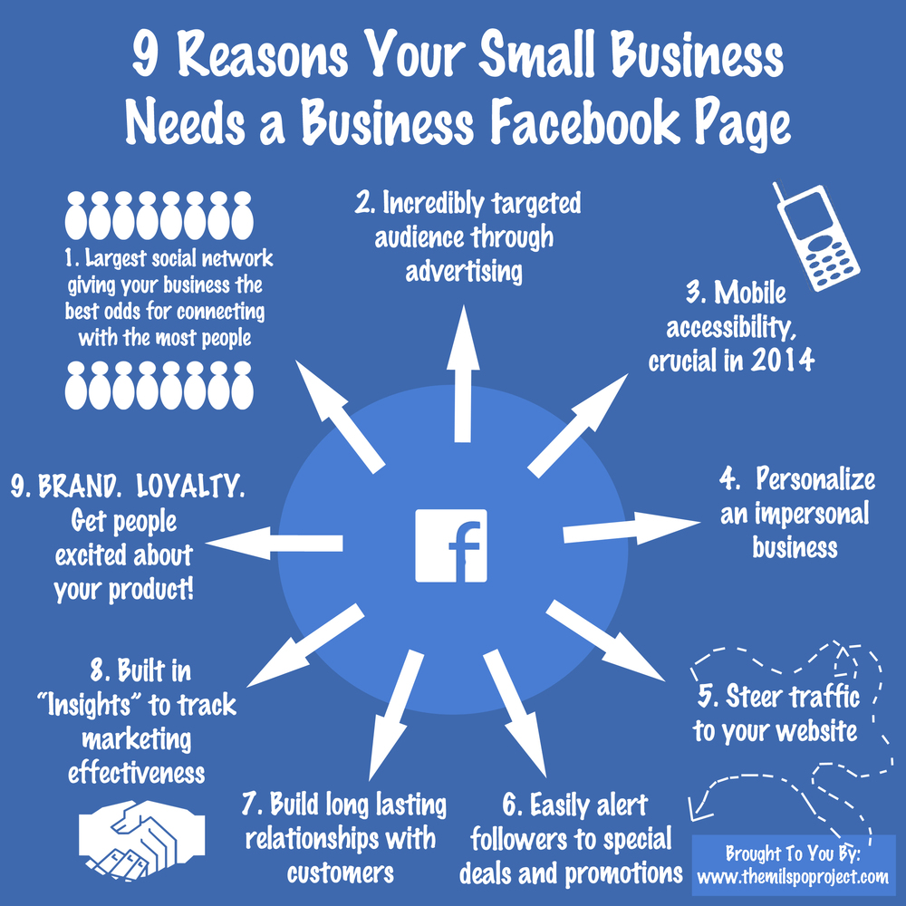

- Facebook is a low-cost marketing strategy
Marketing activities that would cost thousands of dollars through other channels can be used on Facebook for a fraction of the cost. This makes it ideal for small to medium businesses with a limited marketing budget. Larger businesses can also trial marketing concepts and themes through Facebook before committing to bigger campaigns.
- Share basic information about your business
Your Facebook page is a place where you can publicize your business name, address and contact details, and briefly describe your products and services. You can also talk about your staff, history, or any other aspect of your business that is likely to attract other Facebook users and create interest in what you do.
- Share pictures and videos from your business
As well as allowing you to post text, Facebook lets you upload pictures and videos from your business. This can be a powerful way to communicate with customers and potential customers, allowing them to see your product or service without having to visit your premises. Fx. Screenshot below created by the research shows how you can promote your business

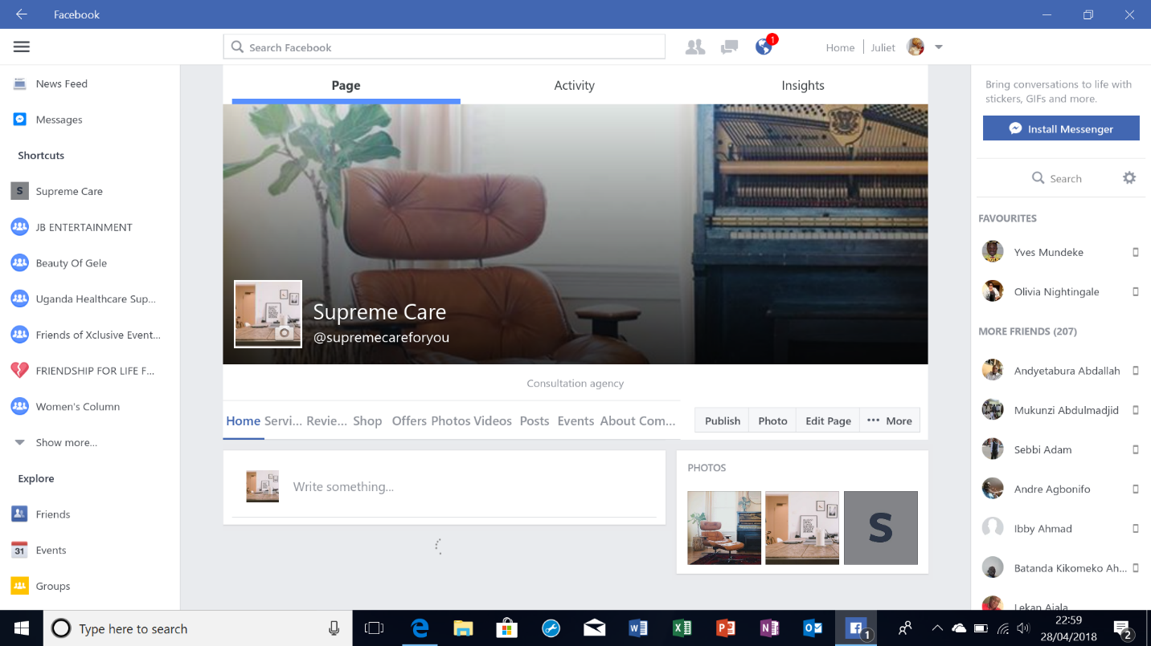

- Talk to existing and potential customers
You can use Facebook to 'talk' to existing and potential customers by posting and receiving messages. You'll have much greater success if you share information related to your business that is actually useful or interesting to other users.
- Raise brand awareness and promote positive word-of-mouth
You can increase your business's profile on Facebook by encouraging existing and potential customers to click the 'Like' button on your Facebook page. Once they like your page, your customers will receive your updates on their wall, where their friends will also see them. This helps to build awareness of your business, and to associate your friends with your brand. Customers can also post positive messages about your products or services, shared on their walls for all their friends

References
See: http://www.pewinternet.org/Reports/2010/Teens-and-Mobile-Phones/Chapter-2/Part-4.aspx
http://www.pewinternet.org/Reports/2012/Cell-Internet-Use-2012.asp
“Gartner Says Worldwide Traditional PC, Tablet, Ultramobile and Mobile Phone Shipments to Grow 4.2 Percent in 2014”, Gartner, 7 July 2014, http://www.gartner.com/newsroom/id/2791017.
Mayer, K., K. Ellis and K. Taylor, Cattle Health Monitoring Using Wireless Sensor Networks, Academia.edu, http:// www.academia.edu/781755/Cattle_health_monitoring_using_wireless_sensor_networks.

