

Assessment 1 – Reading Task Template
PART 1: Upload your photo of your A3 in-class notes here:
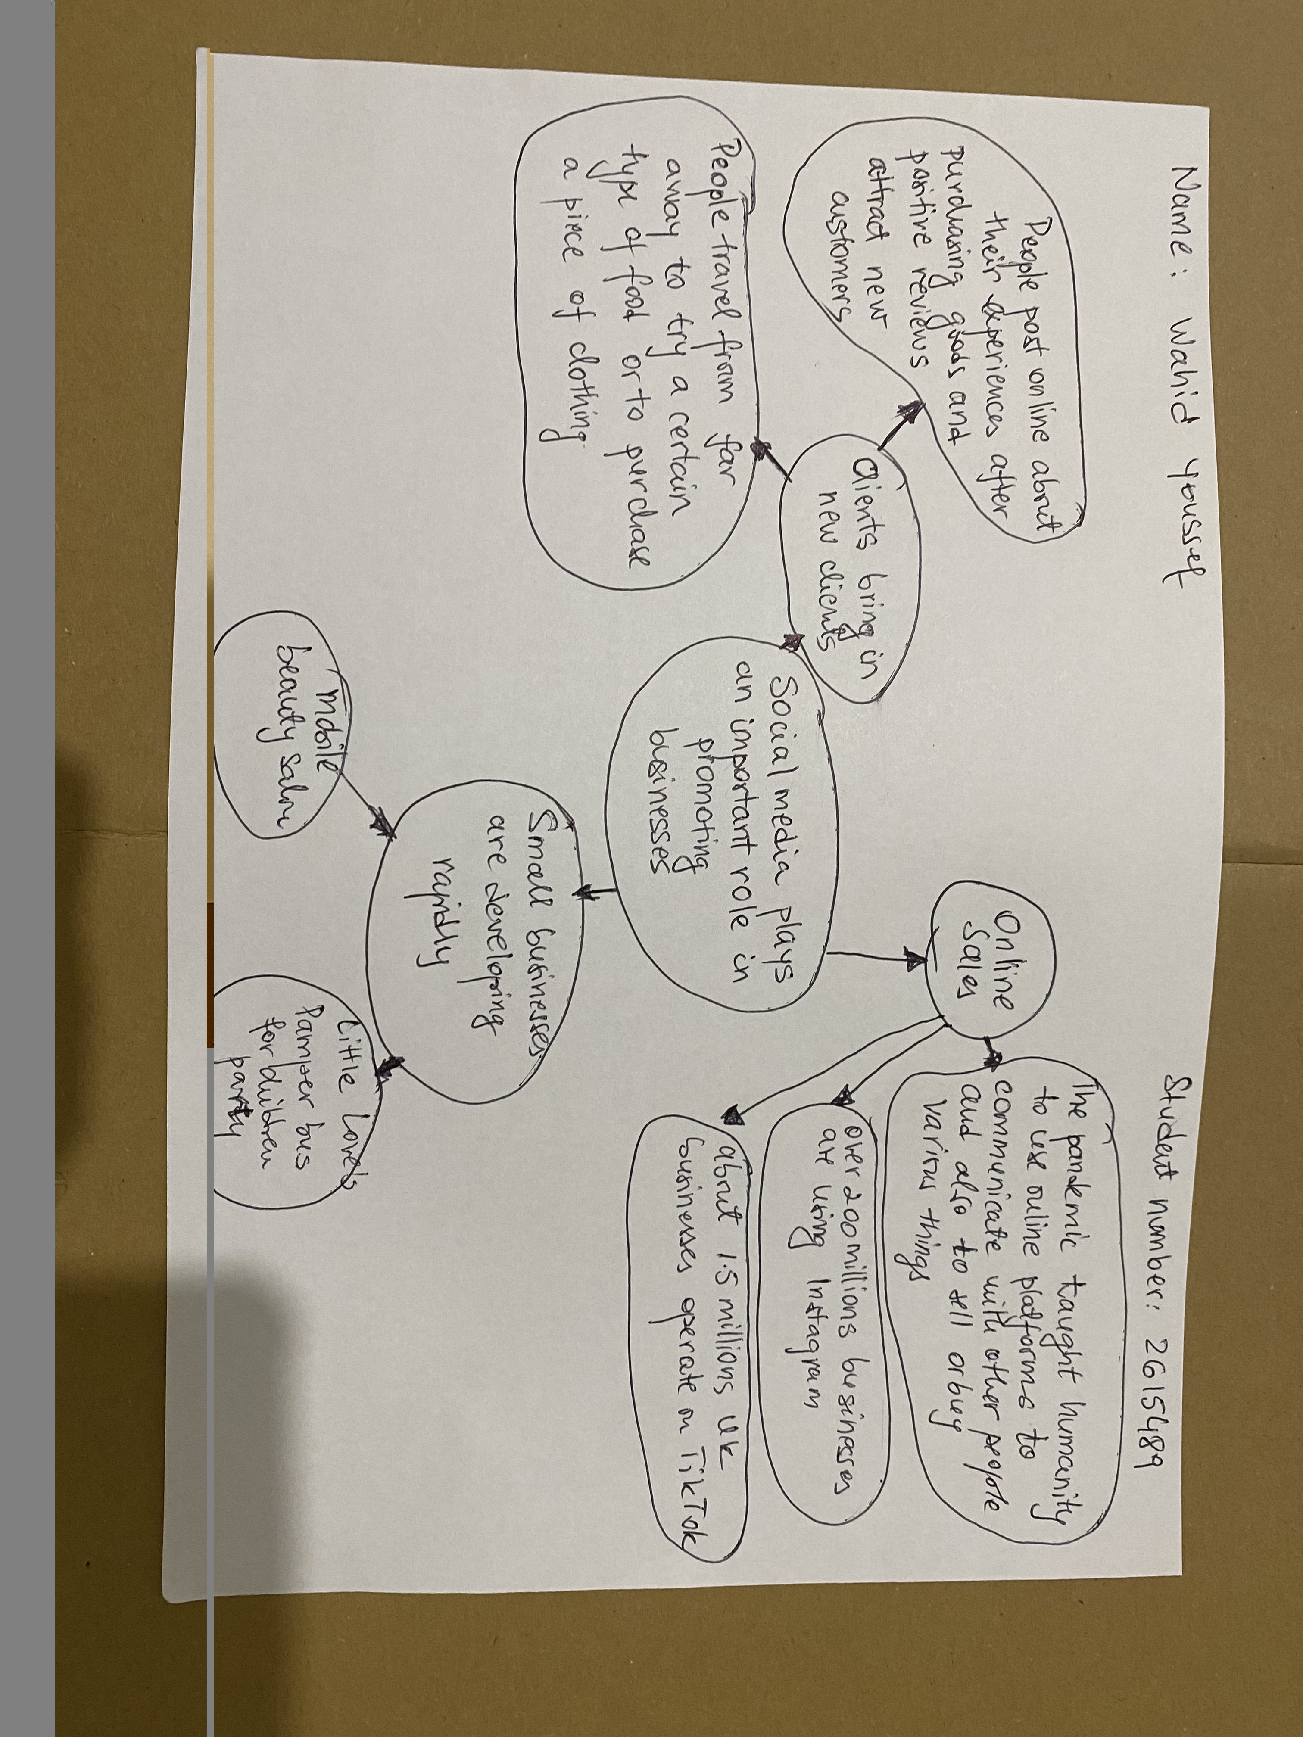

PART 2:
- Answer every question below in 1-3 full sentences.
- Use your own words. Do not use generative AI to answer these questions.
- Include a specific detail from the text when asked.
REMINDER
- The main idea is the overall message of the whole text.
- A key point helps to explain the main idea.
- A specific detail or example from the text shows that the key point is true.

- What is the main idea of the whole text?

Social media plays an important role in promoting businesses.

- What is one key point that supports the main idea, and which specific example from the text shows this?
Online sales.
The pandemic taught us to use online platforms to communicate with other people and also to promote ideas of businesses, to sell or buy various things
Other examples are over 1,5 million UK businesses are active on TikTok, and more than 200 million businesses worldwide use Instagram to reach customers.

- What is a different key point that supports the main idea, and which specific example from the text shows this?

Clients bring in new clients.
People post online their experiences after purchasing goods and positive reviews attract new customers.
Also, people travel from far away to enjoy their favourite breakfast or to purchase a new brand item.

- Which part of the text do you think is most important, and why?

Most important is how online platforms save businesses, promote new ideas, grow up sales and people around the word can purchase any items they wish.
Reflection:
- What did you find difficult in this task (including in-class components), and why was it difficult?
Not difficult, but very interesting how social media influences our life.

- What helped you with this difficulty, and how did it help you?

Sharing ideas In class helps.

