

Programme: Master of Business Administration
Module: Marketing Management
Module Code: LCMB7024
Title: Assesment Component 2: Marketing Portfolio
Word Count: 2488
Lecturer: Dian Mayasari (Birmingham)
Student Name: Promi Das Gupta
Student ID: 2428537
Submission Date: 17/12/2025

Table of Contents
1. STDP Analysis of the Brand 1
Segmentation 2
Targeting 2
Differentiation 3
Positioning 4
2. MARKETING MIX: NESTLÉ VERDE (PLANT-BASED DAIRY BRAND) 6
Product Strategy 6
Pricing Strategy 8
Place (Distribution) Strategy 8
Promotion Strategy 9
3. MARKETING STRATEGY PITCH 11
4. REFLECTION 12
REFERENCES 13
Appendix 15
Poster For the Brand 15

STDP Analysis of the Brand

Nestlé S.A., a Switzerland-based multinational corporation, operates in more than 180 countries with over 2,000 brands across the categories of nutrition, confectionery, and beverages (Nestlé, 2024). Although the company has a strong market presence, it has recently been facing declining trust due to the perception of over-processed food products and harsh environmental impact (Euromonitor, 2023)
To address this issue, Nestlé will introduce Verde, a plant-based dairy brand that produces milk, yogurt, and cheese from oats, almonds, and peas.
The name "Verde" means "green plant" in Spanish and Italian, reflecting the brand's commitment to sustainable nutrition. The concept of this brand acknowledges the rising demand for ethical, health-driven, and environmentally friendly food choices. The Global plant-based dairy market is rapidly expanding, and it is expected to reach USD 55 billion by 2030. The CAGR growth rate is currently 10.3% (Statista, 2025). By leveraging Nestlé's strength in RNG and distribution channels, Verde will aim to lead this fast-growing segment in a short period of time

Segmentation
Segmentation divides a broad market into smaller, meaningful groups based on shared needs (Kottler and Keller, 2022)

Type of Segmentation | Basis | Key Characteristics
Demographic | Age (18–45), middle to upper-middle income, educated urban consumers | Young professionals and families who are willing to pay more for sustainable, healthy options
Psychographic | Lifestyle and values | Health-conscious, environmentally aware, ethical consumers seeking plant-based nutrition
Behavioral | Usage and benefits sought | Flexitarians, vegans, and lactose-intolerant consumers prioritizing taste, freshness, and eco-friendliness
Geographic | Global urban centers (Europe, North America, Asia-Pacific) | Markets with strong demand for plant-based products and modern retail infrastructure
Table 01

Targeting
Nestlé Verde will try to employ a differentiated targeting strategy, which will focus on two core segments-
1. Health-Driven Millennials and Gen Z (18-40): This group of people always actively explores dairy alternatives for personal health, weight control, and ethics. They are highly environmentally conscious and always strive to maintain a minimalist lifestyle with sustainable practices. These digital-first consumers are responsive to influencer and sustainability-based marketing (PwC, 2024)
2. Eco-Conscious Families (30-45): Parents seeking nutritious yet sustainable products from reliable brands will be our target group who value taste, safety, and transparency.
Using Porter's (1985) Focused Differentiation Strategy, Verde will compete on two unique and new values: premium nutrition and sustainability. It is a combination of both premium and sustainability, focusing on a niche market. Based on the differentiation focus strategy, the product will enhance the consumer's lifestyle and brand perception.

Differentiation
The Unique Value Proposition (UVP) will combine nutritional value, sustainability, and taste. The combination of these three features will ensure the premium quality and uniqueness of the product. It is supported by Aaker's (1996) Brand Identity Model. The brand “Verde” is offering the following benefits in its products, which ensure both sustainability and nutrition-
Nutritional Innovation: Fortified with calcium, vitamin B12, and plant-based protein, Verde matches the nutritional value of dairy milk while avoiding cholesterol (Harvard Health, 2023)
Sustainability and Transparency: The product will feature renewable ingredients, including recyclable bioplastic packaging and carbon footprint labels. So, very few competitors, such as Oatly or Alpro, provide complete life cycle transparency (Forbes, 2024)
Taste Leadership: Advanced premium flavor technology ensures creamy texture and authentic dairy taste, addressing the common off-test barrier in existing plant-based products.
Verde will differentiate itself, and this will be the Point of Difference (POD) criteria for the brand, focusing on credibility, nutrition, and sustainable practices.

Positioning
Positioning Statement: For consumers seeking the goodness of dairy without environmental or ethical compromise, Nestlé Verde offers nutritious, delicious, and sustainable plant-based dairy products, crafted with Nestlé's trust and expertise to nourish both people and the planet.
Tagline: "Pure Nutrition, Naturally Crafted ".

Positioning Matrix
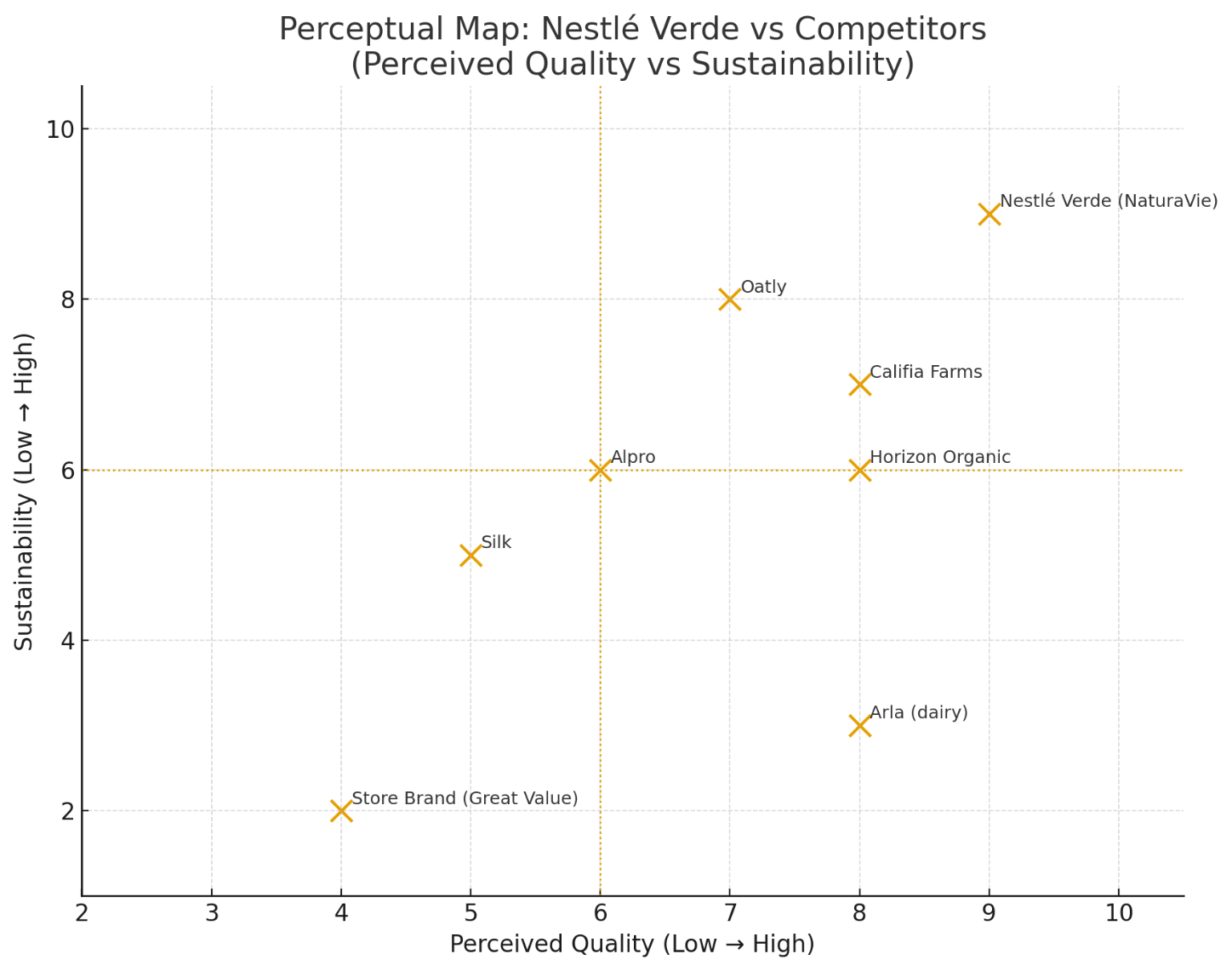

Figure 01
Scores (Perceived Quality, Sustainability):
- Nestlé Verde: (9, 9)
- Oatly: (7, 8)
- Alpro: (6, 6)
- Califia Farms: (8, 7)
- Silk: (5, 5)
- Arla (dairy): (8, 3)
- Horizon Organic: (8, 6)
- Store Brand (Great Value): (4, 2)
The brand has appeal to the current market for the following reasons-
Environmental Responsibility: According to Deloitte (2023), 72% of Gen Z consumers consider sustainability a key driver for their purchasing decisions.
Health Reprioritization Post-COVID-19: In a post-pandemic world, consumers are increasingly valuing immune-boosting, clean-label products.

2. MARKETING MIX: NESTLÉ VERDE (PLANT-BASED DAIRY BRAND)
The Marketing Mix model, introduced by McCarthy (1960) and later refined and expanded by Kotler and Keller (2022), serves as a Foundation for implementing brand strategy. The four key variables in this model are product, price, place, and promotion, which collectively create, deliver, and communicate value to consumers that meet their needs.
For Nestlé Verde, these elements align with the brand's strategy to deliver nutritious, sustainable, and premium-quality plant-based dairy alternatives that enhance Nestlé's ethical and innovative image, meeting the emerging needs of customers.

Product Strategy
The product represents the intangible and tangible benefits that fulfill customers' needs and add value to their lives (Jobber and Ellis-Ellis-Chadwick, 2020). In the context of Nestlé Verde, the product category involves plant-based milk, yogurt, and cheese derived from oats, almonds, and peas. These ingredients balance the taste of the product while maintaining its nutritional value.
Product Levels (Kotler and Keller, 2022)
Product Levels | Nestlé Verde Example
Core Benefit | Healthy, sustainable dairy alternative
Actual Product | Almond and oat-based milk, yogurt, and cheese with recyclable packaging
Augmented Product | Digital nutrition tracker via QR code, recipe suggestions, and carbon footprint display
Table 02
The three main components of Nestlé Verde products are innovation, functionality, and transparency. According to various studies, modern consumers expect brands to use authentic, environmentally friendly ingredients (NielsenIQ, 2024). By displaying a "from farm to shell" traceability code, Nestlé Verde enhances consumer trust, which helps mitigate skepticism about processed alternatives.
Each product will be fortified with vitamin D, B12, and calcium, aligning with the World Health Organization's (2023) recommendations for plant-based diets.
The brand places a strong emphasis on the texture and taste of the product, as its competitors often fall short in this area. Nestlé's strong Research and Development in hydrocolloid technology will help to achieve creamy, dairy-like consistency without additives. This differentiation in product will build on Grunert's (2020) assertion that sensory performance is a crucial factor in the adoption of plant-based products.
The packaging will incorporate bio-based, recyclable cartons and a minimalist design, reflecting the brand's sustainable identity (Verghese et al., 2021). The colors green and white in the packaging will be used to reflect the minimalism. The tagline- "Pure Nutrition, Naturally Crafted" symbolizes freshness and environmental harmony. Overall, Verde's product strategy supports premium differentiation and conveys the message of ethical and experiential value.
The brand will prioritize green logistics, which includes electric delivery fleets and reusable transport crates (Nestlé Sustainability Report, 2024). The efficiency of warehousing will rely heavily on innovative inventory systems that will reduce wastage through AI-based demand forecasting (Accenture, 2023).
According to Kotler et al. (2023), effective place strategies create both functional and emotional value. The brand will integrate digital convenience with physical availability for this purpose.

Pricing Strategy
Price defines the value exchange between brand and consumer, and it is a primary determinant of market positioning (Kotler et al., 2023).
The brand will adopt a value-based pricing strategy, as it reflects superior product quality, sustainability credentials, and the brand's alignment with conscious consumerism.
According to PwC (2024), 60% of consumers are willing to pay a premium price for environmentally friendly and responsible brands. So, Nestlé will position itself 10-15% above average market price (e.g, higher than Alpro but competitive with Oatly and Califia Farms). The premium pricing supports the perceived quality while sustaining the company's profitability.
The brand will also implement psychological pricing, for instance, by offering $3.99 instead of $4.00 to attract purchase behavior and signal competitive fairness (Hinterhuber, 2017).To attract new buyers, introductory bundles and subscription discounts will be offered through Amazon Fresh and Nestlé's direct-to-consumer portal.
Additionally, regional pricing adaptation will be implemented. In developed markets such as Germany, the UK, and Singapore, Nestlé Verde can maintain premium pricing. In emerging markets, a tier pack-size strategy will ensure economic pricing and affordability. This differentiated strategy will enable market penetration without diluting brand prestige (Hinterhuber and Liozu, 2020)
Finally, dynamic pricing analytics using AI-driven tools from Nestlé's E-Commerce system will help to price according to demand elasticity, competitive promotions, and seasonality. This approach ensures long-term alignment among price, value, and profitability.

Place (Distribution) Strategy
Deciding on distribution is crucial in brand development because it determines how easily the product reaches the end consumer, which directly influences accessibility and convenience (Baker, 2021). Nestlé's Verde will adopt a hybrid distribution channel model, which will combine the consumer (D2C channel and multi-channel retail partnerships.
Channel Type | Example and Rationale
Modern Retail (Offline) | Partnerships with major supermarkets (Tesco, Walmart, Carrefour) for mass visibility.
Online Retail (E-commerce) | Nestlé’s official website, Amazon Fresh, and grocery delivery apps such as Instacart.
Food Service Channels | Collaboration with cafés, fitness chains, and eco-restaurants to encourage trial.
Table 03

Promotion Strategy
Promotion encompasses all communication activities designed to inform, persuade, and remind consumers (Fill and Turnbull, 2019). Nestlé Verde's promotional mix will include digital storytelling, influencer engagement, and sustainability campaigns to build an emotional connection with the brand.
Integrated Communication Approach
Approach | Key Activities | Primary Goal | Supporting Data/Rationale
Digital Media Marketing | Targeted campaigns on Instagram, TikTok, & YouTube using #VerdeLife, #PurelyPlant; Short-form videos (recipes, eco-initiatives). | Engage younger consumers and drive discovery. | 73% of Gen Z discover sustainable brands online (Deloitte, 2024).
Content Marketing | Website features: Blogs, podcasts, and sustainability reports. | Educate consumers and foster transparency. | Combats "greenwashing" concerns (White et al., 2023).
Influencer Collaborations | Partnerships with nutritionists, eco-bloggers, & fitness experts (Micro-influencers). | Build credibility and trust. | Micro-influencers generate higher trust than celebrities (Kapitan & Silvera, 2019).
Public Relations & CSR | Launch events ("The Verde Green Breakfast"); Donations to reforestation projects. | Enhance corporate reputation and align with UN SDG 12. | Aligns with UN SDG 12 (Responsible Consumption).
Advertising | Emotional storytelling ads focused on "Nutrition that Nurtures the Planet." | Highlight sustainability/well-being; maintain a hopeful and authentic brand tone. | Reflects Nestlé’s brand personality (Aaker, 1997).
Sales Promotion | Limited-edition Earth Month packaging; Referral rewards via Nestlé One App. | Encourage trial and advocacy. | Drives product trial and customer referrals.
Table 04
All communication activities will follow integrated Marketing communication principles to ensure consistency across different channels (Belch and Belch, 2021).
Measurement through digital KPIs, such as engagement rate, brand sentiment analysis, and conversion rate, will track return on investment and guide an adaptive strategy.
Strategic alignment of 4Ps with Brand Goals
Each element of the marketing mix reinforces Nestlé Verde's strategic positioning:
- Product: Delivers innovation and sustainability through nutrition and eco-friendly packaging.
- Price: Captures premium value while maintaining fairness through innovative models.
- Place: expands accessibility through digital and retail integration.
- Promotion: Builds emotional equity and trust through authentic storytelling.
Together, the 4Ps create a synergistic system that supports Nestlé's purpose of "Good food, Good life" while maintaining modern consumer expectations for transparency, health, and sustainability.

3. MARKETING STRATEGY PITCH
Nestlé introduces “Verde,” a premium plant-based dairy brand designed to meet the shift in consumer preference and taste in today's market.
The emerging trend of sustainable and health-conscious consumption has led to a significant shift in the global food chain. Consumers are increasingly rejecting ultra-processed dairy alternatives due to taste compromises, doubts about ingredients, and a lack of nutritional balance (Statista, 2025; Euromonitor, 2024). Verde solves this issue by integrating Nestlé's world-class R&D with natural, high-protein ingredients sourced completely ethically from almonds, oats, and peas, offering a creamy, dairy-like taste and proper nutritional value.
The brand positions itself as "Pure Nutrition, Naturally Crafted". It targets environmentally conscious millennials who demand sustainable and indulgent products. The differentiation of the product lies in its innovative taste and nutrient-enriched formulation, backed by Nestlé's credibility in quality assurance.
The marketing efforts primarily focus on digital storytelling, influencer partnerships, and sustainability-driven packaging to connect with consumers on an emotional level. The global plant-based dairy market is projected to exceed USD 45 billion by 2030. (Allied Market Research, 2024), with annual growth of over 10%.

4. REFLECTION
Developing the new brand concept for Nestlé and creating a comprehensive marketing strategy for Verde, a plant-based dairy product brand, has been an insightful and transformative experience. The project required integrating theoretical marketing frameworks with practical knowledge and strategies, allowing me to apply different models, such as STDP and 4Ps, coherently and creatively. It helped me to deepen my understanding of brand development processes and allowed me to align marketing decisions with emerging global consumer trends.
Initially, I focused on creating a new brand, conducting extensive research to identify the market gap Nestlé currently faces and the unmet needs of consumers. Nestlé already has a diverse and wide range of brands in its portfolio, so identifying a genuine market gap required extensive research, critical thinking, and analytical reasoning. By examining reports from Euromonitor and Statista (2024-2025), I found out that the consumer demand for plant-based dairy products has emerged in recent years. However, many large companies have yet to tap into that market. So, this is an underserved sector.
Additionally, brands introducing such products are facing challenges in balancing quality and taste. I tried to maintain that balance in this brand. This process taught me the importance of market-driven innovation, where strategy focuses directly on consumer needs and fills market gaps.
Preparing and delivering the marketing strategy pitch was also a valuable learning experience for me. Analyzing complex strategic ideas into a concise, persuasive message requires clear communication and confidence. It taught me how to translate creative and analytical findings into a storytelling manner. It also helped me to prepare my pitch in a way that attracts stakeholders and helps them to understand my idea properly. I also realized the significance of emotional engagement in marketing communication, particularly in the brand development process, in sustainability-oriented brands.
The project significantly improved my research, strategic thinking, storytelling, and presentation skills. I became better at gathering data from different secondary resources and applying them to concept building. I also gathered extensive knowledge on various new research studies in marketing and brand development from credible sources, which allowed me to integrate those concepts into the brand development process. I also developed a deeper awareness of current marketing challenges such as greenwashing, distrust, and ethical sourcing- all of which shaped my understanding of sustainable brand development.
If I have the opportunity to undertake such a project in the future, I would take more time for primary research to validate consumer perceptions and their need directly into brand building. I am also very interested in applying advanced analytical tools, such as perceptual mapping and competitor benchmarking, to increase differentiation in brand development.

REFERENCES
Element 1: STDP Analysis
Aaker, D. A. (2020). Managing brand equity: Capitalizing on the value of a brand name. New York: Free Press.
Euromonitor International (2024) Plant-based Dairy Market Trends: Global Forecast to 2030. Available at: https://www.euromonitor.com
Kotler, P. and Keller, K. L. (2022) Marketing management. 16th edn. Harlow: Pearson Education.
Mintel (2024) Consumer Attitudes Toward Sustainable Dairy Alternatives – Global Report. Available at: https://www.mintel.com
Nestlé (2024) Nestlé Annual Report 2024. Vevey: Nestlé S.A.
NielsenIQ (2023) Plant-Based Foods are Now Mainstream: Global Insights Report. Available at: https://nielseniq.com
Element 2: Marketing Mix (4Ps)
Jobber, D. and Ellis-Chadwick, F. (2020). Principles and practice of marketing. 9th edn. London: McGraw-Hill Education.
Kotler, P. and Keller, K. L. (2022) Marketing management. 16th edn. Harlow: Pearson Education.
McCarthy, E. J. (1960). Basic marketing: A managerial approach. Homewood, IL: Richard D. Irwin.
Grand View Research (2024) Global Plant-Based Dairy Market Size, Share & Trends Analysis Report. Available at: https://www.grandviewresearch.com
Forbes (2023) Nestlé’s Green Shift: How Plant-Based Foods are Shaping the Future of Nutrition. Available at: https://www.forbes.com
PwC (2023) Future of Consumer Markets: The Sustainability Revolution. Available at: https://www.pwc.com
Statista (2025). Revenue of the Plant-Based Dairy Segment Worldwide from 2020 to 2030. Available at: https://www.statista.com
Element 3: Marketing Strategy Pitch
Ginsberg, J. M. and Bloom, P. N. (2022) ‘Choosing the right green marketing strategy,’ MIT Sloan Management Review, 64(2), pp. 45–52.
WARC (2024) Brand Purpose and Green Marketing Effectiveness Report. Available at: https://www.warc.com
World Economic Forum (2024). The Future of Sustainable Food Systems. Available at: https://www.weforum.org
Accenture (2023) Global Consumer Sustainability Survey 2023. Available at: https://www.accenture.com
Element 4: Reflection
Tybout, A. M. and Calkins, T. (2021). Kellogg on branding: The marketing faculty of the Kellogg School of Management. 3rd edn. Hoboken: Wiley.
Jobber, D. and Ellis-Chadwick, F. (2020). Principles and practice of marketing. 9th edn. London: McGraw-Hill Education.
Kotler, P. and Keller, K. L. (2022) Marketing management. 16th edn. Harlow: Pearson Education.
PwC (2023) Future of Consumer Markets: The Sustainability Revolution. Available at: https://www.pwc.com
WARC (2024) Brand Purpose and Green Marketing Effectiveness Report. Available at: https://www.warc.com

Appendix

Poster For the Brand



