

Assessment component one.
Case study-“Troubled families: Portsmouth.” Supporting paper.

Student name: Yuliana Abadzhieva
Student ID:1818406
Module name: Children, young people, and families.
Module code: (BMHP5004-LON).
Lecturer name: Laila Surani
Word count:1000
Introduction

The case study discusses the problem of a single parent of three children living in Portsmouth. The mother has recurring issues with her mental health and cannot cope with the daily tasks she has related to the children. Her mental state has affected her motivation to work, and the conditions in their house are not acceptable for social workers. The children also do not attend school and kindergarten due to the mother's obvious lack of organization and discipline, and often the eldest daughter takes care of the other children. Social workers try to focus on building a good relationship with the mother to have the opportunity to help the family. The main factors in the specific problem are the mother's problem, which affects the care of the home and your children, as there is a potential threat to their clear future. The coursework examines legislation and laws for children, which gives a clear idea of how to approach this case.

Case study

The specific problems in the family have put the single parent in a demanding situation, and the monetary impact is also significant. The children do not attend school or kindergarten because they are not so close to home. The non-working cooking stove in the kitchen does not allow the mother to make homemade healthy food for the children. The mental problems of the single parent violate the children's rights to an everyday and peaceful life. The eldest daughter takes care of the other two children daily instead of dealing with her lessons and homework from school.GOV.UK.(2014).
Anyone with reason to believe that a child may be in danger must act responsibly. A child might interact with various statutory and non-profit organisations, all of which might have some information about the child but not all of it. The fundamental idea is that different agencies should cooperate to safeguard children. The "Working Together" document16 outlines how organisations and professionals (including those in probation, social services, health, education, and law enforcement) should collaborate. The advice applies to the independent, statutory, and non-profit sectors. (Payne, 2008).
Children are best cared for in their homes, with their parents actively involved in their lives, according to a fundamental tenet of the 1989 Act.
Family intervention is essential. This idea is demonstrated by:
The role of the local authority in supporting children and their families, the idea of parental responsibility, the right of unmarried fathers to share that responsibility by agreement with the mother, by joint registration at birth, or by court order, the local authority's obligation to return a looked-after child to their family unless doing so would be against the interests of the child, and the local authority's responsibility, unless it is not reasonably practicable to do so. (Department of Education, 2021).

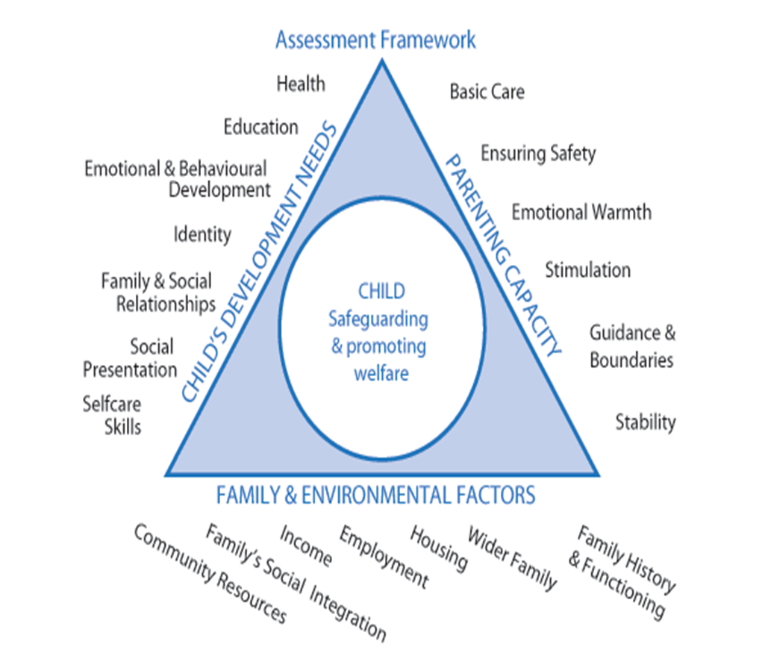

- Assessment Triangle Framework.
- Child`s development needs.
- Educational problems /not attending school.
- Missing family relationship.
- Poor nutrition.
- Parenting capacity.
- Missing stability and stimulation.
- The children are not safe.
- Family and environmental factors.
- The mother is unemployed .
- There is no social interaction.
- Poor house/no accommodation.

Maslow`s Hierarchy of Needs
According to Abraham Maslow, our most fundamental wants are innate and have evolved over thousands of years. The Hierarchy of Wants by Abraham Maslow sheds light on the motivations behind these needs in everyone. According to Maslow's Hierarchy of Needs, we must address each need first, which addresses the most pressing requirements for basic survival. (Cherry, 2022).

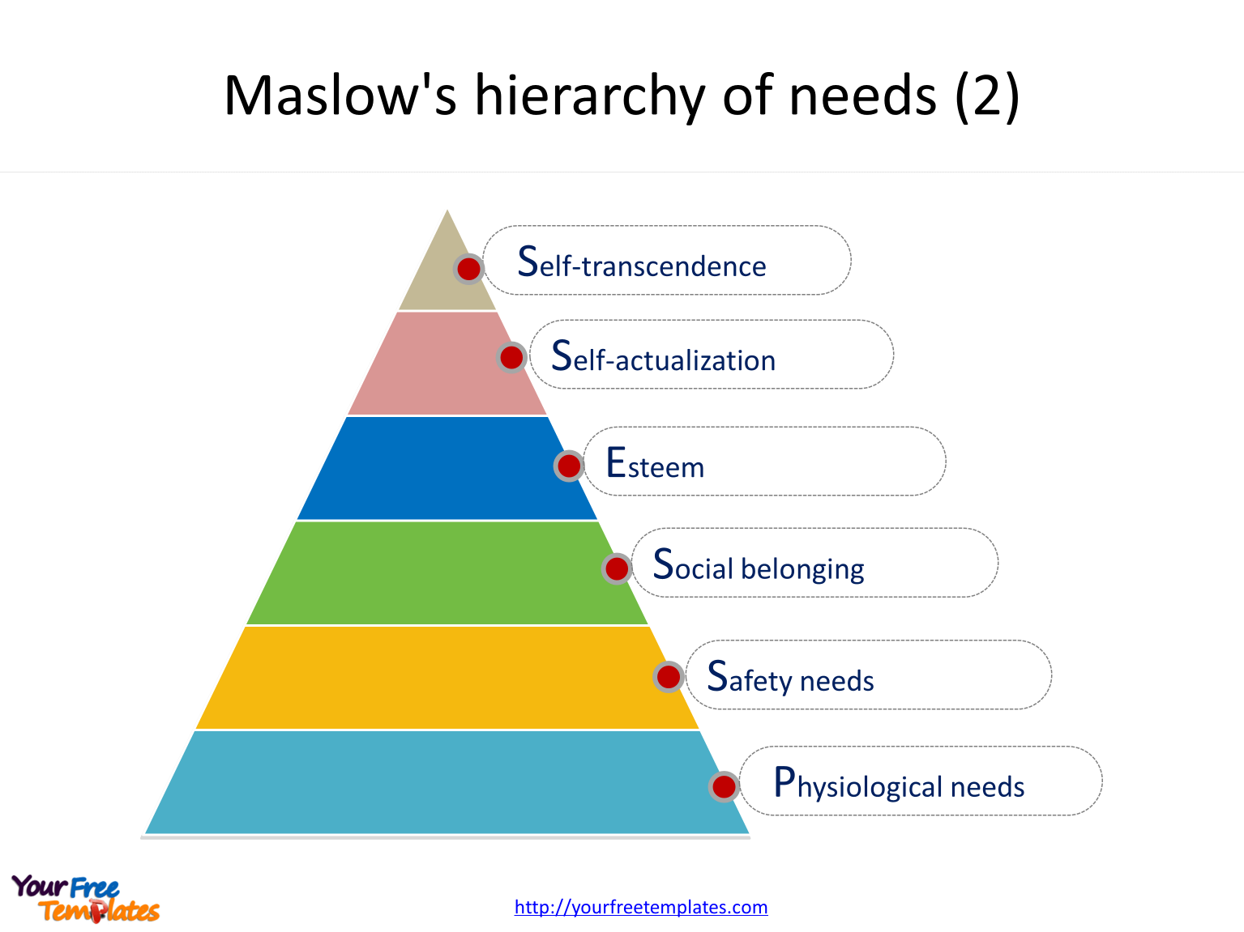

- Self – transcendence – self observing, well -being ,culture, part of the human nature.
- Self-actualization-Interests, skills, and creative endeavours.
- Esteem -positive discipline, skills acquired, respect from parents, teachers, and classmates, and safety from bullying and prejudice.
- Social belongings -unconditional love, affectionate interaction with caretakers, space for exploration and play, and peer engagement.
- Safety needs - It is above the poverty line, having access to health care, being free from abuse and neglect, and protecting children from harm (car seats, babyproofing, watching over them).
- Physiological needs - Wholesome (age-appropriate) diet, rest, shellfish, and human contact. (McLeod, 2022).

Analysis -process of intervention by relevant agency and policy
The social services are connected to the issue via observation, and they provide a family support plan together with a toolkit for the family approach, according to "Portsmouth Safeguarding Children Partnership." (hipsprocedures.org.uk, n.d.).
Professionals in Portsmouth must fill out an inter-agency referral or contact form as part of peer local protocols when they determine that a child or family needs additional help and communicate it with the appropriate multi-agency safeguarding hub.
- Until it is proven that a person lacks capacity, they must be considered to have the ability.
- A person should not be regarded as incapable of decision-making unless all practical measures to assist him have been tried and failed.
- A person should not be viewed as incapable of making a choice.
- Before taking any action or decision, it is essential to consider whether the goal can be reached more effectively and with less interference with the person's rights and freedom of movement. (www.portsmouthsab.uk, n.d.).

The subject of assessment.
The subject in the case study is a single parent and her three children.
The agency "Portsmouth Safeguarding children partnership" made the assessment and built a relationship with the mother and help her to make an appointment to change the children`s school because the school is too far away from their house. The agency set up a payment plan for the mother, and then she can control the situation, and now she is volunteer one of the first steps to returning to work. (hipsprocedures.org.uk, n.d.).

Evaluation of the current policy and the potential impact of their actions.
According to the Children Act of 1989, local governments have a general obligation to advance and protect the welfare of needy children in their district by offering numerous services suited to their requirements.
Anyone working for or on behalf of Safer London is subject to this policy. This includes paid staff, volunteers (including trustees), secondees, agency staff, and students. It also applies to our suppliers and, where necessary, our subcontractors. Unless otherwise specified, all preceding should be considered when this policy pertains to staff or employees. (Department of Education, 2022).
This policy covers all work with children up to the age of eighteen. Please go to Safer London's Adult Safeguarding Policy if you are over eighteen. This policy is not a part of Safer London's employment contract, and the company reserves the right to modify it at any time if they feel it is necessary. However, failure to adhere to this policy may result in disciplinary action against the non-compliant employee, which may result in termination.
This policy was developed following the laws, regulations, and guidance that aim to safeguard children in England and, when applicable, the advice that applies especially to organisations operating in London. (https://frg.org.uk, n.d.).
To identify children's needs, children's services provide them with safety in their homes. The children's educational impact is changed during the observation; they are moved to a new school and are happy to start their new life for the better.

Evaluation
The United Nations General Assembly adopted two optional protocols to the Convention on the Rights of the Child in 2000 to strengthen the protection of children from involvement in armed conflicts and from sale, prostitution, and pornography, to reduce the abuse and exploitation of children globally. A third optional protocol was implemented in 2014, allowing kids to complain directly to the committee on kids' rights. The committee then investigates the claims and has the authority to tell governments what to do. (UNICEF, 2019).
This optional protocol aims to strengthen the Convention's application and improve child safety during armed conflict.
The Convention obligates states to take all practical steps to prevent members of their armed services younger than eighteen from directly participating in hostilities. (UNCRC, 1989).

Recommendation
Children's unique requirements in safe youth facilities should be included in any assessment. In every situation, the local government, where a secure youth facility, oversees ensuring the welfare and safety of the children there. The host local authority should collaborate with the child's home local authority and the governor, director, manager, or principal of the secure adolescent facility. (BBC Children in Need, 2019).

Reference list
BBC Children in Need. (2019). Together we can change young lives - BBC Children in Need. [online] Available at: https://www.bbcchildreninneed.co.uk/ [Accessed 2 Dec. 2022].
Cherry, K. (2022). The Five Levels of Maslow’s Hierarchy of Needs. [online] Overwhelming. Available at: https://www.verywellmind.com/what-is-maslows-hierarchy-of-needs-4136760 [Accessed 1 Dec. 2022].
Department of Education (2021). The Children Act 1989 guidance and regulations Volume 2: care planning, placement, and case review. [online] Available at: https://assets.publishing.service.gov.uk/government/uploads/system/uploads/attachment_data/file/1000549/The_Children_Act_1989_guidance_and_regulations_Volume_2_care_planning__placement_and_case_review.pdf.
Department of Education (2022b). The Children Act 1989 guidance and regulations Volume 2: care planning, placement, and case review. [online] Available at: https://assets.publishing.service.gov.uk/government/uploads/system/uploads/attachment_data/file/1000549/The_Children_Act_1989_guidance_and_regulations_Volume_2_care_planning__placement_and_case_review.pdf.
GOV.UK. (2014). Troubled families: Portsmouth. [online] Available at: https://www.gov.uk/government/case-studies/troubled-families-portsmouth.
hipsprocedures.org.uk. (n.d.). 2.3 Family Approach Protocol and Toolkit | Hampshire, Isle of Wight, Portsmouth, and Southampton. [online] Available at: https://hipsprocedures.org.uk/pkyyop/safeguarding-practice-guidelines/family-approach-protocol-and-toolkit [Accessed 1 Dec. 2022].
hipsprocedures.org.uk. (n.d.). Hampshire, Isle of Wight, Portsmouth, and Southampton. [online] Available at: https://hipsprocedures.org.uk/page/contents#p1 [Accessed 2 Dec. 2022].
https://frg.org.uk (n.d.). Section 47. [online] Family Rights Group. Available at: https://frg.org.uk/get-help-and-advice/a-z-of-terms/section-47/#:~:text=This%20refers%20to%20section%2047%20of%20the%20Children [Accessed 2 Dec. 2022].
McLeod, S. (2022). Maslow’s Hierarchy of Needs. [online] Simply Psychology. Available at: https://www.simplypsychology.org/maslow.html [Accessed 1 Dec. 2022].

Payne, H. (2008). UK law regarding children: essentials for the paediatrician. Paediatrics and Child Health, 18(5), pp.207–212. doi:10.1016/j.paed.2008.02.003.
UNICEF (2019). The Convention on the Rights of the Child: The children’s version. [online] Unicef.org. Available at: https://www.unicef.org/child-rights-convention/convention-text-childrens-version [Accessed 2 Dec. 2022].
UNCRC (1989). UN Convention on the Rights of the Child (UNCRC) - UNICEF UK. [online] UNICEF. Available at: https://www.unicef.org.uk/what-we-do/un-convention-child-rights/ [Accessed 2 Dec. 2022].
www.portsmouthsab.uk. (n.d.). Information & Resources. [online] Available at: https://www.portsmouthsab.uk/information-resources-2/ [Accessed 2 Dec. 2022].

