Problem Solving and Decision Making

BMSW4004

Assignment title: Problem Solving and Decision Making

Student: Mariya Delieva (2007927)
Tutor: Yajesh Kumar
2021/UWTSD

Executive Summary
This study sheds light on identifying the problem in Tesco Plc. It evaluated the problem with different problem-solving tools like brainstorming, SWOT analysis and fishbone diagram. Moreover, the study has further provided three solutions, which are analysed with PMI technique and the best solution is acquired. Furthermore, the planning for implementing, monitoring, controlling, and communicating the solution has also been incorporated in this study.

Table of Contents

Introduction 4
Definition and Identification of Complex Problems in Tesco 4
Application of Problem-Solving Tools 5
Alternate Solutions 8
Evaluation of the alternate solutions 8
Best Solution 11
Plan for the implementation of the solution 11
Monitoring and Control 12
Communication with Stakeholders…………………………………………………………………………………………………..12
Recommendations 14
Conclusion 14
Reference List 16

Introduction
Problem-solving plays a significant role to manage the overall business environment from getting ruined. Alongside, decisions for resolving issues are also a major practice for enhancing the overall business performance. This report defined the problem faced by the employees of Tesco. For this, the identified problem is being solved with the application of SWOT analysis, fishbone diagram and brainstorming. Furthermore, the devised solutions are being evaluated with PMI technique and it further inculcates the planning for implementation and controlling of the best solution.

Definition and Identification of Complex Problems in Tesco
Tesco Plc is a multinational general merchandise and groceries supermarket established in the UK. It is considered to comprise the largest workforce in the UK with employing over 360,000 people (Tescoplc.com, 2021). Alongside, the retail organisation has been identified to generate annual revenue of more than 52 million GBP in the year 2020 (Blázquez, 2021).
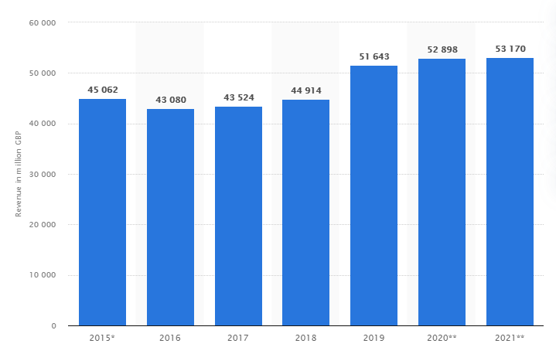
Figure 1: Annual Revenue Generation by Tesco Plc
(Source: Adapted from Blázquez, 2021)
It has been recognised that the number of employees of Tesco has been decreasing since 2020. In 2020, there was an 8.92% decline in the workforce of Tesco, while in 2021, a decline of 13.18% has been encountered (Macrotrends.net, 2021).

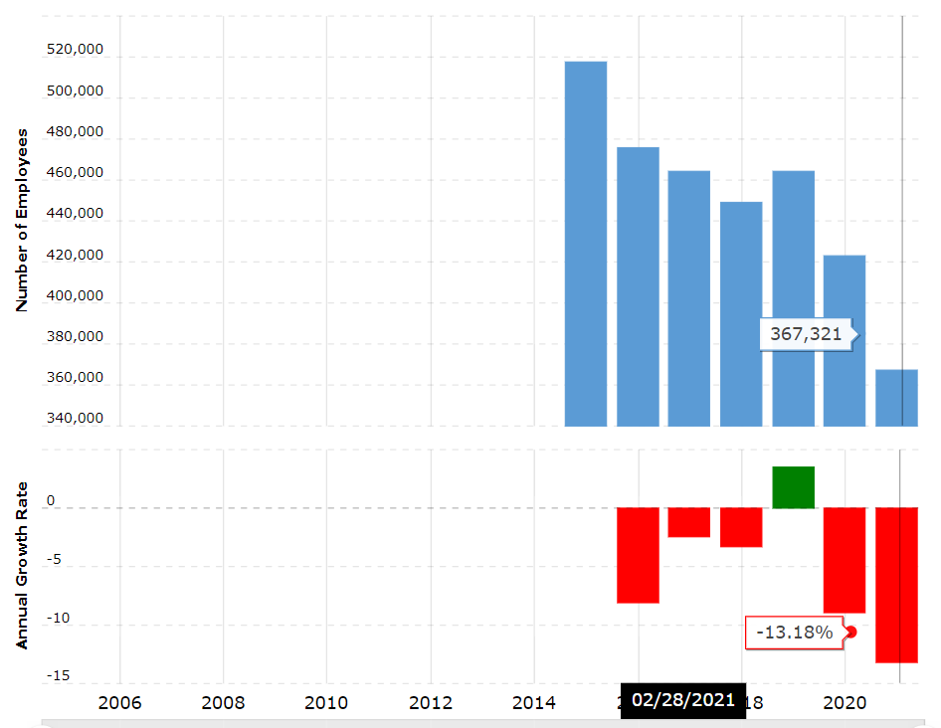
Figure 2: Decrease in the workforce of Tesco Plc
(Source: Extracted from Macrotrends.net, 2021)
The reason behind the increased employee turnover rate is recognised to be a lack of employee motivation (Peacock, 2008). Most of the young employees are acquiring poor self-esteem due to inadequate motivation. Alongside, it has been encountered that the management of the retail organisation has increased the roles and responsibilities of the young employees with cleaning and dusting of the floors in their respective stores (Jones, 2020). This decision was taken to cut down costs during the pandemic situation when the employees already had an immense workload to keep shelves full. The three Problem-solving tools were used to identify the problem and analyse the possible causes and effects:

1. SWOT Analysis
Strengths | Weaknesses
- Largest grocery retailer in the UK with a large workforce  - Exclusive supply chain network  - Enhanced market share  - The largest employer in the UK  - It possesses stores in multiple nations with diverse product ranges including grocery, financial and telephonic | - It faces issues with motivating employees  - Lack of effective operational and financial performance  - Poor employee productivity
Opportunities | Threats
- It acquires the opportunity to enhance its retail business across the globe  - Partnering with other brands  - It attains the opportunity to develop better employee relations to retain them | - Increase threat of employee turnover  - The dropdown of the competitive positioning in the industry  - The threat of deteriorating employee relations

From SWOT analysis, it has been encountered that Tesco is weak in motivating its employees and retaining them for the long term. Alongside, it also faces issues in its operational and financial performance, which its management needs to take into consideration for enhancing its work culture.
2.Brainstorming
With the application of brainstorming, the management of Tesco can form a group of employees and encourage them to share their opinion regarding the existing management practices. The employees can then generate issues faced in different circumstances while working. Moreover, brainstorming helps the employees to aggregate several reasons behind their feeling of demotivation (Mburu, 2020). Besides this, the employees can further come up with solutions for recommending their management regarding methods to motivate employees. For instance, one of the employees might say that the management does not listen to the problems of its employees in any circumstances. However, other employees might say the power culture in the workplace is demotivating.
3.Fishbone Diagram
Lack of employee motivation in Tesco
Poor management practices
Not encouraging employees to share their ideas
Lack of approach
Lack of appreciation
No group discussion
Autocratic culture
Lack of delegating regular tasks
Inadequate maintenance of employee relationships
Not recognizing performances of employees
Not appreciating hard work of employees
Inadequate decision-making sessions
Inadequate leadership

This fishbone diagram is displaying the reasons behind inadequate employee motivation in Tesco Plc. With this, it has been realised that it is not only the responsibility of employees to maintain effective relations within a workplace. However, the management of a workplace also needs to take initiatives to maintain adequate employee’s relations, which is considered as a motivation for employees (Nguyen et al., 020). Alternatively, in the case of Tesco Plc, it has been found that there is a lack of management practice, and the leaders and managers are least concerned with the problems faced by their subordinates. Rather, they intend to put further workload without considering the existing roles. This signifies a lack of leadership. Moreover, the employees are also not provided the opportunity to speak up their opinion or allowed to participate in any decision-making session. Conversely, Carnevale et al. (2017) contradicted that employee participation in decision-making enhances the quality of outcome, thereby accelerates organisational productivity. Thus, the employees of Tesco Plc are feeling demotivated to work with the retail organisation.

Alternate Solutions
Learning from the above problem-solving tools, it has been realised that Tesco management needs to improve its management and leadership skills or effectively administering its employees. This can help them to motivate their employees. As the first solution, it can be stated that the leaders and managers need to set goals for their employees. Alternatively, the second solution is recognising the driver of employee motivation. Thirdly, the management of the retail organisation can also foster autonomy for high performers. It is believed that the application of these solutions might help the retail organisation to encourage its employees for a variety of aspects. Alongside, the retailer would be able to retain talented employees for the long term.

Evaluation of the alternate solutions
The suggested solutions can be analysed with the help of the PMI (Plus/Minus/Interesting) tool. According to Hasibuan (2017), the PMI tool helps in evaluating the pros and cons of implementing a particular idea highlighting the interesting context. With this, an effective solution concerning the realised problem faced by Tesco Plc can be determined.
Solution 1: Setting Goals for employees
Plus (+) | Minus (-) | Interesting
Provides a direction and focus (+5) | Makes result-focused more than progression-focused (-4) | Development of a sense of satisfaction (+4)
Helps to prioritise (+4) | Creates unnecessary pressure and stress (-2) | Enhance productivity (+3)
Enhances knowledge and skills (+5) | Kills creativity (-3) | Generate a sense of motivation but dissatisfaction (-3)
Increases comfort zone (+2) | Goals make an individual addicted to professional life and ignorant to personal life and belongings (-5) | Builds confidence (+4)
(+16) | (-14) | (+8)
Table 2: PMI for Solution 1
(Source: Created by Learner)
Solution 2: Recognising the driver of employee motivation
Plus (+) | Minus (-) | Interesting
A better understanding of employee requirements (+5) | Requires more time apart from work (-3) | Developing better employee relations (+5)
Increases knowledge among employees (+5) | Higher expenses (-3) | Overall enhancement of organisational performance and productivity (+5)
Helps to evaluate the weaknesses and strengths of employees (+4) | The employees might not share their views (-4) | Appropriate employee training needs would be fulfilled (+4)
High motivation and retention of employees (+4) | Inadequate communication due to roles and power (-2) | Acquirement of greater commitment from employees (+4)
(+18) | (-12) | (+18)
Table 3: PMI for Solution 2
(Source: Created by Learner)
Solution 3: Foster autonomy for high performers
Plus (+) | Minus (-) | Interesting
High performers would continue their productivity and contribution (+5) | Increased conflicts among employees due to differences in appreciation and recognition (-5) | Organisations attain adequate support from high performers (+3)
Increase in commitment level of high performers (+4) | Lack of motivation among average or low performers (-5) | The average of low performing individuals might depart from the organisation (-3)
Happier employees lead to higher productivity (+5) | It is too expensive to keep employees happy every time (-4) | The organisation implements certain employee recognition programs (+4)
Motivates the high performers (+5) | Reduces the self-esteem among average performers (-4) | The overall organisation works as a team (-3)
(+19) | (-18) | (+1)
Table 4: PMI for Solution 3
(Source: Created by Learner)
Analysis shows the overall score for the first solution is +8 whereas the scores for the second and third solution is +24 and +2 respectively. From this, it has been encountered that considering the pros and cons of the devised solutions, the management of Tesco can implement the second solution, which is recognition of drivers of employee motivation. This allows them to align their practices accordingly.

Best Solution
From the above-mentioned evaluation, it has been identified that recognising the driver of employee motivation is one of the effective solutions concerning the identified problem of Tesco Plc. It is learnt that recognition of employee motivation drivers helps the organisations to fulfil the same so that they can develop and maintain adequate relationships (Schuh et al., 2018). Besides this, it can be stated that the management of the retailer can undertake a variety of measures for analysing employee requirements, the fulfilment of which motivates them.

Plan for the implementation of the solution
Solution | Actions to be taken | Resources required | Responsible person | Expense (£) | Timeline
Recognising the driver of employee motivation | Analysing the strengths and weaknesses of employees | Performance Metric tool | HR Manager | 1500 | 1 month
Recognising the driver of employee motivation | Potential requirements of employees | Survey Tool or a questionnaire | HR Manager | 700 | 2 months
Recognising the driver of employee motivation | Seeking opinion from employees during decision-making | Suggestion box | Leaders | 500 | 1 month
Table 5: Implementation Plan
(Source: Created by Learner)

Monitoring and Control
The application of the actions for implementing the best solution of recognising the driver of employee motivation would be monitored by the HR Manager and Store Managers of respective Tesco stores. Moreover, the activities of HR executives to acquire information regarding their employees would be administered by the HR manager. Alongside, the store manager would monitor the actions taken by the leader at respective retail stores for encouraging employees to provide their opinion in a suggestion during organisational decision-making sessions. This can create a sense of motivation among the employees of the retail organisation as they can transfer their opinion to their seniors. Furthermore, the quality of outcomes would be controlled by acquiring feedback from employees after implementing the decided actions.

Communication with Stakeholders
The important stakeholders of Tesco associated with this problem are its owner, employees, leaders, and managers. Correspondingly, the actions to be taken for implementing the best solution would be communicated to different stakeholders so that they undertake their respective responsibilities and roles. In this regard, the following table displays the communication aspects, which would be maintained during the implementation of the best solution.
Message | Communicator | Audience | Medium | Frequency
Developing survey questionnaire for analysing employee needs and requirements | HR Manager | Leaders | Face to face conversation | Once in six months
Surveying the employees | Leader | Employees | Email | Once in six months
Applying performance management tools for evaluating the performance of employees | HR Manager | HR executives | Email | Once in a month
Review of survey practice | Leader | HR Manager | Presentation | Once in six months
Review of performance management metrics | HR Executives | HR Manager | Meeting | Every month
Encouraging employees for sharing their views regarding a particular prospect | Leaders | Employees | Face to face conversation | During decision-making sessions
Analysing whether the devised actions are being implemented effectively | HR Executives | HR Manager | Conference | Once in three months
Table 6: Communication Plan with stakeholders
(Source: Created by Learner)

Recommendations
Based on the overall evaluation and analysis of the problem in Tesco Plc, it might be suggested that its HR manager can implement the decided actions to develop knowledge about the requirements of its employees. This can help in increasing the overall productivity of the organisation. This is because, with enhanced motivation, the employees would remain committed to their responsibilities and intend to contribute their best efforts. In this regard, the retail organisation would be able to overcome the recognised problem and motivate its employees.

Conclusion
Considering this study, it can be concluded that the management of Tesco Plc is ineffective in motivating its employees. They are unable to analyse the issues faced by their employees, nor provide them with effective guidance and support to accomplish their professional goals. Alongside, it has been deduced that inadequate leadership skills and the presence of power and role culture affected employees’ self-esteem. Additionally, the problem has further been evaluated with the application of SWOT, fishbone diagram and brainstorming activities. Besides this, it concludes that analysing the motivation drivers of employees can help them to retain them and mitigate the realised issue.

Reference List
Blázquez, A., 2021. Annual revenue of Tesco Group in the United Kingdom (UK) and the Republic of Ireland from financial year 2015 to 2021, Available at: https://www.statista.com/statistics/490931/tesco-group-finance-revenue-united-kingdom-uk/ [Accessed 12 July 2021]
Carnevale, J.B., Huang, L., Crede, M., Harms, P. and Uhl‐Bien, M., 2017. Leading to stimulate employees' ideas: A quantitative review of leader–member exchange, employee voice, creativity, and innovative behaviour. Applied Psychology, 66(4), pp.517-552.
Hasibuan, A., 2017. The Effect of Plus/Minus/Interesting (PMI) Method on Students ‘achievement on Writing Analytical Exposition (A Study At The Eleventh Grade Of Students Smk Negeri 1 Padangsidimpuan. JOURNAL EDUCATION AND DEVELOPMENT, 6(1), pp.1-1.
Jones, S., 2020. Tesco: When cost-cutting goes wrong, Available at: https://www.managementtoday.co.uk/tesco-when-cost-cutting-goes-wrong/reputation-matters/article/1690236 [Accessed 14 July 2021]
Macrotrends.net, 2021. Tesco: Number of Employees 2006-2021 | TSCDY, Available at: https://www.macrotrends.net/stocks/charts/TSCDY/tesco/number-of-employees [Accessed 14 July 2021]
Mburu, L.N., 2020. Examining how employee characteristics, workplace conditions and management practices all combine to support creativity, efficiency, and effectiveness. International Journal of Business Management, Entrepreneurship, and Innovation, 2(1), pp.52-64.
Nguyen, P.T., Yandi, A. and Mahaputra, M.R., 2020. Factors that influence employee performance: motivation, leadership, environment, culture organization, work achievement, competence, and compensation (A study of human resource management literature studies). Dinasti International Journal of Digital Business Management, 1(4), pp.645-662.
Peacock, L., 2008. Tesco failing to motivate its young workers, Available at: https://www.personneltoday.com/hr/tesco-failing-to-motivate-its-young-workers/ [Accessed 14 July 2021]
Schuh, S.C., Zhang, X.A., Morgeson, F.P., Tian, P. and van Dick, R., 2018. Are you really doing good things in your boss's eyes? Interactive effects of employee innovative work behavior and leader–member exchange on supervisory performance ratings. Human Resource Management, 57(1), pp.397-409.
Tescoplc.com, 2021. Tesco Annual Report 2021, Available at: https://www.tescoplc.com/media/757589/tesco_annual_report_2021.pdf [Accessed 12 July 2021]

