

LCHS7000 SOCIAL EPIDEMIOLOGY AND PUBLIC HEALTH DEVELOPMENT
STUDENT NAME : NIDHI DHAVALKUMAR KACHHIA
STUDENT ID : 2527220
Table of Contents
Task 1: Social Epidemiological Analysis 2
Introduction 2
Contextual background and underlying factors 2
National response to reduce health inequalities 5
Organisations that support ethnic groups 5
Goal statement 5
Conclusion 5
Task 2: Epidemiological Analysis 6
Introduction 6
Main body 6
Public health measures drawing on 3P 6
Risk factors 6
Affected or at risk in a specific, defined population 7
Public health approaches and strategies 8
Plan and use epidemiology 8
Design an appropriate health intervention programme and evaluate the impacts 9
Strengths and weaknesses 10
Conclusion 10
References 11

Task 1: Social Epidemiological Analysis
Title: Ethnicity and Health Inequalities

Introduction
Social Epidemiology focuses on the concept of health inequalities, recognising the impact of social determinants on health. In this paper, the target population is Black African and Caribbean people in the UK. The group is disproportionately affected by poor health due to inequalities, such as low socioeconomic status, racial discrimination, and a lack of culturally sensitive health care. These factors can give rise to more prevalent conditions such as hypertension and diabetes, as well as poorer mental health, contributing to ongoing health inequalities.

Contextual background and underlying factors
Diseases
Increased risk of hypertension and cardiovascular disease
Hypertension, a major risk factor for heart disease, is more likely to affect Black Africans and Caribbean people in the UK (Baptiste et al. 2022). Data from an annual report on public health in the UK demonstrates that these populations are more likely to get high blood pressure than White British people. For example, Black people are more likely to have a stroke, with 1.5 to 2.5 times the risk compared to White people (Gov.UK, 2021). These disparities are closely related to systemic factors, including chronic stress, socioeconomic factors, and access to preventative health care services.
High prevalence of Type 2 Diabetes
Black Africans and Caribbean people are disproportionately affected by Type 2 diabetes (Farmaki et al. 2022). UK data shows people from these communities are three times as likely to develop Type 2 diabetes as White British people. And stigma is a serious concern, with 97% of people from ethnic minority backgrounds experiencing diabetes stigma, which can impact adherence and participation in health care (Diabetes UK, 2025). These inequalities are shaped by a mix of genetic factors, high rates of obesity, and issues accessing early diagnosis and prevention.
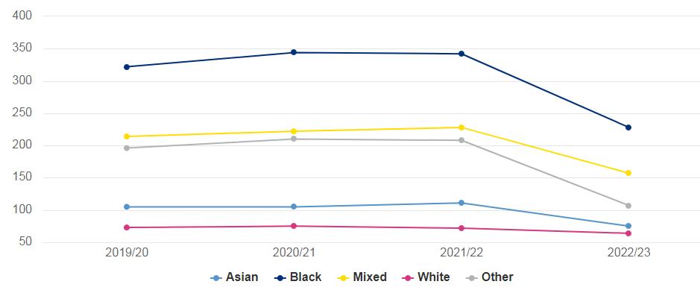
Figure 1: Detentions under the Mental Health Act for every 100,000 people in the UK
(Source: Gov.UK, 2024)
Extreme mental health inequality and detention
Mental health is a major area of inequality relating to the selected ethnic group. In the UK, Black people are 3.5 to 4 times more likely to be detained under the Mental Health Act than White people (Gov.UK, 2024). For instance, recent statistics report 228 detentions per 100,000 Black people and 64 per 100,000 White people. This is linked to accessing mental health services, stigma, distrust, and bias within the system.
Social issues
Socioeconomic inequality and disadvantage
Inequality in health is magnified by socioeconomic disadvantage (Morenz et al. 2024). Black African and Caribbean groups are affected by deprivation and low income in comparison to White British. According to the report, over 18%-20% of Black African and Caribbean people live in the most income-deprived 10% of neighbourhoods in England (Gov.UK, 2020). This exposes them to poor housing and environmental conditions and lack of healthy foods, leading to poorer physical and mental health.
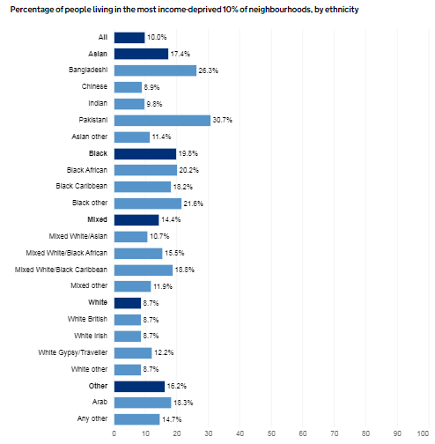
Figure 2: Black Africans and Caribbean in the most income-deprived 10% of neighbourhoods in England
(Source: Gov.UK, 2020)
Access and use of health services
Equality of access to health care services is an important area. Research indicates that black people are less likely to use primary health care services and more likely to enter the system at points of crisis. For example, 65% of black people have reported prejudice by doctors and other care staff (Iacobucci, 2022). This contributes to lower health outcomes and compulsory treatment rates. This may be due to language issues, lack of cultural awareness, or previous poor experiences with health care systems that decrease trust and timely engagement.
Racial discrimination and structural inequality
Racial discrimination remains an important driver of health for ethnic minorities (Javed et al. 2022). Studies have found that discrimination is linked with lower life satisfaction and the development of chronic diseases. Inequalities in employment, housing, and education feed into these disparities. In the UK, the unemployment rate for ethnic minorities was 12.9% compared to 6.3% for White people (EHRC, 2020). African-Caribbean workers with degrees receive 23% less salaries on average than White workers. Discrimination and its impact on chronic stress are associated with health issues such as high blood pressure and psychiatric disorders, resulting in long-term health disparities.

National response to reduce health inequalities
A major national response is the creation of the 'NHS Race and Health Observatory' in 2021, which aims to explore and address ethnic inequalities in health care (NHS Race and Health Observatory, 2026). It offers evidence-informed policy advice and supports improvements in the NHS to address issues facing minority ethnic groups. The initiative is important because Black people are disproportionately impacted by health conditions. For instance, they are nearly five times more likely than white people to be sectioned under the Mental Health Act, indicating a clear need for direct action (NHS Race and Health Observatory, 2026).
A second key response is the ‘NHS Core20PLUS5 strategy’, which is part of the national improvement programme to tackle health inequalities, led by NHS England (NHS England, 2026). This strategy targets the most disadvantaged 20% of the population and certain ethnic minority populations, emphasising conditions like cardiovascular diseases and diabetes. This is a critical response as 26% of deaths in ethnic minority groups are attributed to cardiovascular effects, proving the need for prevention and targeted care.

Organisations that support ethnic groups
A UK-based charity organisation that focuses on addressing health disparities in Black African and Caribbean communities is Black Health Initiative. It focuses on physical and mental health through culturally relevant education and engagement activities (Black Health Initiative, 2026). It raises awareness of issues, including diabetes, hypertension, and mental health, that disproportionately affect people of African descent. Significantly, it seeks to mitigate stigma and increase access to health services through outreach, workshops, and collaborations with community health providers. For instance, it helps people identify early signs and promotes early access to preventative care. Through community empowerment and equitable health care advocacy, this organisation helps to address both health inequalities and broader injustice.

Goal statement
This task aims to review health inequalities for Black African and Caribbean communities in the UK, including disease types and social determinants. It seeks to assess national and organisational responses and identify gaps in policy and practice, in the hope of informing more equitable and culturally sensitive care and better health outcomes.

Conclusion
Lastly, this task raises important health inequalities among Black African and Caribbean populations in the UK, including greater risks of hypertension, diabetes, and mental health inequalities. These are compounded by low socioeconomic status, healthcare access barriers, and racism. National programs and strategies, such as the NHS Race and Health Observatory, and community organisations, like Black Health Initiative, are critical, but there is room for bridging gaps to ensure equitable health outcomes.

Task 2: Epidemiological Analysis

Introduction
Type 2 Diabetes is a chronic metabolic condition that results in insulin resistance and high blood glucose levels, and can cause a range of complications, including heart disease, renal failure, and peripheral nerve damage. In the UK, the impact of the condition is especially marked in South Asian populations in urban areas like Tower Hamlets. The condition has significant cultural, social, and health implications, including decreased quality of life, higher health-care costs, and loss of productivity. Cultural food preferences, socioeconomic disadvantage, and low levels of exercise in some cultures are also contributing factors to this health burden. The chronicity of the disease places additional demand on the health system and has the potential to increase health inequalities and disadvantage.
Type 2 Diabetes is a global health concern. About 590 million people have diabetes in the world, of which 90% are Type 2 diabetes (IDF, 2024). In the UK, some 4.2 million people have diabetes, and rates are rising, according to the National Health Service (NHS) England (NHS, 2025). Thus, this disease has severity among the largest population.

Main body

Public health measures drawing on 3P
The management of Type 2 Diabetes in Tower Hamlets has adopted the 3P's approach to improve public health: prevention, protection, and promotion. Prevention strategies include early risk detection strategies led by local authorities and health providers such as the NHS Diabetes Prevention scheme. The NHS Diabetes Prevention scheme has helped about 1 million people, and it has reduced the development of Type 2 diabetes by 37% (NHS, 2025). This uses lifestyle change techniques such as physical activity and diet modification for individuals with pre-diabetes.
Early detection rates have been chosen through screening initiatives across East London. Finally, promotion strategies by Diabetes UK selectively target culturally-specific education strategies and community engagement.

Risk factors
Determinants / Risk Factors | Explanation
Ethnicity | South Asian populations living in Tower Hamlets have a significantly higher genetic susceptibility to Type 2 Diabetes compared with White European groups.
Obesity and Physical Inactivity | Excess body weight and sedentary lifestyles increase insulin resistance and are major contributors to diabetes development.
Socioeconomic Deprivation | Higher levels of poverty limit access to healthy foods, healthcare services, and opportunities for physical activity.
Dietary Patterns | High consumption of refined carbohydrates, sugary drinks, and processed foods increases long-term diabetes risk.
Age and Family History | Individuals over 40 and those with a family history of diabetes have a greater likelihood of developing the disease.
Table 1: Type 2 diabetes in Tower Hamlets
(Source: Self-created)

Affected or at risk in a specific, defined population
The determination of risk in Type 2 Diabetes in Tower Hamlets with the help of epidemiological research and health needs assessment statistics. Local health profiles indicate that the prevalence of diabetes in the borough is one of the highest in London, with approximately 6.8% of registered GPs showing diabetes diagnosis, and thousands more are believed to be undiagnosed because of the low use of screenings (Tower Hamlets Council, 2023). Also, national epidemiological data show that 243,160 people in England are living with Type 2 diabetes, showing the level of seriousness of the disease on a national scale (NHS Digital, 2023). Some population groups within Tower Hamlets are more at risk, such as adults aged over 40 years, those of South Asian descent, and anyone who is socioeconomically deprived. Moreover, 3,615,330 people in England have been detected as having pre-diabetes through national screening programmes (NHS, 2024). This means that there are many people at risk of getting this condition even in the future. The results underscore the importance of community-specific public health interventions in high-risk communities.
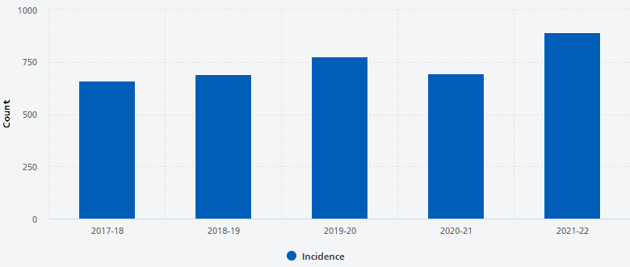
Figure 3: Incidence of Type 2 diabetes in England
(Source: NHS, 2023)

Public health approaches and strategies
One of the primary sources of data is the National Diabetes Audit, which gathers data from GP surgeries and hospitals to monitor the diagnosis, treatment, and complications of diabetes. The audit reveals that nearly 98% of General Practices in England report diabetes data, enabling the monitoring of diabetes incidence and quality of care in local populations (NHS, 2023).
Another key surveillance mechanism is data collection by the NHS Digital, which gathers primary care and hospital acute admissions data. They allow tracking of diabetes-related hospital admissions, which provides information about the cost of diabetes. The cost of diabetes in England is £1.5m an hour or 10% of the NHS budget (Diabetes, 2025). Furthermore, the Office for Health Improvement and Disparities publishes local public health profiles which track trends in diabetes prevalence, risk factors, and inequalities on a borough-by-borough basis. By integrating these surveillance systems, policymakers and health care providers can determine risk factors, monitor trends in incidence, and implement prevention and management strategies in Tower Hamlets

Plan and use epidemiology
A community-based intervention programme that facilitates a reduction in the rate of Type 2 Diabetes burden in Tower Hamlets must be based on community preventive measures and models of behavioural change. The Health Belief Model can be used to guide the intervention, as it is assumed that a person will have a higher probability of engaging in healthier behaviours as soon as the person is aware of the severity of possible complications. Culturally specific education reinforcement might be administered within the framework of community centres, mosques, and GP clinics to raise awareness about Type 2 diabetes (Abu-Ras et al. 2024). The programme can be comprised of free screening of blood-glucose, dietary counselling, and formal physical-activity consultation. These approaches can be compared to the NHS Diabetes Prevention Scheme, which has proved to have quantifiable results. The interventions, the subjects who completed the programme had reduced weight and were now able to regulate their blood sugar levels better, meaning that they were at a lower risk of becoming diabetic. Participation, body mass index changes, and a decrease in new diabetes cases based on GP records and community health surveys in Tower Hamlets can be monitored in programme evaluation. Constant observation might aid in the identification of whether the intervention is beneficial in enhancing prevention and early diagnosis.
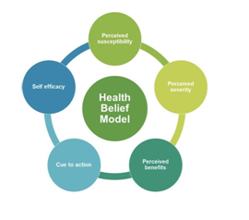
Figure 4: Health Belief Model
(Source: Week 4, Slide no.11)

Design an appropriate health intervention programme and evaluate the impacts
A successful intervention programme to decrease the burden of Type 2 Diabetes in Tower Hamlets needs to be prevention-based, early diagnosis, and lifestyle change among the vulnerable population. An appropriate example is a prevention programme that can be found in a community that is connected with the NHS Diabetes Prevention Scheme (NHS, 2025). The intended intervention would include free health screenings, culturally relevant education, and physical exercise activities delivered in custodial centres and GP practices. One advantage of lifestyle interventions is that they have been proven to decrease the risk of disease significantly.
Those who took part in it not only lost an average weight but also had a lower HbA1c level, which showed that they were in better control of their metabolic condition. Moreover, an effective intervention includes. Proper diet and medication can reduce the risk of Type 2 diabetes by 50% (NIHR, 2023). Measurements of screening uptake changes, blood glucose levels, and screenings detecting new cases of diabetes can be used at the borough to evaluate the programme. Constant follow-up of GP records and community surveys might aid in assessing whether the intervention enhances the early identification and decreases the prevalence of diseases in the long term.

Strengths and weaknesses
The epidemiological methods are valuable in terms of informing about the distribution and determinants of Type 2 Diabetes in a given population, like Tower Hamlets. One of the strongest things about epidemiology is that it offers the analysis of large population data to determine trends and risk factors. As an example, the prevalence of diseases by age, ethnicity, and socioeconomics can be studied using national data on health collected by the Office for National Statistics and NHS Digital. This information is useful to policy-makers in distributing resources in healthcare and formulating specific prevention programmes. The other benefit is that epidemiological research is capable of measuring the financial impact of illnesses. Diabetes is estimated to cost the NHS approximately £10 billion each year, which is about 10% of the NHS's spending (NHS, 2022).
However, there are also limitations with epidemiological approaches. Most of the datasets are based on those diagnosed, whereas those not diagnosed might not be represented, and the true prevalence is underestimated. Also, observational studies tend to determine associations and not specific cause and effect between risk factors and disease. In spite of the restrictions, epidemiology is still critical in comprehending the contexts of diseases and directing effective interventions and health planning to populations.

Conclusion
It can be concluded that Type 2 diabetes is a significant health problem in Tower Hamlets due to high prevalence and effect on health care resources. Epidemiological evidence is useful for monitoring disease patterns, identifying high-risk populations, and determining determinants such as socioeconomic inequality. Public health surveillance systems and health needs assessments also provide significant information for the prevention of this disease. Application of the health belief model might be effective for early detection and developing health outcomes.

References
Abu-Ras, W., Aboul-Enein, B.H., Almoayad, F., Benajiba, N. and Dodge, E., (2024). Mosques and public health promotion: a scoping review of faith-driven health interventions. Health Education & Behavior, 51(5), pp.677-690.
Baptiste, D.L., Turkson‐Ocran, R.A., Ogungbe, O., Koirala, B., Francis, L., Spaulding, E.M., Dennison Himmelfarb, C. and Commodore‐Mensah, Y., (2022). Heterogeneity in Cardiovascular Disease Risk Factor Prevalence Among White, African American, African Immigrant, and Afro‐Caribbean Adults: Insights From the 2010–2018 National Health Interview Survey. Journal of the American Heart Association, 11(18), p.e025235.
Black Health Initiative, (2026). Providing Information & Practical Support. Available at: https://www.blackhealthinitiative.org/ [Accessed on: 27th April, 2026]
Diabetes UK, (2025). 97% of people from ethnic minority communities have experienced diabetes-related stigma. Available at: https://www.diabetes.org.uk/about-us/news-and-views/97-per-cent-people-non-white-communities-have-experienced-diabetes-related-stigma [Accessed on: 27th April, 2026]
Diabetes, (2025). Cost of Diabetes. Available at: https://www.diabetes.co.uk/cost-of-diabetes.html [Accessed on: 26th April, 2026]
EHRC, (2020). Race report statistics. Available at: https://www.equalityhumanrights.com/our-work/our-research/race-report-statistics [Accessed on: 27th April, 2026]
Farmaki, A.E., Garfield, V., Eastwood, S.V., Farmer, R.E., Mathur, R., Giannakopoulou, O., Patalay, P., Kuchenbaecker, K., Sattar, N., Hughes, A. and Bhaskaran, K., (2022). Type 2 diabetes risks and determinants in second-generation migrants and mixed ethnicity people of South Asian and African Caribbean descent in the UK. Diabetologia, 65(1), pp.113-127.
Gov.UK, (2020). People living in deprived neighbourhoods. Available at: https://www.ethnicity-facts-figures.service.gov.uk/uk-population-by-ethnicity/demographics/people-living-in-deprived-neighbourhoods/latest/ [Accessed on: 27th April, 2026]
Gov.UK, (2021). Independent report: Health. Available at: https://www.gov.uk/government/publications/the-report-of-the-commission-on-race-and-ethnic-disparities/health [Accessed on: 27th April, 2026]
Gov.UK, (2024). Detentions under the Mental Health Act. Available at: https://www.ethnicity-facts-figures.service.gov.uk/health/mental-health/detentions-under-the-mental-health-act/latest/ [Accessed on: 27th April, 2026]
Iacobucci, G., (2022). Most black people in UK face discrimination from healthcare staff, survey finds. BMJ.
IDF, (2024). Diabetes Facts & figure. Available at: https://idf.org/about-diabetes/types-of-diabetes/type-2-diabetes/ [Accessed on: 26th April, 2026]
Javed, Z., Haisum Maqsood, M., Yahya, T., Amin, Z., Acquah, I., Valero-Elizondo, J., Andrieni, J., Dubey, P., Jackson, R.K., Daffin, M.A. and Cainzos-Achirica, M., (2022). Race, racism, and cardiovascular health: applying a social determinants of health framework to racial/ethnic disparities in cardiovascular disease. Circulation: Cardiovascular Quality and Outcomes, 15(1), p.e007917.
Morenz, A.M., Liao, J.M., Au, D.H. and Hayes, S.A., (2024). Area-level socioeconomic disadvantage and health care spending: a systematic review. JAMA network open, 7(2), p.e2356121.
NHS England, (2026). Core20PLUS5 (adults) – an approach to reducing healthcare inequalities. Available at: https://www.england.nhs.uk/about/equality/equality-hub/national-healthcare-inequalities-improvement-programme/core20plus5/ [Accessed on: 27th April, 2026]
NHS Race and Health Observatory, (2026). About us. Available at: https://nhsrho.org/about-us/ [Accessed on: 27th April, 2026]
NHS Race and Health Observatory, (2026). Driving racial equity in health and care. Available at: https://rho-harp.org/ [Accessed on: 27th April, 2026]
NHS, (2022). NHS Prevention Programme cuts chances of Type 2 diabetes for thousands. Available at: https://www.england.nhs.uk/2022/03/nhs-prevention-programme-cuts-chances-of-type-2-diabetes-for-thousands/ [Accessed on: 27th April, 2026]
NHS, (2023). National Diabetes Audit 2021-22, Report 1: Care Processes and Treatment Targets, Detailed Analysis Report. Available at: https://digital.nhs.uk/data-and-information/publications/statistical/national-diabetes-audit/report-1-care-processes-and-treatment-targets-2021-22-full-report/section-1---incidence-and-prevalence-17-18---21-22-copy [Accessed on: 26th April, 2026]
NHS, (2023). National Diabetes Audit 2021-22, Type 1 Diabetes - Overview. Available at: https://digital.nhs.uk/data-and-information/publications/statistical/national-diabetes-audit-type-1-diabetes/nda-type-1-2021-22-overview [Accessed on: 26th April, 2026]
NHS, (2024). NHS identifies over half a million more people at risk of type 2 diabetes in a Year. Available at: https://www.england.nhs.uk/2024/06/nhs-identifies-over-half-a-million-more-people-at-risk-of-type-2-diabetes-in-a-year [Accessed on: 26th April, 2026]
NHS, (2025). Diabetes treatment and care programme. Available at: https://www.england.nhs.uk/diabetes/treatment-care/ [Accessed on: 26th April, 2026]
NHS, (2025). NHS diabetes prevention scheme helps one million people. Available at: https://www.england.nhs.uk/2025/12/nhs-diabetes-prevention-scheme-helps-one-million-people/ [Accessed on: 26th April, 2026]
NIHR, (2023). Reducing the risk of type 2 diabetes. Available at: https://bepartofresearch.nihr.ac.uk/news-and-features/type-2-diabetes [Accessed on: 27th April, 2026]
Towerhamlets, (2023). Tower Hamlets Pharmaceutical Needs Assessment (PNA) 2023. Available at: https://www.towerhamlets.gov.uk/Documents/Public-Health/JSNA/Pharmaceutical-needs-assessment-report.pdf [Accessed on: 26th April, 2026]

