

  - Elliot Allsop

  - MODELLING- M5X01280

  - IRINa Neaga

  - contents

- Introduction

- History of Toyota

- The Supermarket Method

- Kanban Signal

- Main Items

- Kanban Board

- Advantages

- Case Studies- McDonalds

Executive summary
First the following report aims to define and explain the two frequently used manufacturing terms called Kanban and lean production, these two terms tend to be used similarly as they both are used similarly when thought about in terms of saving or reducing waste within a business, Also discussed below will be the history of the superior Toyota and how Kanban came about and where the credit is due to whom actually created the idea and then pioneered it greatly. Then highlighted within the rest of the report will be a compare and contrast between Kanban systems and however similar they may be and used conjunctively, which is a lot. Next the report will correspondingly identify potential problems within Kanban models and analyze potential opportunities in order to solve them as well as within simulations of Kanban models. This will be completed by finding suitable Kanban models and vigorously identifying potential flaws within the system and then confidently solving the potential issues. Some case studies may also be incorporated within the report especially on Kanban signal cards, to show what they typically look like as well as what all the content contained on them means or job is exactly. McDonalds will also be touched on to show how their production line runs and what systems are used.

1 Introduction
So let’s start with explaining what a Kanban system is and what it consists of, so Kanban Is a Japanese word and means visible record which will make a lot of sense soon and according to the Kanban blog (Kanbanblog.com, 2018), It is a “new technique for managing a software development process in a highly efficient way” (Kanbanblog.com, 2018). The Kanban further highlights on Toyota’s “just in time production system” JIT which some business will use if they are efficiently run. The main factor to recall here with using the Kanban system is that it is so versatile and can be used variously whether it be mass-producing cars or in food or retail, the main component for running the production line lean can still be applied. Kanban is so great and widely used because it logically helps business whom implement a system into their business which drastically reduces wastage. As discussed by Arnaldo Hernandez “Toyota developed Kanban to move materials in a controlled environment” this environment was only driven by the usage of parts (Hernández del Campo, 1989). In some respect Kanban systems are seen as a “visual workflow management tool” when put simply and can lead to greater results and output with reduced stress levels. (LeanKit, 2018)
2 Toyota’s History with Kanban
One of the main reasons for Toyota’s superior recognition is down to all its methodologies such as Kanban which it was recognized for back in the seventies due to reducing and maintaining the lowest levels of raw materials at the time. These levels were thought to be dreamed off then. Another closely featuring technique was their just in time approach with producing their automobiles “only what is needed, when it is needed and in the amount needed” (CORPORATION. 2018) Toyota state that when sticking to production plan whenever producing lots of automobiles helps them to eliminate waste due to only supplying what they need, when they need it and in the quantity required. In addition to this behavior or method it can also reduce or eliminate any inconsistencies and non-requirements which will effectively improve efficiency and productivity whilst maintaining reasonable costs.

3 The Supermarket Method
Within Toyotas production system Kanban plays a crucial role, the Kanban system which has also been referred to as the “supermarket method”. The reason behind this is because like Taiichi Ohno explains that a supermarket is where a customer’s “can get (1) what is needed, (2) at the time needed, (3) in the amount needed” and finalizes by stating that a supermarket is a place that we go to when we purchase in the quantity that we need when we need it. Which when reflect over makes a lot of sense and readers can then see why Taiichi adopted this methodology and created Kanban to what it is widely known as today. Taiichi also saw the benefit in American supermarkets to withdraw the shopkeeper and make supermarkets more self-serviced in the ways of American supermarket and had also adapted it to work suitably with the production line for his automobiles.
By also implementing the supermarket method or Kanban it saved Toyota at one point $250,000 and spared up another 60,000 square foot of storage space which could now be used for something totally different if desired. (Emiliani, 2018)

4 Kanban Signal card
Firstly there are many different Kanban cards out there and it will vary between businesses and some may even have adapted to or implemented Ekanban, totally ejecting physical Kanban cards form the business totally which to some will seem a more sustainable move, and to others it will not due to the fact that using computer software may use more energy and produce more pollution. Anyhow Kanban cards have many different markings or different pieces of text on them, below in figure one and figure tow are Kanban cards which are relatively simple when explained, one very basic in style with a lot of info for the worker and the other rather colorful as more short and snappy really with more meaning.

Kanban one 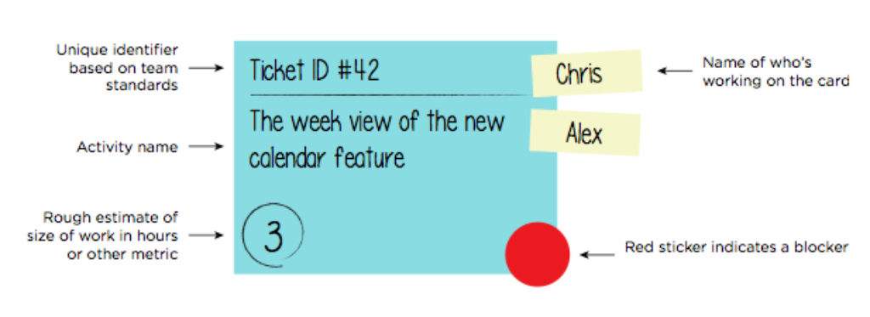
Figure 1 source: (LeanKit, 2018)

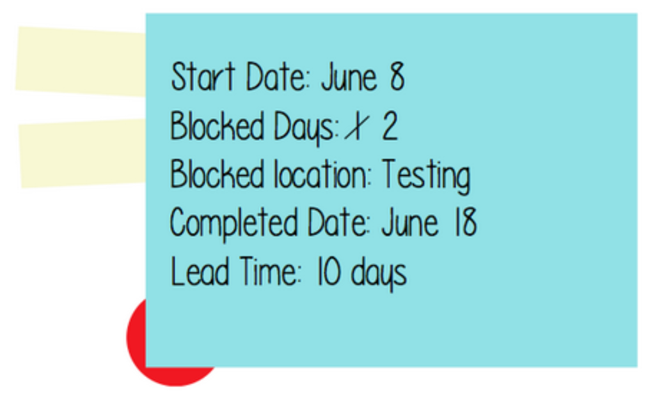
Kanban two
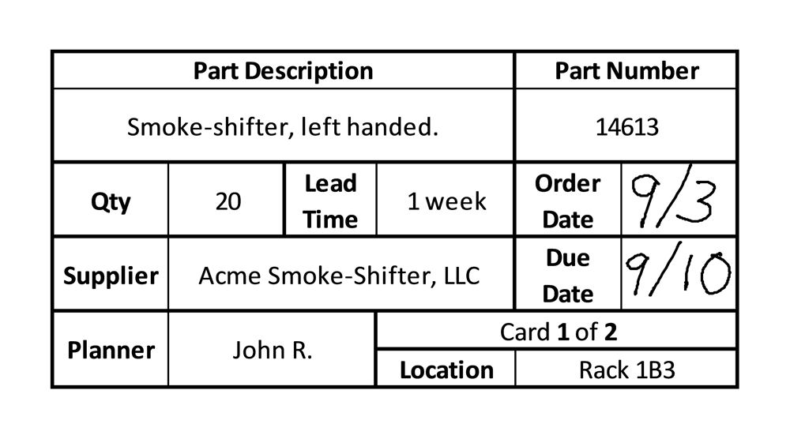
Figure two Source: http://cerasis.com/2013/10/14/what-is-kanban/

So as above you can see Kanban one looks very friendly and informative and simple to follow as if a child just made it and the other, Kanban two very basic and boring some may think, however it be viewed it’s there as a set of instructions in order to restock a specific inventory within a specific time and specific quantity. It will even have a certain individuals name or photo id in order to recollect who’s produced the card or whom is to receive the card and restock the inventory as follows. The Kanban will aid workers when trying to understand items in the work detail. It will also help members when progressing up through the production line. It can be sued to document crucial notes and also record specific work measures and metrics which can be used at a later date and massively improve the flow of work and progress.
5 Main items
All in all the main requirements to be presented on the card are the ticket id, name of individual working on the card, task description, minimum quantity needed, urgency of ticket usually represented by a symbol likewise with the red circle above. Date issued and how long it should take. In addition to this part number or characteristics such as location will regularly be found too. ON the rear of the Kanban card more details will also be found but these however will be more specific than the front or will be finished on the back in the sense that there want enough room on the front as these Kanban cards aren’t that big. However not all Kanban cards have information on the back this is optional though, the main information contained on the back are can be contact numbers for help, task checklists as well as what cannot fit on the front (Shmula, 2018). In addition to above the front side of the card is what all workers see first and so needs to contain the most crucial information and can be color coded accordingly to whom it may concern or for specific tasks to be undertaken.

6 Kanban Board
Most business that use physical Kanban cards/ tickets will also have a Kanban board which you can see below in figure four and it simply allows them to track the progress of the projects or task being undertaken. This is done by splitting the board into three sections starting with “To do, in progress and done”.

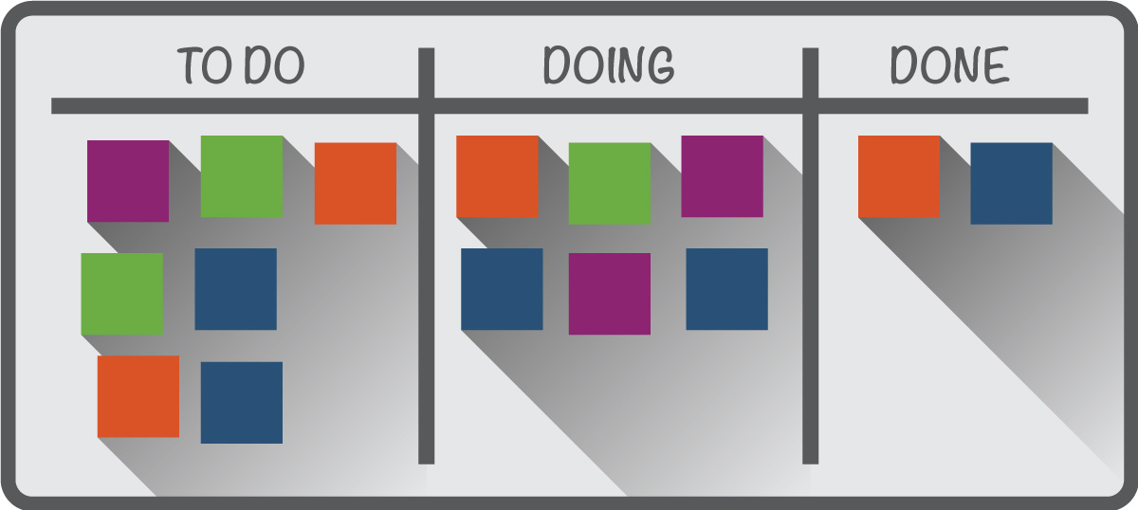
Figure 4 Source: (Smartsheet, 2018)

7 Advantages of implementing Kanban
There are many advantages to using Kanban systems within the workplace and
These will differ according to the business type and size. However the advantages are as follows in figure five.
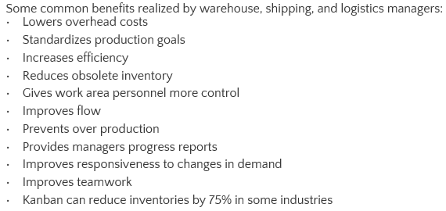
Figure five Source: cerasis.com
Overall the main advantage to realize is the reduced or even eliminated cost of maintaining stock due to the Kanban system allowing the business to entirely reduce their inventory levels however this can be catastrophic when thought about in undesired scenarios where businesses may order their stock to the production line vie a just in time technique and so if the delivery is late then that production line is not moving which means no goods being made however staff and utilities are still being incurred. Creatively some businesses use their customers demand to know when to order stock rather than base it off forecasts and off previous ales data from last year. (Transportation Management Company | Cerasis, 2018)

Disadvantages
The main disadvantages would logically be stock outs due to insufficient stock inventory being reordered which would lead to a stock out and then again lead to the production line shutting down which equals not good. Additionally depending on how large the lead time is would have an effect on the business because logically if too long and the current stock is depleted again there would be a stock out. Lastly according to (Chron.com) the business may adjust their Kanban levels more than several times in order to find the optimum level of materials to have for production or distribution.

8 Kanban Case Studies
So analyzing a simulation and modelling of a Kanban system well let’s start with McDonalds, Remember back in the older days when you were a child ordering your food and McDonalds were really quick at it. Like literally the burger would just come off the cooked shelf. People would notice that there were a few rows of ready cooked and ready to eat burgers. In addition to this once the last burger was taken there would be a warning plate (Kanban) and this would be put in the tray so that workers would know to make more of them burgers. However when thought about those burgers were not needed right away just then more than likely and so are deemed as a waste off stock as well as efficiency when thought about. No doubt they would have been sold say five minutes later but that not really an efficient usage of stock (Tqm.com.hk, 2018).
Now today it’s totally different now as they have actually gotten rid of this Kanban approach within their production line and apart from the ticket really being the Kanban. However if this is the case there are thousands of Kanban’s every day when thought about, due to the fact that no customers order is ever the same. The only thing Kanban about McDonalds now is the ticket with your order because as soon as this is put through that’s when the burgers or other products are made further utilizing the efficiency of stock use rather than making products for customers who haven’t ordered yet etc. This system further ignores past sales data. The advantages of this approach are fresh food of course, it improves efficiency of stock as well as minimizing it, and it also allows lower inventory levels to be held which also means less stock to maintain which also means a lot of reduced costs. So it’s relatively clear to see that McDonalds used to focus on a Kanban Push system however things have now changed and now they use pull production instead. The greater benefits of this type of Kanban are that McDonalds as a manufacturer if you like have more precise production as well as the actual consumption of their customers, again there are lower inventories needed due to less waste and all products being produced by order, waste is now heavily reduced, management will be by sight so if lots of customers walk in then one little workers will be cooking a lot of fries ready (Speedboard.co.uk, 2018).
Obeyaka
It’s clear to see that McDonalds does have one feature rather complicit at every branch and that is their layout or as (Lean Production, 2018) refer to it , Obeyaka which means lean layout which coincidentally makes a lot of sense due to the nature of McDonalds Kanban pull system. What is meant by the above point is that if people think reflectively to every McDonalds they have been to, then they will notice everything is relatively consistent in its own place. Noticeably customers will be able to see most of the sections distinguishably such as the fryers, the burger and wrap making section and the preparation unit at the front. This will drastically aid the pull-Kanban system in place as each section once completed their product will just report to the preparation unit. Making the most out of their space efficiently and topping up items where required (Lean Production, 2018).

Conclusion
It’s fair to say that Kanban systems however sophisticated they are, are truly simple when broken down and explained easily. Also, respectively towards Taiichi Ohno as the founder of the Kanban and later pioneered it when implementing into Toyota’s production line when developing upon their just in time method of restocking. Which beneficially enables them to reduce stock holding costs however it can be very risky when stock outs occur due to late deliveries. It should be noted that Kanban was derived from supermarkets not just initially created by Ohno. Due to Ohno’s cleverness and ability to visualize running the production line on as little materials and only when needed earned Toyota superiority back in the seventies as the levels were extremely lower than ever. To remember if ever using Kanban systems is that the signal cards should be simple to follow, and nay extra crucial information can be placed on the back fi needed and that the card is the key to restocking. Kanban boards are highly effective tools for tracking the progress of the production and to see where more effort is required. One solution for using Kanban is to use it effectively and ensure there an adequate number of Kanban signal cards to keep up with the customer demand, this is because this demand will fluctuate daily. Also, it’s imperative to have Kanban systems in place to maintain the efficiency within the business and reduce wastage. Kanban systems also free up a lot more space which can be used for more vital equipment or work area.
Also, when looking at McDonalds when they used to hot hold some food beforehand or in and out of the day using their Kanban cards for 10 more burgers or so was not really efficient and so stock would be wasted due to legal reasons, in addition to this the food would not be fresh either. Now in McDonalds everything is prepared freshly in front of you as soon as the ticket comes through. These are the reasons why Kanban systems should be adopted more for efficiency rather than convenience.

References
Browne, J., Harhen, J. and Shivnan, J. (1999). Production management systems. Harlow, England: Addison-Wesley Pub. Co.
Contributor, S. (2018). How to Implement Kanban Cards |. [online] Shmula. Available at: http://www.shmula.com/how-to-implement-kanban-cards/22430/ [Accessed 23 Apr. 2018].
CORPORATION., T. (2018). Toyota Global Site | Just-in-Time. [online] Toyota Motor Corporation Global Website. Available at: http://www.toyota-global.com/company/vision_philosophy/toyota_production_system/just-in-time.html [Accessed 17 Apr. 2018].
Emiliani, B. (2018). Toyota's Supermarket Method. [online] Bob Emiliani. Available at: https://bobemiliani.com/toyotas-supermarket-method/ [Accessed 17 Apr. 2018].
Hernández del Campo, A. (1989). Just-in-time manufacturing. Englewood Cliffs, New Jersey: Prentice-Hall.
Hygger. (2018). Lean vs Kanban. [online] Available at: https://hygger.io/blog/lean-vs-kanban/ [Accessed 17 Apr. 2018].
Lean Production. (2018). Pull & Kanban - 5 Learnings from McDonald's - Lean Tutorials. [online] Available at: http://www.lean-production.org/3m-lean-layout/kanban-pull-mcdonalds/ [Accessed 23 Apr. 2018].
LeanKit. (2018). What is a Kanban Card? | LeanKit. [online] Available at: https://leankit.com/learn/kanban/kanban-card/ [Accessed 23 Apr. 2018].
LeanKit. (2018). What is Kanban? | LeanKit. [online] Available at: https://leankit.com/learn/kanban/what-is-kanban/ [Accessed 17 Apr. 2018].
Muhlemann, A., Oakland, J. and Lockyer, K. (2006). Production and operations management. Harlow [etc.]: Prentice Hall/Pearson Education.
Pdfs.semanticscholar.org. (2018). [online] Available at: https://pdfs.semanticscholar.org/3622/6df1ce4f102f979a6c5799cda053e2ff0b5e.pdf [Accessed 23 Apr. 2018].
Smallbusiness.chron.com. (2018). What Is an Inventory Kanban?. [online] Available at: http://smallbusiness.chron.com/inventory-kanban-13301.html [Accessed 23 Apr. 2018].
Smartsheet. (2018). Everything You Need to Know About Kanban Cards. [online] Available at: https://www.smartsheet.com/everything-you-need-know-about-kanban-cards [Accessed 23 Apr. 2018].
Speedboard.co.uk. (2018). Kanban System in Manufacturing- Speedboard Asssembly Services. [online] Available at: http://www.speedboard.co.uk/materials-management/kanban/ [Accessed 23 Apr. 2018].
Tqm.com.hk. (2018). KanBan System in McDonalds. [online] Available at: http://www.tqm.com.hk/index.php/en/news-events/insight/593-kanban-system-in-mcdonalds [Accessed 23 Apr. 2018].
Transportation Management Company | Cerasis. (2018). What is Kanban and How Can it Aid in Lean Manufacturing?. [online] Available at: http://cerasis.com/2013/10/14/what-is-kanban/ [Accessed 23 Apr. 2018].
Wheatley, M. (1992). Understanding just in time in a week. [S. l.]: Headway.

