

Did Local Implementations of Defence Plans for the Second World War in Suffolk Match Those Laid Out by the GHQ ‘Stop-Line’ Plans?
Rachel Marsh

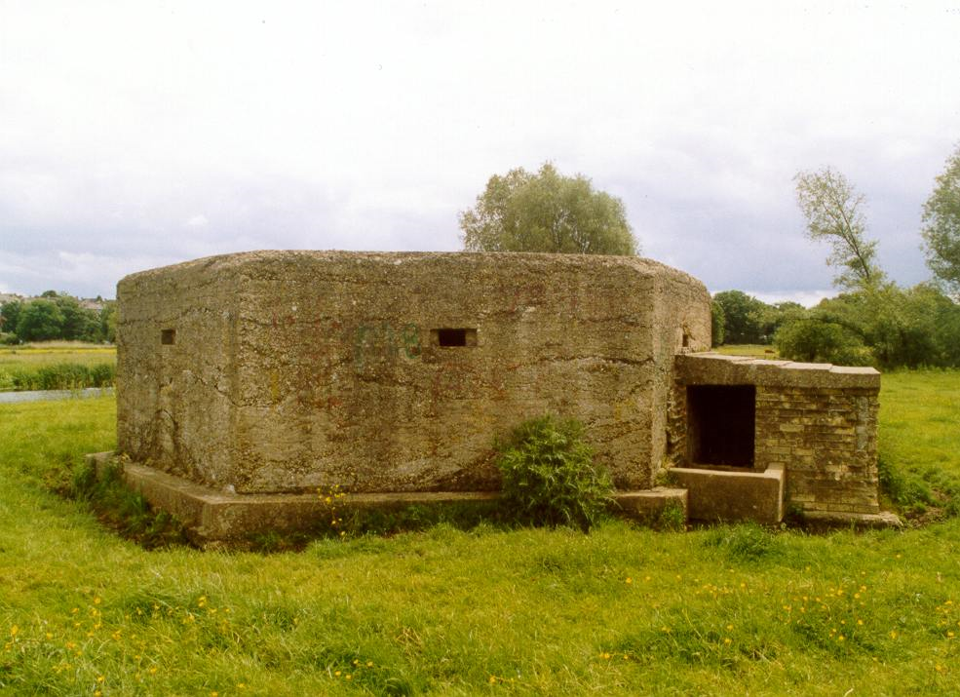

Acknowledgements
The writer of this report would like to thank Ros and Martin for their virtually endless patience and wisdom, which has hopefully translated into a readable report. The greatest thanks go to the volunteer recorders for the ADS “Defence of Britain” project without whom this report would have been missing a data set and therefore been impossible.
Also, thanks to Radio 4 whose background chatter and light comedy has aided productivity, paused meltdowns and stopped burnout. Finally, to Gilbert and Sullivan whose tune has been borrowed in the appendix, so that ideas could be worked through and facts remembered, all under the guise of procrastination and operatic comedy.

Table of Contents
- Summary……………………………………………………………………………………………...Page 4
- Introduction………….……………………………………………………………………………..Page 5
- Aims and objectives……………………………………………………………………………..Page 6
- Method………………………………………………………………………………………………..Pages 7-9
- Discussion…………………………………………………………………………………………….Page 10
- Conclusion……………………………………………………………………………………………Pages 11-16
- References and Image Credits…………………………………………………………..…Page 18
- Appendix (the ‘Alternative Summary’)…………………………………………..…….Page 19-20
List of Figures
Cover Photo
Figure 1) Map of surviving WW2 defence installations in Suffolk…………………………Page 7
Figure 2) National map of GHQ stop-lines as planned in May 1940……………………..Page 9
Figure 3) Map of surviving defences showing deviation from GHQ planning……….Page 11
Figure 4) Map showing local Suffolk area defences as designed by 11 Corps……….Page 13
Figure 5) Map showing the Bawdsey area defences in detail……………………………... Page 16

- Summary
This report has been prepared to establish whether Suffolk defences during World War Two followed the General Headquarters (GHQ) stop-line plan of May 1940. This has been carried out by comparison of maps showing:
- The intended national stop-line of fixed defences.
- Surviving fixed defences in Suffolk, prepared by using the Defence of Britain archive.
A case study using these two sources the coastal town of Bawdsey has also been used to demonstrate the differences in nationally planned defences and local interpretations of these. Through these sources it has been established that Suffolk defences, though utilising some stop-line defences was not based on its principles for the majority of the war. Heavy local adaptions were also made to address shortcomings in the GHQ plan. However despite the stop-line as a whole being rendered obsolete very quickly, some defences such as those on the coast and others near towns of strategic importance were reused.

- Introduction
With the threat of imminent German invasion in 1940, General Ironside of General Headquarters (GHQ), the office of the Chiefs of Staff, formed a plan for the defence of the nation from the expected attack. This plan relied upon ‘stop-lines’ of fixed installations such as pillboxes for the protection, and some of these lines, including one main line ran through Suffolk. In this report ‘fixed installations’ should be taken to mean any individual sites meant to aid in defence efforts based in one location for a length of time.
Drawn up in May 1940, the stop lines were intended as the last possible defence for London and the industrial centres from German raids or invasion efforts but were seen by area commanders more as a way of buying time for a reserve force based centrally than a full defence. Stop-lines were planned as forming a line inland across the south, and another inland across the east of Britain up past the Scottish border, though only the Eastern Command and Southern Command areas were actually developed to any extent, during the short period allowed for construction. Many of those built were likely strategically useless but were in most cases maintained if not manned, allowing for a record to be made of known sites which has enabled this report to take place.
This report examines whether this defence plan was followed through in Suffolk by comparing the limited remaining plans of GHQ and Eastern Command with a map created by collating records of existing and known defences within the county.

- Aims and Objectives
The objective of this report is to establish whether Defence Plans in Suffolk during the Second World War followed the GHQ stop-line plan.
The report aims to demonstrate whether the stop-line plan of June 1940 was followed; by comparing the planned defence line with a map of Suffolk’s surviving defences.
The report also aims to suggest whether the stop-line defences were possibly incorporated into later defence plans by comparing their location with known points of importance such as the Suffolk nodal points or ‘vulnerable points’.

- Method
This report started by focussing the investigation on a small area, in this case Suffolk, in order to examine the question in enough to detail to come to a conclusion. Suffolk is especially valuable because the line itself is fairly well documented and some specialist records have survived opposed to other counties, allowing for the possibility of an educated conclusion being drawn. The county was also chosen as it represents a county where the GHQ line is fairly clear, and where surviving installations as recorded for the Defence of Britain Project can be compared to the map of the intended GHQ Stop-Line as drawn up in 1940.
The first dataset is the Defence of Britain Project’s database, created when the Archaeology Data Service (ADS) ended the project in 2002 and updated into its final form in 2006. This included entries for all installations in Suffolk known to the recorders, and classified into groups rather than origin (for instance stop-line installations were alongside later constructions and in some cases dates were not recorded at all). All 523 Suffolk entries had Ordnance Survey Co-ordinates and these were plotted onto a map using Digimap software, in order to demonstrate the distribution of defence installations across a modern map of the county. The map itself has been plotted with different symbols to denote the basic types of defence installations covered by the recorders. These include the pillboxes and defensive earthworks of the GHQ stop-line, as well as others such as gun emplacements, Home Guard outposts, anti-tank defences and roadblocks as well as the nodal points that some localised and later national plans. This is shown below as figure one.
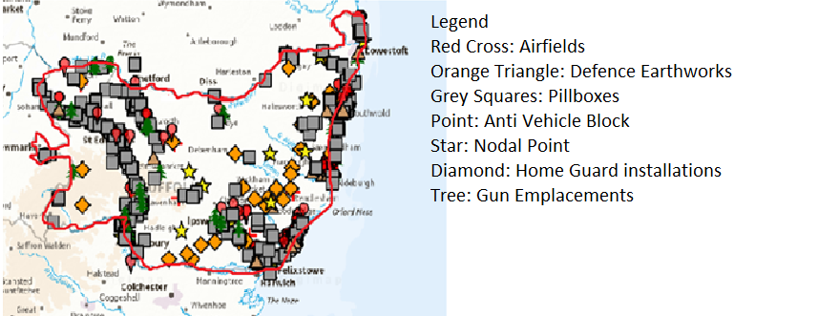
(Figure 1 – Map of surviving installations of Suffolk. The red line indicates the modern county boundaries. Map credit Ordnance Survey)
However, this dataset does have some limitations. The ADS estimates that around 28,000 defence sites (not necessarily individual defences) were constructed nationally during WW2. Of these only about 8000 remained to be recorded by the time of the survey, though some defences that had been removed but which sites could be confirmed, or those identified through aerial photography, were recorded bringing the total for the project to 14691. In addition, since the survey a few further sites may have become known, and the total number of sites across the county is unknown. However, this archive is the best resource available and the margin of error among Suffolk sites cannot be enough to demerit any patterns established from the data sets.
The second dataset comes from the surviving documents and accompanying illustrations of the GHQ wartime plans. This report, as well as looking closely at those records concerning General Ironside’s stop-line plans explicitly, particularly GHQ Operational Orders No.1 and No.3, is also examining reports from around this period, both before and after the period. This is to better understand the plan in context, to see how the defences were supposed to work with the situation at that point in the war. The stop line plan was a last-ditch effort, and is reflected in the simple reading of the memos sent out to Eastern Command and the nature of the maps representing the line.
In order to establish whether the stop line plans were followed in Suffolk this report aims to compare these two datasets. For this, a simple method will be a comparison of the map signifying the known defence installations in Suffolk with the map representing the GHQ line as planned across Britain, where the Suffolk stretch is known to have been virtually completed as intended before the project was cancelled. This map comparison will show whether for the most part the line of actual defences in evidence matches the line as planned. Specific points will be harder to identify as these were rarely specified in the general order, however a general pattern should be visible. Localised defences may represent outliers in this pattern or where show where the pattern has been altered slightly but defences still built. See figure 2 below.
Observations can also be made as to whether any of these defence installations would possibly have been used in later plans such as the replacement “anti-tank” scheme or the nodal point plans, or used to defend specific positions. This can be done by comparing the different types of legends on the map, such as looking at which GHQ line defences lay especially close to airfields or nodal points, and those right on the coast which would almost certainly have seen some use and been incorporated into these defences. Whilst not a guarantee that these would have seen service this too allows the formation of a pattern which should be able to provide some answers.
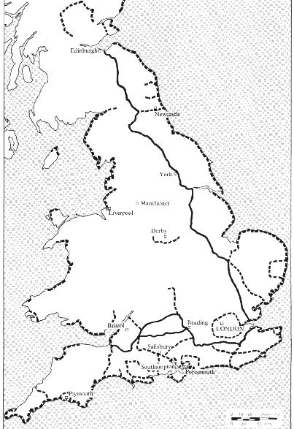
(Figure 2) The GHQ stop lines as planned in May 1940. The bold line denotes the main stop lines, with the dotted lines representing auxiliary lines, including the “coastal crust”.)

- Results
As shown in figures one and two patterns were identifiable showing the correlation between the planned structure of the stop-line defences and the actual field defences as constructed in Suffolk. Obvious there are some limitations brought about in that the GHQ map shows Britain as a whole, and does not go into detail about how the Suffolk line should be constructed. If the report was a simple matter of map analyses it would be possible to state that there is a correlation and that therefore defence plans in Suffolk were at least partially dependent on the stop-line regardless of the many field defences recorded and shown in figure one that do not fit.
However, the extent and detail in the patterning are not obvious in the map comparison and therefore documents from GHQ and the local defence command; Eastern Command are also being analysed to provide further evidence for to support or contradict the aims and objective of this report and will be addressed in the discussion below. This will establish in more detail whether localised defence plans in Suffolk were based on the GHQ plan or if they can otherwise be explained and allow for a more detailed conclusion.

- Discussion
The objective of this report has been to establish whether defence plans in Suffolk broadly follows the stop-line plan laid down by General Ironside in June 1940. This has been done by seeking to find a similarity in the recorded defence positions as shown in figure 1 and the lines as demonstrated in figure 2. This has been aided by the notation in a field report from General Brooke in July 1940, after his replacement of General Ironside as Commander in Chief of the Home Forces. Examining Eastern Command, he noted that ‘… much effort and energy was being expanded on an extensive system of rear defence, comprising an ant-tank ditch and pill-boxes, running roughly parallel to the coast and situated well inland…’. By the time the project was officially cancelled for Eastern Command on August 8th, the lines were ‘…actually almost complete and could act as an anti-tank stop line.’ Work in hand was finished and the stop lines would progress no further. This means that the line in evidence from the known examples were likely as close to the proposed form of the GHQ national plans as the Royal Engineers and Eastern Command intended to follow.
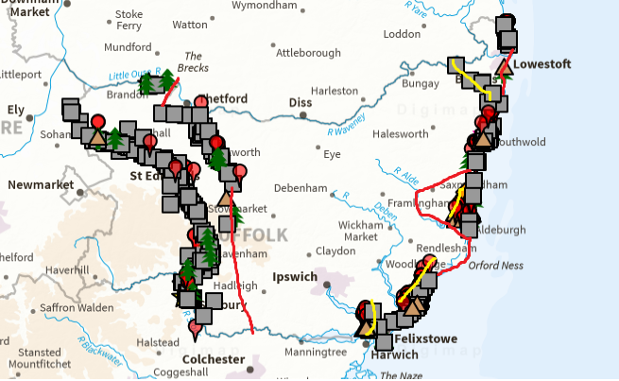
Figure 3) map of Suffolk adapted to show only those defences along the stop lines. Red Lines represent missing defences according to the national plan. Yellow lines represent local additions or bolstering. Map Credit Ordnance Survey)
Figure 3, shown above, evidences the identifiable pattern of the stop-lines running through Suffolk, which formed part of the Eastern Command Stop line. These linked as a bigger entity with defences in Norfolk and Essex to create a solid static defence. Progress was very fast and the line was built over only three months, since Suffolk was part of the high priority zone, ‘between The Wash and Newhaven’ as established in Operational Order No.3. The line on the far left, very much inland, was the main GHQ line, forming an anti-tank defence which could defend the industrial heartland and London from the threat of invasion. The unfinished line in front, was an intended Corps/Division stop-line, an auxiliary line which aimed to allow an advance line for mobile columns to push an invasion force away. With the early realisation that the Home Forces did not have the men or equipment to man even the main lines fully the decision was made not to complete them post August 1940. One small gap in the line is probably due to a local decision that the natural defences provided by the River Waveney were sufficient but the larger part of the missing stretch cannot be recognised as taking advantage of naturally obstructions.
The “coastal crust” was also subject to local adaptions. Defences were thickened at certain key points, especially at Felixstowe, Aldeburgh and Lowestoft, where it was believed landing enemy troops would be easiest. A line running perpendicular to the coast reached Bungay, a local adaption to address fears that a flank could be brought down from Lowestoft. An area of beach defence planned for the Orford Ness area was locally cancelled after a local beach survey carried out by Lt. Col. Spicer of the Royal Marines. Spicer identified that a sandbar would make landing difficult for larger craft and was difficult to approach. Any landing would need detailed local knowledge, so the seaborne invasion beach defences were intended to impede would be extremely unlikely. An airborne invasion was possible but defence was not established. Another relatively undefended area was the coast between Southwold and Lowestoft, though the latter itself is very well fortified. Spicer found that landing a force would be difficult along this stretch with some cliffs, and only available as a landing ground at certain hours but that the area behind it ‘was good tank country’. The coast from Kessingland to Lowestoft was considered ‘suitable for infantry but not tanks’, but still required defence.
Finally, 11 Corps, the force based in Suffolk created their own version of the stop-line plan which was far from in agreement with the national plans, realistically designed for raids more than invasion. This plan more closely resembles the patterns visible in figure one, which included the main stop-line as well as corps stop-lines and “reinforced roads”, a network ‘to delay and impede enemy movement by road’ this opposed to being a series of defended reserve lines as in the national plan. . Defence was based around ‘strong points’ mostly later classified as nodal points, with special protection for Lowestoft with its harbour, having an entire battalion equipped with 18pdr guns dedicated for its defence. The beaches themselves were to remain lightly defended, but the beach exits onto main roads were heavily fortified, explaining the thickening of beach defences visible on figure three. Virtually the whole Suffolk coast was evaluated by 11 Corps as being vulnerable and with personnel shortages, defences were concentrated onto the entries onto hard ground, the German’s only option to avoid the marshes. These were further protected with inland artillery. Demolition charges were placed on all crossings on coastal rivers to bring further delays on invaders. All defences were to be kept to the last man, similarly to the national plan. Also, unlike the national stop-line plan, these were developed well into the war, and most remained in service throughout, with the HLI based in Suffolk in 1941-2 continuing to develop strengthening to the nodal point system under 11 Corps orders. Locally planned pillboxes were built using plans by the division in place and explains the siting of some defences as taking advantage of local knowledge, and even designs were changed from the national standard to take into account Eastern Command’s own requirements.
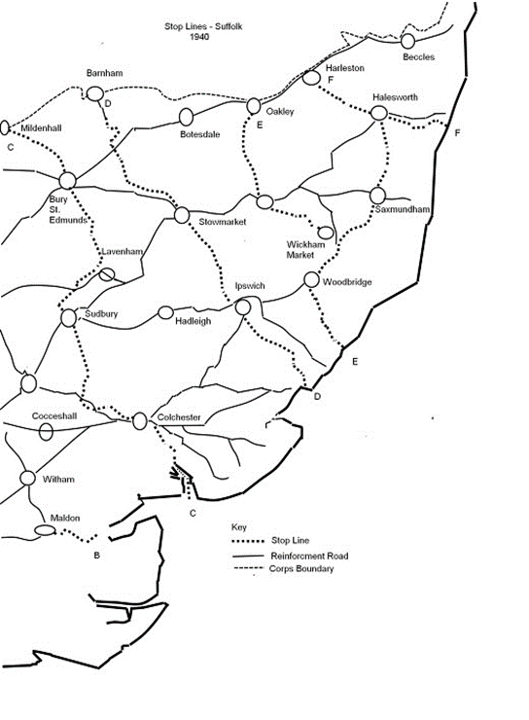
(Figure 4: A defence plan map illustrating the 11 Corps/ Eastern Command localised stop line plan. Image credit to The National Archives )
Even as the stop lines were being constructed the plans were facing heavy criticism by the Vice Chiefs of Staff who were of the opinion that, constructing the line of resistance so far inland was suicidal; ‘it appears that the main resistance might only be offered after the enemy had overrun nearly half of the country, and obtained possession of aerodromes and other vital facilities…’. They advocated the abandoning of some sections. However, regardless of what part of the stop-line plan each defence came under, General Brooke failed to see the value in the static defences so far inland, favouring ‘mobile defences to be held near the coast’. Guns held within fixed gun emplacements on the stop-line were immediately made obsolete with the guns moved to beach defences, and ‘the whole defence was to be moved nearer the coast. The GHQ reserves were to be moved… reducing the distance to the coast by about half’. Initially the GHQ lines were to continue to be manned wherever possible, but early in 1941 Eastern command were instructed to pass many positions onto the Home Guard, or abandoned altogether. Given the hasty building program some had already been abandoned, and even demolished, with some pillboxes facing the wrong way, and roadblocks placed in positions the enemy could simply go around. In some places the Martello towers had simply been requisitioned for the duration such as at Aldeburgh, though these were considered more securely defended than modern pillboxes and were used throughout the war.
During February 1941, the Eastern Command; which covered parts of Lincolnshire, East Anglia and down to the South coast was split into two to allow for easier command. The new boundary reached as far as the Thames estuary, but was still expected to bear the brunt of any invasion attempts, and a 1941 assessment of the defence preparations decided that Eastern command was to be expected to remain secure against forces of ‘up to 20 seaborne divisions and 2-4 airborne brigades’. Much of this landing force was expected along the Suffolk coast and this made correct planning and use of resources even more vital.
Around this time Brooke had fully abandoned any pretence towards the stop-line plan, with enough defences built up along his own plans of “anti-tank islands” and “nodal points” that the stop-line defences were now almost fully obsolete. Whilst some defences, especially pillboxes and anti-tank blocks were incorporated into these plans, the majority were assigned to the Home Guard, or rear defence units with no real necessity to man them except when invasion was imminent – and the War Department expected about at least a month’s notice of attack with so many of Germany’s resources being committed against Russia. With Brooke’s own focus being on a mobile lightly defended coast able to be secured at short notice by a highly mobile defensive force, the stop line became a series of observation posts, last resort positions for the Home Guard to ‘fight to the last man and the last bullet’ if the invasion make it past the army.
Twenty-nine nodal points were identified, as key junctions for any invasion force and these were to have ‘excellent all-round defence’. Nodal points were divided according to their priority, A being within 15 miles of the coast, B being east of the stop line, and C west of it, in that order of importance, and only four Class B points lay on the national line. Other defences, particularly pillboxes were manned only if they were on important communication links - along major roads, next to railways or navigable rivers, which were heavily defended. Military targets were also obviously protected though not all of these installations were under the command of C-in-C Home Forces and therefore were not part of home defence. Arranged vulnerable points, liable to be targets of raids or sabotage were also to be prioritised for defences with permanently manned pillboxes or roadblocks operated by military forces, police or Home Guard dependent on its classification. Twelve nationally recognised points were situated in Suffolk.
By the beginning of 1943 the chance of invasion was very small, though GHQ was still very guarded about the possibility of raiding. Large scale raids were unlikely, but smaller raids could be mounted ‘without prior warning’. Eastern Command Staff were expecting up to 10 armoured divisions and 21 infantry divisions, but GHQ considered the invasion risk to be minimal now that the Americans were in Europe and were helping to weaken Germany’s war materiel. Some defences, including localised defences such as underwater obstacles and minefields were removed, but most remained more as a morale boost and a way to avoid alienating the Home Guard who were outspoken about any defence. However, by the Autumn of 1944 it was recognised that any possibility of incursion had ended and most defence regulations were ended; road signs were replaced, the Home Guard stood down, and beach defences were dismantled including clearing the locally planned 18 minefields from the Suffolk coast. Many of the temporary defences such as barbed wire and ditches were cleared so thoroughly that there is no trace of them today and so their locations are unknown, only hardened defences such as pillboxes were likely to survive the war, though some have been removed, or were demolished during the war and locations are not known.
The coastal defence of the vicinity around Bawdsey, shown below, demonstrates a microcosm of defences across Suffolk. The town being a particularly important military post with AA batteries, a Radar station and home defences, largely part of the stop-line crust though with some later additions and local adaptions. National plans show Bawdsey as being not particularly important, with most defence in the hands of the RAF and only typical coastal crust defences. However local commanders, aided by Spicer’s beach survey which identified this area as being ‘suitable for landing tanks and infantry’ were more convinced of its importance. In Local 11 Corps plans, the town was classified as a ‘defended place’ – a similar to a nodal point though never officially classed as one. Bawdsey also featured a number of bridges and a ferry across the River Deben, in an area marked with ‘vulnerable points’ including the RAF experimental station, the town was permanently guarded by 55 Division. The general area features just about every kind of defence installation commonly used by Eastern Command and represents elements of both the GHQ plans and Eastern Command defences.
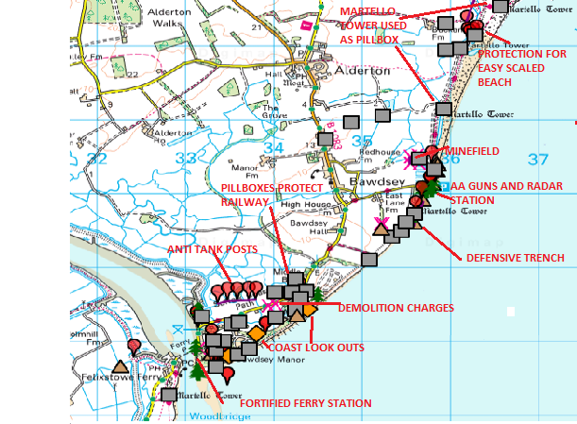
(Figure 5: Map showing Bawdsey and general area exhibiting different types of field defences. Many of these were constructed under the stop-line plan. Map credit Ordnance survey)

- Conclusion
Through the evidence collected it can be said that to an extent defences followed the GHQ stop-line plan. The main stop line forms a visible pattern of defences along Eastern Suffolk which represents the stop line as intended. The beach defences or ‘coastal crust’ have also seemed to follow the general idea of this order. However it is an overstatement to say that the plans formed the basis of defence in Suffolk. To start with, the construction appears to have only partially followed the national plan, with heavy adaptions to follow the plans of Eastern Command, the operators in Suffolk, creating a hybrid defence system across the county. Secondly, whilst defence construction followed the general pattern of the plan, it does not automatically follow that defence planning also followed it. The stop-line plan was replaced officially in September 1940, and was replaced by more mobile defences closer to the coast that rendered parts of the line useless. Others were handed over to the Home Guard in case of invasion as a last resort or remained in use on the coast, but it cannot be said that defence planning for the vast majority of the war followed the pattern of the GHQ stop-line plan.
This report also intended to establish whether stop line defences were incorporated into these later plans. This has been extremely hard to find evidence for. Whilst it seems likely that Eastern Command would could continue to use defences built for the stop-line that were both built correctly and close to a significant location that later defences followed (a nodal point or vulnerable point) this cannot be proven. Other defences may have also had a new lease of life used for training, or by the other armed forces (mostly the RAF) with bases with the stop-line on its perimeter such as RAF Mildenhall. Coastal defences, mostly built under the stop-line plan, as adapted by 11 Corps, naturally remained in use throughout the war, or at least late 1944 when the defences were largely stood down. Whilst it seems that many of the defence structures built for the stop-line were incorporated into the later plans this seems to be a result of fortuitous location of individual defences rather than any intentional reuse of the line. Therefore, this report acknowledges that individual defences remained in use, this was not the case for the majority of the Suffolk stop-line.
This report is by no means exhaustive, being limited by the availability of those GHQ records available easily. The National Archives has not made most records available online and neither a visit nor requesting the items in paper form were feasible with the time limitations. Further research using these records and conducted in further detail would likely be able to more thoroughly research the aims and objectives of this report. However, the general aims and objectives were at least answered generally with the evidence available and have established that the premises were only partially correct. The stop-line was followed in construction, but it was adapted locally and in many cases it seems what was built so hurriedly was never used. Some stop-line defences were incorporated into later defences but this was not the case for the line as a whole. Local changes were extensive and seemed to be better regarded later than the nationally designed defences.

A- References
http://archaeologydataservice.ac.uk/archives/view/dob/
Field Marshal Lord Alanbrooke., A, War Diaries, 1939-1945, (2002, Orion Publishing, London)
Gilbert W.S., and Sullivan A., I’ve Got a Little List, (The Mikado) 1885
http://www.pillboxes-suffolk.webeden.co.uk (accessed 11/11/18)
http://www.pillbox-study-group.org.uk (accessed 11/11/18)

B- Image credits
http://archaeologydataservice.ac.uk/archiveDS/archiveDownload?t=dob_cba_2005/ahds/dissemination/jpg/DASudbury6433(2).jpg Cover photograph.
Ordnance Survey OS maps (accessed through Digimap) figures 1,3 and 5 (https://digimap.edina.ac.uk/roam/map/os)
http://www.pillbox-study-group.org.uk/uk-defence-locations/stoplinenew/ figure 2
http://pillboxes-suffolk.webeden.co.uk/stop-lines/4536742313 figure 4

- Appendix 1: The Alternative Summary
A Song of Suffolk Pillboxes (to the tune of I’ve Got a Little List)
As someday it may happen that a pillbox must be found
I’ve got a little list, I’ve got a little list
Of the Suffolk field defences the recorders went around
The ones they didn’t miss, the ones they haven’t missed.
There’re the swampy field outliers who must muck up your graph
The ones with bad coordinates that want to make you laugh
All field trenches without their dates that trip you up quite flat
And roadblocks on just every road that pulled you up like that
And the entries with no details that the archives should insist
They’d none of them be missed, there’s none of ‘em been missed

I’ve got a little list, I’ve got a little list
And I hope I haven’t missed, or else I will be… you get the idea.

There’s the anti-tank cylinder and others without trace
And the dragons teeth, I’ve got them on my list
And the coastal minefields just detonating in your face
Some may indeed be missed, but I’ve got some on my list
There’s the Home Guard observation post with its annoying tone
Ignoring every false alarm but this, every church bell but its own.
And the spigot mortar in a ditch or underused layby
And whose hapdash appearance – ‘protecting what?’ it makes you sigh
And that single anomaly in Dunwich, many metres out to sea
I don’t think it’s been missed , for I’ve got it on my list

I’ve got them on my list, I’ve got them on my list
And I don’t think it’s missed, since its on the flipping list
And that GHQ line nonsense, in this report its rather rife
The Force’s strategist – I’ve got him on a list!
All outposts, camps, and shelters of military life
They’re not on the list, so they’ve probably been missed*
And apoplectic Corpsmen of enterprising mind,
Such as what d’ye call em, thingummy bob and Brooke – oh
Never mind!
And Ironside, 11 Corps, and also Churchill too.

The task of filling up the blanks for M.A research; true.
But it doesn’t really matter what goes on in that list.
For nothing has been missed, all the entries on my list.

The recorders made a list, I mapped it out whilst… well
And nothing has been missed, they’ve none of them been missed.

https://digimap.edina.ac.uk/roam/map/os
http://archaeologydataservice.ac.uk/archives/view/dob/overview.cfm
Credit to the Pillbox Study Group, http://www.pillbox-study-group.org.uk/psgwordpress/wp-content/uploads/2013/01/StoplineNew.jpg
Field Marshal Lord Alanbrooke, War Diaries, 1939-1945, (2002, Orion Publishing, London) cited in http://pillboxes-suffolk.webeden.co.uk/anti-tank-islands/4553500638
https://digimap.edina.ac.uk/roam/map/os
http://pillboxes-suffolk.webeden.co.uk/ghq-stop-line/4536645955
http://pillboxes-suffolk.webeden.co.uk/infantry-in-defence/4539085080
http://pillboxes-suffolk.webeden.co.uk/inv-beach-survey/4557061830
Ibid.
http://pillboxes-suffolk.webeden.co.uk/stop-lines/4536742313
http://pillboxes-suffolk.webeden.co.uk/eastern-command-line/4550611193
National Archives cited in Ibid.
http://pillboxes-suffolk.webeden.co.uk/ghq-stop-line/4536645955
http://pillboxes-suffolk.webeden.co.uk/anti-tank-islands/4553500638
ibid
http://pillboxes-suffolk.webeden.co.uk/invasion-imminent/4553642028
http://pillboxes-suffolk.webeden.co.uk/1941-defence-plan/4556896540
http://pillboxes-suffolk.webeden.co.uk/invasion-imminent/4553642028
http://archaeologydataservice.ac.uk/archives/view/dob/ai_r.cfm?REDSQUIDARCHIVES_64185d5f-b1d6-4020-83e9-f591d3e2c82d_0
http://pillboxes-suffolk.webeden.co.uk/vulnerable-points/4546308631
http://pillboxes-suffolk.webeden.co.uk/1943-assessment/4565349055
ibid
http://pillboxes-suffolk.webeden.co.uk/immobilizations/4543697167
http://pillboxes-suffolk.webeden.co.uk/inv-beach-survey/4557061830
http://pillboxes-suffolk.webeden.co.uk/vulnerable-points/4546308631
https://digimap.edina.ac.uk/roam/map/os
W.S. Gilbert and A. Sullivan, I’ve Got a Little List (The Mikado) 1885
In the majority of cases the Defence of Britain archives did not include these in their classification of Second World War Defences for a variety of reasons, foremost being that they were not specific anti-invasion defences. In this report, since they were not classified anti-invasion defences they were not included. So they didn’t need to be on this list.

