

Name: Declan Thomas
Student Number: 1908075
Module: BIM
Lecturer: Gavin Traylor

Assignment Index
- Introduction to assignment.
- The letter to the client.
- BIM Execution Plan.
- Conclusion.
- References.

Introduction

Within this assignment I shall begin by writing a letter to the client of which is Swansea Council regarding BIM level 2 and how BIM level 2 will work for their project. Also, within the letter I shall be showing my understanding of the requirements of BIM maturity for the project and giving details on how information will be shared, coordinated, managed and what needs to be done for this to be successfully. Also, within this assignment I shall be carrying out a BIM execution plan of which will include the project information, management, planning, documentation, standards, methods, procedures, and IT solutions.

Letter to Swansea Council

DT Consultancy,
Thomas road,
Glynneath,
Neath,
SA11 5AA.

Swansea Council,
Civic Centre,
Oystermouth Road,
Swansea,
SA1 3SN.

Dear Swansea Council,

Hope this letter finds you well. I am writing to you as the lead consultant of the new ‘state of the art’ infant school in Swansea. I’m writing to you to inform you about how we shall be using the BIM level 2 as a mean of managing, controlling, and sharing information needed to carry out the works to the new infant school within Swansea, known as ‘Ysgol Bae Abertawe’. I am writing to you to plan and outline the measures that we are going to be carrying out to show the competency of my project team which will help us reach and achieve the BIM level 2.

Before I begin to discuss BIM level 2, I will firstly discuss what BIM is. BIM is a 3D model-based process which will provide construction, engineering, and architecture professionals the understanding and will enable them to design, plan, and construct more efficiently and effectively. Also, it will allow these professionals to manage the projects much more effectively. BIM will allow greater visibility, helping better decision making, while helping cost savings and sustainable options. By producing these 3D models, it will help demonstrate the true and full potential of the project. If this process is used correctly will create a healthy working environment for everybody involved and will help create a very successful project. By us using BIM level 2 on this project I believe will give an immense benefit to you as a client by allowing us to produce a much higher build of quality, while helping to reduce any costs and removal of wastages and most importantly ensuring reducing any health and safety issues by improving the safety on site.

(Autodesk, n.d.)

For us to reach the BIM level 2 for this project our BIM process must result in a good and full collaborative way. It’s also important that the information is to be shared in a way where its fully accessible for everybody to use across the project. This is a minimum requirement set by the UK Government and this is across all construction work in the public sector. This means that our contractors will have to demonstrate that they can work this way too. Otherwise, if not demonstrated a compliance with BIM level 2, the funding will not be released from the treasury. (Storma Group, 2019)

Below listed are key factors that are included in BIM Level 2. (The CAD Room, 2017)
- Collaborative working.
- Covers the creation of federal model.
- The common classification of data.
- Employers’ information requirements.
- Information exchange methods.

Also, to achieve BIM Level 2, certain standards must be met. These standards are as follows. (BRE, 2022)
- BS EN ISO 19650 1 2018
- BS EN ISO 19650 2 2018
- ISO 19650 – 3
- ISO 19650 – 5
- BS 8536 -1:2015
- BS 1192-4:2014
- PAS 1192-6:2018
- BS 7000-4:2013
- ISO 22014
- ISO 22057

The information we have regarding our BIM Models and processes will all be stored and saved using CDE. CDE is Common Data Environment. CDE is a central repository where all project information will be stored. This is an online storage system with a single source of information for the project. CDE is used to store, collect, manage, collaborate, and share project information with any of the project team efficiently. By having the single source of information used by CDE, it will reduce any errors while avoiding duplications and by guarantying best practices as not only does it provide secure storage but provides clear and secure audit trail of all changes made and any amendments. (Carey, 2020)

I believe by using BIM level 2 and the process of BIM, it will ensure a “State of the art” project will be completed while also allowing a full collaborative working environment and enabling full sharing and communicating through the CDE between all parties involved. BIM level 2 will allow a smooth and clear project and will show all benefits to you as a client, not only just during the construction phase but over the lifetime of the project. I’ve also attached the BIM execution plan for the project. This will help get more of an understanding of the process and to aid everything I have discussed.

If you do have any queries, please feel free to contact myself using the below details.

Yours sincerely,
Declan Thomas
Lead Consultant
Tel – 07472 880777
Email – declan.thomas@dtconsultancy.co.uk

BIM Execution Plan (BEP)
BIM Maturity Level 2

Project: Ysgol Bae Abertawe

Author: Declan Thomas

DT Consultancy.

Table of Contents
1. Project Revision Table. 8
2. The Purpose of the BIM Execution Plan (BEP). 9
2.1 Purpose of BIM Execution plan. 9
3. Project Information 10
3.1 Project Overview 10
4. Management 11
4.1 Roles. 11
4.2 Responsibilities. 12
4.3 Surveying and Co-ordination 13
4.4 The Project Milestones 13
4.5 Approval and Information Exchange. 13
5. Planning and Documentation 14
5.1 Project Collaboration 14
5.2 Delivery Plan 14
6. Standards, Methods, and Procedures 15
6.1 Volume Strategy 15
6.2 Federation Strategy 15
6.3 Naming Conventions 15
6.4 Layer Naming 15
6.5 Agreed Construction Tolerance 16
6.6 Levels and sections 16
6.7 Drawing Output and Room Numbering 16
6.8 Title Block 16
7. IT Solutions 17
Conclusion 18
References 19

Project Revision Table.

Record of amendments made to the BIM Execution Plan (BEP)

Revisions | Date | Authors | Comments
Rev.1 | 01.03.2022 | Declan Thomas | First edition of the BIM Execution plan for the client. Created by Declan Thomas.

Important notice.

Please note, that the table is to be updated every time there is to be a amendment made to the BIM Execution Plan (BEP). The same order as above must apply accordingly.

The Purpose of the BIM Execution Plan (BEP).

2.1 Purpose of BIM Execution plan.

The main purpose of the BIM Execution plan is to define the foundational framework and to ensure a successful development of a project. The plan is to set out a ‘PAS 1192-2:2013’ which is a creation of a BIM Execution plan. ‘PAS 1192-2:2013’ will propose that the precontract BEP will be a direct response the employer’s information requirement (EIR). The EIR is a very important document which will set out all information required from the employer that will be aligned to key points or project stages. A BEP shall be produced for every BIM project as it will need to respond to the EIR. Within the BEP will be all information needed regarding a project. The BEP is very important and very detailed as it breakdown every elements and parties involved within a project. It’s important that the project shall deliver whatever information that has been discussed within the BEP.

(Designing Buildings, 2020)

Project Information

Project Overview

Project Number: | 5010.
Project Title: | Ysgol Bae Abertawe.
Project Description: | 1 form entry infant school for 90 pupils, with 48 PT Nursery provision.
Site Location: | Located in Swansea, by the eclipse tower, opposite the multistorey carpark. (Plan of site will be below).
Client: | Swansea Council.
Lead Consultant: | Declan Thomas from DT Consultancy.

Above shows the site location with the red lines showing the boundary lines.

Management

Roles.

The below table shows the breakdown of all individuals involved within the project with their represented companies and roles within.

Company | Name | Role | Contact Information | Resources
Swansea City Council. | Swansea Council | Client | Info@Swanseacouncil.co.uk | CL-1
Glynneath Architects. | Andrew Williams | Architect | Glynarchitects@hotmail.co.uk | AT-1
DT Consultancy. | Declan Thomas | Lead consultant | declan.thomas@dtconsultancy.co.uk | LC-1
Pro Electrical. | Rhys Owen | Electrical Engineer | Rhys.owen@google.com | EE-1
RT Mechanical | Rowan Thomas | Mechanical Engineer | Row.Thomas@gmail.com | ME-1

4.2 Responsibilities.

The below table shows the breakdown of each contractor’s responsibilities and assigned to their resource pack.

Representative | Resources | Responsibilities
Swansea City Council | CL-1 | As this is the client, the client must ensure that throughout out all the project, construction must apply to all building regulations, standards, and procedures. The client must also always be updated regarding any changes being made throughout the project and to be reminded of the BIM processes throughout the projects lifetime to ensure all BIM targets will get hit.
Glynneath Architects | AT-1 | As the architect of the project, the architects will be responsible for producing the plans for the project which will allow all parties of the project to work to and follow. Also allowing the designers to produce the design drawings. The architects and designers must work closely with each other to ensure all details meet the building standards and regulations while also meeting the BIM Level 2 requirements.
DT Consultancy | LC-1 | As the lead consultant, the responsibilities of decision making are very important. Also, deciding where and how the information is to be shared and stored. The choice of appointments regarding the consultant team will be chosen by the lead consultant and then helping them direct the work. Another key role as the lead consultant is how the lead consultant is the main point of contact between the client and team. Another key responsibility for the lead consultant is working closely with the team and making sure that all parties are using the CDE correctly and how the information is being stored and shared correctly while also being updated correctly.
Pro Electrical | EE-1 | As the electrical contractor on the project, the contractor shall be responsible for all the electrical designing and construction of the project.
RT Mechanical | ME-1 | As the mechanical contractor on the project, the contractor shall be responsible for all the electrical designing and construction of the project.

4.3 Surveying and Co-ordination

The project Ysgol Bae Baglan will use the building and survey points of 192364.7N and 265976.9E co-ordinates with the elevation of 0. Throughout all of the project, all software and information regarding Ysgol Bae Baglan will be designed from the same origin point. Allowing all drawings and information to be on the same orientation. By having this on the same orientation, it will reduce and highlight any makes with the project.

4.4 The Project Milestones

Project milestones are used as a project management tool that is used as a component of project scheduling. The lead consultant, client and main contractors shall discuss and work together to set any milestones. This will involve any of the listed:
- Completing the design stage.
- Appointments of contractors.
- Project start date.
- Key dates for each work activities to start.
- Completion dates for activities.
- Completion date of project.
- Rectifying any defects.

By having these project milestones in place, will allow the management team to obtain a more accurate understanding of the project and how the project is advancing accordingly. It also allows the client the see information clearly and they can then make decision based on these milestones if needed and can also be used in meetings while showing information to help show the change in decision. Also, once a milestone is achieved this then means that information is ready to be exchanged. Then, once the information is exchanged the programme shall be updated and then a revision will be added. The lead consultant must then add this to the Project Information Management System (PIM). PIM is a project management system that will allow all parties to keep up to date of the information that’s being exchanged and any data that has been shared.

4.5 Approval and Information Exchange.

The approval of information weather it is new or updated information, before uploading to the CDE the information must go through an approval process. When a milestone is achieved or completed, it must be signed off from either the lead consultant or the client. The achieved milestone then must go through an approval document, which makes sure that there is full confirmation from the client. If there is to be any changes made, then the lead consultant or client is to complete the below table.

Author: | Project: | Reference Number: | Notes: | Revision: | Date: | Signature:

Planning and Documentation

The planning and documentation shall be vital and hugely important during this project, if used correctly it will allow a smooth and efficient construction.

Project Collaboration

A previously mentioned, all information shall be stored within the CDE once it has had the confirmation from the approval stage as mentioned in 4.5. This will then allow accurate data which has also been confirmed by the client and the lead consultant. This also minimizes any mistakes and allowing the BIM protocol to be followed.

Delivery Plan

The delivery plan for the project has yet to be finalised by the lead consultant and the client. Therefore, below is a draft version of the delivery plan. This plan shall show all parties involved, the current project milestones and any key dates. Once again, the client must sign the delivery plan to make sure of the confirmation. Below, is the draft delivery plan. Again, please note this is only a draft and once the confirmation has been given a master document shall be produced.

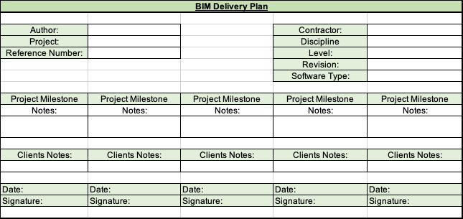

6. Standards, Methods, and Procedures

Within this section of the BIM Execution Plan, this section will highlight and detail all the strategies, methods and procedures that will be needed to be followed. This section shall cover, naming conventions, gird references and units to be used.

6.1 Volume Strategy

At the beginning of the design, the volume strategy will be used. This shall help identifying 3D spatial coordination for each discipline. At the beginning of the project, if a volume strategy is required it is up to the design team to agree the required volume. For this project, it does not require any geometric subdivision. Therefore, the volume codes ‘ZZ’ shall be used for the project.

6.2 Federation Strategy

Also, during the design stage under the ISO 19650 a federation strategy is to be created. This is a process of creating and managing any digital information regarding a built asset. For this project, the lead consultant and the project manager will work closely to divide all the project disciplines on the project. This will then allow several parties to work on the project at the same time.

6.3 Naming Conventions

The naming conventions shall be always used during the construction, its vital and important as it’s such an effective procedure. Also, all naming conventions are to be in accordance with the BS 1992 and any object naming is to be in accordance with BS 8541-1. Below, are the naming conventions that are to be used on the project Ysgol Bae Abertawe. Also, fully labelled.

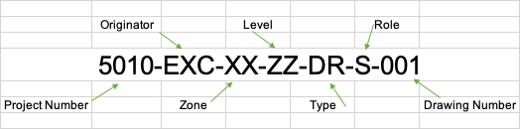

(SYMETRI, 2020)

6.4 Layer Naming

All layers which are within the BIM information shall be named within accordance to BS1192.

6.5 Agreed Construction Tolerance

The information used within BIM for this project will be in accordance with ISO 5601.

6.6 Levels and sections

During this project, all levels and sections must be the same in all models to allow a full collaboration process to work. All the levels and grid references must be confirmed and used correctly by every party.

6.7 Drawing Output and Room Numbering

It’s very important that every model has the correct labelling and room numbering. The simple but effective procedure of having labels and room numbering is very beneficial. It will allow all parties on the project to know what area which is and what area they are working on without any confusion. The drawings are to be produced and altered in the correct required software. It’s important that the drawings are to be labelled and saved in the correct naming conventions as previously mentioned in accordance with BS 1192.

6.8 Title Block

Every drawing for this project must be in accordance with ISO 5457 and the title block shall be in accordance with ISO 7200. Below, is a labelled title block with all points mentioned from 6.6 and 6.7.

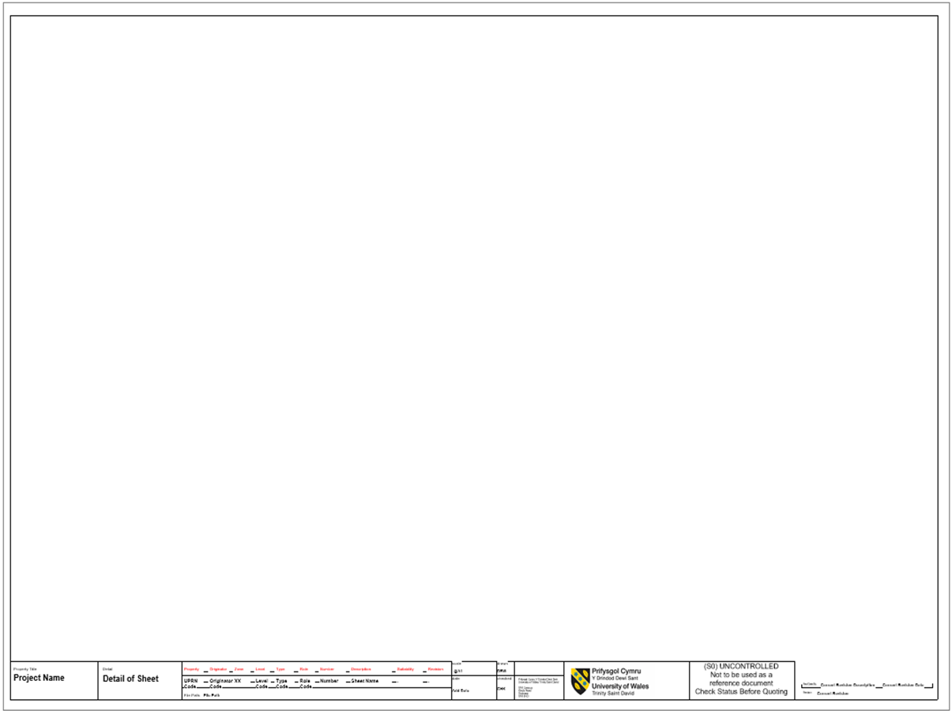

7. IT Solutions

For the project Ysgol Bae Abertawe, the software of which has been used to develop and design the whole project will be Revit 2022 and the use of PDF for 2D drawings and any documentations. It’s vital that every party involved within the project are using and working on the same version of each software to ensure all information is correct and to avoids any mistakes and a false information. By having all parties work on the same software allows the information to be stored, shared, and processed correctly. Following this, the information that is to be processed in these software’s will be stored within the CDE as previously mentioned while using the correct naming conventions. Below, shows both software’s and how they are used to produce all information needed for this project.

Version | Software | Application | File Format
2022 | Revit | All 3D modelling for the project. | RVT Files.
2022 | PDF | For all 2D drawings and any documents. | PDF Files.

Conclusion

After researching and studying the BIM Process, I have come to an understanding that using BIM is a great tool to use on construction projects. I believe this because, it helps with managing projects, storing, and sharing information clearly, helps reducing any mistakes, reduces cost by helping with cost managements, allowing a visualized project, and all this while helping improve collaboration and communication in construction. Although it takes some time and management using, but once you have the knowledge and understanding it can be very straight forward. BIM is process that is advancing quickly and bring time forward within the construction industry. It’s a very effective digital tool, that will help save time and energy with sharing, saving, storing, and creating information needed for projects. All the mentioned benefits also help the design team, client and all parties involved within the project and help show the information clearly and effectively.

The use of the BIM execution plan will outline the guidelines which are used on a specific project. These guidelines will show how BIM shall be used on the project, who will be involved and responsibilities on the project and how the information is to be stored, shared, and then managed. This then helps with clearly show information that allows all parties to understand, which helps reduce any mistakes or any misconceptions on site. Therefore, if BIM is used correctly on any project, it will be a great tool and will help reap the benefits.

References

Autodesk. (n.d.). Autodesk. Retrieved from Autodesk: https://www.autodesk.com/industry/aec/bim/benefits-of-bim
BRE. (2022). Retrieved from BRE: https://www.bre.co.uk/page.jsp?id=3508&utm_content=buffer52b3e&utm_medium=social&utm_source=twitter.com&utm_campaign=buffer
Carey, R. (2020, March 17). ASITE. Retrieved from ASITE: https://www.asite.com/blogs/what-is-a-common-data-environment
Designing Buildings. (2020, August 31). Retrieved from Designing Buildings: https://www.designingbuildings.co.uk/wiki/BIM_execution_plan_BEP
Storma Group. (2019, May 2). Retrieved from Storma Group: https://www.stroma.com/certification/news/bim-levels
SYMETRI. (2020, January 24). SYMETRI. Retrieved from SYMETRI: https://www.symetri.co.uk/insights/blog/iso-19650-compliance-doesn-t-have-to-be-difficult
The CAD Room. (2017, April 25). Retrieved from The CAD Room: https://www.thecadroom.com/bim-compliance-ready-bim-level-2/

