Employability Skills

WIE18838697 (Rhys Wiemers)

Contents
Website and Database Design 2
Website Design 2
Database Design 3
Software Development 3
Network and Cyber Security 3
Data Analysis and Visualisation 4
Data Visualisation 4
Data Analysis 4
Computer Architecture and Operating Systems 4
Overall Growth 5
References 6

Website and Database Design

Website Design
During the time I spent working on the website development, I learnt how to use bootstrap [1] to make websites which are far more versatile due to having the ability to make your website change design based on screen size which allows the same website to work for mobile phones and computers. As shown in the image below, when the size of the display area increases, the website adapts for the user.
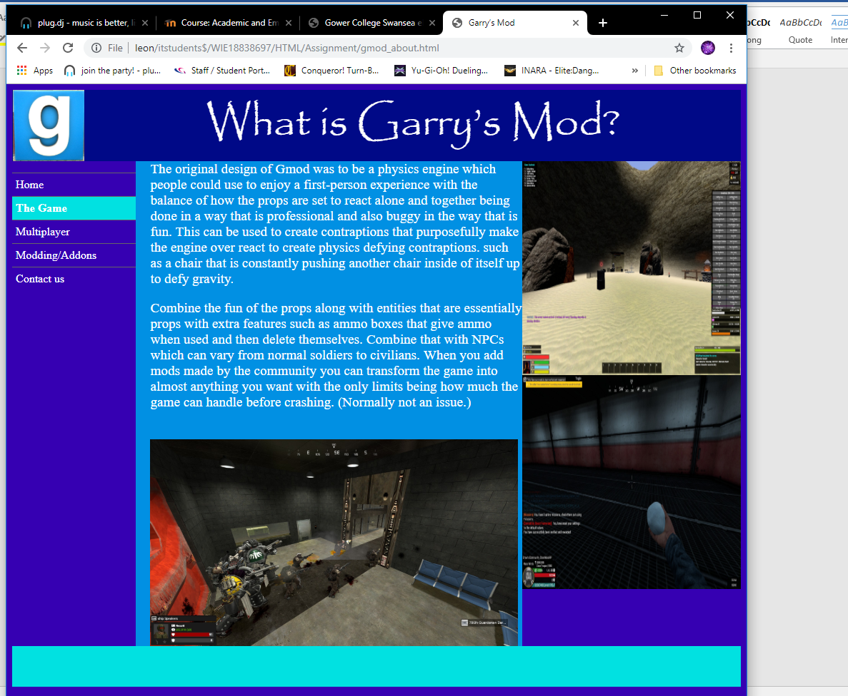
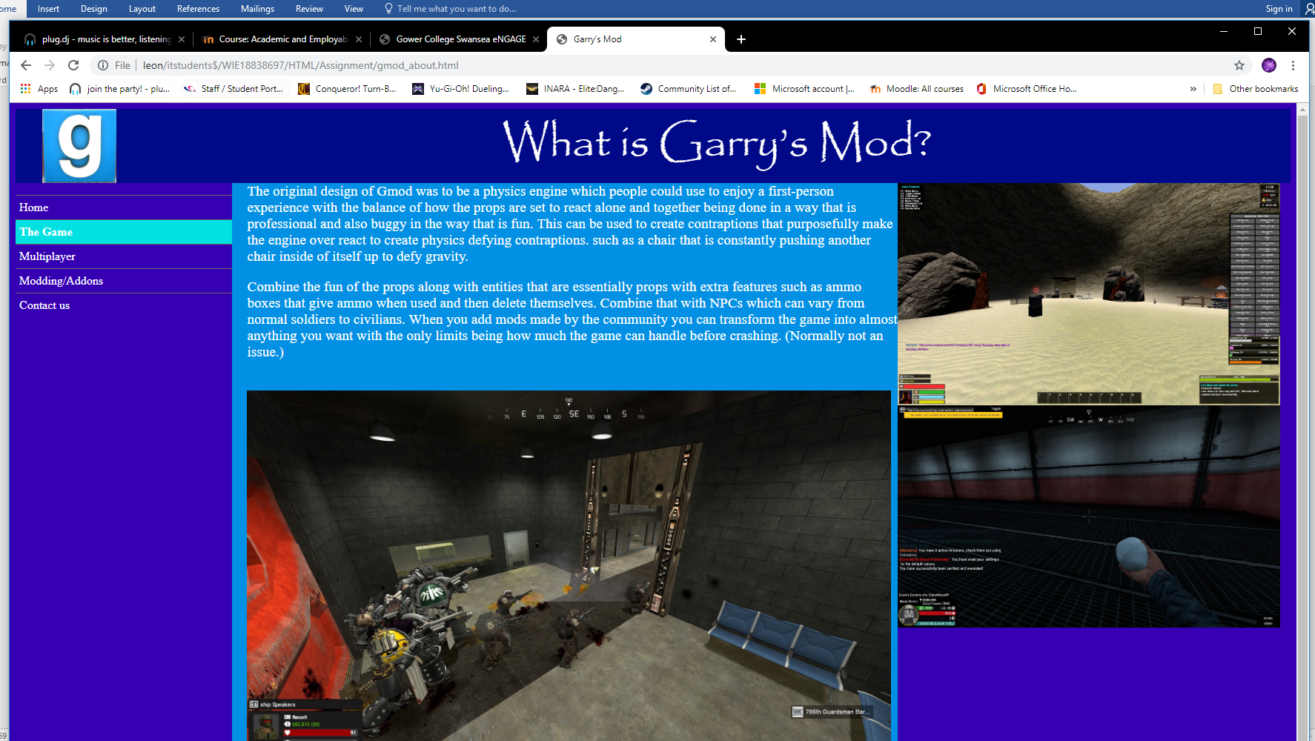
If I decide to move in the direction of website development, it is now far more important to know what your customers expect from a website and this can help make specific looks for different devices to best suit the customers who use that device. Many companies need to have website made and if they need one more advanced than the current free to use programs, then a website developer will be required. Having evidence that I can create websites which have advanced features in them will be helpful in finding companies wanting a website developer.

Database Design
While working on the Database Design segment of this module, I learnt how to use Sequel Server which allows for much easier to create designs due to the design being done using a lower level coding scheme which is specifically made for making Databases. Many people use databases on a daily basis such as cashiers who use a database of foods and their prices using the register to scan a barcode which says what item it is a pulls the item name and price for the cashier. This creates a simple and easy to use database that the cashier needs less training to use and cannot accidently modify the contents of the database. Database Designers are needed to make databases like this and databases which will hold millions of records and must be designed as such to minimize background operations to reduce the amount of CPU usage searching for a single record.

Software Development

For this module, I have learnt how to create code using C# and how to minimize the amount of work the computer must do to reach the same outcome. These techniques are useful as when you create massive programs it can sometimes use too much CPU for lower end computers. This means that optimizing the code is required to make processes more efficient and reduce the overall requirements to use the software created. I also learnt how to create small functions inside my programs which can complete specific tasks such as giving a date or performing a calculation. This can be used to repeat anything that must be done many times such as dividing by 2. Along with this, I have learnt how to set up inheritance which can be used to give an already created list of commands an npc can do to another npc and then add new ones. This allows you to have incremental authorities such as an admin inherits the permissions of moderator plus some extra permissions and so on.

Network and Cyber Security

In this module I have learnt how to make use of Cisco Packet Tracer to create virtual layouts of how a computer network can be setup. I have used this to create basic networks and have assigned IP addresses and setup the routers to allow the router to connect with other nearby routers. The use of the internet is widespread today with most of the world having access to it. With so many people connecting and disconnecting every second, the network infrastructure has to be able to transmit incomprehensible amounts of data and be versatile enough to recognise when an IP address is dropped and to drop any packets that were headed there. The internet is essentially just thousands of companies connected by a network of cables and satellites which move data from point A to point B. because of the volume of data, the best route is not always picked and packets may even be lost. Network management is a complex and constant job not only because the network is hard to setup but also because you need to constantly look for any malicious packets or abnormal traffic on the network as someone could try to break into a network

Data Analysis and Visualisation

Data Visualisation

For this segment, I learnt about how to make a poster that is easy to look at and does not look too different when a colour-blind person looks at it. I also learnt how to properly look at data and turn it into graphs and other bits of useful information which is easy to read for users.

Data Analysis

In this segment, I learnt how to analyse data and to find out if there is a significant difference between two pieces of related data such as how high someone can jump and how tall they are. This must then be proven on a group of volunteers to gather the data and it must then be tested for any outliers which could have been mistakes and remove them, then we test the data to find out if there is more than a 5/10% difference.

Computer Architecture and Operating Systems

In this module I learnt how to comb through the specifications of different computer components to find a list of computer parts to make a computer which will satisfy the needs of a customer. This is useful as computer specialists can use this to make budget computers that satisfy the needs of a customer and can say what more is required to make the computer perfect for the user’s needs.
I have also started learning how to make use of the command line to gain a higher level of control over what is possible to do on a computer such as copying and pasting something into many different folders. Along with learning how to make use of Linux which is an operating system I have little experience with.

Overall Growth

Over this year I have gone through many assignments and although in the beginning I failed to do much work from home and gather enough references, I have collected a couple tools which have helped me to do more of the work even outside of lectures one of these is Mendeley [2] which allows me to make bookmarks to help me find references I made before.

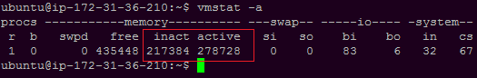
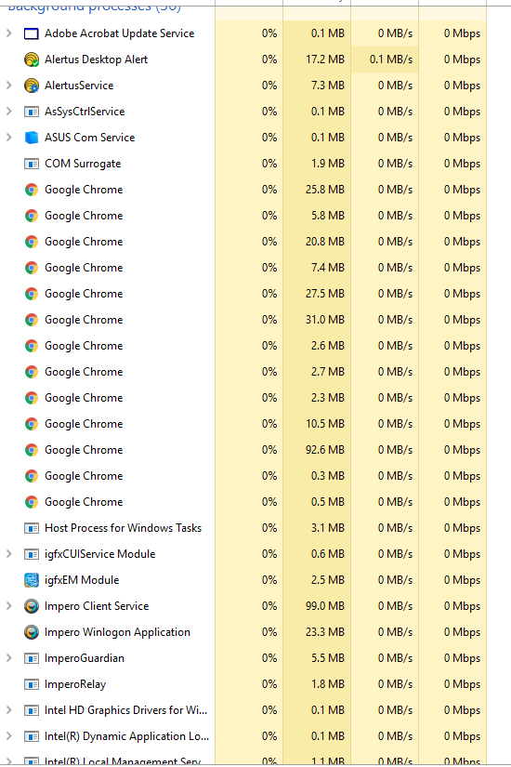
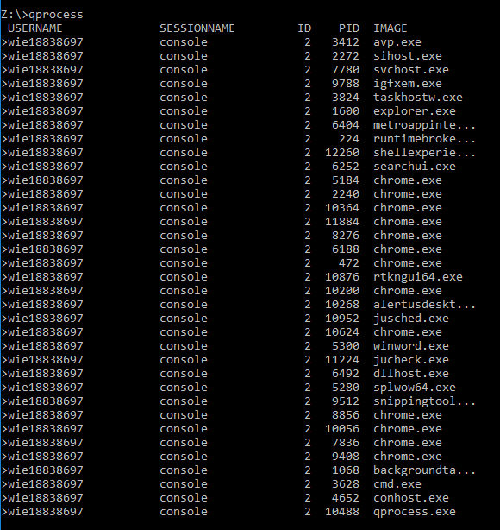
For the Christmas holiday, I failed to do more than a couple hours of work. However, for the Easter holiday I have spent a much more reasonable amount of time working on parts of the Database design and a little time spent searching through all the different commands in Linux and windows such as vmstat and qprocess. Qprocess shows all of the basic processes going on. As shown in the images below, this is very similar to the task manager in display. Vmstat is used to check how much memory is available, and how much is used. This is an overall more detailed way to check how much ram your computer is using.

References

https://www.w3schools.com/bootstrap4/bootstrap_get_started.asp
A repository of bootstrap features which can be made use of when creating a website. There are ways to make use of these displayed. [1]

https://www.mendeley.com/download-reference-manager/windows
Mendeley helps with managing references [2]

