

Student name: Sharon McDermott
Student ID:2243145

Module name: Empowering the Older Person

Module code: BMHP6027
Lecturer’s name: Dr Laila Surani

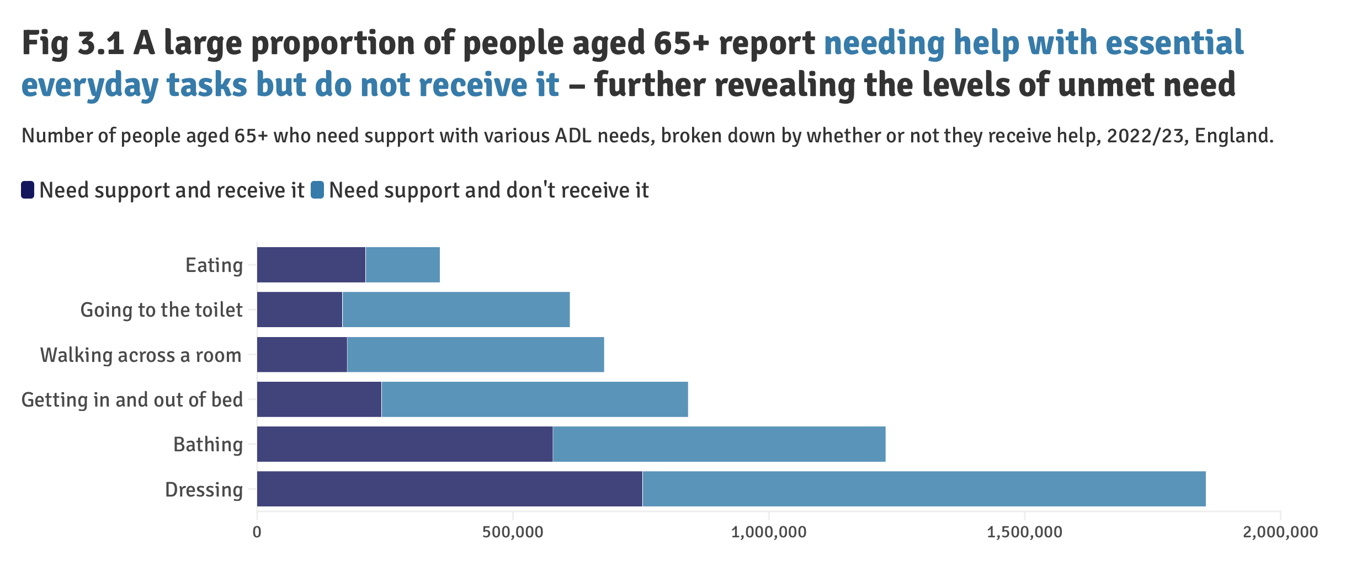  (Age UK, 2024) |  | Empowerment Older people require support Needs  Functional Needs:  - Support to perform daily tasks Stiltz (2025)  - Access to mental health services, cognitive stimulation (NICE, 2015).  - Adequate sleep, regular physical activity, enjoyable daily routines, good oral health, and balanced nutrition (Kelly et al., 2017).  Freedom and choice:  - Access to services, mobility, and social engagement.  - Choosing hobbies, social activities, or religious practices.  - Being Heard and Respected  Emotional Needs:  - Strong relationships, feelings of safety and respect, and opportunities for independence and autonomy (NHS England, 2023). |  |   (BBC, 2025)
Introduction  - Older age: are commonly defined as 65 years and older – WHO (2025) considers 60+ as older age, especially in the UK and globally.  - Life expectancy: today in the UK is expected to live to 89 years, and this could rise to 91 years by 2030 (AgeUK,2024).  UK Policies and Theories  - Equality Act 2010: This UK legislation safeguards individuals from discrimination based on protected characteristics, such as age.  - Care Act 2014: This law outlines the framework for supporting adults in England, emphasizing their wellbeing, autonomy, and the ability to make informed choices about their care.  - Person-centred approach: This method prioritizes each person's distinct needs, preferences, and values, aiming to deliver care that respects their dignity and promotes independence (NHS England, 2025).  - Biological aging theory: This concept explains that aging involves gradual physical changes and deterioration in the body over time (de Magalhães, 2024). |  |  |  | Challenges and Independence  - Limited finances affect quality of life.  - Presence of multiple long-term health conditions and physical issues (pain and mobility) and cognitive decline (such as memory loss or dementia)  - Social isolation and reduced community engagement (Crocker et al., 2024).  - Shortages and strain within the care workforce.  - Unable to use new digital technologies.  Recommendation  Empowerment in older people can be achieved through:  - Develop community programmers.  - Promote holistic, person-centered models of care (Crocker et al., 2024)  - Improve digital literacy and inclusion.  - Enhance service accessibility, particularly in rural areas.  - Prioritise high-quality palliative and end-of-life care.  - Increase the use of innovative and assistive technologies (Advanced ACA, 2025; Age UK, 2025; BBC, 2025).

Conclusion
As the UK population continues to age, it is vital to empower older adults by recognising their individual needs and promoting their health and wellbeing. Supporting independence and choice helps older people live fulfilling lives and stay active in their communities.
References
Age UK (2024) State of Health and Care of Older People in England 2024. Available at: https://www.ageuk.org.uk/discover/2024/september/state-of-health-and-care-of-older-people-in-england-2024/ (Accessed: 25 October 2025).
Advanced ACA (2025) Transforming Adult Social Care in 2025: What to Expect. Available at: https://advancedaca.co.uk/transforming-adult-social-care-in-2025-what-to-expect/ (Accessed: 22 October 2025).
Age UK (2025) How to support older people in 2025. Available at: https://www.ageuk.org.uk/discover/2025/january/how-to-support-older-people-in-2025/#:~:text=Age%20UK%20remains%20committed%20to%20supporting%20older%20people,and%20wellbeing%20and%20to%20change%20how%20they%20age. (Accessed: 27 October 2025).
BBC (2025) Older community activities boost with £132k grant. Available at: https://www.bbc.co.uk/news/articles/c625dg6yepvo (Accessed: 27 October 2025).
Centre for Aging Better (2025) Our Ageing Population | The State of Ageing 2023-24. Available at: https://ageing-better.org.uk/our-ageing-population-state-ageing-2023-4 (Accessed: 16 October 2025).
Crocker, T. et al (2024) ‘Community-based complex interventions to sustain independence in older people’, systematic review and network meta-analysis, BMJ 2024: 384; Available at: https://doi.org/10.1136/bmj-2023-077764.
GOV. UK (2015) Equality Act 2010: Guidance. Available at: https://www.gov.uk/guidance/equality-act-2010-guidance (Accessed: 18 October 2025).
GOV.UK (2014) Care Act 2014, UK Public General Acts 2014 c. 23 Available at: https://www.legislation.gov.uk/ukpga/2014/23/contents (Accessed: 15 October 2025).
Kelly, M.E. et al. (2017) 'The impact of social activities, social networks, social support and social relationships on the cognitive functioning of healthy older adults: a systematic review', Systematic Reviews, 6(259).
National Institute for Health and Care Excellence (2015) Older people with social care needs and multiple long-term conditions. Available at: https://www.nice.org.uk/guidance/ng22/evidence/full-guideline-552742669 (Accessed: 27 October 2025).
NHS England (2025) Improving care for older people. Available at: https://www.england.nhs.uk/ourwork/clinical-policy/older-people/improving-care-for-older-people/ (Accessed: 27 October 2025).
NHS England (2025) Person-centred care. Available at: https://www.hee.nhs.uk/our-work/person-centred-care (Accessed: 21 October 2025).
Office for National Statistics (ONS) (2023) Profile of the older population living in England and Wales in 2021 and changes since 2011, Census 2021. Available at: https://www.ons.gov.uk/peoplepopulationandcommunity/birthsdeathsandmarriages/ageing/articles/olderpeoplelivingincarehomesin2021andchangessince2011/2023-10-09 (Accessed: 27 October 2025).
Stiltz (2025) Research Reveals Independent Living Barriers for the Elderly. Available at: https://www.stiltz.co.uk/accessibility-at-home-for-older-adults/ (Accessed: 20 October 2025).
WHO, World Health Organisation (2025) Ageing and Health. Available at https://www.who.int/news-room/fact-sheets/detail/ageing-and-health (Accessed: 21 October 2025).
de Magalhães, J.P. (2024) ‘Distinguishing between driver and passenger mechanisms of aging’, Nature genetics, 56(2), pp. 204–211. Available at: https://doi.org/10.1038/s41588-023-01627-0.

