DS 1 Template

My Screenshots/Photos

Screenshot/Photo 1
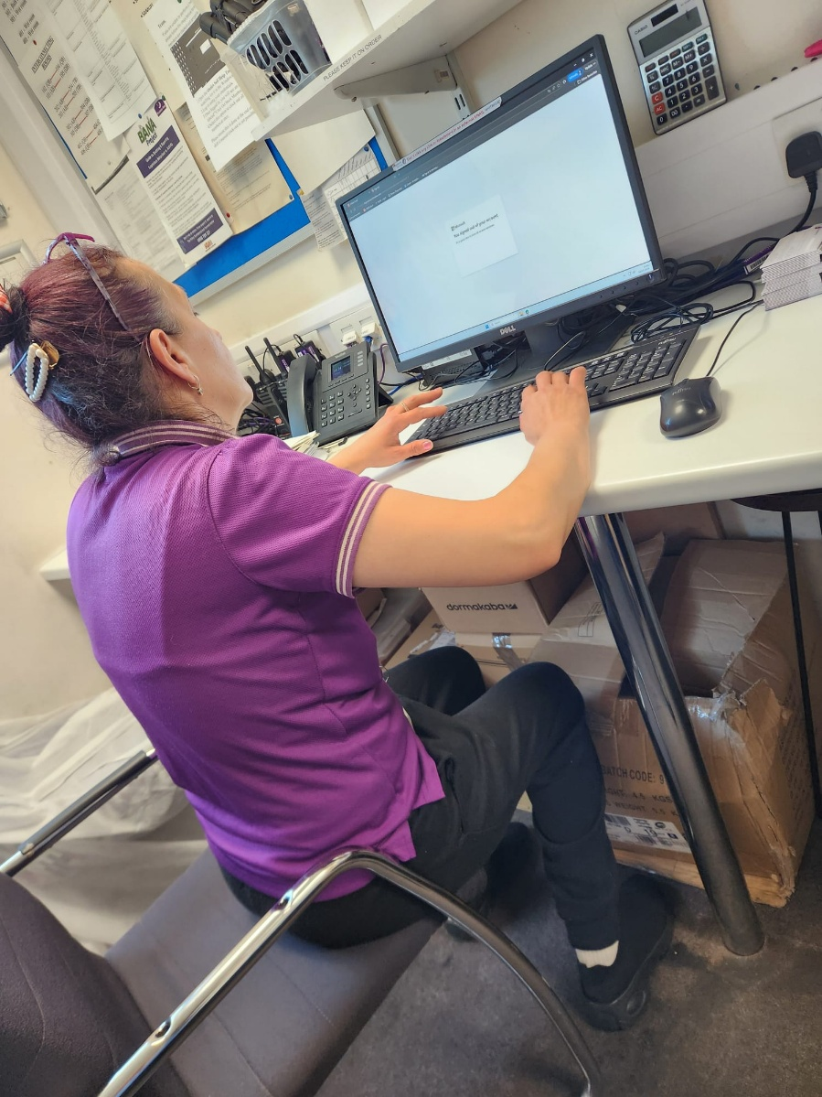
The above image is indicative of my digital life, where I use my desktop to access my college portal, and check for lecture notes, and assignment tasks.

Screenshot/Photo 2
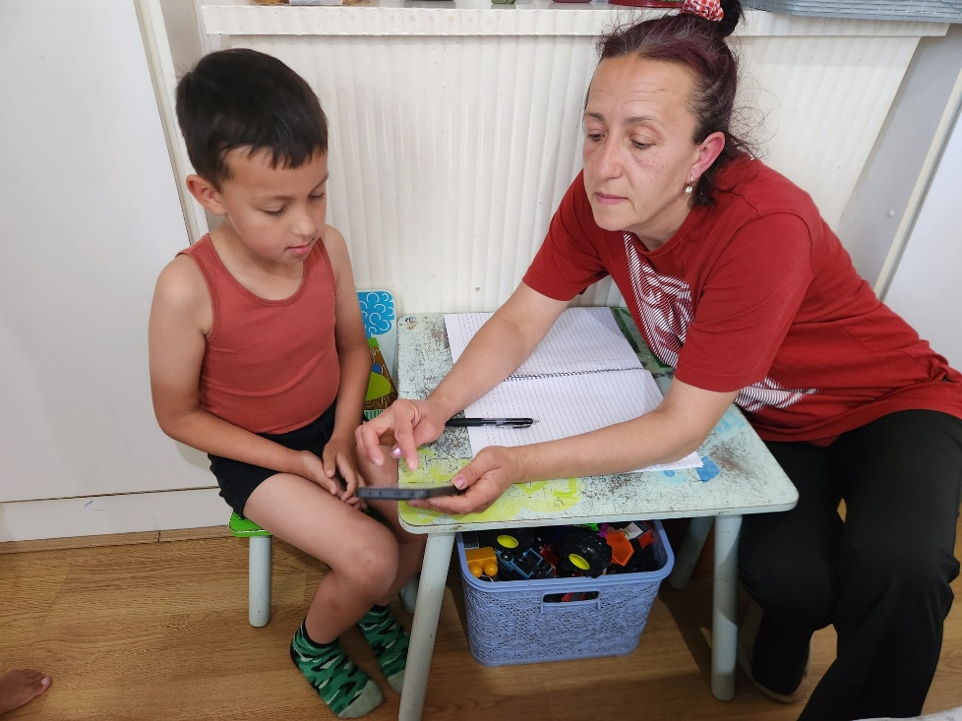
The image also shows the way I use my mobile phone to teach my son. I use it to access informational videos when required.

Screenshot/Photo 3
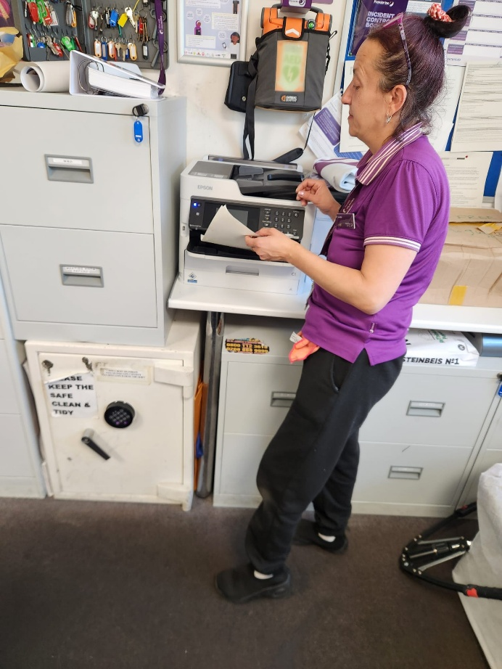
I often require using a printer, to print out my class notes and important information. This helps me equipped to use a digital tool like the computer and a printing machine.

Screenshot/Photo 4
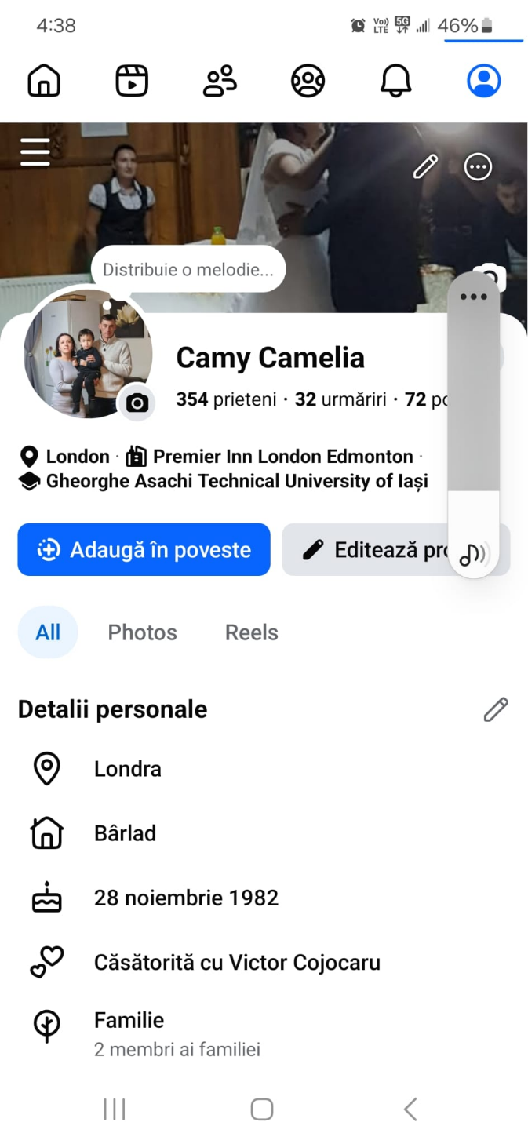
The above image is of my Facebook account, using which I maintain my digital presence. It shows that I have 354 friends and 72 posts.

Screenshot/Photo 5
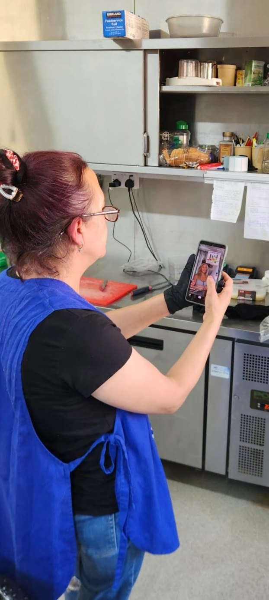
The above image is of me using the Instagram. I often watch reels during my free time through this digital application.

My Short Reflection

In my everyday life, I use digital tools for a variety of purpose. I feel confident in using my computer to access information from the university portal, or using my phone while teaching my son. I want to improve my digital skills in terms of editing pictures, and creating videos. I often use tools like computer, printer, and my mobile phone and so on. I also use digital applications such as Facebook and Instagram to maintain a social presence and remain connected with my friends. I sometimes feel nervous about not being updated with modern digital and ongoing social trends. I hope this module will help me to understand the ways to use digital tools to quicken my tasks and improve my productivity. Digital skill is an important employability skill, and it will help me to maintain my competence in my present workplace.

