Assessment Component 1
Individual report
Student Name: Mariana Acris
Student Number: 2239619
Lecturer Name: Dr Mudassar Hasan
Module Name: LCBB5008
Management Economics
Structure and nature of competition in the UK supermarket industry

Table of Contents
1. Introduction 3
2. Current Nature and Structure of the Market 4
2.1. Tesco’s Corporate Culture and Internal Operations 4
3. Current Position of Industry Participants 6
3.1. Theory of Firm (Behaviour of Costs and Revenues) 6
3.2. Nature of Competition 7
4. Challenges (Short-Term and Long-Term) 9
4.1. Profit Decline Among the UK’s Top Four Supermarkets 10
4.2. Short-Term Challenges in the UK Supermarket Industry. 11
4.3. Long-Term Challenges in the UK Supermarket Industry 12
5. Conclusion and Recommendations 13
References 14

Introduction
Understanding the UK’s Top Four Supermarkets position in the industry requires an evaluation of economic theories, including supply and demand, price elasticity, cost analysis, and the impact of government policies (Clarke, 2010). However, it is currently facing a period of significant transformation driven by several factors, including rising inflation, shifting consumer behaviour, and intensified competition from both discount retailers and premium grocery chains. While the sector has seen growth in market value, the dynamics behind this growth are complex, with increasing prices rather than higher sales volumes contributing to the overall figures. Retailers are under pressure to adapt, balancing the need for competitive pricing with the demand for quality, convenience, and sustainability.
The market is subject to various economic, regulatory, and competitive pressures that influence strategic decision-making (Sama, 2015). Economic theories and business models provide valuable insights into Tesco’s operations, pricing strategies, and competitive positioning. By applying concepts such as supply and demand, price elasticity, cost analysis, and economies of scale, we can better understand Tesco’s decision-making process (Radosevic, 2020). Additionally, government policies, including trade regulations, labour laws, and inflation control measures, significantly impact the grocery retail market.
This project explores the challenges and opportunities within the UK supermarket industry, both in the short and long term. It examines how major players in the market are navigating inflationary pressures, the rise of own-label products, and evolving consumer preferences. Through this analysis, the project aims to provide a comprehensive overview of the current state of the industry, along with strategic recommendations for supermarkets to remain competitive, sustainable, and resilient in the years to come.

Current Nature and Structure of the Market
The UK grocery retail industry consists of supermarkets, convenience stores, online retailers, and discount stores. The sector is highly competitive, with major players such as Tesco, Sainsbury's, Asda, Aldi, and Lidl (Pettinger, 2021).Consumer preferences have evolved, emphasizing affordability, convenience, and sustainability. 
Technological advancements have led to a surge in online grocery shopping, compelling retailers to enhance digital capabilities. Tesco has responded by expanding its online delivery services and click-and-collect options. Additionally, sustainability concerns have influenced purchasing behaviour, prompting supermarkets to adopt environmentally friendly practices.
Government regulations, including minimum wage laws, Brexit-related supply chain disruptions, and inflation, further shape market dynamics. Understanding these elements is essential to analysing Tesco’s strategic decisions.

Tesco’s Corporate Culture and Internal Operations
Tesco’s corporate culture is centred around customer satisfaction, innovation, and ethical business practices. The company integrates data-driven decision-making, employee development programs, and technological advancements into its operations.

Customer-Centric Approach | - Tesco leverages its Clubcard loyalty program to collect consumer data and personalize marketing strategies.  - The company adapts to consumer trends by introducing halal, vegan, gluten-free, and Fairtrade product lines.
Employee Development and Workplace Ethics | - Tesco fosters a positive workplace environment by investing in employee training and career development programs.  - The company rewards staff for innovation and encourages internal promotions to strengthen workforce engagement.
Corporate Social Responsibility (CSR) Initiatives | - Environmental Responsibility  - Tesco aims to achieve net-zero carbon emissions by 2050.  - The company has committed to making its packaging 100% recyclable by 2025.  - Investments in renewable energy sources and waste reduction programs.  - Social Responsibility  - Tesco partners with local charities to combat food poverty (e.g., the Tesco Food Collection initiative).  - The company promotes fair wages and ethical labour practices across its global supply chain.

Current Position of Industry Participants
Tesco maintains its market leadership through economies of scale, competitive pricing, and an extensive supply chain network. The company invests in technological innovations, such as AI-driven inventory management and loyalty programs like Clubcard, to enhance customer experience.
In contrast, Aldi and Lidl focus on cost leadership, offering lower prices through lean operations and limited product assortments. Sainsbury’s and Asda position themselves as mid-tier retailers, balancing quality and affordability. Tesco differentiates itself by blending affordability with premium offerings through its Finest range and sustainability initiatives (Rice, 2019).
The growing competition from online retailers, such as Amazon Fresh, challenges traditional supermarkets. Tesco's response includes strengthening e-commerce and partnerships with third-party delivery services.

Theory of Firm (Behaviour of Costs and Revenues)
The majority of markets are imperfectly competitive, with many operating under an oligopolistic structure (Vorster, 2024). Examples include banks, insurance providers, department stores, supermarkets, fuel retailers, and sporting goods stores.
Market power is the ability of a firm to shape and control market conditions, giving it considerable influence over pricing, output levels, and other key market factors.

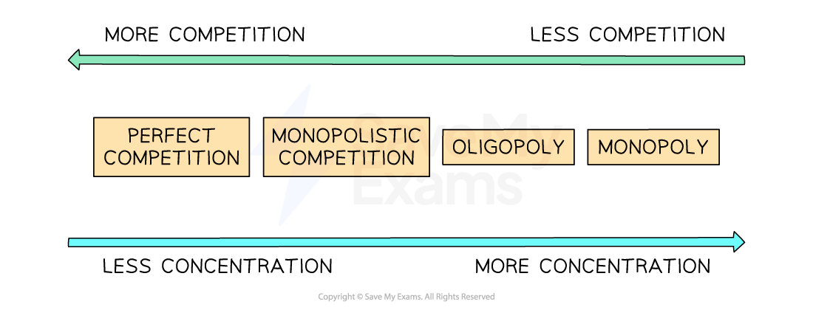
Oligopoly firms possess substantial market power, holding a large share of the market, with the top five firms typically having a high concentration ratio. Market failures are prevalent in oligopolistic structures (Vorster, 2024). To prevent any single firm from exceeding a 25% market share, many governments regulate and oversee mergers and acquisitions.
A collusive oligopoly eliminates competition, leading firms within the industry to operate collectively as a monopoly.
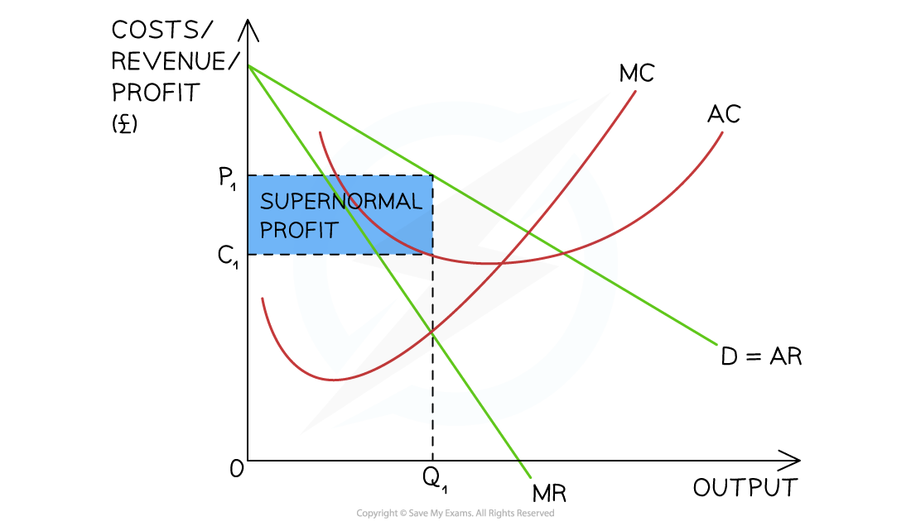
Diagram Analysis:
Five firms, holding an 80% concentration ratio, secretly agree to set prices at a fixed level (Vorster, 2024).
These firms function as a single entity in the market.
Production occurs at the profit-maximizing output where marginal cost (MC) equals marginal revenue (MR) at Q1.
At this output level, the average revenue (AR) (P1) exceeds the average cost (AC) (C1).
As a result, the collusive oligopoly generates significantly higher abnormal profits.
Price elasticity varies across product categories; essential goods exhibit inelastic demand, while luxury items show greater sensitivity to price changes.

Nature of Competition
In addition to pressure from discount retailers, traditional UK supermarkets are also facing growing competition from high-end specialty grocery chains that are capturing a portion of their market share (Jones, 2020). These premium retailers, similar to Whole Foods Market in the U.S., have leveraged their upscale reputation and capitalized on trends like organic and specialty products, which continue to gain traction among UK consumers. According to “City AM”, while these high-end chains haven’t experienced the same rapid growth as discounters, they have also avoided the significant losses seen by major players like Asda and Tesco.
To remain competitive, traditional supermarkets must find ways to attract consumers beyond simply cutting prices and reducing store sizes. While these tactics may provide short-term relief, they have failed to drive meaningful same-store sales growth or significantly improve market share. Some experts have suggested a controversial approach of restructuring large supermarket chains into multiple sub-brands that cater to different market segments, from premium to discount. However, other strategies, such as optimizing supply chain efficiency, renegotiating supplier contracts, and reducing food waste, could also yield financial benefits (Jones, 2020).
“Asda’s Q1 results reflect a period of expected turbulence, not distress,” said Clark in his report. While the challenges facing supermarkets are significant, a well-executed strategy that avoids a race to the bottom on pricing could help them navigate these difficulties and maintain long-term stability.
The UK grocery market is characterized by intense price competition, product differentiation, and brand loyalty. Discount retailers like Aldi and Lidl have disrupted the market, pressuring Tesco to maintain competitive pricing while sustaining profitability.
Competition in the UK supermarket industry is intense, with multiple strategies deployed:
Price Leadership: Tesco often sets prices that competitors follow, influencing market trends.
Differentiation: Tesco invests in private-label products, loyalty schemes (Clubcard), and sustainability initiatives.
Technological Advancement: Expansion of online grocery delivery and cashier-less stores enhances convenience.
The UK's Competition and Markets Authority (CMA) initiated a review of supermarket unit pricing in January and announced last month that it would intensify its scrutiny of grocery prices. So far, no significant issues have been identified, and an update on the findings is expected by late July (Davey, 2023).
Grocery inflation eased slightly to 17.2% in May, industry data showed.
Shares in Tesco, which is scheduled to update on first quarter trading on June 16, were down 0.4% in morning trading, paring 2023 gains to 16.4%.
E-commerce competition has intensified, with online grocery shopping gaining traction post-pandemic. Tesco competes by enhancing its digital infrastructure, ensuring efficient home deliveries, and expanding click-and-collect services.

Challenges (Short-Term and Long-Term)
The UK grocery market has maintained positive value growth despite economic challenges, this expansion is largely driven by inflation rather than increased sales volumes. Shopper behaviour is shifting as consumers respond to the rising cost of living by trading down to discounters, impacting the performance of the big four operators. Looking ahead, market growth is expected to continue, with a peak in 2023, but retailers must navigate evolving consumer preferences and competitive pressures to sustain momentum (figure 1).
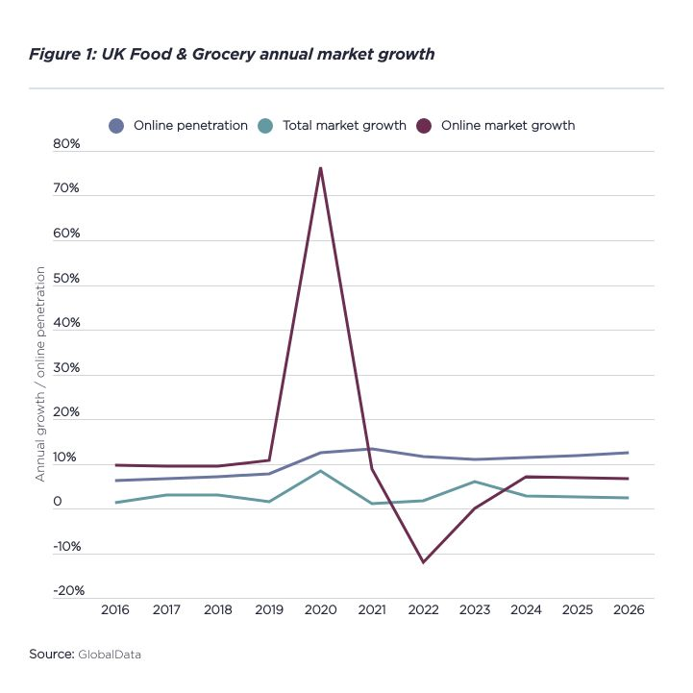
Individual grocery retailers have continued to experience year-on-year growth. In the 12 weeks leading up to May 15, the UK’s three largest supermarket chains recorded similar sales increases, with Asda leading at 10.6%, followed by Sainsbury’s at 10.5% and Tesco at 8.9%. Meanwhile, Morrisons saw only slight growth at 0.6%. However, Aldi and Lidl remained the fastest-growing supermarkets during this period, with sales surging by 24.0% and 23.2%, respectively (figure2).
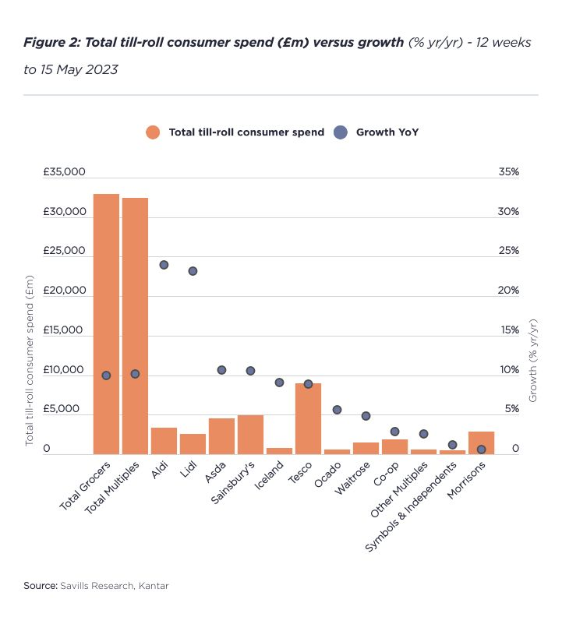

Profit Decline Among the UK’s Top Four Supermarkets
The UK’s largest grocery operators have seen a decline in profits despite continued sales growth, largely due to rising inflation and their commitment to keeping prices low for consumers.
Tesco reported a 6.1% drop in attuned marketing operating profit, falling to £2.49bn in the year ending February, compared to £2.650bn in FY21/22. The retailer attributed this decline to “unprecedented levels of inflation” and expects flat profits in FY23/24 as it continues efforts to shield customers from rising costs (Gulliford, 2023).
Similarly, Sainsbury’s recorded a 5% fall in underlying operating profit before tax, reaching £690m in FY21/22. However, despite this decline, the company performed well given inflationary pressures, landing at the topmost conclusion of its projected range (£630m–£690m) and marking an 18% increase from FY2019/20. Sainsbury’s now forecasts underlying profits to range between £640mil and £700mil for the future economic year.
Morrisons also reported a 15% drop in annual profits, falling to £828m for the year ending 30 October 2022. Meanwhile, Asda’s profits declined by 24% to £886m in FY2022 (ending 31 December), despite a marginal 0.1% increase in total sales to £20.45bn and a 5.1% rise in like-for-like sales in the second half of the year (Gulliford, 2023).
Each of these retailers has cited their commitment to easing inflationary pressures on consumers as a key reason for their reduced profitability. Tesco has maintained its focus on affordability with initiatives like ‘Aldi Price Match,’ ‘Clubcard’ offers, and ‘Low Everyday Prices.’ Sainsbury’s has invested £560m over the past two years in its ‘Food First’ strategy and recently launched ‘Nectar Prices’ to enhance affordability. Asda has cut prices on over 100 branded and own-brand products by an average of 12% and introduced its ‘Just Essentials’ value range. Similarly, Morrisons has implemented price cuts, price freezes, and fuel promotions to improve its competitive standing.
This strategic shift highlights the retailers’ efforts to support budget-conscious consumers, who are increasingly trading down to private-label products. In May, own-label sales rose by 15.2%, with the most affordable value ranges now appearing in nearly one in five baskets-up 46% from April last year. While branded goods continue to grow at a slower rate of 8.3%, the gap between private-label and branded sales is narrowing, partly due to loyalty schemes such as Sainsbury’s ‘Nectar Prices,’ which has boosted the sale of branded products on promotion by over 25% in the past month.
Although these inflation-mitigation strategies have impacted short-term profits, they are likely to drive long-term growth by fostering customer loyalty and maintaining market share in an increasingly price-sensitive retail landscape.

Short-Term Challenges in the UK Supermarket Industry.
The UK supermarket industry is currently facing several short-term challenges driven by economic pressures and shifting consumer behaviours.
Inflation and Rising Costs: High inflation continues to squeeze profit margins as supermarkets struggle to absorb rising costs while keeping prices competitive. Retailers are investing heavily in price-cutting strategies to retain customers, leading to reduced profitability (Gov, 2024).
Consumer Trading Down – Shoppers are increasingly opting for discount retailers and own-label products to cope with the cost-of-living crisis. This shift is putting pressure on traditional supermarkets, particularly the "big four" (Tesco, Sainsbury’s, Asda, and Morrisons), as they lose market share to budget-friendly alternatives like Aldi and Lidl.
Supply Chain Disruptions: Brexit-related trade barriers and global supply chain constraints affect inventory management and costs (BAKKER, 2022).
Changing Consumer Behaviour: The shift towards online shopping and demand for sustainable products necessitate rapid adaptation.
Profit Declines – Despite growing sales, major supermarket chains are experiencing declining profits due to their focus on affordability. Investments in price reductions, loyalty schemes, and operational costs have impacted overall earnings in the short term.
While these challenges present immediate difficulties, supermarkets that successfully adapt their pricing strategies, streamline operations, and strengthen customer loyalty programs will be better positioned for long-term resilience and growth.
  - Long-Term Challenges in the UK Supermarket Industry.
The UK supermarket industry faces several structural challenges that could impact its long-term sustainability and growth.
Technological Disruption – Automation, AI-driven supply chain management, and self-checkout systems are reshaping the industry. While these advancements improve efficiency, they also require significant capital investment and may lead to job reductions, sparking concerns over workforce stability (Xuan Wang, 2022).
Changing Retail Formats – The traditional large-format supermarket model is under strain as smaller, convenience-focused stores gain popularity. Adapting to these changing formats without losing economies of scale presents a long-term challenge for major retailers.
Intensifying Competition – Discount retailers like Aldi and Lidl continue to expand aggressively, putting long-term pressure on traditional supermarkets to maintain market share. At the same time, high-end specialty chains are capturing premium customers, forcing mainstream retailers to find a balance between affordability and quality.
To succeed in the long run, UK supermarkets will need to innovate, optimize operations, and strike a careful balance between cost efficiency, customer experience, and sustainability.

Conclusion and Recommendations
The UK supermarket industry is undergoing significant transformation due to inflation, shifting consumer preferences, and increased competition from both discount and high-end grocery retailers. While overall market value continues to grow, this is largely driven by inflation rather than increased sales volumes. Traditional supermarkets face mounting pressure as consumers trade down to budget-friendly options and seek better value for money. Despite these challenges, major retailers are heavily investing in price cuts, loyalty schemes, and operational efficiencies to retain customers and remain competitive.
In the long term, the industry must navigate structural changes, including digital transformation, sustainability regulations, and evolving shopping behaviours. Supermarkets that successfully balance affordability with innovation and efficiency will be better positioned for sustainable growth.
Recommendations:
- Enhance Competitive Pricing & Value Proposition – Continue to invest in own label products, loyalty programs, and competitive pricing strategies to retain cost-conscious consumers.
- Invest in Digital & E-Commerce Expansion – Strengthen online shopping platforms, optimize home delivery services, and integrate AI-driven analytics to improve demand forecasting.
- Optimize Supply Chain Efficiency – Reduce food waste, streamline logistics, and renegotiate supplier contracts to lower operational costs while maintaining profitability.
- Commit to Sustainability & Regulatory Compliance – Implement environmentally friendly practices, reduce carbon footprints, and align with evolving government regulations to meet consumer expectations.
- Innovate with Store Formats & Customer Experience – Develop hybrid store models, enhance in-store experiences, and offer personalized promotions to differentiate from competitors.
By focusing on these strategies, UK supermarkets can adapt to changing market conditions, strengthen their market position, and ensure long-term resilience in an increasingly competitive landscape.

References
BAKKER, J. D., 2022. POST-BREXIT IMPORTS,SUPPLY CHAINS, AND THE EFFECT ON CONSUMER PRICES, s.l.: https://media.ukandeu.ac.uk/wp-content/uploads/2022/04/UKICE-Supply-Chains-Report_Final.pdf.
Clarke, S. B. &. I., 2010. The economic and social role of small stores: a review of UK evidence. The International Review of Retail, Distribution and Consumer Research, 20(2), pp. 187-215.
Davey, J., 2023. [Online]
Available at: https://uk.finance.yahoo.com/news/tesco-reported-competition-watchdog-consumer-073620899.html?guccounter=1
[Accessed 9 June 2023].
Gov, 2024. Competition and profitability in the groceries sector, London: publishing.service.gov.uk.
Gulliford, S. A. &. J., 2023. Spotlight: UK Grocery Report – 2023. 05 June.
Jones, F., 2020. fooddigital-3 challenges UK supermarkets are facing in a shifting economy. [Online]
Available at: https://fooddigital.com/retail/3-challenges-uk-supermarkets-are-facing-shifting-economy
[Accessed 17 May 2020].
Pettinger, T., 2021. Economics Help. [Online]
Available at: https://www.economicshelp.org/blog/6288/economics/uk-grocery-market-share/
Radosevic, D. E. Y. &. S., 2020. INTERNATIONAL EXPANSION AND BUYER-DRIVEN ...COMMODITY CHAIN: THE CASE OF TESCO*, London: University College London.
Rice, X., 2019. theguardian: The Aldi effect: how one discount supermarket transformed the way Britain shops. [Online]
Available at: https://www.theguardian.com/business/2019/mar/05/long-read-aldi-discount-supermarket-changed-britain-shopping
[Accessed 5 March 2019].
Sama, S. P. S. &. L. M., 2015. Ethical Behavior as a Strategic Choice by Large Corporations: The Interactive Effect of Marketplace Competition, Industry Structure and Firm Resources. In: Business Ethics Quarterly. s.l.:Cambridge University Press.
Vorster, S., 2024. Market Power & Oligopolies (DP IB Economics): Revision Note. Save My ExamsHome.
Xuan Wang, V. K. K. &. E. K., 2022. Impact of Digital Technology on Supply Chain Efficiency in Manufacturing Industry. researchgate, pp. 347-371.

