DIGITAL SKILLS AND RESEARCH METHODS
THE IMPACT OF THE VIRTUAL LEARNING ENVIRONMENT ON STUDENTS
STUDENT NAME: Florence Odonkor
STUDENT ID: 1818734
LECTURER: Koushik Modak
MODULE CODE/ COD Y MODIWL: BMSW4003

Table of Contents
Rationale 3
Objectives 3
Literature Review 3
Methodology 5
Primary Data Analysis 6
Secondary Data Analysis 11
Conclusion and Recommendation 11
References 13

Rationale
This study is based on the impact that the virtual learning environment has on the functioning as well as the learning capability of the students as a whole, wherein the study highlights the impact of the modern audio-visual aids and the utilisation of Artificial intelligence, as well as the virtual reality platform on the retention of the students as well as their overall understanding, as new and modern technologies, come into play in the overall educational mainframe (Giannakos et al. 2020). Thereby, this study had aimed to assess and study the impact that the modern technologies has on the overall understanding, whether they can understand better, and can retain what they learn as opposed to the traditional methods of education as well as learning as a whole. This study had also aimed to highlight the impact of flexible learning has on the overall educational mainframe, and whether the modern learning tools and techniques have been able to allow the students to adapt to the current environment wherein jobs are based on the skills as well as the capabilities of the individuals to adapt to the modern technologies as a whole, as in the realm of service new technologies are implemented and integrated as a way to remain sustainable.

Objectives
The primary objectives of the research are as follows:
- To assess the impact of the Virtual Learning Environment on the retention as well as the capability of the student to understand.
- To assess and ascertain the effectiveness of the Modern Learning tools over traditional learning
- To establish the impact of the Virtual Learning Environment on the overall Satisfaction and engagement over the students.
- To assess whether modern learning tools have been able to create service ready individuals.

Literature Review
The virtual learning environment can be portrayed as the use of educational technology of web-based learning platforms for enabling students to access and utilise different modern tools as well as architectural mainframes through digital landscapes within an educational institution. devotional learning environment allows the students as well as the education institutions to present their resources as well as activities and integrate interactions within the structure of a course or itinerary along with providing accounting for the different stages of the assessment as a whole and includes the tools of student tracking as well as communication and collaboration as a whole (Kahu and Nelson, 2018).
Thereby as highlighted by Davis et al. (2019), do need as well as the advantage of a Virtual Learning Environment and online classroom can help the students enjoying and you know rising a flexible as well as a lucid schedule that can be assessed as per their needs as well as their priorities along with reducing or minimising the cost of the degree of the student and allowing them to develop their career also with their enhancing their education as well as allowing them to chase after their personal as well as professional aspirations as a whole.
Thereafter, Chen, (2016), also resonated with, Davis et al. (2019), and said that the benefits of the virtual learning environment in terms of career advancement opportunities that it provides to the students are primarily in the form of providing them with the opportunity to learn and understand at their own pace through utilising flexible and lucid educational platforms that can accommodate and designed to provide learning opportunities to individuals are currently employed. It provides them better opportunities to collaborate and communicate with international classmates and has more individual contact with students and the processes through the virtual learning platforms which allow them to learn about networking and education (Luo et al. 2017).
Thereafter, as stated by Makransky et al. (2016), the virtual learning platforms also trained the individuals to adapt as well as integrate any major changes in the terms of technology in their professional lives, as they are prone and adept to utilise new platforms as well as modern tools for undertaking their education and enhancing their theoretical knowledge. Thus, it allows the students to be more competent and adapt to any major changes within their professional life giving them more confidence to discharge the obligations and pursue their professional as well as personal aspirations within the organisational mainframe of this service that they provide as a whole (Kahn et al. 2017).
Though, as argued by Efstathiou et al. (2018), the virtual learning environment as a hole in the current mainframe application due to the residence and the lack of necessary technological tools that are required by the students as well as teachers for undertaking this platform of learning as a whole. In addition to that, the virtual learning environment can also lead to social isolation as they utilise and require laptops and computers for undertaking the education curing of the interaction that is made in the traditional classrooms thus enhancing the level of social isolation as a whole (Rienties et al. 2016).

Methodology
The methodology in research can be illustrated as the techniques as well as procedures that are used to identify, select as well as process and analyse the information about any topic as a whole, and allows the audience to evaluate as well as validate the overall reliability of the research (Iovino and Tsitsianis, 2020).
In this assignment, the researcher has utilised the research philosophy of Pragmatism, wherein the researcher had set out with pre-established questions as well as the hypothesis and has constructed the entire research to find solutions of those hypotheses as well as research questions through the collection as well as analysis and interpretation of the data (Trimmer, 2020).
Thereafter, the researcher has utilised mixed research strategy, wherein the researcher had utilised both quantitative as well as qualitative data along with the primary and secondary data for establishing the answers to the hypothesis or research questions as a whole, and for this end, the researcher had utilised Surveys for primary data and the case studies on this topic undertaken by other researchers for proving a comparison and analysis of the primary and secondary data as a whole of this research as a whole (Manzoor, 2020).
Therein the researcher had utilised the data collected from over 15 students through a survey for the collection and analysis of data, and the case studies of establishing the hypothesis or the research questions as a whole.
Thus, conclusively, the data that had been collected from the participants to the survey had been stored by the researcher in compliance with the data protection act for ensuring that the data is not used against them or without the permission of the participants by a third party (Ess, 2020). The researcher had also ensured the anonymity of the participants along with ensuring the overall safety and wellbeing of the participants at every stage of Data collection.

Primary Data Analysis
1. Are you able to understand the concepts being taught through the Virtual Learning Environment.
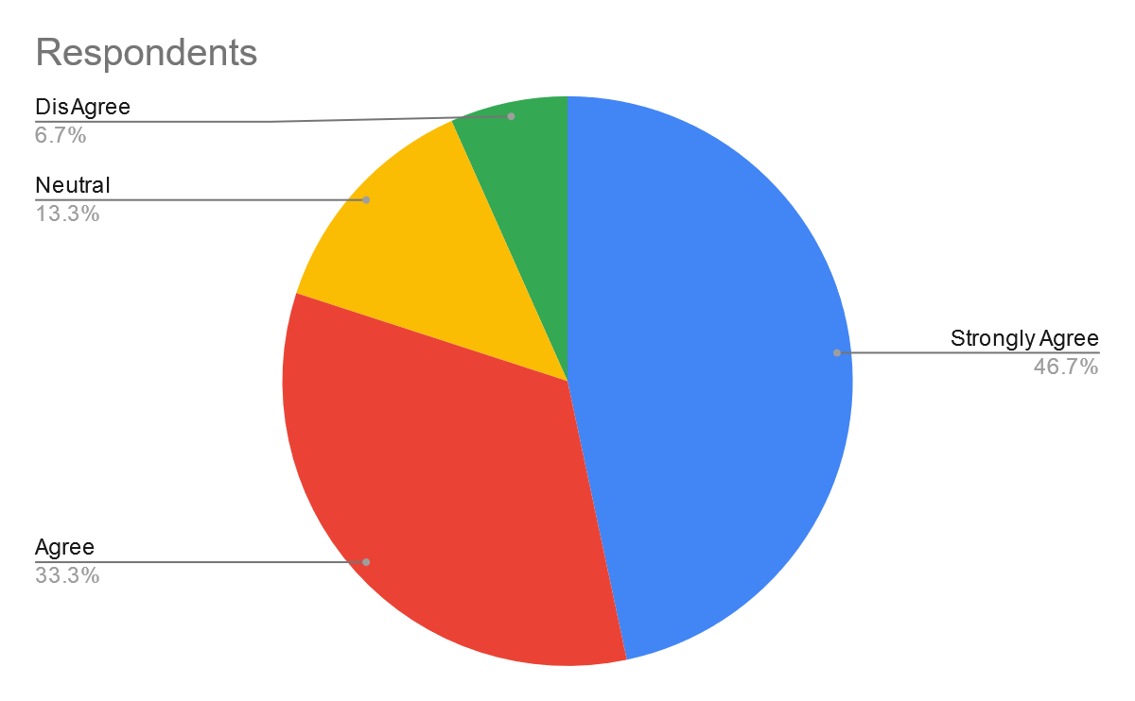
Category | Respondents | Percentage
Strongly Agree | 7 | 46.67
Agree | 5 | 33.33
Neutral | 2 | 13.33
DisAgree | 1 | 6.67
Strongly disagree |  | 0
 | 15
On the question of understanding the concepts as well as the theories that were eng taught through the Virtual Learning Platform, majority of the participants that is over 46.67% of them were very positive and had established that they were able to utilise the Virtual Learning Environments as well as platforms to an optimum level, and were able to understand the things being taught, whereas, 13% remained neutral and 6% were of a different opinion.
2. Are you able to recall the theories and concepts being taught through the Virtual Learning Environment.
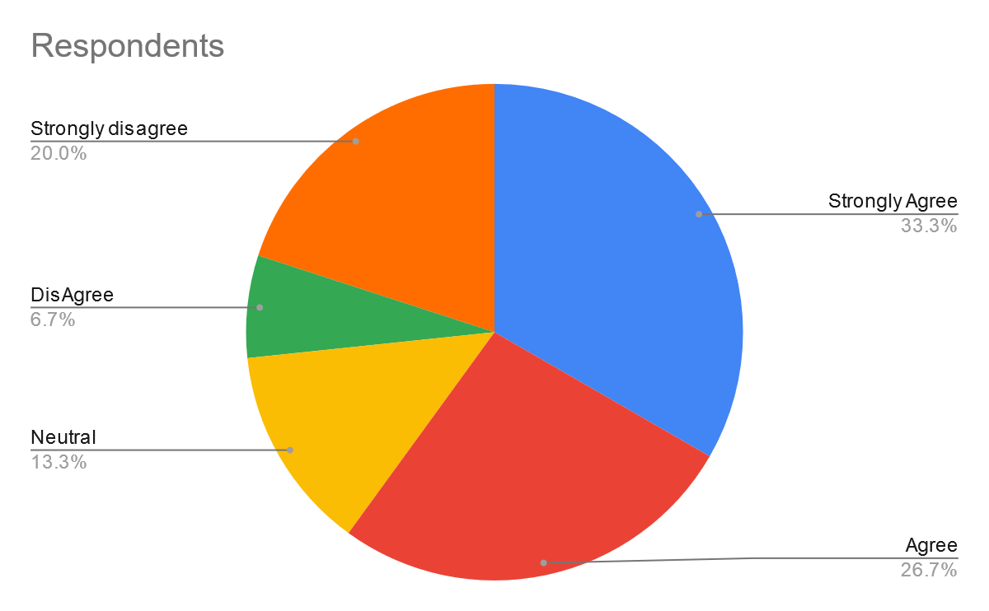
Category | Respondents | Percentage
Strongly Agree | 5 | 33.33
Agree | 4 | 26.67
Neutral | 2 | 13.33
Disagree | 1 | 6.67
Strongly disagree | 3 | 20.00
 | 15
On the question of being able to recall the theories that were being taught through the virtual Learning Platforms, the majority of the students had a positive opinion about it, wherein 60% of the participants were positive, and 20% were strongly against the statement and 13% remained neutral.
3. Are you able to communicate and resolve any doubts as well as get clarification from the teachers through the Virtual Learning Platforms.
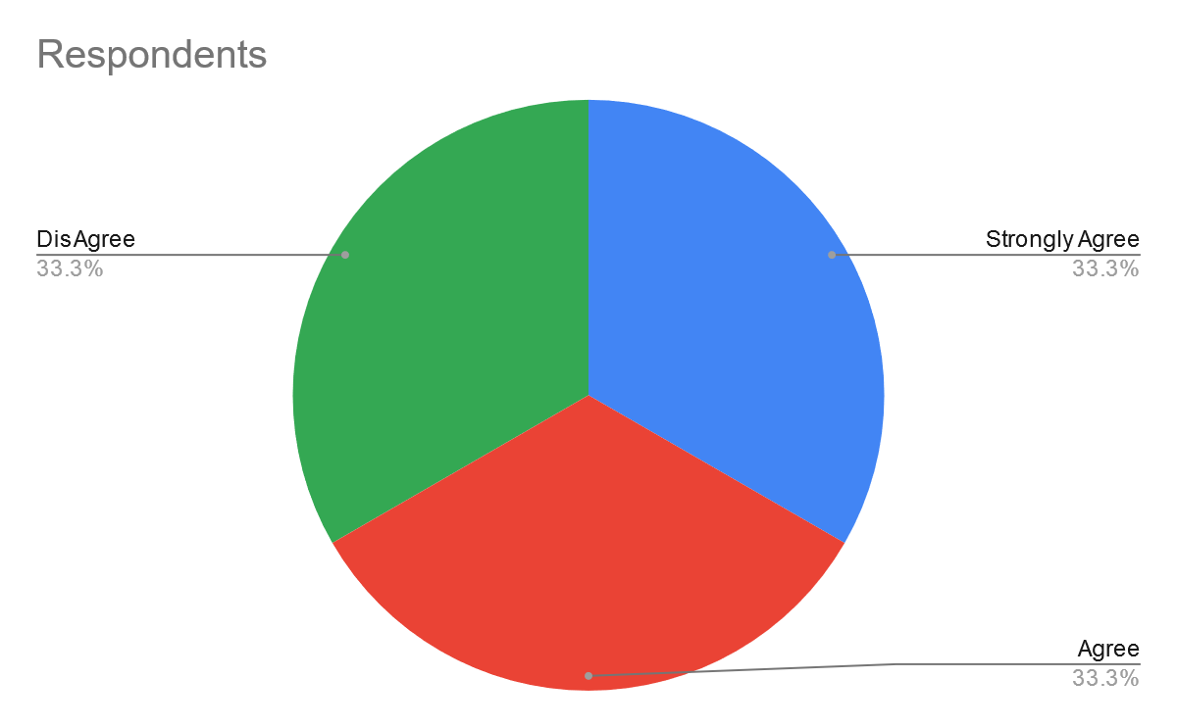
Category | Respondents | Percentage
Strongly Agree | 5 | 33.33
Agree | 5 | 33.33
Neutral | 0 | 0.00
Disagree | 5 | 33.33
Strongly disagree |  | 0.00
 | 15
Thereafter, on the question of being able to communicate and resolve queries with the teachers and mentors, the participant’s opinion was largely positive, with over two-thirds or 66.67% of the participants agreeing to the statement and over 33.33% of the participants gaining the statement as a whole.
4. Are you confident in taking on any challenges and adapt to the changes in the technological environment in your personal and professional life.
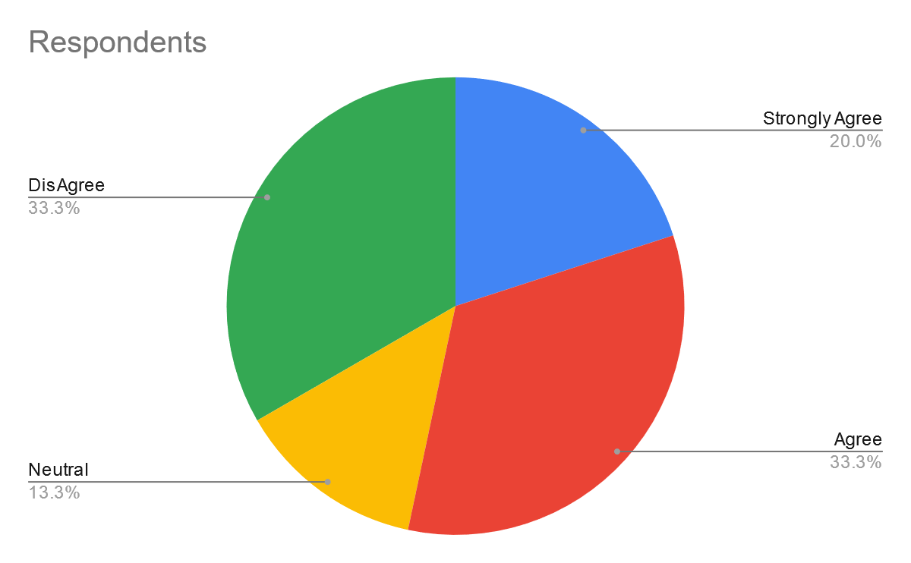
Category | Respondents | Percentage
Strongly Agree | 3 | 20.00
Agree | 5 | 33.33
Neutral | 2 | 13.33
Disagree | 5 | 33.33
Strongly disagree |  | 0.00
 | 15
On the statement of being able to utilize and implement the modern technology and being more confident in integrating as well utilizing modern technology through the use of Virtual learning tools, a quarter of the participants disagreed to it whereas 13% stayed neutral, with over 53% of the participants agreeing to the statement as a whole.
5. On the question of comparison between the Traditional and Virtual Learning Environment, would you prefer Virtual Learning Environment.
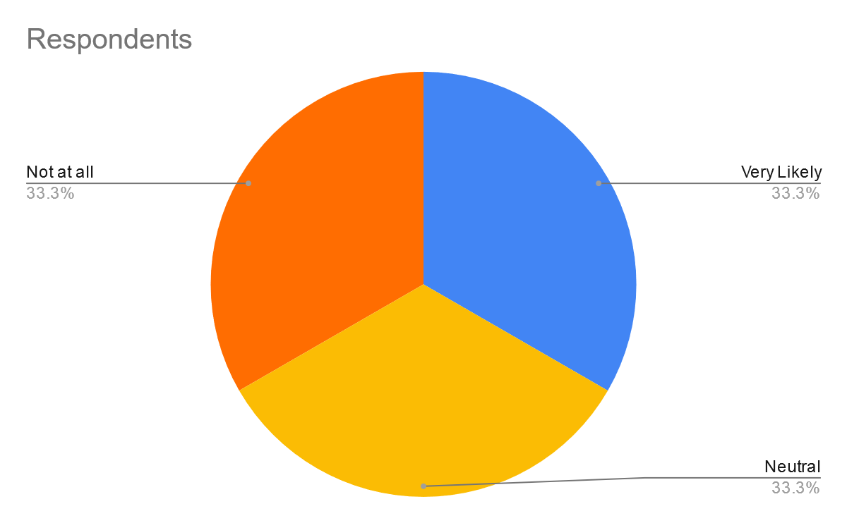
Category | Respondents | Percentage
Very Likely | 5 | 33.33
Likely |  | 0.00
Neutral | 5 | 33.33
Not Likely |  | 0.00
Not at all | 5 | 33.33
 | 15
Lastly, on the preference to adapt to the Virtual Learning environment and giving it more preference over traditional means, the participant inputs were split evenly, wherein a quarter remained neutral, while a quarter were very likely to integrate the platform and a quarter strongly opposed the statement.

Secondary Data Analysis
The secondary data analysis has been undertaken through the utilisation of a case study on the “THE IMPACT OF THE VIRTUAL LEARNING ENVIRONMENT ON STUDENTS”, which was undertaken by Alves et al, (2017), wherein they had sampled over 6700 undergraduate students, and had tried to assess the impact that VLE has on their overall retention and understanding capability as a whole.
The sample size or the participants were divided into two identical groups, wherein one group utilised Digital Learning Platforms and other groups had a traditional setup with their results being compared at the end of the session.
Thus, it was established that the students with Virtual Learning Environment had better recall, as well as retention capability, and were able to understand better. This was also highlighted through their grades wherein they had better overall grades as compared to the students who were using traditional means and platforms. In a further query, it was also established that the students who had used Virtual Learning Environment were better able and adept in using as well as integrating modern tools as well as techniques as a whole in their personal as well as professional lives through understanding the need and working of the technology as a whole.

Conclusion and Recommendation
Thus, in a nutshell, this assignment effectively presents the concepts of Virtual Learning environment and their overall impact on the understanding as well as the retention capability of the students as a whole. Herein, it was highlighted that the students who had used Virtual Learning Environment were better able and adept in using as well as integrating modern tools as well as techniques, and had better recall, as well as retention capability, and were able to understand better in comparison with the traditional learning tools as well as techniques, and thus, it can also be established that the Virtual Learning Environment is the need of the hour and should be implemented on a global basis to better prepare the children.

The Recommendations are as follows:
- Educational institutions must ensure that all the students get equal access and opportunities for resolving any queries.
- Educational institutions must also integrate a range of tools as well as techniques for engaging the students.
- Educational institutions must also ensure that all the students feel comfortable with using and integrating the Virtual Learning tools and environment as a whole.

References
Alves, P., Miranda, L. and Morais, C., 2017. The Influence of Virtual Learning Environments in Students' Performance. Universal Journal of Educational Research, 5(3), pp.517-527.
Chen, Y.L., 2016. The effects of virtual reality learning environment on student cognitive and linguistic development. The Asia-Pacific Education Researcher, 25(4), pp.637-646.
Davis, C., Greenaway, R., Moore, M. and Cooper, L., 2019. Online teaching in social work education: Understanding the challenges. Australian Social Work, 72(1), pp.34-46.
Efstathiou, I., Kyza, E.A. and Georgiou, Y., 2018. An inquiry-based augmented reality mobile learning approach to fostering primary school students’ historical reasoning in non-formal settings. Interactive Learning Environments, 26(1), pp.22-41.
Ess, C.M., 2020. Internet research ethics and social media. Handbook of Research Ethics and Scientific Integrity, pp.283-303.
Giannakos, M.N., Pappas, I.O., Jaccheri, L. and Sampson, D.G., 2017. Understanding student retention in computer science education: The role of environment, gains, barriers and usefulness. Education and Information Technologies, 22(5), pp.2365-2382.
Iovino, F. and Tsitsianis, N., 2020. The Methodology of the Research. In Changes in European Energy Markets. Emerald Publishing Limited.
Kahn, P., Everington, L., Kelm, K., Reid, I. and Watkins, F., 2017. Understanding student engagement in online learning environments: The role of reflexivity. Educational Technology Research and Development, 65(1), pp.203-218.
Kahu, E.R. and Nelson, K., 2018. Student engagement in the educational interface: understanding the mechanisms of student success. Higher Education Research & Development, 37(1), pp.58-71.
Luo, N., Zhang, M. and Qi, D., 2017. Effects of different interactions on students' sense of community in e-learning environment. Computers & Education, 115, pp.153-160.
Makransky, G., Bonde, M.T., Wulff, J.S., Wandall, J., Hood, M., Creed, P.A., Bache, I., Silahtaroglu, A. and Nørremølle, A., 2016. Simulation based virtual learning environment in medical genetics counseling: an example of bridging the gap between theory and practice in medical education. BMC medical education, 16(1), pp.1-9.
Manzoor, A., 2020. Designs of Mixed Method Research. In Cognitive Analytics: Concepts, Methodologies, Tools, and Applications (pp. 95-121). IGI Global.
Rienties, B., Giesbers, B., Lygo-Baker, S., Ma, H.W.S. and Rees, R., 2016. Why some teachers easily learn to use a new virtual learning environment: A technology acceptance perspective. Interactive Learning Environments, 24(3), pp.539-552.
Trimmer, K., 2020. Skilling up: evaluation of a design-based research methodology. The Australian Educational Researcher, 47(2), pp.357-375.

