L5 Group Project
ACDA5022
Luke Malcolm (2030773)
2024
Contents
1. Background & Brief 2
2. Roles & Responsibilities 3
3. Original Design 4
4. Teamwork & Preparation 4
Initial Agreement 4
Weekly Meetings 4
Insensitive Munitions Crash Course 5
Critical Design Review 5
5. Proposed Design 6
Design Summary 6
Modelling & Fill 6
Production & Packing Route 6
Proposed S3 Route 6
Laboratory Analysis 16
Insensitive Munitions & Non-Sequential Safety Tests 16
6. Presentation Delivery 16
Presentation 16
Questions 16
7. Reflections 17
Design 17
Requirements 18
8. Annex A – Meeting Notes 19
Bibliography 21

1. Background & Brief
The class was given a hypothetical scenario regarding the replacement of the current in-service Rapid Cratering Kit.
The following requirements were given to the class [1]:
- Insensitive Munition (IM) compliance
- Desert & hot climate operations (though an all-weather capability was desirable)
- Fully transportable in the current range of fixed and rotary-wing transport aircraft
- Tracked and wheeled road transport
The class was then told we would, in groups, be responsible for the following:
- Comparing the performance of the proposed formulation with existing formulations
- Obtain safety data.
- Propose a design.
- Recommend a production route.
- Describe the Manufacture to Target or Disposal Sequence (MTDS).
- Propose packaging.
- Propose a series of tests to prove the proposed design would meet the MTDS requirements.
The class was then divided into three groups and left to get on with the task.
This report will outline the author’s group’s proposed design, the author’s role within the team, and the documentation they generated to support the presentation.

2. Roles & Responsibilities
The author proposed that our group split the task into five broad sections as follows:
- Design & Modelling
- Manufacture & Packaging
- Sequential Environmental Testing
- Small-Scale Hazard testing & Chemical Analysis
- Non-Sequential Safety Testing (IM assessment)
The author then asked if anyone in the group had any particular preferences as to which section they took, or any pertinent workplace experience. The author volunteered to take the Sequential Environmental Testing aspect, as they have professional experience working in this area (which nobody else in the group did), and it is also one of the most difficult areas to find high-quality information on.
Conveniently, all group members (apart from one) had a professional specialism in each of the other four areas. The author suggested that the one group member who had no particular in-depth experience in any of the five areas took the Non-Sequential Safety Testing section, as the author has fairly extensive knowledge of most of the IM tests, and was happy to provide them a “crash course” on IM testing.
The author also chose Sequential Environmental Testing in the knowledge that it was dependent on the work of others to a minimal degree – as the author had a significant office workload, in addition to scheduled leave, so they did not have the time they would have liked to devote to group collaboration. In other words, Sequential Environmental Testing is comparatively independent of the other areas. The correct tests could be selected through an understanding of the requirements and the MTDS. Key requirements for collaboration with other engineers in the group included:
- Understanding the design – to allow a suitable inspection schedule to be drawn up, and to support the development of test methodology.
- Understanding the needs of Breakdown, Test, and Criticality Analysis (BTCA) and how many munitions they require to be removed mid-test, to allow the round allocation table to be developed accordingly and the correct number of munitions demanded
Neither one of the above examples requires a huge amount of in-depth discussion and as such a reasonable level of independence could be maintained.

3. Original Design
The original design consisted of two charge bags, each filled with an RDX/TNT 60/40 mixture, and a shaped charge, with an identical fill. The shaped charge would be placed onto the ground and fired, leaving behind what can effectively be considered a “pilot hole”. Into this hole either one or both main charge bags were placed and detonated, giving two “crater size” options. The entire kit was packed into a wooden transport crate.
As a group, we identified that the main issue with the legacy kit was the lack of IM compliance. While no trials data was provided, it was assumed that the legacy kit met all other given requirements (air and road transport, all-climate capability, etc etc).

4. Teamwork & Preparation

Initial Agreement
The group first agreed to take a “if it isn’t broken, don’t fix it” approach to the design of the new charge, and not to re-invent the wheel unless absolutely necessary. The original kit is functionally sound, and the tuneable effect offered by two main charge bags is something the group wanted to maintain. We agreed that our initial approach would be to effectively take the existing kit, change the energetic, and propose an updated manufacturing plan and trial series.

Weekly Meetings
The group also agreed that it was a good idea to set up a weekly meeting to discuss progress and collaborate on the necessary areas. Another group member set this up as a recurring meeting on MS Teams. The author was not able to attend every single session
Minutes from each meeting were taken and are available in Annex A.

Insensitive Munitions Crash Course
One group member was unfamiliar with Insensitive Munitions testing, and the author had agreed to give her a “crash course” so she could gain some critical understanding of the various tests, their methodology, limitations, background, etc. The author began by acquiring and sharing the relevant test STANAGs, along with AOP-39, which is the general policy for the introduction and assessment of insensitive munitions. Each STANAG was then reviewed in-depth. The author encouraged their “student” to think through each test logically, and in tests which had multiple options, use their own train of thought and knowledge of threats to select the most appropriate option – while giving them nudges in the right direction when required. The author believes this approach is fundamentally much more useful than simply telling which option to take, then explaining why they came to that conclusion, as this does not necessarily allow a student to think through a scenario logically and “use their brain their way”.

Critical Design Review
The Critical Design Review was passed without incident. The author suggested that rather than an unstructured discussion occurring, we each take a turn to explain to the lead reviewer which aspect of the programme we were covering, and give an overview of work completed to-date and the direction being headed in. This was agreed, and the design review was more straightforward as a result (as each group member then knew exactly what they needed to do). Following the design review, the group had an in-person review of other members’ slide packs and passed comment. The author also discussed with the relevant engineer if his aspect of the testing would require some environmentally-stressed munitions (as discussed in a previous meeting) and suggested as to which steps of the environmental test programme the munitions should be selected from

Rehearsals
The group had only two “formal” rehearsals – one the day before, and one on the day of, the presentation. Both were cut short for reasons beyond the group’s control. In the first rehearsal, virtually all group members decided to tweak their slides slightly to keep time down or make the information easier to explain verbally to an audience. In the second, no changes were made, but some IT critical issues were identified and resolved ahead of the assessed delivery.

5. Proposed Design

Design Summary
The group’s proposed design is as follows:
- Replacement of explosive filling with a novel PBX - “Swans-Ex2024”
- PE8 booster charge (dividable)
- Slightly reduced Cone Diameter (CD)
- Carrying straps on shaped charge body and on charge bags
- Addition of aluminium standoff legs
The above will be elaborated on in subsequent sections, in the order they were presented in. The author will discuss their (Sequential Environmental Testing) section in significantly greater depth than the sections of other group members.

Modelling & Fill
Steve McAngus was responsible for Finite Element Analysis (FEA) modelling of the charge, ensuring that a clean and coherent jet was formed – and advising on any necessary modifications. FEA tools are notoriously difficult to use well, the group was wholly reliant on his ability in this respect. Through his FEA analysis, it was found that a slight reduction in cone diameter may be necessitated due to the fact the proposed novel PBX is significantly higher performance than the original RDX/TNT mix.

Production & Packing Route
Max Fisher was responsible for proposing a production route. Two approaches were proposed. The first was bulk mixing of the energetic in a large RAM 55 mixer, before pouring it into casings under vacuum, on a vibration plate, to ensure no air voids were left inside the quick-curing explosive. He pointed out that due to the three-year backorder on RAM 55 mixers, a more realistic alternative would be to mix the filling in-case using a smaller (more available) RAM mixer. Quality Control methods were also proposed, notably including radiography to ensure no voids are present. Max also presented an excellent and well thought-out justification in favour of using wood packaging, as it poses a much lower fragmentation hazard.

Proposed S3 Route
The author proposed a Sequential Environmental Test (SET) programme. Environmental Testing requires a lot of time and effort to grasp; Defence Standard 00-035 is not necessarily straightforward to read or understand. In his professional role, the author manages the technical side of several multi-year environmental test programmes, and as such, was well-suited to outline a proposed programme. One such programme deals with a munition nature that would likely be in service in the same environments as a cratering charge, and used (to some extent) by the same users in “day to day battlefield tasks”. This was useful, as certain elements could be read across to this proposed SET
the slides produced are shown in figures 1 through 9, inline with text for ease of viewing.
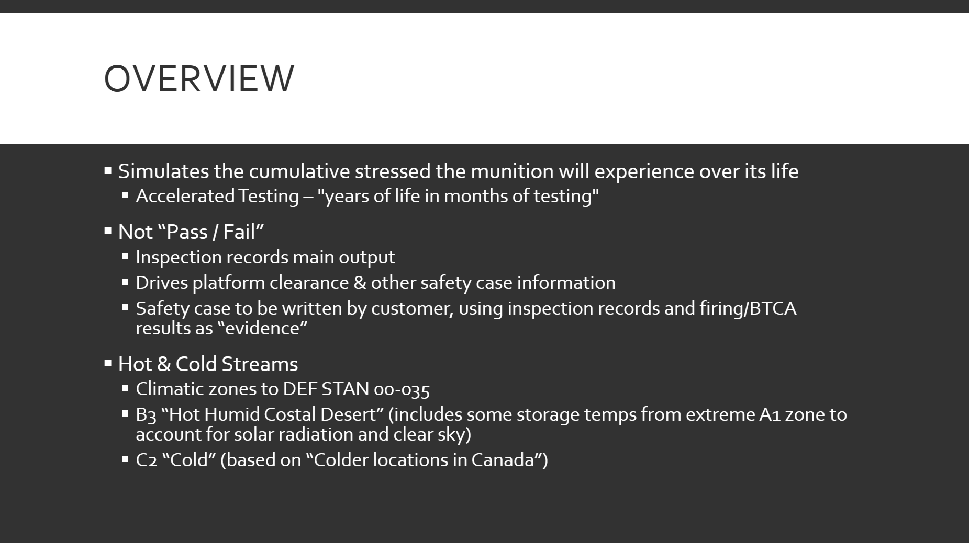
Figure 1 - Overview Slide
This slide aimed to give a general overview of the proposed programme and outlines how the output feeds into the overall safety case for the munition. In this slide, the author also explains the concept of the hot & cold temperature streams. The climate requirement states “Desert & hot climate operations (though an all-weather capability was desirable)”. After examining the relevant Defence Standard [2], the decision was made to select climatic zones B3 and C2. This fits a broad spectrum of climates, and while it is slightly biased towards hot weather, includes some reasonably severe cold – in other words, fitting the requirement perfectly.
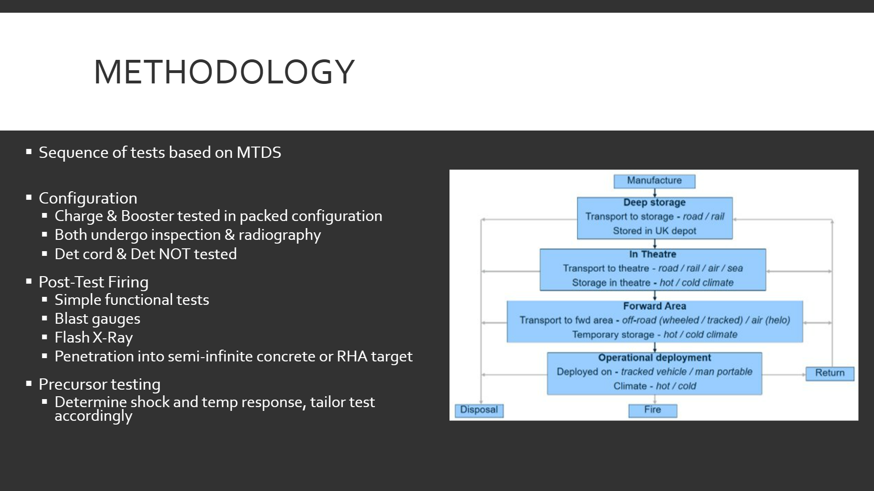
Figure 2 - Methodology Slide
In this section, the author aimed to cover the methodology that would be followed pre- and post-testing and explain the purpose of post-test trials – along with presenting a basic MTDS.
The cratering charge kit would be tested in its full packed configuration, as that is how it would be transported and stored in service and transported on operations.
It should be noted that the cratering charge is an exception to a general rule of function trials in that its function should not be trialled by using it in its “design mode” – ground is variable and not easily measurable or reproducible. As such, the author recommends that post-environmental function trials be carried out as simple functional tests – the shaped charge can be fired into a concrete or metal semi-infinite target (which is repeatable and reproducible). Flash X-ray can be used to look at jet formation, and blast gauges can be used to assess the bag charges.
Precursor testing was also discussed, using inert (but dynamically and thermally representative) stores to allow shaker table responses to be tuned, fixturing methods perfected, temperature cycling levels and times to be ascertained. This is always performed before a test sequence on the live stores.
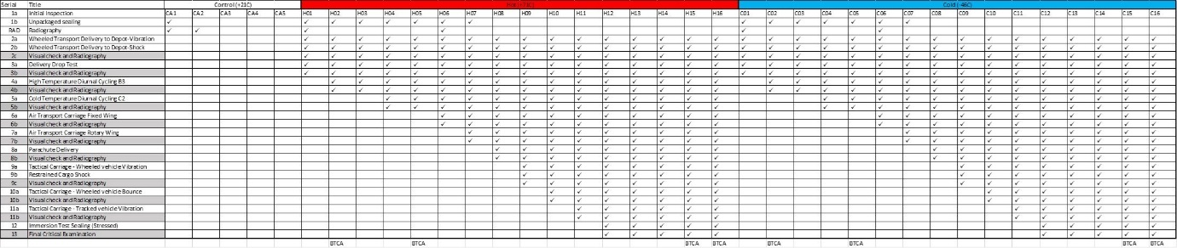
Figure 3 - Full Hot & Cold Stream Round Allocation Table
Presented next was the round allocation table. This gives the order of tests (which is based on the MTDS) and dictates exactly which stores undergo each test. For legibility, the full list of tests is presented below.
Figure 4 – Tests
As can be seem from the above, the tests are broadly representative of the MTDS – after an initial sealing test and radiography (giving a baseline state, and an inspection of features that cannot be seen by the naked eye), the tests begin with transport to depot, and delivery (handling) shocks, followed by diurnal cycling (as the munition is in storage). Air carriage follows, initially fixed-wing for a long transport flight into theatre, followed by rotary wing and parachute delivery, for a short resupply mission. Tactical carriage (use on the ground in operations), on both wheeled and tracked platforms, is the final set of mechanical tests. After the munition has been environmentally stressed, a repeat of the initial immersion test is performed to ensure seals etc. are still functional. Following the final critical examination, stressed rounds go for functional testing.
One round per stream is taken out for BTCA following hot & cold diurnal cycling (as this is deemed most likely test to cause degradation in the energetics), and two at the end of the full series. One round is also retained following each test and does not do undergo any subsequent testing whatsoever – these can be used to investigate potential issues and ascertain what exact test did (or began) the damage if there are issues further through the SET.

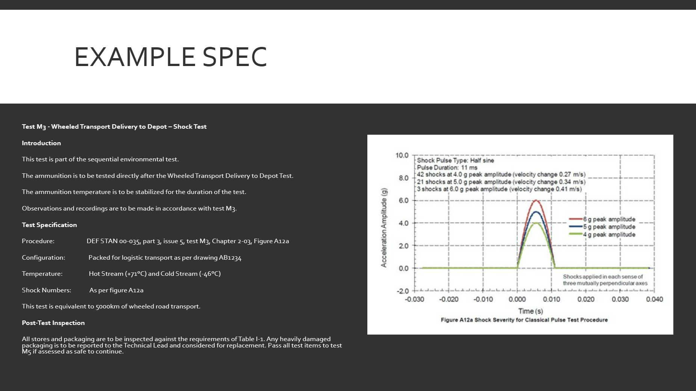
Figure 5 - Example Specification Slide
Next, the author laid out what a typical test specification would look like – there would be one for each and every test, all captured in a document known as the “Trials Requirement Specification”. Key to the test house is a reference to the standard, test description, test method, severity and test parameters, assets under test (and their configuration), and instructions following the test, along with any other useful information. This is all the information required by the test house.

​

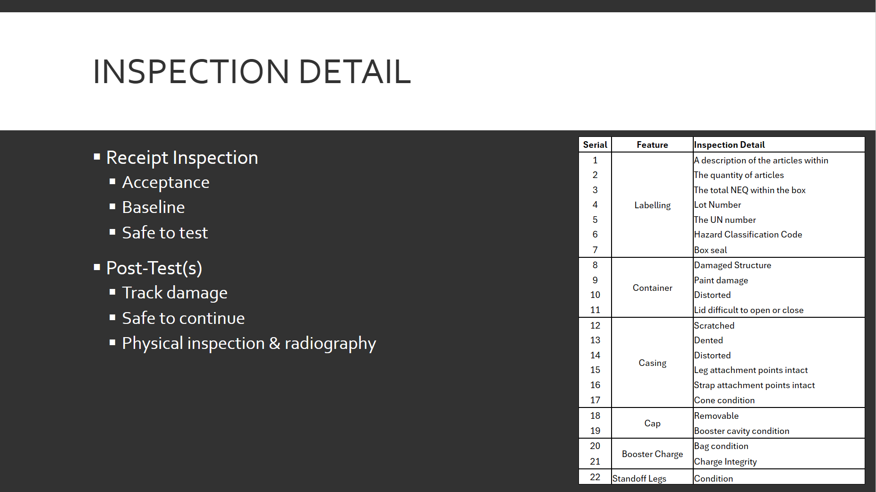
Figure 6 - Inspection Detail Slide
Inspection records form one of the key outputs of an environmental test programme – they allow you to track levels of damage throughout, and pinpoint which tests caused the damage (if damage is visible either by visual inspection or radiography – which in the case of this munition, it should be). The inspection process also ensures that rounds are deemed safe for continued testing.

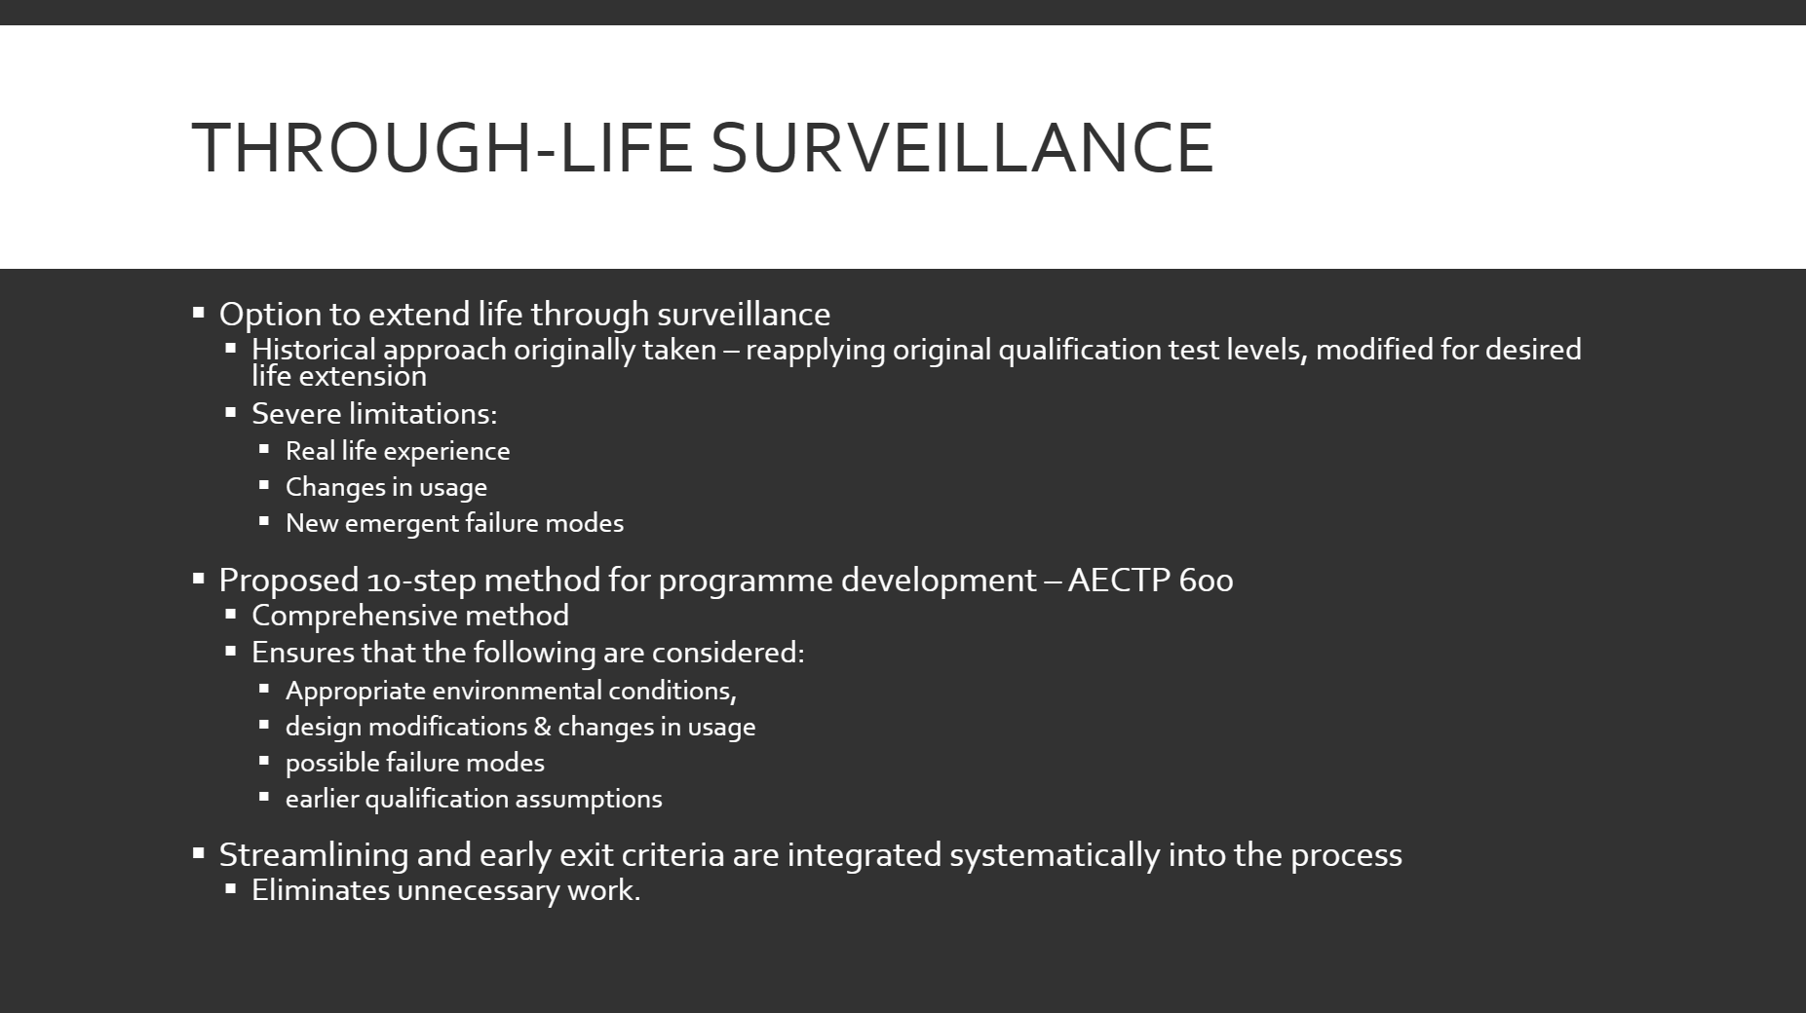
Figure 7 - Through-Life Surveillance Slide
A SET test series is a good way to initially assess the performance of a munition throughout its expected lifecycle, but it does not consider real-world use and emergent failures. Furthermore, an unavoidable limitation of the SET is that often the supplied MTDS, battlefield, or user requirements will simply be incorrect. This is where Through-Life Surveillance (TLS) shines. TLS is also particularly well suited in this instance due to the new novel PBX being employed – the munition can go into service following a straightforward (and not time-consuming and exhaustive) SET, then periodically examined and checked on. This approach allows risk to be balanced well.
There are a variety of methods which can be employed to create a Through-Life Surveillance Strategy, but the author’s preference is to use the relatively straightforward 10-step method proposed in AECTP 600 [3]. This not only allows an assessment of material to meet extended life requirements, but also the requirements of role and deployment changes. Early exit criteria are also integrated into the 10-step framework, easily eliminating unnecessary work. A basic overview of this method will be given below.
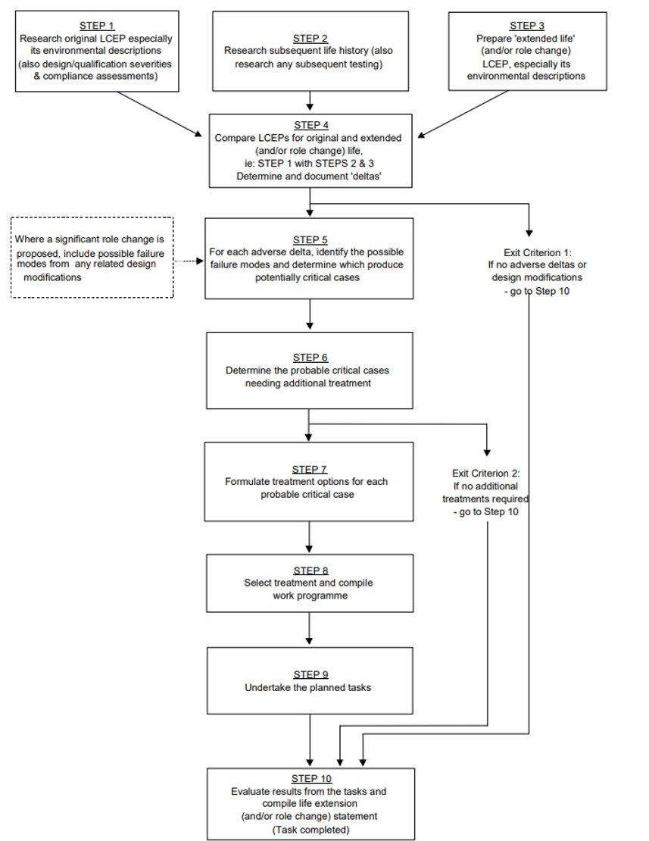
Figure 8 - AECTP 600 10-Step Method
​
1. Research original Life Cycle Environment Profile (LCEP) – this is expected to consist of MTDS and associated environmental descriptions consisting of logistic and operational scenarios. ​If one is not available, reverse-engineer it using techniques given in AECTP 600, Annex D, Leaflet 601.
​
2. Obtain information concerning any modifications to the materiel or changes to its original intended usage, and any problems that have occurred – effectively, gather a full “service history”. Also investigate any additional testing performed after the materiel was placed in service.
​
3. Prepare an LCEP to cover the extended life or role requirement.
​
4. Compare the original and new LCEP (step 1 with steps 2 & 3) and determine document “deltas”. Also determine if original environmental descriptions and failure modes and associated acceptance criteria remain valid.​ If it is found that there are no deltas, the materiel is already qualified and the requirements for exit criterion 1 are met. If any life extension involves a design change, engineering judgement is required to ascertain if these shall be considered deltas.
​
5. Examine the deltas and identify possible new failure modes. Determine which are potentially critical. This should be done quantitatively with matrixes. Potentially critical cases should be examined.

6. Each potential critical case will be evaluated to determine the probable cases – original test results must be available for the original life requirement must be available for analysis. If the results of these evaluations indicate that the estimated life of the materiel based on original environmental conditions is greater than the estimated life based on real or extended life requirements, the requirements for exit criterion 2 are met. ​
​
7. Options for treating the cases identified in step 6 are decided. Remember that use can be constrained if it is deemed that the materiel cannot realistically meet the extended life or role requirement.
​
8. Select the most cost or programme effective option to address the shortfalls identified earlier. The selected option must give an appropriate level of confidence that the store can meet the extended life/role requirement. ​
​
9. Conduct the programme
​
10. Evaluate results & report on findings.

The outcome of the 10-step method is a full report on the safety and suitability for service of the materiel in question, according to its extended life or role requirement, and evidence on which a safety argument can be based on.

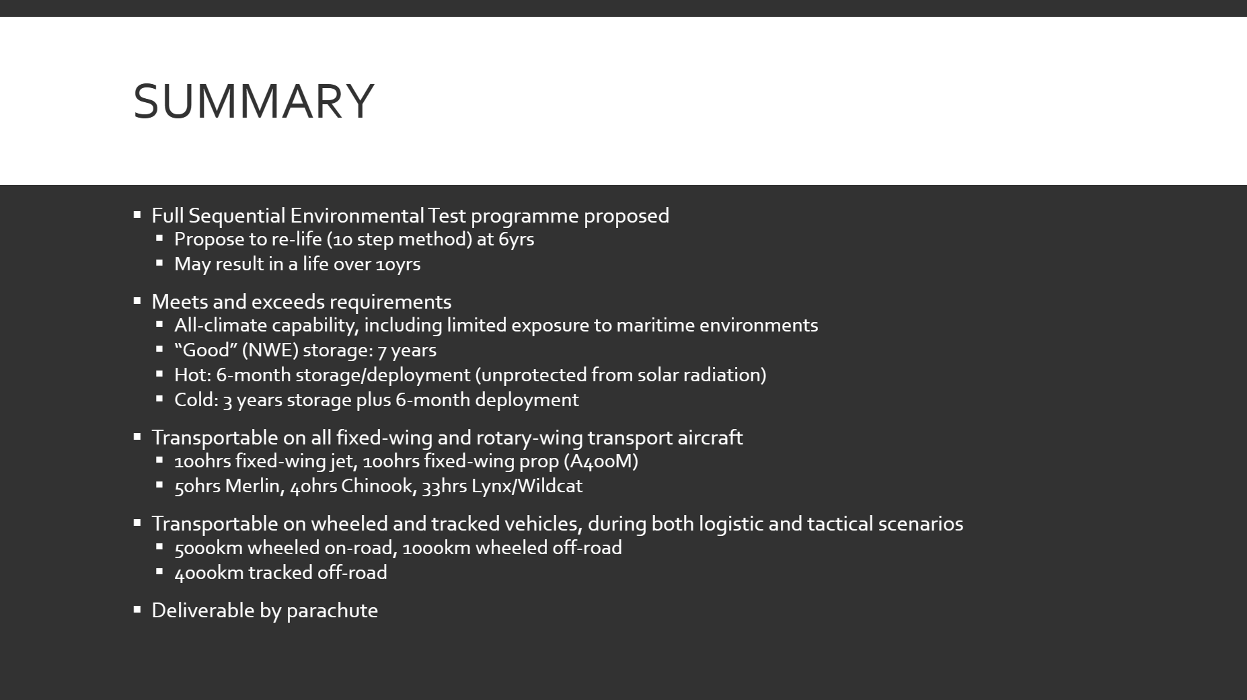
Figure 9 - Summary Slide
A full summary was given in the final slide of exactly what the SET would result in, both with respect to storage and transport. It should be noted that while a 6-month hot climate storage period seems short, this is while the munition is wholly unprotected from solar radiation. With basic measures taken to protect the store from the effects of solar radiation (be this as simple as a shade-producing cover, or as complex as a climate-controlled magazine), this storage life would be significantly extended.

Laboratory Analysis
Silas Blevins spoke about laboratory testing of the energetic components of the charge and proposed a number of different tests to characterise the novel explosive used for the charge - in new, aged, and environmentally stressed forms. This area is complex, and Silas’ professional experience working with energetics in a lab environment shone through and a comprehensive catalogue of tests and methodologies was discussed.

Insensitive Munitions & Non-Sequential Safety Tests
Natalie Coplin presented a proposed programme to ascertain if the munition would meet the requisite IM requirements. While she initially did not have any experience in this area, she confidently presented the test series, justifying each decision made against a threat hazard assessment. Natalie also competently examined the differences in testing in both operational and logistic configurations.

6. Presentation Delivery

Presentation
The presentation itself went well and was delivered without incident. Total runtime was 57 minutes, which is reasonable for five speakers receiving ten minutes of speaking time each, plus a few minutes for introductions and conclusions. The group had actually not done a full start-to-finish timed rehearsal including the introduction and conclusion at the point the presentation was performed, and the author was pleased that all group members were able to effectively “self-moderate” their slide pack length and speaking time.

Questions
The author was asked a specific question around helicopter underslung load vibration and why this had not been specifically addressed in the Sequential Environmental Test series.
While explosive materials are transported as an underslung load on occasion, it is not a routine practice in peacetime. The dynamic environment experienced by an underslung load is mostly (but not completely) isolated from the dynamic environment of the airframe due to the attenuation provided by the suspension system, however a dynamic response due to the airflow past the underslung load will be encountered [4].
There are no platform-specific tests for underslung loads. Current practice is to use a broadband Gaussian vibration test. This test appears to be marginally less severe than the “on-platform” tests (by nature of a lower RMS g value - though the peak-to-peak displacement is higher [5]) – this comes as no surprise given the suspended nature of an underslung load.
The set-down shock loading when landing the load would also in this instance need to be considered – although this is most severe in Naval VERTREP operations, the loadings are “similar to those for general handling conditions” [4]. It is the view of the author that a reasonable argument could be made (which would likely be happily accepted by any reasonable WESCOE – formerly DOSG - safety advisor) for the parachute drop test to also cover underslung load set down, as the drop height and impact velocity figures for parachute drop are several times more severe than the figures for underslung load set down.
A final consideration related to underslung carriage is that driving rain may need to be considered should the load be carried in inclement conditions – the standard sealing test is not sufficient. A test for this is listed in AECTP 300, Method 310.
A final question for the group in the feedback form was around the promulgation of test results, namely how this would be conducted. When bringing something into service, a safety case must be generated and signed off - this is the responsibility of the relevant Ministry of Defence Project Team (PT). Manufacturers are generally not allowed to “mark their own homework”, and as such independent test organisations are used. The test organisation is generally contracted by the project team, or in certain cases, by the manufacturers of the equipment under test, ahead of it being proposed for service. Test reports outline the testing conducted and the results – there is usually a short recommendations section, though this is never exhaustive. The test report is sent to the party that contracted the testing to begin with. It would be commercially frowned upon to release it to any other party – the data belongs to the organisation which paid for it. For example, in the instance that the MoD has contracted testing, the test report must be sent directly to them when finished and not to the manufacturer of the equipment under test – even when the OEM has been part of discussions - unless customer permission has been sought.

7. Reflections

Design
The author (and the wider group) believes the design submitted is highly credible, would pass Safety and Suitability for Service (S3) testing, and would be functional in a battlefield scenario. Many other PBX-containing devices have been qualified for service following a very similar test series, and the group does not see why this would be any different.
The author would have liked to explore the possibility of placing environmentally stressed munitions into IM trials, although it is likely that small-scale hazard testing (of the stressed munitions) would be sufficient to identify any issues, the further investigation of which could be presented to the customer as an option should this situation arise.

Requirements
It was relatively frustrating to be pulled up on matters which were not part of the initial requirement at the beginning – for example, there was no specific requirement to look into UN Hazard Classification testing and as such it was not covered in the presentation (although the author believes that his response to the question of the overall hazard classification, in which the UN Manual of Tests and Criteria, test series 5 was referred to) was sufficient.
Unfortunately, the customer “forgetting” a requirement – or asking why a newly-delivered system does not perform a certain function, despite that certain function never being mentioned to-date, is not an entirely uncommon occurrence, the group’s presentation questions served to be a useful reminder of that.
On teamwork and communication
The author feels that the teamwork and communication aspects went well. There was no friction between any group members, and matters that required collaboration were all dealt with swiftly and concisely. No members of the group were ever left “waiting for an answer”.
On IM crash course
The author was incredibly pleased with the development of their “student” – who went in having very little knowledge of IM testing, and came out being able to confidently discuss it.

8. Annex A – Meeting Notes
Monday 12th February. 3pm. Group meeting notes.
In person
Present: SB, LM, SMC, MF, NC
The group discussed what needed to be covered to complete the assignment. It was agreed we cannot cover all parts that would be required in the workplace, but we could cover a good number of areas of expertise.
MF – Manufacturing
SMC – Modelling
SB – Chemical analysis
LM – Sequential testing
NC – non-sequential testing
SCM proposed fortnightly catch-up meetings on teams if people are available. These wouldn’t be mandatory but attend if you are available/are required. SCM was happy to set these up.
LM explained both sequential and non-sequential testing.
SCM suggested a route for modelling.
SB explained he has been working on some of these tests in the workplace so was very comfortable discussing them for the group project.
NC said she hasn’t been involved in any IM testing but was happy to read relevant documentation and learn.
MF started a discussion on possible options for design which would dictate his manufacturing route.

Monday 18th March. 4pm. Group meeting notes.
Present: SB, LM, SMC, MF, NC
On Teams
The group discussed our own parts of the project – testing plans, chemical analysis, manufacture, modelling.
SCM commented on the difficulties of remoting into the University’s computers to perform full simulations. He was going to continue trying but explained he may have to resort to the student version of the software if problems persisted.
MF noted that we needed details on the melting point of the TAWE Ex2024 composition, SMC took this forward and approached supplier (DH) for further details. In the same instance SMC also requested details pertaining to the EOS of materials.

Group asked the question if we needed to use TAWE Ex 2024 for bag charges, as a previous model of the bag charges was pure RDX, SMC took this to customer (DH).
SB showed some slides he had been working on and discussed a few tests in brief.
SB created a shared area for us to put documents and relevant information.
It was noted the bank holiday would be our next meeting date, so it was agreed to reschedule the next couple of meetings.

Friday 12th April 2024. 4pm. Group meeting notes.
Present: SB (absent, but passed on info to other members of team), LM, SMC, MF, NC
On teams
NC and MF showed slides from their presentations so far. NC noted the steep learning curve she had been on for this project and asked for her work to be reviewed to make sure nothing vital had been missed. LM offered to do this. MF noted a slide was wordy but there was no intention to read off the slide, it is simply a “for information” slide for another who wishes to read more.
LM discussed his environmental test plans and where that fits into the overall project. It was discussed that SB will need some samples from LMs’s test so they can be chemically tested after aging. LM to discuss with SB.
SMC discussed ongoing issues with university software and how he was working around the problems. One solution has been using a student version of the software. It was noted this massively limits the model that can be produced but having a model is better than no model and useful data will still be obtained from the simulations.
SB passed on that he was nearly done with his presentation. He is hoping to add in a few more images.
Practice sessions for the presentation were suggested when we are all on campus next week. Dates and times for this will be discussed in person.

Monday 15th April. 11am. Group meeting notes.
Present: SB, LM, SMC, MF, NC
In person
Team catch-up prior to the design review.
Each member briefly explained where their slides were up to and how work was progressing.
The group put together several questions on topics which needed clarification during the design review.
The group felt they were in a good position for the design review later on in the day.

Monday 15th April. 4pm. Design Review Meeting
Present: SB, LM, SMC, MF, NC, JS, DH
In person
Each member of the team explained to DH and JS what they had been working on, including any issues they had encountered.
MF explained in detail the design the group had taken forward and that this wasn’t very different from the original in the brief. The rationale behind this was explained and DH seemed content.
The date for the presentation was confirmed and DH said he was looking forward to seeing our presentations.

Bibliography

[1] | D. Holley, BEng Group Project 2024, 2024.
[2] | Ministry of Defence, Defence Standard 00-035, Part 04, Issue 5, Ministry of Defence, 2023.
[3] | North Atlantic Treaty Organisation, Allied Environmental Conditions and Test Publication 600, Edition 2, North Atlantic Treaty Organisation Standardisation Agency, 2007.
[4] | Ministry of Defence, Defence Standard 00-035 Part 05, Issue 6, Ministry of Defence, 2023.
[5] | Ministry of Defence, Defence Standard 00-035, Part 03, Issue 6, Ministry of Defence, 2023.

