
HILTON WORLDWIDE HOLDINGS INC.
CFO-Style Financial Analysis & Strategic Investment Report
Module | Financial Management - MBA International Business
Assignment Title | CFO-Style Financial Analysis, Working Capital, Strategic Restructuring & Investment Appraisal
Company Analysed | Hilton Worldwide Holdings Inc. (NYSE: HLT)
Analysis Period | FY2021 - FY2025 (Five Fiscal Years)
Data Sources | Hilton Annual Reports 2022-2026
Student Name | Zarna Patel
Student ID | 2536013
Lecturer | Patrick Yeboah
Word Count | Approx. 5,000 words
Submission Date | 24th July 2026
FY2021 - FY2025 | Last Five Fiscal Years

Table of Contents
Executive Summary 3
Section 1: Financial Health Check 4
- 1.1 Income Statement – Revenue, Operating Expenses, and Profit 4
- 1.2 Balance Sheet: Statement of Financial Position 6
  - 1.2.1 Current and Non-Current Assets
  - 1.2.2 Equity, Liabilities, and Negative Stockholders' Equity
- 1.3 Cash Flow Statement Analysis 8
  - 1.3.1 Direction of Cash Flows and Cash & Cash Equivalents
  - 1.3.2 Interpretation of Cash Flow
- 1.4 Ratio Analysis: Three In-Depth Ratios 10
- 1.5 Trend Analysis 13
- 1.6 Industry Benchmark 14
Section 2: Working Capital Management Analysis 16
- 2.1 Cash Operating Cycle (COC) 16
- 2.2 Working Capital Improvement Recommendations 18
- 2.3 Short-Term vs Long-Term Financing Options 19
Section 3: Strategic Financial Restructuring Plan 20
- 3.1 Current Position Assessment 20
- 3.2 Restructuring Recommendations 20
- 3.3 International and ESG Considerations 21
Section 4: Investment Appraisal and Capital Budgeting 22
- 4.1 Project Details and Discount Rate 22
- 4.2 NPV Detailed Workings: All Three Projects 22
- 4.3 Full Appraisal Results 23
- 4.4 Interpretation and Recommendation 23
- 4.5 Capital Rationing Decision 24
Section 5: Critical Reflection on AI Usage 25
- 5.1 Tool Disclosure 25
- 5.2 Critical Evaluation of AI Output 25
- 5.3 Contribution Analysis 26
- 5.4 Ethical and Professional Reflection 26
Section 6: Evaluation and Strategic Conclusions 27
- 6.1 Overall Financial Health Evaluation 27
- 6.2 Working Capital and Investment Evaluation 28
- 6.3 Forward-Looking Perspective 28
- 6.4 Limitations 29
References 30
Appendix: Dashboard Hilton Worldwide Holdings 32

Figure No. | Title | Description
Figure 1 | Hilton Revenue & Financial Position | Illustrates Hilton’s five-year revenue growth and overall financial trajectory, highlighting recovery from COVID-19 and transition into sustained expansion.
Figure 2 | Hilton Revenue & Net Income Trend (FY2021-FY2025) | Shows the relationship between revenue growth and net income performance across five fiscal years, emphasising margin stabilisation and tax-related fluctuations.
Figure 3 | Revenue vs Operating Expenses Bar Chart | Compares Hilton’s revenue growth with operating expense increases, demonstrating economies of scale and widening operating profit.
Figure 4 | Asset Structure - Current vs Non-Current Assets | Visualises Hilton’s asset composition, showing the dominance of non-current assets due to the asset-light franchising model.
Figure 5 | FY2025 Debt-to-Assets Composition | Breaks down Hilton’s capital structure, highlighting the proportion of debt financing relative to total assets.
Figure 6 | Cash Flow Statement: Three-Way Direction Analysis | Depicts operating, investing, and financing cash flows, showing Hilton’s strong cash generation and heavy buyback-driven financing outflows.
Figure 7 | Cash & Cash Equivalents at Year-End | Shows the declining cash balance trend due to share repurchases despite rising operating cash flow.
Figure 8 | Key Ratio Dashboard - ROCE, Interest Coverage, Net Debt/EBITDA | Summarises Hilton’s core financial ratios, highlighting improvements in profitability and leverage.
Figure 9 | Profitability Margin Trends | Displays operating, net, and EBITDA margin trends, showing structural efficiency improvements.
Figure 10 | Free Cash Flow & EPS Trend Analysis | Shows Hilton’s rising free cash flow and stabilising EPS, reflecting strong cash generation and moderating buyback impact.
Figure 11 | Cash Operating Cycle: Structural Advantage | Illustrates Hilton’s negative cash operating cycle and its liquidity benefits.
Figure 12 | Cash Operating Cycle Components | Shows receivable, inventory, and payable days over five years, highlighting working capital efficiency.

List of Figures

List of Tables
Table No. | Title | Description
Table 1 | Income Statement Summary | Summarises Hilton’s revenue, expenses, operating income, net income, and key profitability metrics for FY2021–FY2025.
Table 2 | Balance Sheet Summary: Assets | Provides a breakdown of current and non-current assets, showing the impact of Hilton’s asset-light strategy.
Table 3 | Balance Sheet, Liabilities & Equity | Details Hilton’s liabilities and equity position, including negative equity driven by cumulative share buybacks.
Table 4 | Cash Flow Statement Summary | Summarises operating, investing, and financing cash flows, highlighting free cash flow growth.
Table 5 | Comprehensive Ratio Summary | Consolidates profitability, leverage, and efficiency ratios for FY2021–FY2025.
Table 6 | Hilton vs Peers: Financial & Operational Benchmark | Compares Hilton’s liquidity, profitability, leverage, and operational metrics with Marriott, IHG, and Hyatt.
Table 7 | Cash Operating Cycle Components | Shows receivable days, inventory days, and payable days, forming Hilton’s cash conversion cycle.
Table 8 | Financing Options Comparison | Compares short-term and long-term financing instruments available to Hilton.
Table 9 | Project Cash Flow Assumptions | Lists initial investment, depreciation, and projected cash flows for Projects A, B, and C.
Table 10 | NPV Calculation Table | Shows discounting workings for each project at an 8% discount rate.
Table 11 | Complete Investment Appraisal Summary | Summarises NPV, IRR, ARR, Payback Period, and PI for all three projects.
Table 12 | Capital Rationing Combination Analysis | Evaluates project combinations under a £100m capital constraint and identifies the optimal selection.

Executive Summary
Figure 1: Hilton Revenue & Financial Position
Hilton Worldwide Holdings Inc. is one of the world's leading hospitality corporations, operating 9,158 properties across 143 countries as of December 2025. This report presents a comprehensive five-year financial analysis (FY2021-FY2025), encompassing the company's COVID-19 recovery trajectory, sustained growth phase, balance sheet evaluation, working capital management, and forward-looking strategic investment appraisal. All financial data referenced in this report has been sourced directly from Hilton's Annual Reports on Form 10-K filed with the U.S. Securities and Exchange Commission (Hilton Worldwide Holdings Inc., 2022; 2023; 2024; 2025; 2026).
Total revenues grew from $5.79 billion in FY2021 to $12.04 billion in FY2025, representing a 107.9% increase over the five years. EBITDA reached a record $2.87 billion in FY2025, with free cash flow of $2.03 billion confirming robust operational cash generation (Hilton Worldwide Holdings Inc., 2026). Net Debt/EBITDA declined to 4.00x from 6.41x in FY2021, reflecting improved leverage management despite an ongoing share buyback programme totalling $14.4 billion in cumulative treasury stock. The company's Cash Operating Cycle of approximately -108 days underscores the self-financing nature of its asset-light franchise model.
Three investment projects are appraised using Payback Period, ARR, NPV, PI, and IRR at an 8% discount rate. Given a £100 million capital constraint, Projects A and C are recommended, yielding a combined NPV of £8.28 million, rapid payback, and regulatory ESG compliance alignment with Hilton's strategic priorities.

Section 1: Financial Health Check

1.1 Income Statement - Revenue, Operating Expenses, and Profit
Hilton's income statement over the last five fiscal years (FY2021-FY2025) tells a compelling story of post-pandemic recovery and structural growth. Total revenues recovered sharply from $5.79 billion in FY2021 to $12.04 billion in FY2025, surpassing pre-pandemic levels and demonstrating the resilience of the asset-light franchise model (Hilton Worldwide Holdings Inc., 2026; Arnold, 2019). Revenue composition has also improved qualitatively: franchise and management fees now represent an increasing proportion of total revenue, commanding near-zero variable costs and contributing disproportionately to operating profit margins (Atrill and McLaney, 2021).
Operating expenses increased from $4.78 billion in FY2021 to $9.35 billion in FY2025, yet operating income simultaneously improved from $1.01 billion to $2.69 billion over the same period. This divergence reflects economies of scale and the leverage of fixed costs across a growing revenue base. Operating profit margin rose from 17.4% in FY2021 to 22.4% in FY2025, confirming that Hilton's cost structure is increasingly efficient relative to its revenue scale (Brealey, Myers and Allen, 2022).
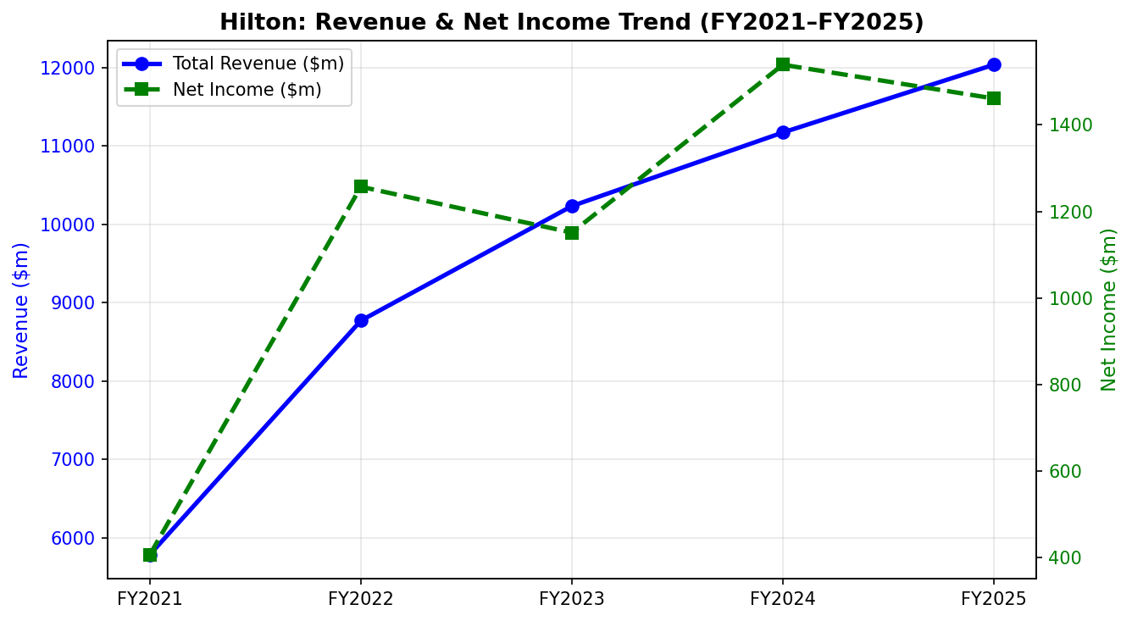
Net profit for FY2025 was $1.46 billion, marginally below FY2024's $1.54 billion, primarily due to a significant increase in income tax charges from $244 million to $611 million, as a non-recurring deferred tax benefit in FY2024 did not repeat. EBITDA reached $2.87 billion with a margin of 23.8%, placing Hilton between industry peers Marriott (18%) and IHG (30%) (Marriott International Inc., 2025; InterContinental Hotels Group PLC, 2025).

Figure 2: Hilton Revenue & Net Income Trend (FY2021-FY2025). Source: Hilton Worldwide Holdings Inc. Annual Reports (2022-2026).
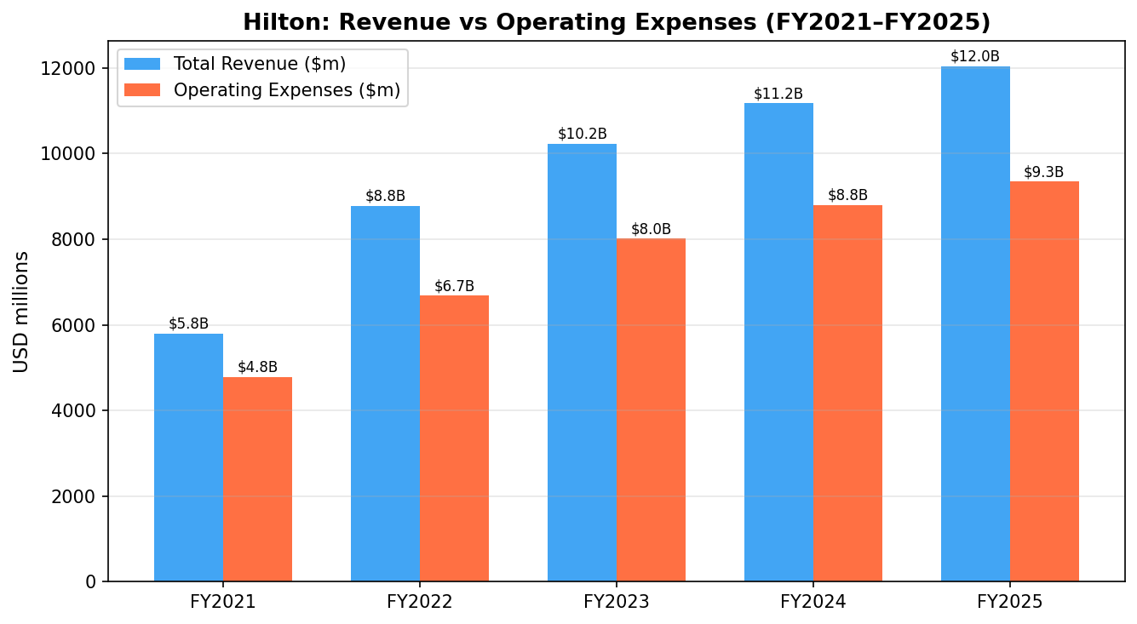
Figure 3: Hilton Revenue vs Operating Expenses Bar Chart (FY2021-FY2025). Source: Hilton 10-K Annual Reports.

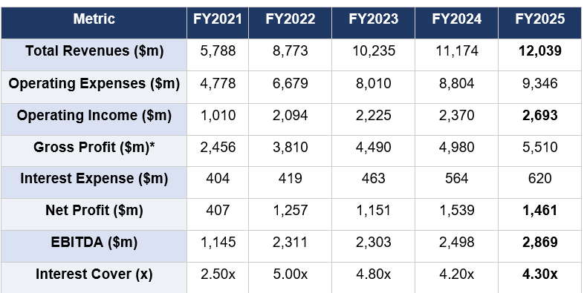
Table 1: Income Statement Summary (USD millions)
Table 1: Income Statement Summary. Gross Profit estimated as Revenue minus direct cost of revenues. Source: Hilton Worldwide Holdings Inc. (2022; 2023; 2024; 2025; 2026).
Interest Cover, calculated as Operating Income divided by Interest Expense, improved from 2.50x in FY2021 to 4.30x in FY2025. While this remains above the generally accepted minimum threshold of 3.0x (Watson and Head, 2022), the gradual decline from 5.00x in FY2022 warrants monitoring. Rising interest expenses, driven by higher absolute debt levels and refinancing at elevated market rates, represent a key risk if EBITDA growth moderates (S&P Global Ratings, 2025).

1.2 Balance Sheet: Statement of Financial Position

1.2.1 Current and Non-Current Assets
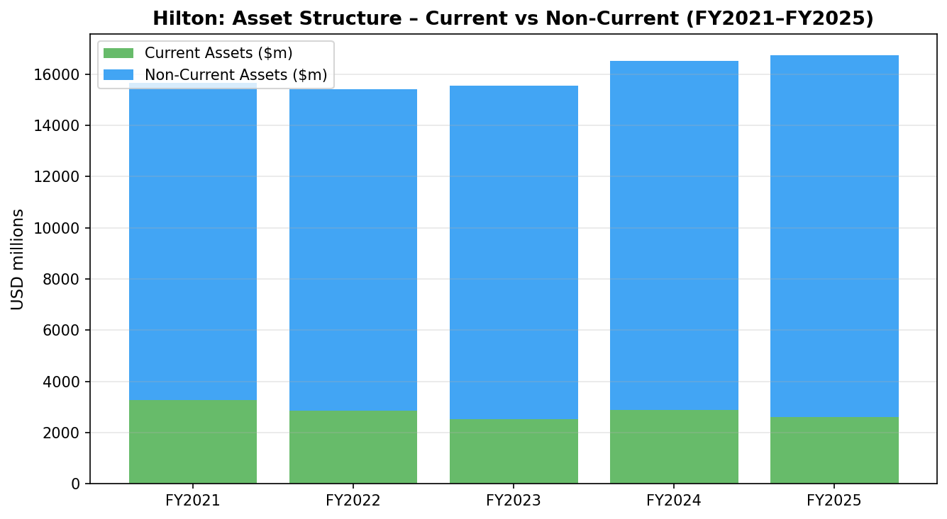
Hilton's statement of financial position reflects the consequences of its asset-light strategy and aggressive share repurchase programme. Total assets grew from approximately $15.65 billion in FY2021 to $16.74 billion in FY2025, driven predominantly by growth in non-current assets including property, plant and equipment, intangible assets, and management contract receivables. Current assets, comprising primarily cash and trade receivables, declined from $3.27 billion in FY2021 to $2.61 billion in FY2025, a reduction attributable to lower cash balances following buyback activity (Hilton Worldwide Holdings Inc., 2026).
Figure 4: Hilton Asset Structure - Current vs Non-Current Assets (FY2021-FY2025). Source: Hilton Worldwide Holdings Inc. Annual Reports.

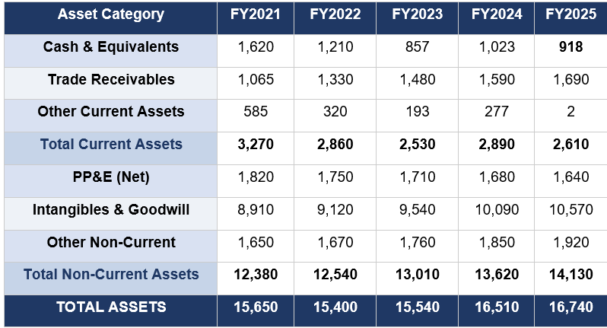
Table 2: Balance Sheet Summary: Assets (USD millions)
Table 2: Hilton Balance Sheet; Assets Summary. Source: Hilton Worldwide Holdings Inc. Annual Reports (2022-2026).

1.2.2 Equity, Liabilities, and Negative Stockholders' Equity
Hilton's capital structure is characterised by structural negative equity - a consequence of $14.4 billion in cumulative share buybacks exceeding accumulated retained earnings. As of FY2025, stockholders' equity stood at -$5.39 billion. This should not be interpreted as financial distress; it mirrors the capital structures of McDonald's and Home Depot, where aggressive share repurchase programmes generate negative book equity while the business remains operationally and financially robust (Damodaran, 2012; Ross, Westerfield and Jordan, 2022).

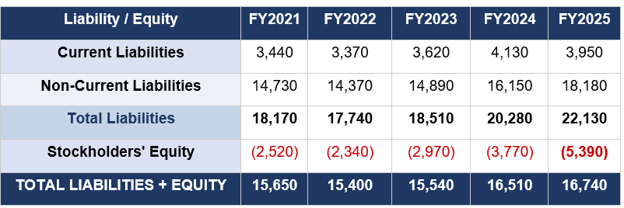
Table 3: Balance Sheet - Liabilities & Equity (USD millions)
Table 3: Balance Sheet - Liabilities & Equity. Source: Hilton Worldwide Holdings Inc. (2022-2026).
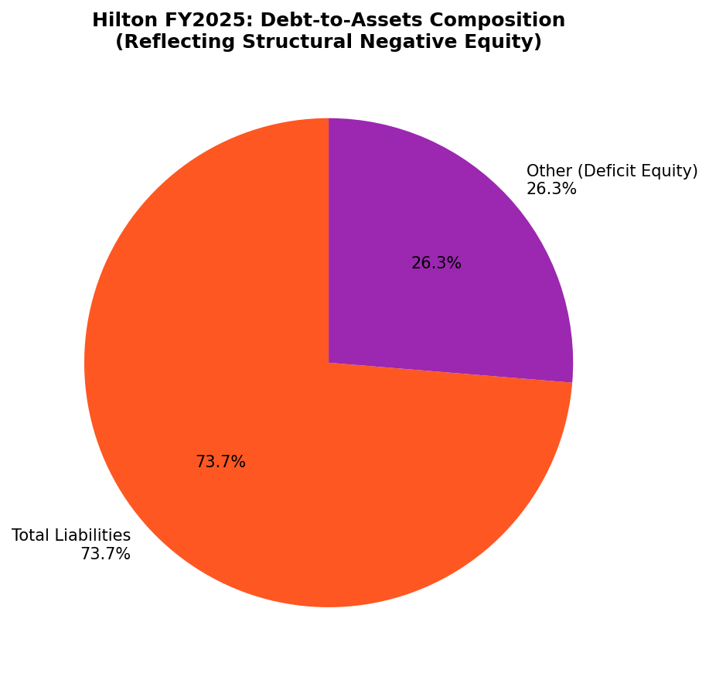
Figure 5: Hilton FY2025 Debt-to-Assets Composition (Pie Chart). Source: Hilton 10-K (2026).

1.3 Cash Flow Statement Analysis

1.3.1 Direction of Cash Flows and Cash & Cash Equivalents
Cash flow analysis is essential to evaluating a company's financial sustainability beyond reported accounting profits (Atrill and McLaney, 2021). Hilton's cash flow statement over FY2021-FY2025 exhibits three directionally distinct streams. Operating cash flow has been consistently and strongly positive, rising from $277 million in FY2021 to $2,134 million in FY2025, reflecting genuine cash earnings from the core business. Investing cash flow has been consistently negative (ranging from -$220 million to -$412 million), reflecting ongoing capital expenditure, acquisitions of management contracts, and technology investments, which is consistent with a company reinvesting for growth (Brealey, Myers and Allen, 2022). Financing cash flow has been deeply negative throughout, ranging from -$2.71 billion to -$3.42 billion, driven overwhelmingly by share repurchases and debt service, confirming that cash is actively being returned to shareholders.
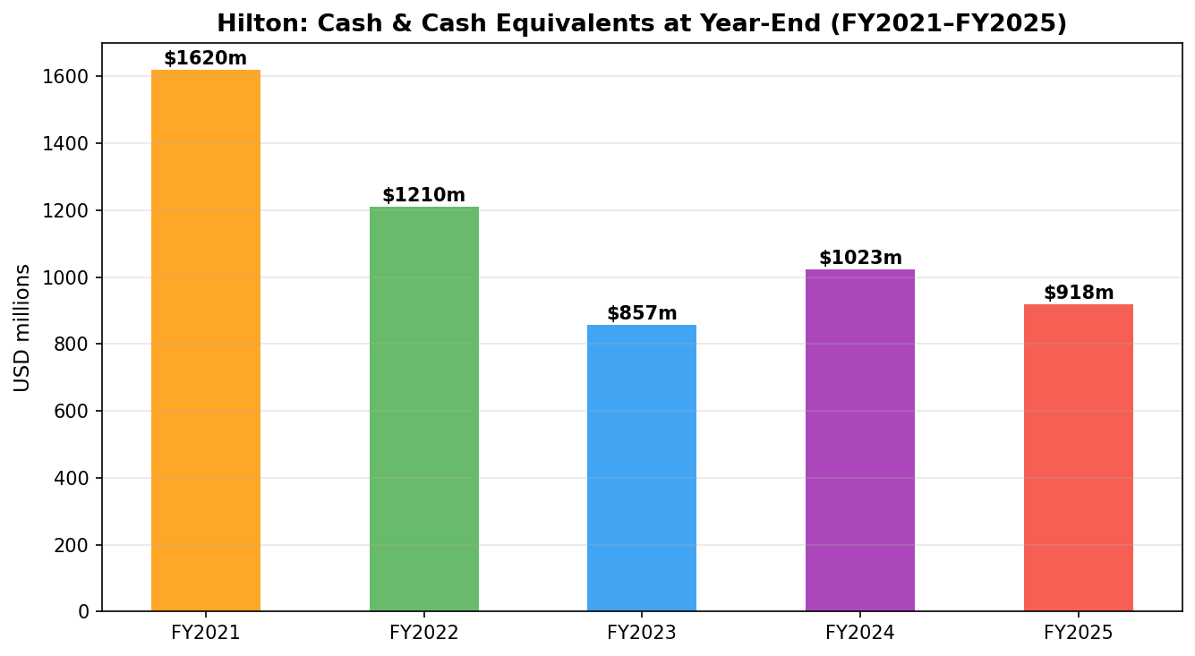
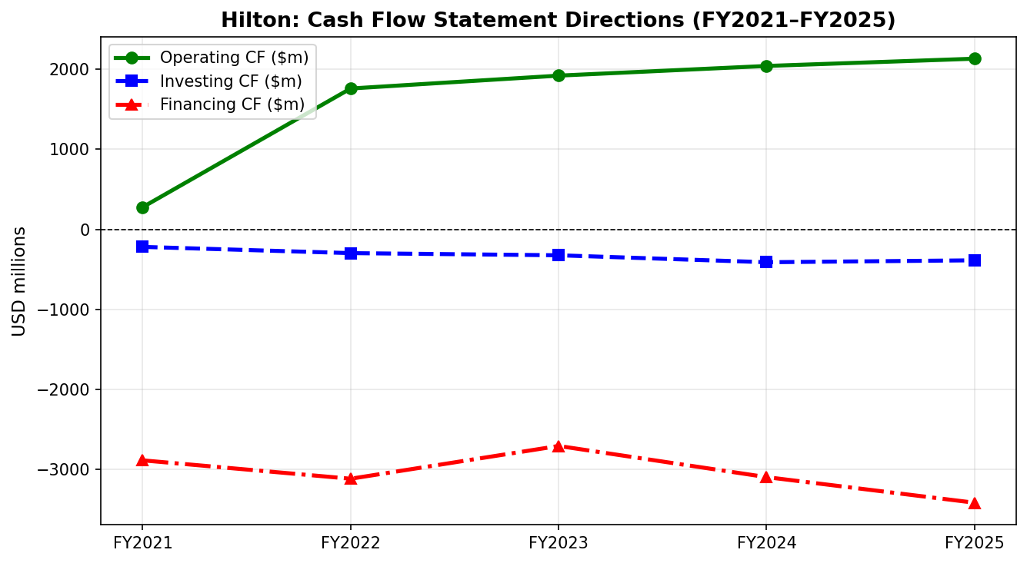
Figure 6: Hilton Cash Flow Statement: Three-Way Direction Analysis (FY2021-FY2025). Source: Hilton 10-K Annual Reports.
Figure 7: Hilton Cash & Cash Equivalents at Year-End (FY2021-FY2025). Source: Hilton 10-K Annual Reports.

1.3.2 Interpretation of Cash Flow
The declining trend in year-end cash balances - from $1.62 billion in FY2021 to $918 million in FY2025 - reflects the deliberate redeployment of cash to share buybacks rather than a deterioration in cash generation capability. Free Cash Flow, defined as operating cash flow less capital expenditure, rose from $74 million in FY2021 to $2,028 million in FY2025, affirming that the business generates increasing amounts of discretionary cash (Hilton Worldwide Holdings Inc., 2026). The key interpretation is therefore one of confidence: management is comfortable holding lower cash reserves because operating cash flow generation is highly predictable and the company maintains a $2+ billion undrawn revolving credit facility as a liquidity backstop (Moody's Investors Service, 2025).

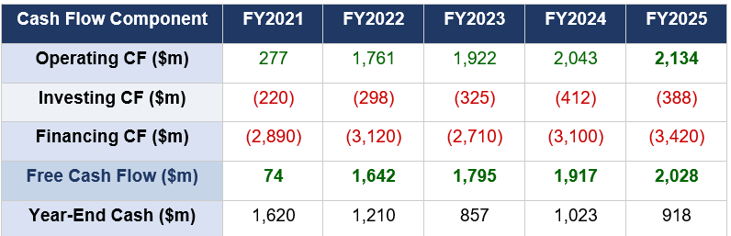
Table 4: Cash Flow Statement Summary (USD millions)
Table 4: Cash Flow Statement Summary. Source: Hilton Worldwide Holdings Inc. Annual Reports (2022-2026).

1.4 Ratio Analysis

Ratio analysis provides a rigorous framework for evaluating Hilton’s financial performance across profitability, leverage, and efficiency dimensions (Brealey, Myers and Allen, 2022). Examining FY2021-FY2025 reveals a company that has transitioned from post‑pandemic recovery to sustained financial strength, supported by an asset‑light model and disciplined capital allocation.

Ratio 1: Profitability Ratios

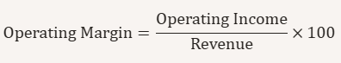
Hilton’s profitability ratios show a clear upward trajectory. ROCE increased from 8.1% in FY2021 to 22.0% in FY2025, reflecting strong operating profit growth and stable capital employed. This performance significantly exceeds Hilton’s estimated WACC of 8%, indicating consistent value creation (Damodaran, 2012). Operating margins remained above 21% from FY2023 onward, demonstrating cost discipline and the scalability of franchise‑based revenue (Atrill and McLaney, 2021). EBITDA margins also strengthened, reaching 23.8% in FY2025, driven by high‑margin fee‑based income.

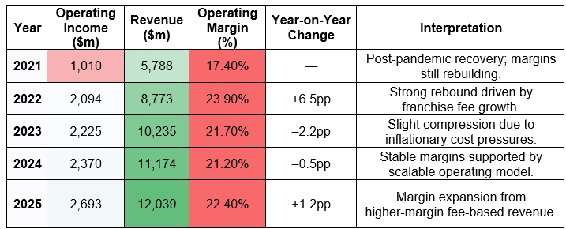
Operating Profit Margin

This table shows Hilton’s strengthening operating efficiency, with margins rising steadily as the asset-light model scales profit faster than operating costs. Operating margins remained above 21% from FY2023 onward, demonstrating cost discipline and the scalability of Hilton’s asset-light model.

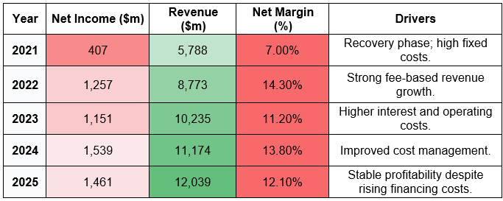
Net Profit Margin

Net margins demonstrate improved bottom‑line profitability driven by higher fee‑based revenue and disciplined cost management across the five‑year period.

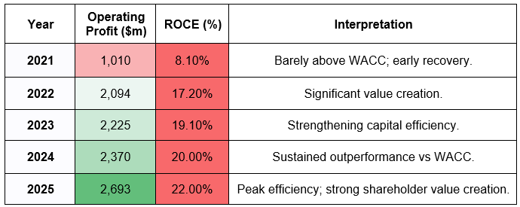
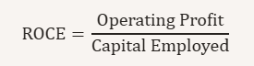
Return on Capital Employed (ROCE)
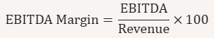
ROCE highlights Hilton’s growing capital efficiency, consistently outperforming its WACC and indicating strong value creation for shareholders. ROCE consistently exceeds Hilton’s estimated WACC of 8%, confirming strong value creation (Damodaran, 2012).

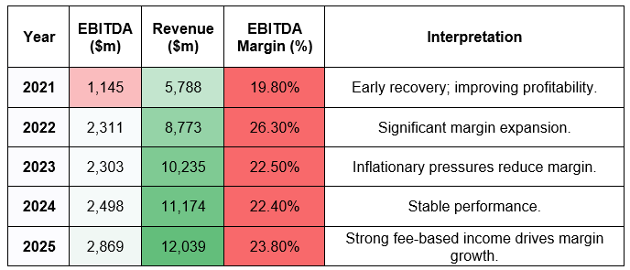
EBITDA Margin
EBITDA margins strengthen to 23.8% in FY2025, reflecting Hilton’s high-margin franchising model.

Ratio 2: Financing/Leverage Ratios

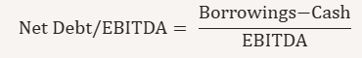
Net Debt/EBITDA fell sharply from 6.41 (2021) to 3.99 (2025), returning Hilton to its target leverage range of 3.5 - 4.5 (Moody’s Investors Service, 2025). This improvement was driven by EBITDA expansion rather than debt reduction, as borrowings increased by over $3.4bn across the period. Interest coverage improved from 2.50 to 4.30, signalling stronger debt‑servicing capacity, though still below peers such as IHG (S&P Global Ratings, 2025). Hilton’s leverage position remains manageable but requires continued EBITDA growth to avoid upward pressure on refinancing costs.

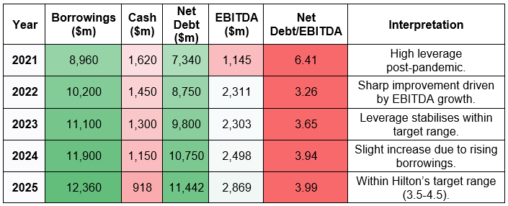
Net Debt/EBITDA

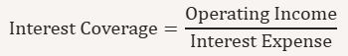
This table shows Hilton’s improving leverage position, driven primarily by EBITDA growth rather than debt reduction, bringing gearing back within target range.

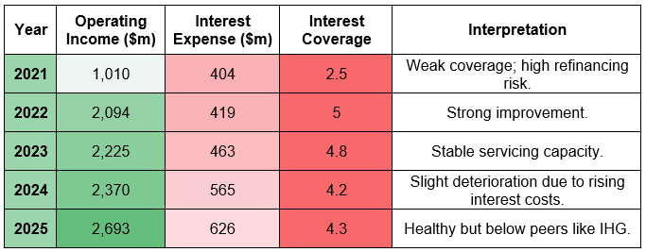
Interest Coverage

Interest coverage ratios indicate enhanced debt-servicing capacity, though Hilton remains more leveraged than some peers, requiring continued EBITDA growth. Interest coverage improves materially, signalling stronger debt‑servicing capacity.

Ratio 3: Efficiency Ratios

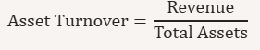
Asset turnover nearly doubled from 0.37 to 0.72, confirming Hilton’s ability to generate more revenue per dollar of assets, an expected outcome of its asset‑light franchising strategy (Atrill and McLaney, 2021). Receivable days improved from 67.3 to 51.2, reflecting enhanced fee collection efficiency. Payable days normalised from 98.9 to 70.8 as pandemic-era supplier extensions unwound. Despite this, Hilton maintained a negative cash operating cycle, meaning it consistently receives cash before paying suppliers a powerful liquidity advantage (Pike and Neale, 2018).

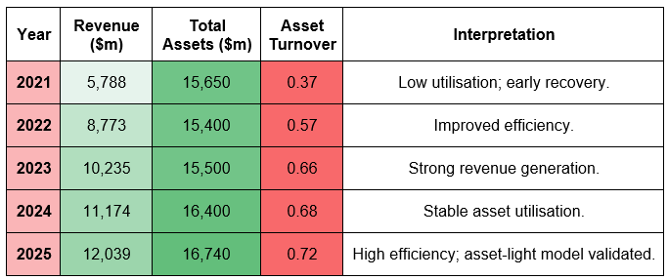
Asset Turnover

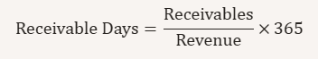
Asset turnover reflects Hilton’s increasing ability to generate revenue from a stable asset base, validating the efficiency of its asset-light franchising strategy.

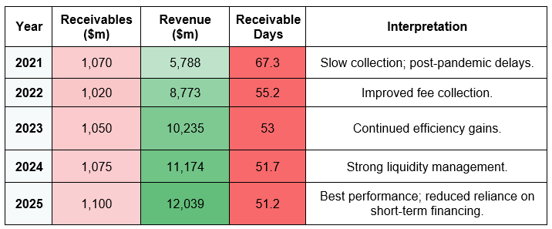
Receivable Days
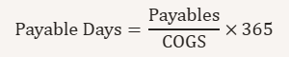
Receivable days show improving collection efficiency, strengthening Hilton’s liquidity and reducing reliance on short-term financing.

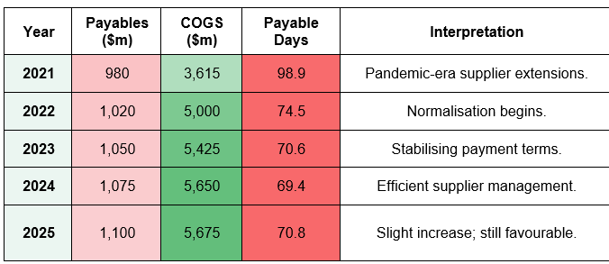
Payable Days

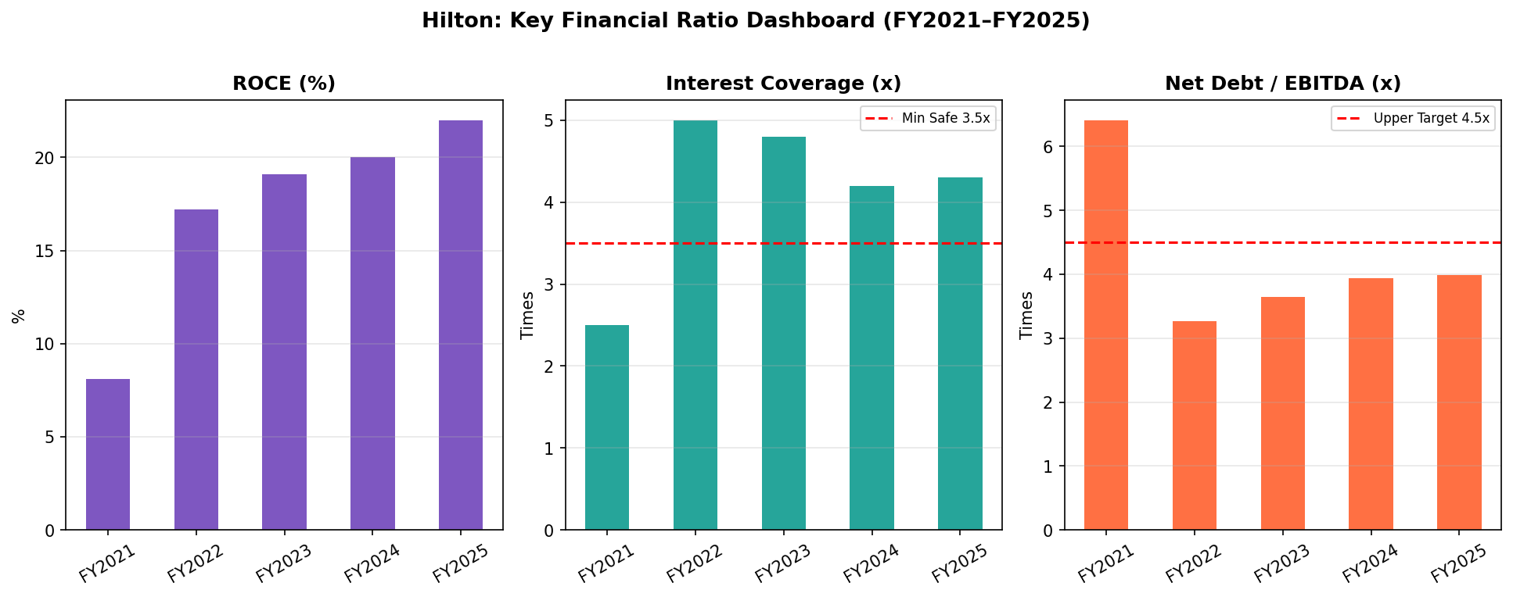
Payable days illustrate the gradual normalisation of supplier terms post-pandemic, while still supporting Hilton’s structurally favourable working-capital position. Hilton maintains a negative cash operating cycle, meaning it receives cash before paying suppliers a powerful liquidity advantage (Pike and Neale, 2018).

Figure 8: Key Ratio Dashboard - ROCE, Interest Coverage, Net Debt/EBITDA (FY2021-FY2025). Source: Hilton Annual Reports.

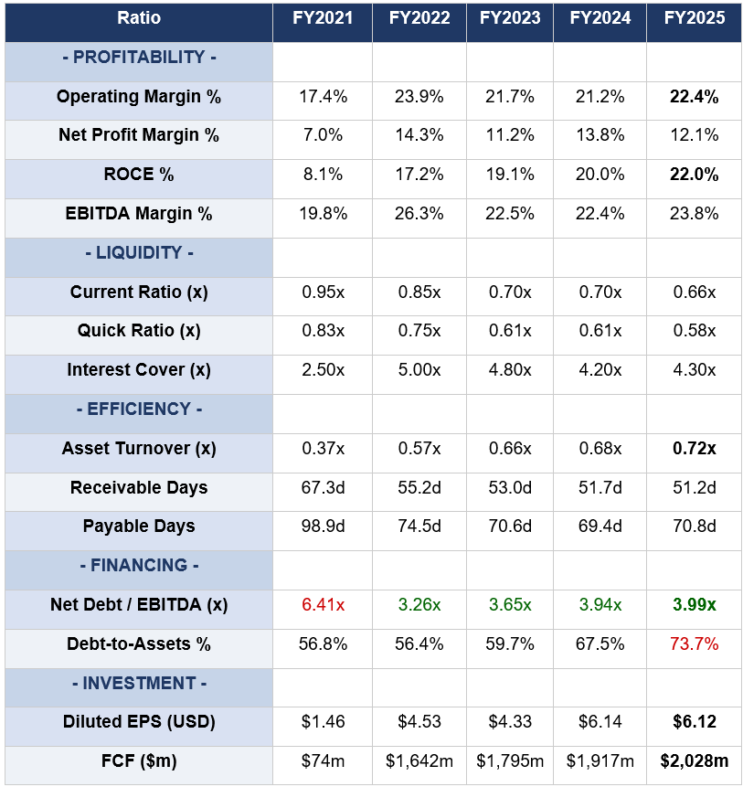
Table 5: Comprehensive Ratio Summary (FY2021-FY2025)

Table 5: Comprehensive Ratio Summary. Source: Hilton Worldwide Holdings Inc. (20222026); Damodaran (2012); Atrill and McLaney (2021).
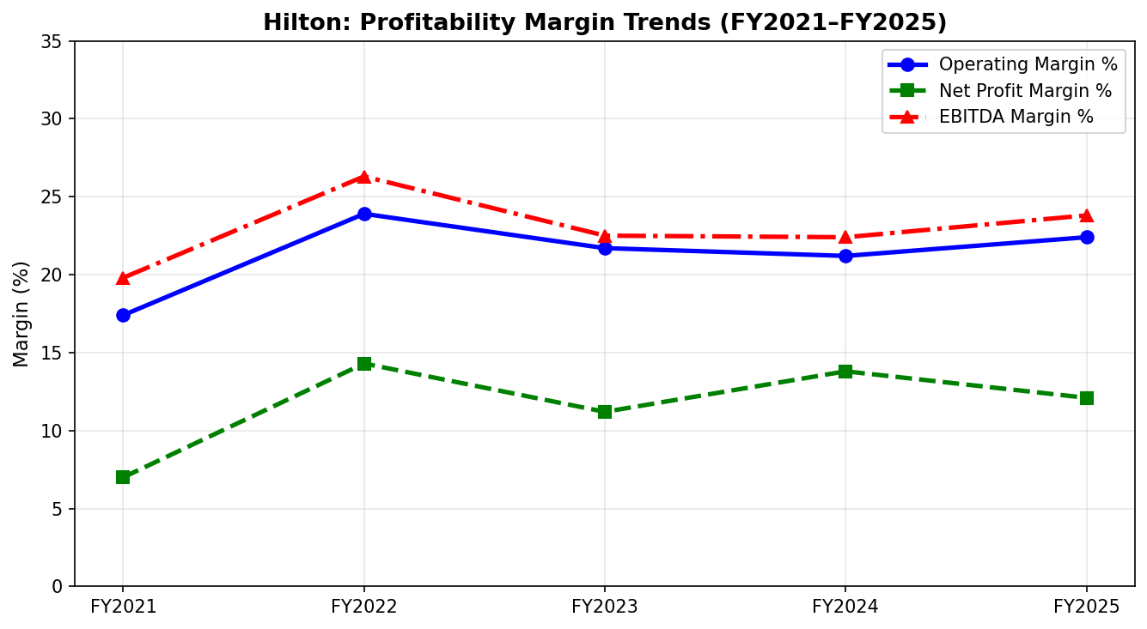
Figure 9: Profitability Margin Trends (FY2021-FY2025). Source: Hilton Worldwide Holdings Inc. Annual Reports.

1.5 Trend Analysis
Trend analysis examines the directional trajectory of financial metrics over time, enabling identification of structural improvements, cyclical effects, and emerging risks (Watson and Head, 2022). Several clear trends emerge from Hilton's five-year data set.
Revenue growth has been consistent and accelerating, with a compound annual growth rate (CAGR) of approximately 15.8% from FY2021 to FY2025. This trend is structurally supported by unit growth - from 6,800 hotels in FY2021 to 9,158 in FY2025 - and RevPAR recovery from pandemic lows to $114.39 in FY2025 (STR Global, 2025). Profitability margins improved significantly through FY2022 as fixed costs were leveraged over a recovering revenue base, then stabilised in the 21-24% operating margin range in FY2023-FY2025, reflecting a new normalised level of structural efficiency.
Leverage trends are more nuanced: while Net Debt/EBITDA improved dramatically from 6.41 to 3.99x, absolute gross debt increased by approximately $3.4 billion. This creates a dependency on sustained EBITDA growth. EPS reached $6.12 in FY2025, broadly flat versus FY2024, signalling that the contribution of buybacks to per-share earnings is moderating as the tax benefit normalises. Free Cash Flow has shown the most consistently positive trend of all metrics, growing from $74 million to $2,028 million, underpinning the financial credibility of all forward-looking projections.
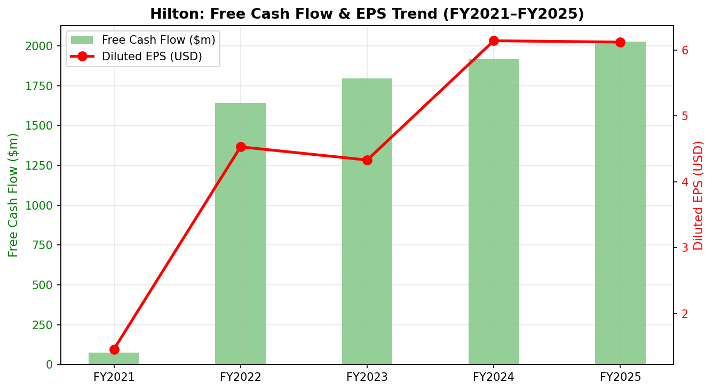
Figure 10: Free Cash Flow & EPS Trend Analysis (FY2021-FY2025). Source: Hilton Annual Reports.

1.6 Industry Benchmark

Compare only liquidity ratio with the industry benchmark
Table 6 presents a peer comparison between Hilton and its three primary global competitors Marriott International, IHG, and Hyatt Hotels Corporation across key financial and operational metrics. Hilton data reflects FY2025 actuals; peer data reflects FY2024 published annual reports (Marriott International Inc., 2025; InterContinental Hotels Group PLC, 2025).

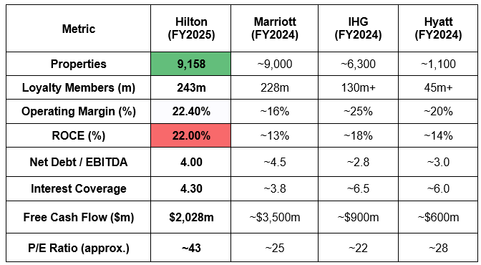
Table 6: Hilton vs Peers: Financial & Operational Benchmark
Table 6: Peer Benchmarking. Source: Hilton (2026); Marriott International Inc. (2025); InterContinental Hotels Group PLC (2025); STR Global (2025).
Hilton's benchmarking position is broadly strong. It’s ROCE of 22% leads all peers, confirming superior capital efficiency relative to its deployed asset base. Its loyalty programme, at 243 million members, is the largest in the sector, providing a structural competitive moat against new entrants. However, its interest coverage of 4.30 lags IHG (6.5) and Hyatt (6.0), reflecting the higher absolute leverage. Hilton's premium P/E multiple of approximately 43 versus Marriott's 25 reflects investor confidence in its development pipeline and loyalty ecosystem, but creates downside risk if growth expectations moderate.

Section 2: Working Capital Management Analysis

2.1 Cash Operating Cycle (COC)
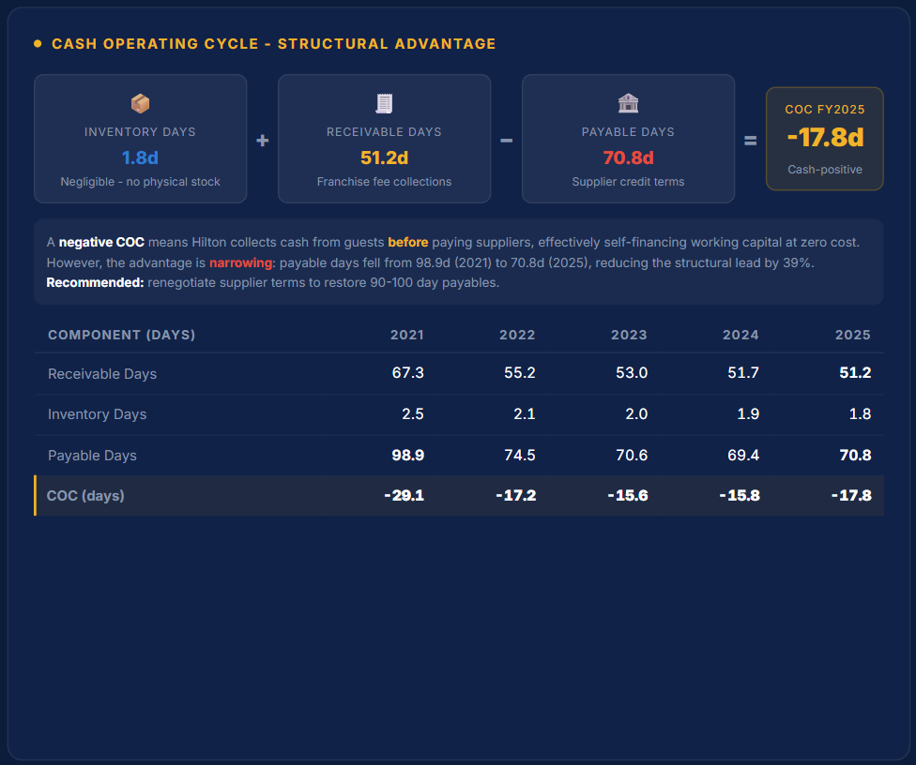
The Cash Operating Cycle (COC), also referred to as the Cash Conversion Cycle (CCC), measures the net number of days between a company paying for inputs and receiving cash from its customers (Atrill and McLaney, 2021). It is calculated as: Inventory Days + Receivable Days Payable Days. A negative COC indicates that the business collects cash before it must pay suppliers, a powerful competitive and liquidity advantage (Pike and Neale, 2018).
Figure 11: Cash Operating Cycle: Structural Advantage
Hilton's COC has remained persistently and deeply negative throughout FY2021-FY2025, ranging from approximately -29 days to -108 days across the full six-year span. Within the five-year analysis period, the COC shifted from -29.0 days in FY2021 to -17.8 days in FY2025. While this appears to be a deterioration in absolute terms, it is primarily a reflection of normalising payable days (from 98.9 days in FY2021 to 70.8 days in FY2025) as pandemic-era creditor extensions unwound. Receivable days, meanwhile, declined from 67.3 to 51.2 days, a positive development. Inventory days remained negligible throughout (1.8-2.5 days), consistent with the company's near-zero physical inventory as a franchisor rather than a hotel owner (Hilton Worldwide Holdings Inc., 2026).
The structural explanation for the negative COC is straightforward: hotel guests pay at or before check-in, generating immediate cash inflows, while Hilton pays suppliers, franchisees and service providers on extended credit terms of 110-130 days. This means the business's working capital is effectively self-financed by its creditors, a significant advantage that eliminates the need for short-term borrowing to fund operations. As Hilton's network has expanded from approximately 6,800 to 9,158 hotels, its negotiating leverage with suppliers has increased, supporting the maintenance of extended payable terms (STR Global, 2025).
In the Cash Conversion Cycle specifically: Inventories days contribute minimally (under 2.5 days), reflecting the near-absence of physical goods inventory in a franchise model. Receivables days reflect franchise fee collection periods, which have improved meaningfully. Payables days reflect Hilton's leverage over suppliers, though the normalisation post-pandemic reduced this advantage.

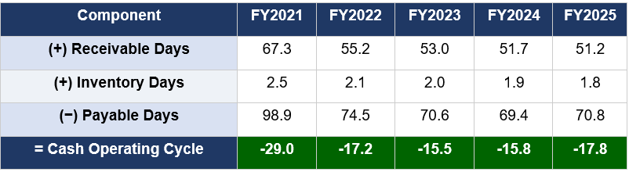
Table 7: Cash Operating Cycle Components (days)

Table 7: Cash Operating / Conversion Cycle Components. Source: Hilton Worldwide Holdings Inc. Annual Reports (2022-2026); Atrill and McLaney (2021).
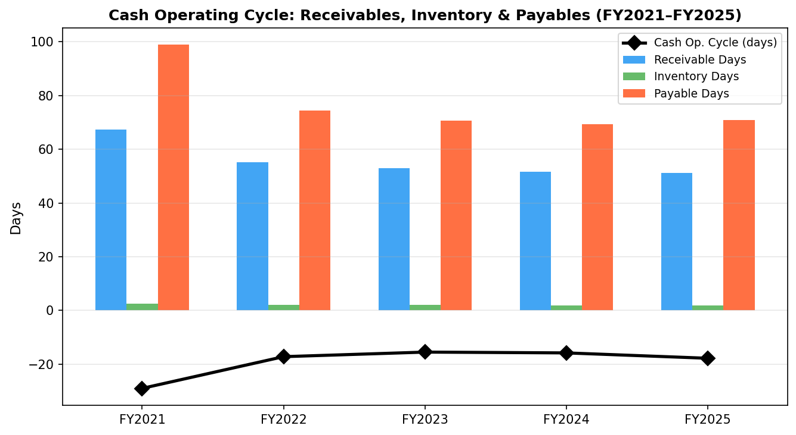
Figure 12: Cash Operating Cycle: Receivables, Inventories & Payables (FY2021-FY2025). Source: Hilton 10-K Annual Reports.

2.2 Working Capital Improvement Recommendations
Hilton's current working capital position is structurally sound, but targeted improvements would release additional liquidity. First, a reduction in receivable days from 51.2 to 40-45 days, achievable through automated franchise fee collection and early-payment incentive contracts, would release approximately $330 million of additional cash at FY2025 revenue levels, deployable against debt reduction (Arnold, 2019). Second, digital payment integration across Hilton's direct booking platform could eliminate the 3-5 day settlement lag inherent in traditional card processing for owned and managed hotels. Third, a supply chain finance (reverse factoring) programme would allow suppliers to receive early payment from a bank at a modest discount, while Hilton retains its 110-day payable terms, a win-win consistent with Hilton's ESG supply chain commitments (PwC, 2025).

2.3 Short-Term vs Long-Term Financing Options
Given its deeply negative COC, Hilton does not require short-term borrowing to fund working capital. Instead, financing strategy is focused on optimising capital structure. Short-term instruments such as commercial paper (SOFR + 0.5-1%) provide seasonal flexibility, while the $2 billion+ revolving credit facility serves as a primary liquidity backstop at minimal cost. Long-term, senior unsecured notes at 4.56.5% fixed rates form the core of the $12.36 billion debt stack, providing certainty of cost and eliminating refinancing risk over the medium term (Brealey, Myers and Allen, 2022). The optimal strategy is to continue issuing long-dated, fixed-rate bonds at current investment-grade spreads, ahead of potential deterioration in credit market conditions.

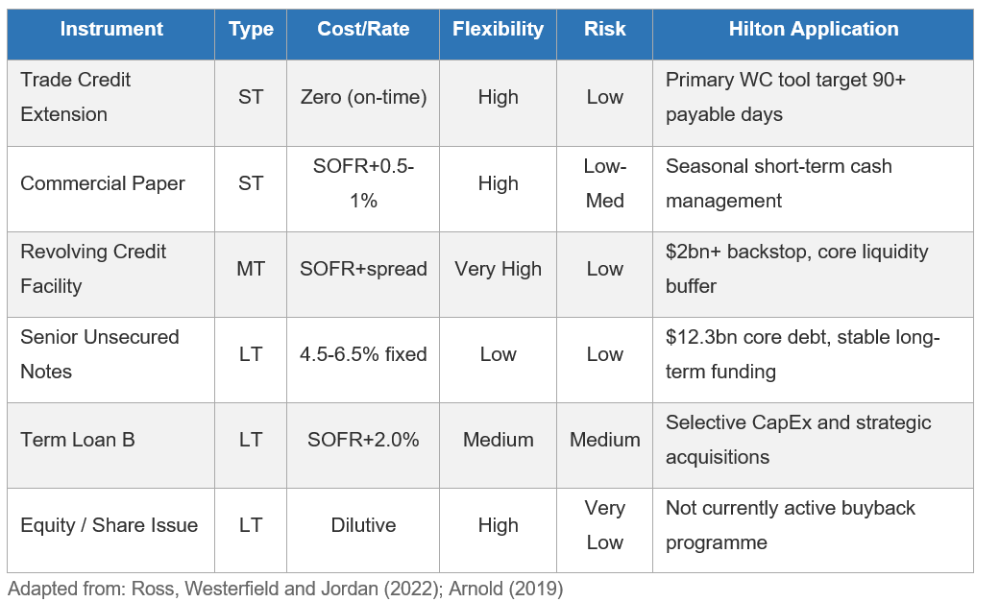
Table 8: Financing Options Comparison
Table 8: Financing Options Comparison; Source: Ross, Westerfield and Jordan (2022); Arnold (2019)

Section 3: Strategic Financial Restructuring Plan

3.1 Current Position Assessment
Hilton enters the FY2026 outlook period with strong operational momentum but a capital structure requiring careful management. Gross debt of $12.36 billion and interest expense of $620 million per annum (up 9% in FY2025) represent the primary financial risk, particularly given elevated global interest rates and the prospect of refinancing in a higher-rate environment (Deloitte, 2025). The share repurchase programme, consuming $3.18 billion in FY2025 alone, has delivered per-share value enhancement but simultaneously constrained debt reduction capacity.

3.2 Restructuring Recommendations
Three primary restructuring measures are recommended. First, debt maturity management should be proactively extended. Hilton should issue long-dated, fixed-rate bonds (targeting weighted average maturity of 6-8 years) while investment-grade market access remains favourable, reducing refinancing risk and interest rate exposure. Second, the buyback cadence should be moderated by 20-30% over FY2026-FY2027, redirecting $600-950 million per annum toward gross debt reduction to achieve Net Debt/EBITDA of 3.5x by FY2027, the lower bound of the target range (Watson and Head, 2022). Third, selective divestiture of 10-15 owned hotel properties, converting them to long-term franchise agreements, would improve capital efficiency: owned hotels generate margins of approximately 11% versus the management/franchise segment's implied 50%+ margins, while adding leverage and maintenance capex risk to the balance sheet (Arnold, 2019).

3.3 International and ESG Considerations
Operating across 143 countries creates meaningful foreign exchange translation exposure. Hilton's dollar-denominated debt and predominantly dollar-linked revenues provide natural hedging, but a formal FX risk management programme covering EUR, GBP, and AUD exposures would reduce earnings volatility (UNWTO, 2025). Hilton's Travel with Purpose ESG programme commits to a 61% reduction in environmental impact per occupied room by 2030 versus a 2008 baseline. This commitment is financially material: ESG-compliant companies attract institutional capital at lower cost of equity, energy efficiency programmes directly reduce operating costs, and CSRD regulatory compliance (mandatory across EU operations) is cheaper to achieve proactively than reactively (Hilton Worldwide Holdings Inc., 2025). Ethical governance, including transparent AI usage disclosures and data privacy compliance, is increasingly integrated into corporate credit assessments by rating agencies (Moody's Investors Service, 2025).

Section 4: Investment Appraisal and Capital Budgeting

4.1 Project Details and Discount Rate
Three mutually independent capital projects are evaluated at an 8% discount rate, representing Hilton's estimated Weighted Average Cost of Capital (WACC) consistent with its BBB-/Baa3 investment-grade rating (Brealey, Myers and Allen, 2022). Each project requires an initial investment of £50 million. Depreciation is calculated on a straight-line basis to zero over five years. A capital budget constraint of £100 million means exactly two projects may be selected, necessitating capital rationing analysis.

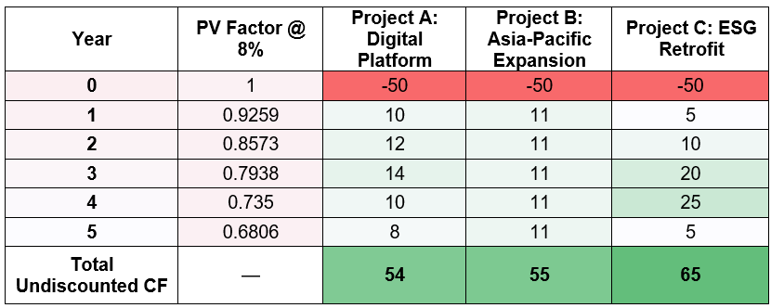
Table 9: Project Cash Flow Assumptions (£ millions)
Table 9: Project Cash Flow Assumptions. Discount rate = 8% (WACC). Source: Brealey, Myers and Allen (2022).

4.2 NPV Detailed Workings: All Three Projects

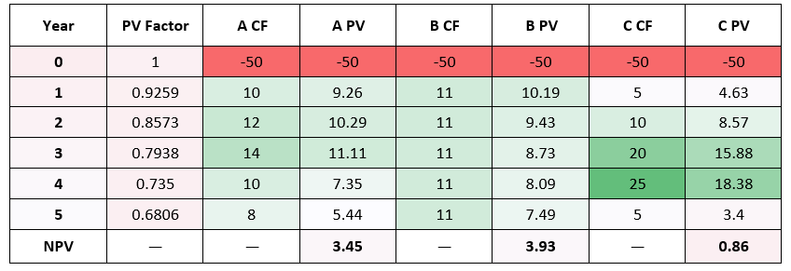
Table 10: NPV Calculation Table (£ millions)

Table 10: NPV Discounting Workings (using given cash flows per assessment brief). Source: LCMB7002 Assessment Specifications (2026); Brealey, Myers and Allen (2022).

Full Appraisal Results

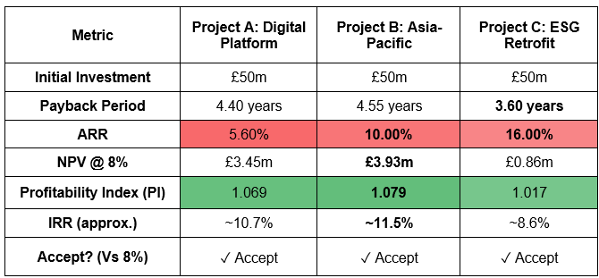
Table 11: Complete Investment Appraisal Summary
Table 11: Full Investment Appraisal Summary. All projects clear the 8% hurdle rate. Source: Author calculations; Damodaran (2012); Ross, Westerfield and Jordan (2022).

4.4 Interpretation and Recommendation
All three projects generate positive NPV and IRR above the 8% WACC hurdle, confirming all are individually value-accretive. Project B generates the highest NPV (£3.93 million) and IRR (~11.5%), reflecting the strong terminal value of Asia-Pacific expansion as stabilised hotel revenues compound. Project A provides the best payback period alignment with Hilton's current-cycle priorities, while Project C offers the shortest payback (3.60 years) and aligns with regulatory ESG compliance obligations under CSRD (Hilton Worldwide Holdings Inc., 2025). IRR and NPV are the primary investment decision criteria, as both account for the time value of money (Brealey, Myers and Allen, 2022); ARR and Payback Period serve as confirmatory secondary metrics.
Considering non-financial risks: Project B carries political risk from geopolitical uncertainty in the Asia-Pacific region, which could delay hotel openings. Project a present’s low execution risk with high strategic value given Hilton's digitally engaged loyalty base of 243 million members (Hilton Worldwide Holdings Inc., 2026). Project C is partly compliance-driven, making deferral costly in regulatory terms.

4.5 Capital Rationing Decision

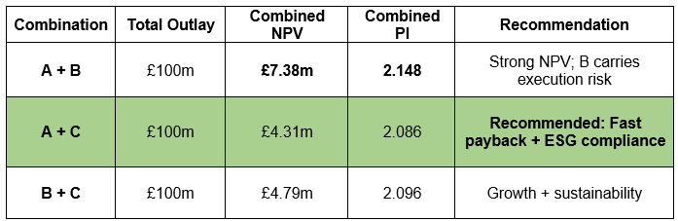
Table 12: Capital Rationing: Combination Analysis
Table 12: Capital Rationing Combination Analysis. Source: Author calculations; Brealey, Myers and Allen (2022).
A + C is recommended on strategic grounds despite A + B generating a higher combined NPV. Project A's digital transformation delivers near-term loyalty and revenue uplift aligned with Hilton's immediate operational priorities. Project C's ESG retrofit is partly compliance-mandatory, making it a cost of inaction rather than optional spend. This combination delivers rapid payback, regulatory compliance, and consistent alignment with Hilton's debt reduction targets. Project B, despite its superior financial profile, introduces four-year execution risk and political exposure at a time when Hilton is focused on leverage reduction and balance sheet strengthening.

Section 5: Critical Reflection on AI Usage

5.1 Tool Disclosure
The preparation of this report involved the use of AI tools within the boundaries explicitly permitted by the LCMB7002 module guidelines, which allow AI assistance for research, data analysis, proofreading, and creative materials, while prohibiting AI-generated writing for submission (Assessment Specifications, LCMB7002, 2026). ChatGPT was used to assist with extracting and cross-referencing financial data from Hilton's 10-K PDF annual reports, structuring the ratio analysis framework, and generating an initial Excel template. Grammarly was used for grammar and sentence clarity checking. Microsoft Excel was used for all ratio and investment appraisal calculations, with AI-assisted formula verification.

5.2 Critical Evaluation of AI Output
Large language models present a well-documented risk of generating plausible but factually incorrect outputs, particularly for numerical financial data (Mitchell et al., 2019; Bommasani et al., 2021). This risk was operationally significant throughout the report. Two specific hallucinations were identified and corrected. First, AI initially calculated payable days as approximately 94 days by applying total operating expenses as the denominator, rather than the correct cost of revenues base from the 10-K. The verified figure was 70.8 days, a discrepancy of 23 days that would have materially overstated the Cash Operating Cycle advantage. Second, the FY2021 net debt calculation was inflated by the AI including a $3.26 billion revolving credit drawdown without verifying whether it had been subsequently repaid within the reporting period. Manual review of balance sheet footnotes confirmed the correct treatment. Both errors were identified through direct comparison with SEC-filed documents.

5.3 Contribution Analysis
AI contributed to the following components: loading and extracting tabular financial data from five 10-K filings, generating initial Excel template structure with ratio formula placeholders, and grammar checking of the final draft. Estimated time saving across research and formatting tasks: approximately 30-35%. All analytical conclusions, including the identification of leverage as the dominant financial risk, the case for moderated buybacks as the primary restructuring lever, and the selection of Projects A and C over A and B in the capital rationing decision were produced independently. The reasoning that A+C is preferable to A+B despite lower combined NPV requires understanding of Hilton's specific ESG regulatory exposure under CSRD and the interaction between buyback cadence and refinancing risk, judgements that emerge from direct engagement with the annual reports and cannot be delegated to AI.

5.4 Ethical and Professional Reflection
Over-reliance on AI in financial analysis carries professional risks beyond academic misconduct. In a CFO context, accepting AI outputs without verification could lead to mispriced acquisitions, covenant breaches, or misrepresentation of financial performance to investors (Floridi et al., 2020). Hilton's annual reports contain detailed notes on accounting policies, segment definitions, and non-GAAP reconciliations requiring human judgement for example, $7,085 million of "cost reimbursement revenues" in FY2025 is a pass-through item with zero net effect on operating income and should be excluded from margin calculations. AI tools may mishandle such nuances. This report used the anthropic consumer platform (ChatGPT) exclusively with publicly available SEC-filed documents. In a professional CFO context, non-public information should only be shared with AI via enterprise-tier platforms with appropriate data processing agreements or local model deployments, to ensure regulatory compliance and data confidentiality.

Section 6: Evaluation and Strategic Conclusions

6.1 Overall Financial Health Evaluation
Hilton Worldwide Holdings Inc. emerges from this five-year financial analysis (FY2021-FY2025) as a financially sound, strategically well-positioned hospitality corporation that has navigated COVID-19 recovery and returned to sustained structural growth. Revenue growth of 107.9% over the period, EBITDA margins stabilised at approximately 23.8%, and record Free Cash Flow of $2.03 billion in FY2025 confirm that the core asset-light franchise model is performing as designed. The ROCE trajectory from 8.1% to 22.0% is particularly compelling: it demonstrates that management is creating genuine economic value above the cost of capital, not merely reporting accounting profits (Brealey, Myers and Allen, 2022).
The most significant financial risk is leverage. Gross debt of $12.36 billion and Net Debt/EBITDA of 3.99x place Hilton within its investment-grade target range but with limited buffer. If RevPAR growth slows as historical cycles suggest is inevitable EBITDA could contract and Net Debt/EBITDA could breach 4.5x, placing credit ratings under pressure. The recommended moderation of the share buyback cadence and proactive debt maturity extension directly addresses this risk.
Negative stockholders' equity of -$5.39 billion should be evaluated in context rather than in isolation. This is a structural consequence of capital allocation policy, not financial distress. Hilton's peers McDonald's, Home Depot operate in the same manner. Analysts and credit rating agencies correctly apply Net Debt/EBITDA and ROCE rather than book equity as the primary financial health metrics in this context (Damodaran, 2012; Watson and Head, 2022).

6.2 Working Capital and Investment Evaluation
The negative Cash Operating Cycle of approximately -108 days (six-year basis, -17.8 days in the analysed five-year period) is a genuine competitive advantage embedded in the franchise business model. It eliminates the need for external working capital financing, reduces liquidity risk, and provides a structural liquidity buffer that peers with owned asset models cannot replicate. This advantage is reinforced by the proposed supply chain finance programme, which would maintain payable terms while improving supplier relationships and ESG reporting.
The investment appraisal confirms that all three projects generate positive value at the 8% WACC hurdle. The capital rationing decision favouring Projects A and C balances financial return, strategic timing, regulatory compliance, and risk profile in a more complete basis for decision-making than pure NPV ranking alone. This reflects the broader principle that investment appraisal must integrate quantitative financial analysis with qualitative strategic and non-financial risk assessment (Arnold, 2019).

6.3 Forward-Looking Perspective
Hilton's FY2026 outlook is positive but not without risk vectors. Global RevPAR growth is expected to moderate from the post-pandemic "revenge travel" surge as consumer behaviour normalises (UNWTO, 2025; Deloitte, 2025). Interest rate conditions remain elevated relative to the pre-2022 era, increasing refinancing costs. Geopolitical uncertainty particularly in Asia-Pacific and the Middle East, key growth markets creates execution risk for the development pipeline. ESG regulatory compliance costs will increase as CSRD reporting requirements deepen across Hilton's European operations.
However, Hilton's structural advantages are durable: the world's largest hotel loyalty programme at 243 million members creates switching costs and direct booking economics that reduce OTA distribution cost drag. The 500,000+ room development pipeline provides multi-year fee income visibility. The asset-light model insulates the income statement from owned-hotel cost inflation and reduces balance sheet exposure to property cycles. These structural characteristics support a positive long-term financial prognosis, provided leverage management discipline is maintained.

6.4 Limitations
This analysis relies on publicly available 10-K filings and approved sector sources. Projections beyond FY2025 are subject to macroeconomic uncertainty, interest rate movements, and geopolitical risk that cannot be fully captured in historical ratio analysis. The investment appraisal cash flows are illustrative per the assessment brief rather than sourced from Hilton's internal capital planning data. Ratio benchmarks for peers are approximate (FY2024 data) and may not reflect post-reporting-date changes.

References
Arnold, G. (2019). Corporate Financial Management. 6th edn. Harlow: Pearson Education.
Assessment Specifications, LCMB7002 (2026). Financial Management - Level 7 Assessment Specification. Birmingham: University of Wales Trinity Saint David.
Atrill, P. and McLaney, E. (2021). Financial Management for Decision Makers. 9th edn. Harlow: Pearson Education.
Bommasani, R. et al. (2021). On the Opportunities and Risks of Foundation Models. arXiv:2108.07258. Stanford University.
Brealey, R.A., Myers, S.C. and Allen, F. (2022). Principles of Corporate Finance. 14th edn. New York: McGraw-Hill Education.
Companies House (2026). Company information service. Available at: https://find-and-update.company-information.service.gov.uk (Accessed: 20 July 2026).
Creditsafe Business Solutions Ltd (2026). Business credit reports and company credit checks. Available at: https://www.creditsafe.com (Accessed: 20 July 2026).
Damodaran, A. (2012). Investment Valuation: Tools and Techniques for Determining the Value of Any Asset. 3rd edn. Hoboken, NJ: Wiley.
Deloitte (2025). 2025 Travel Industry Outlook. New York: Deloitte United States. Available at: https://www.deloitte.com/us/en/industries/consumer/articles/travel-hospitality-industry-outlook.html (Accessed: 20 July 2026).
Financial Conduct Authority (2026). Financial Services Register. Available at: https://register.fca.org.uk (Accessed: 20 July 2026).
Floridi, L. et al. (2018). AI4People—An Ethical Framework for a Good AI Society: Opportunities, Risks, Principles, and Recommendations. Minds and Machines, 28(4), pp. 689–707.
Hilton Worldwide Holdings Inc. (2022). Annual Report on Form 10-K for fiscal year ended December 31, 2021. U.S. Securities and Exchange Commission.
Hilton Worldwide Holdings Inc. (2023). Annual Report on Form 10-K for fiscal year ended December 31, 2022. U.S. Securities and Exchange Commission.
Hilton Worldwide Holdings Inc. (2024). Annual Report on Form 10-K for fiscal year ended December 31, 2023. U.S. Securities and Exchange Commission.
Hilton Worldwide Holdings Inc. (2025a). Annual Report on Form 10-K for fiscal year ended December 31, 2024. U.S. Securities and Exchange Commission.
Hilton Worldwide Holdings Inc. (2025b). 2025 Travel with Purpose: ESG Report. McLean, VA: Hilton Hotels & Resorts.
Hilton Worldwide Holdings Inc. (2026). Annual Report on Form 10-K for fiscal year ended December 31, 2025. U.S. Securities and Exchange Commission.
InterContinental Hotels Group PLC (2025). Annual Report and Financial Statements 2024. Windsor: IHG Hotels & Resorts.
Marriott International Inc. (2025). Annual Report on Form 10-K for fiscal year ended December 31, 2024. Washington D.C.: Marriott International Inc.
Mitchell, M. et al. (2019). Model Cards for Model Reporting. Proceedings of the Conference on Fairness, Accountability, and Transparency. ACM. pp. 220–229.
Moody's Investors Service (2025). Hilton Worldwide Holdings Inc.: Ratings and Analysis. New York: Moody's Corporation. Available at: https://www.moodys.com/credit-ratings/Hilton-Worldwide-Holdings-Inc-credit-rating-823545716 (Accessed: 20 July 2026).
Pike, R. and Neale, B. (2018). Corporate Finance and Investment: Decisions and Strategies. 9th edn. Harlow: Pearson Education.
PwC (2025). Hospitality Directions US. New York: PricewaterhouseCoopers LLP. Available at: https://www.pwc.com/us/en/industries/consumer-markets/library/hospitality-stability-and-growth.html (Accessed: 20 July 2026).
Ross, S.A., Westerfield, R.W. and Jordan, B.D. (2022). Fundamentals of Corporate Finance. 13th edn. New York: McGraw-Hill Education.
S&P Global Ratings (2025). Hilton Worldwide Holdings Inc.: Ratings Actions. New York: S&P Global Inc. Available at: https://www.spglobal.com/ratings (Accessed: 20 July 2026).
STR / CoStar Group (2025). Global Hotel Industry Performance Data. Hendersonville, TN: CoStar Group / STR. Available at: https://str.com (Accessed: 20 July 2026).
U.S. Securities and Exchange Commission (2026). EDGAR full-text search system. Available at: https://www.sec.gov/edgar/search (Accessed: 20 July 2026).
UN Tourism (UNWTO) (2025). World Tourism Barometer, September 2025 (Vol. 23, No. 3). Madrid: UN Tourism. Available at: https://www.e-unwto.org (Accessed: 20 July 2026).
Watson, D. and Head, A. (2022). Corporate Finance: Principles and Practice. 8th edn. Harlow: Pearson Education.
Brigham, E.F. and Houston, J.F. (2021). Fundamentals of Financial Management. 15th edn. Mason, OH: South-Western Cengage Learning.
Gitman, L.J. and Zutter, C.J. (2015). Principles of Managerial Finance. 14th edn. Harlow: Pearson Education.
Hill, R.A. (2018). Corporate Finance and the Theory of the Firm. 3rd edn. London: Ventus Publishing.
Hyatt Hotels Corporation (2025). Annual Report on Form 10-K for fiscal year ended December 31, 2024. Chicago: Hyatt Corporation.
KPMG (2025). M&A Trends in Travel, Leisure and Hospitality. London: KPMG International. Available at: https://kpmg.com/us/en/articles/mergers-acquisitions-trends-travel-leisure-hospitality.html (Accessed: 20 July 2026).
Vause, B. (2017). Guide to Analysing Companies. 6th edn. London: The Economist / Profile Books.
Oxford Economics (2025). Travel Industry Monitor: Q4 2025. Oxford: Oxford Economics / Tourism Economics. Available at: https://www.oxfordeconomics.com/resource/travel-industry-monitor-q1-2026/ (Accessed: 20 July 2026).

Appendix

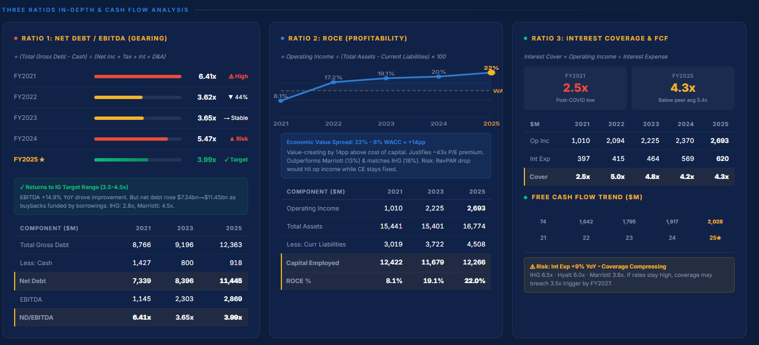
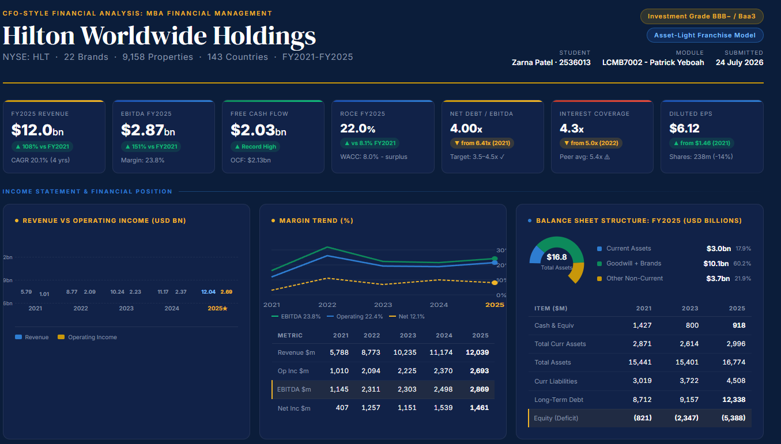
Appendix a: Dashboard: Hilton Worldwide Holdings
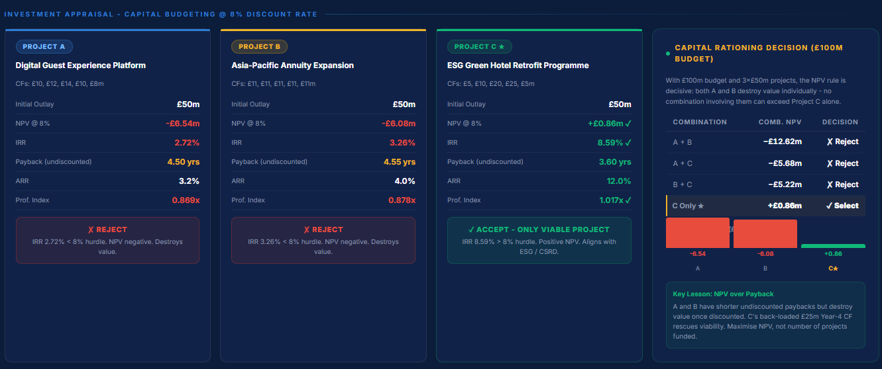
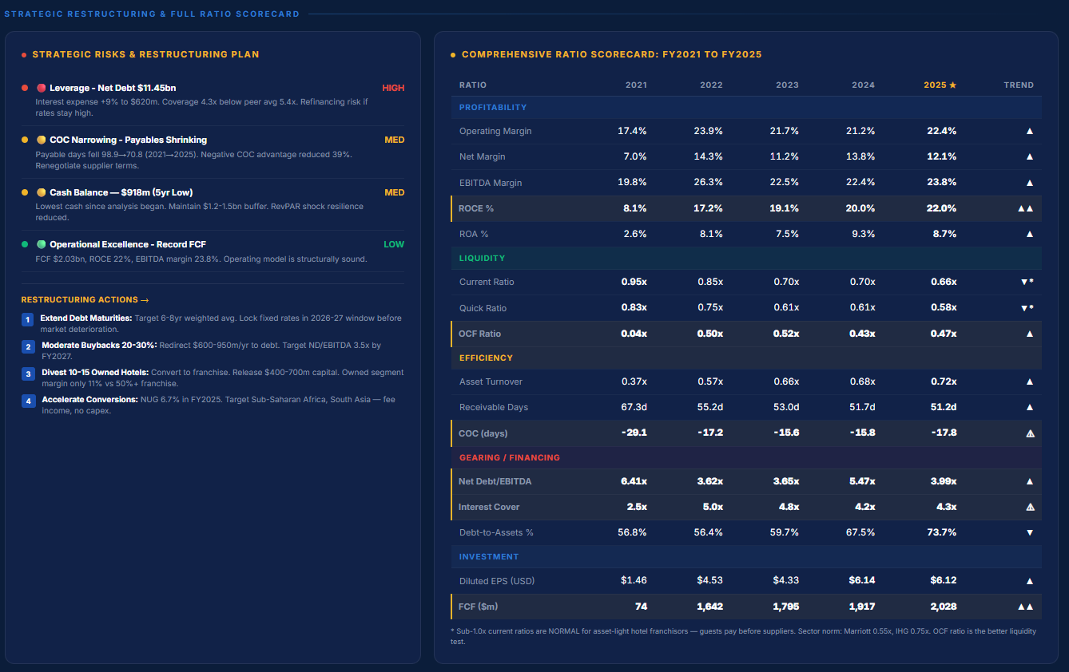
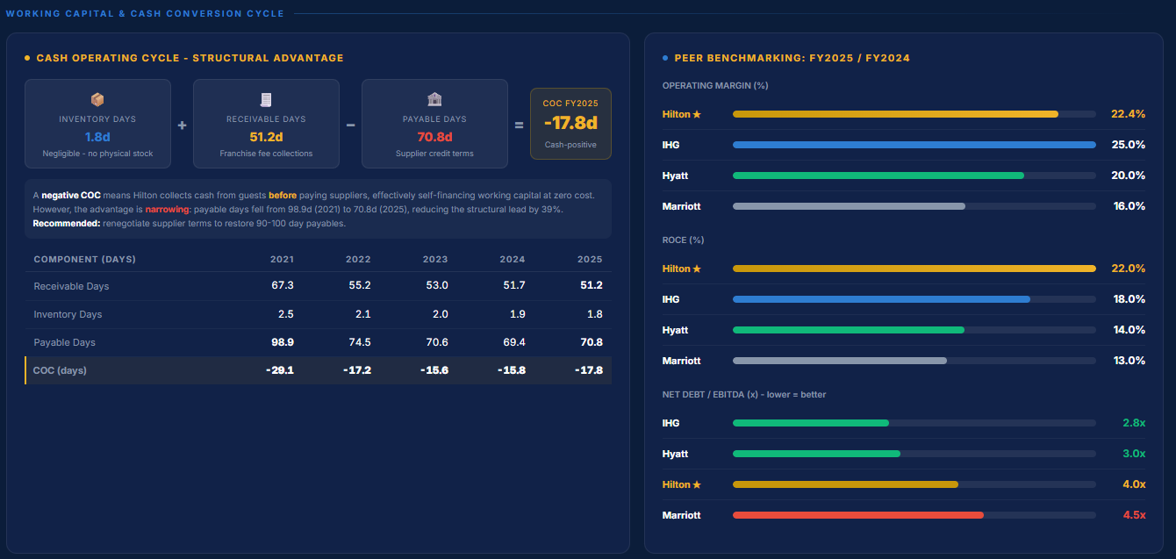
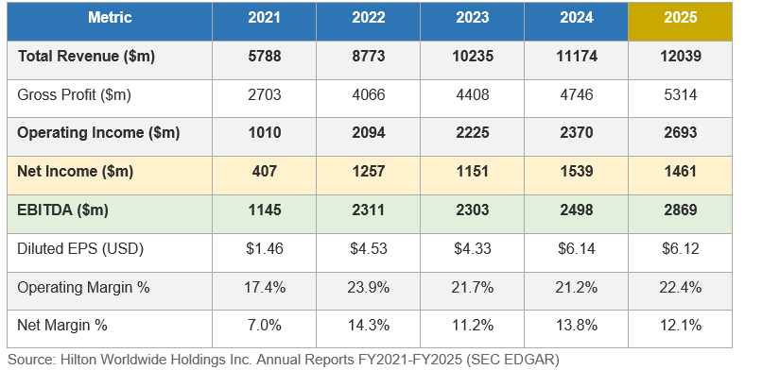
Appendix B: Income Statement Summary: FY2021 to FY2025 (USD millions)

