Name: Haroon Ali
Student ID 2128765
Assignment
Computer system fundamentals

Submitted To:
Jacob wilson pakia das
Date: 11-01-2023

Section 1:
History of Computers

- Definition of computer
- Earliest computer
- Computer History
- Computer Generations
Computer:
Computer is a programmable machine. Computer is a machine that manipulates data according to a list of instructions. Computer is any device which aids humans in performing various kinds of computations or calculations.
Earliest Computer:
These human computers were typically engaged in the calculation of a mathematical expression. The first use of the word "computer" was recorded in 1613, referring to a person who carried out calculations, or computations, and the word continued to be used in that sense until the middle of the 20th century.
Tally Sticks:
A tally stick was an ancient memory aid device to record and document numbers, quantities, or even messages.
Abacus:
An abacus is a mechanical device used to aid an individual in performing mathematical calculations. The abacus was invented in Babylonia in 2400 B.C.It used to perform basic arithmetic operations.

Napier’s Bones:
Invented by John Napier in 1614. Allowed the operator to multiply, divide and calculate square and cube roots by moving the rods around and placing them in specially constructed boards.
Slide Rule:
Invented by William Oughtred in 1622 and based on Napier's ideas about logarithms. Used primarily for multiplication, division, roots, logarithms, Trigonometry .Not normally used for addition or subtraction.
Pascaline:
Invented by Blaise Pascal in 1642. It was its limitation to addition and subtraction. It is too expensive.
Difference Engine and Analytical Engine:
It an automatic, mechanical calculator designed to tabulate polynomial functions. Invented by Charles Babbage in 1822 and 1834. It is the first mechanical computer.
Havard Mark 1:
Known as IBM Automatic Sequence Controlled Calculator (ASCC). Invented by Howard H. Aiken in 1943.
ENIAC:
ENIAC stands for Electronic Numerical Integrator and Computer. It was the first electronic general purpose computer.
UNIVAC 1:
The UNIVAC I (UNIVERSAL Automatic Computer 1) was the first commercial computer.

EDVAC:
EDVAC stands for Electronic Discrete Variable Automatic Computer .The First Stored Program Computer.
Computer Generations
There are five generations of computer:
First generation – 1946 – 1958
Second generation – 1959 – 1964
Third generation – 1965 – 1970
Fourth generation – 1971 – today
Fifth generation – Today to future
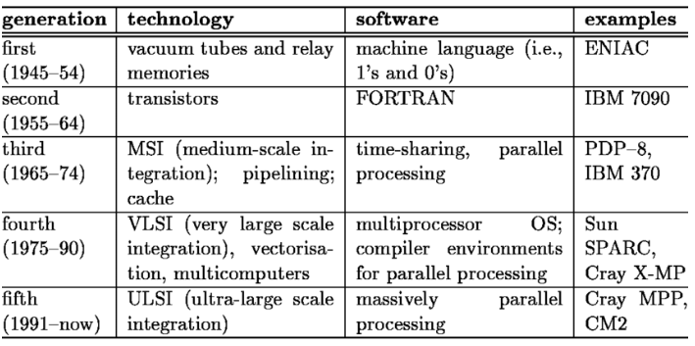

Section 2

Components of Computer and Motherboard
Components of Computer:
- Hardware System
- Software System—Operating System Software and Application Software
- Network System
A computer is an electronic machine that performs input, processing, storing, and output according to programmed instructions to carry out specific tasks. Formerly, computers were used primarily to do arithmetic computations, hence the term, computer. Consider the primitive form of a computer, a calculator. You input the numbers and the arithmetic operation you need the calculator to perform, for example, “3+5=”, and then the calculator processes the arithmetic expression by adding 3 and 5, stores the result of 8, and outputs the result onto the display area.
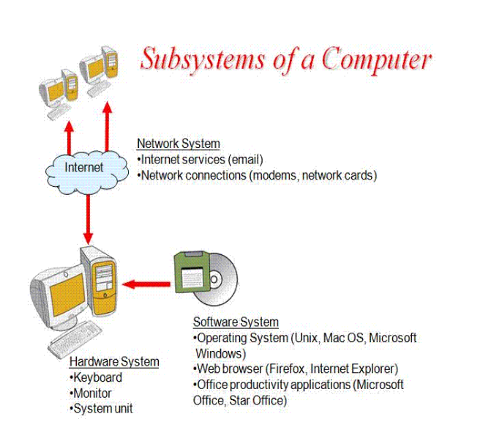

Parts of the Motherboard
- CPU (Central Processing Unit)
- RAM (Random Access Memory)
- Southbridge/Northbridge
- BIOS (Basic Input/output System)
- I/O port

Section 3
Components of CPU

The Central Processing Unit (CPU) consists of six main components:
- Control Unit (CU)
- Arithmetic Logic Unit (ALU)
- Registers.
- Cache.
- Buses.
- Clock.

Section 4
Number System

A number system is defined as a system of writing to express numbers. It is the mathematical notation for representing numbers of a given set by using digits or other symbols in a consistent manner. It provides a unique representation of every number and represents the arithmetic and algebraic structure of the figures.
The four most common number system types are:
- Decimal number system (Base- 10)
- Binary number system (Base- 2)
- Octal number system (Base-8)
- Hexadecimal number system (Base- 16)

Section 5
Logic Gates
A logic gate is a device that acts as a building block for digital circuits. They perform basic logical functions that are fundamental to digital circuits. Most electronic devices we use today will have some form of logic gates in them.
Types of Basic Logic Gates
- OR Gate.
- AND Gate.
- NOT Gate.
- XOR Gate.

Section 6

Computer Networks
Computer Network, two or more computers that are connected with one another for the purpose of communicating data electronically.
7 Types of Computer Networks are:
- PERSONAL AREA NETWORK (PAN)
- LOCAL AREA NETWORK (LAN)
- WIRELESS LOCAL AREA NETWORK (WLAN)
- METROPOLITAN AREA NETWORK (MAN)
- WIDE AREA NETWORK (WAN)
- STORAGE AREA NETWORK (SAN)
- VIRTUAL PRIVATE NETWORK (VPN)

Section 7
Operating System
An operating system is a set of programs that enables a user to operate and interact with a computer.
The top five OS are:
- Apple macOS
- Microsoft Windows
- Google's Android OS
- Linux Operating System
- Apple iOS.
Section 8

Section 8
Modes of Communication
Data communication between different devices are broadly categorized into 3 types:
- Simplex communication
- Half- duplex communication
- Full-duplex communication.

Types of Cables:
There are three types of cables used in LANs i.e.,
- Coaxial cables
- Twisted Pair cables
- Fiber optic cables.
Network Topologies:
Network topologies describe the methods in which all the elements of a network are connected. The topology term refers to both the physical and logical layout of a network.

Types of Network Topologies:

Two main types of network topologies in computer networks are
- Physical topology
- Logical topology

Physical Topology

The computer cables and network devices.

Logical Topology
- P2P Topology
- Bus Topology
- Ring Topology
- Star Topology
- Tree Topology
- Mesh Topology
- Hybrid Topology

Section 9
Internet, Routers, DHCP

Internet:
A worldwide system of computer networks
Routers
A router is a physical or virtual appliance that passes information between two or more packet-switched computer networks.
DHCP
Dynamic Host Configuration Protocol (DHCP) is a client/server protocol that automatically provides an Internet Protocol (IP) host with its IP address and other related configuration information such as the subnet mask and default gateway.
IP address:
A unique string of characters that identifies each computer using the Internet Protocol to communicate over a network.

Modem versus Router
Modem | Router
Brings Internet to your home | Brings Internet to your devices
Has public IP address | Assigns local IP addresses
Uses a WAN network | Creates a LAN network

Thank you!

