Marriott Placement Learning Log

Rohan Dubrey (1905715)

Week 4:

Wednesday 5th February 2020 (14:300-23:00hrs) Thursday 6th January 2020 (14:30-21:00) Friday 6th^{t} January 2020 (07:00-13:00hrs) Saturday 8th February 2020 (07:00-15:30hrs)

Department: Front Office

Work Undertaken:

- Introduction to Opera course passed.
- Answering and transferring telephone calls throughout departments
- Checking in arrivals training Opera
- OPERA pre-arrival training and exam taken and passed
- Compass: The guest arrival training and exam passed
- Marriott Bonvoy membership tier system training
- Mobile key process training and exam passed
- Performing concierge duties
- Training on Customer Service
- Completing VIP list on GXP

- Signing out keys collected from back of front office for the day to other departments
- Training on assigning rooms on Opera
- OPERA 1and 2 online training cont’d

- Attending House Keeping (HSK) morning meetings.
- Handing over procedures on shifts, signing out keys and depositing float to back of front office Glory Machine.

- Checking Alerts on arrivals
- Inputting Traces and Alerts on guest profile bookings.
- Training on precheck-in
- Supervised checking in of guests
- Preparing codes on reservation cards
- Printing next day reports.

Self-Appraisal

Intense week packed with training to ensure greater functionality within the front of house team. I have achieved a lot of knowledge from studying and doing exams. More could have been achieved if communication was effective and placement schedule adhered to. Asking a lot of questions at times showed frustration with training associates not being able to find answers. It can be challenging working with associates who claims they are not equipped to train, after additional hours have been scheduled to be able to learn adequately.

Strengths:

Remaining calm under pressure and acting professional throughout have been paramount within my strength this week. A lot can be achieved by being determined and persistent. Further and continuous training being undertaken will be an advantage to the department I am working in. This has helped me to increase my knowledge within my current role, with exams passed this week.

Weaknesses:

The main challenge this week came from not pointing out areas where training was lacking. However, this will be highlighted in a professional manner going forward. I will address the situation whenever an associate remark that they do not know what to show me immediately.

Lost Opportunities:

The GXP empower training schedule this week had was to be cancelled as the General Manager became ill. This was a lost opportunity to be more educated within that area. My details have already been entered ensuring I am on the next training rescheduled.

.

Plans for next week:

- Working with the night staff doing the 22:30 – 07:00 hrs shift, completing the night auditing.
- Confronting the challenge of learning the Opera Front Office System.
- Turning up for shifts promptly and in proper attire, completing a variety of shifts accumulating to over 30 hours per week.
- Checking in and out of guests to brand standards.

Appendixes

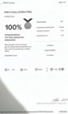

PMS Profile 6.2.2020

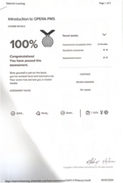

Introduction to OPERA 5.2.2020

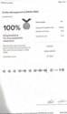

Profile Management 6.2.2020

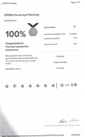
OPERA Pre-arrival exam 5.2.2020

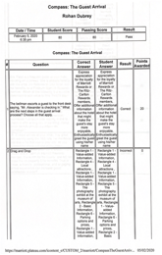
Compass: The guest arrival exam 5.2.2020

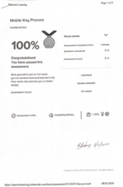

Mobile Key Process exam 8.2.2020

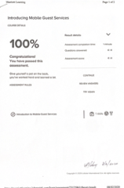
Introducing Mobile Guest Service Exam 8.2.2020

