
Past Peoples, Present Societies

Why we need to study Miracle Belief within the context of Brazil?
13th December, Wednesday, 5pm (GMT) online

A talk presented by Miriam Leal, Universidade Católica de Brasilia

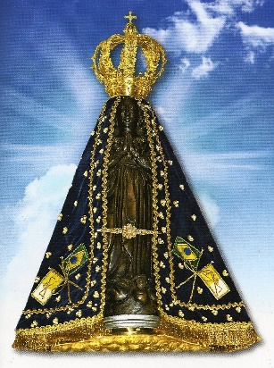

Abstract
Miracles were excluded from scientific inquiry many years ago. The philosopher David Hume conceptualized miracles as events which do not follow the usual laws of nature. Since science is based on the laws of nature, miracles are considered against this principle, leading to the belief that miracles either do not exist or cannot be studied. However, this perspective does not align with the reality of Brazilian society.
Many people in Brazil discuss miracles in various contexts, with one notable example being in the realm of health. A recent systematic review of databases found only 34 papers, 13 of which were empirical research studies. In contrast, my master’s research revealed that 89% of the participants prayed for a Miracle. This research conducted in 2019, focused on pregnant women diagnosed with fetal malformations. While the biological and exact sciences may not delve into this topic, human sciences explore the beliefs and behaviours of people - speaking, praying and hoping for miracles. From a phenomenological psychological perspective, miracles have a place in real life. A miracle can be seen as an extraordinary event. A healing, in particular, can be considered a miracle In this context, a belief in miracles is not intended to undermine medical knowledge or care; instead, it serves to provide individuals with a meaningful significance. The acknowledgement of the wonder associated with a person recovering from an illness or surviving a tragic event through the lens of a miracle contributes to the human experience by ascribing profound meaning to these occurrences.

Tickets and links available on Eventbrite (Past Peoples, Present Societies) or through email to 1811607@student.uwtsd.ac.uk (Please use Subject: TICKETS PPPS)

