Effective team working and communication
University of wales trinity saint David
Student number: 1710012
Date of submission: 10/12/2018



Executive Summary

This report has been complied by student 1710012 is to demonstrate the understanding of the writer regarding effective teamwork and communication. In this report the writer will be show define the problem within the organisation and show knowledge and understanding of the issue which lead to communication issues.

Introduction

In this report the researcher will talk about the importance of effective communication within the workplace which will lead to effective team working. The researcher will be investigating the following case study regarding the communication issues within Sarah Davies large discount store in the middle of Swansea city.
The researcher will examine the following case study and state the why of her company is failing to communicate with her co-workers, why is the lack of communication leading to lack of trust, lack of feedback and unorganised working pattern and shifts.
The researcher will suggest recommendation on how to solve this issue by applying the following models of effective team work and communication such as Tuckman theory and Belbin model which is well renowned to solve organisation communication and effective team working. (Robbins & Finley1998).

Findings
Effective communication is important for the continued success for the organisation so we can achieve goal for the company. Also, we can communicate better with the employee by building a good relationship so we can work with them more effectively. Here are some good examples for better communication which you must have for your business purpose. Communication maybe verbal communications, non-verbal, listening, also written communication. These are the basic elements to use to advance in a business environment. Effective Communication is important is the way we communicate with our staff and communication is the main key for a successful business. This is how we build a good working relationship with the employee and in our working and personal life by applying good communication methods too. It helps us to share information and knowledge and understanding to help the employee to develop a good relationship within the workplace Even though when you are working in team you are communicating well with others you can motivate each other and supporting one and other by forming a strong bond of togetherness. According to P.Morgan (2017.p.204):”mutual accountability a team has a sense of togetherness”.
https;/study .sagepub.com/morgan page 204
First of all, you must know how to communicate verbally or by writing by getting to the point across clearly. For example by email or telephone because technologies has advanced even more further. For business purpose it better to be aware not to take the wrong channel because you could be wasting time and money of the company. Example some work could have been done by face to face, email, or by telephone even by writing a Also the negative side of the communication is you can have conflict amongst the group being able to get straight to the point. This can misinterpret the message passed across to others that can cause verbal and physically.
And the positive side is you can pass the message even the negative ones in a positive manner. Having a positive communication, it is important for the business side so they can communicate with the stakeholder. And sharing information between business manager and other company employees so it can contribute to its commercial success.
htpp;/smallbusiness.chron.com>effects
Negative side is Sara can’t have staff meeting because they all work different hours so it hard to communicate altogether as a group. I am writing about why team meeting are good for so you can communicate more effectively.
If it is a team meeting it is necessary this allow to networking with your group and also shares your ideas. Contributing to team members realising the important of team meeting as you can discuss your goal to reach. If you a team member how they can contribute to task to reach for their goal. As the task are clear and the goal to reach so the employees will be more motivated to their work because they will realise the importance of the business.
Working part time worker you don’t pay taxes for the employer that is good as that keeps the low cost down.
The disadvantages are to recruit a person through a recruitment agency is that cost are too high than taking on a single full-time worker. Also, there could be addition charges likes their benefits, and training off the staff as this is the advantages to be aware off the cost.
As you can bring in highly skilled workers in who cannot work fulltime who preferred to work part time Option will be having more staff meeting, face to face .
Nonverbal communication significantly is a body language is how you would perform at work like your duties as it is important to communicate be positive. Non-verbal is body language how you would react with co-worker this can include eye contact, facial expression, and posture and so on Also, another word when speaking with employees can increase employee morale and job performance. (P.Morgan2017)

The importance two-way communication is when a person is a sender the other is the receiver then the receiver acknowledges to the sender for receiving the message. It is important to transmit the message across for the most important aspect for any business purpose, is so they can evaluate the answer and give their best performance for the answer. Also, it’s important to be a good listener so knowing how to response. There are two ways of listening is which is empathically which shows us how alert and understanding because listening what is being said. The other is listen actively which means literally listen to everything before deciding of the situation. And you are building a good relationship with the employee and also understanding. (P.morgan2017)
Ref https:/www.mindtools.com

This is a two-way communication which messages are transmitted between employers and employee and other stakeholders. Then you should receive your feedback that they have received your message and understood it. (See image 1) Communication is important with the employees and communication is the main key to a success organisation by building a good working relationship. Because it helps to share information and knowledge to help employees to develop good relationships with the employer. Also studying the case of Sarah Davies, she has given each one different department to work on because what they are experience in. Also, she has the trust of the employee that is why she is thinking of expanding her business.

Written communication is a type of communication that is as important to any business because it sends messages that are flat meaning no tone of voice no body language it is an intangibles way to communicate ideas or opinion. According to bizfluent:”whether communicating in person over video in email on the phone or through social media it is critical the message is understood”.

Communication Cycle (Image 1)

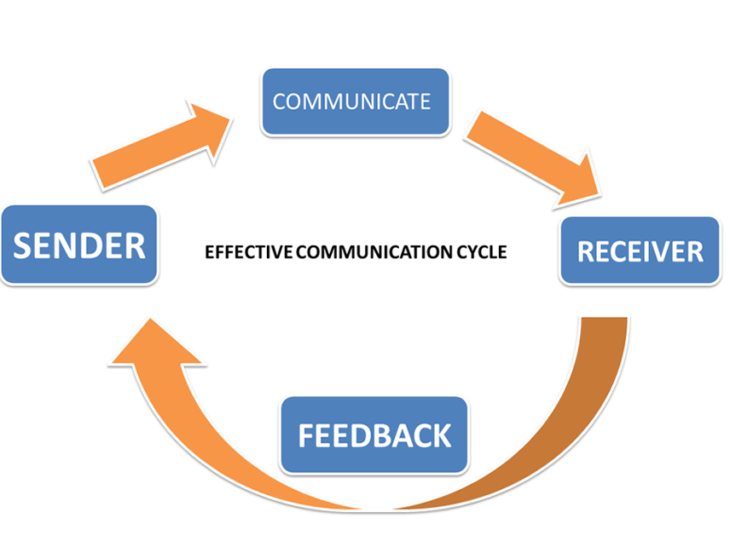

The importance of consultation and the employee voice is first the employee voice should be heard if any issue affecting them at workplace which can be resolved can be after hearing their voice what can be done. Advantages are the employees will feel valued that they are respected and heard. They will work well in a team and also show more commitment an effort which will help the company to be successful. According to business communication:” information flows from sender to receiver and response goes back to the sender”.
Disadvantages there could be unfavourable disagreeable circumstance that could occur in the workplace that can reduces friction with the leader and the employee.
The effective methods of communications is be a good listener, nonverbal communication is being friendless, be positive, empathy, open minded and respect.

Tuckman model (Image 2)

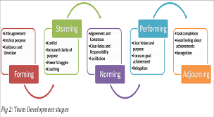

Tuckman theory is a relevant model for successful team building as it challengers phases to the completion of a task to develop a team standard. Tuckman theory is composed of 5 stages in his model which are the following (see image 2). Tuckman model helps the development of team building and helps face challenges, tackle problems and group development. Tuckman’s advantages are of Tuckman model it helps sort out conflict within the team group value and perform excellently within the team and team satisfaction. Disadvantages within the Tuckman theory can’t agree on the same task not listening to each other and team leader want to be obstinate unable to focus on a common goal. According to Morgan (2017.p210):” team will occur in a number of stages, each of which can affect interaction between members of a team”.

Belbin model (image3)

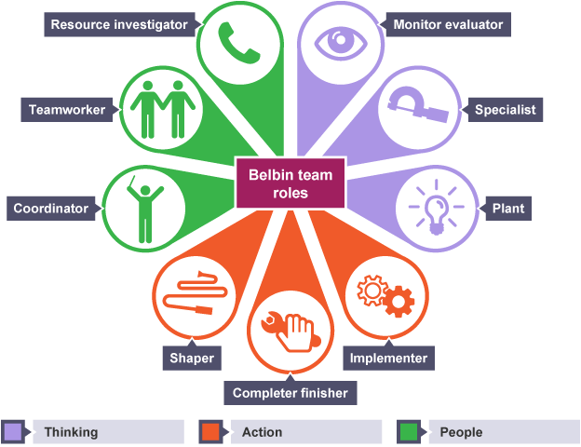

Belbin model is an effective model which helps identify the different strength and weaknesses of each co-worker which helps achieve better results when each team member are knowledgeable of their own role within the team. According to ifm:”Belbin describes a team role as a tendency to behave contribute and interrelate with other in a particular way”. Belbin model has 3 action positioned assessment of team role, use of a team role which u can see described on (image3) it has 9 team roles which consist of co-coordinator, plant, implementer, finisher, evaluator, team worker, specialist, shaper, resource investigator and monitor evaluator it helps build a successful team that work together if this model is used within the organisation.

Conclusion
In conclusion the writer has concluded that Sarah Davies lack of communication issues came from the lack of focus on their staff not focusing on how well the team is performing no feedback and staff meeting unorganised team with unorganised shift pattern. Even though the business grew rapidly she should have spread the work task evenly to each team member and supported them within their roles as expansion grew fast she got disorientated and lost focus on both businesses which lead to communication issues and disorganised workers.

Recommendation
The writer after case examination has come up with the following recommendation for Sarah Davies after close examination of the case study the writer understood that it is necessary that if Sarah Davies want to save her both business from going chaos she must apply the following theory mentioned within the case study which are the following the Tuckman theory to rebuild a strong team and the Belbin method to help monitor each team member their given task and form a successful team within her organisation and that will help promote growth of her business. Also Sarah Davies should apply the communication cycle (see image1) to help her understand if the message she is sending each team member is understood by them and make sure get feedback and ideas to improve her team by incorporating staff meeting and incentive e.g. employee of the month to help them keep focus on their goals.

Reference list

The business student’s guide to study and employability P.Morgan 2017 Sage: London
www.ifm.com
www.mindtools.com/newLDR_86
www.businessballs.com/tuckman
www.bizfluent.com
www.thebusinesscommunication.com

