The process of gene expression within eukaryotes cells
Gene expression is responsible for the organisation of protein synthesis, which engineers the cells structures and activity (Chin, et al, 2006). This is commenced within the cell’s nucleolus (see Figure 1), utilising the genetic sequence within deoxyribonucleic acid (DNA) (Stephens, 2018). DNA is a nucleic acid that holds the essential genetic information and instructions, required for cellular activity. Genes are sequences of DNA in a certain pattern that code for specific protein products (polypeptides). This process is managed by genetic coding and operated by nucleotide molecules (U.S National Library of Medicine, 2020). Stephens (2018) explains that DNA comprises of two strands formed into a double helix generated from alternating sugars, deoxyribose and phosphates. Between these strands are four nitrogen-based molecules known as nucleotides, integrated into specific base pairs to formulate the DNA double helix, containing instructions for genetic code. The base pairs; adenine (A) correlates with thiamine (T) whilst cytosine (C) bonds with guanine (G), are read in three-letter phrases, known as a codon (Stephans, 2018). This sequence is elongated alongside each strand of DNA called genes (Stephens, 2018). Gene expression manufactures products using information coded in genes to formulate the characteristics of human beings. This process is conducted through two stages that determine how a protein will be manufactured.eg. transcription and translation (Clancy, 2008.p. 41).
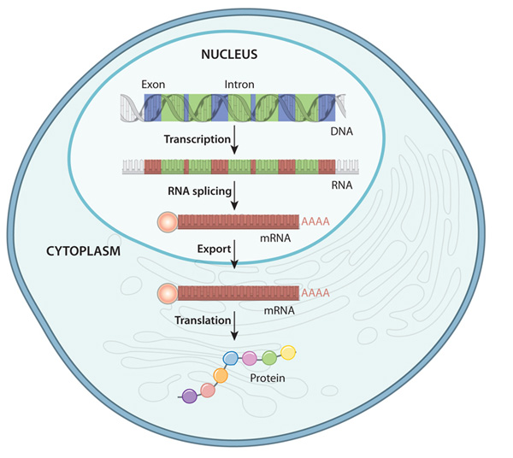
Figure 1: A simplified overview of gene expression, indicating where in the cell, different stages take place (Scitable, 2020). The pale lines in the cytoplasm represent endoplasmic reticulum.

The first stage of gene expression begins when DNA sequences are transcribed and encoded onto an RNA template (Naumova, et al, 2013), also known as transcription (see Figure 1). DNA is engineered into specific genetic code that define the beginning of RNA production, also known as the promotor (Walhout, 2011. Clancy, 2008). The promotor operates in one of two directions along both strands of DNA, upstream on the strand (5 prime to 3 prime) and downstream on the strand (3 prime to 5 prime) (Bhagavan and Ha, 2015). The nucleotides A, T, C and G are assembled into the sequence called the TATA box, which determines where the enzyme RNA polymerase will connect (Bareket-Samish, Cohen and Haran, 2000). RNA polymerase is an enzyme genetically inherited when born, that translates and copies DNA downstream (5 prime to 3 prime), to engineer messenger RNA (mRNA) (Rev,2013). This is undertaken through disengagement of the double helix by RNA polymerase, which finds the correct nucleotide versions within the nucleolus to combine with their match on the DNA strand as shown in Figure 2 (Julicher and Bruinsma, 1998). However, when generating mRNA, the uracil nucleotide bonds with adenine, instead of thiamine (Khan academy, 2020).
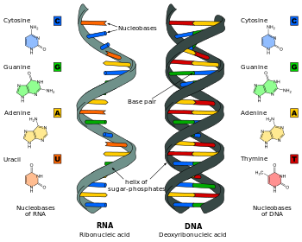
Figure 2: DNA to RNA showing the replacement Uracil base.

At the end of this process another nucleotide triplet known as a termination codon tells the enzyme to stop production and caps both ends of the RNA strand, in preparation to leave the nucleus and to prevent termination by passing enzymes (Buhuler, Wilkinson and Muhlemann, 2002). However, whilst the RNA strand contains the genetic information for manufacturing a protein, it also contains various inaccurate sequences (introns), which require editing before translation (Ribeiro, et al, 2020). This is conducted through a process known as RNA splicing (see Figure 1), which is mediated through two mechanisms, snRNP’s (called snurps) and spliceosomes (Ribeiro, et al, 2020). Whilst snRNP is responsible for identifying areas requiring editing, spliceosomes operate to remove this information, and release nucleotides back into the nucleus for recycling (Wilkinson Charenton and Nagi, 2020). Once this process is complete both ends of the strand are capped with exons and transported by mRNA to the cytoplasm of the cell, for the next stage in gene expression (see Figure 1).
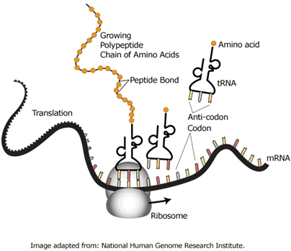
Figure 3: Ribosomal production of polypeptide chains.
Translation of mRNA occurs within the cytoplasm of the cell, mediated by two ribosome molecules, ribosome RNA (rRNA) and transfer RNA (tRNA) (Bailey and Navette, 2019). Ribosomes are constructed from proteins and rRNA, and facilitate the production polypeptide chains of amino acids (see Figure 3). The translation stage occurs in three phases, initiation, elongation and termination (Stephans, 2018). Within the initiation phase the rRNA pulls the mRNA strand into the ribosome beginning with the activation codon A, U and G, originating at the 5-prime end (Kurse and Wilusz, 2017). When this is initiated the ribosome reads the activation codon and determines which of the 20 tRNA molecules will interlink. Ribosomes read the triple nucleotide sequence on the tRNA molecules, known as the anticodons and bind these to the matching codon found on the mRNA strand (Carroll, 2019). The tRNAs function is to translate the nucleotide language to amino acids (Kisselev and Wolfson, 1994). The type of amino acid formed depends on chain of anticodon sequences found on the tRNA molecule, as the mRNA sequence defines which tRNA can attach (Katoh, Tajima and Suga, 2017). As shown in Figure 3 the ribosome continues to read and bind tRNA molecules to the moving mRNA strand (Hopper and Phizicky, 2003). As the mRNA strand moves through the ribosome, the tRNA molecule leaves an amino acid behind generating a collaboration with the preceding amino acid, forming a polypeptide chain (protein) (Lareau, et al, 2014). This production continues until the ribosome reaches one of the three termination codons at the 3-prime cap of the mRNA strand, UAA, UAG or UGA and is then transported into the endoplasmic reticulum for folding into functional proteins (Lareau, et al, 2014. Kleizen and Braakman, 2004)(Figure 4).
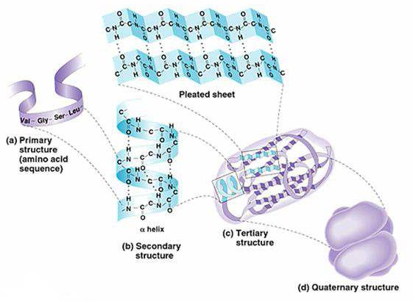
Figure 4: Polypeptide chains folding into functional proteins.

Once the production of translation has terminated the polypeptide chain is displayed within its primary structure. The primary structure refers to the elongated sequence along the polypeptide chain in a single file formation (Kennedy, et al, 2016). This protein undergoes the next stage known as folding. Sharman (2013) indicates that folding is essential for the protein to function, as proteins not correctly formed three-dimensional state could lead to disease within the body. This folding process is influenced by specific amino acids containing hydrogen that magnetise towards another amino acid containing oxygen and bond (peptide bonds) (Cheng, et al, 2003). The protein is also sensitive to water in which the cells contain (Luengo, Mayer and Rudiger, 2019). This comes from the ribosome molecules, which formed the amino acids reacting to water influencing the bonds within protein to compact together forming the stature of the concluded protein product (Khan and Salahuddin, 2017), displayed in Figure 4. Once gene expression has concluded the body uses these proteins in a variety of essential processes providing the necessary functions to build and repair tissues and regulating a whole host of essential bodily processes (Chan and Lakroix, 2018).
Gene expression is a vital part of any living organisms functioning and therefore, an essential function within all cells. DNA contains the codes for genes, but these need to be read and converted into functional products. These products of gene expression allow cells to respond to their environment. According to Yong (2018), there are currently estimated to be between 19,000 to 22,000 genes in the human genome, each playing a role in the formulation of features of who we are, how we respond to our environment and how we ultimately remain healthy and survive, this is central to all life, and as a result, gene expression is also known as the ‘central dogma’.

Word count: 1,100

Reference list
Bareket-Samish, A., Cohen, I. and Haran, T.E., (2000). Signals for TBP/TATA box recognition. Journal of molecular biology, 299(4), p.965-977.
Bhagavan, N. Ha, C. (2015). Essentials of Medical Biochemistery. 2nd ed. N/A: Acedemic Press. p. 419-446.
Bühler, M., Wilkinson, M.F. and Mühlemann, O., 2002. Intranuclear degradation of nonsense codon‐containing mRNA. EMBO reports, 3(7), pp.646-651.
Chin, D., Boyle, G.M., Theile, D.R., Parsons, P.G. and Coman, W.B., (2006). The human genome and gene expression profiling. Journal of plastic, reconstructive & aesthetic surgery, 59(9), p.902-911.
Clancy, S., (2008). DNA transcription. Nature education, 1(1), p.41.
Clancy, S.. (2008). RNA Transcription by RNA Polymerase: Prokaryotes vs Eukaryotes. Nature Education. 1 (1), p.125.
Jülicher, F. and Bruinsma, R., (1998). Motion of RNA polymerase along DNA: a stochastic model. Biophysical journal, 74(3), p.1169-1185.
Kearse, M.G. and Wilusz, J.E., (2017). Non-AUG translation: a new start for protein synthesis in eukaryotes. Genes & development, 31(17), p.1717-1731.
Khan Academy., (2020). Intro to gene expression (central dogma). Available: https://www.khanacademy.org/science/high-school-biology/hs-molecular-genetics/hs-rna-and-protein-synthesis/a/intro-to-gene-expression-central-dogma. Last accessed 25th March 2020
Khan, R.H., Siddiqi, M.K. and Salahuddin, P., (2017). Protein structure and function. Basic Biochemistry, p.1-39.
Naumova, O.Y., Lee, M., Rychkov, S.Y., Vlasova, N.V. and Grigorenko, E.L., (2013). Gene expression in the human brain: the current state of the study of specificity and spatiotemporal dynamics. Child development, 84(1), p.76-88.
Walhout, A.. (2011). Gene-Centered Regulatory Network Mapping. Methods in cell biology. 106 (N/A), p. 271-288.
Yong, E., (2018). The Genes That Never Go Out of Style Fifteen years after the Human Genome Project, scientists are still mostly studying genes that have already been well studied.. Available: https://www.theatlantic.com/science/archive/2018/09/the-popularity-contest-of-human-genes/570586/. Last accessed 25th March 2020
Kisselev, L.L. and Wolfson, A.D., (1994). Aminoacyl-tRNA synthetases from higher eukaryotes. In Progress in nucleic acid research and molecular biology, 48, p. 83-142. Academic Press.
Bailey, N.A., (2019). Dynamics of Translation Elongation in an mRNA Context with a High Frameshifting Propensity (Doctoral dissertation, Columbia University). Available at: https://academiccommons.columbia.edu/doi/10.7916/d8-qsnc-d250. Last accessed 27th March 2020
Carroll, B., (2019). Caught In Motion: Structural Studies Of Nucleic Acid Repair Enzymes. Available at: https://scholarworks.uvm.edu/graddis/1160/. Last accessed 27th March 2020.
Katoh, T., Tajima, K. and Suga, H., (2017). Consecutive elongation of D-amino acids in translation. Cell chemical biology, 24(1), p.46-54.
Wilkinson, M.E., Charenton, C. and Nagai, K., (2020). RNA Splicing by the Spliceosome. Annual Review of Biochemistry, 89.
Ribeiro, M., Furtado, M., Martins, S., Carvalho, T. and Carmo-Fonseca, M., (2020). RNA Splicing Defects in Hypertrophic Cardiomyopathy: Implications for Diagnosis and Therapy. International Journal of Molecular Sciences, 21(4), p.1329.
Hopper, A.K. and Phizicky, E.M., (2003). tRNA transfers to the limelight. Genes & development, 17(2), p.162-180.
Lareau, L.F., Hite, D.H., Hogan, G.J. and Brown, P.O., (2014). Distinct stages of the translation elongation cycle revealed by sequencing ribosome-protected mRNA fragments. Elife, 3, p.e01257.
Kleizen, B. and Braakman, I., (2004). Protein folding and quality control in the endoplasmic reticulum. Current opinion in cell biology, 16(4), p.343-349.
Kennedy, E., Dong, Z., Tennant, C. and Timp, G., (2016). Reading the primary structure of a protein with 0.07 nm 3 resolution using a subnanometre-diameter pore. Nature nanotechnology, 11(11), p.968.

