

MODULE CODE: Digital Skills for Personal Development and Business Growth BMSW4008

ASSESSMENT COMPONENT: PORTFOLIO

STUDENT NAME: Daniel Rojek

STUDENT NUMBER: 2508962

LECTURER: Philippa Fitzgerald

DATE: 12/12/2025
Contents
Task 1 3
Assessment of Digital Skills 3
References 3
Task 2 4
LinkedIn Learning Certificates for Office365 4
Task 3 5
Essay on Relevance of Excel in professional and personal life. 5
References 5
Task 4 6
7 Minute Reflective Presentation 6
References 6

AI Acknowledgement
I confirm that I have not presented any AI generated materials as my own work.
I can that I have copies of my drafts, notes, and other resources I used, which I may be asked to provide in evidence.

Task 1

Assessment of Digital Skills
Image 1 Screen shot of your JISC report
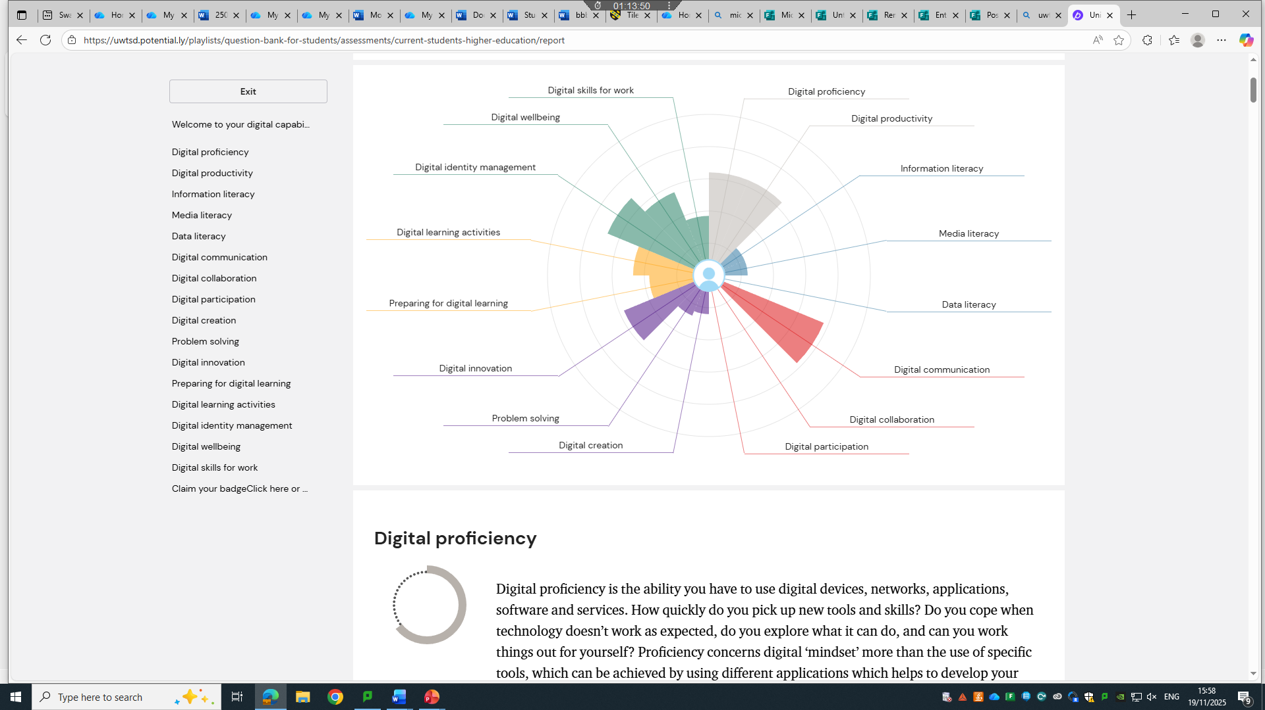

700 words on your assesment of digital skills Plus recommendations and badges you have completed because of this report

In this assessment I will evaluate my ability to use various digital tools, which I have learned at a basic level over the last 11 weeks, and I note that at the beginning my skills were limited. My JISC report is the best evidence and example of my digital competencies at the start of the first semester of Digital Skills for Personal Development and Business Growth (BMSW4008_SWAN), taught by Mrs Philippa Fitzgerald/module lead. This JISC report and the associated chart show different levels of digital skills in 16 different areas of digital topics. And I will be honest, when I first saw all this, I thought, what are you doing here, man. But today, with mild satisfaction, I can say wow, I understand the basics of Microsoft 365, such as Word, Excel, PowerPoint, Teams, Forms, OneNote notebook. But enough boasting, let's get to the topic, that is, critical analysis.
Information, communication, content creation, security and problem solving are the areas I would like to focus on as well as support with scientific literature to which many scholars and writers refer. I will also validate my results by showing badges of their completion; although I am not able to provide all badges at this moment for purely technical reasons, the most important ones will be presented here. So, the JISC results (Eales Reynolds,2013). Clearly show that my fairly developed knowledge, and consequently relatively strong digital skills, namely the use of information tools and data searching, are the positive aspects. A weaker area in my case is so-called critical source analysis and advanced information management. From what I understand, (Livingstone and Wang,2013).This my profile reflects a trend where access to various kinds of technology grows faster than the understanding of their impact and limitations (Werthner,2022).
But going back to my JISC chart, Information, Media and Data show that I am able to search for and organise information sufficiently, but when it comes to analysis, I have a problem; I am able to use the data I find ethically. Creating, problem-solving and innovation are relatively low, rather this is my weakness and, as I suspect, my creativity in this aspect is not the best 'weak'. Communication, collaboration and participation, these digital spheres are fairly well developed, this shows in the knowledge and frequent use of email and messengers as well as sharing data in team work, I probably should participate more in the student community. Learning, identity and digital wellbeing 'wow' very low results, I unconsciously plan my digital development and do not control my online image or balance between online and offline; to be honest, I was not aware of this.
(Havlicek, 2023) suggests to me that my abilities to work with digital information can be strengthened through projects requiring data analysis and presentation, not just retrieval. And here is an interesting point, as the author also emphasises that teachers and students should together create a working environment in which students learn to solve problems independently using digital tools. Meanwhile, the concept of "digital humanism" (Werthner, 2022) suggests that to exist in the so-called virtual world, one must continuously develop in order to be aware of shaping our online presence, being critical of algorithms and understanding the impact various platforms have on public debates. If we add this to our digital self-development and beyond, it not only answers the question of how to use technology, but also why and what consequences we need to face. Meanwhile (Franco, 2020), digital leadership suggests supporting others by helping them use digital tools, online platforms, or creating resources. Digital leadership also teaches that one must continuously learn new tools and be ready to change and adapt to them.
(Livingstone and Wang, 2013) predicted this and basically little has changed since then. They suggest a greater focus and differentiation of misinformation. My JISC report therefore highlights paying attention to deeper checking of online sources, privacy and better management of personal data.
One small chart and I learned so much about my presence in the virtual world, thanks to JISC I now know what I should focus on more to be even better, self-improvement, learning, contact with people, all of this will help me in my academic future and in everyday life too.

(5 references)
Eales –Reynolds,L-J.,Judge,B.,Jones,P and McCreery,E.(2013) Critical thinking skills for education students 2nd edn. London Sage Publications.

Havlicek,J.(2023) The Concept of Developing Geoinformatics Skills in Teaching at Primary and Secondary Schools. 1st edn. Brno: Masarykova Univerzita.

Werthner, H., Prem,E.,Lee,E.A. and Ghezzi, C.(eds) (2022) Perspectives on Digital Humanism. 1st edn. Cham: Springer International Publishing.

Franco,M.(ed) (2020) Digital Leadership: ANew Leadership style for the 21st Century. London: IntechOpen.

Livingstone,S. And Wang,Y. (2013) Media Literacy and the Communication Act: What has been achieved and what should be done? A 2013 update. London: London School of Economics and Political Science.

References

Task 2

LinkedIn Learning Certificates for Office365
Add all the certificates from LinkedIn learning here

Microsoft Forms: Proof badge.

Task 3

Essay on Relevance of Excel in professional and personal life.
Write a 1000 word essay on Relevance of Excel in professional and personal life.
8 references
Use the following information create an Excel spread sheet, looking at income and expenditure of a typical family of 4 over the course of a year. Use formulars to achieve answers and add headings and highlight the different aspects of the finances, be realistic with the monetary amounts used for each area.
Income | Amount per month £££ | Expenditure | Amount per month £££
Wage 1 |  | Rent/Mortgage
Wage 2 |  | Council tax
Trust Funds |  | Electric
Stocks/Share payouts |  | Gas
Universal credit |  | Water rates
Student Finance |  | Food
Other |  | Car insurance
 |  | Car Tax
 |  | Fuel
 |  | Child Care Costs
 |  | Loans/credit cards
 |  | Other eg Birthdays/savings/holidays

Embed your excel here
Excel: Daniel Rojek
Excel. Household expenses
AI Acknowledgement
I confirm that I have not presented any AI generated materials as my own work.
I can that I have copies of my drafts, notes, and other resources I used, which I may be asked to provide in evidence.

By: Daniel Rojek: Relevance of Excel in professional and personal life

If I had any idea about Excel about 10 or 11 weeks ago, I would definitely have started using this programme much earlier, not only to control everyday expenses but also to organise, analyse and present numerical and textual data, because apparently this programme is indispensable and has been with us for about 40 years. It was first introduced in 1987 for the Windows system and became a great success for Microsoft, but let's get to the core of my essay, which is the question 'The importance of Excel in professional and private life
In my opinion, today's world is largely based on processing huge amounts of data and very quick access to information, which definitely translates into a strong emphasis, even a requirement, on efficiently using digital tools, and there is a lot to choose from and learn, but in this essay I will focus on one tool, Microsoft Excel. This programme has been with us for decades and is considered by many as irreplaceable and an indispensable addition to the ecosystem of every office and workplace. In my opinion, its use goes far beyond the basic functions of a spreadsheet, which focuses on data analysis, budget planning, team communication, or, for example, project management.
At this moment in the history of digital tools, Excel has become and is the main digital tool in two spheres, the professional at work and the private, so-called home sphere, contributing to our personal as well as professional digital competences, which in turn raises human standards in efficiency. Excel, as a tool for developing digital competences, aligns with the approach presented by (Krause, 2024). New technologies require not only knowledge of digital tools but also the ability to balance in the digital sphere, and in my opinion, in the most important sphere of our human psyche and wellbeing. Surely, Excel is a good or even excellent example of a programme/technology which, when used in a completely conscious and skilful way, can undoubtedly support cognitive development, organise daily life, and planning at various levels.
And I mean here the visualisation of data and analysis on this basis allows us to understand the phenomena that emerge and thus leads us to so called critical thinking, which enables us to make decisions based on facts rather than assumptions. In practice, digital competences include the ability to process information, analyse data and use IT tools to solve arising problems, according to (Cottrell,2024). After briefly reading some literary works related to the Excel issue, I noticed that Excel supports processes such as effective learning and work, which, however, require the ability to organise knowledge and apply it in a way that is as flexible as possible for us. By supporting these processes, Excel also serves for planning, collecting data and effectively interpreting it, thereby developing the skill of self-organisation and self-improvement.
I think that to a large extent, the role of Excel in the so-called professional environment is its significant value for companies and their employees who benefit from its features, simply due to its universality and versatility. (Cameron, 2021) notes that one of the key skills in office work is the ability to analyse data and create reports. And our essay topic, Excel, allows us to accomplish these tasks in the clearest and most effective way possible. For people working in various professions, mainly related to report writing, it is a wonderful and versatile tool for everyday numerical and analytical communication, spanning from finance departments to marketing, education, and public administration. Meanwhile, in (Global Studies on Management Information System, 2023), it is indicated that despite the passage of years, Excel remains a fundamental tool in the information systems of large corporations and enterprises, connecting and aligning with progressing modern solutions, consequently, not only supports decision-making processes but also facilitates knowledge management based on data in various types of organisations. I have noticed that today's job market largely values people who can skilfully use Excel in the most efficient way possible, which translates into ordinary competitiveness. (Payne, 2006). It draws attention to the fact that knowledge of tools enabling precise analysis of results is crucial to achieving high performance. I have noticed that Microsoft Excel, through functions such as statistical formulas, pivot tables or trend analysis, is certainly capable of continuously controlling and monitoring the effectiveness of actions and identifying areas and levels where correction and improvement are needed.
In private life, in everyday use, Excel is just as useful as in a professional career in the publication (Anderson, West, Dark,2013). I read that basic knowledge of Excel allows for more effective management of the household budget, planning life goals, and what I find relatively important nowadays is controlling expenses. "In this context, I am starting to like Excel more and more" and it seems that this program can serve as our personal digital assistant that can effectively organise our daily life and related responsibilities, plan travels, monitor personal progress, cultivate good habits, and it is not limited to just words or numbers but has the ability to visualise information and this is just the tip of the iceberg that is Excel. (Denny,2009). It says that the key to success in professional and personal life is the ability to communicate clearly, and I believe you cannot disagree with that because there is nothing more satisfying.
Through visualisations of our data, Excel can make them understandable in a detailed and clear way for the entire team or staff, Excel is a common language, I would say of data, and with its help people in our company are able to interpret the same information, of course adapting it to their tasks, and this integration helps in making better and faster decisions. (Denny, second edition, 2009). He wrote that an effective presentation is a combination of content, form and technology. Excel combined with PowerPoint or another Microsoft Office tool enables the creation of comprehensive presentations supported by numerical evidence, which gives credibility in business interactions. (Cameron, 2021). She says that students and pupils who are able to use analytical tools manage work organisation better.
Fun fact: Excel is also an introduction to learning programming and algorithmic problem solving

References
Krause,C.(2024) Digital wellbeing: Empowering connection with wonder and imagination in the age of AI. Newark: Jon Wiley and Sons, Incorporated.

Cameron,S.(2021) The business students handbook: Skills for study and employment.7th edn. Harlow: Pearson Education Limited.

Global studies on management information systems (2023) Istanbul: Istanbul University Press.

Cottrell,S.(2024) The study skills handbook:6th edn. London: Bloomsbury Academic.

Andrews,J, West,J.and Dark,J.(2013) Jump right in! Essential computer skills using Microsoft Office 2013.2nd edn. Upper Saddle River,NJ: Prentice Hall.

Payne,V.(2006) Coaching for high performance. New York: American Management Association.

Denny,R.(2009) Communicate to win. 2nd edn. London: Kogan Page.

Denny,R.(2009) Communicate to win: Learn the secrets of successful communication and presentation. 2nd edn. London and Philadelphia:Kogan Page Ltd.

Task 4

7 Minute Reflective Presentation
Create a PowerPoint presentation using techniques learned in class, reflecting on the module and what you have learned.
Maximum of 15 slides Minimum 7
You will reference your work where appropriate.
Embed PowerPoint here
PowerPoint Presentation Digital skills

References
Krause,C.(2024). Digital Wellbeing: Empowering Connection with Wonder and Imagination in the Age of AI.
Andrews, J.,West,J.,& Dark,J.(2013). Jump Right In! Essential Computer skills Using Microsoft office 2013.

On a side note: These two references are not listed with titles on any slide of my PowerPoint presentation but based on them I was able to roughly approximate and describe what I presented in my presentation, more or less.

