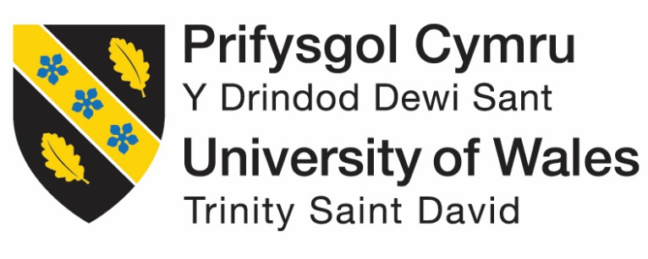

The Impact of Covid-19 upon Rolls Royce

Program: BA Business Management
Module: Marketing Fundamentals
Module code: LCBB4004
Student ID-2111130
Student name: Loredana Andreea Zsofi
Lecturer’s name: Tushara Balendran
Executive Summary
Covid 19 has been the toughest scenario in today’s world to be handled. It has created a huge negative impact on every sector of business. The organizations have been bound to analyze their own strategies to know whether the strategies are appropriate according to the changed scenario. This report is going to focus on the impact of Covid-19 on Rolls-Royce, a well-known British Luxury Car Brands for a long period of time. This report will discuss various analysis methods and their advantages and disadvantages. This report will also discuss these analysis methods with respect to the scenarios faced by Rolls-Royce. This report will also provide the recommendations needed to bring the company back to its previous condition like the pre-pandemic time.
Table of Contents

Introduction 6
Stages of Marketing 6
PESTLE Analysis 9
Political Factor 10
Economical Factor 10
Social Factor 11
Technological Factor 11
Legal Factor 11
Environmental Factor 11
Porter’s 5 Forces Model 12
Threat of new entrants 13
Threat of substitutes 13
Power of customers 13
Power of suppliers 13
Competitive rivalry 14
SWOT Analysis 14
Strengths 14
Weaknesses 15
Opportunities 15
Threats 15
STP 15
Segmentation 15
Targeting 16
Positioning
4ps model 16
Product 17
Price 17
Place 17
Promotion
Conclusion 18
Recommendation 18
References: 19

Introduction

Covid-19 outbreak has put all the industries all over the world in a fight for survival. Appearance of this pandemic has been the most difficult in recent times. Due to the restrictions imposed by different nations the world has stopped running. These actions also have affected various businesses. Automobile industry is one of the most harmed sectors for this purpose. All the manufacturing units, logistics and sales were halted by the restrictions due to the pandemic which caused a decrease in the production of cars. People were more concerned about their health and about being safe rather than purchasing cars. But with a gradual relaxation in the strict norms and regulations, from mid-May of 2020, the car sales were trying to find a way to the light of profit which was still very slow. The total production of cars went 16% down all over the world which is equivalent to a reduction in the number of car production by 78 million due to the lower production (forbes, 2020). This amount of car production was equivalent to the 2010’s car production. It even resulted in shutting down of some automobile industries. Not only the production of the cars was affected. The sales declined by 12% in 2020. Alone in China, the car sales in 2020 reduced by 92% compared to the previous year (ncbi, 2021). Different companies had to take new policies in marketing to increase the sales in the pandemic era. In the words of Hollensen, Kotler and Opresnik (2022), Marketing is the science behind exploring and creating value to satisfy the needs of the market at profit. It is basically the steps taken by a company to promote their products. It includes the advertisement, selling and delivering of the product. This report is going to analyze the impact of the Covid-19 pandemic on Rolls-Royce, a popular British Car company.

Stages of Marketing
Rolls-Royce incurred a loss of 5.4 billion pounds in 2020 which was double than 2019. In the UK, this organization eliminated 9000 employees from their jobs, and it affected its business greatly. To deal with this difficult situation, the marketing team of this company uses different marketing strategies through proper stages of marketing.
Marketing Stage | Discussion
Situational analysis | Situational analysis is the analysis of the marketing position of the associated organization which helps the marketing team to appeal to the target customers by considering the current state of the market. They analyzed the whole scenario through PESTLE analysis, Porter’s 5 Force Analysis, SWOT analysis and other methods so that they would understand their customer’s needs and attitude towards buying Rolls-Royce cars (Jain, Sharma, and Gupta, 2022).
Objectives | Objective is one of the most important factors to set before planning any marketing strategy. Marketing objectives are some concrete and smaller steps which must be achieved by the organization. Rolls-Royce took a SMART (Specific, Measurable, Achievable, Relevant and Time-bound) goal approach to face the pandemic and to handle it (Rauschnabel et al., 2022). They set a specific goal to approach the customers to buy their products even during the pandemic by offering personal family cars rather than public transport. They also set a time limit to do so (King, 2022). This objective is important because it brings all the members together to work collectively and reach the aimed goal. Without this objective, the organization never will be able to find their way to success (theguardian, 2020).
Marketing Strategy | Marketing strategy is the plan undertaken by the organization to reach their customers, to deal with all the obstacles and to deliver the product efficiently. It includes a specific time limit to finish the smaller steps to achieve a bigger goal (Kingsnorth, 2022). It is the outline of the market plans. Rolls-Royce determined their own marketing strategy regarding the increase of their sales and revenues during the covid-19 pandemic era. The basic intention was to communicate with all the customers there so that they would get a competitive advantage over their competitors. They also investigated social media platforms as one of the major tools for their marketing (Ren et al., 2022). They also decided to provide low budget sustainable cars so that the customers got attracted.
Implementation | An expert marketer always prepares a distinct implementation plan to ensure that all the marketing plans and strategies have been implemented successfully. It is a process were depending on the circumstances the organization sets all the tasks, projects and palms for advertisement, promotion and marketing (ugli Togaev and Zubaydullaev, 2022). It turns the marketing strategy into a practical task with proper guidance. Rolls-Royce was able to set a realistic expectation in the pandemic scenario based on this implementation plan. It helped them to review their strategies based on the main threat, covid-19
Control | According to Hakimovna and Muhammedrisaevna (2022), control is the certain phase of marketing which ascertains that the company has met the set goal. It measures the extent in which the organization is following its marketing plans and strategies. It helped the Rolls-Royce company to improve their performance in the pandemic era. Along with various analysis methods, they depended on the customer;’s feedback, their market sales and revenues and finances to have a brighter idea about their own performance.

PESTLE Analysis
PESTLE analysis is a broad area of analyzing the external factors that affect an organization and its decisions to optimize their opportunities towards success. It focuses on various external factors including political, economic, social, technological, legal, and environmental as the majorly concerned factors. It is a very simple framework to use which enhances the understanding of the external situation and strategic thinking based on that. It also helps to predict the upcoming threat for the organization and to take actions accordingly. But sometimes the users of this analysis oversimplify the data and make decisions depending on that. It may bring failure to the organization too (Nusantari, 2022).
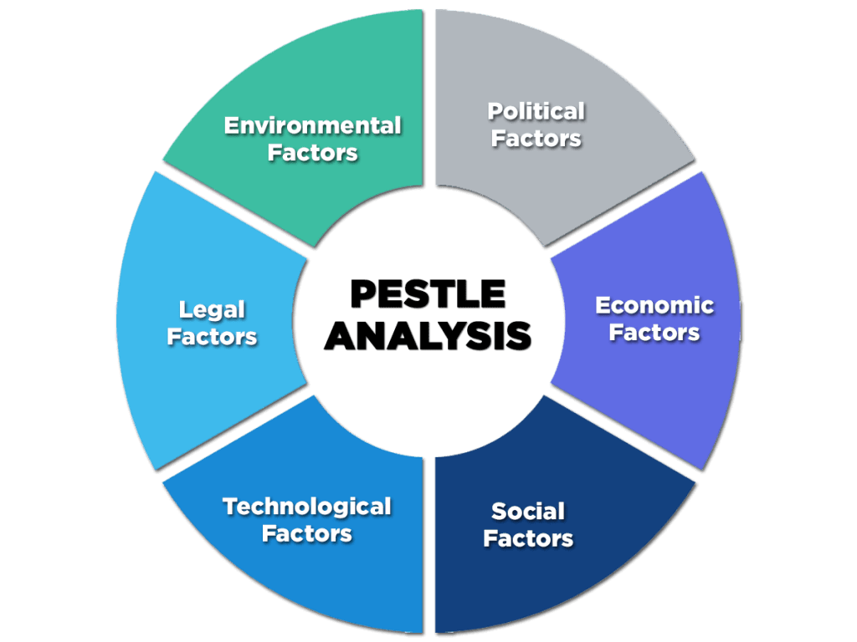
Figure 1: PESTLE Analysis
(Source: Nusantari, 2022)

Political Factor
Rolls-Royce, the British Car company, works throughout the globe. Political impact of the United Kingdom on this brand is huge. After Brexit, business with European countries has been reduced (Oxford Analytica, 2022). Along with this Brexit factor, this company also has faced some severe issues regarding the increased cost, lower sales, and reduced ease of operation during the Covid-19. But it has its business area extended to the army and aircraft production which helps this organization to influence various political situations to turn them into its favor (Jain, 2022). So, it can be said that the political factors can be favorable for the organization to spread the brand like a king.

Economical Factor
As this brand operates worldwide, the economic stability of the area of working is important to its growth. During the pandemic, the UK Economy faced a 35% hit to GDP in the second quarter of 2020 during the pandemic (statista, 2022). The UK Economy shrank the most in three centuries in 2020 which had a huge impact on the selling of the Rolls-Royce cars (Chikwem et al., 2022). It has affected the business of Rolls-Royce as the demand for cars has been reduced by the people. Due to the pandemic, all the productions were stopped which cost more to resume production. In 2021, Rolls-Royce made a revenue of 15.14 billion dollars which was lower than that of 2020, 16.11 billion dollars (statista, 2021). Apart from these, the duopoly of Airbus and Boeing made it difficult for the company to attract the large market of commercial aircrafts. But the buyers of Rolls-Royce are usually rich for which it can be expected that this situation will be overcome sooner or later.

Social Factor
Rolls-Royce is a premium car brand. To have one car from this brand creates a great impact on society. Practically it is a status symbol. But the pandemic has changed many things. People are more concerned about their safety from the corona virus rather than spending a lot of money on buying a luxury car (Cohen and Flood, 2022). Keeping this in mind, the company has brought family cars at a sustainable price. It helped the organization a lot which can be understood by the record booking of Rolls-Royce cars in 2021 with the highest annual sale in 117 years (theguardian, 2022). China and America became the two biggest markets, and the phantom model became the best seller.

Technological Factor
In this ever-advancing technological era, a company like Rolls-Royce is trying hard to come up with the pace. In the 2010-2017 period, this brand has registered 1994 patents in the USA (statista, 2021). This organization has already been interested in producing electric cars with the latest design to cope up with the advancement. It has the great opportunity to go fully electric or to produce hybrid vehicles. They have already introduced Spectre, the first-ever electric car by Rolls-Royce which is going to be handed over to the customers for the first time in the fourth quarter of 2023 (rolls-roycemotorcars, 2022). The pandemic era, although, disrupted its production and research, still unlike other companies, this brand has been successful to maintain their prophecy and make their customers proud.

Legal Factor
To run business across different nations, a company must abide by different laws. But during the pandemic, this became more difficult as different nations put restrictions on business for different time periods. Rolls-Royce faced restrictions on continuing their production, business and using laborers to work for them (Nayak et al., 2022). It created a huge gap in the way of success. They even had to let go of 9000 employees to cut the cost. This wound is going to take a while to be healed and, in the post, pandemic era also, the organization is dealing with this issue.

Environmental Factor
To compete with other popular brands, this company has decided to go for more sustainable car production. After the pandemic, they focused more on manufacturing family cars rather than public transport so that they can provide their customers a safer environment of travel (Weber, 2022). They have focused on using renewable sources in production and in their products. It also uses the most sustainable supply chain. It has taken the required steps to deliver more eco-friendly products like e-cars also.

Porter’s 5 Forces Model
It is the analysis model of the company’s competitive position which helps to understand the factors affecting its business sector. It helps to understand the existing and upcoming competitors of the organization as well as other threats a company is going to face. It also helps to find out the strengths and opportunities of the company which helps to strategize the procedure. But it only concentrates on the suppliers, consumers, and new entrants in the market. It does not consider natural; disasters or other business risk factors except the competitors (de Oliveira Junior, 2022).
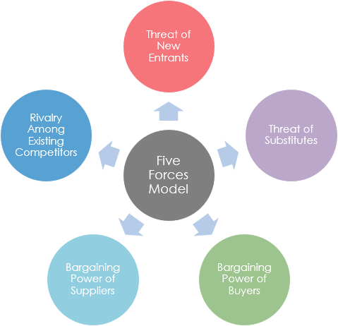

Figure 2: Porter’s 5 Forces Model
(Source: de Oliveira Junior, 2022)

Threat of new entrants
Rolls-Royce is an old and reliable luxury car brand whose parent corporation is BMW. Its total fixed asset in 2021 is 28,775 million euros and the production cost is similarly high (Forbes, 2022). A new entrant will have to build the industry knowledge, qualified human resources, high brand popularity and reliability, high marketing cost and high capital where Rolls-Royce is ahead too much. To bear this high cost after the pandemic is tough for new brands. As already Rolls-Royce has a high production capacity it will give a cost advantage to this company. So, this threat is lower in the case of Rolls-Royce.

The threat of substitutes
This can come based on switching cost, affordability, and accessibility. After the covid pandemic, Rolls-Royce has offered cars at a very affordable price with advanced technology (Martin, 2022). So, affordability is not a major issue regarding this threat. Switching costs are high and in that aspect, Rolls-Royce provides another level of value proposition compared to others which is the main reason behind choosing Rolls-Royce over other brands by the customers. So, the threats of substitutes can also be considered as lower.

Power of customers
Although this company offers luxury and sustainable cars, there are some popular car brands like Mercedes, Audi, Porsche, and Bentley which give tough competition related to price (Mao, Wang and Li, 2022) These brands sometimes offer more options than Rolls-Royce which may go against this very organization. Also, due to this competition, it cannot lower its price too much for the customers which may result in the inclination of the customers to another brand. So, it may be a moderate threat to the organization.

Power of suppliers
Rolls-royce does not depend solely on one supplier. For the luxury car production, it has contracts with different suppliers like Brabo, Thyssenkrupp etc so that in any adverse situation it does not have to face any consequences from the end of suppliers (rolls-royce, 2023). But they put only one supplier for one project so that the integration and length of the contract do not become an issue of threat. So, this threat is also lower.

Competitive rivalry

There are players like Mercedes, Audi or Porsche which offer a similar value proposition as Rolls-Royce. If the new entrant must be considered, Tesla would be the first name (Forbes, 2021). Like Rolls-Royce, these brands also put the effort in R&D and sustainable production which attract customers. All the brands provide a similar safety experience and promotion to the consumers. From that perspective, this threat must be considered high and to be handled tactfully.

SWOT Analysis
It is a method to evaluate the strategies that a company uses to assess their performance and the chance to succeed in the competition. It stands for strength, weakness, opportunity, and threat. By evaluating all these factors, the authority predicts the chance to remain in the competition. It helps to realize the weaknesses as well as strengths to make the organization prepared to deal with difficulties. It also helps to make a better plan to succeed. It also allows to take the opportunities and control the threats. But sometimes it oversimplifies the analysis process and it does not talk about implementation of the plans that are taken by SWOT analysis. 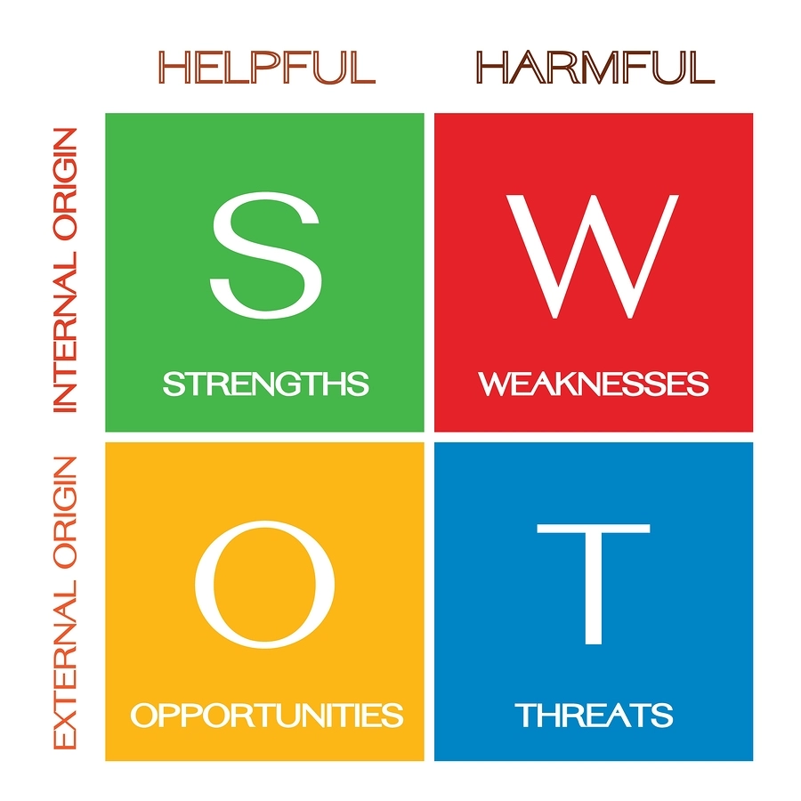

Figure 3: SWOT Analysis
(Source: self-created)

Strengths
It is a leading brand, reliable for a long time. It does not focus only on the interiors. It focuses on the safety, engine, and environmental crisis due to its product. As per Treichel (2022), the most elegant models from Rolls-Royce are Phantom and Ghost which are quite popular to the customers. One of the elite brands in the world along with 150 countries’ customer base and the technical support are the key strengths which has kept it one of the most selling brands even after the pandemic.

Weaknesses
The main weakness of it is its similar looks (Barik and Behera, 2023). It is because the models are evolutionary. They do not focus on the exterior that much. Rather they focus on the safety part which is good. But they must consider the customers’ demand for new looks too. The lesser availability of different loos increases the tendency of the customers to other competitive brands.

Opportunities
There are still some opportunities which they can grab to improve. After the pandemic, the demand for family cars has increased rapidly. It can focus on this part rather than public transport. It has aircrafts business which can be useful during the war between Ukraine and Russia. Nowadays, people want to have luxury without harming the environment along with having a safer environment in the car (Johnston et al., 2022) So, they must move towards electric cars which they have by introducing Spectre. They should try to offer both budget friendly and premium cars so that all levels of customers can buy the cars.

Threats
The biggest threat to Rolls-Royce in this post-pandemic era is the economic condition of the world (Yan et al., 2022) After Covid, there have been several issues in the world like complete lockdown which has increased the price of everything. This inflation restricts people from buying luxury cars rather than spending money on essentials. The world economy has seen the worst scenario during this pandemic. It must wait to get back to its pre-pandemic situation for a while still.

STP

STP is a marketing approach in which an organization focuses on the target customers and how it should target them. It stands for segmentation, target, and positioning. It helps to improve the communication as it becomes more focused and relevant by using this approach. It helps to spot gaps in the market, avoid wastage of money. But it suggests developing different marketing campaigns for each segment the organization wants to touch which creates more chaos.

Segmentation
It is all about finding potential customers along with insisting the former customers to buy from Rolls-Royce. It depends on their needs and demands. This brand breaks the market into smaller parts to identify potential buyers. Demographics help to choose based on gender, age, income, education, occupation etc (McKercher et al., 2022) Psychographics help to determine the reason behind buying these cars. It is based on personality and emotional characteristics. Apart from these, the lifestyle of the customers also has a great impact on their tendency to buy Rolls-Royce cars.

Targeting
To justify the segmentation, the market size must be big enough. Targeting the customers base should be through web-based mediums like social media also so that the premium as well as the common customers of Rolls-Royce can easily access this brand (Infante and Mardikaningsih, 2022). In each segment, potential customers must receive the marketing message without any failure. The marketing team of Rolls-Royce must ensure this. Easy access to mobile phones, overnight delivery and all these aspects of easy accessibility have been improved rapidly. So, it is easier for Rolls-Royce to connect with the customers.

Positioning
It is an aspect of branding. It is important to have an insightful positioning ability to promote your own brand. Rolls-Royce follows three types of positioning (Sigala, 2022). Functional positioning is about the features and user experiences that focus on the value proposition to fulfill customers’ needs. Symbolic positioning is about the brand's core component in maintaining the luxury and pride of the brand to enhance customers’ self-esteem. Experiential positioning focuses on the elements of the brand which takes care of the emotional connection with the customers. Overall positioning is an emphasis on the company’s uniqueness to create a great impact on the customers.

4ps model
This is a marketing strategy which is used to analyze the business processes and elements which are essential to run a successful business. It is very conceptual and can give a full insight of the overall business strategy. It provides many competitive strategies to be at the focus of the competitive market. To explore the opportunities, risks, perception of safety and envisioning the future the 4 elements are important. But it is limited to the mindset of the groups who oversee this evaluation. Also, it takes a great time to analyze based on 4ps which needs experienced personnel.
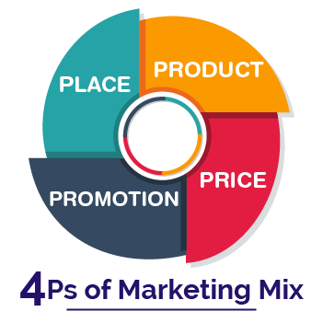
Figure 4: 4P’s of Marketing
(Source: Asdi et al. 2020)

Product

Rolls-Royce is a subsidiary of BMW. It is a globally recognized brand. It has researched a lot to provide excellence to its customers. Phantom, Ghost, Dawn etc are its prominent models. In the words of Yu, (2022), its uniqueness consists of a long front bonnet, metallic finish exteriors, customized interiors, and a retro feeling. Rolls-Royce can be considered as the ultimate criteria of luxury in the automobile industry. These features are unique to Rolls-Royce, and no one can touch the limit here.

Price
Rolls-Royce customizes the interiors and exterior as per the demand of the customers. Normally, the car prices start from 200000 dollars, and it increases with the customizations, additional add ones and interiors (Mutha, Bansal and Guide, 2022). It is quite evident that this brand puts a higher price for the cars as they offer so many benefits to the customers. The costliest Rolls-Royce car was Hyperion Pininfarina which sold at 6 million dollars per car.

Place
Although Rolls-Royce is headquartered in England, it has offices in 50 countries across the globe. People from a total of 150 countries like the USA, UK, India, Middle East, Australia, China are customers of this brand (Smirnov, 2022). This brand has a stronger distribution circle as it has a limited client base across the world. It also provides spare parts and servicing to its cars after selling and this can be accessed being at home.

Promotion
Rolls-Royce follows a unique way for promotion. As it is a very large and aristocratic brand, it does not really need too much promotion. They directly do not use TV advertisements to promote their brands. Words of mouth, usage by various rich and successful people are the most valuable ways for promotion in this case (Villers, 2022). But they also follow regular PR coverage through newspaper articles, advertising the cars by showing it in the popular TV shows where the main leads use the cars as a status symbol etc and the authority does not ignore the social media platforms too.

Conclusion
The Covid-19 pandemic has affected Rolls-Royce to a great extent as the production, logistics everything got held up due to government restrictions. It also faced difficulties during the post-pandemic era to resume its business outside the United Kingdom as there were still some restrictions in some different nations. From that position, where due to the pandemic, it must incur a loss of huge amount of money, today Rolls-Royce is trying to move forward with its strong marketing and production team. After focusing on different analysis, it can be concluded that there is a threat of competitors like Mercedes and Audi which Rolls-Royce has to fight strongly and it has to focus more on the customers’ demands to make them inclined onto only Rolls-Royce.

Recommendation
To compete with Mercedes and Audi like competitors, Rolls-Royce must produce cars with different looks so that customers feel more attracted to the cars. They also must focus on using renewable energy sources instead of using fuel cars. “Specter” is still waiting to be handed over to the customers in 2023. During the meantime, this company should research and develop strategies to manufacture more electric cars which cause no harm to the environment. If they can deal with these factors, it will be just a matter of time to acquire the top position like in the pre-pandemic era.

References:
Asdi, A. and Putra, A.H.P.K., 2020. The Effect of Marketing Mix (4P) on Buying Decision: Empirical Study on Brand of Samsung Smartphone Product. Point Of View Research Management, 1(4), pp.121-130.
Barik, L. and Behera, A., 2023. Smart 3D Nano-Printing in Automobile Industry. In Smart 3D Nanoprinting (pp. 43-72). CRC Press.
Bbc. (2023), Critical thinking and problem solving, available at. https://www.bbc.co.uk/bitesize/guides/zcjhfcw/revision/2 (Accessed on 4th January 2023)
Chikwem, J.O., Chikwem, U.J. and Chikwem, S.D., Impact of COVID-19 pandemic on the economy.
Cohen, D. and Flood, C., 2022. Health economics. In Health Studies (pp. 269-294). Palgrave Macmillan, Singapore.
de Oliveira Junior, N.J., 2022. Modelo das 5 forças de porter adaptadas ao gestão pública: Porter's 5 forces model adapted to public management. STUDIES IN SOCIAL SCIENCES REVIEW, 3(1), pp.120-132.
Forbes (2021), BMW Should Spin Off Rolls-Royce To Take On Tesla, available at. https://www.forbes.com/sites/jimosman/2020/06/04/bmw-spin-off-rolls-royce-tesla/?sh=4339ef497354 (Accessed on 4th January 2023)
Forbes (2022), BMW Group, available at. https://www.forbes.com/companies/bmw-group/?sh=6350ccb33e9c (Accessed on 4th January 2023)
Forbes. (2020), The Coronavirus Holds Down Auto Sales, But It’s Still A Seller’s Market, available at. https://www.forbes.com/sites/jimhenry/2020/12/21/the-coronavirus-holds-down-auto-sales-but-its-still-a-sellers-market/?sh=502a175d3ffe (Accessed on 4th January 2023)
Hakimovna, U.M. and Muhammedrisaevna, T.M.S., 2022. Audit and Marketing Audit in Small Business and Private Entrepreneurship: The Order and Process of Inspection. Journal of Ethics and Diversity in International Communication, 2(3), pp.84-88.
Hollensen, S., Kotler, P. and Opresnik, M.O., 2022. Metaverse–the new marketing universe. Journal of Business Strategy.
Infante, A. and Mardikaningsih, R., 2022. The Potential of social media as a Means of Online Business Promotion. Journal of Social Science Studies (JOS3), 2(2), pp.45-49.
Jain, K., 2022. Aerospace and Defense the Financial Impact of Covid-19 on the Rolls-Royce Supply Chain. The Journal of Purdue Undergraduate Research, 12(1), p.32.
Jain, S., Sharma, T. and Gupta, A.K., 2022. End-of-life management of solar PV waste in India: Situation analysis and proposed policy framework. Renewable and Sustainable Energy Reviews, 153, p.111774.
Johnston, C., Hughes, H., Lingard, S., Hailey, S. and Healy, B., 2022. Immunity and infectivity in covid-19. bmj, 378.
King, K., 2022. AI Strategy for Sales and Marketing: Connecting Marketing, Sales and Customer Experience. Kogan Page Publishers.
Kingsnorth, S., 2022. Digital marketing strategy: an integrated approach to online marketing. Kogan Page Publishers.
Mao, Q., Wang, R. and Li, Z., 2022. Research on the Influence of New Energy Vehicles Industry Eco-Business Model on Brand Competitiveness. In IEIS 2021 (pp. 24-36). Springer, Singapore.
Martin, D.P., 2022. How ASA Provides Rolls-Royce Education at Chevy Prices. ASA Monitor, 86(7), pp.17-17.
McKercher, B., Tolkach, D., Eka Mahadewi, N.M. and Byomantara, D.G.N., 2022. Choosing the optimal segmentation technique to understand tourist behaviour. Journal of Vacation Marketing, p.13567667221078240.
Mutha, A., Bansal, S., and Guide, V.D.R., 2022. What servicizing demands of a company: The need for inter‐functional coordination. Journal of Operations Management.
Nayak, J., Mishra, M., Naik, B., Swapnarekha, H., Cengiz, K. and Shanmuganathan, V., 2022. An impact study of COVID‐19 on six different industries: Automobile, energy and power, agriculture, education, travel and tourism and consumer electronics. Expert systems, 39(3), p.e12677.
ncbi (2021), An impact study of COVID‐19 on six different industries: Automobile, energy and power, agriculture, education, travel and tourism and consumer electronics, available at. https://www.ncbi.nlm.nih.gov/pmc/articles/PMC8014102/ (Accessed on 4th January 2023)
Nusantari, N.K., PESTEL Analysis of Waste-to-Energy at TPPAS Regional Nambo. The International Journal of Business Review (The Jobs Review), 4(1), pp.79-84.
Oxford Analytica, 2022. The impact of Brexit on UK-EU trade is growing. Emerald Expert Briefings, (oxan-db).
Rauschnabel, P.A., Babin, B.J., tom Dieck, M.C., Krey, N. and Jung, T., 2022. What is augmented reality marketing? Its definition, complexity, and future. Journal of Business Research, 142, pp.1140-1150.
Ren, W., Liu, B., Liang, L., Li, X. and Li, H., 2022. The Effectiveness Between Influencer Marketing and Traditional Advertising in the Cosmetics & Skin Care Industry. In International Conference on Business and Policy Studies (pp. 610-617). Springer, Singapore.
rolls-royce (2023), Our suppliers and partners, available at. https://www.rolls-royce.com/sustainability/customers-and-suppliers.aspx#section-industry-partnerships (Accessed on 4th January 2023)
rolls-roycemotorcars (2022), ROLLS-ROYCE SPECTRE UNVEILED: THE MARQUE’S FIRST FULLY ELECTRIC MOTOR CAR, available at. https://www.press.rolls-roycemotorcars.com/rolls-royce-motor-cars-pressclub/article/detail/T0404820EN/rolls-royce-spectre-unveiled:-the-marque%E2%80%99s-first-fully-electric-motor-car?language=en (Accessed on 4th January 2023)
Sigala, M., 2022. Designing servicescape and experience with art: Learnings from the d’Arenberg Cube, Australia. In Case based research in tourism, travel, hospitality, and events (pp. 13-36). Springer, Singapore.
Smirnov, S.V., DIGITAL DOUBLES IN INDUSTRY ABROAD. ТЕНДЕНЦИИ РАЗВИТИЯ НАУКИ И ОБРАЗОВАНИЯ Учредители: ИП Иванов Владислав Вячеславович, pp.136-138.
statista (2021), Number of patents in the USA granted to Rolls-Royce from 2010 to 2017, available at. https://www.statista.com/statistics/633095/rolls-royce-patents-usa-registered/ (Accessed on 4th January 2023)
statista(2022), Annual growth of gross domestic product in the United Kingdom from 1949 to 2022, available at. https://www.statista.com/statistics/281734/gdp-growth-in-the-united-kingdom-uk/ (Accessed on 4th January 2023)
statita(2021), Rolls-Royce Holdings plc's underlying revenue from FY 2010 to FY 2021, avai;able at. https://www.statista.com/statistics/413204/underlying-revenue-of-rolls-royce/#:~:text=In%20the%202021%20fiscal%20year,some%2010.9%20billion%20British%20pounds (Accessed on 4th January 2023).
theguardian(2020), Rolls-Royce reports record £5.4bn loss as Covid-19 hits aviation, available at. https://www.theguardian.com/business/2020/aug/27/rolls-royce-reports-record-loss-as-covid-19-hits-aviation (Accessed on 4th January 2023)
theguardian(2022), Rolls-Royce: Covid has spurred record sales of our cars, available at. https://www.theguardian.com/business/2022/jan/10/rolls-royce-covid-has-spurred-record-sales-of-our-cars (Accessed on 4th january, 2023)
Treichel, A., 2022. Model Archive for BMW models· Rolls-Royce Spectre unveiled· Tuesday, 18th October 2022· bmwarchive. Org.
ugli Togaev, U.S. and Zubaydullaev, F.A., 2022. The Importance of Forming a Marketing and Financial Strategy in Banking. International Journal of Development and Public Policy, 2(5), pp.23-27.
Villers, S., 2022. Ad Prose or Fictomercial? Brand Placement in Literature. The Faces and Stakes of Brand Insertion, p.1.
Weber, J., 2022. Social Trends. In Moving Times (pp. 229-270). Springer, Wiesbaden.
Yan, Y., Zhong, S., Tian, J. and Jia, N., 2022. An empirical study on consumer automobile purchase intentions influenced by the COVID-19 outbreak. Journal of Transport Geography, 104, p.103458.
Yu, Z., 2022. Application of User Experience Gene Extraction Model Based on Industrial Design. Security and Communication Networks, 2022.

