
Cloud Computing
ASSESSMENT -1

April 4, 2022
Student Id:2114820
Andrian Gontea
Data Analysis and Visualisation
Rapport: Physical activities for adults and older adults
Lecturer:Koushik Modak
Table of Contents
Contents:
Introduction 1
Task 1 2
Information on the infographic 2
The following aspects of Visualisation Design: 3
1.Identifying the message from the poster. 4
2.Evaluate the way of colour were used. 4
3.Evaluate the way of Text were used. 4
4.Evaluate the graphs were used. 4
5.Evaluate the suitability of the graphics were used 5
6.Cogintion (can be easily used by viewer). 5
7.How to improve the infographic. 5
Conclusion: 5
References 6

Introduction

In this assessment we need to demonstrate our knowledge and skills accumulated for this module and answer for 2 tasks that have been given and make observations at the Infographic. The infographic is the main point after which we must to give some feedback about what is the message, evaluate the way of text were used, evaluate the of colour were used, evaluate the graphs were used, evaluate the suitability of graphs, cognition and how it can be improved.

Task 1
In this task that is given to us we must to give some feedback and explain how can it be improved if it is needed, explain the mean of information has been represented in the poster. Will this infographic poster help the viewer to understand information has been given and help to accumulate some knowledge to achieve them.

Information on the infographic
On this infographic shows us the physical activity for adults and older adults
how adults and older adults can maintain their body healthy by following some instruction and exercises included.
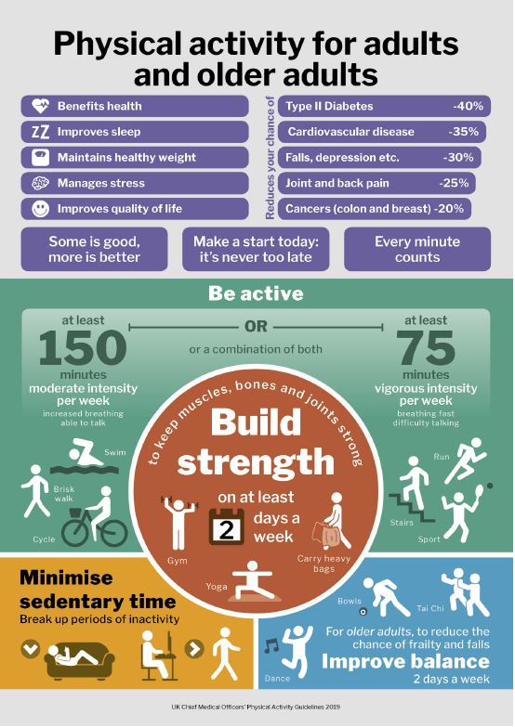

The following aspects of Visualisation Design:
- Identifying the message from the poster
- Evaluate the way of colour were used
- Evaluate the way of text were used
- Evaluate the Graphs were used
- Evaluate The suitability of Graphics
- Cognition (can be easily used by viewer)
- How to improve the infographic

1.Identifying the message from the poster.
The message from this Poster explain the physical activities for adults and older adults how to keep the body healthy followed by daily exercises and keep it in a good balance. The message has different parts and reveals to the viewer what to pay attention to and what is more important. This poster it used to communicate the mining of that. [1]

2.Evaluate the way of colour were used.
In this poster the colour is well determinate and light which do not allow the eyes to strain and read the text easily. In the middle of poster the colour of the word are not clearly visible and can be increased . [2]
The concepts of colour are expressed in language. It is the best way to explain to the viewer the mining.
As we can see the infographic poster has a combination of colours part of them are more pronounced and less that gives opportunities do not affect the general mining. [3]

3.Evaluate the way of Text were used.
The text from this Poster explain the physical activities for adults and older adults how to keep the body healthy followed by daily exercises and keep it in a good balance. In some areas the text is not clearly seen because of small size of words. In some areas is to much fonts in the future can be done less. The text is an idea of words that help the viewer to understand the mining of that. Looking at this infographic poster the text is separated on different ideas and every part of that has their meaning and it is well explained. [4]
The size of text it is good enough for the viewer to understand the meaning.
As the most natural form of storing information is text. Text is based on processing techniques, including text analysis, text categorization, information extraction, and summarization o that. [5]

4.Evaluate the graphs were used.
The graphs is the art of skills that combine the text and pictures in advisements. Creating the graphs we must include some elements such us line,colour,text,form and shape. As we can see on the picture all these elements are present and the poster is separated in different parts that has different information that make easier to understand for viewer. The point on this graphs is represented relationships between more things. In this poster has been used the Icons that explain the process to understand the subject from the title. That is a good thing because can engage the attention of the viewer.

5.Evaluate the suitability of the graphics were used
The graphics is well suitable for the viewer because every part of that gives information. All information represented in the infographic poster explain the information from the title. The design looks not bad but in some areas it can be improved. [6]

6.Cogintion (can be easily used by viewer).
In this infographic poster the cognition for the viewer it is going to be to much information to remember that it has to be done daily although the viewer can choose which of them is more important and start to improve that because every information from this poster has their function separate. The cognition give to the viewer possibility to acquiring knowledge and understanding what was released on the infographic poster. [7]

7.How to improve the infographic.
To improve the infographic we must to determine what we want the viewer to understand from infographic. The another thing all text should be clearly to read and understand as we can see from the poster that the text can be changed to understand better. We must avoid adding irrelevant or unnecessary visual information and if it is possible to add less information that will help the viewer to understand. The most important thing for improving an infographic is the message followed by text, colours and diagrams that attract attention. Another way to improve the infographic is to have an idea, some data and tools that we are going to add in our infographic to make it looks better and attractive. When the data is collected we can start to create our infographic poster and to visualise the idea we have implemented. Do not forget to use the suitable colours and not more that 3 and that will give to as a perfect design.

Conclusion:
In conclusion I can say that this Infographic poster helps us to understand and pay attention about information has been given to us. Every time when we try to create an infographic poster we must to understand at the beginning that we must create our ideas, collecting data and accumulate the suitable tools that will help us to achieve the goal and after that we can start to create and implement all elements such as text,colour,message,ghraphics to make it understandable and attract attention. This infographic poster is an example how to do it properly and to understand what can be changed in the future.

References

[1] | D. M. K. Meenakshi Gigi Durham, “Media and Cultural Studies: Keyworks,” 2001,2006.
[2] | C. Peacocke, “Colour concepts and colour experience,” Published: March 1984.
[3] | C. G. D. C. M. C. Edited by N. Harkness, “Colour and Design in the natural and man-made worlds,” June–September 2006.
[4] | E. K. B. S. &. K. Danielle S. McNamara, “Are Good Texts Always Better? Interactions of Text Coherence, Background Knowledge, and Levels of Understanding in Learning From Text,” 14 Dec 2009.
[5] | G. H. J Morris, “Lexical cohesion computed by thesaural relations as an indicator of the structure of text,” 1991.
[6] | R. I. &. R. Gentelman, “R: A Language for Data Analysis and Graphics,” Published online: 21 Feb 2012.
[7] | R. GoodwinD'Andrade, “The cultural part of cognition,” Volume 5, Issue 3, July–September 1981, Pages 179-195.

