Student Name: Claudio Wong
Programme of Study: Illustration
Word Count: 1474
Tutors Name: Scott Smith

Circle of Life Exhibition

My exhibition consists art works based on Disney classic films and characters from different contemporary artists who illustrate and create Disney themed art.
I wanted my exhibition to be in relation to a Disney theme as it’s where I began my journey as an artist. Watching all of the classic Disney films growing up, from The Lion King which is my all-time favourite animated movie, to The Little Mermaid, Beauty and the Beast, Tangled, Moana and many others.
So in this exhibition I intend to present artworks of Disney characters, films and scenes that have inspired me and have some sort of resemblance on my personality and life growing up, and potentially reflect to others.
One of the first of many inspirational artists that I’ve came across who works on the subject of Disney is Jirka Vinse Jonatan Väätäinen.
“Jirka Vinse Jonatan Väätäinen is a Graphic Designer, Illustrator and Photo Manipulation from Helsinki, Finland.
He graduated as a 1st Class BA (Hons) Graphic Designer in the University of Arts in Bournemouth between 2009-2012.” (JirkaVinse, 2014)
Jirka, is well known for illustrating Disney characters into real life Disney portraits - “Real Life Disney”. I’ve first discovered the art work of Jirka Vinse via Instagram when I’ve been looking for Disney themed art works for inspiration, and he has inspired me a lot.
Ariel from “The Little Mermaid”, was the very first Real Life Disney that I’ve discovered from Jirka, and it absolutely amazed me how one has been able to reimagine an animation character and turn it incredibly realistic.

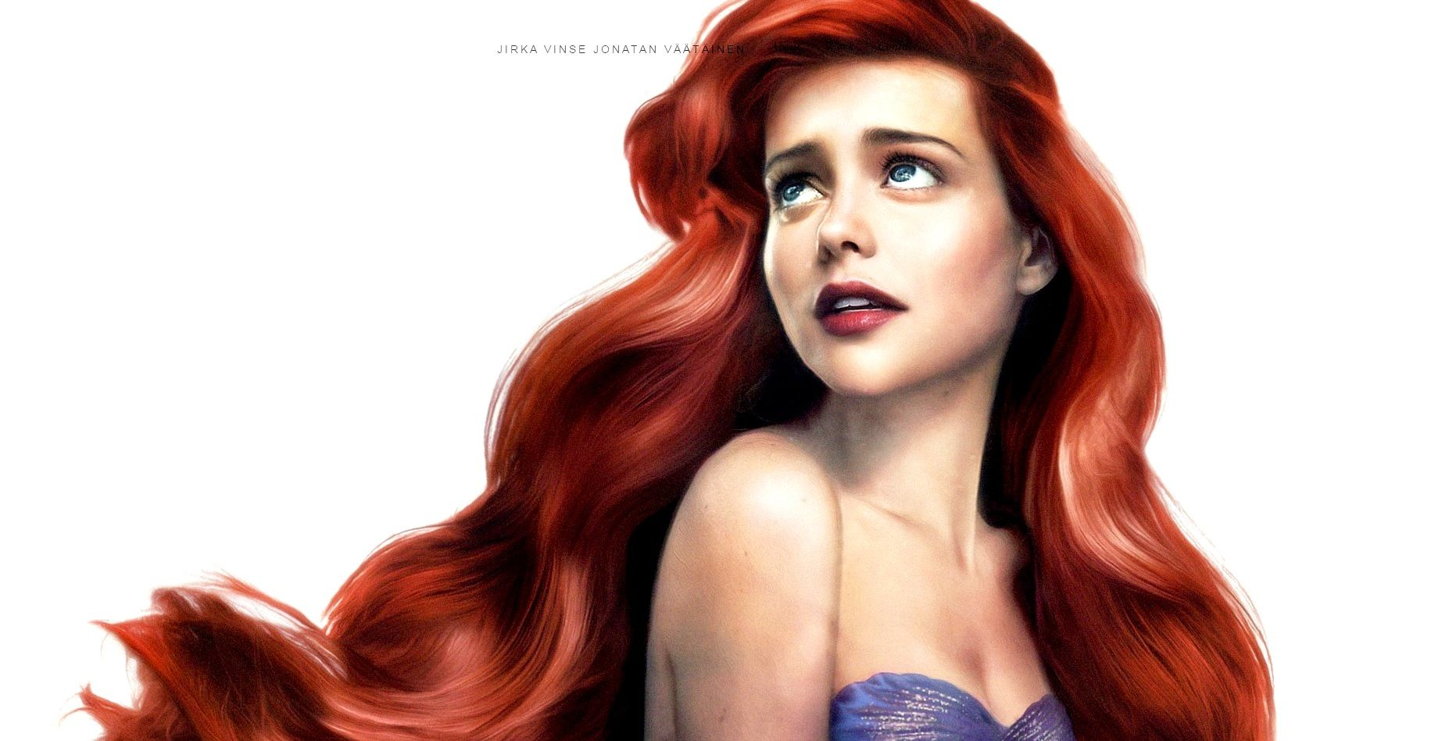
Figure 1. Real Life Disney “Ariel” – from “The Little Mermaid (VäätäineN, 2016)

Jirka’s Real Life Disney art illustration of Ariel from The Little Mermaid, would be the first I’d present in my exhibition space, as it’s the first piece of art I witnessed from Jirka Vinse. Despite it being visually appealing, I chose Ariel based on what we have in common. In the film, even though she has everything, Ariel dreams of exploring life out of the sea and part of the human world. When you observe the image, you can imagine that’s how Vinse wants to portray the character. Looking at her expression, composition and body language, it’s like telling the story in one illustrated picture.
Like me, Ariel is a very determined character, curious to find out about the world and be apart of it. Which is what I dream of, getting to know different cultures, people, and traditions amongst other things is something I always wanted to explore.

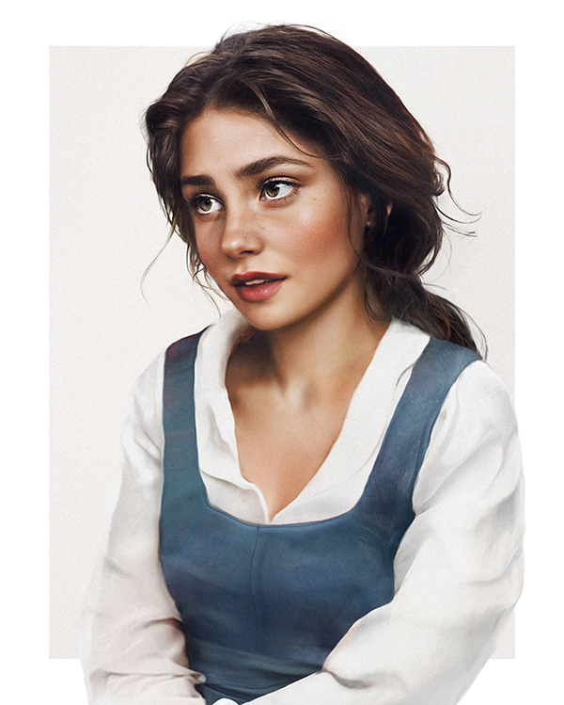

Figure 2. Real Life Disney “Belle” from “Beauty and the Beast” (Väätäinen, 2017)

Another incredibly realistic and beautiful portrait of a Disney animation character, Belle from Beauty and the Beast, again by Jirka Vinse.
Talking from a technical point of view, I just love everything about this portraiture. The composition and facial expression of the character, the tones and colours, and the detail of the eyes and hair is a perfect reimagining of the original animated character of Belle.
I like the character Belle a lot, in the live action movie and the animated movie, she’s very imaginative which as an inspired to be artists is one of the traits I hold and watching a film that has a talking candelabra, clock and teapot taught me to always be creative and imaginative. Also compassionate and brave, are two characteristics I share with Belle.
“If the Disney Villains existed in real life, ominous laughter would echo throughout the world, nefarious plans would go wrong left and right, and there’s a good chance eggs would be in short supply (looking at you, Gaston) Thank goodness the power of art allows us to experience this without well, experiencing it.
These drawings come to us from Finnish artist, Jirka Väätäinen. You may remember his past realistic renderings of the Disney princes and princesses, but we asked him to move onto a subject more … sinister, to celebrate the season.” – (Oh My Disney, 2016)

After gaining so much social media attention for his illustrative Real Life Disney Princesses and Prince and rightly so, Oh My Disney have requested Jirka Vinse to recreating more real life Disney characters.
So Jirka has challenged himself to a new way of Real Life Disney this time reimagining the villains of the classic Disney films. He digitally created many of the famous evil characters such as Maleficent from Sleeping Beauty, Ursula from The Little Mermaid, Cruela deVil from 101 Dalmation along with many more.

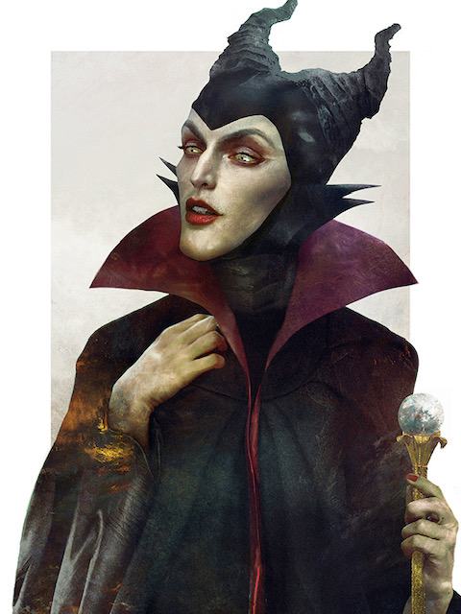

Figure 3. Real Life Disney Villain’s “Maleficent” from “Sleeping Beauty” (Väätäinen, (2015)

Of all the Disney villain’s Vinse has recreated, Maleficent in particular, who is known as the “Mistress of All Evil” has interested me the most based on her evil, grotesque aspect. Apart from the fact that she’s my most favourite villains in Disney, she’s visually the most appealing of all the villains in terms of capturing the evil essence of the original animated character in Sleeping Beauty.

Bibliography

Väätäinen. J.V.J (2014) JIRKA VINSE JONATAN VÄÄTÄINEN. Available at: https://jirkavinse.com/ (Accessed: 7th April 2019).

Berman. R (2015), 6 Pieces of Eeirily Realistic Disney Villains Artwork. Available at: https://ohmy.disney.com/movies/2015/10/27/6-pieces-of-eerily-realistic-disney-villains-artwork/ (Accessed: 7th April 2019)

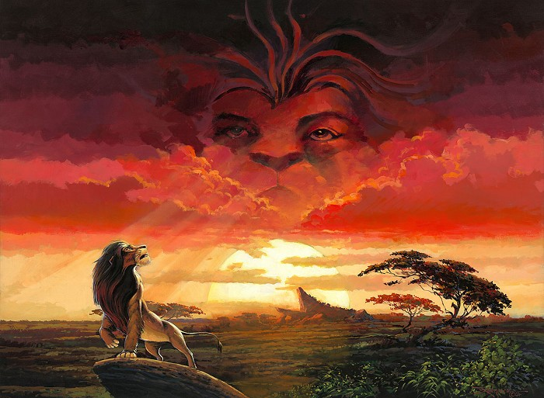

Figure 4. “Remember Who You Are - The Lion King” - (Gonzalez, 2013)
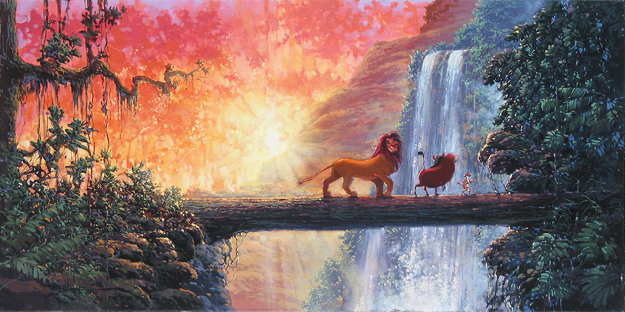

Figure 5. “Hakuna Matata - The Lion King” - (Gonzalez, 2013)

Rodel Gonzalez is a contemporary artists I’ve discovered on the internet. He is known for his hand-embellished giclee on canvas work of many Disney classic films.
“Giclée, is derived from the French verb gicler meaning “to squirt or spray”, Giclee is used to describe fine art digital printing process combining pigment based inks with high quality archival quality paper to achieve giclée prints of superior archival quality, light fastness and stability.” (Metro Print, 2019)

“Disney Fine Art limited edition paintings are carefully handmade. The hand textured process will vary depending on the artists art style each piece is reproduce the look and feel of the artist's original creation. The giclee print is created after an extensive process of colour correction and press calibration to ensure an accurate replica of the original. Originals come in all mediums; limited editions are an art collector's dream, delivering the appearance of hand painted textures, incredible resolution piece of artwork and affordable.” – (Disney Art on Main, 2019)

The two in particular that i’ve picked out and have inspired me are “Remember Who You Are” and “Hakuna Matata” which are both related to my most favourite Disney Classic - ‘The Lion King’.
They’re both the first piece of art works of his that I came across and loved. The 1994 Disney classic is a big part of my life growing up, m teaching me the value and importance of the people in life. Most importantly taught me “Hakuna Matata” it means “No Worries”.

In an interview for Enchanted Paintings, Gonzalez has been asked what was his favourite Disney movie, to which he replied “I believe we all have Disney in us, one movie stands out and I can relate too would be “The Lion King” probably because of that relationship with the dad and Simba.”, - (Enchanted Painting, 2013)

Like Gonzalez, I too had a special relationship with my father who inspired me to work hard to get where I want to, and do what I love and enjoy most. So having these two incredible piece of art work in my exhibition would be huge for me.

Bibliography

Metro Print (2019), Fine Art Giclée Prints. Available at: https://www.metro-print.co.uk/professional-c-type-photo-printing/fine-art-giclee-prints/ (Accessed: 12th April 2019)

Disney Art On Main (2019), Disney Artists - Rodel Gonzalez. Available at: https://www.disneyartonmain.com/rodel-gonzalez/ (Accessed at: 13th April 2019)

Disney Fine Art (2O15), Rodel Gonzalez. Available at: https://www.disneyfineart.com/artists.php?aID=534rodel&p=4/ (Accessed at: 13th April 2019)

Enchanted Paintings (2013), Rodel Gonzalez Interview - Artist for Disney Fine Art - by EnchantedPaintings.com [Video]. Available at: https://www.youtube.com/watch?v=vU2xJWWqpEI/ (Accessed at: 14th April 2019)

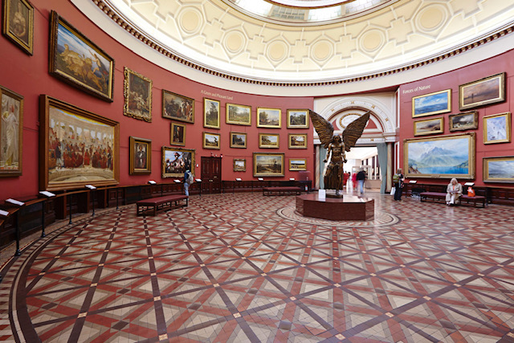
A location for the exhibition is very important from a personal point of view, as I’d like to share with my viewers what these characters and movies mean to me and how they helped me grow as a person and so that maybe see that every Disney lovers can relate to the characters. As well as show them the magnificent art works from the two artists I’ve mentioned. I believe any location would’ve been suitable for an exhibition of this theme, but personally I’d want my exhibition placed in my hometown in Swansea City centre.

Figure 6. “Round Room” - Birmingham Museum & Art Gallery (What’s On, 2018)

The space of my exhibition was inspired by the Round Room in Birmingham Museum & Art Gallery, where I visited a few years ago. I thought about The Round Room as it’s a unique space in terms of its form, I can’t think of many galleries i’ve visited where it had a round dome room.
“A beautiful circular exhibition room at Birmingham Museum and Art Gallery. A Grade II listed building, the Birmingham Museum and Art Gallery opened its doors in 1885. There are over forty galleries to explore all displaying various eras of art, as well as permanent galleries there is a diverse exhibition programme on offer too.” - (Birmingham What’s On, 2018)
I also thought about The Lion King’s opening song “The Circle of Life” as a name replacement for the “Round Room”, it fits the criteria of the Disney theme, it comes from my favourite Disney film, and I believe every space should have its own name.
I wanted to make some metaphorical changes to The Circle of Life Room, one of which is to split it into two room, one dark room that will present the work of Jirka Vinse Jonatan Väätäinen’s Real Life Disney illustration characters through an old fashion film projector towards a big curved projection screen.
The other room, will display the two art works of Rodel Gonzalez’s Lion King themed giclée prints that will be framed and placed against a round, bright yellow wall.

Bibliography

Väätäinen. J.V.J (2014) JIRKA VINSE JONATAN VÄÄTÄINEN. Available at: https://jirkavinse.com/ (Accessed: 7th April 2019).

Berman. R (2015), 6 Pieces of Eeirily Realistic Disney Villains Artwork. Available at: https://ohmy.disney.com/movies/2015/10/27/6-pieces-of-eerily-realistic-disney-villains-artwork/ (Accessed: 7th April 2019)

Metro Print (2019), Fine Art Giclée Prints. Available at: https://www.metro-print.co.uk/professional-c-type-photo-printing/fine-art-giclee-prints/ (Accessed: 12th April 2019)

Disney Art On Main (2019), Disney Artists - Rodel Gonzalez. Available at: https://www.disneyartonmain.com/rodel-gonzalez/ (Accessed at: 13th April 2019)

Disney Fine Art (2O15), Rodel Gonzalez. Available at: https://www.disneyfineart.com/artists.php?aID=534rodel&p=4/ (Accessed at: 13th April 2019)

Enchanted Paintings (2013), Rodel Gonzalez Interview - Artist for Disney Fine Art - by EnchantedPaintings.com [Video]. Available at: https://www.youtube.com/watch?v=vU2xJWWqpEI/ (Accessed at: 14th April 2019)

Birmingham What’s On (2018), Round Room, Birmingham Museum & Art. Available at: https://www.whatsonlive.co.uk/birmingham/venue/round-room-birmingham-museum-and-art-gallery/ (Accessed at: 16th April 2019)

