12/15/2024
Assessment
Portfolio Report on Contemporary Software Applications for Business


Student Name: KALED MENSUR
Student ID: 2514975

Module NaMe: Software solutions for business
Module Code: ACCA 4026
Lecturer: Amitave Banik
Trinity saint david University of Wales (London Campus)

Table of Contents
Introduction 2
Main Body 2
Task 1 2
e-Commerce Website builders/software solutions 2
Task 2 2
Mind-map of Contemporary Software Applications 2
Task 3 3
Office Applications for Creating, Storing, Presenting, and Analysing Data 3
a. 3
b. 3
Task 4 3
a. One contemporary Communication and one Online Collaboration applications/tools 2
MS Outlook 2
MS Teams 2
b. One feature of a freely available Communication (1) and one feature of a Collaboration (1) application 2
MS Outlook 2
Ms Teams 2
Conclusion 2
References 3

Introduction
The quick growth of online sales has made e-commerce website builders and software solutions essential for businesses of all sizes. These platforms provide the necessary infrastructure, integrations, and tools to create, manage, and scale online stores efficiently.
Among the modern solutions available, BigCommerce and Squarespace have come up as popular choices due to their features, manageability, and user-friendliness.

Main Body

e-Commerce Website builders/software solutions

1. BigCommerce
BigCommerce is a cloud-based e-commerce platform that helps businesses of all sizes develop and manage online storefronts. It has a variety of capabilities, including customizable themes, multi-channel selling, and connection with prominent payment methods like PayPal, Stripe, and Apple Pay. BigCommerce's inventory management, analytics, and reporting solutions enable businesses to effectively track sales trends and enhance marketing campaigns [1].

One of BigCommerce’s main strengths is its manageability. With enterprise-grade features like extensive SEO capabilities, API connectors, and customisable checkout experiences, the platform supports both small startups and large organizations. PCI compliance and SSL encryption are commonplace, and security is a top priority.
Besides, BigCommerce authorizes integration with marketplaces such as Amazon, and eBay permits businesses to expand their sales channels and reach a global audience.

2. Squarespace
It is known for eye-catching layouts and all-in-one platform with e-commerce features, Squarespace is a flexible website builder. It is appropriate for small to medium-sized enterprises that value aesthetics and user experience because it blends online store administration with flexible website design. Squarespace offers secure payment processing, product catalogue management, drag-and-drop customization, and shipping integrations.

Squarespace provides integrated marketing features like email campaigns, SEO enhancements, and social media connections, assisting businesses in drawing in and keeping customers. Its AI-driven design assistant and template-based system enable users to effortlessly create professional websites without any coding skills[2].

Squarespace regularly enhances its platform with features such as mobile-first design, subscription products, and in-depth analytics, ensuring that businesses remain competitive in the changing digital landscape.
BigCommerce and Squarespace showcase the flexibility of modern e-commerce platforms. BigCommerce is perfect for companies wanting manageability, multi-channel sales, and advanced functionality, whereas Squarespace provides versatile design and easy-to-use tools for small to medium businesses. Both platforms allow companies to create secure, effective, and attractive online storefronts, assisting them in succeeding in the current competitive digital market.

Task 2: Mind Mapping of Contemporary Software Application

Contemporary​‍​‌‍​‍‌​‍​‌‍​‍‌ companies utilise various software programs to facilitate their daily routines, increase their efficiency, and make better decisions. Mind mapping is a powerful graphical method which helps to clarify such complicated information by displaying the connections between the concepts. This task includes a short description of mind mapping and its advantages in business processes, and then, it presents a summary of a mind map of modern software applications in daily organisational use.

Mind Mapping and Its Benefits in Business Operations:
Mind​‍​‌‍​‍‌​‍​‌‍​‍‌ mapping is a visual tool for organising ideas or information around one central theme or concept through the use of branches and words. Heilman states that this method imitates the brain’s way of making associations while enhancing the understanding of the material and creativity [1]. Mind mapping is used in organisations as a brainstorming, planning and problem-solving tool.
Business tasks and projects can be visually broken down into smaller components, making the concept clearer and easier to manage. Thus, time and resources are managed more effectively without confusion[2].The use of mind mapping comes with a positive impact on communication and collaboration since visuals are much easier to grasp than long texts. The team members can create mind maps to share their ideas and align their goals in face-to-face meetings.
Moreover, mind mapping helps the decision-making process whereby managers can visually compare different choices, predictions, and consequences. This comprehensive outline lessens the load on one’s memory and gives a way for quicker and more informed decisions to be taken. To sum up, mind mapping is a straightforward but very effective tool that elevates the level of clarity, makes more efficient use of time, and promotes teamwork in the day-to-day business ​‍​‌‍​‍‌​‍​‌‍​‍‌operations.
b) Mind Map of Contemporary Software Applications Used in Business Operations
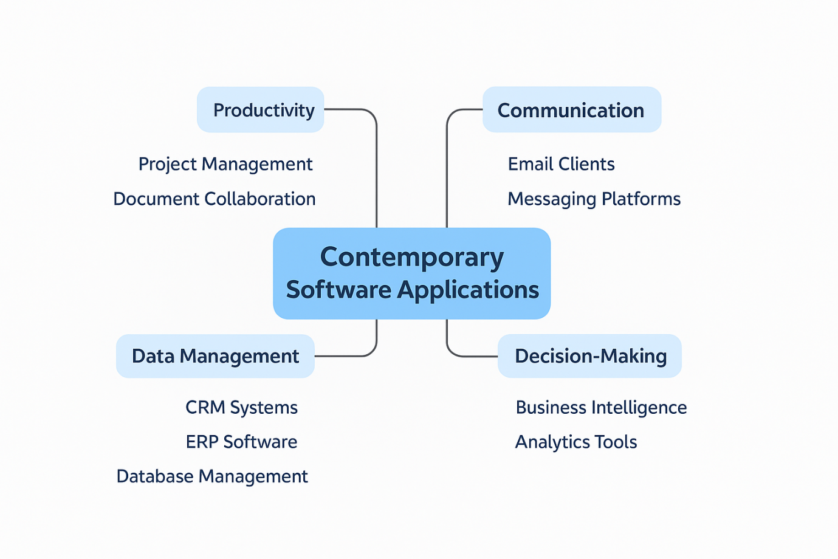
The​‍​‌‍​‍‌​‍​‌‍​‍‌ mind map developed visualises the central theme as "Contemporary Software Applications", from which the key daily activity software categories used in organisations branch out. One such category is Communication and Collaboration Tools (e.g., Microsoft Teams, Zoom, Slack) that enable real-time interaction and teamwork. Another category is productivity and office software (e.g., Microsoft 365, Google Workspace, Notion), which are the tools through which documents are created, and the flow of information is managed. Project and task management tools (e.g., Trello, Asana, Monday.com) are another group of software that are used to plan and track work. Customer Relationship Management systems (e.g., Salesforce, HubSpot, and Zoho CRM) are designed for storing and managing customer data. Lastly, some financial software programs (e.g., QuickBooks, Xero) facilitate financial operations [3].
Such an illustration clearly shows the interrelation among different software categories that lead to smooth and successful business operations.
Mind​‍​‌‍​‍‌​‍​‌‍​‍‌ mapping is an effective method for organising complex business information and understanding digital work environments. Through visual mapping of modern software applications, companies can become more guided, better communicate, and facilitate decision-making of a higher ​‍​‌‍​‍‌​‍​‌‍​‍‌quality.

Task 3 :Office Applications for Creating, Storing, Presenting, and Analysing Data
Office​‍​‌‍​‍‌​‍​‌‍​‍‌ software applications are a major factor in the smooth running of a business in the current world. They facilitate various areas such as documentation, data analysis, presentations, and information management. In general, Microsoft Office applications are regarded as the most popular tools in the working environment of different organizations because they are adaptable, dependable, and can easily be integrated with other systems [1]. This assignment describes four primary office software products that include Microsoft Word, PowerPoint, Excel, and Access. It briefly describes their significant features, advantages, and disadvantages. Besides, it reveals the on-the-spot practical work for two features of Microsoft Excel to obtain the ​‍​‌‍​‍‌​‍​‌‍​‍‌evidence.
a) Office Software Solutions for Business Operations
1. Microsoft Word
Microsoft Word is an initiative in the category of the most common and popular office programmes to be classified as word-processing ones whose main purpose is to generate and manipulate text-based documents, e.g., reports, proposals, letters, and policy documents. Its core features mainly include advanced formatting tools, templates, spell and grammar checking, tracking changes, and commenting [2]. Besides, Word enables mail merge, a process through which organisations can produce individually addressed documents in a short time.
The essential benefits of Microsoft Word are its intuitiveness, capability of professional document formatting, and collaboration through cloud integration. However, Word is not a tool for handling large data and may have formatting inconsistencies between different versions of the software [2].
Example — Practical use of MS Word in a business operation:
Creating a business report:
1. Open MS Word and pick a business report template.
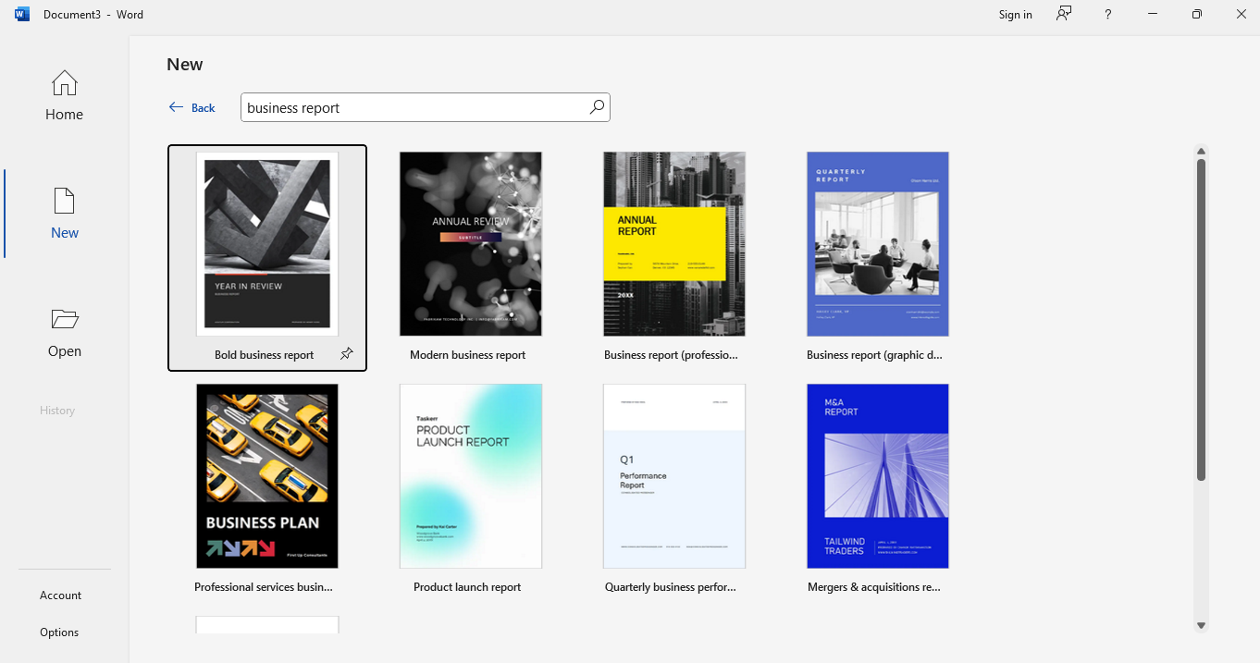

2. Add a title page, table of contents, and executive summary
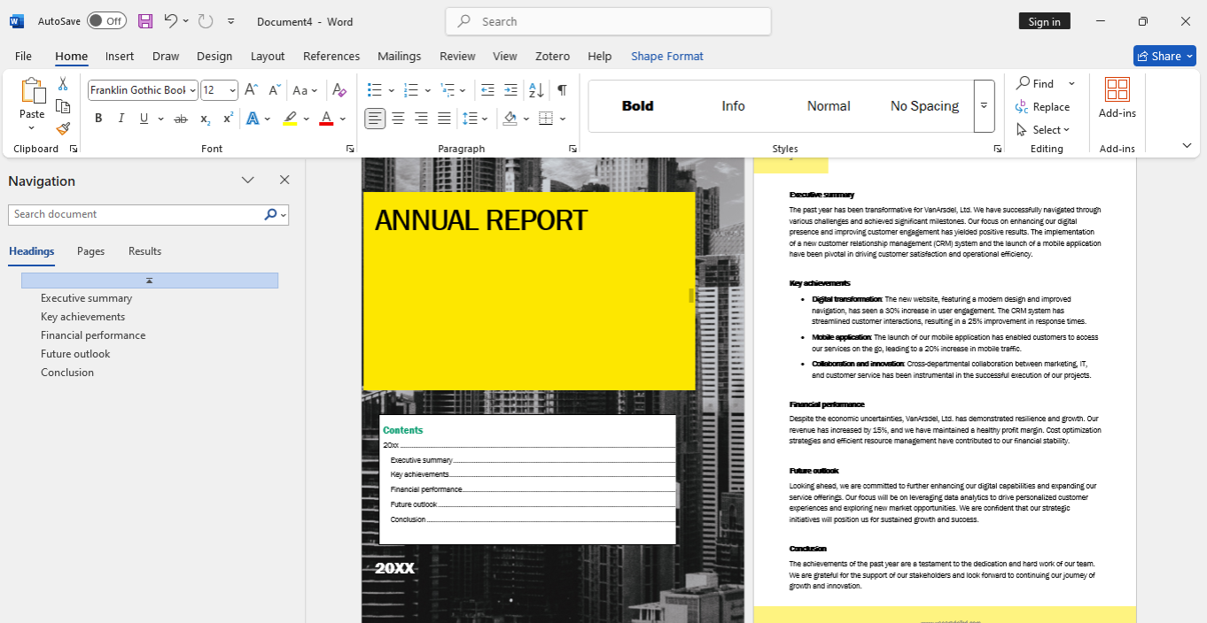

3. Save and share it to review.
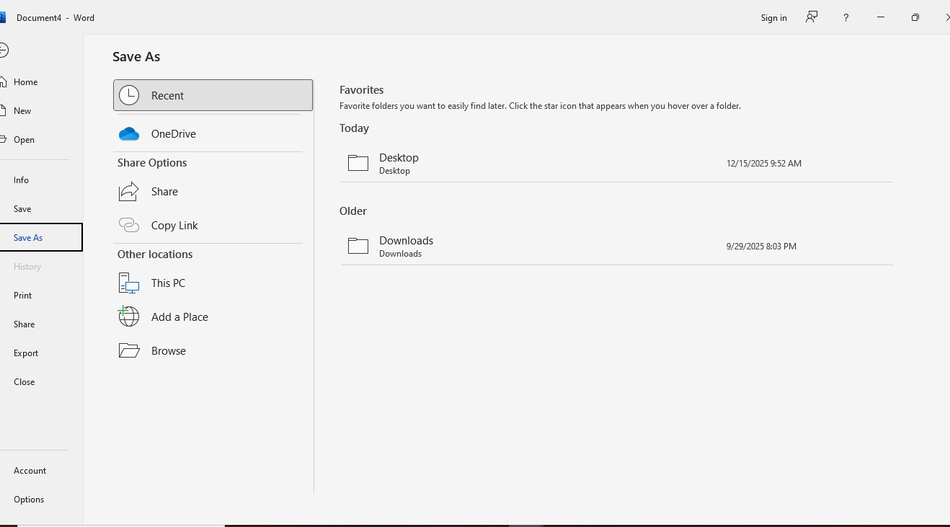

2. Microsoft PowerPoint
Microsoft PowerPoint is a presentation software highly popular in business meetings, training sessions, and marketing pitches. The program enables users to merge text, pictures, graphics, animations, sounds, and videos to create visually attractive presentations. Communication gets more efficient with the help of features like slide templates, SmartArt, presenter view, and real-time collaboration [3].
The main advantage of PowerPoint is that it can visually present even the most complicated ideas in a very simple way. The software is storytelling-friendly and can keep the audience engaged; thus, it is a great tool for decision-making and knowledge sharing. On the other hand, if the user goes too far with the animations, or if there is too much text on the slides, clarity gets compromised, and, thus, the whole presentation can become an ineffective one, even if it is not well-designed [3].
Example — Practical use of MS PowerPoint in a business operation:

1. Open MS PowerPoint and select a business template.
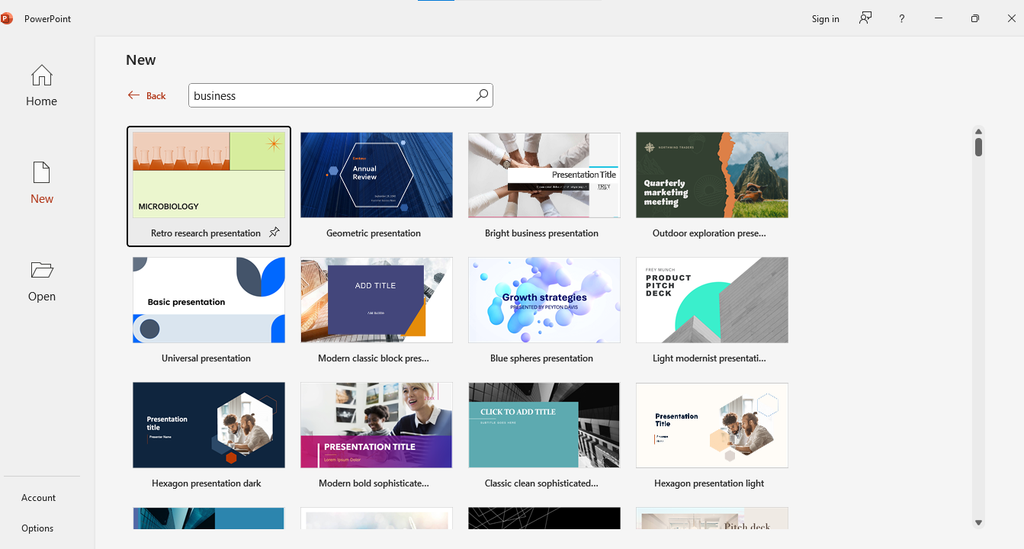
2. Add and modify the title, agenda, and key points in different slides for the business presentation.
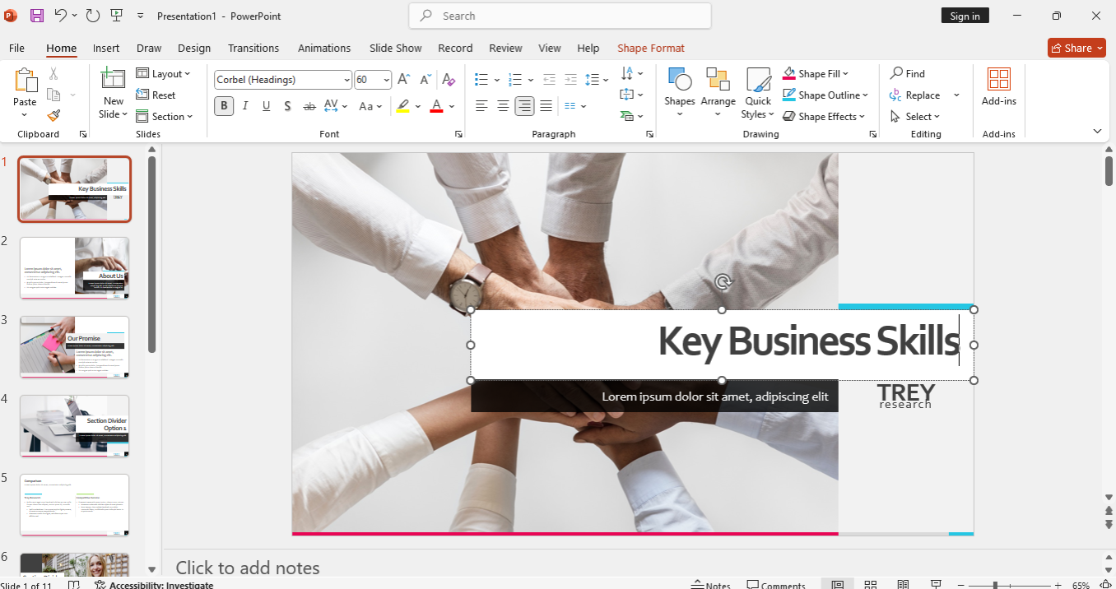

3. Save and share it.
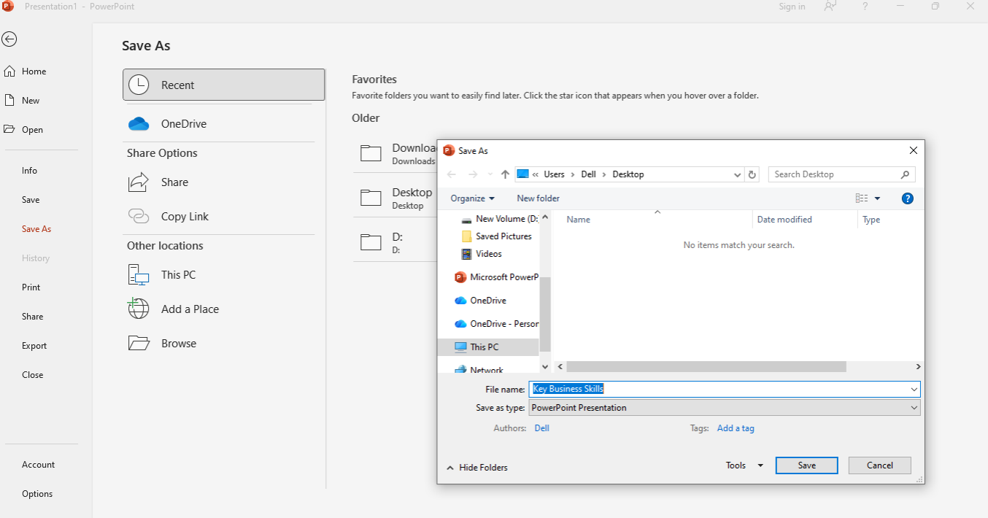
3. Microsoft Excel
Microsoft​‍​‌‍​‍‌​‍​‌‍​‍‌ Excel is potent spreadsheet software that is utilised for data analysis, financial calculations, budgeting, forecasting, and reporting. Its significant features are formulas, functions, charts, pivot tables, conditional formatting, and data validation [4]. Excel accommodates basic calculations along with complex data analysis; therefore, it is a must-have tool for business decision-making.
The foremost reasons to use Excel are its analytical capabilities, flexibility, and, being a standard tool, wide acceptance across industries. Companies can employ Excel to discover trends, handle large datasets, and make their calculations self-running. Nevertheless, Excel can be limited to situations of very large datasets or multi-user database functions where it is possible to have errors if the data integrity is not handled with care [4].

Example — Practical use of MS Excel in a business operation:
- Open Excel and pick a business template.
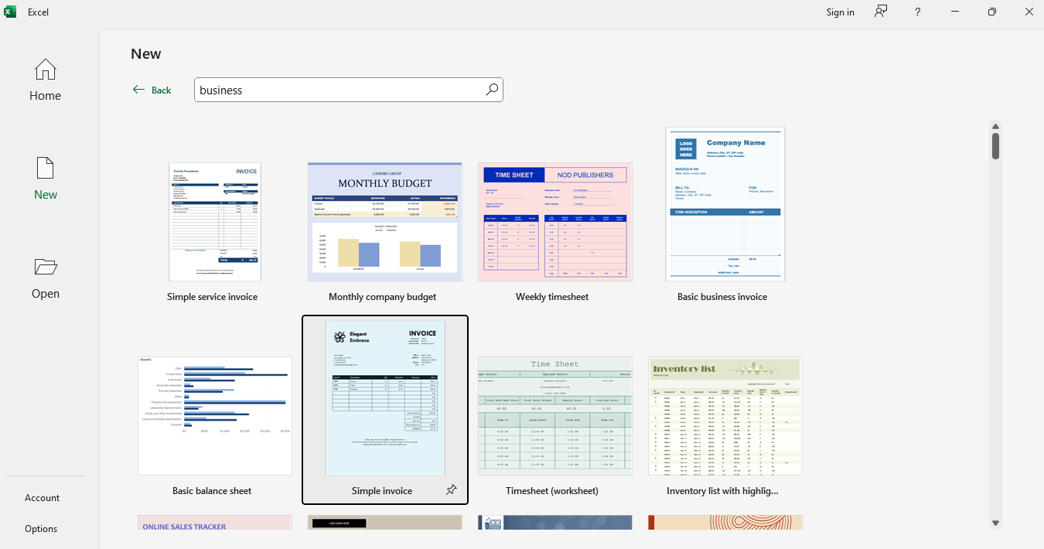
- Enter data in a structured table with headers: Names, Days Present, and Bonus Status.
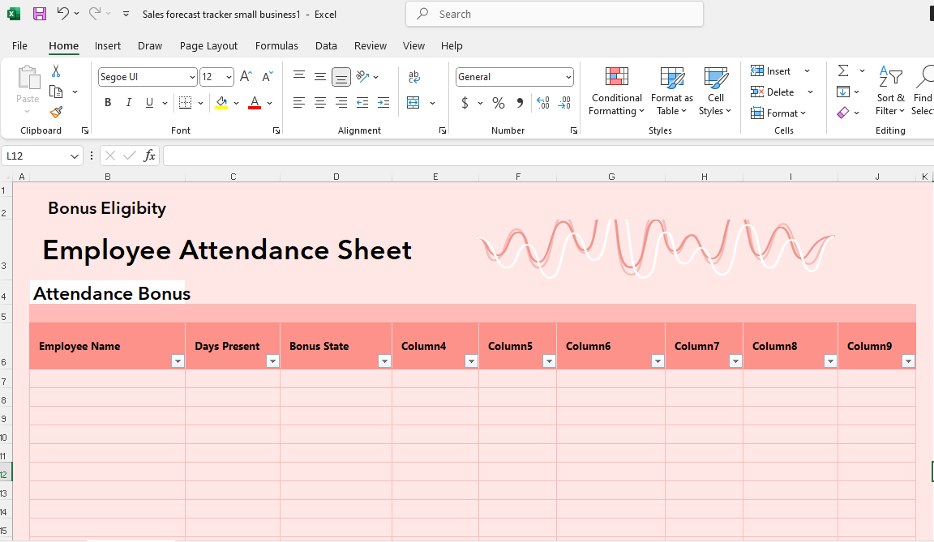
- Use formulas and IF function, e.g., IF(B2>=22, "Eligible", "Not Eligible"), and create a dataset and analyse it using formulas and pivot tables to summarise information
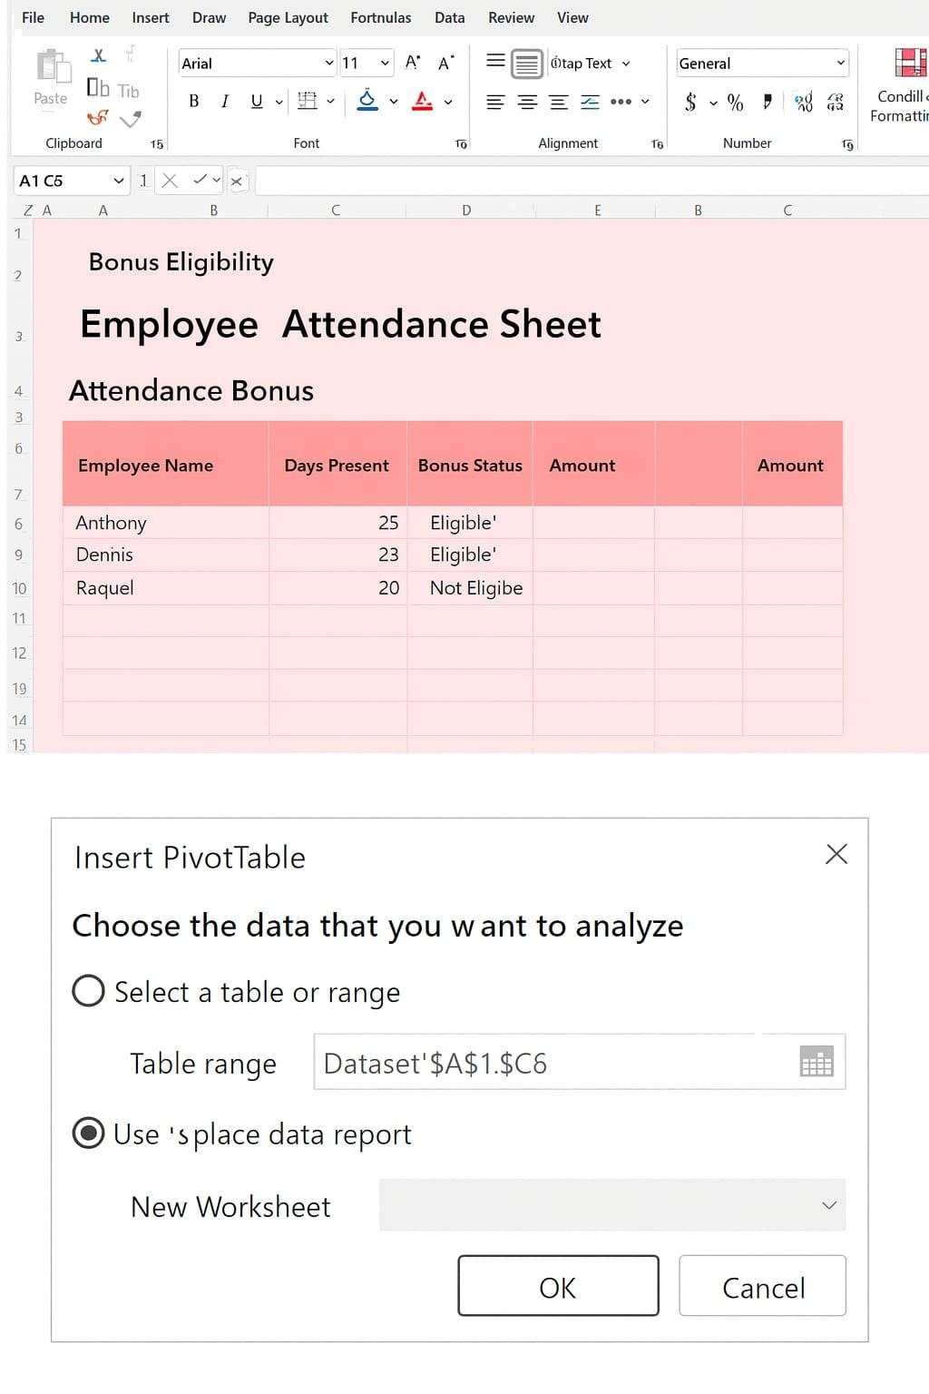

4. Microsoft Access
Microsoft​‍​‌‍​‍‌​‍​‌‍​‍‌ Access is a database management system that is developed to store, manage, and retrieve structured data. The software allows users to create tables, queries, forms, and reports, which makes it a viable option for business databases of small to medium size, like customer records or inventory systems.
The key advantage of Access is that it can handle relational data much more efficiently than spreadsheets. It helps in maintaining data consistency and eliminating redundancy. On the other hand, Access iFunction
very good choice for large-scale enterprise databases, and it still needs users to have some basic knowledge of database design; hence, there may be few non-technical users who will be able to use it ​‍​‌‍​‍‌​‍​‌‍​‍‌[5].
Example — Practical use of MS Access in a business operation:
1.Launch Microsoft Access and make a new empty database or select a template like Customer Management.
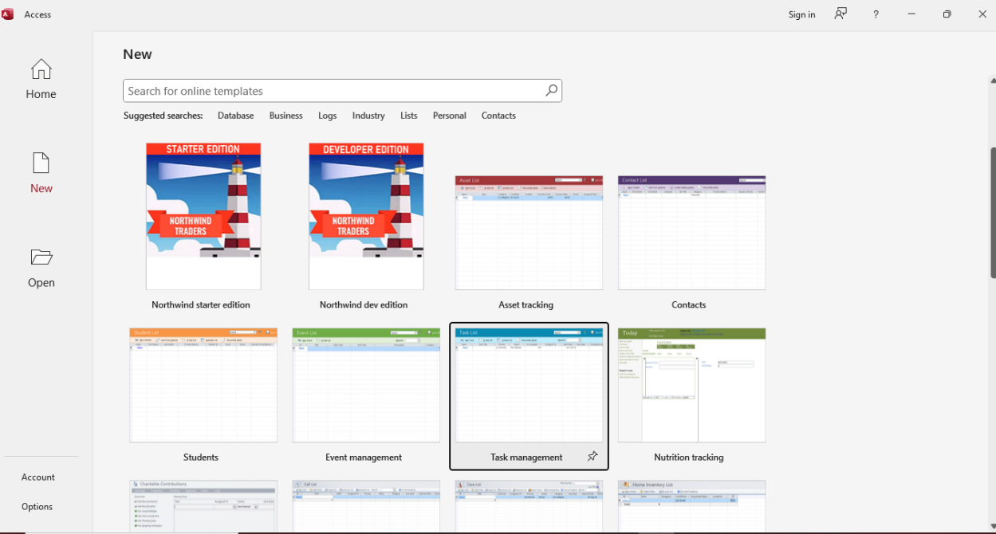

2. Set up tables with fields and the correct data types, e.g., Customer ID, Name, Email, and Phone.
3. Use the Relationships tool to link tables and thus allow referential integrity.
4. Make a data entry form (Create → Form) to facilitate user input and also lessen mistakes.

5. Create queries and reports (Create → Query Design / Report) to get data and also print your ​‍​‌‍​‍‌​‍​‌‍​‍‌reports.
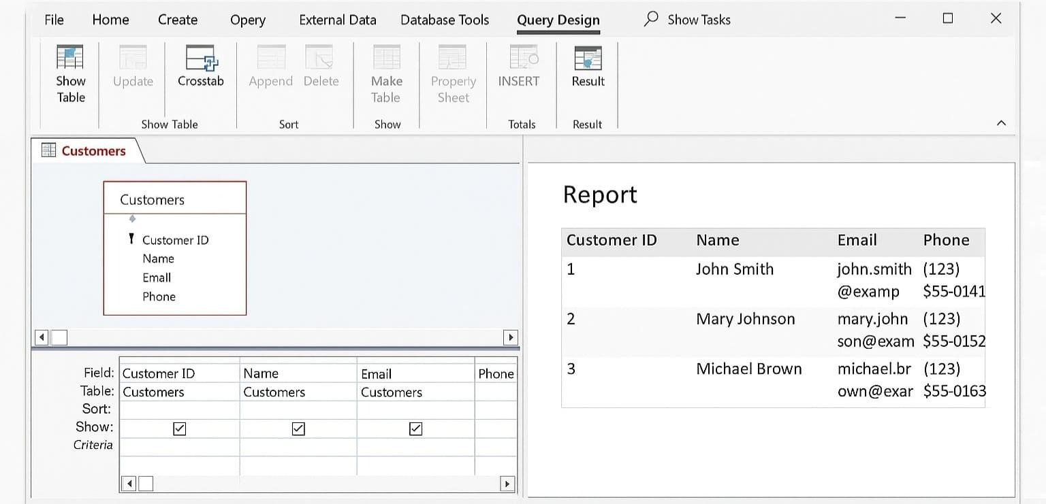

b) Practical Demonstration of Two Office Features
Feature 1: IF Function
The​‍​‌‍​‍‌​‍​‌‍​‍‌ IF function in Microsoft Excel allows you to carry out a logical test and return one value when the condition is TRUE and another value when the condition is FALSE.

Example: A worker attendance record was used to figure out the workers who are qualified for a monthly attendance award based on the total days present (threshold: 22 days).
Step 1: Make a table with the following columns:
Column A: Employee Name
Column B: Days Present
Column C: Bonus Status

Step 2: Put the following formula in cell C2: =IF(B2>=22,"Eligible","Not Eligible")
With this formula, the first thing that it checks is whether the number of days that the employee has been present is at least 22. If that is the case, “Eligible” is the value that is returned by Excel, and if not, “Not Eligible” is returned.

Step 3: Manually fill down to copy this formula in the other cells in the column.
The table with employee attendance records is completed with the automatic output of the bonus eligibility ​‍​‌‍​‍‌​‍​‌‍​‍‌results.

Pivot Table:
A pivot table is a tool that helps one to summarise data of a large volume and get insights that are of value in a quick way.
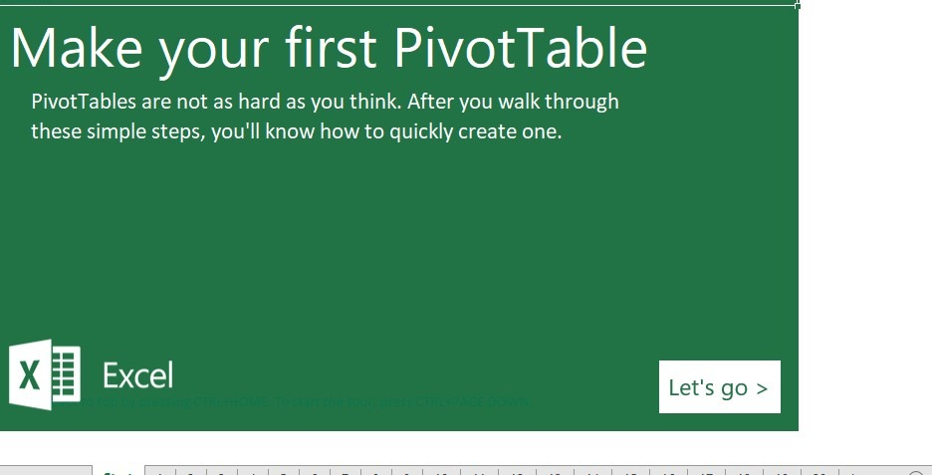
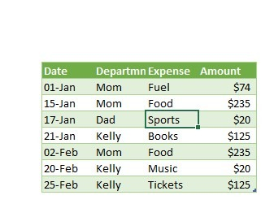

Step 2: Highlight the data range and then click on Insert Pivot Table.
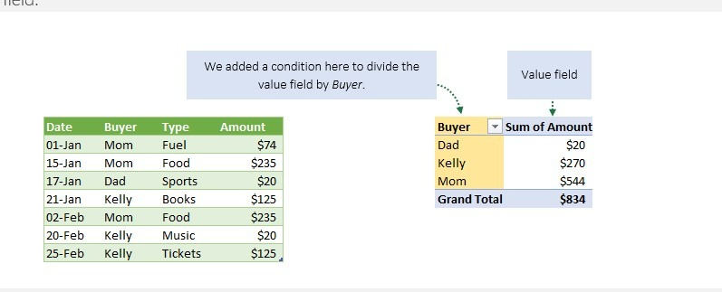
The use of the pivot table enabled a concise overview of the expenses incurred by each department and thus facilitated the making of decisions on budgeting and controlling ​‍​‌‍​‍‌​‍​‌‍​‍‌costs.
Conclusion
The​‍​‌‍​‍‌​‍​‌‍​‍‌ four main Microsoft applications – Word, PowerPoint, Excel, and Access – are essentially the tools through which processes like creation, storage, presentation, and analysis of business information can be carried out. Each programme has its unique features but also has some restrictions. The results of a practical test of Excel's IF function and Pivot Tables serve as examples of how office applications can be used to make decisions based on data and solve business operations issues in a more efficient way. In combination, they become a powerful digital arsenal for businesses of the 21st century.

Task 4(a&b): Communication and Collaboration Applications

In​‍​‌‍​‍‌​‍​‌‍​‍‌ the present-day commercial service, company success heavily depends on communication and teamwork that are of the right quality. Technologies used for communication and information have significantly influenced the ways employees interact, share information, and coordinate their work in the respective departments since the remote and hybrid modes of working have become prevalent.
Digital​‍​‌‍​‍‌​‍​‌‍​‍‌ solutions that enable fast, secure, and flexible communication to also allow teamwork and collaboration beyond geographic borders are essential for enterprises of the present era. Although internet collaboration tools emphasise real-time interaction, shared workspaces, and team problem-solving, communication software mainly focuses on formal data exchange, e.g., mailing and ​‍​‌‍​‍‌​‍​‌‍​‍‌scheduling.
Microsoft Outlook — Contemporary Communication Application
A popular workplace communication tool for handling emails, calendars, tasks, and contacts is Microsoft Outlook. Outlook easily connects with cloud-based services like Exchange Online, OneDrive, SharePoint, and Microsoft Teams as part of the Microsoft 365 package.
Due to its reliability, security, and structured approach to communication, Outlook is commonly used in corporate, academic, and government organizations for formal business correspondence.
Key Features and Analysis
One of the most significant features of Microsoft Outlook is its advanced email management system. Users can organize emails using folders, categories, flags, and conversation threading.
Automated rules allow messages to be filtered, forwarded, or prioritized based on predefined criteria, which significantly reduces manual effort and email overload. This structured organization improves productivity and ensures that important communication is not overlooked [1].
Another really handy feature is Schedule Send—sometimes called Delayed Delivery. It lets you draft an email whenever you want and then pick the exact date and time you’d like it to go out. This is super useful for making sure your message lands during the recipient’s normal working hours, especially when you’re dealing with people in different time zones.

Plus, it gives you a chance to review what you’ve written before it actually sends, which helps keep your communication more polished and professional.[1].

Outlook has this AI-powered feature called Focused Inbox that automatically sorts your emails into two tabs: one for the important stuff and another for everything else.
It learns from how you interact with your emails—who you reply to most, what you read right away—and uses that to prioritize messages that actually matter. This way, you can zero in on the emails that need your attention without getting buried under newsletters, promotions. It’s a real time-saver and helps cut down on those constant distractions. [1].
Outlook's usefulness in corporate settings is further increased by the calendar and Scheduling Assistant functions. Users can share calendars with coworkers, create reminders, and arrange meetings. In order to minimize schedule conflicts and enhance team member cooperation, the schedule Assistant evaluates participants' availability and recommends appropriate meeting times.
Outlook helps closely with other Microsoft 365 applications. Emails can be converted into Teams meetings, attachments can be stored in OneDrive, and collaborative workflows can be managed across platforms. This tight integration makes Outlook a central communication hub within the Microsoft ecosystem.
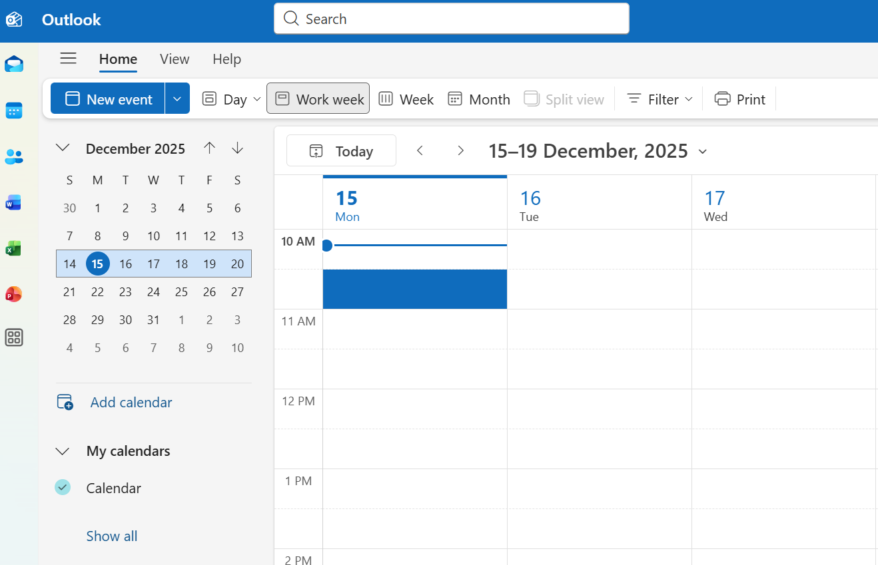
Figure 1: Microsoft Outlook interface screenshot

Microsoft Teams — Online Collaboration Application
Microsoft Teams is an online communication solution that facilitates effortless teamwork. Users may utilize many apps in one location, share files, participate in video conferences, and communicate. Teams allows users to catch up later via shared channels and messages, or to communicate in real time through calls and meetings. It's particularly helpful for contemporary companies where employees have a hybrid work style or work remotely, facilitating coordination even when workers aren't in the same location.
Key Features and Analysis
One of the coolest things about Microsoft Teams is how the chats and channels just stay there forever. Like, teams have these channels for different stuff—maybe one for a school project, one for a specific department at work, or just random topics. All the conversations in those channels don't disappear; you can scroll back anytime to check what people said before, see old decisions, or find files someone shared ages ago. Plus, the threaded replies keep everything organized so discussions don't turn into a total mess. It's super helpful for keeping track of what's going on without losing context.[2].
Microsoft Teams is legit amazing for video calls too. You can just hop into a meeting with your whole crew, share your screen so everyone sees what you're talking about, record the whole thing if you want to watch it later, and it even does live captions which is super helpful. There's all these controls for managing who's talking, muting people if it's getting chaotic lol, and it works great for actual work meetings, online classes, training stuff, or even just presenting something. Basically, no matter where everyone is, you can still chat and collaborate like you're all in the same room [2].
Other advantages of Microsoft Teams include file sharing and real-time communication. Users may upload, share, and co-edit documents immediately within Teams thanks to interaction with OneDrive and SharePoint. The ability for many people to collaborate on the same Word, Excel, or PowerPoint document at once minimizes version control problems and increases team productivity.
Teams also has some pretty cool options for sharing your screen and doing presentations. Like, you can share your whole desktop, or just one window, or even use this thing called PowerPoint Live. PowerPoint Live is very interesting, the presenter can see their own notes on the side without anyone else seeing them, and the audience just sees the slides clean. It makes presentations way better online. And sharing just a window is great for privacy, cause you don't accidentally show your whole screen. No one needs to see that mess.
Microsoft Teams works with many other apps like Planner, Forms, Power Automate, and even third-party tools. This means you can plan tasks, track progress, and work together without leaving the platform. Everything stays in one place, so work feels more organized and you don’t have to jump between different apps all the time[ 2].
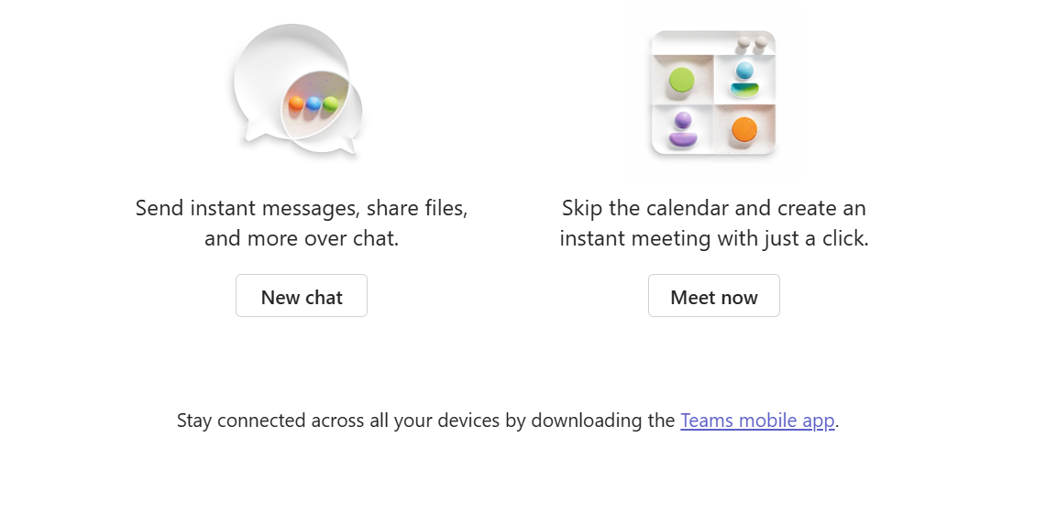Figure 2: Microsoft Teams collaboration screenshot
Microsoft​‍​‌‍​‍‌​‍​‌‍​‍‌ Teams and Microsoft Outlook are two major tools that complement each other in business communication and collaboration in a modern setup. Outlook is a better choice for formal and structured kinds of work, such as sending emails, scheduling meetings, and handling different tasks. Whereas Teams is basically a tool for instant communication, chatting, online meetings, file sharing, and co-working in real time.
These tools are like a dream duo when they are used together. They make work easier and help people stay connected, especially in remote or hybrid work. As the business world is going digital and enterprises are adopting work-from-home or hybrid models, the correct use of these tools will still be the key to the success of any ​‍​‌‍​‍‌​‍​‌‍​‍‌organisation.

References:
TASK:1
[1] BigCommerce, “About BigCommerce,” BigCommerce, 2025. [Online]. Available: https://www.bigcommerce.com/
[2] Squarespace, “Squarespace eCommerce,” Squarespace, 2025. [Online]. Available: https://www.squarespace.com/ecommerce
TASK:2
[1] K. M. Heilman, “Possible brain mechanisms of creativity,” Archives of Clinical Neuropsychology, vol. 31, no. 4, pp. 285–296, 2016, doi: 10.1093/arclin/acw009.
[2] R. Newton, Project Management: Step by Step: How to Plan and Manage a Highly Successful Project, Harlow, UK: Pearson Education, 2016.
[3] A. A. Alhumud and A. Alsulami, “Customer relationship management in the digital age,” in Customer Relationship Management, IntechOpen, 2025, doi: 10.5772/intechopen.1011291.
TASK:3
[1] K. Laudon and C. Traver, E-commerce 2023: Business, Technology, Society, 17th ed. Boston, MA, USA: Pearson, 2023.
[2] Microsoft, “Microsoft Word documentation,” Microsoft Learn, 2024. [Online]. Available: https://learn.microsoft.com/
[3] Microsoft, “Microsoft PowerPoint documentation,” Microsoft Learn, 2024. [Online]. Available: https://learn.microsoft.com/
[4] R. Newton, Project Management: Step by Step: How to Plan and Manage a Highly Successful Project, Harlow, UK: Pearson Education, 2016.
[5] A. A. Alhumud and A. Alsulami, “Customer relationship management in the digital age,” IntechOpen, 2025, doi: 10.5772/intechopen.1011291.
TASK:4
[1] Microsoft, “Outlook features and email management,” Microsoft Support, 2024. [Online]. Available: https://support.microsoft.com
[2] Microsoft, “Microsoft Teams features and collaboration tools,” Microsoft Learn, 2024. [Online]. Available: https://learn.microsoft.com

