DS 1 Assignment

My Screenshots/Photos
- Please add 4–6 screenshots or photos of your digital life.
- You can use your phone or laptop.
- For each screenshot, write one or two sentences explaining what it shows.

Screenshot/Photo 1
[Insert Photo/Screenshot below]
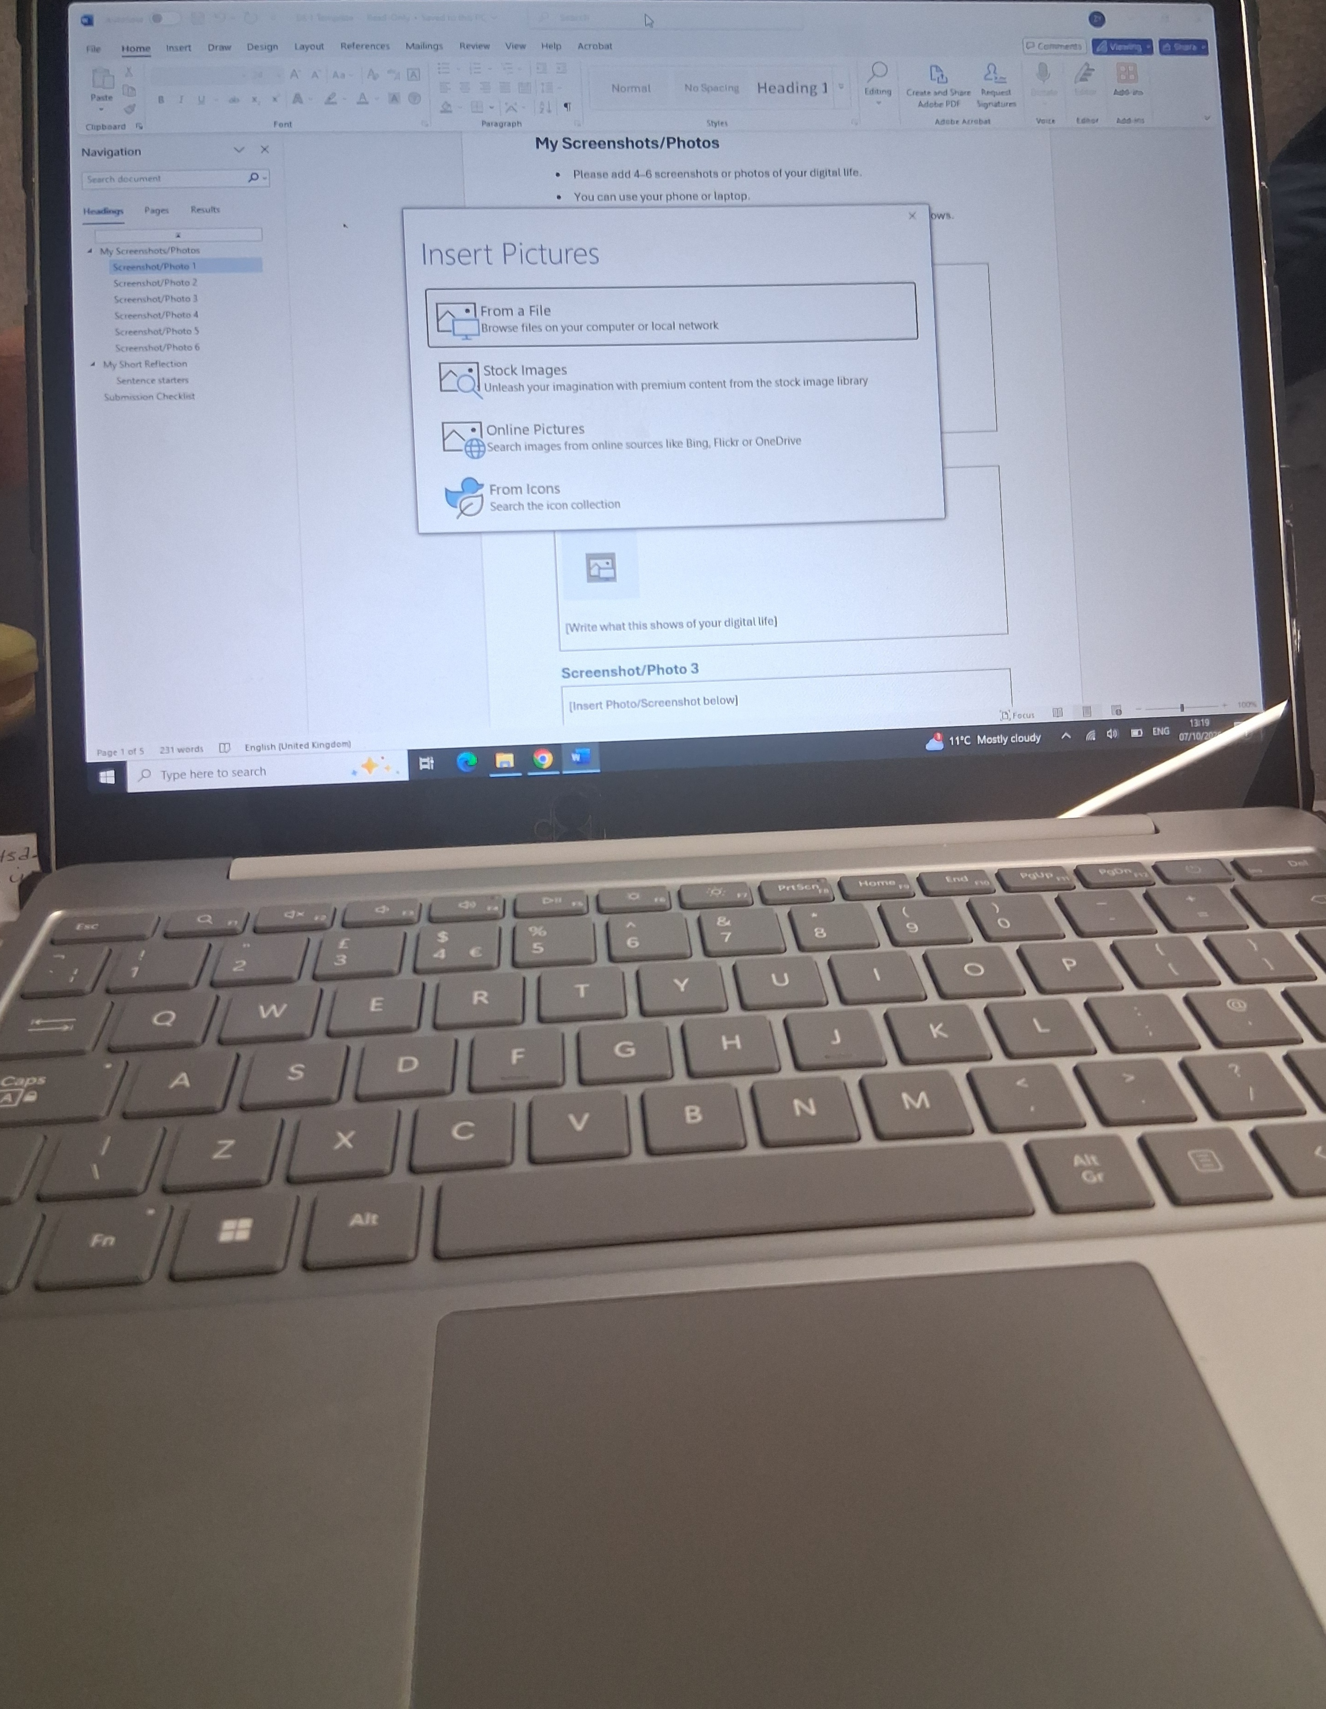
The above picture is a laptop these digital tools we use it for general information for example communication and sharing, for data management quick access and research for study and office use. We use it quick access and research information for work and study

Screenshot/Photo 2
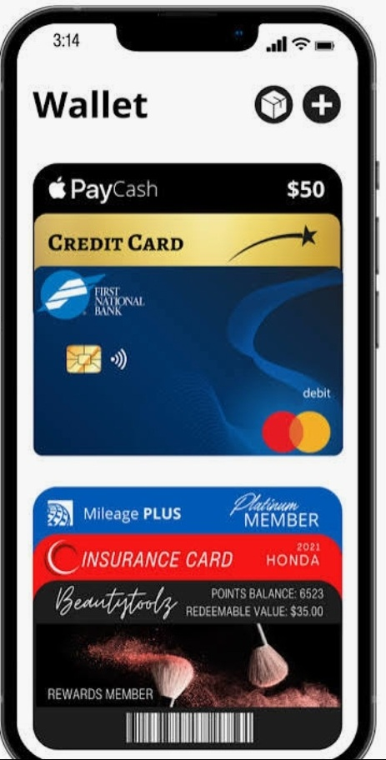
The above picture is a mobile wallet. This is digital app on a smartphone, smart watch or tablet that stores information. We use it for contactless in store payments such as retails, terminals, checkout digital precaches transfers or send or receive money directly and it is convenience, faster than the actual card.

Screenshot/Photo 3
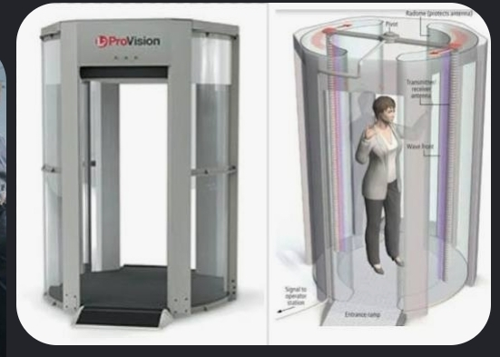
The above picture is Airport body scanner this body digital scanner used at security check points to detect concealed metallic and non-metallic items such as plastic explosive ceramic knives, weapons and hidden liquids underneath a passenger’s clothing without physical contact. This digital tools it works millimetre body scanner wave technology, low radiation, low energy radio waves low energy radio waves far less than a standard mobile phones not known health risks.

Screenshot/Photo 4
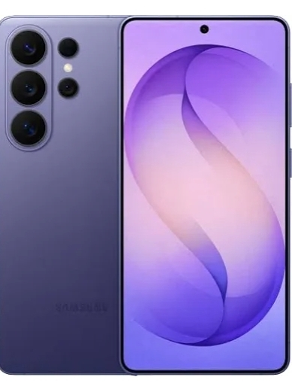
The above digital tool is Samsung mobile smart phone use for everyday communication, information access, communication real time vice and video calls, SMS txt messaging and also browsing the internet searching for real time, GPS navigation, managing digital calendar, content creation and design and more.

Screenshot/Photo 5
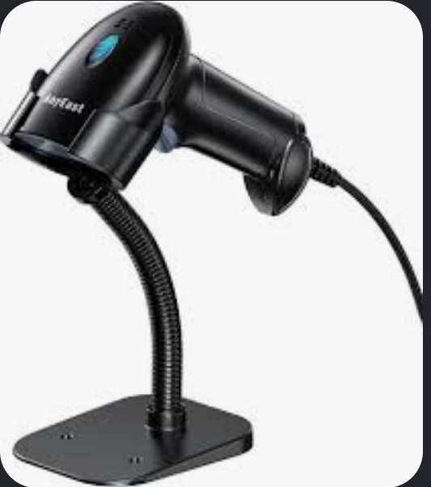
The above picture is hospital ultrasound machine. This diagnostic medical device that integrates digital technology, it works with digital networks and records, signal conversation eliminate hight frequency sound waves in to the body and captures convert these acoustic sound waves in to real time visual data and images on a screen.

Screenshot/Photo 6
[Insert Photo/Screenshot below]

[Write what this shows of your digital life]

My Short Reflection
- Write 5–8 simple sentences about your digital life.
- You can use the sentence starters below if helpful.
Digital life we often use phones or other device without even thinking about it. It is very useful day today life. The concept of digital life refers to experiences relationships or activities that takes place through digital. I use digital tools for everyday life for example my smart phone to navigator GPS navigators and communication real video calls and more I feel confidence that I knew how2 to operate my digital tools.

Sentence starters
- I use digital tools to …
- I feel confident when I …
- I want to improve …
- I often use these tools: …
- I sometimes feel nervous about …
- I hope this module will help me …
- Digital skills are important for me because …
You can write more if you want.

Submission Checklist
Before you submit, please check:
​​​ ☐ I added 4–6 screenshots
☐ I wrote short sentences for each screenshot
☐ I wrote my short reflection
☐ My work is my own
☐ My file opens correctly
​​☐ My file opens correctly

