International Trade
Without international trade we would all be much poorer. There would be some items like pineapples, coffee, cotton clothes, foreign holidays and uranium that we would simply have to go without. Then there would be other items like pineapples and spacecraft that we could produce only very inefficiently.
International trade has the potential to benefit all participating countries.
Totally free trade, however, may bring problems to countries or to groups of people within those countries. Many people argue strongly for restrictions on trade. Textile workers see their jobs threatened by cheap imported cloth. Car manufacturers worry about falling sales as customers switch to Japanese models or other East Asian ones. This chapter, therefore, also examines the arguments for restricting trade. Are people justified in fearing international competition, or are they merely trying to protect some vested interest at the expense of everyone else?
Trading Patterns
International trade has been growing as a proportion of countries' national income (the value of all goods and services produced by a country over a period of time) for many years. This is illustrated in Figure 24.1, which shows the growth in the global volume of exports of goods and in world real GDP (Gross Domestic Product is a monetary measure of the market value of all the final goods and services produced in a period of time, often yearly or quarterly). It shows that exports have been growing much more rapidly than GDP.
Over the 60-year period from 1955 to 2014 the average annual growth in world output was 3.6 per cent, whereas the average annual growth in world exports was over 6.3 per cent. The chart also shows the significant negative impact of the global financial crisis at the end of the 2000s on both world output and, in particular, the volume of exports. The fall in total world output in 2009 was the first since the 1930s.
Despite the impact of the global slowdown at the end of the 2000s, it is likely that trade will continue to increase as a percentage of world GDP. This will further increase countries' interdependence and so their vulnerability to world trade fluctuations.
Figure 24.1
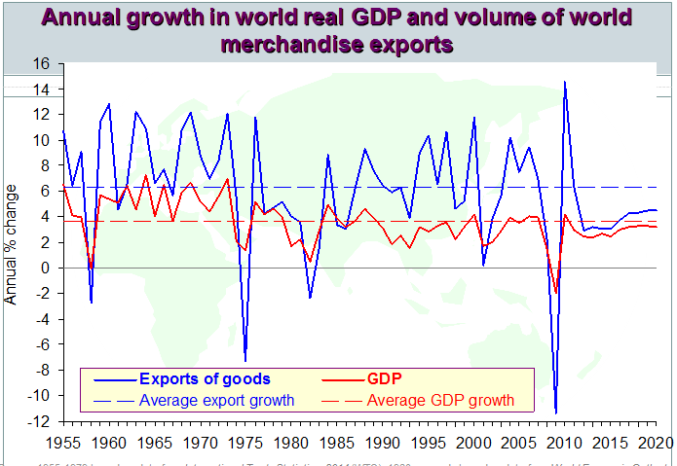
Figure 24.2
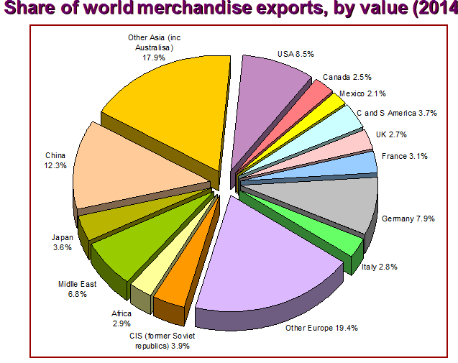
The geography of international trade Developed countries have dominated world trade. But this pattern is changing. In 2014 developing countries accounted for 43 per cent (by value) of all world merchandise trade
Figure 24.2
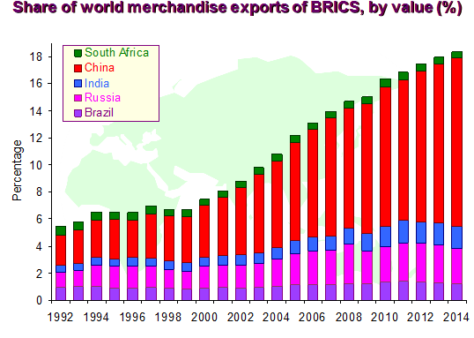
Figure 24.4
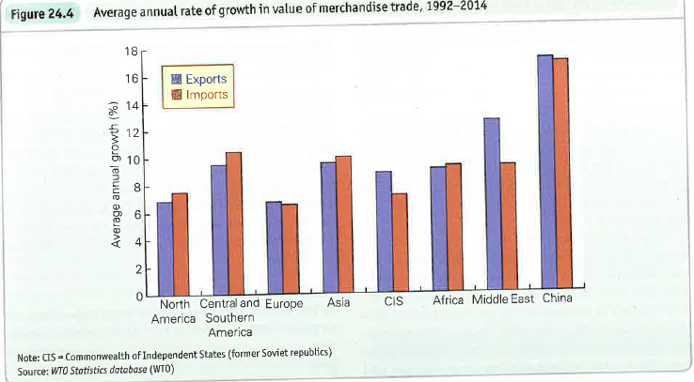
The growth in exports from the group of developing nations collectively known as the BRICS (Brazil, Russia, India, China and South Africa) has been especially rapid. Between them they accounted for just 5.4 per cent of world exports (by value) in 1992; by 2014 this share had more than tripled to 18.3 per cent (see Figure 24.3).
Figure 24.4 shows the growth of exports and imports by region. It helps in assessing the openness of economies and provides further evidence that nations are becoming increasingly interdependent. It again illustrates the spectacular growth rate in trade witnessed by China: its exports increased in value by an average of 17 per cent per year from 1992 to 2014.
Despite more rapid growth in trade values in other regions, Europe remains an important geographical centre for trade (see Figure 24.5). Over the first half of the 2010s it accounted for 36 per cent of both world exports and imports (by value). While Africa, as a whole, has experienced significant growth in trade since the early 1990s, many of the poorest African countries have seen negligible growth in trade over the period. Consequently, over the first half of the 2010s Africa accounted for only around 3.25 per cent of the value of both world exports and imports.
Middle Eastern countries accounted for 6.8 per cent of the value of global exports from 2010 to 2014 compared with just 3.9 per cent of the global value of imports. Oil is important in explaining this differential. However, oil prices are volatile and this affects the growth in export earnings from period to period.
During much of the 1990s, the growth in the value of exports from Middle Eastern countries was weak due to the generally falling price of oil. This changed over the periods 1999¬2000, 2003-8 and 2010-11 as world oil prices surged. However, oil prices were to plummet during the second half of 2014. As a result, the growth in merchandise export values averaged 19 per cent per year over the period from 1999 to 2008 compared with only 0.6 per cent from 1991 to 1998 and a fall of 6.7 per cent per year across 2013 and 2014.
Figure 24.5
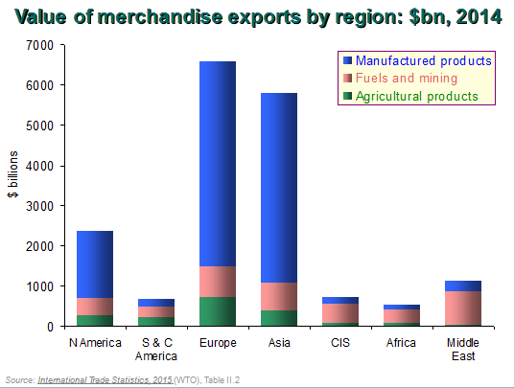
The composition of international trade
Trade in goods
In 2014 the value of global merchandise exports was $18.9 trillion, which is equivalent to 24.5 per cent of the value of global GDP. By far the largest category of traded goods is that of manufactured products (see Figure 24.5), making up almost two-thirds of all merchandise exports. Europe and Asia account almost equally for around 80 per cent of the global value of exports of manufactures. Meanwhile agricultural products account for close to 10 per cent of merchandise exports and fuels and mining products roughly double this at just over 20 per cent.
Trade in services
In 2014 the global value of commercial services was $4.9 trillion which is equivalent in value to 6.3 per cent of global GDP and about 20.4 per cent of total trade. The USA is by far the largest exporter with some 14.1 per cent of all service exports in 2014, followed by the UK (6.8 per cent) and Germany (5.5 per cent). The largest importer of services is the USA with 9.6 per cent of the total, followed by China (8.1 per cent), Germany (6.9 per cent) and France (5.1 per cent).
Trade and the UK
In 2014, the UK was the world's tenth largest exporter of goods, selling 2.7 per cent of the world total, and the fifth largest importer, consuming 3.6 per cent of world total.
In 2014, 42.9 per cent of the UK's exports of goods went to EU countries, 13.0 per cent went to Switzerland, 11.5 per cent to the USA and 3.3 per cent to China.
UK imports, like UK exports, are strongly tied to Europe. In 2013, 53.1 per cent of the imports of goods came from EU countries, 8.8 per cent from China, 8.3 per cent from the USA and 3.9 per cent from Norway.
THE ADVANTAGES OF TRADE
Specialisation as the basis for trade
Why do countries trade with each other and what do they gain out of it? The reasons for international trade are really only an extension of the reasons for trade within a nation. Rather than people trying to be self-sufficient and do everything for themselves, it makes sense to specialise.
Firms specialise in producing certain types of goods. This allows them to gain economies of scale and to exploit their entrepreneurial and management skills and the skills of their labour force. It also allows them to benefit from their particular location and from the ownership of any particular capital equipment or other assets they might possess. With the revenues that firms earn, they buy in the inputs they need from other firms and the labour they require. Firms thus trade with each other.
Countries also specialise. They produce more than they need of certain goods. What is not consumed domestically is exported. The revenues earned from the exports are used to import goods which are not produced in sufficient amounts at home.
But which goods should a country specialise in? What should it export and what should it import? The answer is that it should specialise in those goods in which it has a .comparative advantage. Let us examine what this means.
The law of comparative advantage
Countries have different endowments of factors of production. They differ in population density, labour skills, climate, raw materials, capital equipment, etc. These differences tend to persist because factors are relatively immobile between countries. Obviously land and climate are totally immobile, but even with labour and capital there tend to be more restrictions (physical, social, cultural or legal) on their international movement than on their movement within countries. Thus the ability to supply goods differs between countries.
What this means is that the relative costs of producing goods will vary from country to country. For example, one country may be able to produce 1 fridge for the same cost as 6 tonnes of wheat or 3 MP3 players, whereas another country may be able to produce 1 fridge for the same cost as only 3 tonnes of wheat but 4 MP3 players. It is these differences in relative costs that form the basis of trade.
At this stage we need to distinguish between absolute advantage and comparative advantage.
Absolute advantage
When one country can produce a good with fewer resources than another country, it is said to have an absolute advantage in that good. If France can produce wine with fewer resources than the UK, and the UK can produce gin with fewer resources than France, then France has an absolute advantage in wine and the UK an absolute advantage in gin. Production of both wine and gin will be maximised by each country specialising and then trading with the other country. Both will gain.
Table 24.1 Production possibilities for two countries
 |  | Kilos of wheat |  | Metres of cloth
Less developed country | Either | 2 | or | 1
Developed country | Either | 4 | or | 8

Comparative advantage
The above seems obvious, but trade between two countries can still be beneficial even if one country could produce all goods with fewer resources than the other, providing the relative efficiency with which goods can be produced differs between the two countries.
Take the case of a developed country that is absolutely more efficient than a less developed country at producing both wheat and cloth. Assume that with a given amount of resources (labour, land and capital) the alternatives shown in Table 24.1 can be produced in each country.
Note. Opportunity cost is “the loss of other alternatives when one alternative is chosen.”
Despite the developed country having an absolute advantage in both wheat and cloth, the less developed Country (LDC) has a comparative advantage in wheat, and the developed country has a comparative advantage in cloth. This is because wheat is relatively cheaper in the LDC: only 1 metre of cloth has to be sacrificed to produce 2 kilos of wheat, whereas 8 metres of cloth would have to be sacrificed in the developed country to produce 4 kilos of wheat. In other words, the opportunity cost
(the cost of what you produce divided by what you did not produce) of cloth is 4 times higher in the developed country (8/4 = 2 compared with ½ = 0.5).
This can be seen in terms of wheat production being comparatively cheaper in the less developed country by the opportunity cost of producing wheat and forgoing Cloth production being 4 times higher in the LDC than the developed country (2/1 = 2 compared with 4/8 = 0.5).
To summarise: countries have a comparative advantage in those goods that can be produced at a lower opportunity cost than in other countries.
If countries are to gain from trade, they should export those goods in which they have a comparative advantage and import those goods in which they have a comparative disadvantage. Given this, we can state a law of comparative advantage.
But why do they gain if they specialise according to this law? And just what will that gain be? We will consider these questions next.
The gains from trade based on comparative advantage
Before trade, unless markets are very imperfect, the prices of the two goods are likely to reflect their opportunity costs. For example, in Table 24.1, since the less developed country can produce 2 kilos of wheat for 1 metre of cloth, the price of 2 kilos of wheat will roughly equal 1 metre of cloth.
Assume, then, that the pre-trade exchange ratios of wheat for cloth are as follows:
LDC : 2 wheat for 1 cloth
Developed country : 1 wheat for 2 cloth (i.e. 4 for 8)
Both countries will now gain from trade, provided the exchange ratio is somewhere between 2:1 and 1:2. Assume, for the sake of argument, that it is 1:1. In other words, 1 wheat trades internationally for 1 cloth. How will each country gain?
The LDC gains by exporting wheat and importing cloth. At an exchange ratio of 1:1, it now has to give up only 1 kilo of wheat to obtain a metre of cloth, whereas before trade it had to give up 2 kilos of wheat.
The developed country gains by exporting Cloth and importing wheat. Again at an exchange ratio of 1:1, it now has to give up only 1 metre of cloth to obtain a kilo of cloth and wheat, whereas before it had to give up 2 metres of cloth
Thus both countries have gained from trade.
The actual exchange ratios will depend on the relative prices of wheat and cloth after trade takes place. These prices will depend on total demand for and supply of the two goods. It may be that the trade exchange ratio is nearer to the pre-trade exchange ratio of one country than the other. Thus the gains to the two countries need not be equal.
Other reasons for gains from trade
Decreasing costs. Even if there are no initial comparative cost differences between two countries, it will still benefit both to specialise in industries where economies of scale can be gained, and then to trade. Once the economies of scale begin to appear, comparative cost differences will also appear, and thus the countries will have gained a comparative advantage in these industries.
Increased competition. If a country trades, the competition from imports may stimulate greater efficiency at home. This extra competition may prevent domestic monopolies/oligopolies from charging high prices. It may stimulate greater research and development and the more rapid adoption of new technology. It may lead to a greater variety of products being made available to consumers.
Trade as an 'engine of growth'. In a growing world economy, the demand for a country's exports is likely to grow over time, especially when these exports have a high income elasticity of demand. This will provide a stimulus to growth in the exporting country.
Non-economic advantages. There may be political, social and cultural advantages to be gained by fostering trading links between countries.
Arguments for restricting trade
We have seen how trade can bring benefits to all countries. But when we look around the world, we often see countries erecting barriers to trade. Their politicians know that trade involves costs as well as benefits.
Possible barriers to imports include the following:
- tariffs (i.e. customs duties) on imports;
- quotas (i.e. restrictions on the amount of certain goods that can be imported);
- subsidies on domestic products to give them a price advantage over imports;
- administrative regulations designed to exclude imports, such as customs delays or excessive paperwork;
- procurement procedures whereby governments favour domestic producers when purchasing equipment (e.g. defence equipment).
Alternatively, governments may favour domestic producers by subsidising their exports in a process known as dumping. The goods are 'dumped' at artificially low prices in the foreign market.
In looking at the costs and benefits of trade the choice is not the stark one of whether to have free trade or no trade at all. Although countries may sometimes contemplate having completely free trade, typically countries limit their trade. However, they certainly do not ban it altogether.
Arguments in favour of restricting trade
Arguments having some general validity
The infant industry argument. Some industries in a country may be in their infancy but have a potential comparative advantage. This is particularly likely in developing countries. Such industries are too small yet to have gained economies of scale; their workers are inexperienced; there is a lack of back-up facilities - communications networks, specialist research and development, specialist suppliers, etc. - and they may have only limited access to finance for expansion. Without protection, these infant industries will not survive competition from abroad.
Protection from foreign competition, however, will allow them to expand and become more efficient. Once they have achieved a comparative advantage, the protection can then be removed to enable them to compete internationally. A risk here, however, is that the protectionist measure is not removed once the industry has become established and thus the incentive for efficiency may disappear.
To prevent the establishment of a foreign-based monopoly. Competition from abroad could drive domestic producers out of business. The foreign company, now having a monopoly of the market, could charge high prices with a resulting misallocation of resources. The problem could be tackled either by restricting imports or by subsidising the domestic producer(s).
To take account of externalities. Free trade will tend to reflect private costs. Both imports and exports, however, can involve externalities. The mining of many minerals for export may adversely affect the health of miners; the production of chemicals for export may involve pollution; the importation of juggernaut lorries may lead to structural damage to houses; shipping involves large amounts of Co emissions (estimates typically put this at between 3 to 5 per cent of total world emissions).
Arguments having some validity for specific groups or countries
What are some of the main economic and social arguments against trade protectionist policies?
- Extra costs for exporters: For goods that are produced globally, high tariffs and other barriers on imports act as a tax on exports, damaging economies, and jobs, rather than protecting them
- Regressive effect on the distribution of income: Higher prices from tariffs hit those on lower incomes hardest, because the tariffs (e.g. on foodstuffs, tobacco, and clothing) fall on products that lower income families spend a higher share of their income.
- Production inefficiencies: Firms that are protected from competition have little incentive to reduce their production costs. This can lead to X-inefficiency and higher average costs.
- Trade wars: There is the danger that one country imposing import controls will lead to retaliatory action by another leading to a decrease in the volume of world trade. Retaliatory actions increase the costs of importing new technologies affecting LRAS. Students should mention game theory when discussing the risks of retaliation with countries embroiled in trade disputes.

