Mikolaj Michalski (1900885)
1900885@student.uwtsd.ac.uk
Networking And Cybersecurity
CHANGEMAKERS: CREATIVITY AND VALUE CREATION
Assignment 2: Project Outcomes

Link to power point video presentation
https://youtu.be/2KhsGdDJHpk

Screenshot of my presentation
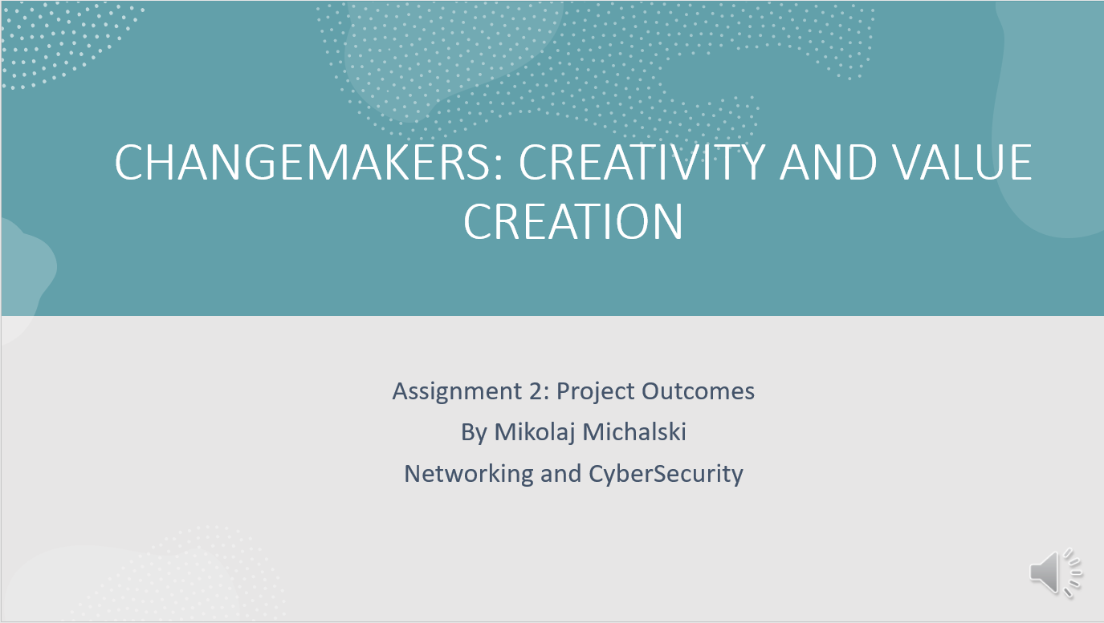
This screenshot is a picture of the first slide in my presentation that is covered in the YouTube link above.

